Supplementary files for manuscript: Patient-reported outcome measures in Takayasu arteritis – a systematic review and meta-analysis
Authors:

- Dr Durga P Misra*, MD, DM, MSc (Epidemiology), FRCP (Edin.)
Associate Professor
Department of Clinical Immunology and Rheumatology,
Sanjay Gandhi Postgraduate Institute of Medical Sciences (SGPGIMS),
Lucknow-226014, India.
email: durgapmisra@gmail.com, dpmisra@sgpgi.ac.in
Phone No: 00917839138932
ORCID ID:http://orcid.org/0000-0002-5035-7396

- Dr Upendra Rathore*, MD
Senior Resident
Department of Clinical Immunology and Rheumatology,
Sanjay Gandhi Postgraduate Institute of Medical Sciences (SGPGIMS),
Lucknow-226014, India.
email: upen0007@gmail.com
ORCID ID: https://orcid.org/0000-0003-1658-8155

- Dr Pallavi Patro, MD
School of Telemedicine
Sanjay Gandhi Postgraduate Institute of Medical Sciences (SGPGIMS),
Lucknow-226014, India.
email: patropallavi17@gmail.com
Phone No. 00915222495274
ORCID ID: http://orcid.org/0000-0002-7645-5883

- Dr Vikas Agarwal, MD, DM, FRCP (Edin)
Professor
Department of Clinical Immunology and Rheumatology,
Sanjay Gandhi Postgraduate Institute of Medical Sciences (SGPGIMS),
Lucknow-226014, India.
email: vikasagr@yahoo.com , vikasagr@sgpgi.ac.in
Phone No: 00915222494318
ORCID ID:http://orcid.org/0000-0002-4508-1233

- Dr Aman Sharma, MD, FRCP (London)
Professor
Clinical Immunology and Rheumatology Services,
Department of Internal Medicine
Postgraduate Institute of Medical Education and Research (PGIMER),
Chandigarh-160012, India
email: amansharma74@yahoo.com
ORCID ID: http://orcid.org/0000-0003-0813-1243

*Dr Durga P Misra and Dr Upendra Rathore are joint first authors.

Supplementary table S1: PRISMA 2009 checklist

Section/topic | # | Checklist item | Reported on page #
TITLE
Title | 1 | Identify the report as a systematic review, meta-analysis, or both. | Title, p 1
ABSTRACT
Structured summary | 2 | Provide a structured summary including, as applicable: background; objectives; data sources; study eligibility criteria, participants, and interventions; study appraisal and synthesis methods; results; limitations; conclusions and implications of key findings; systematic review registration number. | p7-8
INTRODUCTION
Rationale | 3 | Describe the rationale for the review in the context of what is already known. | p8
Objectives | 4 | Provide an explicit statement of questions being addressed with reference to participants, interventions, comparisons, outcomes, and study design (PICOS). | p8
METHODS
Protocol and registration | 5 | Indicate if a review protocol exists, if and where it can be accessed (e.g., Web address), and, if available, provide registration information including registration number. | Not pre-registered
Eligibility criteria | 6 | Specify study characteristics (e.g., PICOS, length of follow-up) and report characteristics (e.g., years considered, language, publication status) used as criteria for eligibility, giving rationale. | p9
Information sources | 7 | Describe all information sources (e.g., databases with dates of coverage, contact with study authors to identify additional studies) in the search and date last searched. | p9
Search | 8 | Present full electronic search strategy for at least one database, including any limits used, such that it could be repeated. | Supplementary table S4
Study selection | 9 | State the process for selecting studies (i.e., screening, eligibility, included in systematic review, and, if applicable, included in the meta-analysis). | p9-10
Data collection process | 10 | Describe method of data extraction from reports (e.g., piloted forms, independently, in duplicate) and any processes for obtaining and confirming data from investigators. | p9-10
Data items | 11 | List and define all variables for which data were sought (e.g., PICOS, funding sources) and any assumptions and simplifications made. | p9, p11
Risk of bias in individual studies | 12 | Describe methods used for assessing risk of bias of individual studies (including specification of whether this was done at the study or outcome level), and how this information is to be used in any data synthesis. | p10
Summary measures | 13 | State the principal summary measures (e.g., risk ratio, difference in means). | p10
Synthesis of results | 14 | Describe the methods of handling data and combining results of studies, if done, including measures of consistency (e.g., I²₎ for each meta-analysis. | p10

Section/topic | # | Checklist item | Reported on page #
Risk of bias across studies | 15 | Specify any assessment of risk of bias that may affect the cumulative evidence (e.g., publication bias, selective reporting within studies). | p10
Additional analyses | 16 | Describe methods of additional analyses (e.g., sensitivity or subgroup analyses, meta-regression), if done, indicating which were pre-specified. | p10
RESULTS
Study selection | 17 | Give numbers of studies screened, assessed for eligibility, and included in the review, with reasons for exclusions at each stage, ideally with a flow diagram. | Supplementary figure S1
Study characteristics | 18 | For each study, present characteristics for which data were extracted (e.g., study size, PICOS, follow-up period) and provide the citations. | Table 1
Risk of bias within studies | 19 | Present data on risk of bias of each study and, if available, any outcome level assessment (see item 12). | p12, supplementary tables S6, S7
Results of individual studies | 20 | For all outcomes considered (benefits or harms), present, for each study: (a) simple summary data for each intervention group (b) effect estimates and confidence intervals, ideally with a forest plot. | p12-21;  Figures 2, 3, 4, 5
Synthesis of results | 21 | Present results of each meta-analysis done, including confidence intervals and measures of consistency. | p12-21;  Figures 2, 3, 4, 5
Risk of bias across studies | 22 | Present results of any assessment of risk of bias across studies (see Item 15). | p12; p21
Additional analysis | 23 | Give results of additional analyses, if done (e.g., sensitivity or subgroup analyses, meta-regression [see Item 16]). | p12-21
DISCUSSION
Summary of evidence | 24 | Summarize the main findings including the strength of evidence for each main outcome; consider their relevance to key groups (e.g., healthcare providers, users, and policy makers). | p22-24
Limitations | 25 | Discuss limitations at study and outcome level (e.g., risk of bias), and at review-level (e.g., incomplete retrieval of identified research, reporting bias). | p22-24
Conclusions | 26 | Provide a general interpretation of the results in the context of other evidence, and implications for future research. | p22-24
FUNDING
Funding | 27 | Describe sources of funding for the systematic review and other support (e.g., supply of data); role of funders for the systematic review. | p3

From: Moher D, Liberati A, Tetzlaff J, Altman DG, The PRISMA Group (2009). Preferred Reporting Items for Systematic Reviews and Meta-Analyses: The PRISMA Statement. PLoS Med 6(7): e1000097. doi:10.1371/journal.pmed1000097
For more information, visit: www.prisma-statement.org.
Supplementary table S2: PRISMA-S checklist

Section/topic | # | Checklist item | Location(s) Reported
INFORMATION SOURCES AND METHODS
Database name | 1 | Name each individual database searched, stating the platform for each. | p9
Multi-database searching | 2 | If databases were searched simultaneously on a single platform, state the name of the platform, listing all of the databases searched. | p9
Study registries | 3 | List any study registries searched. | p9
Online resources and browsing | 4 | Describe any online or print source purposefully searched or browsed (e.g., tables of contents, print conference proceedings, web sites), and how this was done. | p9
Citation searching | 5 | Indicate whether cited references or citing references were examined, and describe any methods used for locating cited/citing references (e.g., browsing reference lists, using a citation index, setting up email alerts for references citing included studies). | p9
Contacts | 6 | Indicate whether additional studies or data were sought by contacting authors, experts, manufacturers, or others. | No contact made with authors
Other methods | 7 | Describe any additional information sources or search methods used. | None
SEARCH STRATEGIES
Full search strategies | 8 | Include the search strategies for each database and information source, copied and pasted exactly as run. | Supplementary table S4
Limits and restrictions | 9 | Specify that no limits were used, or describe any limits or restrictions applied to a search (e.g., date or time period, language, study design) and provide justification for their use. | p9
Search filters | 10 | Indicate whether published search filters were used (as originally designed or modified), and if so, cite the filter(s) used. | No
Prior work | 11 | Indicate when search strategies from other literature reviews were adapted or reused for a substantive part or all of the search, citing the previous review(s). | No
Updates | 12 | Report the methods used to update the search(es) (e.g., rerunning searches, email alerts). | No
Dates of searches | 13 | For each search strategy, provide the date when the last search occurred. | p9
PEER REVIEW
Peer review | 14 | Describe any search peer review process. | No
MANAGING RECORDS
Total Records | 15 | Document the total number of records identified from each database and other information sources. | Supplementary figure S1
Deduplication | 16 | Describe the processes and any software used to deduplicate records from multiple database searches and other information sources. | p9
PRISMA-S: An Extension to the PRISMA Statement for Reporting Literature Searches in Systematic Reviews
Rethlefsen ML, Kirtley S, Waffenschmidt S, Ayala AP, Moher D, Page MJ, Koffel JB, PRISMA-S Group.
Last updated February 27, 2020.

Supplementary table S3: Meta-analysis of observational studies in epidemiology checklist

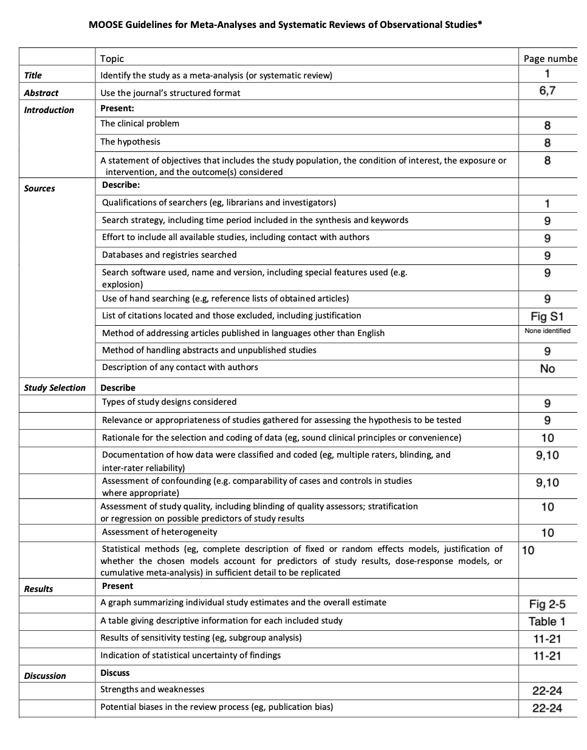

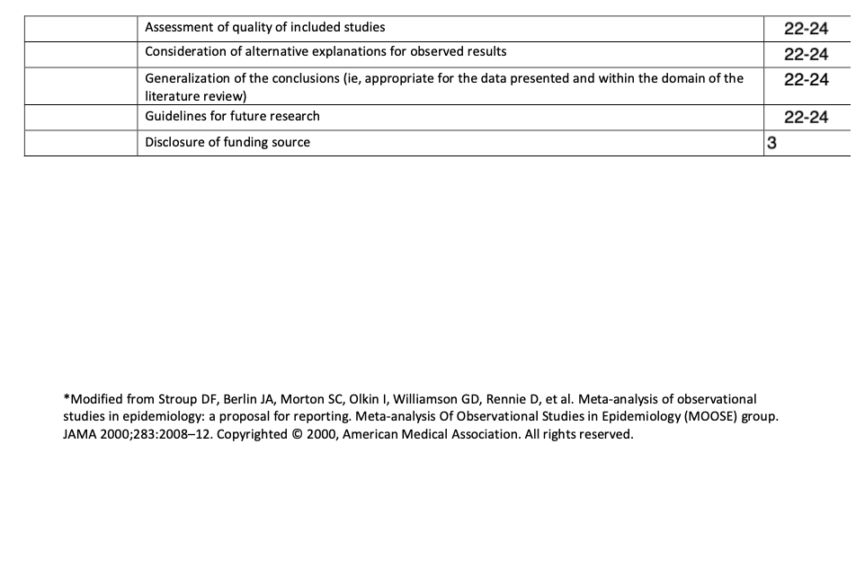

Supplementary table S4: Search strategy for database searches (date of search 12th April 2021)

EMBASE via OVID
1 | Takayasu arteritis.mp. or exp aortic arch syndrome/ | 4324
2 | quality of life.mp. or exp "quality of life"/ | 645134
3 | patient reported outcomes.mp. or exp patient-reported outcome/ | 42582
4 | 2 or 3 | 669849
5 | 1 and 4 | 77
MEDLINE via OVID
1 | Takayasu arteritis.mp. or exp Takayasu Arteritis/ | 4680
2 | patient reported outcomes.mp. or exp Patient Reported Outcome Measures/ | 19486
3 | quality of life.mp. or exp "Quality of Life"/ | 369617
4 | 2 or 3 | 380872
5 | 1 and 4 | 46
Pubmed Central via Pubmed
1 | ("takayasu arteritis"[MeSH Terms]) AND (("quality of life"[MeSH Terms]) OR "patient reported outcomes") | 6
Web of Science
#1 | TOPIC: (Takayasu arteritis OR Takayasu's arteritis)  Indexes=SCI-EXPANDED, SSCI, A&HCI, CPCI-S, CPCI-SSH, ESCI Timespan=All years | 4296
#2 | TOPIC: (quality of life)  Indexes=SCI-EXPANDED, SSCI, A&HCI, CPCI-S, CPCI-SSH, ESCI Timespan=All years | 558123
#3 | TOPIC: (patient reported outcomes)  Indexes=SCI-EXPANDED, SSCI, A&HCI, CPCI-S, CPCI-SSH, ESCI Timespan=All years | 297403
#4 | #3 OR #2  Indexes=SCI-EXPANDED, SSCI, A&HCI, CPCI-S, CPCI-SSH, ESCI Timespan=All years | 801375
#5 | #4 AND #1  Indexes=SCI-EXPANDED, SSCI, A&HCI, CPCI-S, CPCI-SSH, ESCI Timespan=All years | 154
Scopus
1 | TITLE-ABS-KEY ( ( takayasu OR takayasu's ) AND arteritis ) | 5421
2 | TITLE-ABS-KEY ( quality AND of AND life ) | 731491
3 | TITLE-ABS-KEY ( patient AND reported AND outcome ) | 287389
4 | ( TITLE-ABS-KEY ( quality AND of AND life ) ) OR ( TITLE-ABS-KEY ( patient AND reported AND outcome ) ) | 975215
5 | ( TITLE-ABS-KEY ( ( takayasu OR takayasu's ) AND arteritis ) ) AND ( ( TITLE-ABS-KEY ( quality AND of AND life ) ) OR ( TITLE-ABS-KEY ( patient AND reported AND outcome ) ) ) | 172

Supplementary Table S5: Details of medications received by the patients with Takayasu arteritis included in the study
Study [Reference number] | Medications received by the patients (%)
Abularrage 2008 [37] | Corticosteroids (66%), anticoagulants (65%), cytotoxic drugs (37%), immunomodulatory agents (18%), immunosuppressive drugs (16%), no medical therapy (13%)
Akar 2008 [38] | Corticosteroids (41.2%), methotrexate (45.1%), azathioprine (3.9%), cyclophosphamide (3.9%), leflunomide (2%)
Quartuccio 2012 [39] | Antiaggrecant drugs (93.3%), anticoagulant agents (6.7%), azathioprine (6.7%), cyclosporine (13.3%), corticosteroids (93.3%), methotrexate (93.3%), infliximab (100%) $
Alibaz-Oner 2013 [40] | Corticosteroids (90.9%), azathioprine (60%), methotrexate (32.7%), leflunomide (5.4%), infliximab (1.8%)
Grayson 2021 [41] | Not mentioned
Yilmaz 2013 [42] | Methotrexate with corticosteroids (45.4%), azathioprine with corticosteroids (30.9%), cyclophosphamide with corticosteroids (3%), leflunomide with corticosteroids (1.8%), mycophenolate mofetil with corticosteroids (1.2%), cyclosporine with corticosteroids (0.6%), infliximab (4.2%), only corticosteroids (3.6%), no medical therapy (9.1%)
Sreih 2016 [43] | Not mentioned
Gunsay 2017 [44] | Not mentioned
Oliveira 2017 [45] | Corticosteroids (9%), azathioprine (36%), methotrexate (45%), mycophenolate mofetil (9%), hydroxychloroquine (73%), aspirin (73%), statin (36%)
Omma 2017 [46] | Corticosteroids alone (4.8%), corticosteroids along with other disease-modifying anti-rheumatic drugs (86%), methotrexate (63%, azathioprine (27%), cyclophosphamide (8%), leflunomide (19.3%), mycophenolate mofetil (8.4%), methotrexate and azathioprine (4.2%), methotrexate and leflunomide (7.2%), anti-tumor necrosis factor alpha agents (6%), tocilizumab (1.2%), antiaggrecant drugs alone (6.6%), no medical therapy (2.4%).
Chen 2018 [47] | Corticosteroids (82.4%), cyclophosphamide (52.9%), hydroxychloroquine (11.8%), methotrexate (5.9%), azathioprine (5.9%)
Sreih 2018 [48] | Not mentioned
Campochiaro 2020 [49] | Infliximab (100%), corticosteroids (91.3%), other conventional synthetic disease-modifying anti-rheumatic drugs (82%)
Garen 2020 [50] | Not mentioned
Luna-Vargas 2020 [51] | Corticosteroids (87%), methotrexate (53%), antiplatelet drugs (53%), antihypertensive drugs (27%)
Nakaoka 2020 [52] | Corticosteroids (100%), tocilizumab (100%)
Rimland 2020 [53] | Corticosteroids (percentage not available), other immunosuppressive drugs (36%)
Schwartz 2020 [54] | Not mentioned
Astley 2021 [55] | Corticosteroids (23.5%), methotrexate (47%), leflunomide (29.4%), infliximab (29.4%), enalapril (29.4%), amlodipine (17.2%)
dos Santos 2021 [56] | Corticosteroids (10%), methotrexate (30%), azathioprine (10%), leflunomide (5%), infliximab (10%), tocilizumab (5%),
Erdal 2021 [57] | Corticosteroids (48.1%), conventional synthetic disease-modifying antirheumatic drugs (79.2%), biologic disease-modifying antirheumatic drugs (20.8%).
$For the entire cohort of 15 patients

Supplementary table S6: Quality assessment of included cross-sectional studies using the Joanna Briggs Institute Critical Appraisal Checklist
Study  [Reference No] | Inclusion criteria clearly defined? | Study subjects and setting detailed? | Exposure measurement valid and reliable? | Objective and standard criteria for condition? | Confounders? | Adjustment for confounders? | Outcomes valid and reliable? | Appropriate statistical analysis?
Abularrage 2008 [37] | √ | √ | √ | √ | √ | √ | √ | √
Akar 2008 [38] | √ | √ | √ | √ | √ | X | √ | X
Grayson 2013 [41] | √ | √ | √ | √ | √ | √ | √ | √
Yilmaz 2013 [42] | √ | √ | √ | √ | √ | √ | √ | √
Omma 2017 [46] | √ | √ | √ | √ | √ | √ | √ | √
Sreih 2018 [48] | √ | √ | √ | √ | NA | NA | √ | √
Luna-Vargas 2020 [51] | √ | √ | √ | √ | X | X | √ | X
Astley 2021 [55] | √ | √ | √ | √ | X | X | √ | X
dos Santos 2021 [56] | √ | √ | √ | √ | X | X | √ | X
Erdal 2021 [57] | √ | √ | √ | √ | √ | √ | √ | √
√ - Yes; X – No; NA – Not available

Supplementary table S7: Quality assessment of included cohort studies using the Newcastle-Ottawa Scale
Study  [Reference No] | Selection | Comparability | Outcome | Total stars
Quartuccio 2012 [39] | *** | - | *** | 6
Alibaz-Oner 2013 [40] | *** | ** | ** | 7
Oliveira 2017 [45] | *** | - | *** | 6
Chen 2018 [47] | ** | - | ** | 4
Rimland 2020 [53] | **** | - | *** | 7
Schwartz 2020 [54] | *** | - | *** | 6

Supplementary table S8: Assessment of certainty of evidence using GRADE profiler
Outcome [References] | Certainty of evidence | Justification
SF-36 scores for patients with TAK compared with healthy controls [39, 40, 55, 56] | Low | Observational studies, serious inconsistency and imprecision in pooled estimates, large effect size.
Longitudinal changes in SF-36 scores for patients with TAK or changes following therapeutic interventions [39, 45] | Very low | Observational studies, serious risk of bias in Chen et al due to low quality on the Newcastle Ottawa scale, serious inconsistency and imprecision in pooled estimates.
HAQ for patients with TAK compared with healthy controls [40, 42, 56] | Very low | Observational studies, serious risk of bias due to lack of adjustment for confounders by dos Santos et al.
HADS for patients with TAK compared with healthy controls [40, 42] | Very low | Observational studies, serious inconsistency and imprecision in pooled estimates,
HADS: Hospital Anxiety and Depression Scale; HAQ: Health Assessment Questionnaire; SF-36: 36-item short form score; TAK: Takayasu arteritis

Supplementary figure S1: Search results.
The flowchart is derived from the PRISMA [15] and PRISMA-S [16] flowchart.

