Supplemental Figure 1. PRISMA flow diagram showing the selection of studies for the systematic review of LCBM receptor expression compared to primary tumor immunophenotypes.
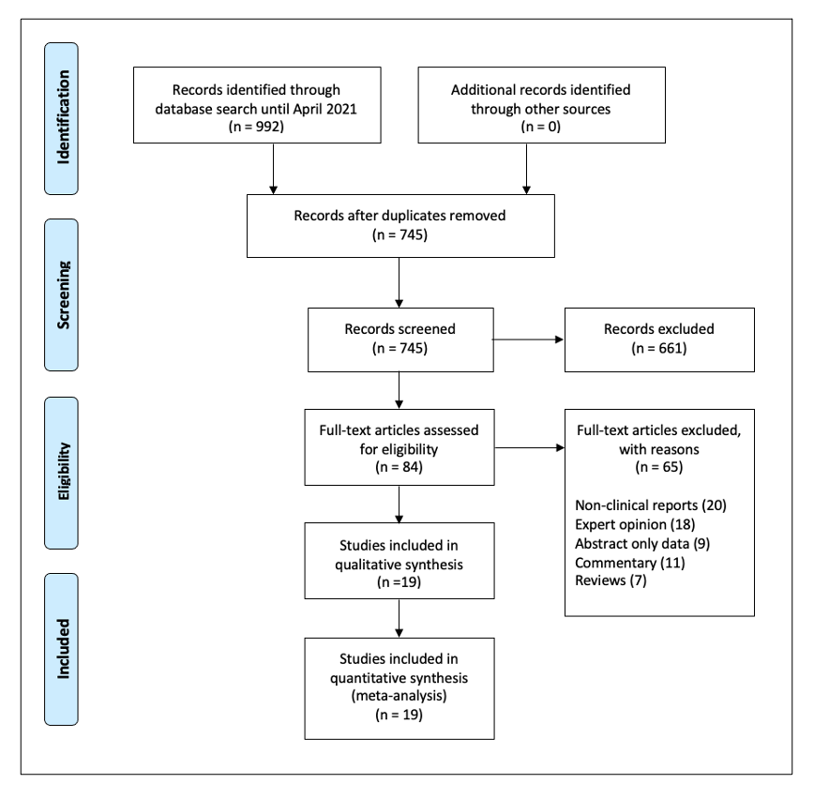

Supplemental Figure 2. Funnel plots for (A) for lung/BM EGFR discordance, (B) BM EGFR gain, and (C) BM EGFR loss to assess the potential for publication bias. The measure of effect size and study precision are shown on x- and y-axis.

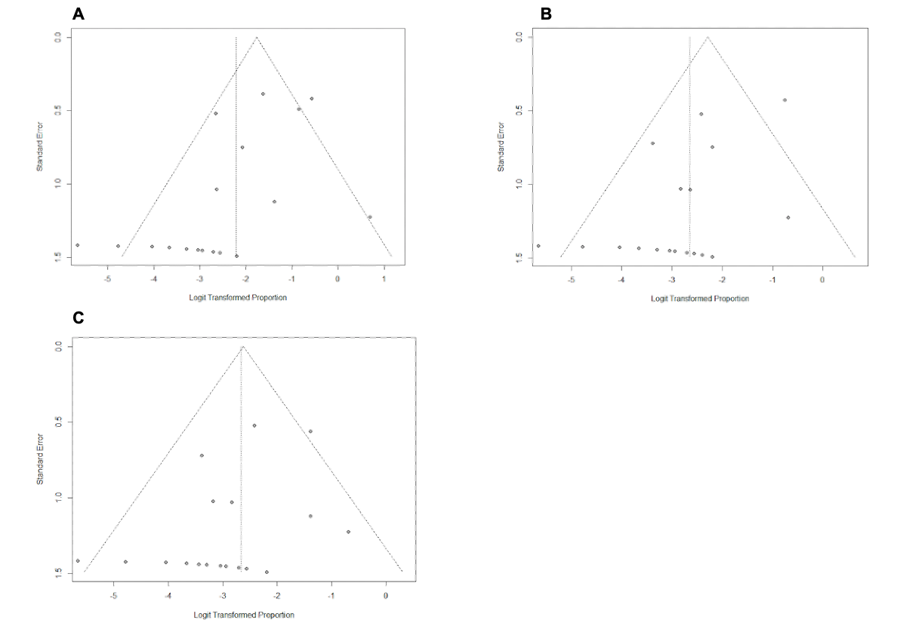

Supplemental Figure 3. Funnel plots for (A) lung/BM KRAS discordance (B) BM KRAS gain, and (C) BM KRAS loss to assess the potential for publication bias. The measure of effect size and study precision are shown on x- and y-axis.

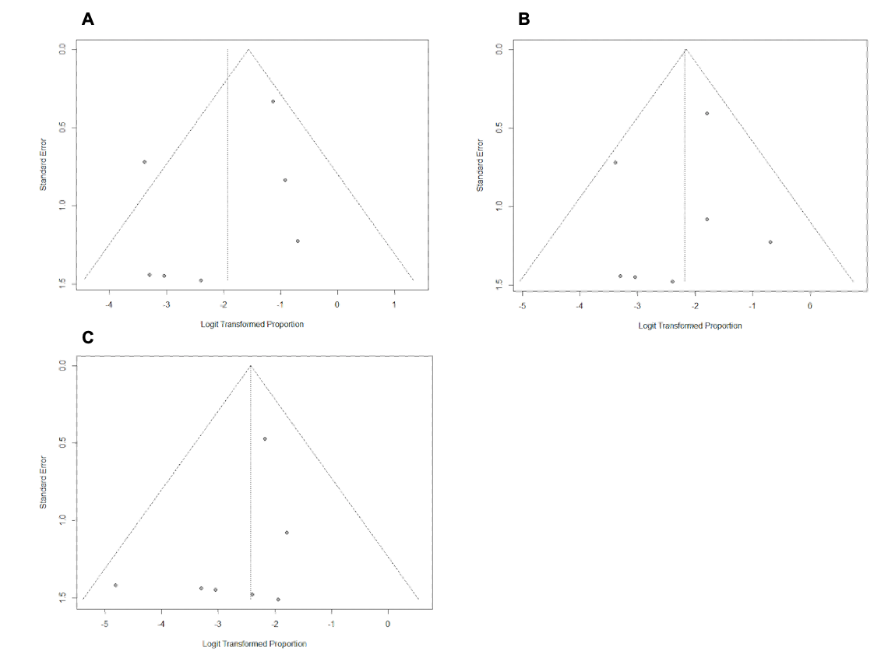

Supplemental Table 1: Search strategy for each database

Database | Search Term
MEDLINE (PubMed) | (Lung Neoplasms[MeSH] OR lung[tiab] AND (cancer[tiab] OR carcinoma[tiab] OR tumor[tiab]) AND ("Receptor, Epidermal Growth Factor"[MeSH] OR epidermal growth factor receptor[tiab] OR EGFR[tiab]) AND (discordant[tiab] OR discordance[tiab] OR concordance[tiab] OR concordant[tiab] OR conversion[tiab])
CENTRAL (Cochrane Central Register of Controlled Trials) | MeSH Term - lung cancer; metastatic; epidermal growth factor receptor; EGFR; discordant; receptor discordance; receptor concordance; receptor concordant; receptor conversion

Supplemental Table 2: PICOS criteria for inclusion and exclusion criteria in meta-analysis

Parameter | Inclusion Criteria | Exclusion Criteria
Patient | Patients diagnosed with primary lung tumor and LCBM | Patients with primary lung tumor and extracranial metastases
Publication Type | Retrospective or prospective cohort studies >10 patients documenting EGFR and KRAS status in primary lung cancers compared to LCBM, and receptor conversion or discordance published in English. | Reviews, expert opinions, case reports, animal studies, case series <10 patients published in non-English language
Intervention | Studies that have tissue samples of primary tumor and LCBM | Studies that have tissue samples of primary tumor and extracranial metastases
Outcomes | Studies including the discordance/conversion rates of EGFR and KRAS between primary tumour and LCBM | Studies excluding the discordance/conversion rates of EGFR and KRAS between primary tumour and LCBM
Follow-up Time | N/A (pathology comparison study) | N/A (pathology comparison study)

Abbreviations: LCBM = Lung Cancer Brain Metastases; EGFR = Epidermal growth factor receptor; KRAS = Kirsten rat sarcoma viral oncogene homolog; PICOS = Population, Intervention, Control, Outcomes, Study Design

Supplemental Table 3 – GRADE approach to assess quality of the body of evidence

Outcomes (number of studies) references | Summary of findings |  | Quality Assessment
Outcomes (number of studies) references | Number of events | Effect size | Inconsistency | Imprecision | Quality | Importance
LC / BM EGFR discordance  (19 studies) | 501 | 0.10 (0.05-0.17) | Serious | Serious | Moderate | Important
BM EGFR gain  (19 studies) | 501 | 0.07 (0.04-0.12) | Serious | Serious | Moderate | Important
BM EGFR loss  (19 studies) | 501 | 0.07 (0.04-0.10) | Serious | Serious | Moderate | Important
LC / BM KRAS discordance  (7 studies) | 148 | 0.13 (0.05-0.27) | Serious | Serious | Moderate | Important
BM KRAS gain  (7 studies) | 148 | 0.10 (0.06-0.18) | Serious | Serious | Moderate | Important
BM KRAS loss  (7 studies) | 148 | 0.08 (0.04-0.15) | Serious | Serious | Moderate | Important

Abbreviations: LC = Lung Cancer; BM = Brain Metastases; EGFR = Epidermal growth factor receptor; KRAS = Kirsten rat sarcoma viral oncogene homolog

