Supplementary file 1:
Search Strategy:
(hypertension or blood pressure or systolic hypertension or diastolic hypertension or systolic blood pressure or diastolic blood pressure) AND
(child or children or childhood or adolescent or teens or teenage or youth or infant or paediatric or pediatric) AND
(african or africa or north africa or northern africa or central africa or middle africa or southern africa or east african or eastern african or west africa or western africa or algeria or angola or portuguese west africa or benin or dahomey or botswana or bechuanaland burkina faso or upper volta or haute voltaire or burundi or cameroon or cabo verde or cape verde central african republic or chad or comoros or congo or moyen congo or french congo or democratic republic of congo or zaire or cote d’ivoire or ivory coast or djibouti or french territory of afar issas or equatorial guinea or rio muni or fernando po or egypt or eritrea or ethiopia or gabon or gambia or ghana or guinea or french guinea or guinea bissau or portuguese guinea or kenya or lesotho or basutoland or liberia or libya or madagascar or malawi or nyasaland or mali or mauritania or mauritius or morocco or mozambique or portuguese east africa or namibia or south west africa or niger or nigeria or rwanda or Ruanda urundi or saharawi arab democratic republic or sao tome principe or senegal or seychelles or sierra leone or somalia or british somaliland or south africa or south sudan or sudan or kingdom of swaziland or eswatini or tanzania or tanganyika or togo or tunisia or uganda or zambia or northern rhodesia or zimbabwe or rhodesia or western sahara) NOT (african american or black americans)

Supplementary table 1. Predefined data extraction form
Author | Year published | Year Collected | Country | Region | Geographical Setting | GDP per capita at collection | Sample size | Age range | Mean Age
- | - | - | - | - | - | - | - | - | -
Males | Females | Prevalence HTN (%) | Prevalence HTN (n) | Prevalence Elevated BP (%) | Prevalence Elevated BP (n) | Prevalence combined HTN and elevated BP (%) | Prevalence combined HTN and elevated BP (n) | % Normal BMI | % Overweight
- | - | - | - | - | - | - | - | - | -
% Obese | % Overweight + Obese | HTN per weight category | HTN per sex category | Relevant Associations | HTN classification used | Automated vs manual measurement | Number of occasions measurement | Risk of bias score | Additional Notes
- | - | - | - | - | - | - | - | - | -

Supplementary table 2. Univariate regression analysis results for hypertension prevalence
Variable | Coefficient | Standard error | p-value | 95% Confidence interval | I² residual (%) | Adjusted R² (%)
Log-GDP (n=35) | 0·016 | 0·023 | 0·496 | -0·031-0·063 | 91·3 | -3·15
Mean BMI (n=19) | -0·005 | 0·009 | 0·598 | -0·024-0·014 | 78·1 | -0·69
Mean age (n=29) | -0·002 | 0·005 | 0·735 | -0·012-0·009 | 90·0 | -5·3
Urb/rural (n=20)  1=urban, 2= rural | -0·051 | 0·031 | 0·118 | -0·117-0·014 | 75·0 | 12·1
Auto/Manual  (n=32)  1=auto, 2=manual | -0·041 | 0·024 | 0·102 | -0·091-0·009 | 69·6 | 7·5
Nr of measures (n=36)  1=1; 2=multiple | -0·035 | 0·025 | 0·117 | -0·5086-0·017 | 71·8 | 1·7
Standards (n=38)  1=4th report, 2=other | 0·024 | 0·032 | 0·449 | -0·040-0·088 | 89·4 | -0·9

Supplementary table 3. Risk of Bias
Author | Criteria 1 | Criteria 2 | Criteria 3 | Criteria 4 | Criteria 5 | Criteria 6 | Criteria 7 | Criteria 8 | Criteria 9 | Criteria 10 | Total | Classification
Bouhenni et al⁹⁰ | High | High | Low | Low | Low | Low | Low | Low | Low | Low | 8 | Low
Gomwe et al⁷⁵ | High | Low | Low | Low | Low | Low | Low | Low | Low | Low | 9 | Low
Sherif et al³⁸ | High | High | High | Low | Low | Low | High | Low | Low | Low | 6 | Moderate
Abu et al⁵⁷ | High | High | Low | Low | Low | Low | Low | Low | Low | Low | 8 | Low
Matjuda et al⁹² | High | High | High | Low | Low | Low | Low | Low | Low | High | 6 | Moderate
Nqweniso et al⁷³ | High | High | High | Low | Low | Low | Low | Low | Low | Low | 7 | Moderate
Sekokotla et al⁴⁵ | High | High | High | Low | Low | Low | Low | Low | Low | Low | 7 | Moderate
Katamba et al³⁹ | High | Low | High | Low | Low | Low | Low | Low | Low | Low | 8 | Low
Okpokowuruk et al⁹⁷ | High | High | Low | Low | Low | Low | Low | Low | Low | Low | 8 | Low
Nsanya et al⁷² | High | Low | High | High | Low | Low | Low | Low | Low | Low | 7 | Moderate
Ibrahim et al⁵⁶ | High | Low | High | Low | Low | Low | Low | Low | Low | Low | 8 | Low
Chelo et al⁶⁹ | High | Low | Low | High | Low | Low | Low | Low | Low | Low | 8 | Low
Nakiriba et al⁴² | High | Low | Low | Low | Low | Low | Low | Low | Low | High | 8 | Low
Gerber et al⁴⁴ | High | High | High | Low | Low | Low | Low | Low | Low | Low | 7 | Moderate
Leyvraz et al⁴⁰ | Low | High | High | Low | Low | Low | Low | Low | Low | Low | 8 | Low
Sekgala et al⁹³ | High | Low | Low | Low | Low | Low | Low | Low | Low | High | 8 | Low
Schoenbuchner et al⁷⁴ | High | High | Low | Low | Low | Low | Low | Low | Low | High | 7 | Moderate
Nkwana et al⁴⁹ | High | Low | Low | Low | Low | High | Low | Low | Low | Low | 8 | Low
Chungag et al⁴⁷ | High | High | High | Low | Low | High | Low | Low | Low | Low | 6 | Moderate
Mphekgwana et al³² | High | Low | Low | Low | Low | Low | Low | Low | Low | Low | 9 | Low
Mokwatsi at al⁹⁴ | High | High | High | Low | Low | Low | Low | Low | Low | Low | 7 | Moderate
Jobe et al⁹⁶ | High | High | Low | Low | Low | Low | Low | Low | Low | Low | 8 | Low
Abiodun et al⁵⁸ | HIgh | High | High | Low | High | Low | Low | Low | Low | Low | 6 | Moderate
Emmanuel et al⁵⁹ | High | High | Low | Low | Low | Low | Low | Low | Low | Low | 8 | Low
Ezeudu et al⁶⁰ | HIgh | Low | High | Low | Low | Low | Low | Low | Low | Low | 8 | Low
Amadi et al⁶¹ | High | High | High | Low | Low | Low | Low | Low | Low | Low | 7 | Moderate
Benmohammed et al⁷⁰ | High | High | Low | Low | Low | Low | Low | Low | Low | Low | 8 | Low
Omisore et al⁶² | High | Low | High | Low | Low | Low | Low | Low | Low | Low | 8 | Low
Masocha et al⁵⁰ | High | High | High | Low | Low | High | Low | Low | Low | High | 5 | High
Azupogo et al⁵³ | Low | Low | Low | Low | Low | Low | Low | Low | Low | High | 9 | Low
Hassan et al³⁷ | High | High | High | Low | Low | Low | Low | Low | Low | Low | 7 | Moderate
Adeomi et al ⁶³ | High | High | Low | Low | Low | Low | Low | Low | Low | Low | 8 | Low
Ukoh et al⁶⁴ | High | High | Low | Low | Low | Low | Low | Low | Low | Low | 8 | Low
El-Koofy et al³⁴ | High | High | High | Low | Low | Low | Low | Low | Low | Low | 7 | Moderate
Wariri et al⁷¹ | High | Low | Low | Low | Low | Low | Low | Low | Low | High | 8 | Low
Negash et al⁵² | High | Low | Low | Low | Low | Low | Low | Low | Low | Low | 9 | Low
Elseifi et al³⁵ | High | High | Low | Low | Low | Low | Low | Low | Low | Low | 8 | Low
Muhihi et al⁴¹ | High | High | High | Low | Low | Low | Low | Low | Low | Low | 7 | Moderate
Matjuda et al⁴⁶ | High | High | High | Low | Low | Low | Low | Low | Low | Low | 7 | Moderate
Amponsem-Boateng et al⁵⁴ | High | High | High | Low | Low | Low | Low | Low | Low | Low | 7 | Moderate
Raphadu et al⁵¹ | High | High | High | Low | Low | Low | Low | Low | Low | Low | 7 | Moderate
Alicke et al⁵⁵ | High | High | High | Low | Low | Low | Low | Low | Low | Low | 7 | Moderate
Sebati et al⁴⁸ | High | High | High | Low | Low | Low | Low | Low | Low | Low | 7 | Moderate
Lule et al⁹¹ | High | High | Low | Low | Low | Low | Low | Low | Low | Low | 8 | Low
Nyangasa et al⁴³ | High | Low | Low | Low | Low | Low | Low | Low | Low | Low | 9 | Low
Hassana et al³⁶ | High | High | High | Low | Low | Low | Low | Low | Low | Low | 7 | Moderate
Musa et al³³ | High | High | Low | Low | Low | Low | Low | Low | Low | Low | 7 | Moderate
Isezuo et al⁶⁵ | High | High | High | Low | Low | Low | Low | Low | Low | Low | 7 | Moderate
Houle et al⁹⁵ | High | High | Low | Low | Low | Low | Low | Low | Low | Low | 8 | Low
Chedjou-Nono et al⁶⁸ | High | Low | High | Low | Low | Low | Low | Low | Low | Low | 8 | Low
Akinbodewa et al⁹⁸ | High | High | High | Low | Low | Low | Low | Low | Low | Low | 7 | Moderate
Sadoh et al | High | High | High | Low | Low | Low | Low | Low | Low | High | 6 | Moderate
Yilgwan et al⁶⁶ | High | High | Low | Low | Low | Low | Low | Low | Low | Low | 8 | Low

Criteria:
- Was the study’s target population a close representation of the national population in relation to relevant variables, e.g. age, sex, occupation?
- Was the sampling frame a true or close representation of the target population?
- Was some form of random selection used to select the sample, OR, was a census undertaken?
- Was the likelihood of non-response as minimal?
- Were data collected directly from the subjects (as opposed to a proxy)?
- Was an acceptable case definition used in the study?
- Was the study instrument that measured the parameter of interest (e.g. prevalence of low back pain) shown to have reliability and validity if necessary)?
- Was the same mode of data collection used for all subjects?
- Was the length of the shortest prevalence period for the parameter of interest appropriate?
- Were the numerator(s) and denominator(s) for the parameter of interest appropriate?
Supplementary figure 1. Funnel plots for meta-analysis for prevalence of a) hypertension b) elevated blood pressure and c) combined elevated blood pressure and hypertension.

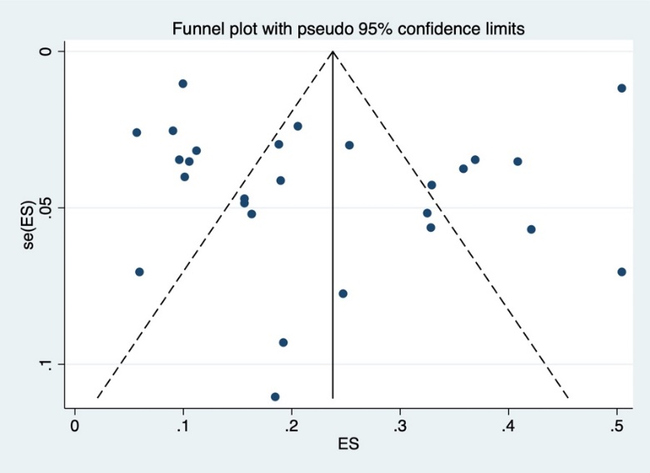
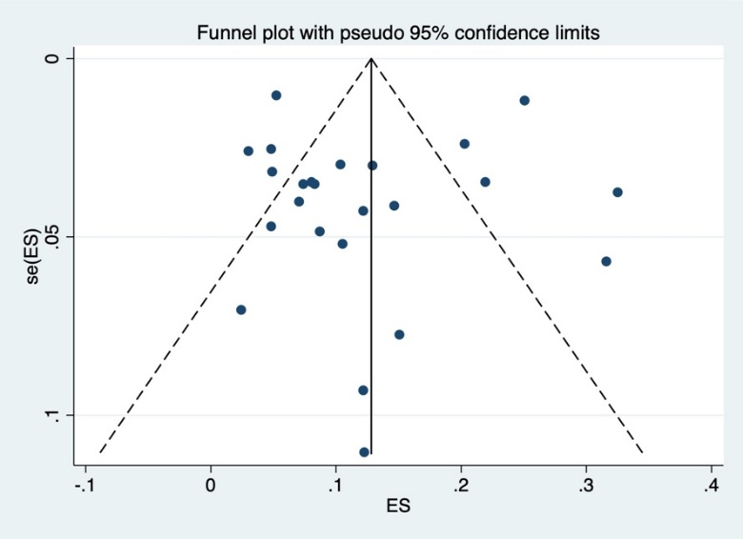
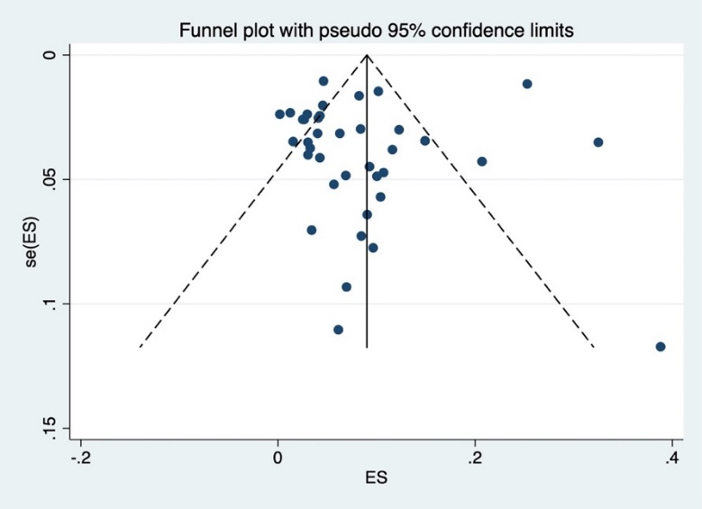
A) B) C)

Supplementary figure 2. Funnel plots for hypertension meta-analysis by subgroup: Africa region
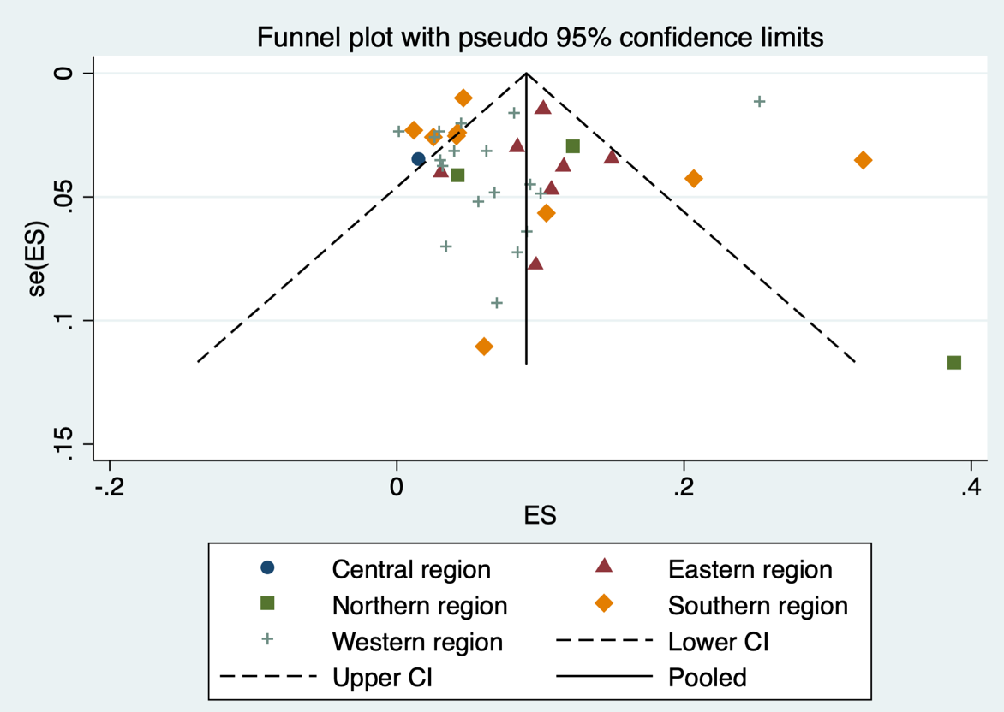

Supplementary figure 3. Funnel plots for hypertension meta-analysis by subgroup: Geographical setting
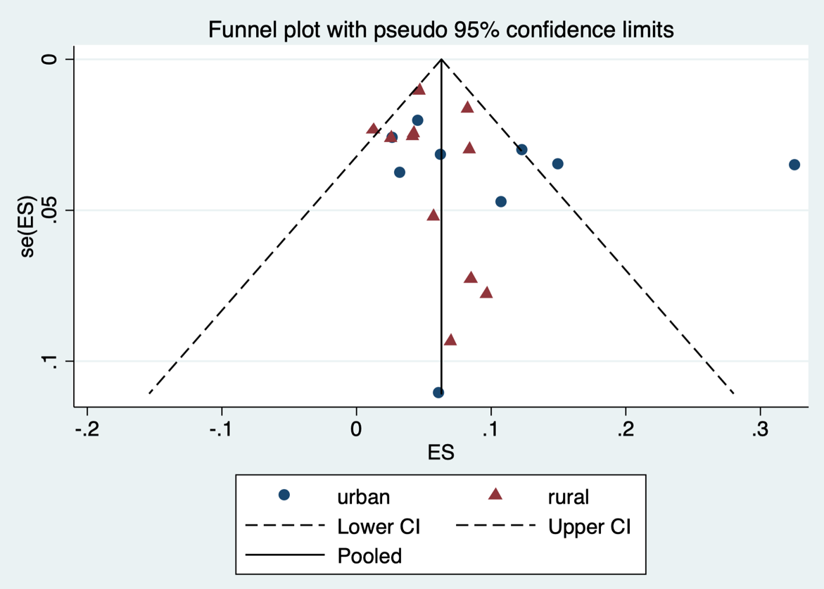

Supplementary figure 4. Funnel plots for hypertension meta-analysis by subgroup: Timing of data collection
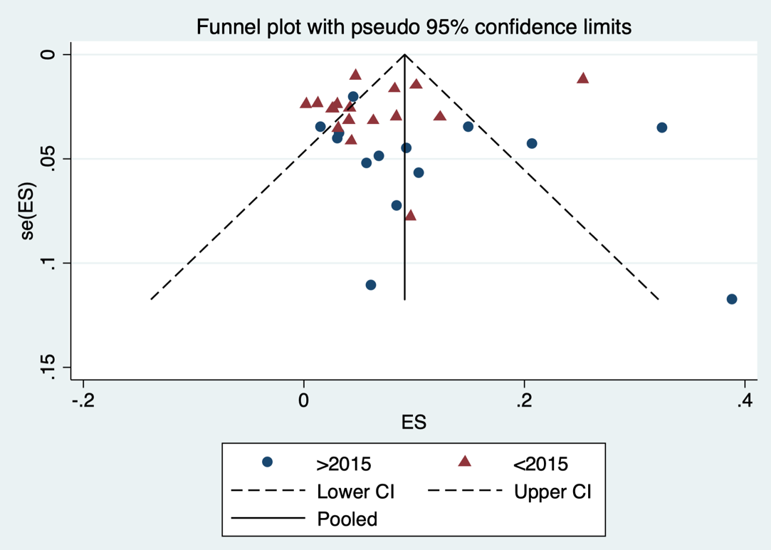

Supplementary figure 5. Funnel plots for hypertension meta-analysis by subgroup: Age group
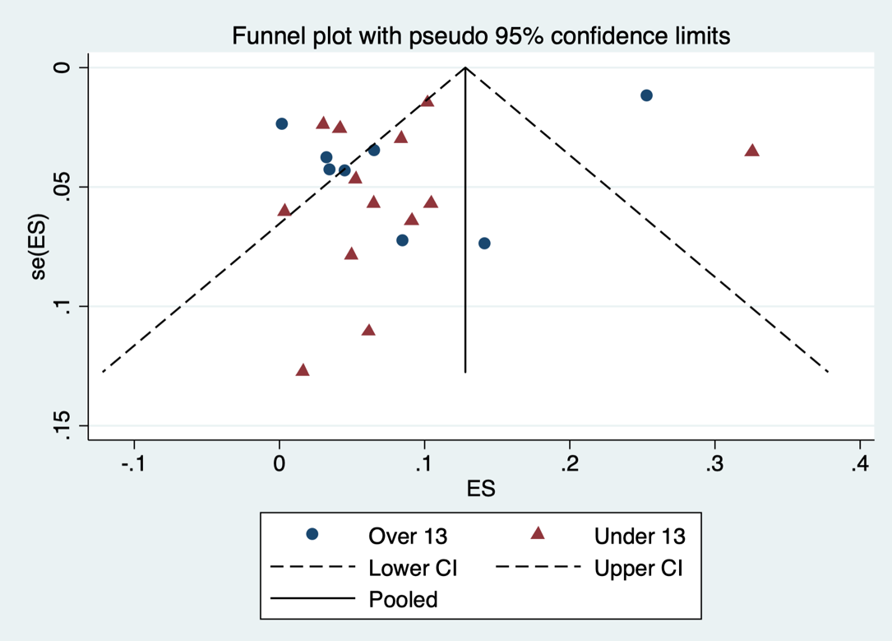

Supplementary figure 6. Funnel plots for hypertension meta-analysis by subgroup: Sex

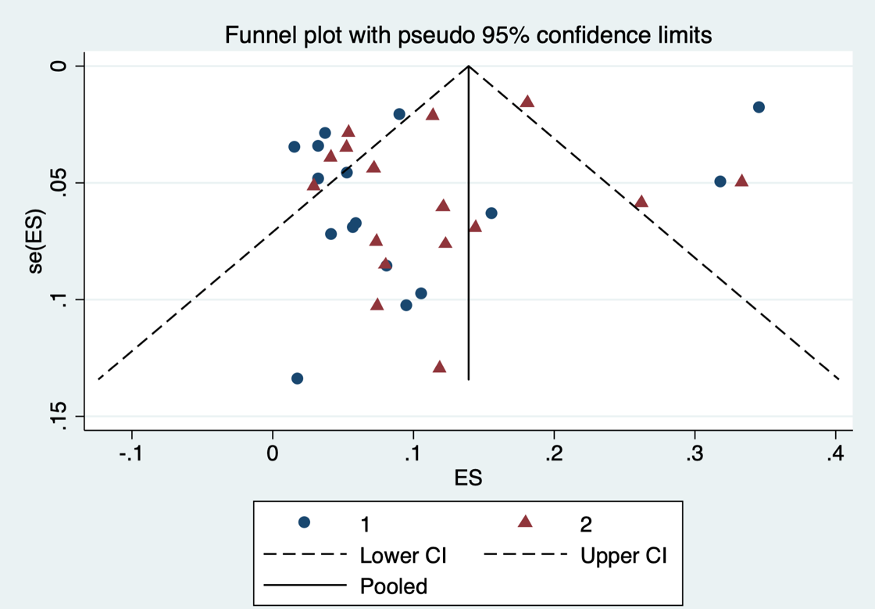

Supplementary figure 7. Funnel plots for hypertension meta-analysis by subgroup: BMI category
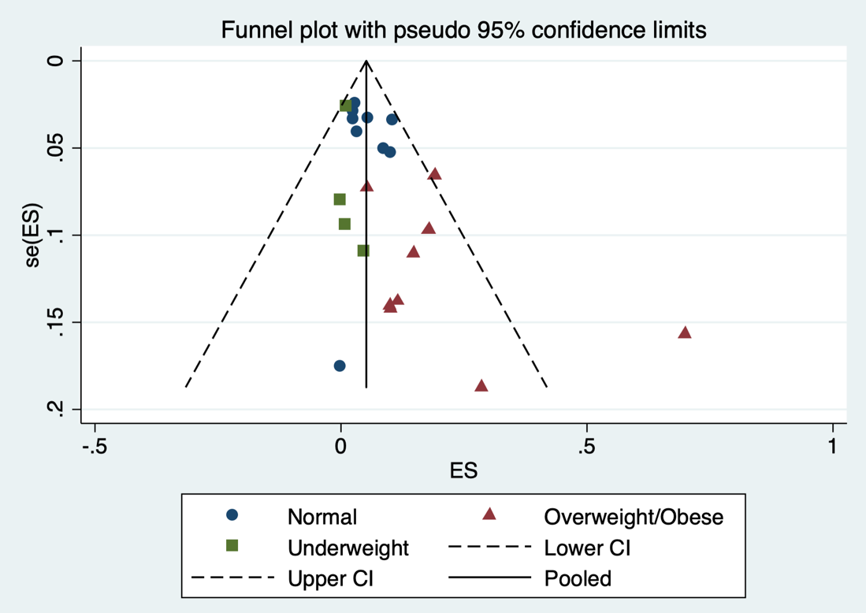

Supplementary figure 8. Funnel plots for hypertension meta-analysis by subgroup: BP methodology
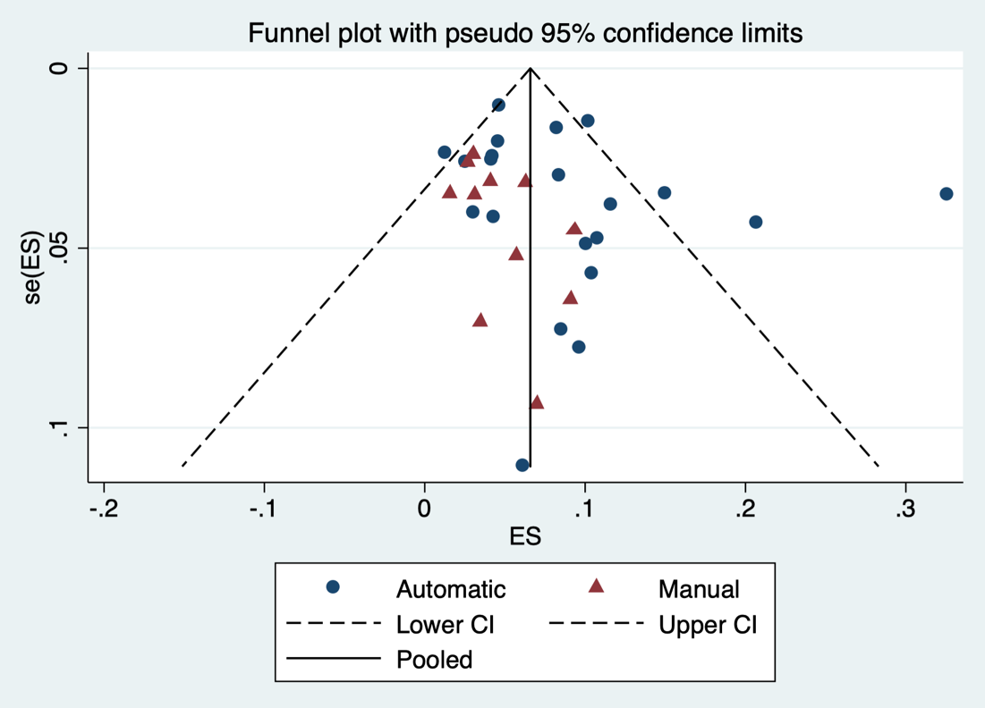

Supplementary figure 9. Funnel plots for hypertension meta-analysis by subgroup: Number of measurement occasions
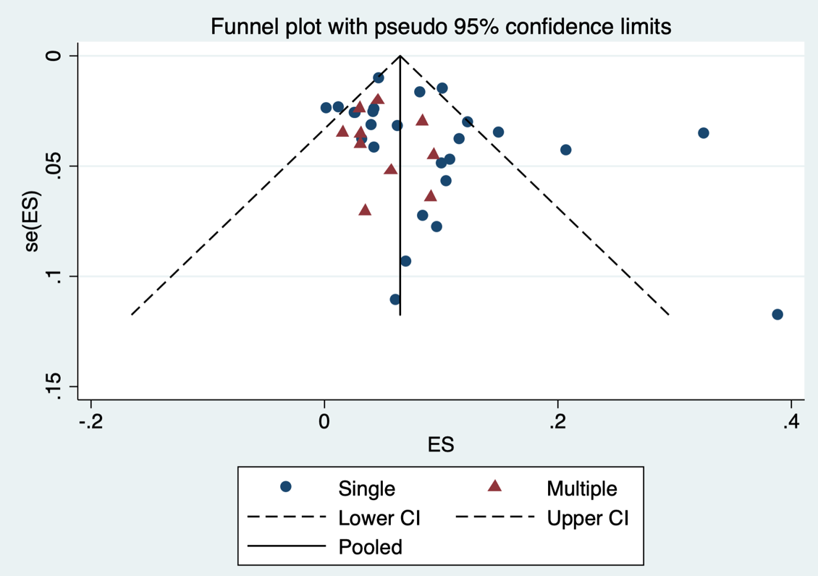

Supplementary figure 10. Funnel plots for hypertension meta-analysis by subgroup: Standards used for classification of HTN
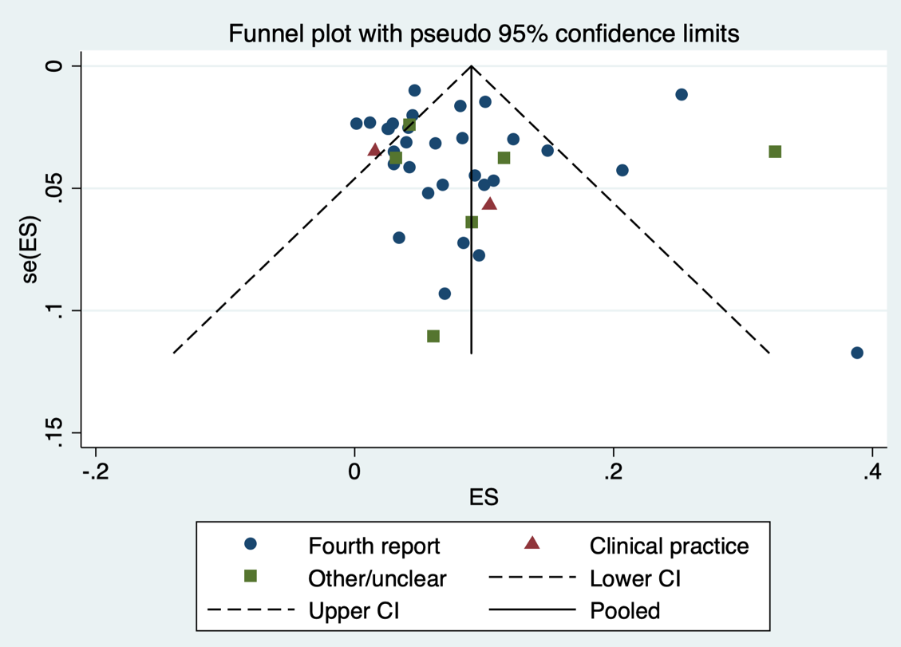

Supplementary figure 11. Funnel plots for hypertension meta-analysis by subgroup: Sample size
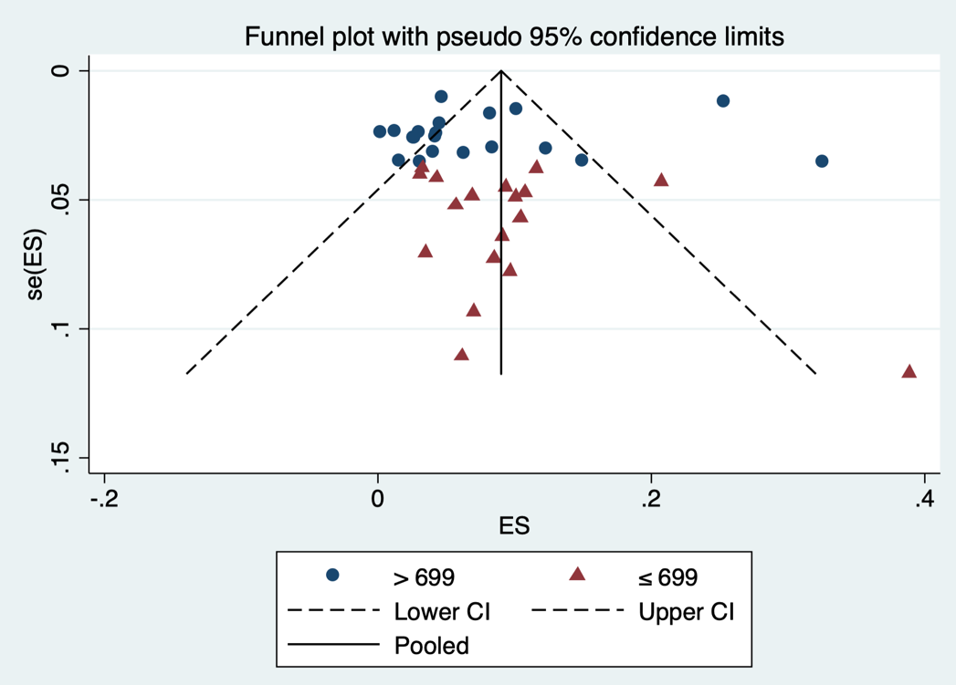

Supplementary figure 12. Funnel plots for hypertension meta-analysis by subgroup: Risk of bias score
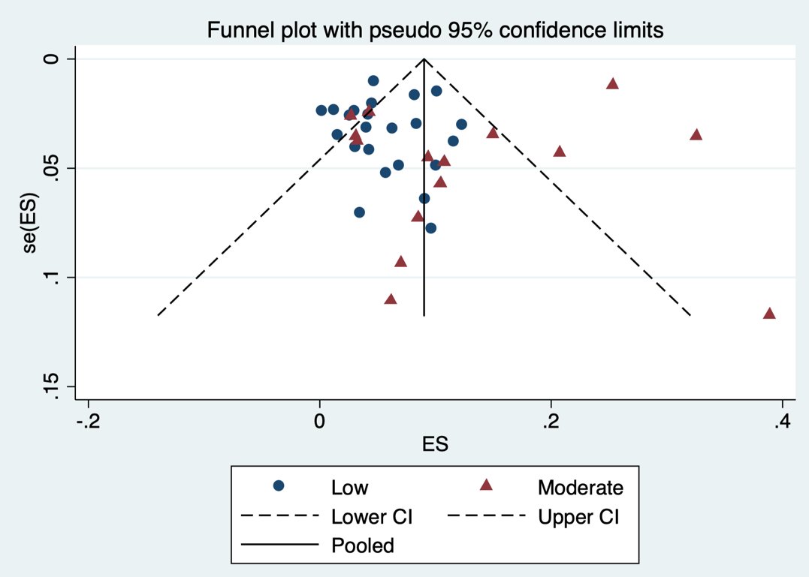

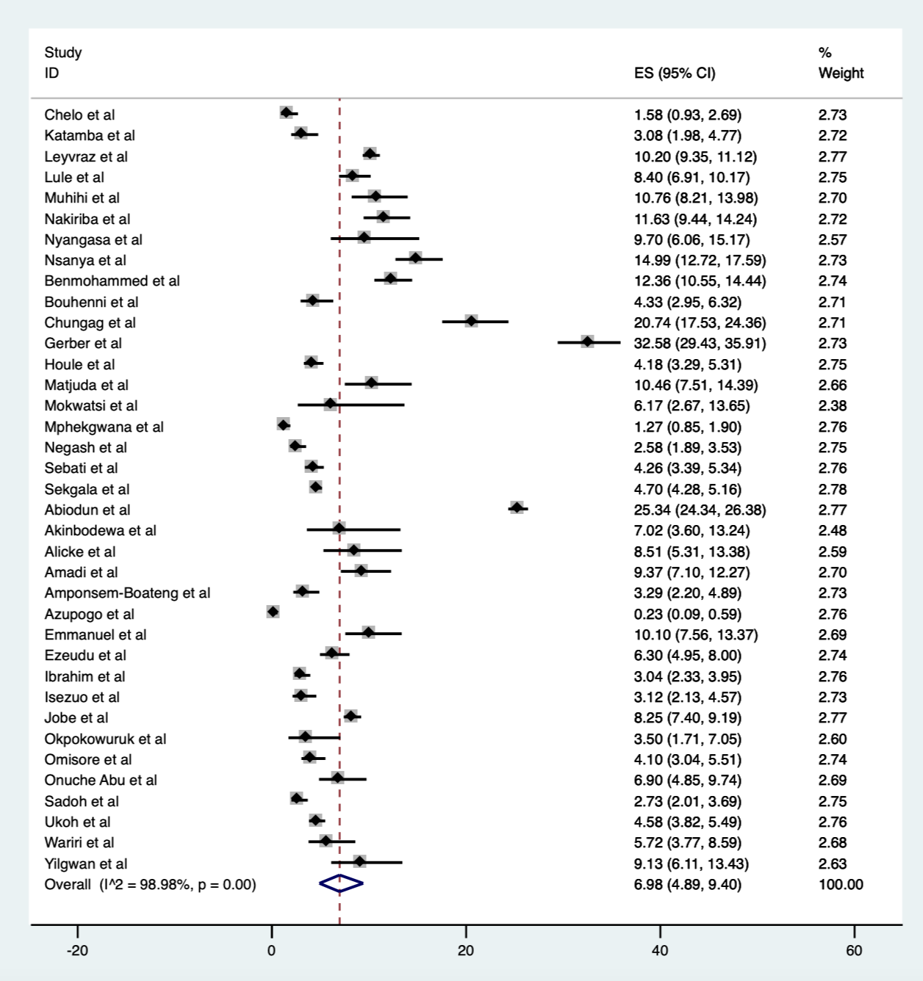
Supplementary figure 13. Meta-analysis for hypertension prevalence excluding study (ref: 44) not reporting, or adjusting for lack of, multiple measures.

