Supplementary data

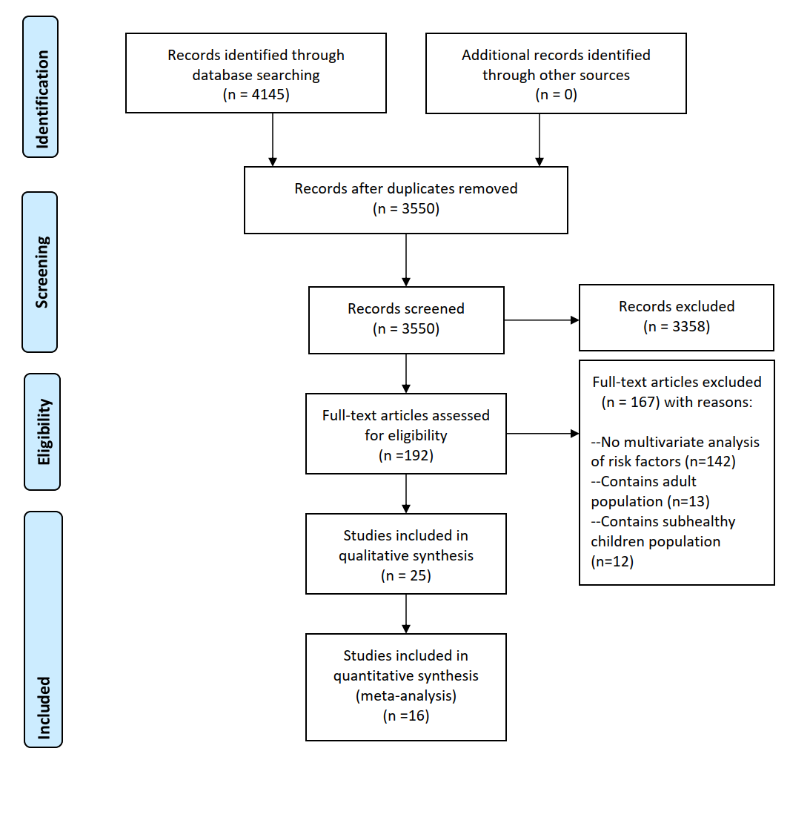
Figure S1: PRISMA flow chart
Table S1: Summary of studies included in the systematic review
Studies | Region | Study design | Participants ,study setting and study period | Prevalence of resistant pathogen | Guidelines applied to determine MIC | Significant risk factors | NOS assessment | Included in the meta-analysis
Boost et al. 2001²⁹ | Hong Kong | Cross sectional | Throat swabs from 1455 primary one school children with mean age 77 months | carriage rate of S. pneumoniae is 3.5%, 49% were penicillin resistant  penicillin intermediate and highly resistant S. pneumoniae: 3.5% x 49% = 1.72% | NCCLS | Presence of younger siblings | ** | Yes
Chiu et al. 2001¹⁸ | Hong Kong | Cross sectional | Nasopharyngeal swab specimens from 1,978 children (ages, 2 to 6 years) attending day care centers or kindergartens | carriage rate of S. pneumoniae is 19.4%, 58.2% were penicillin non-susceptible  penicillin non-susceptible (intermediate and resistant) S. pneumoniae prevalence: 58.2% x 19.4% = 11.3% | NCCLS | Antibiotics use in the preceding 3 months | ** | Yes
Lee et al. 2001¹⁰ | Asian countries | Prospective observational | Nasal swab of 4963 Asian children attending daycare center/outpatient clinic during January 1998 to March 1999 | Nasal carriage of S. pneumoniae is 22.3%, 35.8% of them were penicillin non-susceptible  prevalence of penicillin non-susceptible(intermediate and highly) S. pneumoniae: 22.3% x 35.8% = 7.98% | NCCLS | History of acute otitis media, geographical location of residency, daycare attendance | ** | Yes
Schlesinger et al. 2003¹⁶ | Israel | Prospective observational | Nasal swab from 831 healthy children aged 0.5 to 17 years visiting outpatient clinics or the pediatric emergency room | MRSA prevalence: 5/831 = 0.6% | MIC lower than 4 mg/L classified as MRSA | Older age and a family member who is a healthcare worker | ** | No
Lu et al. 2005²⁸ | Taiwan | Prospective observational | Nasal swab from 1838 community resident+393 subjects from healthcare facility (only 987 school students (aged 2-18 years) are counted) from 1 April to 31 October 2001 | MRSA prevalence: 3.3% | NCCLS | Recent gastrointestinal disease and hospital admission | ** | Yes
Uzuner et al. 2007⁵⁵ | Turkey | Cross sectional | Nasopharyngeal specimens of 369 children ranging from 9 days to 67 months in a health center between February 2 and March 5, 2004 | 44/301(14.6%) children contain penicillin non-susceptible (intermediate and high-level) S. pneumoniae | NCCLS | Antibiotics use in the last 2 months | *** | No
ÖKsÜZ et al. 2007⁵⁶ | Turkey | Cross sectional | Nasopharyngeal and nasal culture of 484 healthy schoolchildren (6-14 years old) | 24 out of 484 nasal cultures contained MRSA (5%) | CLSI | Age | ** | No
Adler et al. 2010⁹ | Israel | Prospective observational | Nasal swab from 553 healthy 2-12 months infants in outpatient clinic from September 2005 to June 2006 | MRSA prevalence: 32/553 = 5.7% | CLSI | Ethnicity | ** | No
Lo et al. 2010 (a)²¹ | Taiwan | Prospective observational | Nasal swab from 1195 healthy children aged 14 years or below in healthcare visit/kindergarten | MRSA prevalence: 89/1195 = 7.4% | CLSI | Household contact  with a high-risk individual and recent antibiotic use | *** | Yes
Lo et al. 2010 (b)¹⁷ | Taiwan | Prospective observational | Nasal swab from 3200 children with ages 14 years or below in healthcare visit/kindergarten from 2004 to 2009 | MRSA prevalence: 371/3200 = 11.6% | CLSI | Antibiotic use in past 12 months, Diagnosis of atopic dermatitis, Hospitalization in the past 12 months, History of skin/soft  tissue infection, Household contact with hospital staff | *** | No
Pathak et al. 2010¹⁴ | India | Prospective observational | Nasal samples of 1562 children aged 1-59 months in outpatient clinic from November 2007 to February 2009 | 98 children out of 1562 children had S. aureus carriage, of which 16.3% were MRSA  MRSA prevalence: 98/1562 x 16.3% = 1.02% | CLSI | Child attending preschool or school and family size more than 10 members | *** | No
Chen et al. 2011¹¹ | Taiwan | Prospective observational | Nasal and nasopharyngeal swab of 6,057 healthy children aged 2 to 60 months in well-child clinic between July 2005 and June 2008 | MRSA prevalence: 473/6057 = 7.8% | CLSI | Residing in northern Taiwan, subject enrollment  at a later time in the study, age of 2 to 6 months, a greater number of children in the family, and daycare attendance | *** | Yes
Kuo et al. 2011 ²⁷ | Taiwan | Prospective observational | Nasopharyngeal swab from 6057 children aged >2 months to 5 years at hospitals from July 1, 2005 to June 31, 2008 | Carriage of S. pneumoniae is 14.1%, 92.8% of them were penicillin non-susceptible using penicillin meningitis criteria  prevalence of penicillin non-susceptible (intermediate and fully resistant)S. pneumoniae: 14.1% x 92.8% = 13.1% | NCCLS | Having at least one sibling, attendance at daycare centers, a history of otitis media, and history of upper respiratory tract infection in the previous 2 weeks | ** | Yes
Biber et al. 2012¹⁹ | Gaza strip | Cross sectional | Nasal swab from 379 children younger than 5.5 years and their caregiver from village between March and July 2009 | MRSA prevalence: 50/379= 13.2% | VITEK-2 | Having an MRSA  carrier-parent | ** | Yes
Dyar et al. 2012¹³ | Vietnam | Cross sectional | Fecal samples from 818 preschool children aged 6-60 months between March and June 2007 | (60%) E. coli was resistant to 3 or more AB | CLSI | Geographic location of residency-living in highland area | ** | No
Dey et al. 2013¹⁵ | India | Prospective observational | Nasal swab of 1002 preschool children aged 1-6 years from January 2008 to April 2010 | 102 MRSA isolates out of 1002 participants  MRSA prevalence: 102/1002 = 10.2% | CLSI | Age, number of family members in the household, protein energy malnutrition | ** | Yes
Shakya et al. 2013²⁴ | India | Cross sectional | Stool samples from 529 children aged 3-14 years old in villages | ESBL E. coli prevalence was 9% | CLSI | Female Sex, antibiotics use in the past 3months, family type | *** | Yes
Erami et al. 2014²⁰ | Iran | Cross sectional | Nasal samples were obtained from 350 healthy children aged 1 month to 14 years old in healthcare center in Kashan city, Iran from July 2012 to March 2013 | 33 MRSA isolates in 350 participants  MRSA prevalence: 33/350= 9.43% | CLSI | Male sex and antibiotics use in the past 3 months | *** | Yes
Shetty et al. 2014⁵⁷ | India | Cross sectional | Anterior nasal samples from 500 children aged 1month to 17 years old at hospital and public school over July to September 2010 | 4/500 (0.8%) specimens obtained CA-MRSA | CLSI | Age younger than 6 years and members of joint families | ** | No
Soltani et al. 2014²³ | Iran | Cross sectional | Nasal samples from 350 healthy children aged one month to 14 years in healthcare center between July 2012  and March 2013 | 33 MRSA isolates out of 350 participants  MRSA prevalence: 33/350 = 9.43% | CLSI | Age of less than four years, male sex, family size being more than four, antibiotic use and admission during the previous three months, parental smoking and sleep with parents | *** | Yes
Stoesser et al. 2015³⁰ | Laos | Cross sectional | Stools from 397 healthy children ≤6 years of age in preschool childcare facility in March–June 2011 | 92 children in 397 children, 78 E. coli colonies and 18 K. pneumoniae colonies in 100 colonies  ESBL E. coli  92/397 X 78/100 = 18.1%  ESBL K. pneumoniae  92/397 X 18/100 = 4.17% | CLSI | Antibiotics use in the last 3 months | ** | Yes
Hu et al. 2016¹² | Shanghai,China | Cross sectional | Nasopharyngeal samples of 614 children aged 12 to 18 months in immunization clinic in 2009, April and May(spring) and October and November (autumn) | 6 out of 614 isolates were intermediary to penicillin and none was resistant  penicillin resistant S. pneumoniae: 6/614 = 0.98% | Standard methods | Household residency | ** | No
Chan et al. 2018²⁶ | Hong Kong | Cross sectional | Deep nasopharyngeal samples from 1541 healthy children aged 2-18 months in maternal and child health center from June 2013 to June 2014 | carriage rate of S. pneumoniae is 5.5%, 7.3% were penicillin non-susceptible  penicillin non-susceptible (intermediate and resistant) S. pneumoniae: 5.5% x 7.3% = 0.40% | CLSI | Age, presence of young siblings and respiratory disease in recent 3 days | ** | Yes
Chen et al. 2019²⁵ | Taiwan | Prospective observational | Nasal swab of 3020 healthy children aged 2–60 months in well-child clinic from October 2005 to December 2010 | 246 MRSA isolates out of 3020 children  MRSA prevalence: 246/3020 = 8.15% | CLSI | Age, daycare attendance, breastfeeding, flu vaccination | ** | Yes
Pan et al. 2019²² | Taiwan | Prospective observational | Nasal samples of 3144 healthy children aged 2–60 months who visited Taichung Veterans General Hospital (TCVGH) from July 2005 to Dec 2010 | 165 MRSA isolates in 3144 participants  MRSA prevalence: 165/3144 = 5.25% | CLSI | Age, season, colonization by S. pneumoniae | ** | Yes
Bolded percentages are calculated prevalence
Abbreviations: S. pneumoniae: Streptococcus pneumoniae; E. coli: Escherichia coli; K. pneumoniae: Klebsiella pneumoniae.
Methods 1
Search Strategy
Search engine | Keywords | Number of articles retrieved
Pubmed | ("Escherichia coli Infections/microbiology"[MeSH] OR "Klebsiella pneumoniae/pathogenicity"[MAJR] OR "Staphylococcal Infections/epidemiology"[MAJR] OR "Streptococcal Infections/epidemiology"[MeSH] OR "Escherichia coli" OR "Klebsiella pneumoniae" OR "Staphylococcal aureus" OR "Streptococcus pneumoniae" OR "e coli" OR "k pneumoniae" OR "s aureus" OR "s pneumoniae") AND ("drug-resistan*" OR "drug resistan*" OR carrier* OR "beta-Lactam Resistance"[MAJR] OR "Methicillin Resistance/genetics"[MAJR] OR "Carbapenem-Resistant Enterobacteriaceae"[MAJR] OR "Vancomycin Resistance"[MAJR] OR "Drug Resistance, Multiple, Bacterial"[MAJR] OR "Carrier State/microbiology"[MeSH]) AND ("Child"[MeSH] or child*) AND ("Asia/epidemiology"[MeSH] OR "Afghanistan" OR "Bangladesh" OR "Bhutan" OR "Burma" OR "Myanmar" OR "Cambodia" OR "China" OR "Hong Kong" OR "Indonesia" OR "India" OR "Iran" OR "Iraq" OR "Israel" OR "Japan" OR "Kazakhstan" OR "Korea" OR "Laos" OR "Malaysia" OR "Mongolia" OR "Nepal" OR "Pakistan" OR "Philippines" OR "Russia" OR "Saudi Arabia" OR "Singapore" OR "Sri Lanka" OR "Syria" OR "Taiwan" OR "Thailand" OR "Turkey" OR "Uzbekistan" OR "Vietnam") | 2095
EMBASE | 1. antimicrobial resistance.mp. or antibiotic resistance/  2. carbapenem resistant.mp.  3. vancomycin resistant.mp.  4. methicillin resistant.mp.  5. multidrug resistance/ or multidrug resistant.mp. or drug resistance/  6. bacterial colonization.mp. or bacterial colonization/  7. antibiotic resistance/ or extended spectrum beta lactamase.mp. or beta lactamase/ or extended spectrum beta lactamase/  8. Staphylococcus aureus/ or methicillin resistant Staphylococcus aureus/ or Staphyloccus aureus.mp.  9. Staphylococcus aureus/ or s aureus.mp. or methicillin resistant Staphylococcus aureus/  10. streptococcus pneumoniae.mp. or Streptococcus pneumoniae/  11. Streptococcus pneumoniae/ or s pneumoniae.mp.  12. Escherichia coli.mp. or Escherichia coli/  13. e coli.mp. or Escherichia coli/  14. Klebsiella pneumoniae.mp. or Klebsiella pneumoniae/  15. k pneumoniae.mp. or Klebsiella pneumoniae/  16. child/ or child.mp.  17. Afghanistan.mp. or Afghanistan/  18. Bangladesh.mp. or Bangladesh/  19. Bhutan.mp. or Bhutan/  20. Burma.mp. or Myanmar/  21. Cambodia.mp. or Cambodia/  22. China.mp. or China/  23. Hong Kong.mp. or Hong Kong/  24. Indonesia.mp. or Indonesia/  25. "Punjab (India)"/ or India/ or India.mp.  26. Iran.mp. or Iran/  27. Iraq.mp. or Iraq/  28. Israel.mp. or Israel/  29. Japan.mp. or Japan/  30. Kazakhstan.mp. or Kazakhstan/  31. North Korea/ or Korea.mp. or Korea/ or South Korea/  32. Laos.mp. or Laos/  33. Malaysia.mp. or Malaysia/  34. Mongolia/ or Inner Mongolia/ or Mongolia.mp.  35. Nepal.mp. or Nepal/  36. Pakistan.mp. or Pakistan/  37. Philippines.mp. or Philippines/  38. Russia.mp. or Russian Federation/  39. Saudi Arabia.mp. or Saudi Arabia/  40. Singapore.mp. or Singapore/  41. Sri Lankan.mp. or Sri Lanka/ or Sri Lankan/  42. Syria.mp. or Syrian Arab Republic/  43. Taiwan.mp. or Taiwan/  44. Thailand/ or Thailand.mp.  45. Turkey.mp.  46. Uzbekistan.mp. or Uzbekistan/  47. Vietnam.mp. or Viet Nam/  48. 1 or 2 or 3 or 4 or 5 or 6 or 7  49. 8 or 9 or 10 or 11 or 12 or 13 or 14 or 15  50. 17 or 18 or 19 or 20 or 21 or 22 or 23 or 24 or 25 or 26 or 27 or 28 or 29 or 30 or 31 or 32 or 33 or 34 or 35 or 36 or 37 or 38 or 39 or 40 or 41 or 42 or 43 or 44 or 45 or 46 or 47  51. 16 and 48 and 49 and 50 | 1939
Cochrane Library | #1 antimicrobial resistan*  #2 multidrug resistan*  #3 methicillin resistan*  #4 vancomycin resistan*  #5 extended spectrum beta lactamase  #6 carbapenem resistan*  #7 Escherichia coli  #8 Staphylococcus aureus  #9 Streptococcus pneumoniae  #10 Klebsiella pneumoniae  #11 child  #12 #1 or #2 or #3 or #4 or #5 or #6  #13 s aureus  #14 e coli  #15 s pneumoniae  #16 k pneumoniae  #17 #7 or #8 or #9 or #10 or #13 or #14 or #15 or #16  #18 Afghanistan  #19 Bangladesh  #20 Bhutan  #21 Burma  #22 Myanmar  #23 Cambodia  #24 China  #25 Hong Kong  #26 Indonesia  #27 India  #28 Iran  #29 Iraq  #30 Israel  #31 Japan  #32 Kazakhstan  #33 Korea  #34 Laos  #35 Malaysia  #36 Mongolia  #37 Nepal  #38 Pakistan  #39 Philippines  #40 Russia  #41 Saudi Arabia  #42 Singapore  #43 Sri Lanka  #44 Syria  #45 Taiwan  #46 Thailand  #47 Turkey  #48 Uzbekistan  #49 Vietnam  #50 #18 or #19 or #20 or #21 or #22 or #23 or #24 or #25 or #26 or #27 or #28 or #29 or #30 or #31 or #32 or #33 or #34 or #35 or #36 or #37 or #38 or #39 or #40 or #41 or #42 or #43 or #44 or #45 or #46 or #47 or #48 or #49  #51 #11 and #12 and #17 and #50 | 112

Methods 2
Modified NOS rating scale
1) Representativeness of the exposed cohort
a) truly representative of the average ___ in the community *
b) somewhat representative of the average ______________ in the community *
c) selected group of users eg nurses, volunteers
d) no description of the derivation of the cohort
2) Ascertainment of exposure (risk factors)
a) secure record (eg surgical records) *
b) structured interview where blind to case/control status *
c) interview not blinded to case/control status
d) written self report
e) no description
3) Assessment of outcome (AR identification)
a) independent blind assessment / independent validation*
b) record linkage *
c) self report
d) no description
Ranking:

Figure S3- Forest plots

Figure S3.1 Sex

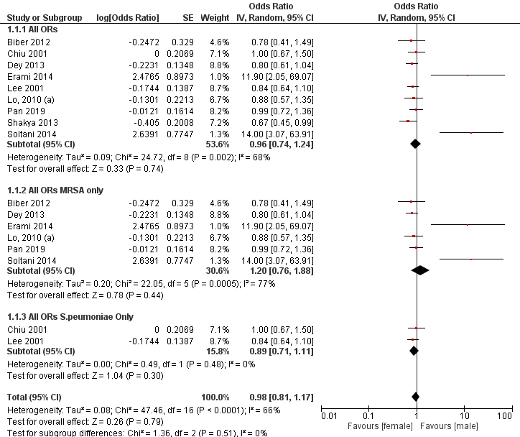

Figure S3.2 Age
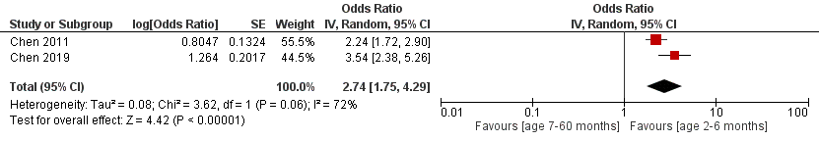

Figure S3.3 Daycare attendance
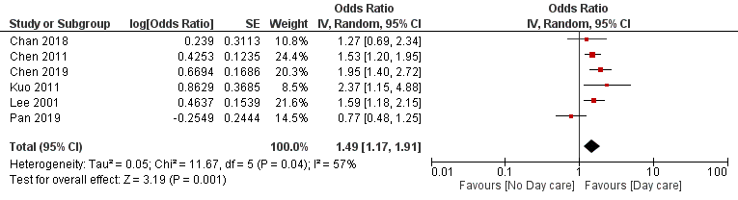

Figure S3.4 Breastfeeding status

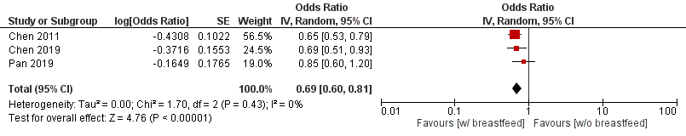

Figure S3.5 Concurrent colonization by S. Pneumoniae
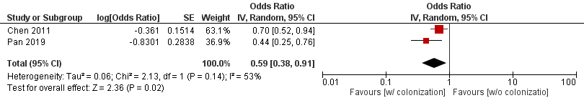

Figure S3.6 History of hospital admission within past 3 months
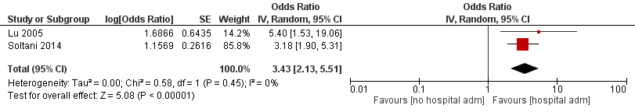

Figure S3.7 Antibiotics use within past 3 months


