Supplementary files
Supplementary Table 1: Newcastle-Ottawa quality assessment scale for risk of bias assessment for cohort studies

Study | Selection |  |  |  | Comparability | Outcomes |  |  | Total
Study | Representativeness of the exposed cohort () | Selection of the non-exposed cohort () | Ascertainment of exposure () | Outcome of interest was not present at start of study () | Study compares for most important factor and/or additional factors () | Assessment of outcomes () | Length of follow-up () | Adequacy of follow up () | Total
Ne et al., (2013) | ✵ | ✵ | ✵ | ✵ |  | ✵ | ✵ | ✵ | 9/9
Drod et al., (2013) | ✵ | ✵ | ✵ | ✵ |  | ✵ | ✵ | - | 8/9
Verdoia et al., (2020) | ✵ | ✵ | ✵ | ✵ |  | ✵ | ✵ | - | 8/9
Mahdavi et al., (2013) | ✵ | - | ✵ | ✵ | - | ✵ | - | - | 4/9
Walker et al., (2015) | - | ✵ | ✵ | ✵ |  | ✵ | ✵ | - | 7/9
Schiller at al., (2015) | - | ✵ | ✵ | ✵ |  | ✵ | ✵ |  | 8/9

Supplementary Table 2: Modified Newcastle-Ottawa quality assessment scale for risk of bias assessment for cross-sectional studies
Study | Selection |  |  |  | Comparability | Outcomes |  | Total
Study | Representativeness of the sample () | Sample size () | Non-respondents () | Ascertainment of exposure () | The study controls for the most important factor and/or any additional factor () | Assessment of outcomes () | Length of follow-up () | Total
Khalili et al., (2012) | ✵ | - | - | ✵ |  | ✵ | - | 5/8
Khademvatani et al., (2017) | ✵ | - | - | ✵ |  | ✵ | - | 5/8

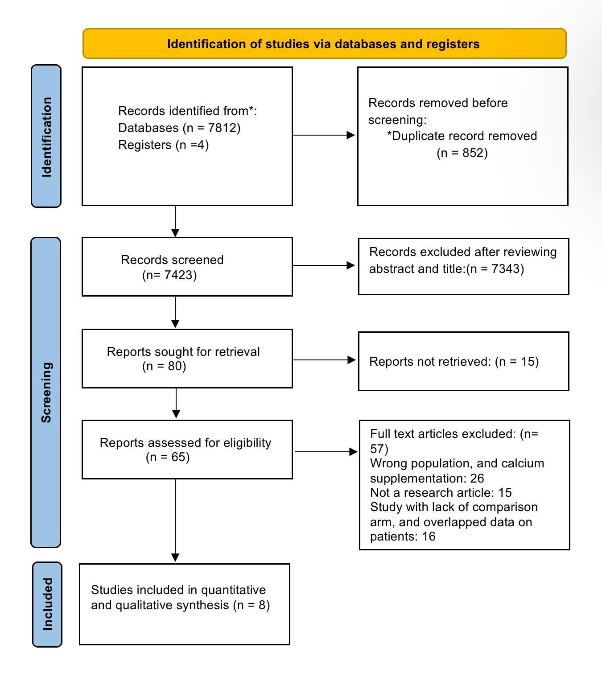

Supplementary figure 1 PRISMA flow diagram

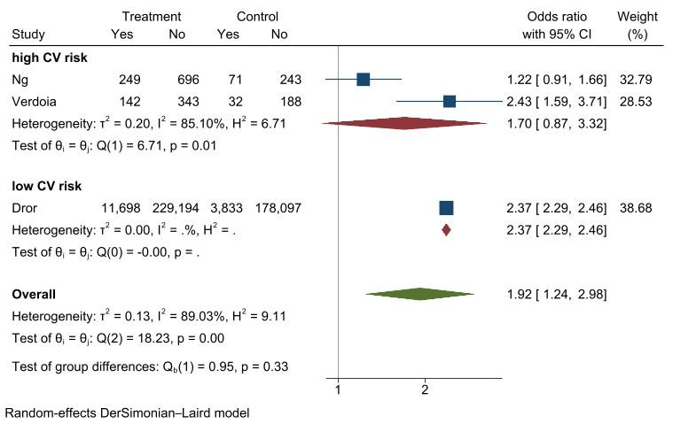
Supplementary figure 2 Forest plots of subgroup analyses for MACE, by CV risk

- Follow-up period
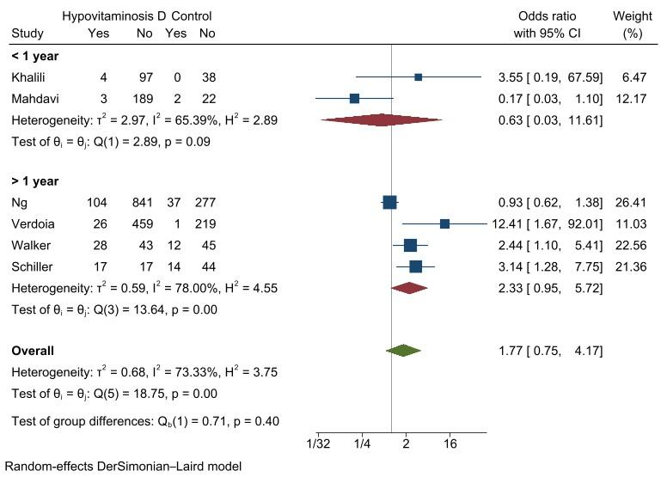
- CKD vs non-CKD
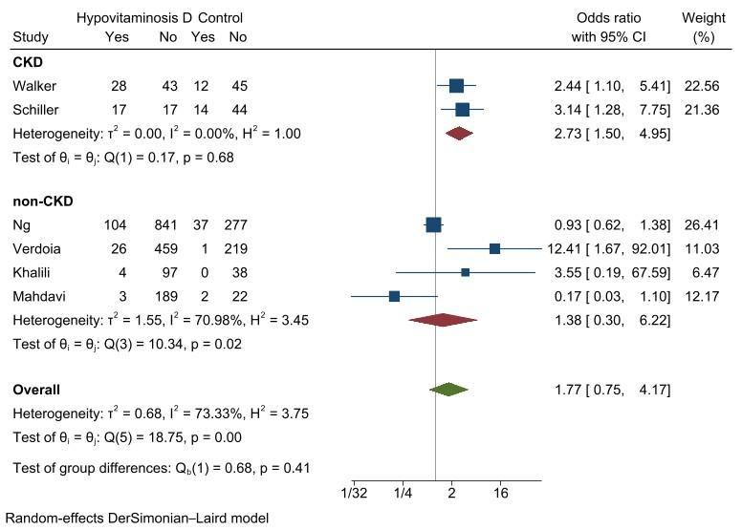
Supplementary figure 3 Forest plots of subgroup analyses for mortality, (A) by follow-up period; and (B) by CKD against non-CKD
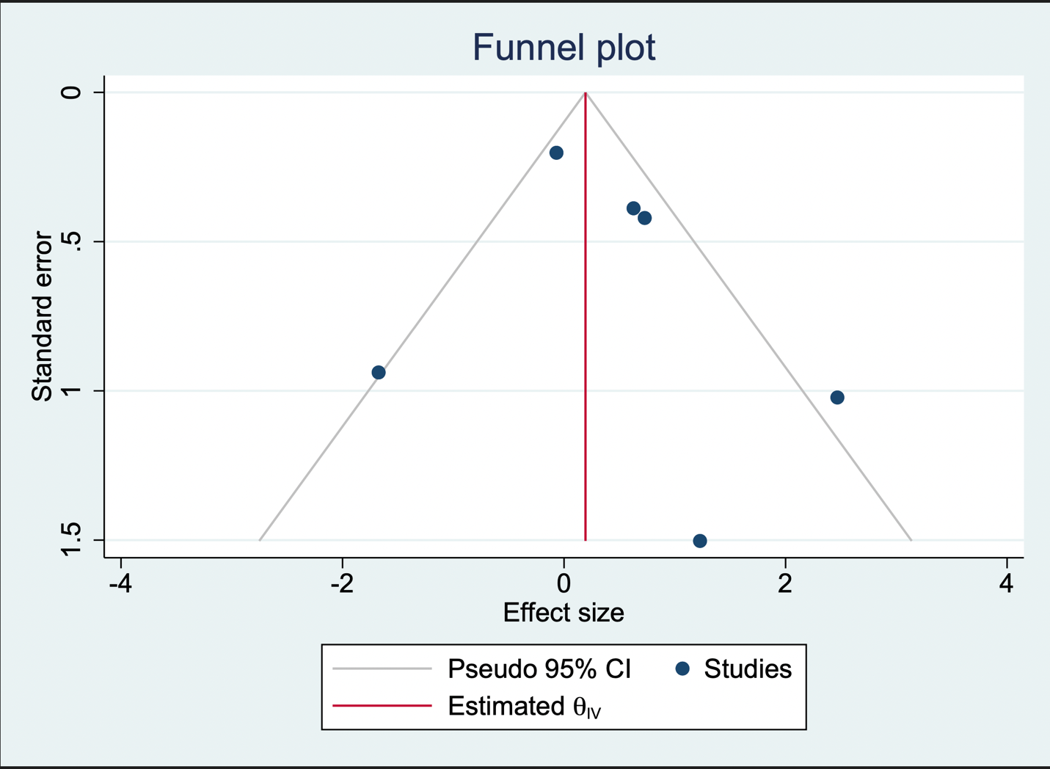
Supplementary figure 4 Funnel plot assessing publication bias for all-cause mortality

