Online Supplementary Material for Publication in The Gerontologist:

Person-Centered Care in Persons Living with Dementia: A Systematic Review and Meta-Analysis

Kyung Hee Lee, PhD, GNP, MPH, RN^{1,2}, Ji Yeon Lee, GNP-BC, MSN, RN¹, & Bora Kim, MSN, RN¹

1. Yonsei University College of Nursing, Seoul, South Korea
2. Mo-Im Kim Nursing Research Institute, Seoul, South Korea

*Address correspondence to: Bora Kim, MSN, RN, Yonsei University College of Nursing, 50-1 Yonsei-Ro, Seodaemun-Gu, Seoul, South Korea, 03722. E-mail: kbr7431@yuhs.ac

Supplementary Table 1. PRISMA 2009 Checklist
Section/topic | # | Checklist item | Reported on page #
TITLE
Title | 1 | Identify the report as a systematic review, meta-analysis, or both. | Title
ABSTRACT
Structured summary | 2 | Provide a structured summary including, as applicable: background; objectives; data sources; study eligibility criteria, participants, and interventions; study appraisal and synthesis methods; results; limitations; conclusions and implications of key findings; systematic review registration number. | Abstract
INTRODUCTION
Rationale | 3 | Describe the rationale for the review in the context of what is already known. | Background
Objectives | 4 | Provide an explicit statement of questions being addressed with reference to participants, interventions, comparisons, outcomes, and study design (PICOS). | Background
METHODS
Protocol and registration | 5 | Indicate if a review protocol exists, if and where it can be accessed (e.g., Web address), and, if available, provide registration information including registration number. | Protocol and registration
Eligibility criteria | 6 | Specify study characteristics (e.g., PICOS, length of follow-up) and report characteristics (e.g., years considered, language, publication status) used as criteria for eligibility, giving rationale. | Selections of studies
Information sources | 7 | Describe all information sources (e.g., databases with dates of coverage, contact with study authors to identify additional studies) in the search and date last searched. | Search strategy
Search | 8 | Present full electronic search strategy for at least one database, including any limits used, such that it could be repeated. | Search strategy
Study selection | 9 | State the process for selecting studies (i.e., screening, eligibility, included in systematic review, and, if applicable, included in the meta-analysis). | Study selection
Data collection process | 10 | Describe method of data extraction from reports (e.g., piloted forms, independently, in duplicate) and any processes for obtaining and confirming data from investigators. | Data extraction
Data items | 11 | List and define all variables for which data were sought (e.g., PICOS, funding sources) and any assumptions and simplifications made. | Data extraction
Risk of bias in individual studies | 12 | Describe methods used for assessing risk of bias of individual studies (including specification of whether this was done at the study or outcome level), and how this information is to be used in any data synthesis. | Quality assessment  Supplementary Table 2
Summary measures | 13 | State the principal summary measures (e.g., risk ratio, difference in means). | Data analysis
Synthesis of results | 14 | Describe the methods of handling data and combining results of studies, if done, including measures of consistency (e.g., I²) for each meta-analysis. | Data analysis
Risk of bias across studies | 15 | Specify any assessment of risk of bias that may affect the cumulative evidence (e.g., publication bias, selective reporting within studies). | Quality assessment  Supplementary Table 2
Additional analyses | 16 | Describe methods of additional analyses (e.g., sensitivity or subgroup analyses, meta-regression), if done, indicating which were pre-specified. | Data analysis
RESULTS
Study selection | 17 | Give numbers of studies screened, assessed for eligibility, and included in the review, with reasons for exclusions at each stage, ideally with a flow diagram. | Outcomes  Figure 1
Study characteristics | 18 | For each study, present characteristics for which data were extracted (e.g., study size, PICOS, follow-up period) and provide the citations. | Results  Table 1
Risk of bias within studies | 19 | Present data on risk of bias of each study and, if available, any outcome level assessment (see item 12). | Quality assessment  Supplementary Table 2
Results of individual studies | 20 | For all outcomes considered (benefits or harms), present, for each study: (a) simple summary data for each intervention group (b) effect estimates and confidence intervals, ideally with a forest plot. | Effects of intervention  Table 2
Synthesis of results | 21 | Present results of each meta-analysis done, including confidence intervals and measures of consistency. | Effects of intervention  Table 2
Risk of bias across studies | 22 | Present results of any assessment of risk of bias across studies (see Item 15). | Quality assessment  Supplementary Table 2
Additional analysis | 23 | Give results of additional analyses, if done (e.g., sensitivity or subgroup analyses, meta-regression [see Item 16]). | Effects of intervention  Table 2
DISCUSSION
Summary of evidence | 24 | Summarize the main findings including the strength of evidence for each main outcome; consider their relevance to key groups (e.g., healthcare providers, users, and policy makers). | Discussion
Limitations | 25 | Discuss limitations at study and outcome level (e.g., risk of bias), and at review-level (e.g., incomplete retrieval of identified research, reporting bias). | Limitations
Conclusions | 26 | Provide a general interpretation of the results in the context of other evidence, and implications for future research. | Discussion and Conclusion
FUNDING
Funding | 27 | Describe sources of funding for the systematic review and other support (e.g., supply of data); role of funders for the systematic review. | Funding
From: Moher D, Liberati A, Tetzlaff J, Altman DG, The PRISMA Group (2009). Preferred Reporting Items for Systematic Reviews and Meta-Analyses: The PRISMA Statement. PLoS Med 6(6): e1000097. doi:10.1371/journal.pmed1000097

Supplementary Table 2. Methodological Quality of Studies
Study | Selection |  |  | Performance |  |  |  | Attrition |  |  |  | Detection |  |  | Average points
Study | A1 | A2 | A3 | B1 | B2 | B3 | C1 | C2 | C3 | D1 | D2 | D3 | D4 | D5 | Average points
Amieva et al. (2016) | 2 | 0 | 2 | 2 | 0 | 0 | 2 | 2 | 2 | 1 | 2 | 2 | 2 | 2 | 1.5
Aslakson (2010) | 1 | 1 | 2 | 0 | 2 | 0 | 2 | 2 | 2 | 1 | 2 | 2 | 2 | 2 | 1.5
Bailey et al. (2017) | 2 | 0 | 2 | 2 | 2 | 0 | 2 | 1 | 2 | 1 | 2 | 2 | 1 | 1 | 1.4
Bakshi (2004) | 2 | 2 | 2 | 2 | 2 | 1 | 2 | 2 | 2 | 1 | 2 | 2 | 1 | 1 | 1.7
Chu et al. (2014) | 2 | 2 | 2 | 2 | 2 | 0 | 2 | 2 | 2 | 1 | 2 | 2 | 1 | 1 | 1.6
Clare et al. (2010) | 2 | 2 | 2 | 2 | 2 | 0 | 2 | 2 | 2 | 1 | 2 | 2 | 2 | 2 | 1.8
Duru Aşiret & Kapucu (2016) | 2 | 0 | 2 | 2 | 1 | 0 | 2 | 2 | 2 | 0 | 2 | 2 | 1 | 1 | 1.4
Hong & Choi (2011) | 2 | 2 | 1 | 2 | 2 | 1 | 2 | 2 | 2 | 1 | 2 | 2 | 0 | 0 | 1.5
Hsieh et al. (2010) | 1 | 1 | 2 | 1 | 1 | 0 | 2 | 1 | 2 | 0 | 2 | 2 | 1 | 1 | 1.2
Hsu et al. (2015) | 2 | 2 | 2 | 2 | 0 | 0 | 2 | 1 | 2 | 1 | 2 | 2 | 0 | 0 | 1.3
Hutson et al. (2014) | 2 | 2 | 1 | 2 | 1 | 0 | 2 | 2 | 2 | 1 | 2 | 2 | 2 | 2 | 1.6
Ito et al. (2007) | 2 | 2 | 2 | 2 | 0 | 0 | 2 | 1 | 2 | 1 | 2 | 2 | 2 | 2 | 1.6
Kallio et al. (2018) | 2 | 2 | 2 | 2 | 2 | 0 | 2 | 0 | 2 | 1 | 2 | 2 | 2 | 2 | 1.6
Lai et al. (2004) | 1 | 1 | 2 | 2 | 2 | 0 | 2 | 2 | 2 | 2 | 2 | 2 | 2 | 2 | 1.7
Lawton et al. (1998) | 2 | 2 | 1 | 1 | 2 | 0 | 2 | 2 | 2 | 1 | 2 | 2 | 0 | 0 | 1.4
Lök et al. (2019) | 2 | 2 | 2 | 1 | 2 | 0 | 2 | 2 | 2 | 0 | 2 | 2 | 0 | 0 | 1.4
Lopes et al. (2016) | 2 | 2 | 2 | 2 | 2 | 0 | 2 | 2 | 2 | 1 | 2 | 2 | 2 | 2 | 1.8
Lyu et al. (2018) | 2 | 2 | 2 | 2 | 2 | 1 | 2 | 2 | 2 | 1 | 2 | 2 | 2 | 2 | 1.9
Maseda et al. (2014) | 2 | 1 | 2 | 2 | 1 | 1 | 2 | 2 | 2 | 2 | 2 | 2 | 1 | 1 | 1.6
Nakamae et al. (2014) | 1 | 1 | 2 | 2 | 2 | 0 | 2 | 2 | 2 | 1 | 2 | 2 | 2 | 2 | 1.6
Pérez-Ros et al. (2019) | 2 | 2 | 2 | 2 | 2 | 1 | 2 | 2 | 2 | 0 | 2 | 2 | 2 | 2 | 1.8
Raglio et al. (2015) | 2 | 1 | 2 | 2 | 2 | 1 | 2 | 2 | 2 | 1 | 2 | 2 | 2 | 2 | 1.8
Ridder et al. (2013) | 2 | 2 | 2 | 2 | 2 | 0 | 2 | 2 | 2 | 1 | 2 | 2 | 2 | 2 | 1.8
Sánchez et al. (2016) | 2 | 1 | 2 | 2 | 1 | 1 | 0 | 2 | 2 | 1 | 2 | 2 | 1 | 1 | 1.4
Shiltz et al. (2018) | 2 | 1 | 1 | 2 | 1 | 0 | 2 | 2 | 2 | 1 | 2 | 2 | 1 | 1 | 1.4
Staal et al. (2007) | 1 | 1 | 2 | 2 | 2 | 1 | 2 | 2 | 2 | 1 | 2 | 2 | 2 | 2 | 1.7
Tadaka & Kanagawa (2007) | 2 | 2 | 2 | 2 | 2 | 0 | 2 | 2 | 2 | 1 | 2 | 2 | 2 | 2 | 1.8
Tanaka et al. (2017) | 2 | 1 | 2 | 2 | 2 | 1 | 2 | 2 | 2 | 1 | 2 | 2 | 2 | 2 | 1.8
Van Bogaert et al. (2013) | 2 | 2 | 2 | 2 | 2 | 0 | 2 | 2 | 2 | 1 | 2 | 2 | 2 | 2 | 1.8
Van Bogaert et al. (2016) | 2 | 2 | 2 | 2 | 2 | 0 | 2 | 2 | 2 | 0 | 2 | 2 | 2 | 2 | 1.7
van der Ploeg et al. (2013) | 2 | 1 | n/a | n/a | 2 | 1 | 2 | 2 | 2 | 0 | 2 | 2 | 1 | 1 | 1.5
Wang (2007) | 2 | 1 | 2 | 1 | 2 | 1 | 2 | 2 | 2 | 1 | 2 | 2 | 2 | 2 | 1.7
Wang et al. (2018) | 2 | 1 | 2 | 2 | 1 | 1 | 2 | 1 | 1 | 1 | 2 | 2 | 1 | 1 | 1.4
Weise et al. (2019) | 2 | 2 | 1 | 2 | 2 | 0 | 2 | 2 | 2 | 0 | 2 | 2 | 0 | 0 | 1.4
Wu & Koo (2016) | 2 | 1 | 2 | 0 | 2 | 1 | 2 | 2 | 2 | 1 | 2 | 2 | 1 | 1 | 1.5
Yamagami et al. (2012) | 2 | 1 | 2 | 2 | 2 | 1 | 2 | 2 | 2 | 1 | 2 | 2 | 2 | 2 | 1.8
Note. n/a= not applicable

Supplementary Figure 1. Forest Plot for Overall Effect of Person-Centered Care
A
BPSD

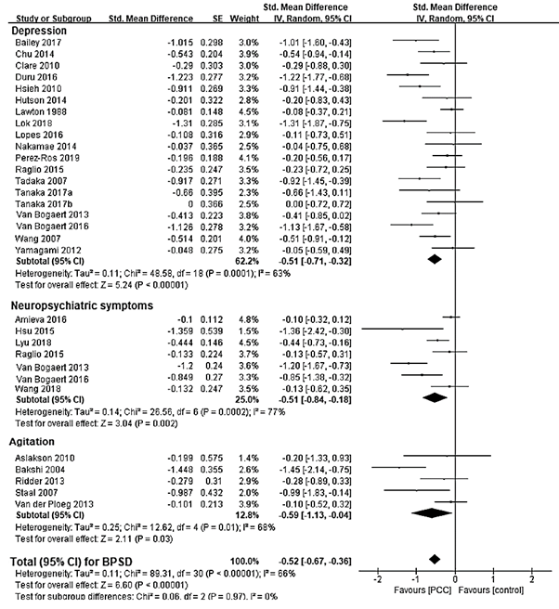

B
Cognitive function

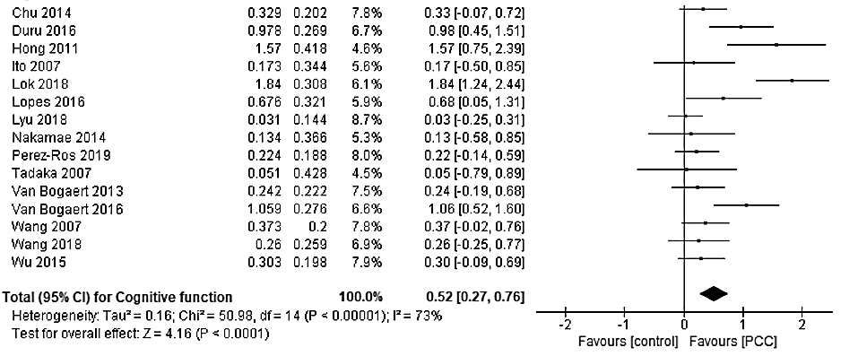
Supplementary Figure 2. Forest Plot for Effect of Music Therapy
A
BPSD

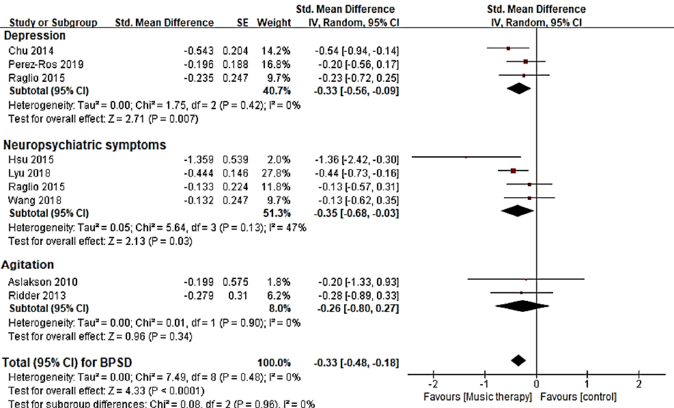

B
Cognitive function

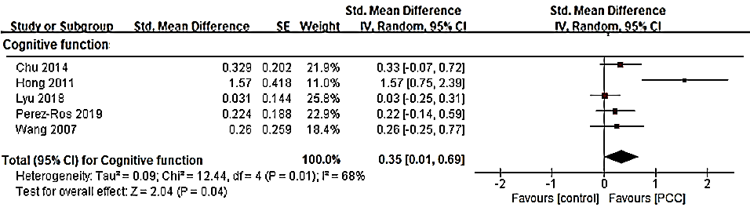
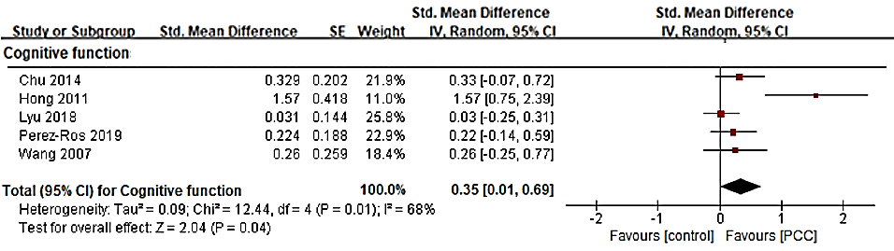

Supplementary Figure 3. Forest Plot for Effect of Reminiscence Therapy
A
BPSD

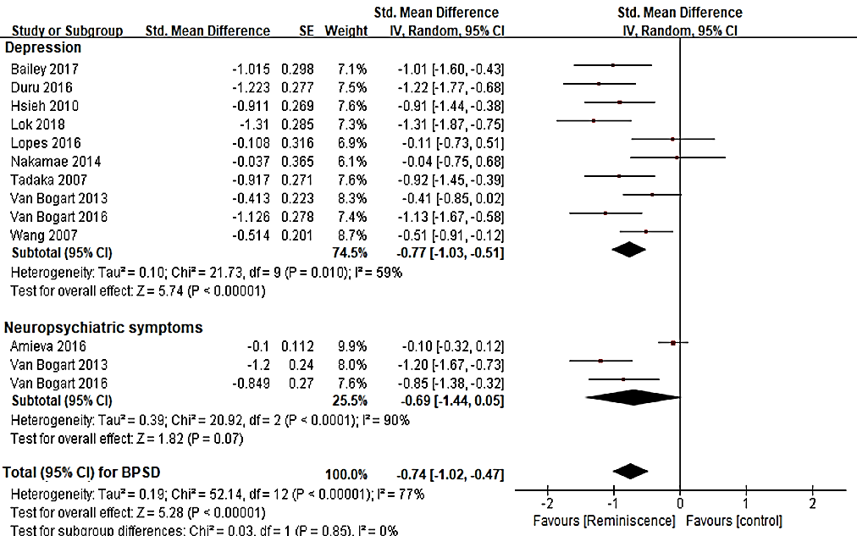
B
Cognitive function

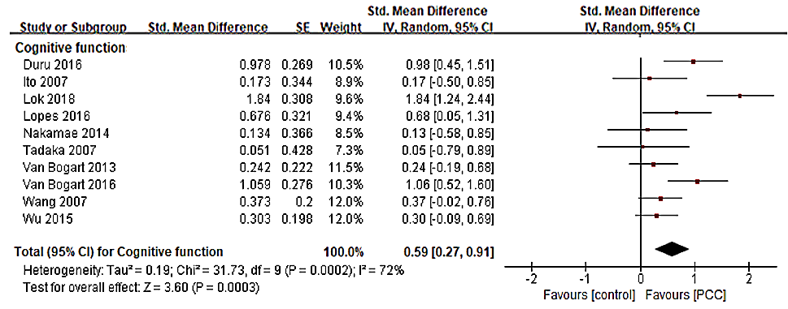

Supplementary Figure 4. Forest Plot for Effect of Cognitive Therapy
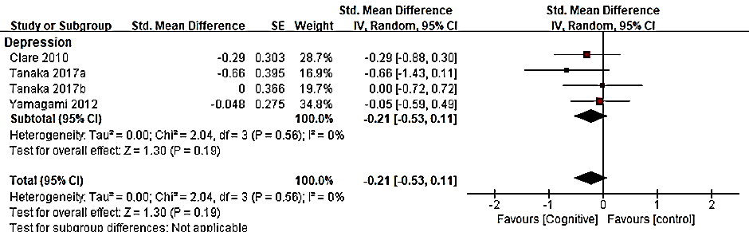

Supplementary Figure 5. Forest Plot for Effect of Multisensory Stimulation


