Appendix S14: Bias adjustment models – results

Mild-to-moderate acne

A. Percentage change in total lesion count from baseline
There was sufficient variation in the ratings of studies to fit bias models on two risk of bias domains:
- Domain 2: Deviation from interventions
- Domain 4: Outcome measurement (efficacy)
There was no evidence of bias arising from these domains as the 95% credible intervals of the posterior mean bias included zero. However, there was evidence of small-study bias (Table S14-1). Figure S14-1 displays both the unadjusted and bias-adjusted relative effects of each class versus placebo, where the bias-adjusted estimates are the expected estimates from an RCT of 1670 participants, which was the size of the largest RCT included in the NMAs for mild-to-moderate ane.
Table S14-1 Bias model fit statistics for efficacy (percentage change in total lesion count from baseline) – mild-to-moderate acne.
Model | Between Study Heterogeneity - SD (95% CrI) | Posterior total residual devianceª | DIC^{b} | Bias
 |  |  |  | Posterior median (95% CrI) | Between Study SD (95% CrI)
NMA model: RE, fixed class | 9.88 (8.04, 12.25) | 273.0 | 1540.0 | --- | ---
Bias model: Domain 2 | 9.60 (7.63, 12.09) | 271.4 | 1539.0 | 7.53 (-3.17, 19.16) | 6.06 (0.28, 15.63)
Bias model: Domain 4 | 9.79 (7.90, 12.23) | 272.8 | 1540.0 | 2.44 (-6.95, 12.10) | 5.51 (0.28, 16.14)
Bias model: Small study | 8.89 (6.95, 11.28) | 268.8 | 1536.0 | 123.1 (33.50, 216.50) | 67.61 (4.81, 149.10)
Abbreviations: CrI, credible interval; DIC, deviance information criteria; FE, fixed study-specific treatment effects; NMA, network meta-analysis; SD, standard deviation
Data in red indicate presence of bias
ª Posterior mean residual deviance compared to 273 total data points
^{b} Lower values of DIC preferred

Figure S14-1: Forest plot of unadjusted NMA estimates (blue circles) and bias-adjusted estimates which would be expected from a RCT of 1670 participants (red squares), efficacy analysis (% change in total lesion count from baseline), mild-to-moderate acne
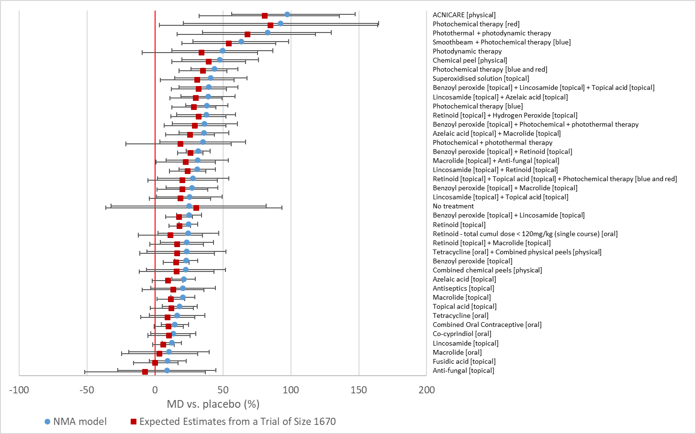

B. Discontinuation for any reason
There was sufficient variation in the ratings of studies to fit bias models on two risk of bias domains:
- Domain 1: Randomisation
- Domain 4: Outcome measurement (efficacy)
No evidence of bias arising from these domains was found, nor was small study effect bias, as the 95% credible intervals of the posterior mean bias include zero (Table S14-2).
Table S14-2: Bias model fit statistics for discontinuation for any reason – mild-to-moderate acne.
Model | Posterior total residual devianceª | DIC^{b} | Bias
Model | Posterior total residual devianceª | DIC^{b} | Posterior median (95% CrI) | Between Study SD (95% CrI)
NMA model: FE, fixed class | 189.3 | 1023.19 | --- | ---
Bias model: Domain 1 | 188.8 | 1026.62 | -0.06 (-0.41, 0.29) | 0.11 (0.00, 0.34)
Bias model: Domain 4 | 189.1 | 1026.24 | 0.11 (-0.26, 0.51) | 0.19 (0.01, 0.64)
Bias model: Small study | 188.5 | 1026.23 | 2.62 (-2.69, 8.08) | 1.39 (0.06, 4.54)
Abbreviations: CrI, credible interval; DIC, deviance information criteria; FE, fixed study-specific treatment effects; NMA, network meta-analysis; SD, standard deviation
ª Posterior mean residual deviance compared to 202 total data points
^{b} Lower values of DIC preferred

C. Discontinuation due to side effects
There was sufficient variation in the ratings of studies to fit bias models on one risk of bias domains:
- Domain 4: Outcome measurement (efficacy)
Although there was a meaningful reduction in the posterior mean residual deviance of the model exploring this domain, the 95% credible intervals of the posterior mean bias included zero. Similarly, there was no evidence of small study effect bias, as the 95% credible intervals of the posterior mean bias included zero (Table S14-3).
Table S14-3: Bias model fit statistics for discontinuation due to side effects – mild-to-moderate acne.
Model | Posterior total residual devianceª | DIC^{b} | Bias
Model | Posterior total residual devianceª | DIC^{b} | Posterior median (95% CrI) | Between Study SD (95% CrI)
NMA model: FE, fixed class | 125.3 | 500.612 | --- | ---
Bias model: Domain 4 | 120.8 | 501.349 | 0.54 (-0.92, 1.98) | 0.98 (0.05, 3.21)
Bias model: Small study | 122.7 | 501.466 | 15.72 (-2.77, 35.59) | 4.55 (0.24, 17.38)
Abbreviations: CrI, credible interval; DIC, deviance information criteria; FE, fixed study-specific treatment effects; NMA, network meta-analysis; SD, standard deviation
ª Posterior mean residual deviance compared to 123 total data points
^{b} Lower values of DIC preferred

Moderate-to-severe acne

A. Percentage change in total lesion count from baseline
There was sufficient variation in the ratings of studies to fit bias models on two risk of bias domains:
- Domain 2: Deviation from interventions
- Domain 4: Outcome measurement (efficacy)
No evidence of bias arising from these domains was found, nor was small study effect bias, as the 95% credible intervals of the posterior mean bias include zero (Table S14-4).

Table S14-4: Bias model fit statistics for efficacy (percentage change in total lesion count from baseline) – moderate-to-severe acne.
Model | Between Study Heterogeneity - SD (95% CrI) | Posterior total residual devianceª | DIC^{b} | Bias
 |  |  |  | Posterior median (95% CrI) | Between Study SD (95% CrI)
NMA model: RE, fixed class | 5.74 (3.26, 8.97) | 138.0 | 828.1 | --- | ---
Bias model: Domain 2 | 5.25 (2.80, 8.40) | 137.0 | 828.3 | 11.56 (-8.25, 34.42) | 12.88 (0.62, 42.30)
Bias model: Domain 4 | 4.95 (2.20, 8.27) | 135.3 | 826.6 | 12.63 (-4.03, 36.44) | 17.29 (2.07, 41.60)
Bias model: Small study | 5.27 (2.37, 8.64) | 137.8 | 829.9 | 47.20 (-98.03, 190.40) | 64.55 (3.38, 173.80)
Abbreviations: CrI, credible interval; DIC, deviance information criteria; RE, random study-specific treatment effects; NMA, network meta-analysis; SD, standard deviation
ª Posterior mean residual deviance compared to 133 total data points
^{b} Lower values of DIC preferred

B. Discontinuation for any reason
There was sufficient variation in the ratings of studies to fit bias models on two risk of bias domains:
- Domain 2: Deviation from interventions
- Domain 4: Outcome measurement (efficacy)
No evidence of bias arising from these domains was found, nor was small study effect bias, as the 95% credible intervals of the posterior mean bias include zero (Table S14-5).
Table S14-5: Bias model fit statistics for discontinuation for any reason – moderate-to-severe acne.
Model | Between Study Heterogeneity - SD (95% CrI) | Posterior total residual devianceª | DIC^{b} | Bias
 |  |  |  | Posterior median (95% CrI) | Between Study SD (95% CrI)
NMA model: RE, fixed class | 0.40 (0.19, 0.68) | 94.74 | 548.326 | --- | ---
Bias model: Domain 2 | 0.39 (0.17, 0.68) | 94.54 | 549.961 | 0.07 (-1.39, 1.54) | 0.78 (0.06, 3.23)
Bias model: Domain 4 | 0.30 (0.04, 0.64) | 97.01 | 550.06 | -0.29 (-1.17, 0.76) | 0.48 (0.03, 1.64)
Bias model: Small study | 0.28 (0.01, 0.62) | 94.86 | 549.33 | -0.67 (-19.25, 15.78) | 6.55 (0.46, 13.8)
Abbreviations: CrI, credible interval; DIC, deviance information criteria; RE, random study-specific treatment effects; NMA, network meta-analysis; SD, standard deviation
ª Posterior mean residual deviance compared to 133 total data points
^{b} Lower values of DIC preferred

C. Discontinuation due to side effects
There was sufficient variation in the ratings of studies to fit bias models on one risk of bias domains:
- Domain 2: Deviation from interventions
- Domain 4: Outcome measurement (efficacy)
No evidence of bias arising from domain 2 was found, nor was there evidence of small study effect bias, as the 95% credible intervals of the posterior mean bias include 0. There is evidence of bias arising from domain 4 (Table S14-6). Figures S14-2 and S14-3 display both the unadjusted and bias-adjusted relative effects of each class versus placebo for females and males, respectively.

Table S14-6: Bias model fit statistics for discontinuation due to side effects – moderate-to-severe acne.
Model | Posterior total residual devianceª | DIC^{b} | Bias
Model | Posterior total residual devianceª | DIC^{b} | Posterior median (95% CrI) | Between Study SD (95% CrI)
NMA model: FE, fixed class | 70.25 | 298.251 | --- | ---
Bias model: Domain 2 | 71.6 | 301.1 | 0.48 (-6.46, 8.34) | 1.84 (0.07, 9.16)
Bias model: Domain 4 | 64.7 | 294.5 | -2.15 (-4.09, -0.30) | 0.46 (0.02, 2.99)
Bias model: Small study | 70.8 | 301 | 14.2 (-46.2, 100.3) | 4.94 (0.28, 19.8)
Abbreviations: CrI, credible interval; DIC, deviance information criteria; FE, fixed study-specific treatment effects; NMA, network meta-analysis; SD, standard deviation
Data in red indicate presence of bias
ª Posterior mean residual deviance compared to 73 total data points
^{b} Lower values of DIC preferred

Figure S14-2: Forest plot of unadjusted NMA estimates (blue circles) and bias-adjusted estimates in terms of Domain 4: Outcome measurement (efficacy) for females (red squares)
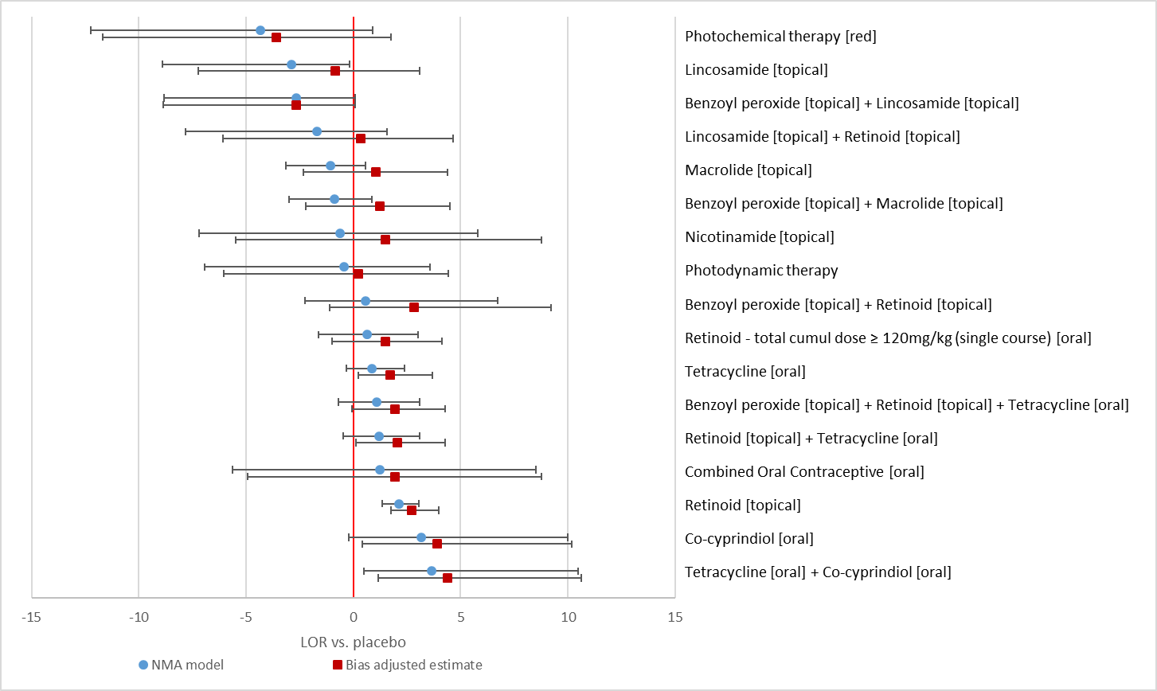
Figure S14-3: Forest plot of unadjusted NMA estimates (blue circles) and bias-adjusted estimates in terms of Domain 4: Outcome measurement (efficacy) for males (red squares)


