Appendix S15: NMA additional results

Mild-to-moderate acne

A. Percentage change in total lesion count from baseline

Base-case results

Figure S15-1. Treatment efficacy in people with mild-to-moderate acne, base-case forest plots: treatment class effects versus placebo.
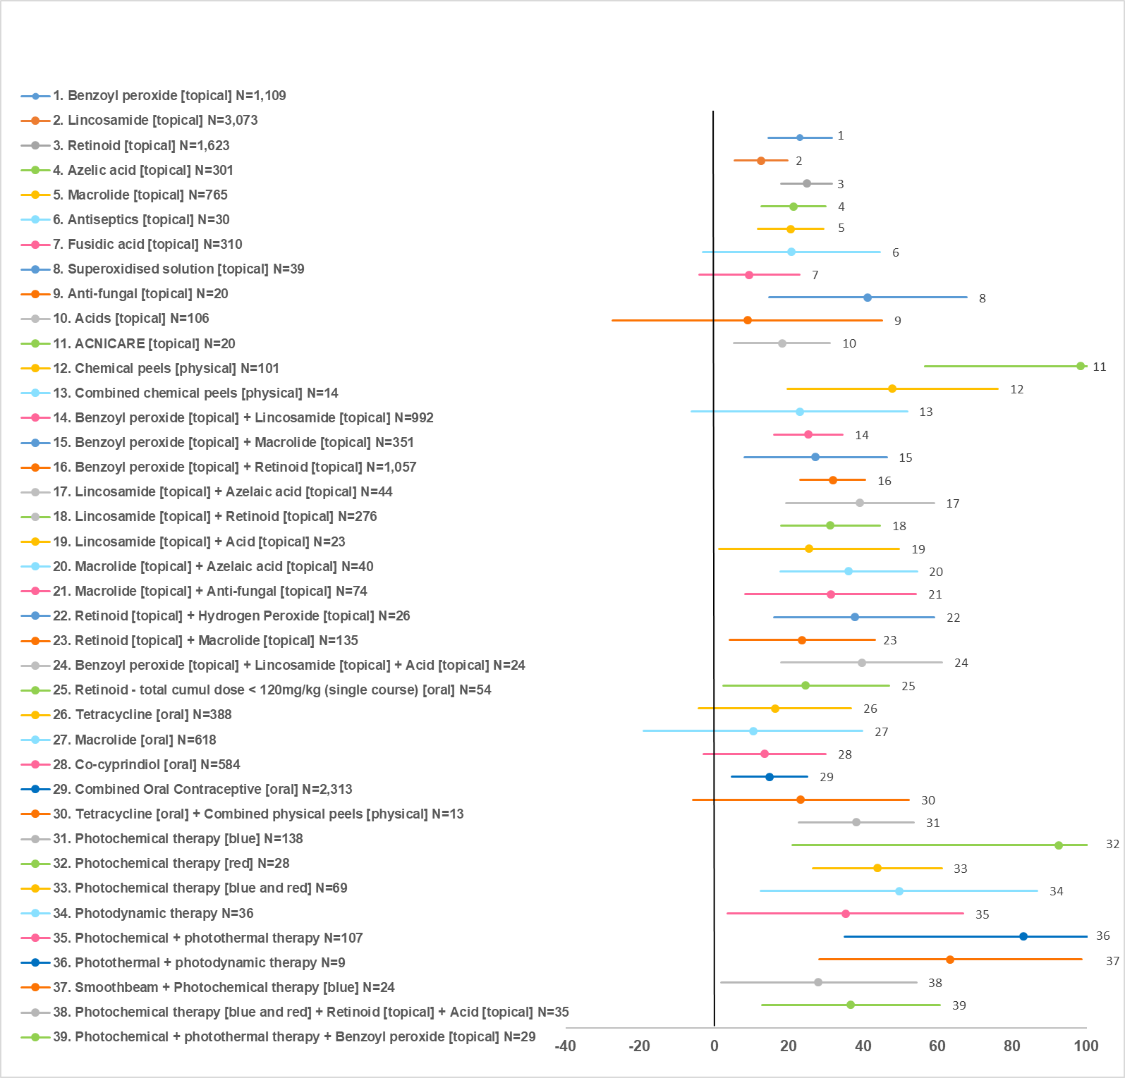
All treatment class effects versus placebo (N=2698). N indicates number of observations across trials included in the analysis. Results expressed as mean difference in % change from baseline; values on the right side of the vertical axis indicate higher effect compared with placebo.

Table S15-1. Treatment efficacy in people with mild-to-moderate acne, base-case treatment class effects versus placebo & rankings
Class | N | Effect vs placebo (mean, 95% CrI) | Rank, females  (mean, 95% CrI) | Rank, males  (mean, 95% CrI)
ACNICARE [topical] | 20 | 98.43 (56.59 to 147.20) | 2.05 (1 to 5) | 2.05 (1 to 5)
Photothermal + photodynamic therapy | 9 | 82.96 (35.10 to 129.90) | 3.37 (1 to 13) | 3.36 (1 to 13)
Photochemical therapy [red] | 28 | 92.59 (21.00 to 164.60) | 3.87 (1 to 27) | 3.84 (1 to 27)
Smoothbeam + Photochemical therapy [blue] | 24 | 63.39 (28.11 to 98.57) | 5.67 (1 to 20) | 5.66 (1 to 20)
Chemical peels [physical] | 101 | 47.88 (19.73 to 76.10) | 9.63 (3 to 29) | 9.59 (3 to 28)
Photodynamic therapy | 36 | 49.72 (12.46 to 86.70) | 10.15 (3 to 34) | 10.07 (3 to 33)
Photochemical therapy [blue and red] | 69 | 43.78 (26.46 to 61.11) | 10.19 (4 to 21) | 10.18 (4 to 21)
Superoxidised solution [topical] | 39 | 41.09 (14.66 to 67.84) | 12.89 (3 to 33) | 12.81 (3 to 32)
Benzoyl peroxide [topical] + Lincosamide [topical] + Other acid [topical] | 24 | 39.58 (17.88 to 61.17) | 13.04 (4 to 31) | 12.99 (4 to 30)
Azelaic acid [topical] + Lincosamide [topical] | 44 | 39.16 (19.23 to 59.00) | 13.13 (4 to 30) | 13.09 (4 to 29)
Photochemical therapy [blue] | 138 | 38.09 (22.75 to 53.63) | 13.26 (6 to 25) | 13.24 (6 to 25)
Retinoid [topical] + Hydrogen Peroxide [topical] | 26 | 37.67 (16.09 to 59.16) | 14.26 (4 to 32) | 14.19 (4 to 32)
Azelaic acid [topical] + Macrolide [topical] | 40 | 36.04 (17.72 to 54.44) | 14.98 (5 to 31) | 14.92 (5 to 30)
Benzoyl peroxide [topical] + Photochemical + photothermal therapy | 29 | 36.56 (12.77 to 60.66) | 15.23 (4 to 34) | 15.12 (4 to 33)
Photochemical + photothermal therapy | 107 | 35.27 (3.62 to 66.86) | 17.17 (5 to 38) | 16.94 (5 to 37)
Benzoyl peroxide [topical] + Retinoid [topical] | 1057 | 31.81 (22.99 to 40.55) | 17.40 (10 to 26) | 17.36 (10 to 26)
Lincosamide [topical] + Retinoid [topical] | 276 | 31.26 (17.91 to 44.51) | 18.08 (8 to 31) | 18.01 (8 to 30)
Macrolide [topical] + Anti-fungal [topical] | 74 | 31.33 (8.38 to 54.21) | 18.83 (5 to 37) | 18.63 (5 to 36)
Benzoyl peroxide [topical] + Macrolide [topical] | 351 | 27.33 (8.20 to 46.29) | 21.59 (8 to 36) | 21.32 (8 to 34)
Retinoid [topical] + Other acid [topical] + Photochemical therapy [blue and red] | 35 | 27.98 (1.84 to 54.28) | 21.63 (6 to 39) | 21.27 (6 to 37)
Lincosamide [topical] + Other acid [topical] | 23 | 25.52 (1.37 to 49.60) | 23.39 (7 to 39) | 22.98 (7 to 38)
No treatment | 39 | 25.07 (-32.23 to 81.90) | 23.45 (4 to 41) | 22.74 (4 to 39)
Benzoyl peroxide [topical] + Lincosamide [topical] | 992 | 25.28 (16.06 to 34.46) | 23.50 (15 to 33) | 23.32 (15 to 32)
Retinoid [topical] | 1623 | 24.82 (17.90 to 31.67) | 23.90 (16 to 32) | 23.75 (16 to 31)
Retinoid - total cumulative dose < 120mg/kg (single course) [oral] | 54 | 24.51 (2.35 to 47.01) | 24.27 (8 to 39) | 23.84 (8 to 37)
Tetracycline [oral] + Combined chemical peels [physical] | 13 | 23.25 (-5.69 to 52.28) | 24.82 (6 to 40) | 24.25 (6 to 38)
Retinoid [topical] + Macrolide [topical] | 135 | 23.58 (4.06 to 43.19) | 24.95 (10 to 39) | 24.51 (10 to 37)
Combined chemical peels [physical] | 14 | 22.89 (-6.10 to 51.79) | 25.09 (6 to 40) | 24.51 (6 to 38)
Benzoyl peroxide [topical] | 1109 | 23.03 (14.47 to 31.59) | 25.79 (18 to 33) | 25.53 (18 to 33)
Antiseptics [topical] | 30 | 20.69 (-3.12 to 44.54) | 27.10 (9 to 40) | 26.46 (9 to 38)
Azelaic acid [topical] | 301 | 21.26 (12.57 to 29.88) | 27.46 (18 to 36) | 27.09 (18 to 35)
Macrolide [topical] | 765 | 20.45 (11.72 to 29.26) | 28.24 (19 to 36) | 27.81 (19 to 35)
Other acid [topical] | 106 | 18.21 (5.29 to 31.04) | 29.84 (17 to 39) | 29.18 (17 to 37)
Tetracycline [oral] | 388 | 16.43 (-4.11 to 36.79) | 30.75 (15 to 40) | 29.90 (15 to 38)
Combined Oral Contraceptive [oral] | 2313 | 14.75 (4.74 to 24.94) | 32.75 (22 to 39) | Not relevant
Anti-fungal [topical] | 20 | 8.93 (-27.32 to 45.06) | 32.77 (9 to 41) | 31.56 (9 to 39)
Co-cyprindiol [oral] | 584 | 13.48 (-2.87 to 29.95) | 32.92 (18 to 40) | Not relevant
Macrolide [oral] | 143 | 10.45 (-19.04 to 39.80) | 33.30 (12 to 41) | 32.12 (12 to 39)
Lincosamide [topical] | 3073 | 12.60 (5.55 to 19.65) | 34.70 (28 to 39) | 33.52 (28 to 37)
Fusidic acid [topical] | 310 | 9.32 (-4.06 to 22.88) | 35.82 (25 to 41) | 34.43 (25 to 39)
Placebo | 2698 | Reference | 39.80 (37 to 41) | 37.85 (35 to 39)
Classes ordered by mean rank for females (rank=1 indicates highest efficacy).
N: number of observations across trials included in the analysis.
In red, effects with 95% CrI crossing the no effect line and respective classes.
CrI: credible intervals
Bias-adjusted results
Figure S15-2. Treatment efficacy in people with mild-to-moderate acne, biad-adjusted forest plots: treatment class effects versus placebo.
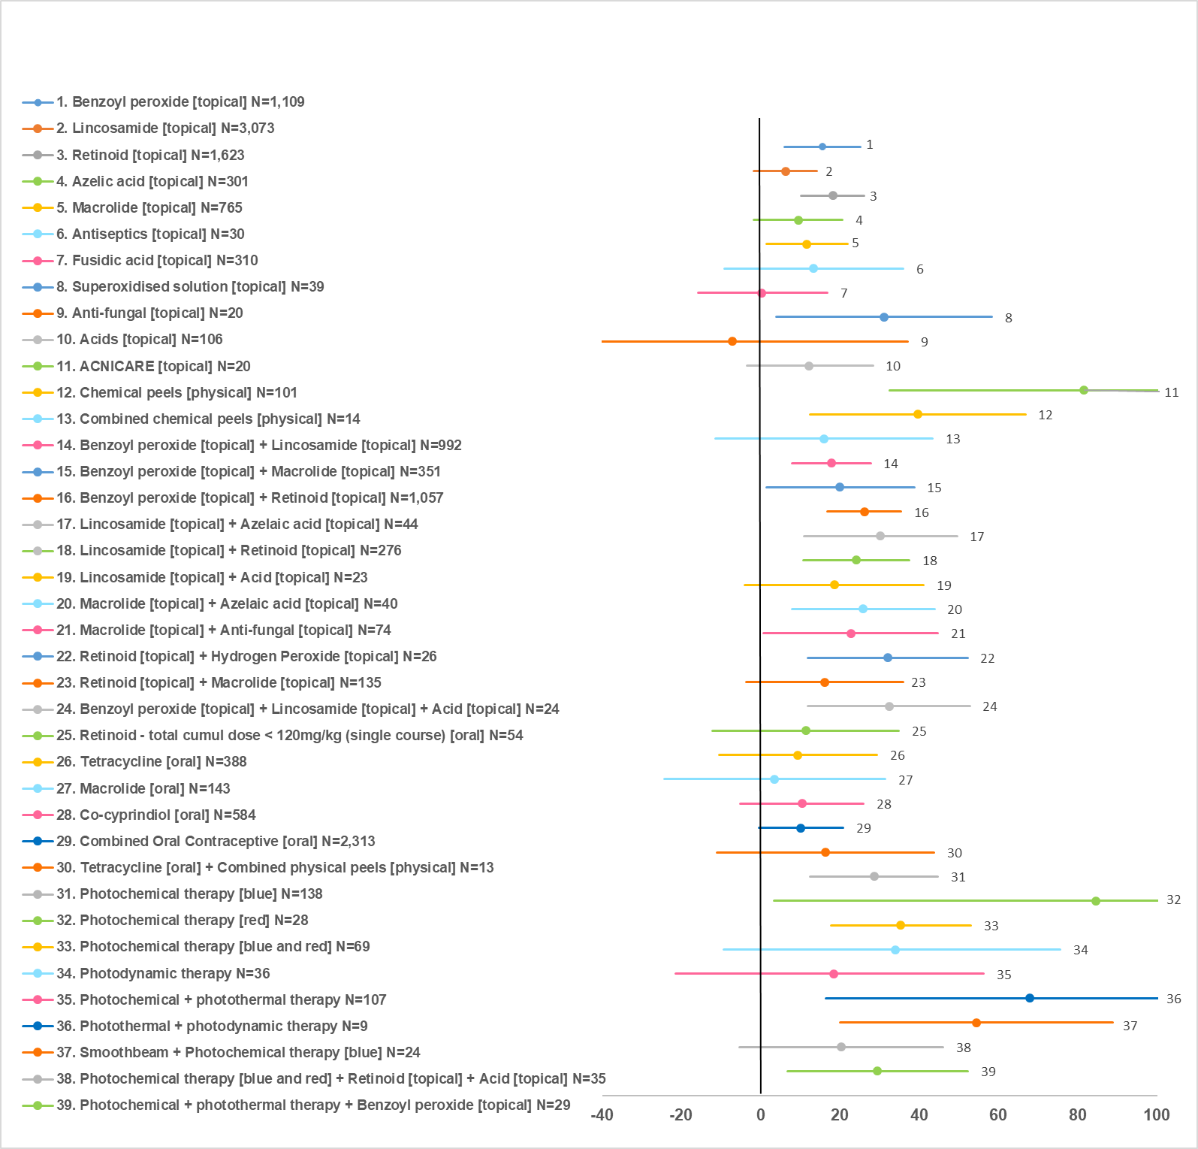
All treatment class effects versus placebo (N=2698). N indicates number of observations across trials included in the analysis. Results expressed as mean difference in % change from baseline; values on the right side of the vertical axis indicate higher effect compared with placebo.

For Table of results on treatment efficacy in people with mild-to-moderate acne, bias-adjusted treatment class effects versus placebo & rankings: see main article (Table 1).

B. Discontinuation for any reason

Figure S15-3. Discontinuation for any reason in people with mild-to-moderate acne, forest plots: treatment class effects versus placebo.
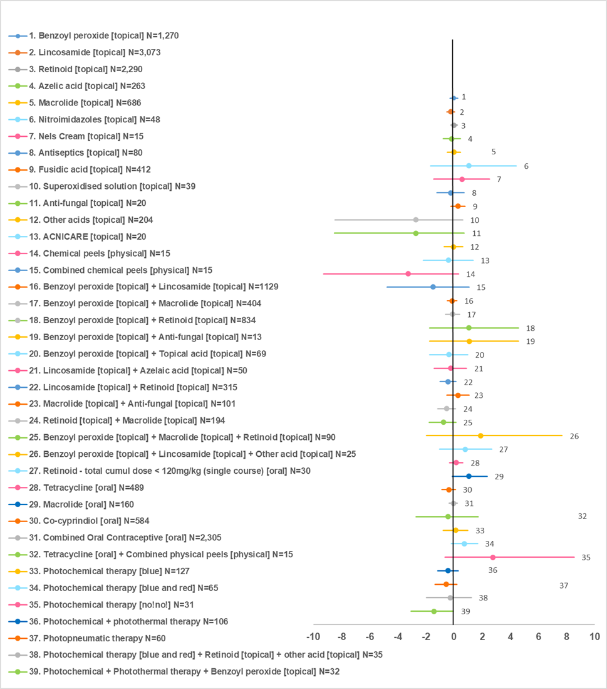
All treatment class effects versus placebo (N=2893). N indicates number of participants across trials included in the analysis. Results expressed as log-odds ratios; values on the left side of vertical axis indicate lower discontinuation for any reason compared with placebo.

Table S15-2. Treatment discontinuation for any reason in people with mild-to-moderate acne, treatment class effects versus placebo & rankings
Class | N | logOR vs placebo (mean, 95% CrI) | Rank, females  (mean, 95% CrI) | Rank, males  (mean, 95% CrI)
Chemical peel [physical] | 15 | -3.27 (-9.28 to 0.32) | 4.25 (1 to 31) | 4.13 (1 to 29)
Superoxidised solution [topical] | 39 | -2.72 (-8.47 to 0.60) | 5.85 (1 to 34) | 5.65 (1 to 32)
Benzoyl peroxide [topical] + Photochemical + photothermal therapy | 32 | -1.44 (-3.05 to -0.05) | 6.00 (1 to 22) | 5.88 (1 to 20)
Anti-fungal [topical] | 20 | -2.72 (-8.50 to 0.72) | 6.05 (1 to 35) | 5.84 (1 to 33)
Combined chemical peels [physical] | 15 | -1.49 (-4.78 to 1.07) | 9.39 (1 to 36) | 9.01 (1 to 34)
Benzoyl peroxide [topical] + Macrolide [topical] + Retinoid [topical] | 90 | -0.76 (-1.77 to 0.13) | 10.13 (3 to 28) | 9.81 (3 to 26)
Photopneumatic therapy | 60 | -0.58 (-1.36 to 0.18) | 12.00 (4 to 30) | 11.56 (4 to 28)
Retinoid [topical] + Macrolide [topical] | 194 | -0.53 (-1.17 to 0.11) | 12.05 (5 to 26) | 11.59 (5 to 24)
Lincosamide [topical] + Retinoid [topical] | 315 | -0.42 (-1.00 to 0.14) | 13.78 (6 to 28) | 13.19 (6 to 27)
Photochemical + photothermal therapy | 106 | -0.44 (-1.17 to 0.28) | 14.18 (5 to 31) | 13.57 (5 to 29)
Co-cyprindiol [oral] | 584 | -0.38 (-0.86 to 0.09) | 14.39 (6 to 28) | Not relevant
Lincosamide [topical] | 3073 | -0.25 (-0.51 to 0.02) | 16.67 (10 to 25) | 15.81 (10 to 23)
Benzoyl peroxide [topical] + Topical acid [topical] | 69 | -0.36 (-1.73 to 0.97) | 17.04 (3 to 36) | 16.19 (3 to 34)
ACNICARE [physical] | 20 | -0.39 (-2.21 to 1.34) | 17.26 (3 to 38) | 16.41 (3 to 36)
Tetracycline [oral] + Combined chemical peels [physical] | 15 | -0.42 (-2.72 to 1.72) | 17.56 (2 to 38) | 16.69 (2 to 36)
Antiseptics [topical] | 80 | -0.25 (-1.23 to 0.72) | 18.30 (5 to 35) | 17.35 (5 to 33)
Retinoid [topical] + Topical acid [topical] + Photochemical therapy [blue and red] | 35 | -0.27 (-1.96 to 1.23) | 18.83 (3 to 37) | 17.85 (3 to 35)
Lincosamide [topical] + Azelaic acid [topical] | 50 | -0.23 (-1.40 to 0.88) | 18.87 (4 to 36) | 17.88 (4 to 34)
Benzoyl peroxide [topical] + Lincosamide [topical] | 1129 | -0.16 (-0.49 to 0.18) | 19.48 (11 to 29) | 18.37 (11 to 28)
Benzoyl peroxide [topical] + Retinoid [topical] | 834 | -0.15 (-0.45 to 0.15) | 19.51 (11 to 29) | 18.38 (11 to 27)
Azelaic acid [topical] | 263 | -0.16 (-0.78 to 0.44) | 19.61 (8 to 33) | 18.52 (7 to 31)
Benzoyl peroxide [topical] + Macrolide [topical] | 404 | -0.12 (-0.61 to 0.38) | 20.56 (10 to 32) | 19.36 (10 to 30)
Combined Oral Contraceptive [oral] | 2305 | -0.06 (-0.35 to 0.23) | 22.28 (13 to 32) | Not relevant
Topical acid [topical] | 204 | -0.04 (-0.69 to 0.60) | 22.44 (8 to 35) | 21.12 (8 to 33)
Macrolide [topical] | 686 | -0.02 (-0.47 to 0.44) | 23.20 (12 to 32) | 21.77 (11 to 31)
Benzoyl peroxide [topical] | 1270 | -0.01 (-0.29 to 0.26) | 23.70 (15 to 31) | 22.20 (15 to 29)
Retinoid [topical] | 2290 | 0.00 (-0.23 to 0.22) | 24.24 (16 to 31) | 22.70 (15 to 30)
Placebo | 2893 | Reference | 24.40 (18 to 31) | 22.80 (16 to 29)
Photochemical therapy [blue] | 127 | 0.11 (-0.77 to 0.98) | 25.15 (8 to 36) | 23.67 (8 to 34)
Tetracycline [oral] | 489 | 0.16 (-0.31 to 0.63) | 27.67 (16 to 35) | 25.94 (15 to 33)
Macrolide [topical] + Anti-fungal [topical] | 101 | 0.26 (-0.53 to 1.06) | 28.28 (11 to 37) | 26.60 (11 to 35)
Nels Cream [topical] | 15 | 0.56 (-1.45 to 2.50) | 28.66 (4 to 39) | 27.09 (4 to 37)
Fusidic acid [topical] | 412 | 0.27 (-0.24 to 0.77) | 29.64 (18 to 36) | 27.81 (17 to 34)
Nitroimidazoles [topical] | 48 | 1.03 (-1.68 to 4.42) | 30.12 (4 to 40) | 28.52 (4 to 38)
Benzoyl peroxide [topical] + Anti-fungal [topical] | 13 | 1.08 (-1.75 to 4.58) | 30.20 (4 to 40) | 28.60 (4 to 38)
Retinoid - total cumulative dose < 120mg/kg (single course) [oral] | 30 | 0.78 (-1.03 to 2.68) | 30.95 (6 to 40) | 29.25 (6 to 38)
Benzoyl peroxide [topical] + Lincosamide [topical] + Topical acid [topical] | 25 | 1.88 (-1.95 to 7.68) | 31.93 (3 to 40) | 30.28 (3 to 38)
Photochemical therapy [blue and red] | 65 | 0.73 (-0.19 to 1.66) | 33.67 (19 to 39) | 31.74 (18 to 37)
Macrolide [oral] | 160 | 1.06 (-0.13 to 2.35) | 35.24 (21 to 40) | 33.29 (20 to 38)
Photochemical therapy [no!no!] | 31 | 2.74 (-0.65 to 8.54) | 36.47 (10 to 40) | 34.58 (9 to 38)
Classes ordered by mean rank for females (rank=1 indicates lowest risk of discontinuation for any reason)
N: number of participants across trials included in the analysis.
Effects with 95% CrI NOT crossing the no effect line and respective classes are shown in red.
CrI: credible intervals; OR: odds ratio

C. Discontinuation due to side effects

Figure S15-4. Discontinuation due to side effects in people with mild-to-moderate acne, forest plots: treatment class effects versus placebo.

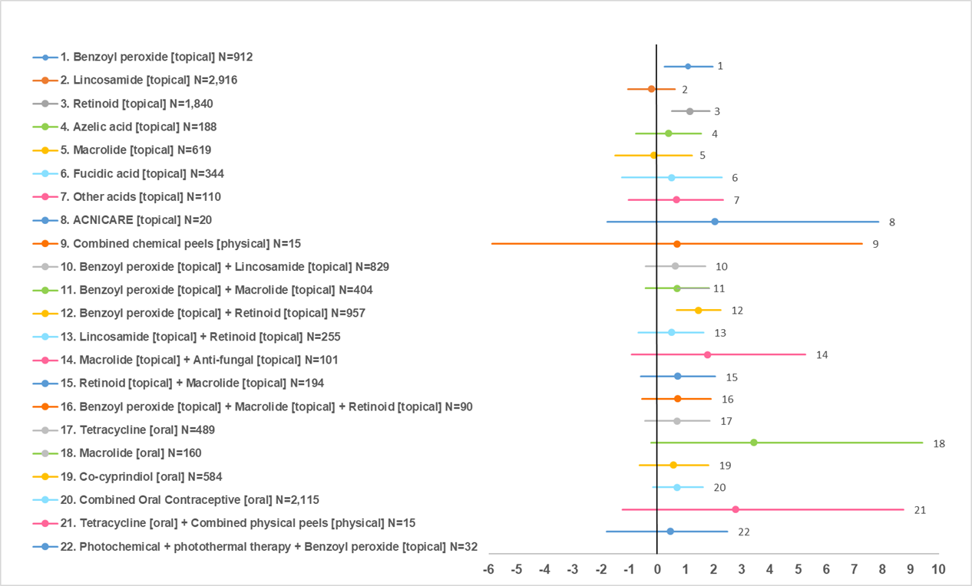
All treatment class effects versus placebo (N=2024). N indicates number of participants across trials included in the analysis. Results expressed as log-odds ratios; values on the left side of vertical axis indicate lower discontinuation due to side effects compared with placebo.

Table S15-3. Treatment discontinuation due side effects in people with mild-to-moderate acne, treatment class effects versus placebo & rankings
Class | N | logOR vs placebo (mean, 95% CrI) | Rank, females  (mean, 95% CrI) | Rank, males  (mean, 95% CrI)
Lincosamide [topical] | 2916 | -0.22 (-1.05 to 0.63) | 3.97 (1 to 10) | 3.76 (1 to 9)
Placebo | 2024 | Reference | 5.19 (1 to 11) | 4.96 (1 to 10)
Macrolide [topical] | 619 | -0.12 (-1.49 to 1.23) | 5.19 (1 to 15) | 4.80 (1 to 14)
Azelaic acid [topical] | 188 | 0.39 (-0.77 to 1.56) | 8.93 (1 to 20) | 8.18 (1 to 18)
Lincosamide [topical] + Retinoid [topical] | 255 | 0.51 (-0.68 to 1.64) | 9.86 (2 to 19) | 8.99 (2 to 17)
Fusidic acid [topical] | 344 | 0.50 (-1.25 to 2.28) | 10.01 (1 to 21) | 9.12 (1 to 19)
Benzoyl peroxide [topical] + Photochemical + photothermal therapy | 32 | 0.46 (-1.80 to 2.48) | 10.04 (1 to 22) | 9.14 (1 to 20)
Co-cyprindiol [oral] | 584 | 0.58 (-0.63 to 1.81) | 10.54 (1 to 21) | Not relevant
Benzoyl peroxide [topical] + Lincosamide [topical] | 829 | 0.63 (-0.41 to 1.70) | 11.03 (3 to 20) | 10.04 (3 to 18)
Topical acid [topical] | 110 | 0.68 (-1.01 to 2.33) | 11.38 (1 to 22) | 10.34 (1 to 20)
Combined chemical peels [physical] | 15 | 0.70 (-5.88 to 7.27) | 11.41 (1 to 23) | 10.39 (1 to 21)
Tetracycline [oral] | 489 | 0.71 (-0.43 to 1.86) | 11.48 (4 to 19) | 10.42 (3 to 17)
Benzoyl peroxide [topical] + Macrolide [topical] | 404 | 0.71 (-0.41 to 1.83) | 11.52 (4 to 19) | 10.45 (3 to 17)
Combined Oral Contraceptive [oral] | 2115 | 0.70 (-0.15 to 1.63) | 11.65 (3 to 20) | Not relevant
Retinoid [topical] + Macrolide [topical] | 194 | 0.73 (-0.59 to 2.06) | 11.79 (2 to 21) | 10.71 (2 to 19)
Benzoyl peroxide [topical] + Macrolide [topical] + Retinoid [topical] | 90 | 0.73 (-0.55 to 1.91) | 11.82 (2 to 21) | 10.72 (2 to 19)
Benzoyl peroxide [topical] | 912 | 1.11 (0.25 to 1.96) | 15.52 (9 to 20) | 14.03 (8 to 19)
ACNICARE [physical] | 20 | 2.03 (-1.78 to 7.85) | 15.58 (1 to 23) | 14.18 (1 to 21)
Retinoid [topical] | 1840 | 1.16 (0.51 to 1.85) | 15.98 (10 to 21) | 14.39 (9 to 19)
Macrolide [topical] + Anti-fungal [topical] | 101 | 1.78 (-0.91 to 5.26) | 16.51 (2 to 23) | 15.00 (2 to 21)
Tetracycline [oral] + Combined chemical peels [physical] | 15 | 2.77 (-1.25 to 8.75) | 18.16 (2 to 23) | 16.54 (2 to 21)
Benzoyl peroxide [topical] + Retinoid [topical] | 957 | 1.46 (0.69 to 2.26) | 18.34 (12 to 22) | 16.56 (11 to 20)
Macrolide [oral] | 160 | 3.43 (-0.23 to 9.42) | 20.09 (4 to 23) | 18.28 (4 to 21)
Classes ordered by mean rank for females (rank=1 indicates lowest risk of discontinuation due to side effects)
N: number of participants across trials included in the analysis.
Effects with 95% CrI NOT crossing the no effect line and respective classes are shown in red.
CrI: credible intervals; OR: odds ratio

Moderate-to-severe acne

A. Percentage change in total lesion count from baseline

Figure S15-5. Treatment efficacy in people with moderate-to-severe acne, forest plots: treatment class effects versus placebo.
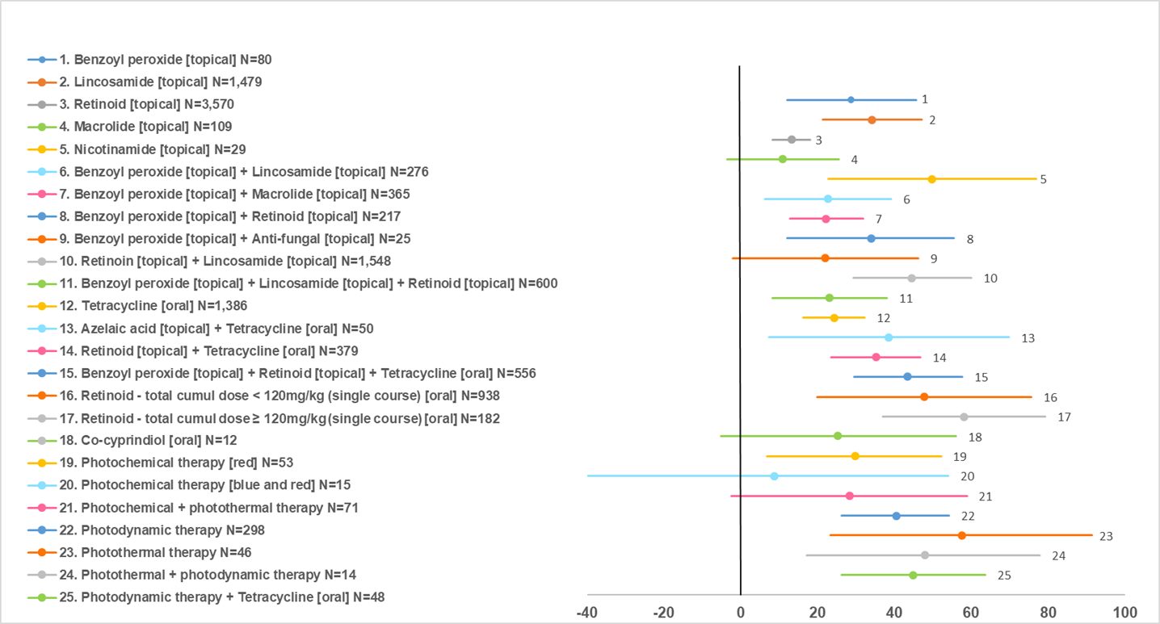
All treatment class effects versus placebo (N=4122). N indicates number of observations across trials included in the analysis. Results expressed as mean difference in % change from baseline; values on the right side of vertical axis indicate higher effect compared with placebo.

For Table of results on treatment efficacy in people with moderate-to-severe acne, treatment class effects versus placebo & rankings: see main article (Table 2).

B. Discontinuation for any reason

Figure S15-6. Discontinuation for any reason in people with moderate-to-severe acne, forest plots: treatment class effects versus placebo.
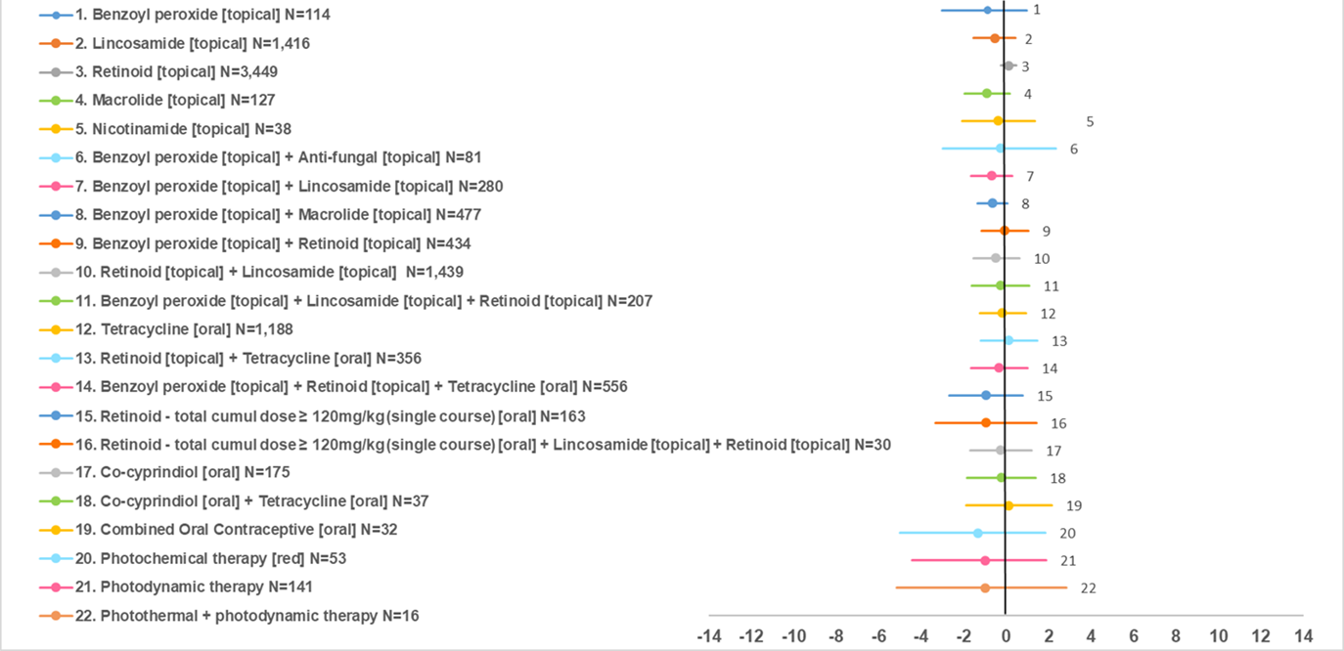
All treatment class effects versus placebo (N=4133). N indicates number of participants across trials included in the analysis. Results expressed as log-odds ratios; values on the left side of vertical axis indicate lower discontinuation for any reason compared with placebo. Results for males, estimated after exclusion of studies assessing hormonal treatments, were very similar.

Table S15-5. Treatment discontinuation for any reason in people with moderate-to-severe acne, treatment class effects versus placebo & rankings
Class | N | logOR vs placebo (mean, 95% CrI) | Rank, females  (mean, 95% CrI) | Rank, males  (mean, 95% CrI)
Macrolide [topical] | 127 | -0.90 (-1.97 to 0.16) | 7.67 (1 to 19) | 7.28 (1 to 17)
Retinoid - total cumulative dose ≥ 120mg/kg (single course) [oral] | 163 | -0.95 (-2.67 to 0.78) | 7.74 (1 to 21) | 6.52 (1 to 18)
Photochemical therapy [red] | 53 | -1.34 (-5.01 to 1.83) | 7.86 (1 to 23) | 7.31 (1 to 20)
Retinoid - total cumulative dose ≥ 120mg/kg (single course) [oral] + Lincosamide [topical] + Retinoid [topical] | 30 | -0.95 (-3.35 to 1.44) | 8.73 (1 to 23) | 7.35 (1 to 20)
Benzoyl peroxide [topical] | 114 | -0.88 (-3.05 to 0.98) | 9.02 (1 to 22) | 8.29 (1 to 19)
Benzoyl peroxide [topical] + Lincosamide [topical] | 280 | -0.69 (-1.65 to 0.27) | 9.34 (2 to 20) | 8.77 (2 to 18)
Benzoyl peroxide [topical] + Macrolide [topical] | 477 | -0.65 (-1.35 to 0.05) | 9.52 (2 to 18) | 9.03 (3 to 16)
Photodynamic therapy | 141 | -1.00 (-4.42 to 1.89) | 9.57 (1 to 23) | 8.88 (1 to 20)
Photothermal + photodynamic therapy | 16 | -1.00 (-5.16 to 2.83) | 9.95 (1 to 23) | 9.15 (1 to 20)
Lincosamide [topical] | 1416 | -0.55 (-1.53 to 0.45) | 10.62 (3 to 20) | 9.90 (3 to 18)
Lincosamide [topical] + Retinoid [topical] | 1439 | -0.48 (-1.56 to 0.64) | 11.33 (2 to 22) | 10.49 (2 to 19)
Nicotinamide [topical] | 38 | -0.38 (-2.09 to 1.34) | 12.36 (1 to 23) | 11.35 (1 to 20)
Benzoyl peroxide [topical] + Retinoid [topical] + Tetracycline [oral] | 556 | -0.34 (-1.66 to 1.02) | 12.63 (3 to 22) | 10.59 (3 to 19)
Benzoyl peroxide [topical] + Anti-fungal [topical] | 81 | -0.26 (-2.98 to 2.33) | 13.27 (1 to 23) | 11.89 (1 to 20)
Co-cyprindiol [oral] | 175 | -0.25 (-1.70 to 1.20) | 13.30 (3 to 22) | not relevant
Benzoyl peroxide [topical] + Lincosamide [topical] + Retinoid [topical] | 207 | -0.26 (-1.64 to 1.10) | 13.38 (2 to 23) | 12.23 (2 to 20)
Tetracycline [oral] + Co-cyprindiol [oral] | 37 | -0.23 (-1.84 to 1.39) | 13.51 (2 to 23) | not relevant
Tetracycline [oral] | 1188 | -0.18 (-1.23 to 0.92) | 14.22 (6 to 21) | 11.90 (4 to 19)
Benzoyl peroxide [topical] + Retinoid [topical] | 434 | -0.08 (-1.15 to 1.04) | 14.99 (4 to 23) | 13.64 (4 to 20)
Combined Oral Contraceptive [oral] | 32 | 0.12 (-1.91 to 2.15) | 15.90 (2 to 23) | not relevant
Placebo | 4133 | Reference | 16.36 (10 to 21) | 14.95 (10 to 19)
Retinoid [topical] + Tetracycline [oral] | 356 | 0.12 (-1.19 to 1.45) | 17.02 (6 to 23) | 14.37 (5 to 20)
Retinoid [topical] | 3449 | 0.12 (-0.24 to 0.46) | 17.71 (11 to 23) | 16.11 (10 to 20)
Classes ordered by mean rank for females (rank=1 indicates lowest risk for discontinuation for any reason)
Effects with 95% CrI NOT crossing the no effect line and respective classes are shown in red.
logORs are for females; logORs for males, estimated after exclusion of hormonal treatments, were very similar
CrI: credible intervals; OR: odds ratio

C. Discontinuation due to side effects

Base-case results

Figure S15-7. Discontinuation due to side effects in people with moderate-to-severe acne, base-case forest plots: treatment class effects versus placebo.
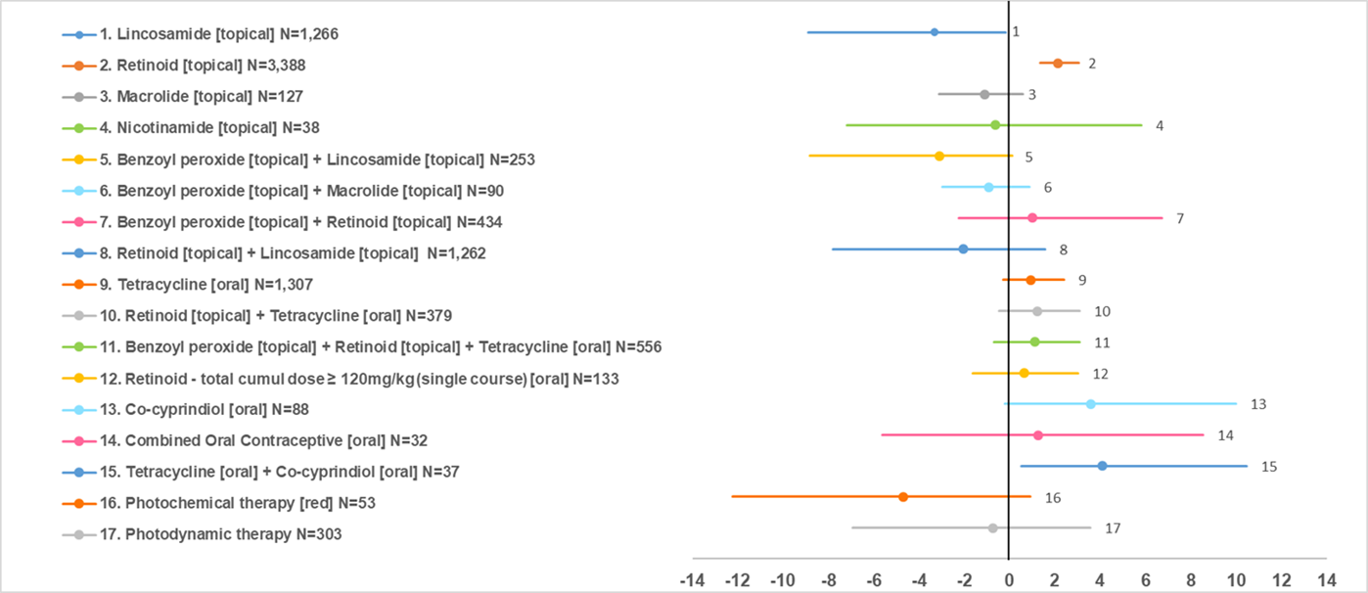
All treatment class effects versus placebo (N=3920). N indicates number of participants across trials included in the analysis. Results expressed as log-odds ratios; values on the left side of vertical axis indicate lower discontinuation due to side effects compared with placebo. Results for males, estimated after exclusion of studies assessing hormonal treatments, were very similar.

Table S15-6. Treatment discontinuation due side effects in people with mild-to-moderate acne, base-case treatment class effects versus placebo & rankings
Class | N | logOR vs placebo (mean, 95% CrI) | Rank, females  (mean, 95% CrI) | Rank, males  (mean, 95% CrI)
Photochemical therapy [red] | 53 | -4.71 (-12.23 to 0.92) | 2.72 (1 to 10) | 2.60 (1 to 9)
Lincosamide [topical] | 1266 | -3.30 (-8.89 to -0.18) | 2.95 (1 to 7) | 2.82 (1 to 7)
Benzoyl peroxide [topical] + Lincosamide [topical] | 253 | -3.11 (-8.83 to 0.10) | 3.68 (1 to 9) | 3.58 (1 to 9)
Lincosamide [topical] + Retinoid [topical] | 1262 | -2.05 (-7.81 to 1.57) | 5.63 (2 to 14) | 5.34 (2 to 13)
Macrolide [topical] | 127 | -1.12 (-3.13 to 0.57) | 6.14 (2 to 12) | 5.95 (2 to 11)
Benzoyl peroxide [topical] + Macrolide [topical] | 90 | -0.91 (-2.99 to 0.87) | 6.65 (2 to 13) | 6.40 (2 to 12)
Photodynamic therapy | 303 | -0.75 (-6.92 to 3.58) | 8.19 (2 to 17) | 7.66 (2 to 15)
Nicotinamide [topical] | 38 | -0.63 (-7.19 to 5.82) | 8.47 (2 to 18) | 7.84 (2 to 15)
Placebo | 3920 | Reference | 8.94 (6 to 13) | 8.59 (6 to 12)
Retinoid - total cumulative dose ≥ 120mg/kg (single course) [oral] | 133 | 0.65 (-1.63 to 3.01) | 10.69 (5 to 16) | 10.11 (4 to 15)
Benzoyl peroxide [topical] + Retinoid [topical] | 434 | 1.00 (-2.25 to 6.72) | 11.04 (3 to 18) | 10.33 (3 to 15)
Combined Oral Contraceptive [oral] | 32 | 1.27 (-5.64 to 8.53) | 11.27 (1 to 18) | not relevant
Tetracycline [oral] | 1307 | 0.92 (-0.30 to 2.41) | 11.67 (8 to 15) | 11.08 (8 to 14)
Benzoyl peroxide [topical] + Retinoid [topical] + Tetracycline [oral] | 556 | 1.12 (-0.69 to 3.09) | 12.41 (7 to 17) | 11.72 (7 to 15)
Retinoid [topical] + Tetracycline [oral] | 379 | 1.24 (-0.46 to 3.11) | 12.76 (8 to 17) | 12.05 (8 to 15)
Retinoid [topical] | 3388 | 2.14 (1.36 to 3.06) | 15.06 (11 to 18) | 13.91 (10 to 15)
Co-cyprindiol [oral] | 88 | 3.59 (-0.22 to 10.00) | 15.88 (9 to 18) | not relevant
Tetracycline [oral] + Co-cyprindiol [oral] | 37 | 4.11 (0.50 to 10.48) | 16.86 (12 to 18) | not relevant
Classes ordered by mean rank for females (rank=1 indicates lowest risk of discontinuation due to side effects)
N: number of participants across trials included in the analysis.
Effects with 95% CrI NOT crossing the no effect line and respective classes are shown in red.
logORs are for females; logORs for males, estimated after exclusion of hormonal treatments, were very similar
CrI: credible intervals; OR: odds ratio

Bias-adjusted results

Figure S15-8. Discontinuation due to side effects in people with moderate-to-severe acne, bias-adjusted forest plots: treatment class effects versus placebo.
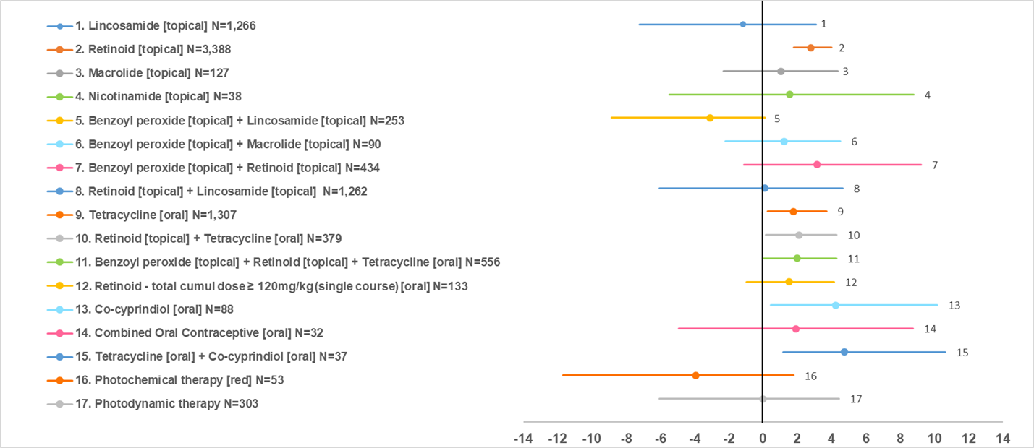
All treatment class effects versus placebo (N=3920). N indicates number of participants across trials included in the analysis. Results expressed as log-odds ratios; values on the left side of vertical axis indicate lower discontinuation due to side effects compared with placebo. Results for males, estimated after exclusion of studies assessing hormonal treatments, were very similar.

Table S15-7. Treatment discontinuation due side effects in people with mild-to-moderate acne, bias-adjusted treatment class effects versus placebo & rankings
Class | N | logOR vs placebo (mean, 95% CrI) | Rank, females  (mean, 95% CrI) | Rank, males  (mean, 95% CrI)
Photochemical therapy [red] | 53 | -3.95 (-11.68 to 1.77) | 2.40 (1 to 9) | 2.29 (1 to 8)
Benzoyl peroxide [topical] + Lincosamide [topical] | 253 | -3.12 (-8.87 to 0.10) | 2.54 (1 to 7) | 2.40 (1 to 6)
Lincosamide [topical] | 1266 | -1.14 (-7.22 to 3.09) | 4.44 (1 to 13) | 4.21 (1 to 12)
Placebo | 3920 | Reference | 5.69 (3 to 10) | 5.34 (2 to 9)
Photodynamic therapy | 303 | -0.01 (-6.06 to 4.44) | 7.25 (2 to 17) | 6.88 (2 to 15)
Lincosamide [topical] + Retinoid [topical] | 1262 | 0.10 (-6.06 to 4.67) | 7.56 (2 to 17) | 7.12 (2 to 14)
Macrolide [topical] | 127 | 1.055 (-2.32 to 4.38) | 8.76 (2 to 17) | 8.14 (2 to 14)
Benzoyl peroxide [topical] + Macrolide [topical] | 90 | 1.22 (-2.21 to 4.52) | 9.28 (3 to 17) | 8.68 (3 to 15)
Retinoid - total cumulative dose ≥ 120mg/kg (single course) [oral] | 133 | 1.51 (-0.97 to 4.15) | 9.73 (4 to 16) | 9.13 (4 to 15)
Nicotinamide [topical] | 38 | 1.54 (-5.49 to 8.79) | 10.25 (2 to 18) | 9.41 (2 to 15)
Combined Oral Contraceptive [oral] | 32 | 1.92 (-4.92 to 8.77) | 10.44 (1 to 18) | not relevant
Tetracycline [oral] | 1307 | 1.78 (0.25 to 3.71) | 10.58 (6 to 14) | 9.95 (6 to 13)
Benzoyl peroxide [topical] + Retinoid [topical] + Tetracycline [oral] | 556 | 1.98 (-0.04 to 4.28) | 11.48 (6 to 16) | 10.74 (6 to 15)
Retinoid [topical] + Tetracycline [oral] | 379 | 2.09 (0.14 to 4.29) | 11.83 (6 to 17) | 11.06 (6 to 15)
Benzoyl peroxide [topical] + Retinoid [topical] | 434 | 3.14 (-1.11 to 9.24) | 13.15 (4 to 18) | 11.89 (4 to 15)
Retinoid [topical] | 3388 | 2.77 (1.77 to 4.00) | 13.89 (8 to 18) | 12.77 (8 to 15)
Co-cyprindiol [oral] | 88 | 4.24 (0.43 to 10.17) | 15.31 (8 to 18) | not relevant
Tetracycline [oral] + Co-cyprindiol [oral] | 37 | 4.77 (1.16 to 10.64) | 16.44 (10 to 18) | not relevant
Classes ordered by mean rank for females (rank=1 indicates lowest risk of discontinuation due to side effects)
N: number of participants across trials included in the analysis.
Effects with 95% CrI NOT crossing the no effect line and respective classes are shown in red.
logORs are for females; logORs for males, estimated after exclusion of hormonal treatments, were very similar
CrI: credible intervals; OR: odds ratio

