Appendix S12: Inconsistency checks - results

Mild-to-moderate acne

A. Percentage change in total lesion count from baseline
Although there were no meaningful differences between the fit of the random effects consistency and inconsistency models, the between-study SD slightly decreased in the inconsistency models, suggesting some evidence of inconsistency (Appendix S11). The area below the line of equality in the deviance plot (Figure S12-1) highlights where the inconsistency model better predicted data points: there were notable improvements in the prediction of data in Rademaker 2014, which assessed oral isotretinoin total cumulative dose of <120mg/kg per single course and daily dose <0.5mg/kg, total duration 12 to <24 weeks versus placebo [oral], 12 to < 24 weeks; and Strauss 1984, which compared erythromycin [topical] with zinc acetate dihydrate, 6 to <12 weeks versus placebo [topical], 6 to <12 weeks.

Although there were no meaningful differences between the fit of the node split models and the consistency model (Table S12-1), there were differences between the direct and indirect estimates of the following class comparisons (Figure S12-2):
- Azelaic acid [topical] vs. Placebo (6 vs. 1)
- Azelaic acid [topical] vs. Lincosamide [topical] (6 vs. 4)
- Retinoid - total cumul dose < 120mg/kg (single course) [oral] vs. Placebo (16 vs. 1)
- Photochemical therapy [blue] vs. Retinoid - total cumul dose < 120mg/kg (single course) [oral] (22 vs. 16)

Figure S12-1: Deviance contributions for the random effects consistency and inconsistency models. Percentage change in total lesion count from baseline – mild-to-moderate acne. (A) Intervention level and (B) Class level
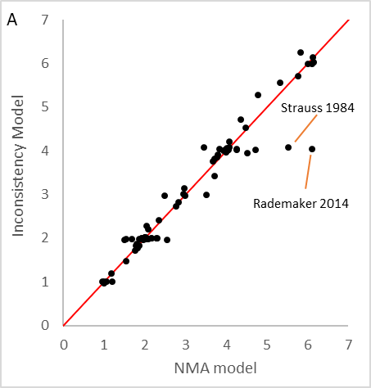 | 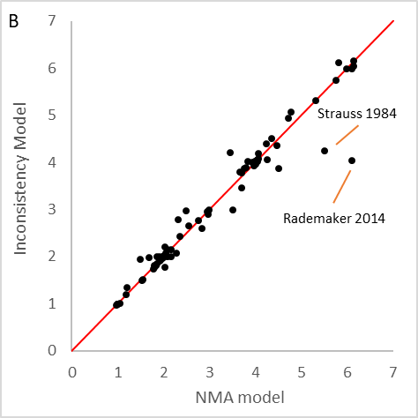

Table S12-1: Summary of node-splitting results. Percentage change in total lesion count from baseline – mild-to-moderate acne.
Node split model | Between Study Heterogeneity - SD (95% CrI) | Posterior total residual devianceª | DIC^{b} | p-value^{c}
Benzoyl peroxide [topical] vs. Placebo (3 vs. 1) | 9.95 (8.10, 12.37) | 273.2 | 1682.0 | 0.95
Lincosamide [topical] vs. Placebo (4 vs. 1) | 9.86 (8.02, 12.26) | 273.1 | 1681.0 | 0.39
Retinoid [topical] vs. Placebo (5 vs. 1) | 9.85 (8.03, 12.21) | 272.3 | 1680.0 | 0.21
Azelaic acid [topical] vs. Placebo (6 vs. 1) | 9.52 (7.73, 11.84) | 273.0 | 1680.0 | 0.03
Macrolide [topical] vs. Placebo (7 vs. 1) | 9.92 (8.08, 12.31) | 273.0 | 1682.0 | 0.49
Fusidic acid [topical] vs. Placebo (9 vs. 1) | 9.93 (8.07, 12.32) | 273.1 | 1682.0 | 0.59
Topical acid [topical] vs. Placebo (12 vs. 1) | 9.71 (7.88, 12.09) | 273.1 | 1681.0 | 0.11
Retinoid - total cumul dose < 120mg/kg (single course) [oral] vs. Placebo (16 vs. 1) | 9.69 (7.90, 12.00) | 271.0 | 1679.0 | 0.03
Co-cyprindiol [oral] vs. Placebo (19 vs. 1) | 9.94 (8.09, 12.33) | 273.3 | 1682.0 | 0.92
Photochemical therapy [blue and red] vs. Placebo (21 vs. 1) | 9.90 (8.04, 12.30) | 273.5 | 1682.0 | 0.60
Photochemical therapy [blue] vs. Placebo (22 vs. 1) | 9.94 (8.10, 12.33) | 272.6 | 1681.0 | 0.39
Benzoyl peroxide [topical] + Retinoid [topical] vs. Placebo (30 vs. 1) | 9.90 (8.08, 12.23) | 271.3 | 1680.0 | 0.16
Lincosamide [topical] + Retinoid [topical] vs. Placebo (32 vs. 1) | 9.90 (8.08, 12.31) | 273.3 | 1683.0 | 0.68
Retinoid [topical] + Macrolide [topical] vs. Placebo (35 vs. 1) | 9.93 (8.07, 12.34) | 273.1 | 1682.0 | 0.59
Lincosamide [topical] vs. Benzoyl peroxide [topical] (4 vs. 3) | 9.88 (8.03, 12.27) | 273.3 | 1682.0 | 0.45
Retinoid [topical] vs. Benzoyl peroxide [topical] (5 vs. 3) | 9.87 (8.00, 12.27) | 273.4 | 1682.0 | 0.43
Photochemical therapy [blue] vs. Benzoyl peroxide [topical] (22 vs. 3) | 9.86 (8.03, 12.25) | 272.8 | 1681.0 | 0.28
Benzoyl peroxide [topical] + Macrolide [topical] vs.  Benzoyl peroxide [topical] (29 vs. 3) | 9.92 (8.08, 12.32) | 273.2 | 1682.0 | 0.70
Benzoyl peroxide [topical] + Retinoid [topical] vs. Benzoyl peroxide [topical] (30 vs. 3) | 9.94 (8.11, 12.34) | 272.5 | 1681.0 | 0.42
Azelaic acid [topical] vs. Lincosamide [topical] (6 vs. 4) | 9.47 (7.67, 11.80) | 273.5 | 1681.0 | 0.03
Macrolide [topical] vs. Lincosamide [topical] (7 vs. 4) | 9.83 (7.98, 12.25) | 273.7 | 1682.0 | 0.41
Benzoyl peroxide [topical] + Lincosamide [topical] vs.  Lincosamide [topical] (28 vs. 4) | 9.87 (8.03, 12.27) | 272.9 | 1681.0 | 0.31
Lincosamide [topical] + Retinoid [topical] vs.  Lincosamide [topical] (32 vs. 4) | 9.98 (8.12, 12.40) | 272.7 | 1681.0 | 0.76
Azelaic acid [topical] vs. Retinoid [topical] (6 vs. 5) | 9.92 (8.08, 12.32) | 273.0 | 1682.0 | 0.42
Benzoyl peroxide [topical] + Lincosamide [topical] vs. Retinoid [topical] (28 vs. 5) | 9.97 (8.11, 12.41) | 273.0 | 1682.0 | 0.87
Benzoyl peroxide [topical] + Retinoid [topical] vs. Retinoid [topical] (30 vs. 5) | 9.88 (8.02, 12.27) | 272.9 | 1681.0 | 0.28
Macrolide [topical] vs. Azelaic acid [topical] (7 vs. 6) | 9.82 (7.99, 12.21) | 272.8 | 1681.0 | 0.18
Benzoyl peroxide [topical] + Lincosamide [topical] vs. Azelaic acid [topical] (28 vs. 6) | 9.70 (7.86, 12.07) | 273.4 | 1681.0 | 0.12
Fusidic acid [topical] vs. Macrolide [topical] (9 vs. 7) | 9.94 (8.08, 12.36) | 273.0 | 1682.0 | 0.58
Benzoyl peroxide [topical] + Lincosamide [topical] vs. Macrolide [topical] (28 vs. 7) | 9.97 (8.10, 12.39) | 273.0 | 1681.0 | 0.91
Retinoid [topical] + Macrolide [topical] vs. Macrolide [topical] (35 vs. 7) | 9.92 (8.07, 12.35) | 273.4 | 1682.0 | 0.72
Benzoyl peroxide [topical] + Retinoid [topical] vs. Topical acid [topical] (30 vs. 12) | 9.69 (7.86, 12.07) | 273.3 | 1681.0 | 0.10
Photochemical therapy [blue] vs. Retinoid - total cumul dose < 120mg/kg (single course) [oral] (22 vs. 16) | 9.68 (7.91, 11.98) | 271.2 | 1679.0 | 0.03
Photochemical therapy [blue] vs. Photochemical therapy [blue and red] (22 vs. 21) | 9.94 (8.09, 12.30) | 272.4 | 1681.0 | 0.41
Lincosamide [topical] + Retinoid [topical] vs. Benzoyl peroxide [topical] + Lincosamide [topical] (32 vs. 28) | 9.98 (8.11, 12.38) | 272.8 | 1681.0 | 0.95
Retinoid [topical] + Macrolide [topical] vs. Benzoyl peroxide [topical] + Macrolide [topical] (35 vs. 29) | 9.91 (8.07, 12.31) | 273.3 | 1682.0 | 0.75
NMA (no nodes split)^{d} | 9.88 (8.05, 12.26) | 272.9 | 1681.0
Abbreviations: CrI, credible interval; DIC, deviance information criteria; NMA, network meta-analysis; SD, standard deviation
ª Posterior mean residual deviance compared to 273 total data points
^{b} Lower values of DIC preferred
^{c} p-values are calculated as 2×min{prob, 1- prob} where prob is the probability that the difference between the direct and indirect relative effects is positive; p-values < 0.05 are indicative of evidence of inconsistency between the direct and indirect estimates
^{d} Model fit statistics produced in R2OpenBUGS

Figure S12-2: Direct, indirect, and network estimates of relative treatment effects based on node-splitting results. Percentage change in total lesion count from baseline – mild-to-moderate acne (continued on next page).
Class codes: 1 - Placebo, 2 - No treatment, 3 - Benzoyl peroxide [topical], 4 - Lincosamide [topical], 5 - Retinoid [topical], 6 - Azelaic acid [topical], 7 - Macrolide [topical], 8 - Antiseptics [topical], 9 - Fusidic acid [topical], 10 - Superoxidised solution [topical], 11 - Anti-fungal [topical], 12 - Topical acid [topical], 13 - Chemical peel [physical], 14 - Combined chemical peels [physical], 15 - ACNICARE [physical], 16 - Retinoid - total cumul dose < 120mg/kg (single course) [oral], 17 - Tetracycline [oral], 18 - Macrolide [oral], 19 - Co-cyprindiol [oral], 20 - Combined Oral Contraceptive [oral], 21 - Photochemical therapy [blue and red], 22 - Photochemical therapy [blue], 23 - Photochemical therapy [red], 24 - Photochemical + photothermal therapy, 25 - Photodynamic therapy, 26 - Photothermal + photodynamic therapy, 27 - Smoothbeam + Photochemical therapy [blue], 28 - Benzoyl peroxide [topical] + Lincosamide [topical], 29 - Benzoyl peroxide [topical] + Macrolide [topical], 30 - Benzoyl peroxide [topical] + Retinoid [topical], 31 - Lincosamide [topical] + Azelaic acid [topical], 32 - Lincosamide [topical] + Retinoid [topical], 33 - Macrolide [topical] + Anti-fungal [topical], 34 - Retinoid [topical] + Hydrogen Peroxide [topical], 35 - Retinoid [topical] + Macrolide [topical], 36 - Lincosamide [topical] + Topical acid [topical], 37 - Azelaic acid [topical] + Macrolide [topical], 38 - Tetracycline [oral] + Combined physical peels [physical], 39 - Retinoid [topical] + Topical acid [topical] + Photochemical therapy [blue and red], 40 - Benzoyl peroxide [topical] + Lincosamide [topical] + Topical acid [topical], 41 - Benzoyl peroxide [topical] + Photochemical + photothermal therapy.
Figure S12-2. (continued from previous page and to next page)
Class codes: 1 - Placebo, 2 - No treatment, 3 - Benzoyl peroxide [topical], 4 - Lincosamide [topical], 5 - Retinoid [topical], 6 - Azelaic acid [topical], 7 - Macrolide [topical], 8 - Antiseptics [topical], 9 - Fusidic acid [topical], 10 - Superoxidised solution [topical], 11 - Anti-fungal [topical], 12 - Topical acid [topical], 13 - Chemical peel [physical], 14 - Combined chemical peels [physical], 15 - ACNICARE [physical], 16 - Retinoid - total cumul dose < 120mg/kg (single course) [oral], 17 - Tetracycline [oral], 18 - Macrolide [oral], 19 - Co-cyprindiol [oral], 20 - Combined Oral Contraceptive [oral], 21 - Photochemical therapy [blue and red], 22 - Photochemical therapy [blue], 23 - Photochemical therapy [red], 24 - Photochemical + photothermal therapy, 25 - Photodynamic therapy, 26 - Photothermal + photodynamic therapy, 27 - Smoothbeam + Photochemical therapy [blue], 28 - Benzoyl peroxide [topical] + Lincosamide [topical], 29 - Benzoyl peroxide [topical] + Macrolide [topical], 30 - Benzoyl peroxide [topical] + Retinoid [topical], 31 - Lincosamide [topical] + Azelaic acid [topical], 32 - Lincosamide [topical] + Retinoid [topical], 33 - Macrolide [topical] + Anti-fungal [topical], 34 - Retinoid [topical] + Hydrogen Peroxide [topical], 35 - Retinoid [topical] + Macrolide [topical], 36 - Lincosamide [topical] + Topical acid [topical], 37 - Azelaic acid [topical] + Macrolide [topical], 38 - Tetracycline [oral] + Combined physical peels [physical], 39 - Retinoid [topical] + Topical acid [topical] + Photochemical therapy [blue and red], 40 - Benzoyl peroxide [topical] + Lincosamide [topical] + Topical acid [topical], 41 - Benzoyl peroxide [topical] + Photochemical + photothermal therapy.

Figure S12-2. (continued from previous page)
Class codes: 1 - Placebo, 2 - No treatment, 3 - Benzoyl peroxide [topical], 4 - Lincosamide [topical], 5 - Retinoid [topical], 6 - Azelaic acid [topical], 7 - Macrolide [topical], 8 - Antiseptics [topical], 9 - Fusidic acid [topical], 10 - Superoxidised solution [topical], 11 - Anti-fungal [topical], 12 - Topical acid [topical], 13 - Chemical peel [physical], 14 - Combined chemical peels [physical], 15 - ACNICARE [physical], 16 - Retinoid - total cumul dose < 120mg/kg (single course) [oral], 17 - Tetracycline [oral], 18 - Macrolide [oral], 19 - Co-cyprindiol [oral], 20 - Combined Oral Contraceptive [oral], 21 - Photochemical therapy [blue and red], 22 - Photochemical therapy [blue], 23 - Photochemical therapy [red], 24 - Photochemical + photothermal therapy, 25 - Photodynamic therapy, 26 - Photothermal + photodynamic therapy, 27 - Smoothbeam + Photochemical therapy [blue], 28 - Benzoyl peroxide [topical] + Lincosamide [topical], 29 - Benzoyl peroxide [topical] + Macrolide [topical], 30 - Benzoyl peroxide [topical] + Retinoid [topical], 31 - Lincosamide [topical] + Azelaic acid [topical], 32 - Lincosamide [topical] + Retinoid [topical], 33 - Macrolide [topical] + Anti-fungal [topical], 34 - Retinoid [topical] + Hydrogen Peroxide [topical], 35 - Retinoid [topical] + Macrolide [topical], 36 - Lincosamide [topical] + Topical acid [topical], 37 - Azelaic acid [topical] + Macrolide [topical], 38 - Tetracycline [oral] + Combined physical peels [physical], 39 - Retinoid [topical] + Topical acid [topical] + Photochemical therapy [blue and red], 40 - Benzoyl peroxide [topical] + Lincosamide [topical] + Topical acid [topical], 41 - Benzoyl peroxide [topical] + Photochemical + photothermal therapy.

B. Discontinuation for any reason
There were no meaningful differences between the fit of the fixed effects consistency and inconsistency models (Appendix S11). Nevertheless, the area below the line of equality in Figure S12-3 highlights where the inconsistency model better predicted data points, and there were notable improvements in the prediction of data in Draelos 2002, a five-arm trial which compared Clindamycin [topical], Tazarotene [topical], Benzoyl peroxide [topical] + Tazarotene [topical], Clindamycin [topical] + Tazarotene [topical], and Benzoyl peroxide [topical] + Erythromycin [topical] + Tazarotene [topical], all with a duration of 12 to <24 weeks; and Thielitz 2015, a three-arm trial which compared Adapalene [topical], Azelaic Acid [topical], and another Azelaic Acid [topical], all with a duration of 12 to <24 weeks.

For most comparisons, there were no meaningful differences between the fit and DIC of the node split models and the consistency model, apart from Benzoyl peroxide [topical] + Macrolide [topical] vs. Tetracycline [oral] (30 vs. 18) and Lincosamide [topical] + Retinoid [topical] vs. Benzoyl peroxide [topical] + Retinoid [topical] (33 vs. 31) (Table 38). There were differences between the direct and indirect estimates of the latter class comparison (Table S12-2, Figure S12-4).

Figure S12-3: Deviance contributions for the random effects consistency and inconsistency models. Discontinuation for any reason – mild-to-moderate acne. (A) Intervention level and (B) Class level
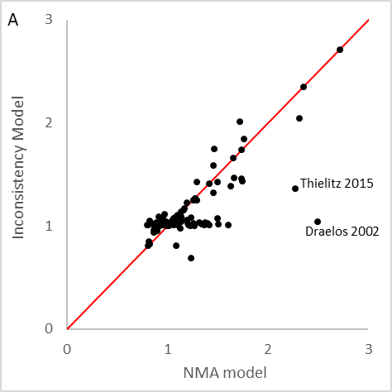 | 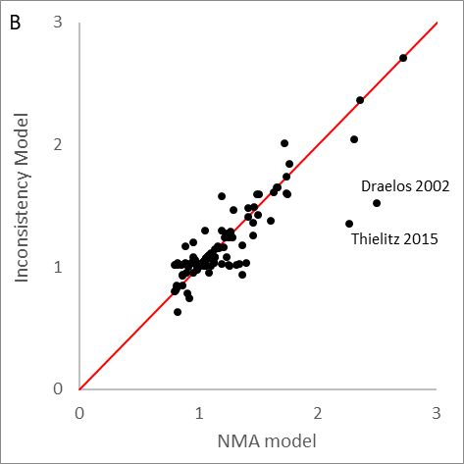

Table S12-2: Summary of node-splitting results. Discontinuation for any reason – mild-to-moderate acne.
Node split modelª | Posterior total residual deviance^{b} | DIC^{c} | p-value^{d}
Benzoyl peroxide [topical] vs. Placebo (2 vs. 1) | 188.9 | 1024.0 | 0.29
Lincosamide [topical] vs. Placebo (3 vs. 1) | 189.9 | 1025.0 | 0.58
Retinoid [topical] vs. Placebo (4 vs. 1) | 190.1 | 1025.0 | 0.73
Azelaic acid [topical] vs. Placebo (5 vs. 1) | 188.6 | 1023.0 | 0.19
Macrolide [topical] vs. Placebo (6 vs. 1) | 190.2 | 1025.0 | 0.78
Antiseptics [topical] vs. Placebo (9 vs. 1) | 189.7 | 1024.0 | 0.35
Fusidic acid [topical] vs. Placebo (10 vs. 1) | 190.1 | 1025.0 | 0.84
Topical acid [topical] vs. Placebo (13 vs. 1) | 190.1 | 1025.0 | 0.43
Co-cyprindiol [oral] vs. Placebo (20 vs. 1) | 190.3 | 1025.0 | 0.74
Photochemical therapy [blue and red] vs. Placebo (22 vs. 1) | 188.3 | 1023.0 | 0.12
Photochemical therapy [blue] vs. Placebo (23 vs. 1) | 190.1 | 1025.0 | 0.73
Benzoyl peroxide [topical] + Retinoid [topical] vs. Placebo (31 vs. 1) | 190.3 | 1025.0 | 0.85
Lincosamide [topical] + Retinoid [topical] vs. Placebo (33 vs. 1) | 189.6 | 1024.0 | 0.32
Retinoid [topical] + Macrolide [topical] vs. Placebo (35 vs. 1) | 189.7 | 1025.0 | 0.46
Retinoid [topical] vs. Benzoyl peroxide [topical] (4 vs. 2) | 189.8 | 1025.0 | 0.45
Azelaic acid [topical] vs. Benzoyl peroxide [topical] (5 vs. 2) | 190.2 | 1025.0 | 0.54
Antiseptics [topical] vs. Benzoyl peroxide [topical] (9 vs. 2) | 189.8 | 1025.0 | 0.34
Topical acid [topical] vs. Benzoyl peroxide [topical] (13 vs. 2) | 190.2 | 1025.0 | 0.81
Tetracycline [oral] vs. Benzoyl peroxide [topical] (18 vs. 2) | 189.1 | 1024.0 | 0.29
Benzoyl peroxide [topical] + Macrolide [topical] vs. Benzoyl peroxide [topical] (30 vs. 2) | 189.6 | 1024.0 | 0.47
Benzoyl peroxide [topical] + Retinoid [topical] vs. Benzoyl peroxide [topical] (31 vs. 2) | 189.8 | 1025.0 | 0.41
Retinoid [topical] vs. Lincosamide [topical] (4 vs. 3) | 189.6 | 1024.0 | 0.45
Azelaic acid [topical] vs. Lincosamide [topical] (5 vs. 3) | 189.6 | 1024.0 | 0.38
Macrolide [topical] vs. Lincosamide [topical] (6 vs. 3) | 189.7 | 1025.0 | 0.44
Benzoyl peroxide [topical] + Lincosamide [topical] vs. Lincosamide [topical] (29 vs. 3) | 190.1 | 1025.0 | 0.70
Benzoyl peroxide [topical] + Retinoid [topical] vs. Lincosamide [topical] (31 vs. 3) | 190.0 | 1025.0 | 0.62
Lincosamide [topical] + Retinoid [topical] vs. Lincosamide [topical] (33 vs. 3) | 190.2 | 1025.0 | 0.71
Azelaic acid [topical] vs. Retinoid [topical] (5 vs. 4) | 188.5 | 1023.0 | 0.17
Benzoyl peroxide [topical] + Lincosamide [topical] vs. Retinoid [topical] (29 vs. 4) | 188.7 | 1023.0 | 0.23
Benzoyl peroxide [topical] + Retinoid [topical] vs. Retinoid [topical] (31 vs. 4) | 190.4 | 1025.0 | 0.78
Lincosamide [topical] + Retinoid [topical] vs. Retinoid [topical] (33 vs. 4) | 189.7 | 1025.0 | 0.45
Benzoyl peroxide [topical] + Lincosamide [topical] vs. Azelaic acid [topical] (29 vs. 5) | 189.1 | 1024.0 | 0.26
Fusidic acid [topical] vs. Macrolide [topical] (10 vs. 6) | 189.0 | 1024.0 | 0.25
Benzoyl peroxide [topical] + Lincosamide [topical] vs. Macrolide [topical] (29 vs. 6) | 189.8 | 1025.0 | 0.50
Retinoid [topical] + Macrolide [topical] vs. Macrolide [topical] (35 vs. 6) | 190.1 | 1025.0 | 0.56
Tetracycline [oral] vs. Fusidic acid [topical] (18 vs. 10) | 189.1 | 1024.0 | 0.28
Benzoyl peroxide [topical] + Macrolide [topical] vs. Tetracycline [oral] (30 vs. 18) | 189.1 | 1019.0 | 0.43
Photochemical therapy [blue] vs. Photochemical therapy [blue and red] (23 vs. 22) | 190.2 | 1025.0 | 0.74
Lincosamide [topical] + Retinoid [topical] vs.  Benzoyl peroxide [topical] + Lincosamide [topical] (33 vs. 29) | 190.3 | 1025.0 | 0.63
Retinoid [topical] + Macrolide [topical] vs.  Benzoyl peroxide [topical] + Macrolide [topical] (35 vs. 30) | 189.7 | 1025.0 | 0.46
Lincosamide [topical] + Retinoid [topical] vs.  Benzoyl peroxide [topical] + Retinoid [topical] (33 vs. 31) | 186.0 | 1021.0 | 0.03
NMA (no nodes split) | 189.3 | 1023.2
Abbreviations: CrI, credible interval; DIC, deviance information criteria; NMA, network meta-analysis; SD, standard deviation
ª Continuity correction applied to studies containing zero cells
^{b} Posterior mean residual deviance compared to 202 total data points
^{c} Lower values of DIC preferred
^{d} p-values are calculated as 2×min{prob, 1- prob} where prob is the probability that the difference between the direct and indirect relative effects is positive; p-values < 0.05 are indicative of evidence of inconsistency between the direct and indirect estimates

Figure S12-4: Direct, indirect, and network estimates of relative treatment effects based on node-splitting results. Discontinuation for any reason – mild-to-moderate acne (continued on next page).
Class codes: 1 – Placebo, 2 - Benzoyl peroxide [topical], 3 - Lincosamide [topical], 4 - Retinoid [topical], 5 - Azelaic acid [topical], 6 - Macrolide [topical], 7 - Nitroimidazoles [topical], 8 - Nels Cream [topical], 9 - Antiseptics [topical], 10 - Fusidic acid [topical], 11 - Superoxidised solution [topical], 12 - Anti-fungal [topical], 13 - Topical acid [topical], 14 - Chemical peel [physical], 15 - Combined chemical peels [physical], 16 - ACNICARE [physical], 17 - Retinoid - total cumul dose < 120mg/kg (single course) [oral], 18 - Tetracycline [oral], 19 - Macrolide [oral], 20 - Co-cyprindiol [oral], 21 - Combined Oral Contraceptive [oral], 22 - Photochemical therapy [blue and red], 23 - Photochemical therapy [blue], 24 - Photochemical therapy [no!no!], 25 - Photochemical + photothermal therapy, 26 - Photopneumatic therapy, 27 - Benzoyl peroxide [topical] + Anti-fungal [topical], 28 - Benzoyl peroxide [topical] + Topical acid [topical], 29 - Benzoyl peroxide [topical] + Lincosamide [topical], 30 - Benzoyl peroxide [topical] + Macrolide [topical], 31 - Benzoyl peroxide [topical] + Retinoid [topical], 32 - Lincosamide [topical] + Azelaic acid [topical], 33 - Lincosamide [topical] + Retinoid [topical], 34 - Macrolide [topical] + Anti-fungal [topical], 35 - Retinoid [topical] + Macrolide [topical], 36 - Benzoyl peroxide [topical] + Macrolide [topical] + Retinoid [topical], 37 - Retinoid [topical] + Topical acid [topical] + Photochemical therapy [blue and red], 38 - Benzoyl peroxide [topical] + Lincosamide [topical] + Topical acid [topical], 39 - Benzoyl peroxide [topical] + Photochemical + photothermal therapy, 40 - Tetracycline [oral] + Combined physical peels [physical].
Figure S12-4. (continued from previous page and to next page)
Class codes: 1 – Placebo, 2 - Benzoyl peroxide [topical], 3 - Lincosamide [topical], 4 - Retinoid [topical], 5 - Azelaic acid [topical], 6 - Macrolide [topical], 7 - Nitroimidazoles [topical], 8 - Nels Cream [topical], 9 - Antiseptics [topical], 10 - Fusidic acid [topical], 11 - Superoxidised solution [topical], 12 - Anti-fungal [topical], 13 - Topical acid [topical], 14 - Chemical peel [physical], 15 - Combined chemical peels [physical], 16 - ACNICARE [physical], 17 - Retinoid - total cumul dose < 120mg/kg (single course) [oral], 18 - Tetracycline [oral], 19 - Macrolide [oral], 20 - Co-cyprindiol [oral], 21 - Combined Oral Contraceptive [oral], 22 - Photochemical therapy [blue and red], 23 - Photochemical therapy [blue], 24 - Photochemical therapy [no!no!], 25 - Photochemical + photothermal therapy, 26 - Photopneumatic therapy, 27 - Benzoyl peroxide [topical] + Anti-fungal [topical], 28 - Benzoyl peroxide [topical] + Topical acid [topical], 29 - Benzoyl peroxide [topical] + Lincosamide [topical], 30 - Benzoyl peroxide [topical] + Macrolide [topical], 31 - Benzoyl peroxide [topical] + Retinoid [topical], 32 - Lincosamide [topical] + Azelaic acid [topical], 33 - Lincosamide [topical] + Retinoid [topical], 34 - Macrolide [topical] + Anti-fungal [topical], 35 - Retinoid [topical] + Macrolide [topical], 36 - Benzoyl peroxide [topical] + Macrolide [topical] + Retinoid [topical], 37 - Retinoid [topical] + Topical acid [topical] + Photochemical therapy [blue and red], 38 - Benzoyl peroxide [topical] + Lincosamide [topical] + Topical acid [topical], 39 - Benzoyl peroxide [topical] + Photochemical + photothermal therapy, 40 - Tetracycline [oral] + Combined physical peels [physical].

Figure S12-4. (continued from previous page)
Class codes: 1 – Placebo, 2 - Benzoyl peroxide [topical], 3 - Lincosamide [topical], 4 - Retinoid [topical], 5 - Azelaic acid [topical], 6 - Macrolide [topical], 7 - Nitroimidazoles [topical], 8 - Nels Cream [topical], 9 - Antiseptics [topical], 10 - Fusidic acid [topical], 11 - Superoxidised solution [topical], 12 - Anti-fungal [topical], 13 - Topical acid [topical], 14 - Chemical peel [physical], 15 - Combined chemical peels [physical], 16 - ACNICARE [physical], 17 - Retinoid - total cumul dose < 120mg/kg (single course) [oral], 18 - Tetracycline [oral], 19 - Macrolide [oral], 20 - Co-cyprindiol [oral], 21 - Combined Oral Contraceptive [oral], 22 - Photochemical therapy [blue and red], 23 - Photochemical therapy [blue], 24 - Photochemical therapy [no!no!], 25 - Photochemical + photothermal therapy, 26 - Photopneumatic therapy, 27 - Benzoyl peroxide [topical] + Anti-fungal [topical], 28 - Benzoyl peroxide [topical] + Topical acid [topical], 29 - Benzoyl peroxide [topical] + Lincosamide [topical], 30 - Benzoyl peroxide [topical] + Macrolide [topical], 31 - Benzoyl peroxide [topical] + Retinoid [topical], 32 - Lincosamide [topical] + Azelaic acid [topical], 33 - Lincosamide [topical] + Retinoid [topical], 34 - Macrolide [topical] + Anti-fungal [topical], 35 - Retinoid [topical] + Macrolide [topical], 36 - Benzoyl peroxide [topical] + Macrolide [topical] + Retinoid [topical], 37 - Retinoid [topical] + Topical acid [topical] + Photochemical therapy [blue and red], 38 - Benzoyl peroxide [topical] + Lincosamide [topical] + Topical acid [topical], 39 - Benzoyl peroxide [topical] + Photochemical + photothermal therapy, 40 - Tetracycline [oral] + Combined physical peels [physical].

C. Discontinuation due to side effects
There were no meaningful differences between the fit of the fixed effects consistency and inconsistency models (Appendix S11). Nevertheless, the area below the line of equality in Figure S12-5 highlights where the inconsistency model better predicted data points, and there were notable improvements in the prediction of data in Gollnick 2009, a four-arm trial which compared Placebo [topical], Benzoyl peroxide [topical], Adapalene [topical], and Benzoyl peroxide [topical] + Adapalene [topical], all with a duration of 12 to <24 weeks; and Van Vloten 2002, a two-arm trial which compared Co-Cyprindiol (Ethinylestradiol with Cyproterone Acetate) [oral] and Ethinylestradiol [oral] + Drospirenone [oral], all with a duration of 24+ weeks.

For most comparisons, there were no meaningful differences between the fit and/or DIC of the node split models and the consistency model. There were some differences for the following class comparisons (Table S12-3):
- Co-cyprindiol [oral] vs. Placebo (12 vs. 1)
- Retinoid [topical] vs. Benzoyl peroxide [topical] (4 vs. 2)
- Benzoyl peroxide [topical] + Retinoid [topical] vs. Lincosamide [topical] (16 vs. 3)
- Benzoyl peroxide [topical] + Macrolide [topical] vs. Tetracycline [oral] (15 vs. 10)

In addition to the first three listed class comparisons, there were differences between the direct and indirect estimates of the following class comparisons (Table S12-3, Figure S12-6):
- Tetracycline [oral] vs. Benzoyl peroxide [topical] (10 vs. 2)
- Fusidic acid [topical] vs. Macrolide [topical] (7 vs. 6)
- Tetracycline [oral] vs. Fusidic acid [topical] (10 vs. 7)

Figure S12-5: Deviance contributions for the random effects consistency and inconsistency models. Discontinuation due to side effects – mild-to-moderate acne. (A) Intervention level and (B) Class level
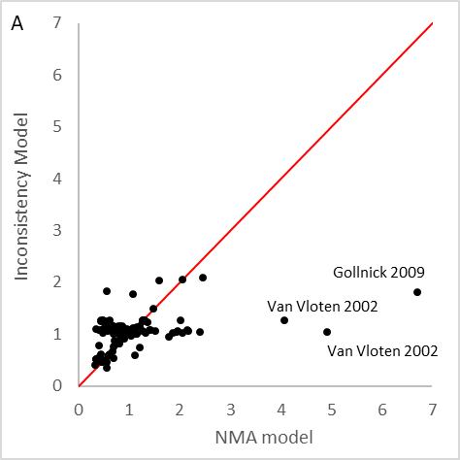 | 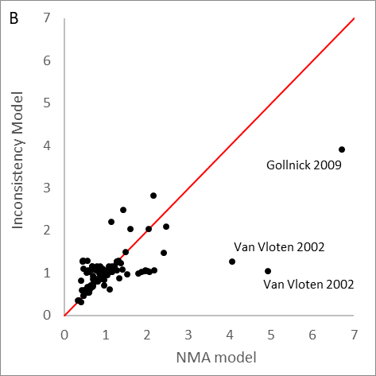

Table S12-3: Summary of node-splitting results. Discontinuation due to side effects – mild-to-moderate acne.
Node split modelª | Posterior total residual deviance^{b} | DIC^{c} | p-value^{d}
Benzoyl peroxide [topical] vs. Placebo (2 vs. 1) | 126.3 | 502.6 | 0.82
Lincosamide [topical] vs. Placebo (3 vs. 1) | 126.1 | 502.5 | 0.68
Retinoid [topical] vs. Placebo (4 vs. 1) | 123.6 | 500.0 | 0.09
Azelaic acid [topical] vs. Placebo (5 vs. 1) | 125.9 | 502.3 | 0.46
Macrolide [topical] vs. Placebo (6 vs. 1) | 126.3 | 502.4 | 0.45
Topical [acid] vs. Placebo (8 vs. 1) | 126.2 | 502.4 | 0.72
Co-cyprindiol [oral] vs. Placebo (12 vs. 1) | 116.1 | 492.1 | 0.00
Benzoyl peroxide [topical] + Retinoid [topical] vs. Placebo (16 vs. 1) | 123.3 | 499.6 | 0.08
Lincosamide [topical] + Retinoid [topical] vs. Placebo (17 vs. 1) | 126.4 | 502.5 | 0.53
Retinoid [topical] + Macrolide [topical] vs. Placebo (19 vs. 1) | 125.4 | 501.6 | 0.27
Retinoid [topical] vs. Benzoyl peroxide [topical] (4 vs. 2) | 114.3 | 490.6 | 0.00
Topical [acid] vs. Benzoyl peroxide [topical] (8 vs. 2) | 126.5 | 502.5 | 0.59
Tetracycline [oral] vs. Benzoyl peroxide [topical] (10 vs. 2) | 122.8 | 499.1 | 0.04
Benzoyl peroxide [topical] + Macrolide [topical] vs. Benzoyl peroxide [topical] (15 vs. 2) | 125.4 | 501.6 | 0.27
Benzoyl peroxide [topical] + Retinoid [topical] vs. Benzoyl peroxide [topical] (16 vs. 2) | 126 | 502.3 | 0.63
Retinoid [topical] vs. Lincosamide [topical] (4 vs. 3) | 123.1 | 499.5 | 0.07
Macrolide [topical] vs. Lincosamide [topical] (6 vs. 3) | 124.2 | 500.5 | 0.14
Benzoyl peroxide [topical] + Lincosamide [topical] vs. Lincosamide [topical] (14 vs. 3) | 125.4 | 501.7 | 0.29
Benzoyl peroxide [topical] + Retinoid [topical] vs. Lincosamide [topical] (16 vs. 3) | 122.2 | 498.6 | 0.04
Lincosamide [topical] + Retinoid [topical] vs. Lincosamide [topical] (17 vs. 3) | 126.4 | 502.6 | 0.53
Azelaic acid [topical] vs. Retinoid [topical] (5 vs. 4) | 126.3 | 502.6 | 0.79
Benzoyl peroxide [topical] + Lincosamide [topical] vs. Retinoid [topical] (14 vs. 4) | 124.9 | 501.1 | 0.18
Benzoyl peroxide [topical] + Retinoid [topical] vs. Retinoid [topical] (16 vs. 4) | 122.8 | 499.2 | 0.06
Lincosamide [topical] + Retinoid [topical] vs. Retinoid [topical] (17 vs. 4) | 123.1 | 499.4 | 0.07
Benzoyl peroxide [topical] + Lincosamide [topical] vs. Azelaic acid [topical] (14 vs. 5) | 126.1 | 502.2 | 0.39
Fusidic acid [topical] vs. Macrolide [topical] (7 vs. 6) | 122.9 | 499.2 | 0.04
Benzoyl peroxide [topical] + Lincosamide [topical] vs. Macrolide [topical] (14 vs. 6) | 126.2 | 502.3 | 0.61
Retinoid [topical] + Macrolide [topical] vs. Macrolide [topical] (19 vs. 6) | 126.3 | 502.5 | 0.46
Tetracycline [oral] vs. Fusidic acid [topical] (10 vs. 7) | 122.8 | 499.0 | 0.04
Benzoyl peroxide [topical] + Macrolide [topical] vs. Tetracycline [oral] (15 vs. 10)^{e} | 124.8 | 497.2 | 0.30
Retinoid [topical] + Macrolide [topical] vs. Benzoyl peroxide [topical] + Macrolide [topical] (19 vs. 15) | 125.5 | 501.8 | 0.26
Lincosamide [topical] + Retinoid [topical] vs. Benzoyl peroxide [topical] + Retinoid [topical] (17 vs. 16) | 126.5 | 502.8 | 0.99
NMA (no nodes split) | 125.3 | 500.6
Abbreviations: CrI, credible interval; DIC, deviance information criteria; NMA, network meta-analysis; SD, standard deviation
ª Continuity correction applied to studies containing zero cells
^{b} Posterior mean residual deviance compared to 123 total data points
^{c} Lower values of DIC preferred
^{d} p-values are calculated as 2×min{prob, 1- prob} where prob is the probability that the difference between the direct and indirect relative effects is positive; p-values < 0.05 are indicative of evidence of inconsistency between the direct and indirect estimates
^{e} One multi-arm trial made this comparison twice, so one of the repeated interventions was randomly removed to approximate direct and indirect estimates.

Figure S12-6: Direct, indirect, and network estimates of relative treatment effects based on node-splitting results. Discontinuation due to side effects – mild-to-moderate acne (continued on next page).
Class codes: 1 – Placebo, 2 - Benzoyl peroxide [topical], 3 - Lincosamide [topical], 4 - Retinoid [topical], 5 - Azelaic acid [topical], 6 - Macrolide [topical], 7 - Fusidic acid [topical], 8 - Topical [acid], 9 - ACNICARE [physical], 10 - Tetracycline [oral], 11 - Macrolide [oral], 12 - Co-cyprindiol [oral], 13 - Combined Oral Contraceptive [oral], 14 - Benzoyl peroxide [topical] + Lincosamide [topical], 15 - Benzoyl peroxide [topical] + Macrolide [topical], 16 - Benzoyl peroxide [topical] + Retinoid [topical], 17 - Lincosamide [topical] + Retinoid [topical], 18 - Macrolide [topical] + Anti-fungal [topical], 19 - Retinoid [topical] + Macrolide [topical], 20 - Benzoyl peroxide [topical] + Macrolide [topical] + Retinoid [topical], 21 - Benzoyl peroxide [topical] + Photochemical + photothermal therapy, 22 - Combined chemical peels [physical], 23 - Tetracycline [oral] + Combined physical peels [physical].

Figure S12-6. (continued from previous page and to next page)

Class codes: 1 – Placebo, 2 - Benzoyl peroxide [topical], 3 - Lincosamide [topical], 4 - Retinoid [topical], 5 - Azelaic acid [topical], 6 - Macrolide [topical], 7 - Fusidic acid [topical], 8 - Topical [acid], 9 - ACNICARE [physical], 10 - Tetracycline [oral], 11 - Macrolide [oral], 12 - Co-cyprindiol [oral], 13 - Combined Oral Contraceptive [oral], 14 - Benzoyl peroxide [topical] + Lincosamide [topical], 15 - Benzoyl peroxide [topical] + Macrolide [topical], 16 - Benzoyl peroxide [topical] + Retinoid [topical], 17 - Lincosamide [topical] + Retinoid [topical], 18 - Macrolide [topical] + Anti-fungal [topical], 19 - Retinoid [topical] + Macrolide [topical], 20 - Benzoyl peroxide [topical] + Macrolide [topical] + Retinoid [topical], 21 - Benzoyl peroxide [topical] + Photochemical + photothermal therapy, 22 - Combined chemical peels [physical], 23 - Tetracycline [oral] + Combined physical peels [physical].

Figure S12-6. (continued from previous page)
Class codes: 1 – Placebo, 2 - Benzoyl peroxide [topical], 3 - Lincosamide [topical], 4 - Retinoid [topical], 5 - Azelaic acid [topical], 6 - Macrolide [topical], 7 - Fusidic acid [topical], 8 - Topical [acid], 9 - ACNICARE [physical], 10 - Tetracycline [oral], 11 - Macrolide [oral], 12 - Co-cyprindiol [oral], 13 - Combined Oral Contraceptive [oral], 14 - Benzoyl peroxide [topical] + Lincosamide [topical], 15 - Benzoyl peroxide [topical] + Macrolide [topical], 16 - Benzoyl peroxide [topical] + Retinoid [topical], 17 - Lincosamide [topical] + Retinoid [topical], 18 - Macrolide [topical] + Anti-fungal [topical], 19 - Retinoid [topical] + Macrolide [topical], 20 - Benzoyl peroxide [topical] + Macrolide [topical] + Retinoid [topical], 21 - Benzoyl peroxide [topical] + Photochemical + photothermal therapy, 22 - Combined chemical peels [physical], 23 - Tetracycline [oral] + Combined physical peels [physical].

Moderate-to-severe acne

A. Percentage change in total lesion count from baseline
Although there were no meaningful differences between the fit of the random effects consistency and inconsistency models, the between-study SD slightly decreased in the inconsistency models, suggesting some evidence of inconsistency (Appendix S11). The area below the line of equality in Figure S12-7 highlights where the inconsistency model better predicted data points, and there were notable improvements in the prediction of data in Braathen 1984, which compared Clindamycin [topical], Tetracycline [oral], and Placebo [oral] + Vehicle, all with a duration of 6 to <12 weeks; Peacock 1990, which compared Clindamycin [topical] and Minocycline [oral], all with a duration of 12 to <24 weeks; Sami 2008, which compared Pulsed Dye Laser, Intense Pulsed Light (IPL), and Blue + Red light; and Stewart 2006, which compared two variations of Minocycline [oral] and Placebo [oral], all with a duration of 12 to <24 weeks.
For most comparisons, there were no meaningful differences between the fit and DIC of the node split models and the consistency model, apart from Lincosamide [topical] vs. Placebo (4 vs. 1) (Table S12-4); there were differences between the direct and indirect estimates of this class comparisons (Figure S12-8).

Figure S12-7: Deviance contributions for the random effects consistency and inconsistency models. Percentage change in total lesion count from baseline – moderate-to-severe acne. (A) Intervention level and (B) Class level
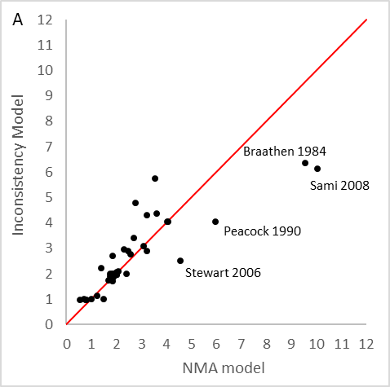 | 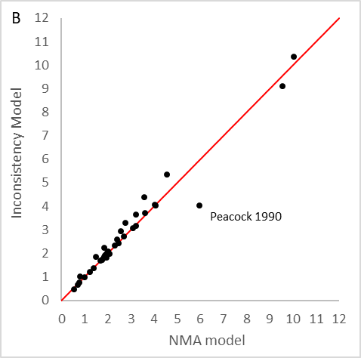

Table S12-4: Summary of node-splitting results. Percentage change in total lesion count from baseline – moderate-to-severe acne.
Node split model | Between Study Heterogeneity - SD (95% CrI) | Posterior total residual devianceª | DIC^{b} | p-value^{c}
Benzoyl peroxide [topical] vs. Placebo (3 vs. 1) | 5.78 (3.28, 9.05) | 137.9 | 886.9 | 0.40
Lincosamide [topical] vs. Placebo (4 vs. 1) | 5.31 (2.96, 8.36) | 136.1 | 884.0 | 0.02
Retinoid - total cumul dose < 120mg/kg (single course) [oral] vs. Placebo (8 vs. 1) | 5.75 (3.28, 9.00) | 138.4 | 887.3 | 0.57
Tetracycline [oral] vs. Placebo (10 vs. 1) | 5.81 (3.30, 9.10) | 137.5 | 886.6 | 0.45
Photodynamic therapy vs. Placebo (15 vs. 1) | 5.79 (3.24, 9.08) | 138.0 | 887.0 | 0.47
Benzoyl peroxide [topical] + Lincosamide [topical] vs. Placebo (19 vs. 1) | 5.75 (3.23, 9.07) | 138.0 | 887.0 | 0.35
Benzoyl peroxide [topical] + Lincosamide [topical] vs. Benzoyl peroxide [topical] (19 vs. 3) | 5.77 (3.28, 8.97) | 138.1 | 887.1 | 0.36
Benzoyl peroxide [topical] + Macrolide [topical] vs. Benzoyl peroxide [topical] (20 vs. 3) | 5.74 (3.19, 9.02) | 138.2 | 887.2 | 0.41
Tetracycline [oral] vs. Lincosamide [topical] (10 vs. 4) | 5.78 (3.24, 9.06) | 138.6 | 887.7 | 0.73
Retinoid - total cumul dose ≥ 120mg/kg (single course) [oral] vs. Retinoid - total cumul dose < 120mg/kg (single course) [oral] (9 vs. 8) | 5.76 (3.25, 9.02) | 138.6 | 887.8 | 0.89
Benzoyl peroxide [topical] + Retinoid [topical] + Tetracycline [oral] vs. Retinoid - total cumul dose ≥ 120mg/kg (single course) [oral] (26 vs. 9) | 5.78 (3.28, 9.04) | 138.5 | 887.8 | 0.90
Retinoid [topical] + Tetracycline [oral] vs. Tetracycline [oral] (25 vs. 10) | 5.82 (3.37, 9.08) | 137.7 | 886.7 | 0.28
Benzoyl peroxide [topical] + Retinoid [topical] + Tetracycline [oral] vs. Tetracycline [oral] (26 vs. 10) | 5.74 (3.24, 8.99) | 138.6 | 887.7 | 0.74
Retinoid [topical] + Tetracycline [oral] vs. Photodynamic therapy (25 vs. 15) | 5.80 (3.29, 9.02) | 137.8 | 886.7 | 0.29
NMA (no nodes split)^{d} | 5.78 (3.27, 9.04) | 137.9 | 886.3
Abbreviations: CrI, credible interval; DIC, deviance information criteria; NMA, network meta-analysis; SD, standard deviation
ª Posterior mean residual deviance compared to 133 total data points
^{b} Lower values of DIC preferred
^{c} p-values are calculated as 2×min{prob, 1- prob} where prob is the probability that the difference between the direct and indirect relative effects is positive; p-values < 0.05 are indicative of evidence of inconsistency between the direct and indirect estimates
^{d} Model fit statistics produced in R2OpenBUGS

Figure S12-8: Direct, indirect, and network estimates of relative treatment effects based on node-splitting results. Percentage change in total lesion count from baseline – moderate-to-severe acne.
Class codes: 1 - Placebo, 2 - No treatment, 3 - Benzoyl peroxide [topical], 4 - Lincosamide [topical], 5 - Retinoid [topical], 6 - Macrolide [topical], 7 - Nicotinamide [topical], 8 - Retinoid - total cumul dose < 120mg/kg (single course) [oral], 9 - Retinoid - total cumul dose ≥ 120mg/kg (single course) [oral], 10 - Tetracycline [oral], 11 - Co-cyprindiol [oral], 12 - Photochemical therapy [red], 13 - Photochemical therapy [blue and red], 14 - Photochemical + photothermal therapy, 15 - Photodynamic therapy, 16 - Photothermal + photodynamic therapy, 17 - Photothermal therapy, 18 - Benzoyl peroxide [topical] + Anti-fungal [topical], 19 - Benzoyl peroxide [topical] + Lincosamide [topical], 20 - Benzoyl peroxide [topical] + Macrolide [topical], 21 - Benzoyl peroxide [topical] + Retinoid [topical], 22 - Lincosamide [topical] + Retinoid [topical], 23 - Benzoyl peroxide [topical] + Lincosamide [topical] + Retinoid [topical], 24 - Azelaic acid [topical] + Tetracycline [oral], 25 - Retinoid [topical] + Tetracycline [oral], 26 - Benzoyl peroxide [topical] + Retinoid [topical] + Tetracycline [oral], 27 - Tetracycline [oral] + Photodynamic therapy.

B. Discontinuation for any reason
The random effects consistency model provided a better fit than the inconsistency model at the intervention level, and there were no meaningful differences between the fit of the random effects consistency and inconsistency model at the class level (Appendix S11). The area below the line of equality in Figure S12-9 highlights where the inconsistency model better predicted data points, and there were notable improvements in the prediction of data in Dubertret 2003, a three-arm trial which compared two variations of Lymecycline [oral] and Placebo [oral], all with a duration of 12 to <24 weeks; and Pariser 2005, a three-arm trial which compared two variations of Adapalene [topical] and Placebo [topical], all with a duration of 12 to <24 weeks.

No evidence of inconsistency was found through the node splitting analysis at the class level, as there were no meaningful differences between the fit and DIC of the node split models and the consistency model, nor were there any notable differences between the direct and indirect estimates (Table S12-5, Figure S12-10).

Figure S12-9: Deviance contributions for the random effects consistency and inconsistency models. Discontinuation for any reason – moderate-to-severe acne. (A) Intervention level and (B) Class level
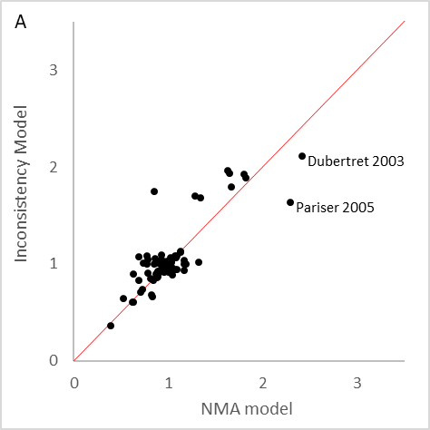 | 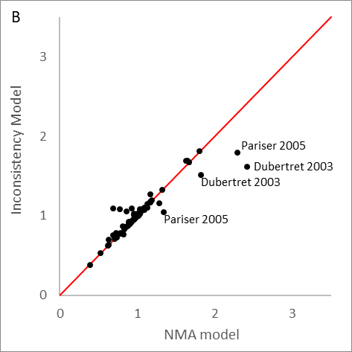

Table S12-5: Summary of node-splitting results. Discontinuation for any reason – moderate-to-severe acne.
Node split modelª | Between Study Heterogeneity - SD (95% CrI) | Posterior total residual deviance^{b} | DIC^{c} | p-value^{d}
Lincosamide [topical] vs. Placebo (3 vs. 1) | 0.41 (0.20, 0.70) | 95.28 | 549.9 | 0.73
Tetracycline [oral] vs. Placebo (8 vs. 1) | 0.41 (0.20, 0.70) | 95.05 | 549.7 | 0.58
Co-cyprindiol [oral] vs. Placebo (9 vs. 1) | 0.41 (0.20, 0.69) | 95.07 | 549.6 | 0.57
Benzoyl peroxide [topical] + Lincosamide [topical] vs. Placebo (15 vs. 1) | 0.41 (0.20, 0.71) | 95.09 | 549.7 | 0.73
Lincosamide [topical] + Retinoid [topical] vs. Lincosamide [topical] (18 vs. 3) | 0.41 (0.20, 0.70) | 95.23 | 549.8 | 0.73
Co-cyprindiol [oral] vs. Tetracycline [oral] (9 vs. 8) | 0.41 (0.19, 0.69) | 95.16 | 549.7 | 0.58
Lincosamide [topical] + Retinoid [topical] vs. Benzoyl peroxide [topical] + Lincosamide [topical] (18 vs. 15) | 0.41 (0.20, 0.70) | 95.23 | 549.8 | 0.73
NMA (no nodes split) | 0.40 (0.19, 0.68) | 94.74 | 548.326
Abbreviations: CrI, credible interval; DIC, deviance information criteria; NMA, network meta-analysis; SD, standard deviation
ª Continuity correction applied to studies containing zero cells
^{b} Posterior mean residual deviance compared to 93 total data points
^{c} Lower values of DIC preferred
^{d} p-values are calculated as 2×min{prob, 1- prob} where prob is the probability that the difference between the direct and indirect relative effects is positive; p-values < 0.05 are indicative of evidence of inconsistency between the direct and indirect estimates

Figure S12-10: Direct, indirect, and network estimates of relative treatment effects based on node-splitting results. Discontinuation for any reason – moderate-to-severe acne.
Class codes: 1 - Placebo, 2 - Benzoyl peroxide [topical], 3 - Lincosamide [topical], 4 - Retinoid [topical], 5 - Macrolide [topical], 6 - Nicotinamide [topical], 7 - Retinoid - total cumul dose ≥ 120mg/kg (single course) [oral], 8 - Tetracycline [oral], 9 - Co-cyprindiol [oral], 10 - Combined Oral Contraceptive [oral], 11 - Photochemical therapy [red], 12 - Photodynamic therapy, 13 - Photothermal + photodynamic therapy, 14 - Benzoyl peroxide [topical] + Anti-fungal [topical], 15 - Benzoyl peroxide [topical] + Lincosamide [topical], 16 - Benzoyl peroxide [topical] + Macrolide [topical], 17 - Benzoyl peroxide [topical] + Retinoid [topical], 18 - Lincosamide [topical] + Retinoid [topical], 19 - Benzoyl peroxide [topical] + Lincosamide [topical] + Retinoid [topical], 20 - Retinoid [topical] + Tetracycline [oral], 21 - Benzoyl peroxide [topical] + Retinoid [topical] + Tetracycline [oral], 22 - Retinoid - total cumul dose ≥ 120mg/kg (single course) [oral] + Lincosamide [topical] + Retinoid [topical], 23 - Tetracycline [oral] + Co-cyprindiol [oral].

C. Discontinuation due to side effects
Based on the DIC, the fixed effects consistency model was preferred over the inconsistency model at the the intervention level, and there were no meaningful differences between the fit of the random effects consistency and inconsistency model at the class level (Appendix S11). The area below the line of equality in Figure S12-11 highlights where the inconsistency model better predicted data points, and there were notable improvements in the prediction of data in Dubertret 2003, a three-arm trial which compared two variations of Lymecycline [oral] and Placebo [oral], all with a duration of 12 to <24 weeks; and Eichenfield 2010 (Study 2), a two-arm trial which compared Adapalene [topical] and Placebo [topical], all with a duration of 12 to <24 weeks.
There were no loops with three independent sources of direct evidence at the class level, and so node splitting models could not be fitted at this level. Node splitting was conducted at the intervention level and there was evidence of inconsistency for the following treatment comparisons:
- Lymecycline [oral], 12 to <24 weeks vs. Placebo [oral], 12 to <24 weeks (p-value = 0.053)
  - Direct estimate (log-odds ratio (LOR) (95% CrI)): -0.67 (-2.41, 1.42)
  - Indirect estimate (LOR (95% CrI)): 2.09 (0.31, 4.89)
  - NMA estimate (LOR (95% CrI)): 0.87 (-0.30, 2.41)
- Minocycline [oral], 12 to <24 weeks vs. Placebo [oral], 12 to <24 weeks (p-value = 0.478)
  - Direct estimate (LOR (95% CrI)): 2.16 (0.30, 5.18)
  - Indirect estimate (LOR (95% CrI)): -0.62, (-2.31, 1.41)
  - NMA estimate (LOR (95% CrI)): 0.87 (-0.30, 2.41)

Figure S12-11: Deviance contributions for the random effects consistency and inconsistency models. Discontinuation due to side effects – moderate-to-severe acne. (A) Intervention level and (B) Class level
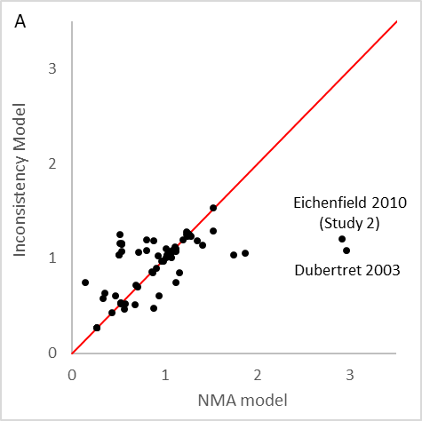 | 

