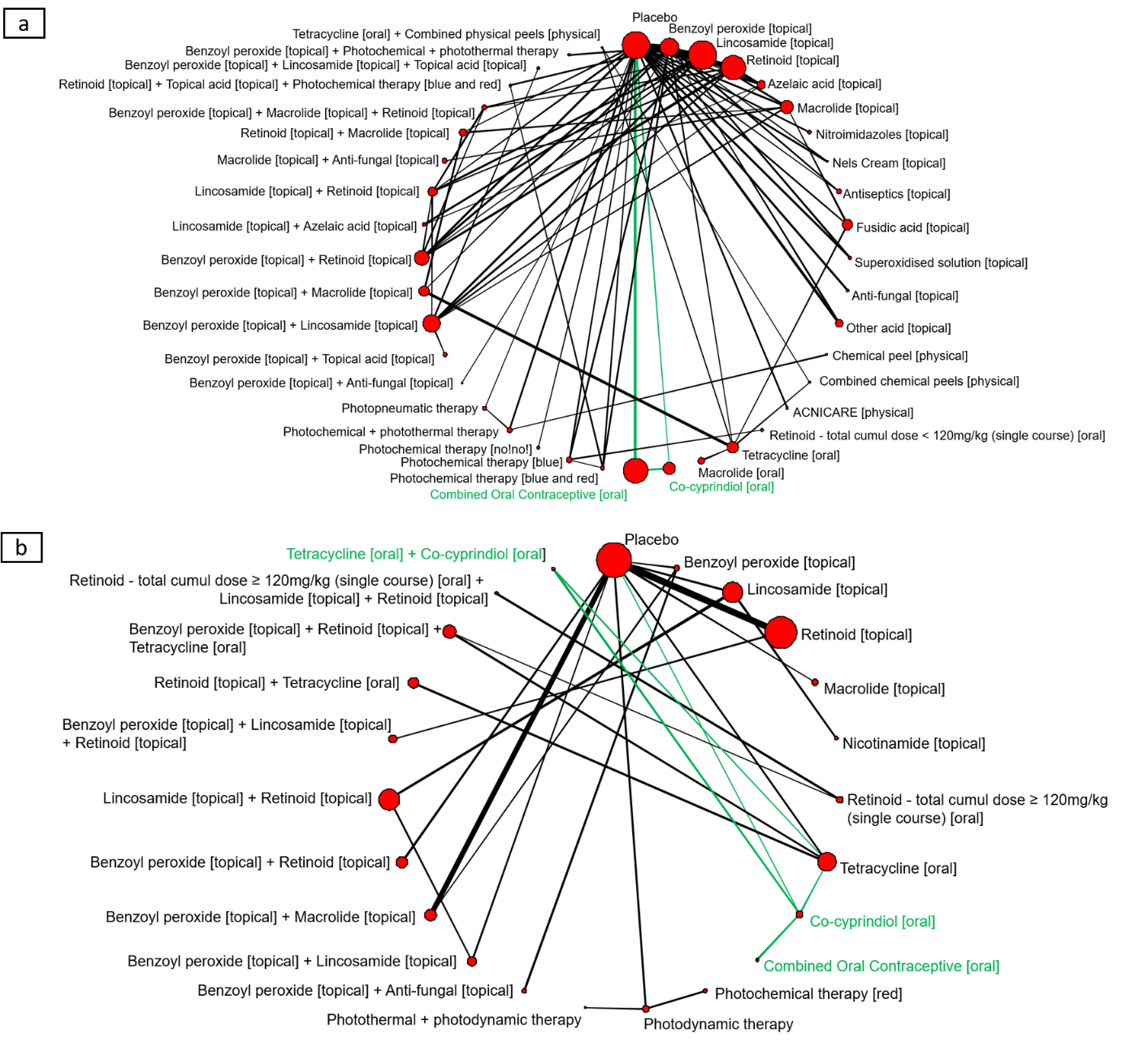
Figure S1 Network of treatment classes for people with (a) mild-to-moderate acne and (b) moderate-to-severe acne on discontinuation for any reason.

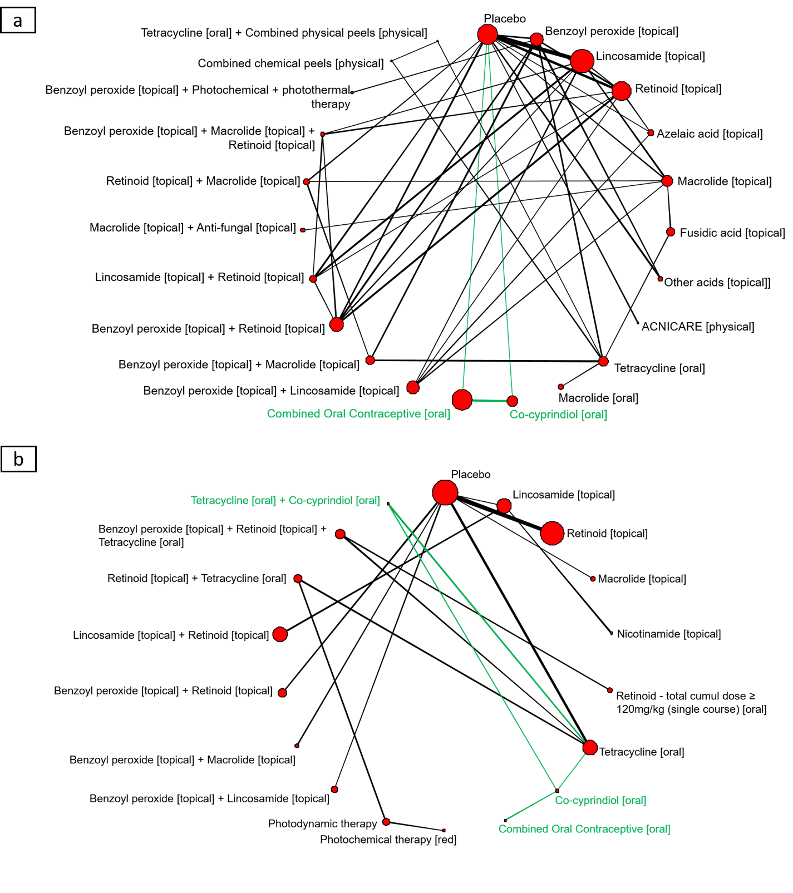
Figure S2 Network of treatment classes for people with (a) mild-to-moderate acne and (b) moderate-to-severe acne on discontinuation due to side-effects.

