Appendix S13: Risk of bias of studies included in the NMA

Mild-to-moderate acne

Risk of bias graph: reviewers’ judgements about each risk of bias item presented as percentages across all included studies.

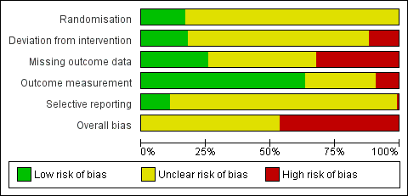

Risk of bias graph: reviewer’s judgements about each risk of bias item presented by study.

Moderate-to-severe acne

Risk of bias graph: reviewers’ judgements about each risk of bias item presented as percentages across all included studies.

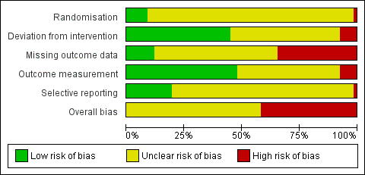

Risk of bias graph: reviewer’s judgements about each risk of bias item presented by study.



