Table S1 Search Strategy
PubMed
Step | Query | Items found
#1: | Search: "Melanoma"[MeSH Terms] OR "Melanoma"[Title/Abstract] OR "Melanomas"[Title/Abstract] OR "malignant melanoma"[Title/Abstract] OR "malignant melanomas"[Title/Abstract] OR "melanoma malignant"[Title/Abstract] OR "melanomas malignant"[Title/Abstract] | 136545
#2: | Search: "Anti-programmed-death-receptor-1"[Title/Abstract] OR "programmed death ligand 1"[Title/Abstract] OR "PD-L1"[Title/Abstract] OR "programmed death 1"[Title/Abstract] OR "PD-1"[Title/Abstract] OR "anti-programmed death ligand 1"[Title/Abstract] OR "Anti-PD-L1"[Title/Abstract] OR "anti-programmed death 1"[Title/Abstract] OR "Anti-PD-1"[Title/Abstract] OR "Nivolumab"[Title/Abstract] OR "Pembrolizumab"[Title/Abstract] OR "Avelumab"[Title/Abstract] OR "Atezolizumab"[Title/Abstract] OR "Durvalumab"[Title/Abstract] OR "Cemiplimab"[Title/Abstract] OR "anti-cytotoxic t lymphocyte antigen 4"[Title/Abstract] OR "Anti-CTLA-4"[Title/Abstract] OR "Ipilimumab"[Title/Abstract] OR "Tremelimumab"[Title/Abstract] OR "Immunotherapy"[Title/Abstract] OR "immune checkpoint inhibitors"[Title/Abstract] OR "ICI"[Title/Abstract] | 111350
#3: | Search: "clinical trial"[Title/Abstract] OR "controlled clinical trial"[Title/Abstract] OR "randomized controlled trial"[Title/Abstract] OR "RCT"[Title/Abstract] OR "random"[Title/Abstract] OR "randomized"[Title/Abstract] | 898300
#4 | #1 AND #2 AND #3 | 891
Embase
Step | Query | Collapse
#1 | 'melanoma'/exp | 172036
#2 | 'melanoma':ab,ti | 163179
#3 | 'melanomas':ab,ti | 26324
#4 | 'malignant melanoma':ab,ti | 33539
#5 | 'malignant melanomas':ab,ti | 4225
#6 | 'melanoma malignant':ab,ti | 131
#7 | 'melanomas malignant':ab,ti | 20
#8 | #1 OR #2 OR #3 OR #4 OR #5 OR #6 OR #7 | 210237
#9 | 'anti-programmed-death-receptor-1':ab,ti | 67
#10 | 'programmed death ligand 1':ab,ti | 5531
#11 | 'pd-l1':ab,ti | 29535
#12 | 'programmed death 1':ab,ti | 5108
#13 | 'pd-1':ab,ti | 34079
#14 | 'anti-programmed death ligand 1':ab,ti | 268
#15 | 'anti-pd-l1':ab,ti | 3964
#16 | 'anti-programmed death 1':ab,ti | 588
#17 | 'anti-pd-1':ab,ti | 9759
#18 | 'nivolumab':ab,ti | 12283
#19 | 'pembrolizumab':ab,ti | 10315
#20 | 'avelumab':ab,ti | 1118
#21 | 'atezolizumab':ab,ti | 2944
#22 | 'durvalumab':ab,ti | 1798
#23 | 'cemiplimab':ab,ti | 221
#24 | 'anti-cytotoxic t lymphocyte antigen 4':ab,ti | 176
#25 | 'anti-ctla-4':ab,ti | 3025
#26 | 'ipilimumab':ab,ti | 7528
#27 | 'tremelimumab':ab,ti | 693
#28 | 'Immunotherapy':ab,ti | 123357
#29 | 'immune checkpoint inhibitors':ab,ti | 13155
#30 | 'ici':ab,ti | 13408
#31 | #9 OR #10 OR #11 OR #12 OR #13 OR #14 OR #15 OR #16 OR #17 OR #18 OR #19 OR #20 OR #21 OR #22 OR #23 OR #24 OR #25 OR #26 OR #27 OR #28 OR #29 OR #30 | 181767
#32 | 'clinical trial':ab,ti | 223515
#33 | 'controlled clinical trial':ab,ti | 20406
#34 | 'randomized controlled trial':ab,ti | 106283
#35 | 'rct':ab,ti | 41312
#36 | 'random':ab,ti | 347794
#37 | 'randomized':ab,ti | 796062
#38 | #32 OR #33 OR #34 OR #35 OR #36 OR #37 | 1264705
#39 | #8 AND #31 AND #38 | 2481
Cochrane
Step | Search manager | Items found
#1 | MeSH descriptor: [Melanoma] explode all trees | 1838
#2 | (Melanoma):ti,ab,kw OR (Melanomas):ti,ab,kw OR (malignant melanoma):ti,ab,kw OR (malignant melanomas):ti,ab,kw OR (melanoma malignant):ti,ab,kw | 5525
#3 | melanomas malignant | 1364
#4 | #1 OR #2 OR #3 | 5527
#5 | (Anti-programmed-death-receptor-1):ti,ab,kw OR (programmed death ligand 1):ti,ab,kw OR (PD-L1):ti,ab,kw OR (programmed death 1):ti,ab,kw OR (PD-1):ti,ab,kw | 6283
#6 | (anti programmed death ligand 1):ti,ab,kw OR (Anti-PD-L1):ti,ab,kw OR (anti programmed death 1):ti,ab,kw OR (Anti-PD-1):ti,ab,kw OR (Nivolumab):ti,ab,kw | 3181
#7 | (Pembrolizumab):ti,ab,kw OR (Avelumab):ti,ab,kw OR (Atezolizumab):ti,ab,kw OR (Durvalumab):ti,ab,kw OR (Cemiplimab):ti,ab,kw | 3197
#8 | (anti cytotoxic t lymphocyte antigen 4):ti,ab,kw OR (Anti-CTLA-4):ti,ab,kw OR (Ipilimumab):ti,ab,kw OR (Tremelimumab):ti,ab,kw OR (Immunotherapy):ti,ab,kw | 11313
#9 | (immune checkpoint inhibitors):ti,ab,kw OR (ICI):ti,ab,kw | 1528
#10 | #5 OR #6 OR #7 OR #8 OR #9 | 18357
#11 | #4 AND #11 | 1404

Table S2 Multiple treatment comparison for IRP based on network consistency model (for grade 1–5 IRP).
OR with 95% CI for grade 1–5 IRP
Chemotherapy | 6.34 (0.97,41.50) |  | 5.92 (1.03,34.11) | 28.55 (4.50,180.96) | 10.93 (1.56,76.39) |  | 1.87 (0.21,16.47)
0.16 (0.02,1.03) | Ipil |  | 0.93 (0.34,2.54) | 4.51 (2.06,9.86) | 1.72 (0.46,6.44) |  | 0.29 (0.06,1.47)
0.17 (0.03,0.97) | 1.07 (0.39,2.91) |  | Niv | 4.82 (2.13,10.93) | 1.85 (0.41,8.39) |  | 0.32 (0.05,1.81)
0.04 (0.01,0.22) | 0.22 (0.10,0.49) |  | 0.21 (0.09,0.47) | Niv+Ipil | 0.38 (0.09,1.58) |  | 0.07 (0.01,0.34)
0.09 (0.01,0.64) | 0.58 (0.16,2.17) |  | 0.54 (0.12,2.46) | 2.61 (0.63,10.81) | Pem |  | 0.17 (0.05,0.54)
0.54 (0.06,4.72) | 3.39 (0.68,16.93) |  | 3.17 (0.55,18.18) | 15.28 (2.93,79.66) | 5.85 (1.84,18.56) |  | Placebo

Table S3 Multiple treatment comparison for IRP based on network consistency model (for grade 3–5 IRP).
OR with 95% CI for grade 3–5 IRP
Chemotherapy | 0.99 (0.09,11.31) |  | 0.95 (0.10,8.96) | 1.95 (0.16,23.65) | 3.34 (0.34,32.83) |  | 0.67 (0.03,13.75)
1.01 (0.09,11.58) | Ipil |  | 0.96 (0.19,4.95) | 1.97 (0.47,8.27) | 3.37 (0.53,21.33) |  | 0.68 (0.05,9.01)
1.05 (0.11,9.92) | 1.04 (0.20,5.35) |  | Niv | 2.05 (0.45,9.24) | 3.51 (0.43,28.79) |  | 0.70 (0.05,9.50)
0.51 (0.04,6.24) | 0.51 (0.12,2.13) |  | 0.49 (0.11,2.20) | Niv+Ipil | 1.71 (0.21,14.18) |  | 0.34 (0.03,4.65)
0.30 (0.03,2.95) | 0.30 (0.05,1.87) |  | 0.28 (0.03,2.34) | 0.58 (0.07,4.83) | Pem |  | 0.20 (0.02,2.15)
1.50 (0.07,30.76) | 1.48 (0.11,19.70) |  | 1.42 (0.11,19.20) | 2.91 (0.21,39.48) | 4.99 (0.47,53.47) |  | Placebo

Table S4 Evaluation of inconsistency for four treatment groups
Outcomes | Cycle | Inconsistency Factors (IF) | seIF | CI_95 | P Value
Grade 1-5 IRP | Dual ICIs combination-ICIs monotherapy-Placebo | 0.077 | 1.636 | (0.00,3.28) | 0.962
Grade 3-5 IRP | Dual ICIs combination-ICIs monotherapy-Placebo | 2.216 | 2.452 | (0.00,7.02) | 0.904

Table S5 Results of Node-splitting analysis for the assessment of inconsistency for four treatment groups
Comparator | Intervention | Direct |  | Indirect |  | Difference |  | P | Tau
Comparator | Intervention | Coef. | Std. Err. | Coef. | Std. Err. | Coef. | Std. Err. | P | Tau
Grade 1-5 IRP
Chemotherapy | ICIs monotherapy | 1.99 | 0.85 | -1.19 | 141.25 | 3.18 | 141.25 | 0.98 | 0.00
Dual ICIs combination | ICIs monotherapy | -1.52 | 0.38 | -0.62 | 3.21 | -0.89 | 3.27 | 0.79 | 0.00
Dual ICIs combination | Placebo | -3.51 | 1.35 | -3.08 | 0.74 | -0.43 | 1.51 | 0.77 | 0.00
ICIs monotherapy | Placebo | -1.58 | 0.60 | -3.11 | 2.28 | 1.52 | 2.36 | 0.52 | 0.00
Grade 3-5 IRP
Chemotherapy | ICIs monotherapy | 0.55 | 1.02 | -0.45 | 141.26 | 1.00 | 141.27 | 0.99 | 0.00
Dual ICIs combination | ICIs monotherapy | -0.67 | 0.69 | 4.55 | 4.58 | -5.22 | 4.64 | 0.26 | 0.00
Dual ICIs combination | Placebo | 0.07 | 2.01 | -2.78 | 1.61 | 2.85 | 2.57 | 0.27 | 0.00
ICIs monotherapy | Placebo | -1.38 | 1.20 | 1.58 | 3.78 | -2.96 | 3.96 | 0.46 | 0.00

Table S6 Evaluation of inconsistency for six treatment groups
Outcomes | Cycle | Inconsistency Factors (IF) | seIF | CI_95 | P Value
Grade 1-5 IRP | Ipil-Niv-Placebo | 1.47 | 2.77 | (0.00,6.89) | 0.60
Grade 1-5 IRP | Chemotherapy-Niv-Pem-Placebo | 1.45 | 2.53 | (0.00,6.41) | 0.57
Grade 1-5 IRP | Niv-Niv+Ipil-Placebo | 1.36 | 2.33 | (0.00,5.92) | 0.56
Grade 1-5 IRP | Ipil-Pem-Placebo | 0.72 | 1.16 | (0.00,2.99) | 0.53
Grade 1-5 IRP | Ipil-Niv-Niv+Ipil | 0.38 | 1.83 | (0.00,3.97) | 0.84
Grade 1-5 IRP | Ipil-Niv+Ipil-Placebo | 0.10 | 2.05 | (0.00,4.12) | 0.96
Grade 3-5 IRP | Ipil-Niv+Ipil-Placebo | 2.40 | 2.86 | (0.00,8.01) | 0.40
Grade 3-5 IRP | Chemotherapy-Ipil-Niv-Pem | 2.14 | 2.94 | (0.00,7.91) | 0.47
Grade 3-5 IRP | Ipil-Niv-Placebo | 2.02 | 2.57 | (0.00,7.05) | 0.43
Grade 3-5 IRP | Niv-Niv+Ipil-Placebo | 0.99 | 3.00 | (0.00,6.86) | 0.74
Grade 3-5 IRP | Ipil-Niv-Niv+Ipil | 0.20 | 1.86 | (0.00,3.84) | 0.91
Grade 3-5 IRP | Ipil-Pem-Placebo | 0.12 | 3.23 | (0.00,6.46) | 0.97

Table S7 Results of Node-splitting analysis for the assessment of inconsistency for six treatment groups
Comparator | Intervention | Direct |  | Indirect |  | Difference |  | P | Tau
Comparator | Intervention | Coef. | Std. Err. | Coef. | Std. Err. | Coef. | Std. Err. | P | Tau
Grade 1-5 IRP
Chemotherapy | Niv | 1.86 | 1.05 | 1.57 | 1.69 | 0.29 | 1.99 | 0.88 | 0.00
Chemotherapy | Pem | 2.24 | 1.45 | 2.53 | 1.36 | -0.29 | 1.99 | 0.88 | 0.00
Ipil | Niv | 0.14 | 0.59 | -0.66 | 1.00 | 0.80 | 1.16 | 0.49 | 0.00
Ipil | Niv+Ipil | 1.42 | 0.42 | 2.29 | 1.19 | -0.87 | 1.25 | 0.49 | 0.00
Ipil | Pem | 0.62 | 0.79 | 0.36 | 1.27 | 0.26 | 1.49 | 0.86 | 0.00
Niv | Niv+Ipil | 1.68 | 0.43 | 0.27 | 1.39 | 1.41 | 1.43 | 0.33 | 0.00
Niv | Placebo | 0.09 | 2.01 | -1.46 | 0.99 | 1.55 | 2.24 | 0.49 | 0.00
Niv+Ipil | Placebo | -3.37 | 1.36 | -2.41 | 0.99 | -0.96 | 1.60 | 0.55 | 0.00
Pem | Placebo | -1.75 | 0.63 | -1.89 | 1.67 | 0.14 | 1.79 | 0.94 | 0.00
Grade 3-5 IRP
Chemotherapy | Niv | -0.48 | 1.42 | 0.76 | 1.94 | -1.25 | 2.41 | 0.60 | 0.00
Chemotherapy | Pem | 1.68 | 1.48 | 0.43 | 1.90 | 1.25 | 2.41 | 0.60 | 0.00
Ipil | Niv | 0.47 | 1.07 | -0.83 | 1.34 | 1.30 | 1.71 | 0.45 | 0.00
Ipil | Niv+Ipil | 0.79 | 0.81 | 0.22 | 1.67 | 0.56 | 1.86 | 0.76 | 0.00
Ipil | Pem | 0.62 | 1.12 | 2.65 | 1.73 | -2.03 | 2.06 | 0.32 | 0.00
Niv | Niv+Ipil | 0.86 | 0.85 | 0.07 | 1.77 | 0.80 | 1.95 | 0.68 | 0.00
Niv | Placebo | 0.09 | 2.01 | -0.70 | 1.77 | 0.79 | 2.68 | 0.77 | 0.00
Niv+Ipil | Placebo | 0.07 | 2.01 | -1.96 | 1.77 | 2.04 | 2.68 | 0.45 | 0.00
Pem | Placebo | -2.19 | 1.49 | -0.49 | 2.07 | -1.71 | 2.55 | 0.50 | 0.00

Figure S1 Risk of bias for included studies
- Risk of bias graph: review authors’ judgements about each risk of bias item presented as percentages
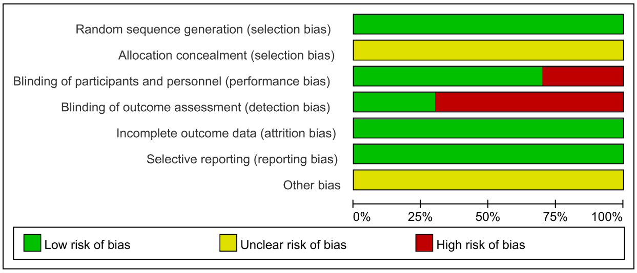

- Risk of bias summary: review authors’ judgements about each risk of bias item for each included study
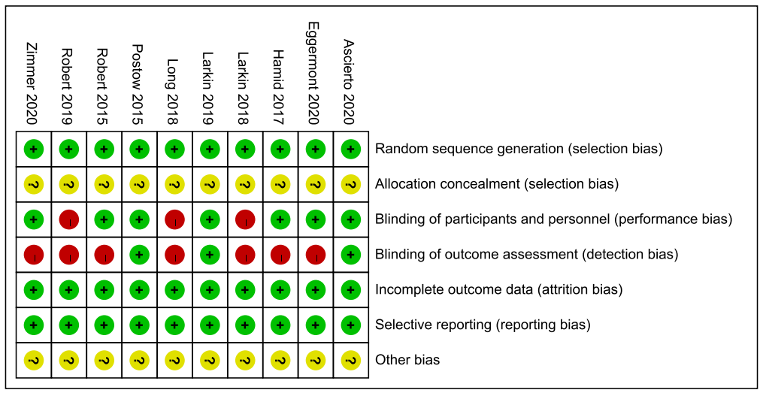

Figure S2 Publication bias for grade 1-5 IRP in four treatment groups
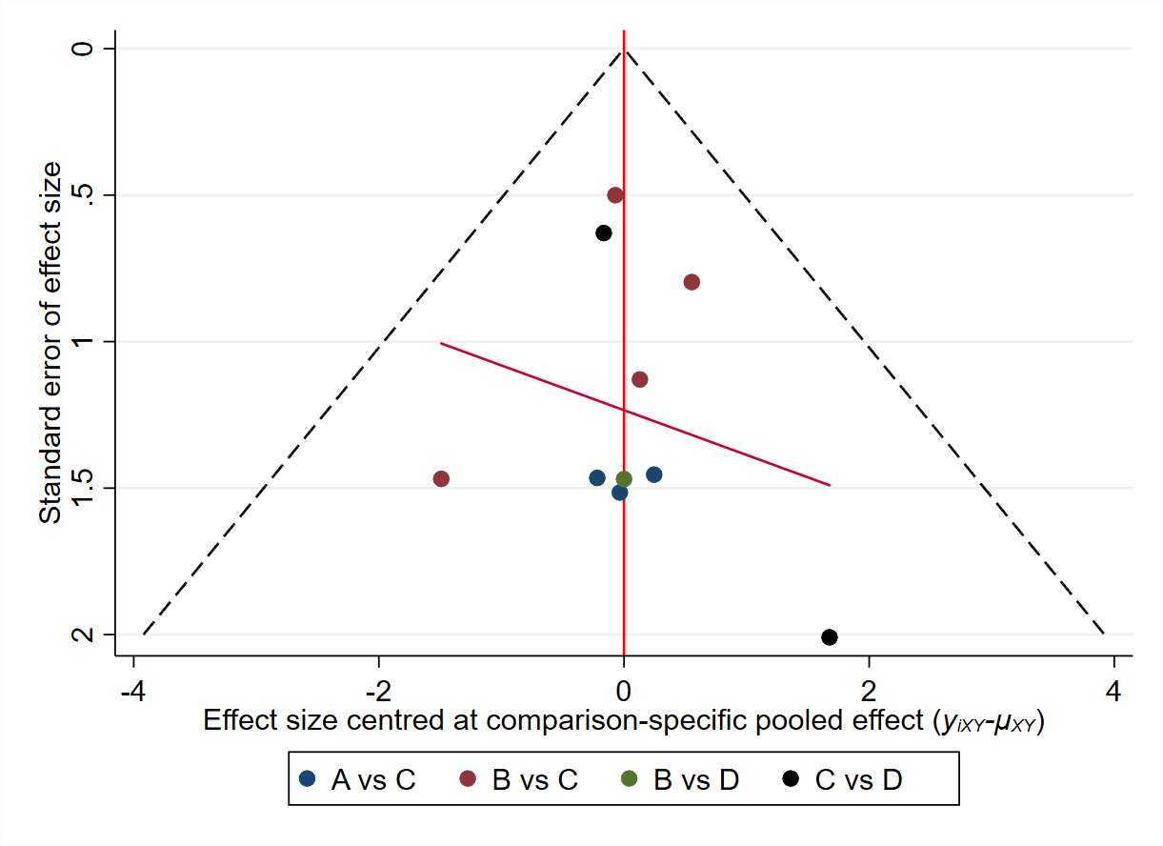
A：Chemotherapy | B：Dual ICIs combination | C：ICIs monotherapy
D：Placebo

Figure S3 Publication bias for grade 3-5 IRP in four treatment groups
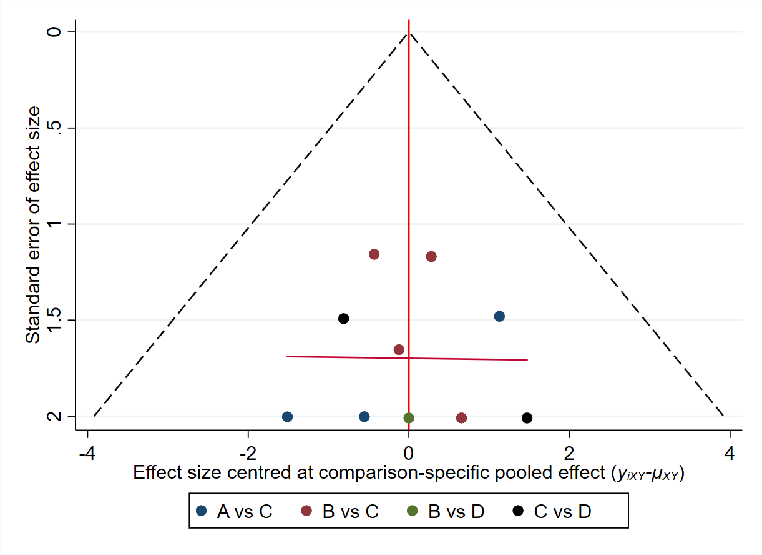
A：Chemotherapy | B：Dual ICIs combination | C：ICIs monotherapy
D：Placebo

Figure S4 Publication bias for grade 1-5 IRP in six treatment groups
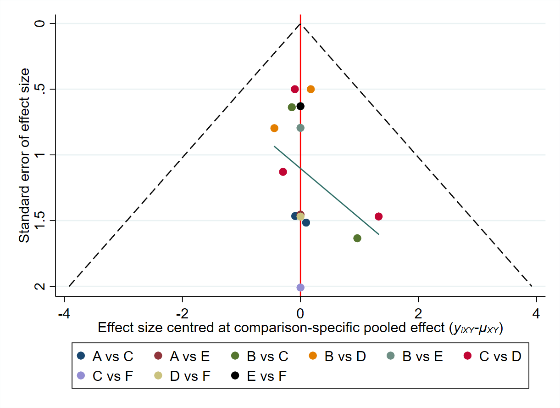
A: Chemotherapy | B: Ipilimumab | C: Nivolumab | D: Niv + Ipi
E: Pembrolizumab | F: Placebo

Figure S5 Publication bias for grade 3-5 IRP in six treatment groups
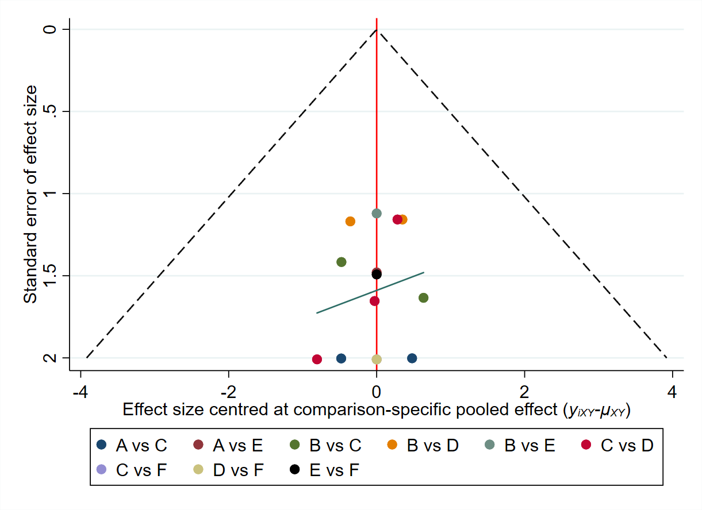
A: Chemotherapy | B: Ipilimumab | C: Nivolumab | D: Niv + Ipi
E: Pembrolizumab | F: Placebo

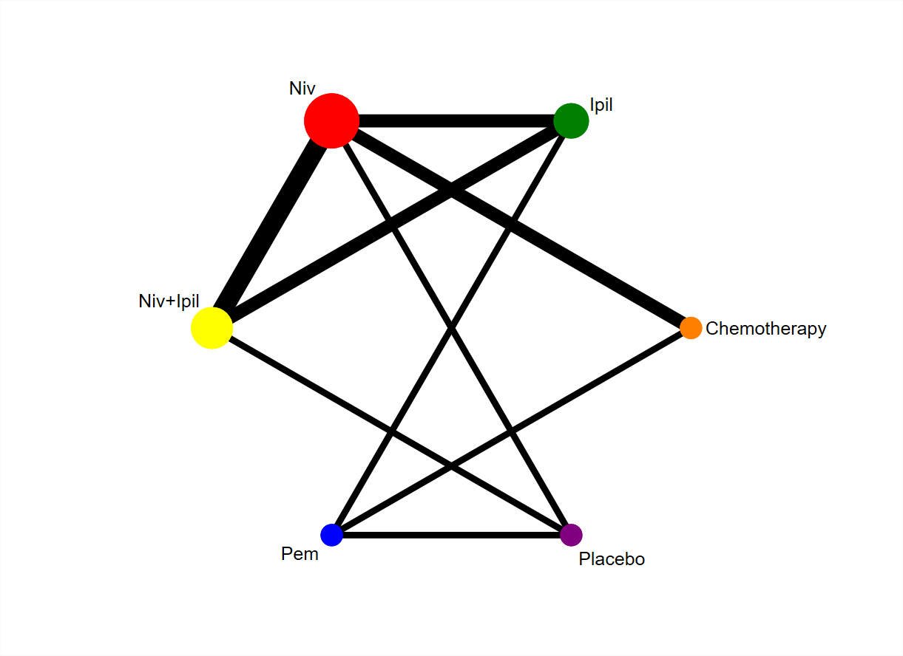
Figure S6 Network established for comparisons based on six treatment groups. Circular nodes indicate treatment regimens. The node size corresponds with the total number of patients randomized to receive the treatment. Each line represents a type of head-to-head comparison. The width of the lines is proportional to the number of trials comparing the connected treatments.

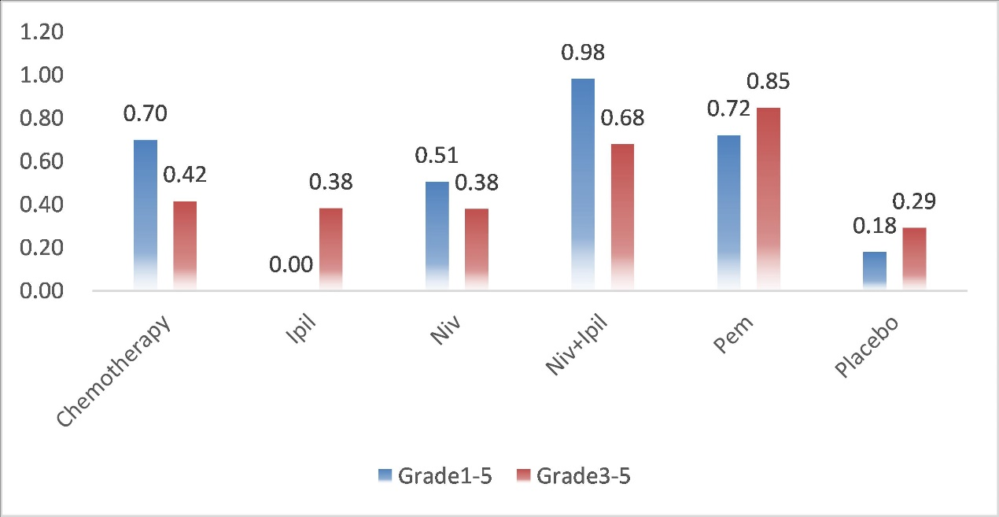
Figure S7 Rank probabilities with SUCRA value for IRP in six treatment groups based on the network consistency model. Higher SUCRA scores are correlated with higher risk of IRP. SUCRA, surface under the cumulative ranking curve.

Figure S8 Forest plots and pairwise meta-analysis of head-to-head comparisons for the risk of grade 1-5 IRP in four treatment groups
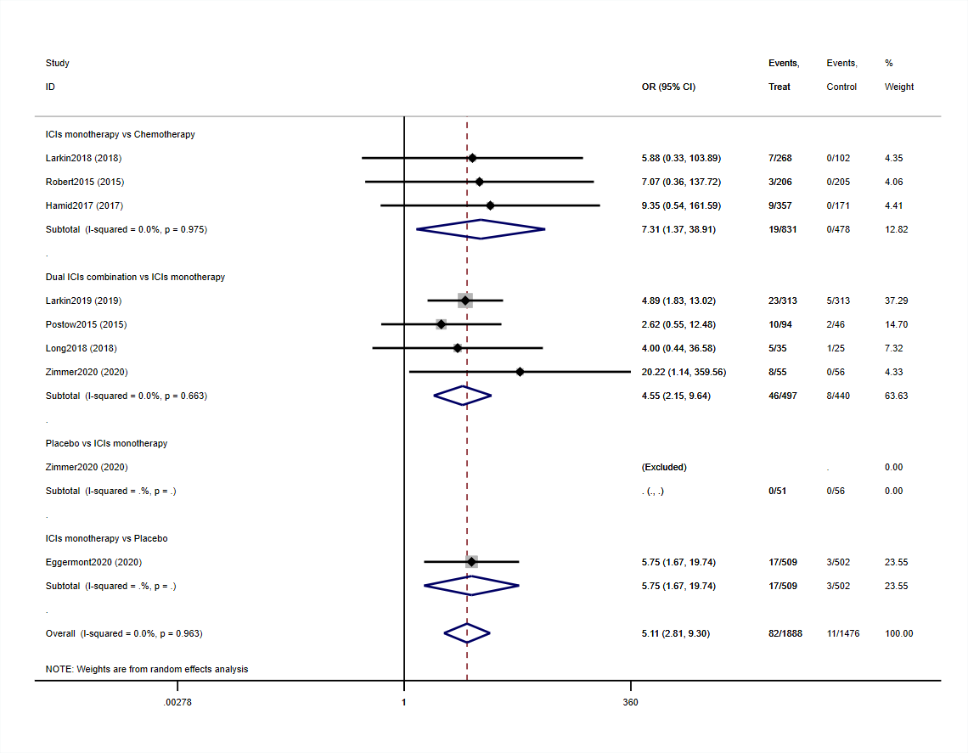

Figure S9 Forest plots and pairwise meta-analysis of head-to-head comparisons for the risk of grade 3-5 IRP in four treatment groups
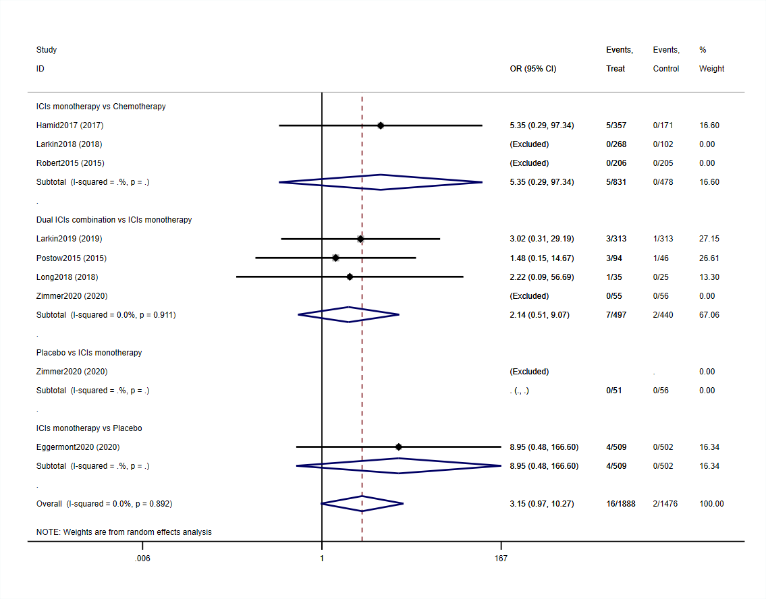

Figure S10 Forest plots and pairwise meta-analysis of head-to-head comparisons for the risk of grade 1-5 IRP in six treatment groups
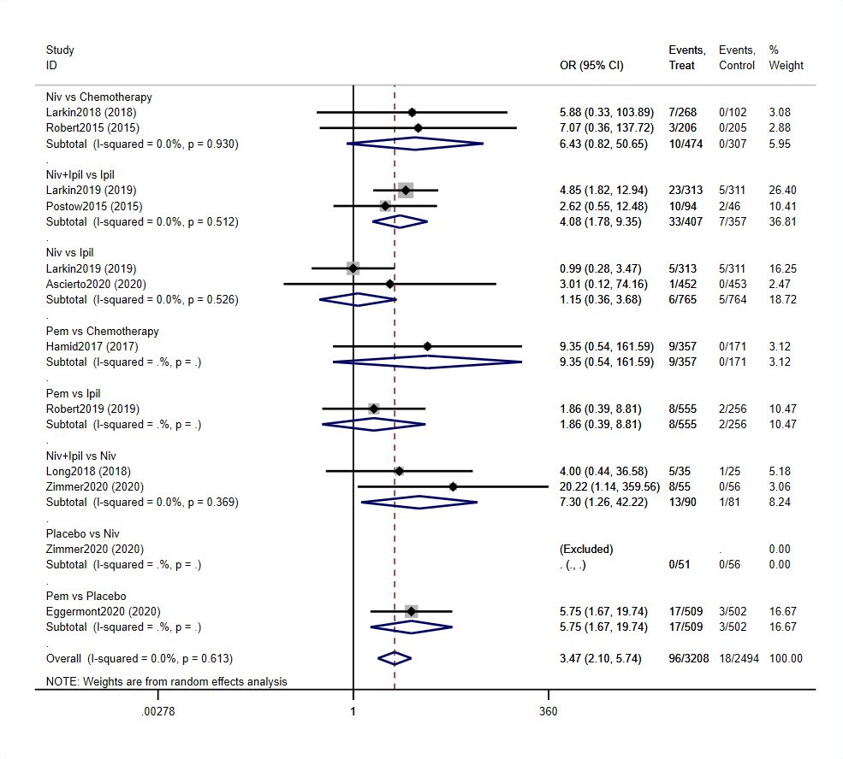

Figure S11 Forest plots and pairwise meta-analysis of head-to-head comparisons for the risk of grade 3-5 IRP in six treatment groups


