PubMed:
((((((((((wound healing[Title/Abstract]) OR (wound healings[Title/Abstract])) OR (healing, wound[Title/Abstract])) OR (healings, wound[Title/Abstract])) OR (regeneration[Title/Abstract])) OR (injury repair[Title/Abstract])) OR (wound repair[Title/Abstract])) OR (re epithelialization[Title/Abstract])) OR (wound epithelialization[Title/Abstract])) OR ("Wound Healing"[Mesh])) AND ((((((((((((((((((((Oligochaeta[Title/Abstract]) OR (Oligochaetas[Title/Abstract])) OR (Dilong[Title/Abstract])) OR (Di Long[Title/Abstract])) OR (Earthworms[Title/Abstract])) OR (Earthworm[Title/Abstract])) OR (Lumbricus terrestris[Title/Abstract])) OR (Lumbricus terrestri[Title/Abstract])) OR (terrestris, Lumbricus[Title/Abstract])) OR (Lumbricus[Title/Abstract])) OR (Eisenia worm[Title/Abstract])) OR (Eisenia worms[Title/Abstract])) OR (worm, Eisenia[Title/Abstract])) OR (Eisenia foetida[Title/Abstract])) OR (Eisenia foetidas[Title/Abstract])) OR (foetidas, Eisenia[Title/Abstract])) OR (Eisenia fetida[Title/Abstract])) OR (Eisenia fetidas[Title/Abstract])) OR (fetida, Eisenia[Title/Abstract])) OR ("Oligochaeta"[Mesh]))

EMBASE:
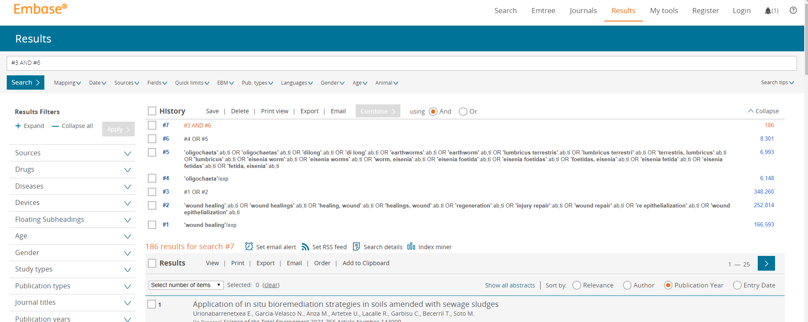

Web of Science:

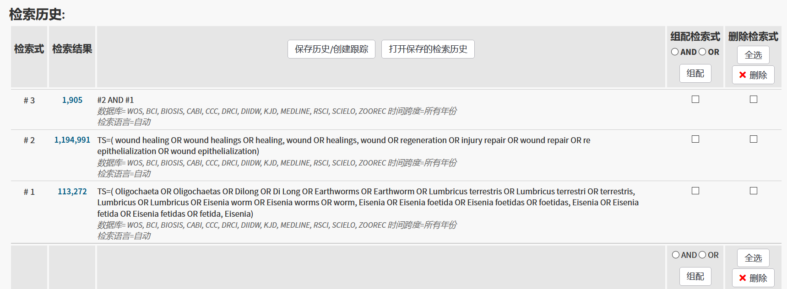

the Cochrane Library:
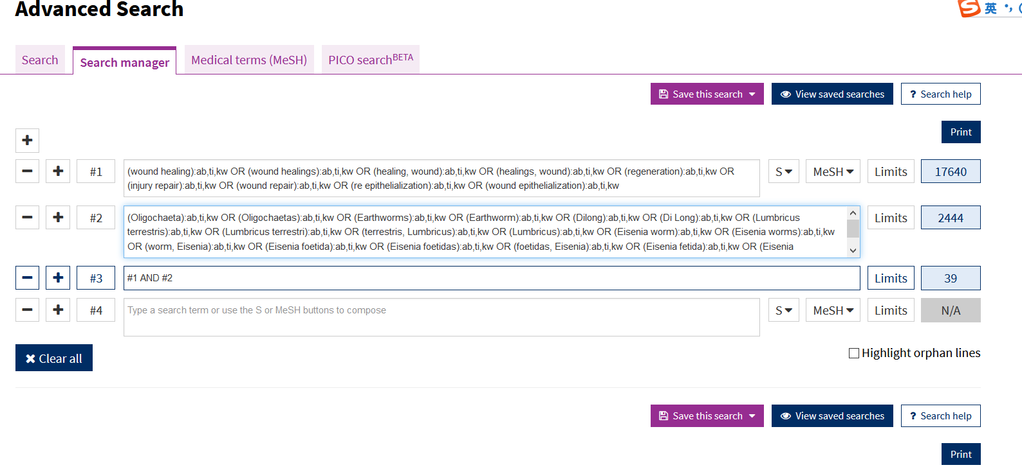
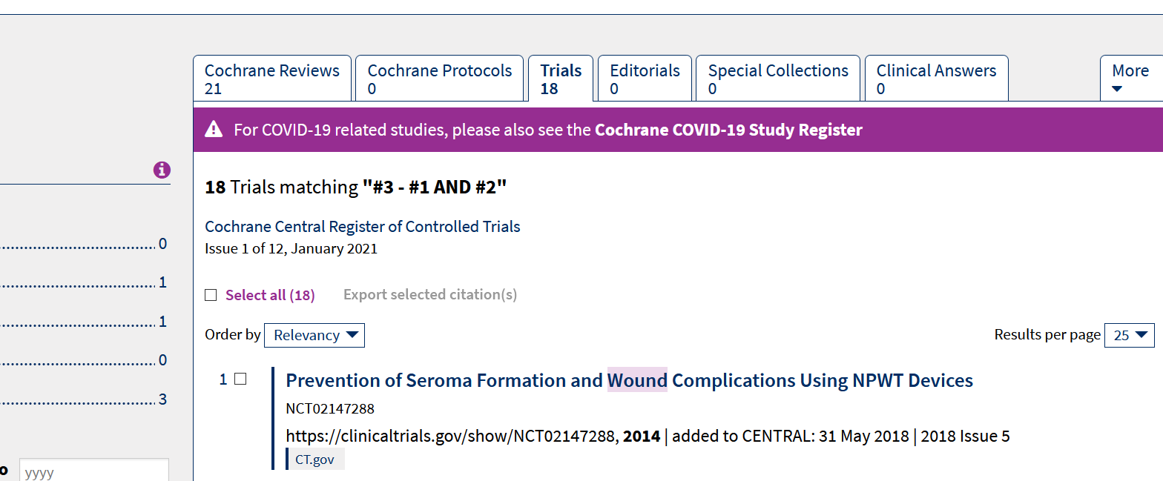

CNKI:
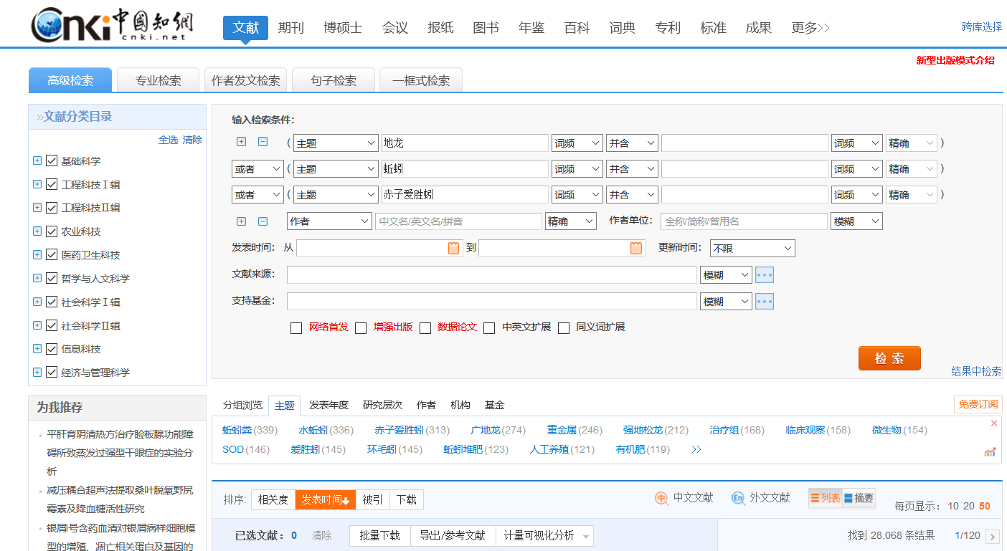

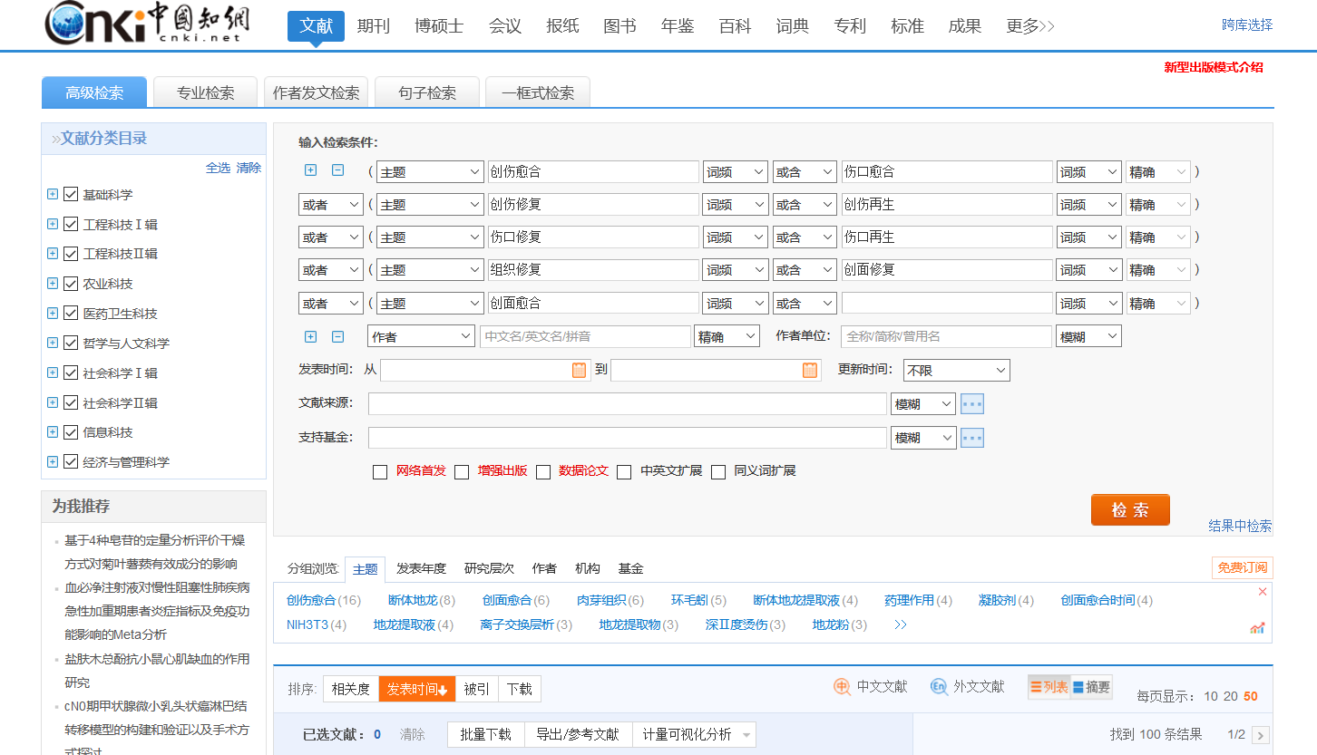
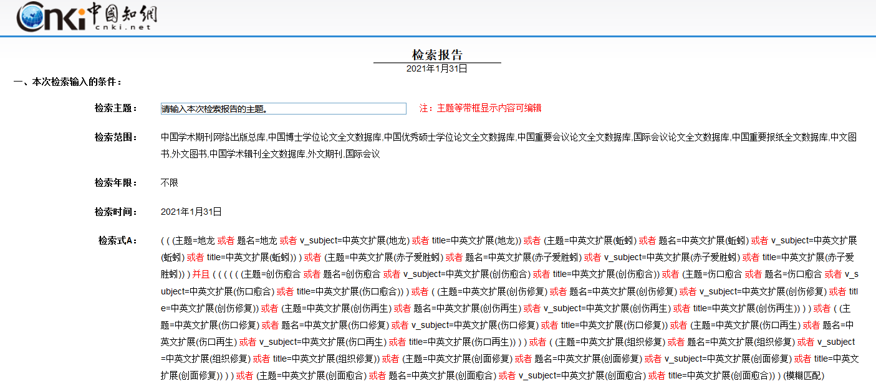
VIP:
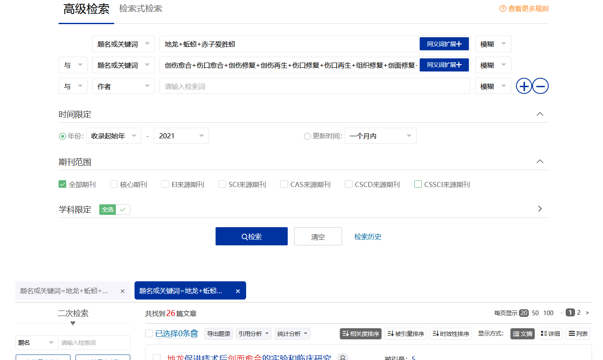

WanFang:


