Supplemental Table 1
Search: Ready to Use Therapeutic Food
Database [Platform] Searches run Jan 27, 2020 | Results
MEDLINE(R) and Epub Ahead of Print, In-Process & Other Non-Indexed Citations and Daily [OVID] 1946 to Jan 24, 2020 | 2399
Embase Classic+Embase [OVID] 1947 to week 4 | 2956
Cochrane Library [Wiley] Jan 27, 2020 | 1367
CINAHL [EBSCO] Jan 27, 2020 | 665
Web of Science [Clarivate Analytics] Jan 27, 2020 | 2811
TOTAL | 10,198

Ovid MEDLINE(R) and Epub Ahead of Print, In-Process & Other Non-Indexed Citations and Daily 1946 to January 27, 2020
Search Strategy:
# | Searches | Results
1 | (therapeutic adj3 (food* or diet*)).tw,kf. | 2279
2 | (("ready-to-use" or "ready to use") adj2 (feed* or food*)).tw,kf. | 283
3 | (RUTF or RTUF or "plumpy?nut" or "plumpy nut" or chiponde or nourimanba or nutriset or dutasi or "high energy bar").tw,kf. | 143
4 | or/1-3 | 2399

Embase Classic+Embase 1947 to 2020 Week 04
Search Strategy:
# | Searches | Results
1 | "ready to use therapeutic food"/ | 48
2 | (therapeutic adj3 (food* or diet*)).tw,kw. | 2781
3 | (("ready-to-use" or "ready to use") adj2 (feed* or food*)).tw,kw. | 330
4 | (RUTF or RTUF or "plumpy?nut" or "plumpy nut" or chiponde or nourimanba or nutriset or dutasi or "high energy bar").tw,kw. | 172
5 | or/1-4 | 2956

Cochrane Library (Wiley)
Date Run: 27/01/2020 15:27:23

ID Search Hits
#1 ((*therapeutic near/3 (food* or diet*))):ti,ab,kw (Word variations have been searched) 1275
#2 ("ready to use" near/2 (feed* or food*)):ti,ab,kw (Word variations have been searched) 182
#3 ("ready-to-use" near/2 (feed* or food*)):ti,ab,kw (Word variations have been searched) 0
#4 (RUTF or RTUF or "plumpy?nut" or "plumpy nut" or chiponde or nourimanba or nutriset or dutasi or "high energy bar"):ti,ab,kw (Word variations have been searched) 116
#5 #1 OR #2 OR #3 OR #4 1367

CINAHL [EBSCO]
Jan 27, 2027
Monday, January 27, 2020 2:44:13 PM

# | Query | Limiters/Expanders | Last Run Via | Results
S9 | S1 OR S2 OR S3 OR S4 OR S5 OR S6 OR S7 OR S8 | Search modes - Boolean/Phrase | Interface - EBSCOhost Research Databases  Search Screen - Advanced Search  Database - CINAHL | 665
S8 | TI ( chiponde or nourimanba or nutriset or dutasi or "high energy bar" ) OR AB ( chiponde or nourimanba or nutriset or dutasi or "high energy bar" ) | Search modes - Boolean/Phrase | Interface - EBSCOhost Research Databases  Search Screen - Advanced Search  Database - CINAHL | 7
S7 | TI "plumpy nut" OR AB "plumpy nut" | Search modes - Boolean/Phrase | Interface - EBSCOhost Research Databases  Search Screen - Advanced Search  Database - CINAHL | 1
S6 | TX Plumpy'Nut | Search modes - Boolean/Phrase | Interface - EBSCOhost Research Databases  Search Screen - Advanced Search  Database - CINAHL | 11
S5 | TI plump?nut OR AB plump?nut | Search modes - Boolean/Phrase | Interface - EBSCOhost Research Databases  Search Screen - Advanced Search  Database - CINAHL | 0
S4 | TI ( RUTF or RTUF ) OR AB ( RUTF or RTUF ) | Search modes - Boolean/Phrase | Interface - EBSCOhost Research Databases  Search Screen - Advanced Search  Database - CINAHL | 64
S3 | TI ( ("ready-to-use" N2 (feed* or food*)) ) OR AB ( ("ready-to-use" N2 (feed* or food*)) ) | Search modes - Boolean/Phrase | Interface - EBSCOhost Research Databases  Search Screen - Advanced Search  Database - CINAHL | 146
S2 | TI ( ("ready to use" N2 (feed* or food*)) ) OR AB ( ("ready to use" N2 (feed* or food*)) ) | Search modes - Boolean/Phrase | Interface - EBSCOhost Research Databases  Search Screen - Advanced Search  Database - CINAHL | 146
S1 | TI ( (therapeutic N3 (food* or diet*)) ) OR AB ( (therapeutic N3 (food* or diet*)) ) | Search modes - Boolean/Phrase | Interface - EBSCOhost Research Databases  Search Screen - Advanced Search  Database - CINAHL | 603

Web of Science [Clarivate Analytics]
Jan 27, 2020

# 9 | 2,811 | #8 OR #7 OR #6 OR #5 OR #4 OR #3 OR #2 OR #1  Indexes=SCI-EXPANDED, SSCI, A&HCI, CPCI-S, CPCI-SSH, BKCI-S, BKCI-SSH, ESCI Timespan=All years | Edit
# 8 | 14 | TS=(chiponde or nourimanba or nutriset or dutasi or "high energy bar")  Indexes=SCI-EXPANDED, SSCI, A&HCI, CPCI-S, CPCI-SSH, BKCI-S, BKCI-SSH, ESCI Timespan=All years | Edit
# 7 | 21 | TS=("plumpy nut")  Indexes=SCI-EXPANDED, SSCI, A&HCI, CPCI-S, CPCI-SSH, BKCI-S, BKCI-SSH, ESCI Timespan=All years | Edit
# 6 | 21 | TS=("plumpy'nut")  Indexes=SCI-EXPANDED, SSCI, A&HCI, CPCI-S, CPCI-SSH, BKCI-S, BKCI-SSH, ESCI Timespan=All years | Edit
# 5 | 2 | TS=(plumpy*nut)  Indexes=SCI-EXPANDED, SSCI, A&HCI, CPCI-S, CPCI-SSH, BKCI-S, BKCI-SSH, ESCI Timespan=All years | Edit
# 4 | 132 | TS=(RUTF OR RTUF)  Indexes=SCI-EXPANDED, SSCI, A&HCI, CPCI-S, CPCI-SSH, BKCI-S, BKCI-SSH, ESCI Timespan=All years | Edit
# 3 | 340 | TS=("ready-to-use" NEAR/2 (feed* or food*))  Indexes=SCI-EXPANDED, SSCI, A&HCI, CPCI-S, CPCI-SSH, BKCI-S, BKCI-SSH, ESCI Timespan=All years | Edit
# 2 | 340 | TS=("ready to use" NEAR/2 (feed* or food*))  Indexes=SCI-EXPANDED, SSCI, A&HCI, CPCI-S, CPCI-SSH, BKCI-S, BKCI-SSH, ESCI Timespan=All years | Edit
# 1 | 2,668 | TS=(therapeutic NEAR/3 (food* or diet*))  Indexes=SCI-EXPANDED, SSCI, A&HCI, CPCI-S, CPCI-SSH, BKCI-S, BKCI-SSH, ESCI Timespan=All years | Edit

Supplemental Table 2. Excluded studies.
Study | Reason for exclusion
Akram 2016 (44) | No intervention of RUTF containing less than 50% of protein from dairy products (high-density diet including milk powder)
Bahwere 2014 (18) | No intervention of RUTF containing less than 50% of protein from dairy products (milk whey protein RUTF)
Bhandari 2016 (45) | No intervention of RUTF containing less than 50% of protein from dairy products (RUTF with similar milk composition)
Borg 2019 (46) | Systematic or narrative review (summary of locally produced RUTF) and no child outcomes evaluated
Brown 2015 (47) | No intervention of RUTF containing less than 50% of protein from dairy products (bigh-density diet including milk powder)
Chauhan 2019 (48) | No comparison to RUTF containing at least 50% of protein from milk and other dairy products (standard RUTF)
Choudhury 2018 (49) | No child outcomes evaluated (acceptability study only)
Dibari 2013 (50) | Adults or older children (age over 18 years) and no child outcomes evaluated (acceptability study)
Dube 2009 (51) | No comparison to RUTF containing at least 50% of protein from milk and other dairy products (standard RUTF)
Fatima 2017 (52) | Infants/children without SAM (focused on mildly underweight children)
Hassan 2016 (53) | Animal study (not human research)
Hsieh 2015 (54) | No intervention of RUTF containing less than 50% of protein from dairy products (RUTF with milk whey and dry skimmed milk)
Huynh Phuong 2014 (55) | No intervention of RUTF containing less than 50% of protein from dairy products (RUTF with similar milk composition) and no child outcomes evaluated
Jadhav 2019 (56) | No intervention of RUTF containing less than 50% of protein from dairy products (RUTF with similar milk composition)
Jones 2015 (57) | No intervention of RUTF containing less than 50% of protein from dairy products (RUTF with similar milk composition)
Kohlmann 2019 (42) | No intervention of RUTF containing less than 50% of protein from dairy products (milk whey protein RUTF)
Manary 2013 (58) | Systematic or narrative review (protein source and quality of RUTF)
Manary 2016 (14) | Systematic or narrative review (protein source and quality of RUTF)
Ndekha 2005 (59) | No intervention of RUTF containing less than 50% of protein from dairy products (standard RUTF in home setting)
Nga 2013 (60) | No intervention of RUTF containing less than 50% of protein from dairy products (RUTF with similar milk composition)
Owino 2014 (61) | Infants/children without SAM (healthy school-aged children)
Sandige 2004 (62) | No intervention of RUTF containing less than 50% of protein from dairy products (RUTF with similar milk composition)
Schlossman 2018 (63) | Adults or older children(school age children and adults) and infants/children without SAM
Shewade 2013 (64) | No intervention of RUTF containing less than 50% of protein from dairy products (RUTF with similar milk composition)
Sigh 2018 (65) | No child outcomes evaluated (acceptability study)
Thapa 2017 (66) | No intervention of RUTF containing less than 50% of protein from dairy products (RUTF with similar milk composition)
Weber 2017 (67) | Infants/children without SAM (children with MAM included)

Supplemental Figure 1. Subgroup meta-analysis comparing non-dairy and low dairy versions of ready-to-use therapeutic food in terms of the rate of weight gain in grams per kilogram of body weight per day.
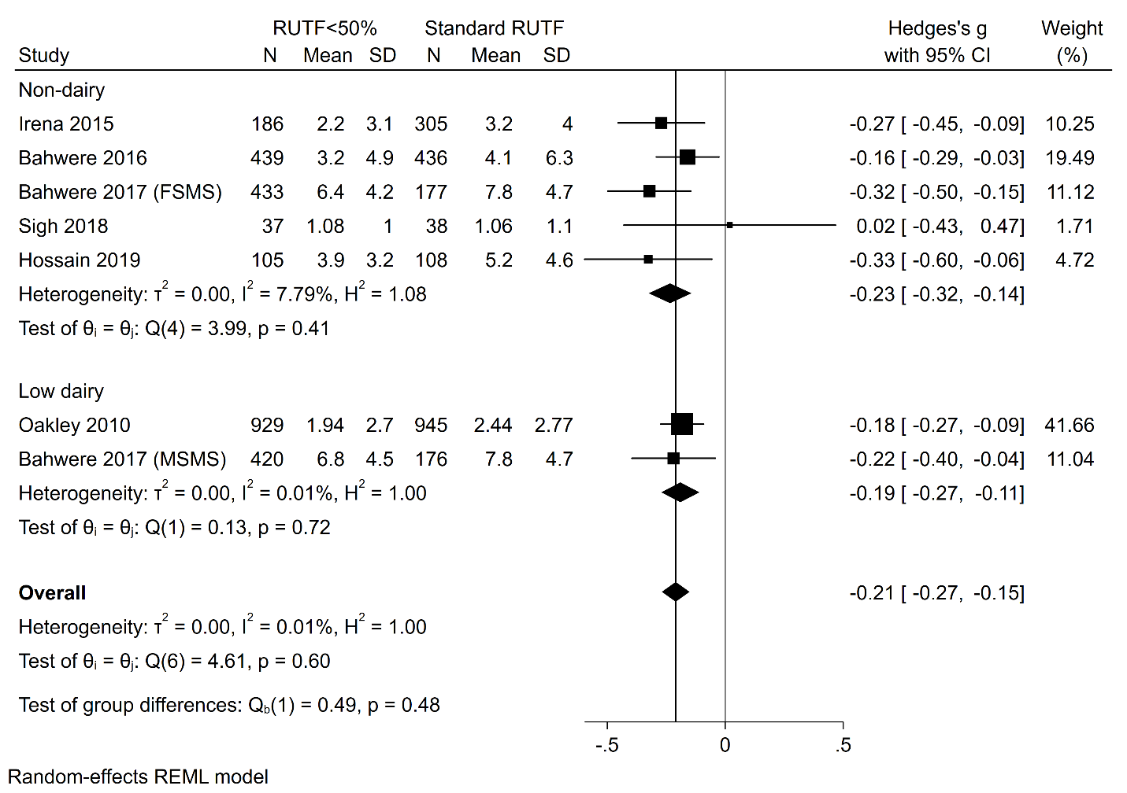
RUTF<50% represents RUTF with less than 50% of protein coming from dairy products; REML: restricted maximum likelihood; RUTF: ready-to-use therapeutic food.

Supplemental Figure 2. Network meta-analysis comparing non-dairy and low dairy versions of ready-to-use therapeutic food in terms of the rate of weight gain in grams per kilogram of body weight per day.
RUTF: ready-to-use therapeutic food.

Supplementary Figure 3. Meta-analysis of time to recovery in days.

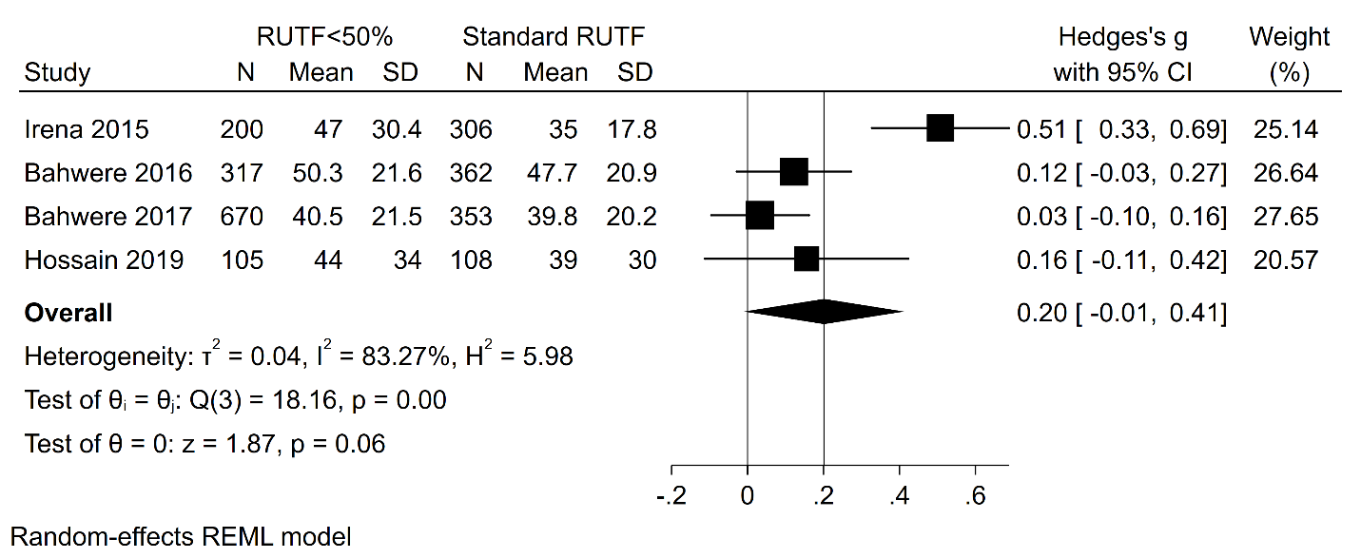

RUTF<50% represents RUTF with less than 50% of protein coming from dairy products; REML: restricted maximum likelihood; RUTF: ready-to-use therapeutic food.

Supplementary Figure 4. Meta-analysis of weight-for-height z-scores.

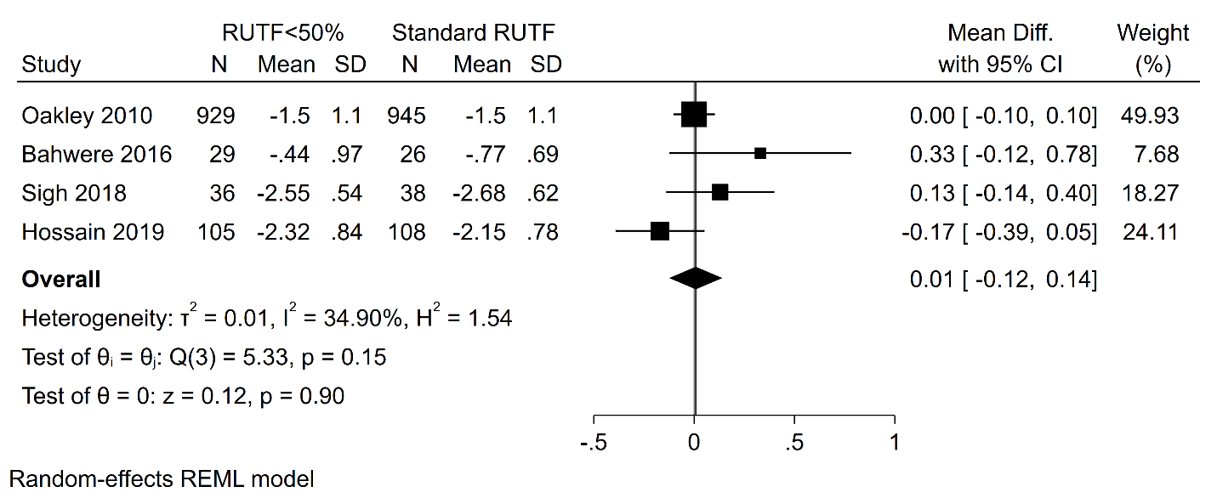

RUTF<50% represents RUTF with less than 50% of protein coming from dairy products; REML: restricted maximum likelihood; RUTF: ready-to-use therapeutic food.

Supplementary Figure 5. Meta-analysis of mid-upper arm circumference.

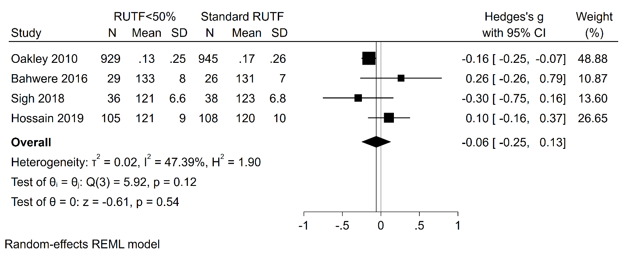

RUTF<50% represents RUTF with less than 50% of protein coming from dairy products; REML: restricted maximum likelihood; RUTF: ready-to-use therapeutic food.

Supplementary Figure 6. Meta-analysis of weight-for-age z-scores.

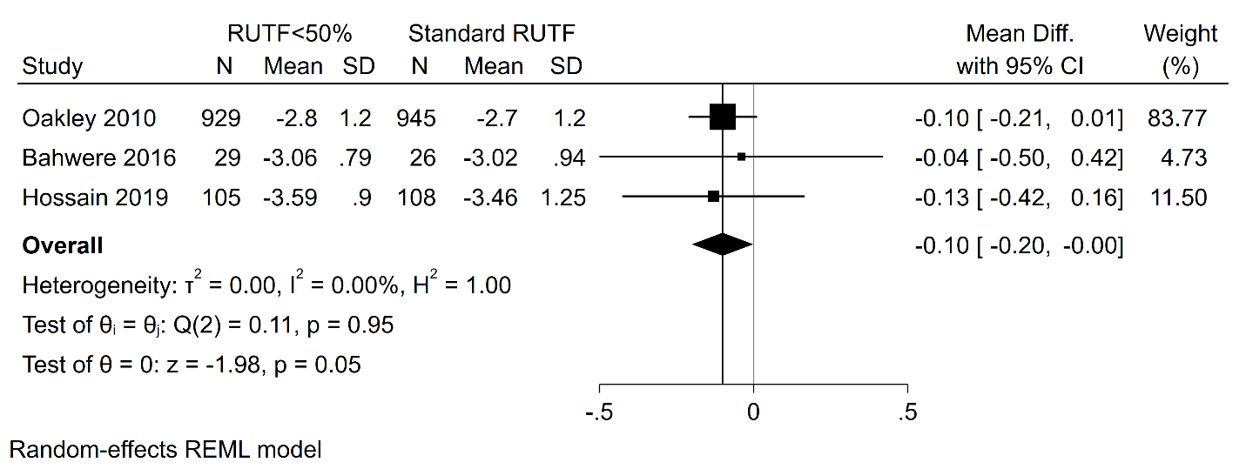

RUTF<50% represents RUTF with less than 50% of protein coming from dairy products; REML: restricted maximum likelihood; RUTF: ready-to-use therapeutic food.

Supplementary Figure 7. Meta-analysis of height-for-age z-scores.

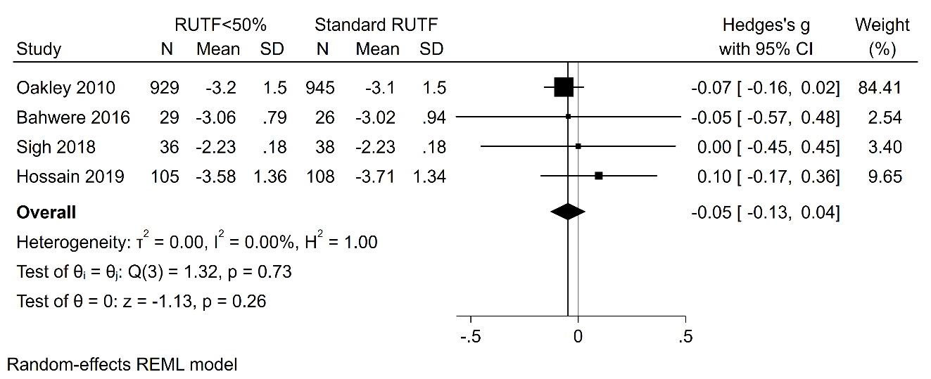

RUTF<50% represents RUTF with less than 50% of protein coming from dairy products; REML: restricted maximum likelihood; RUTF: ready-to-use therapeutic food.

