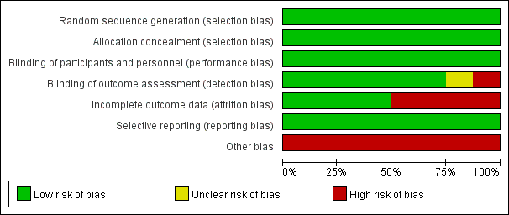
Supplementary Figure S1. Results of risk of bias assessment for individual level studies

Supplementary Figure S2. An overall summary of the risk of bias assessment for the included studies
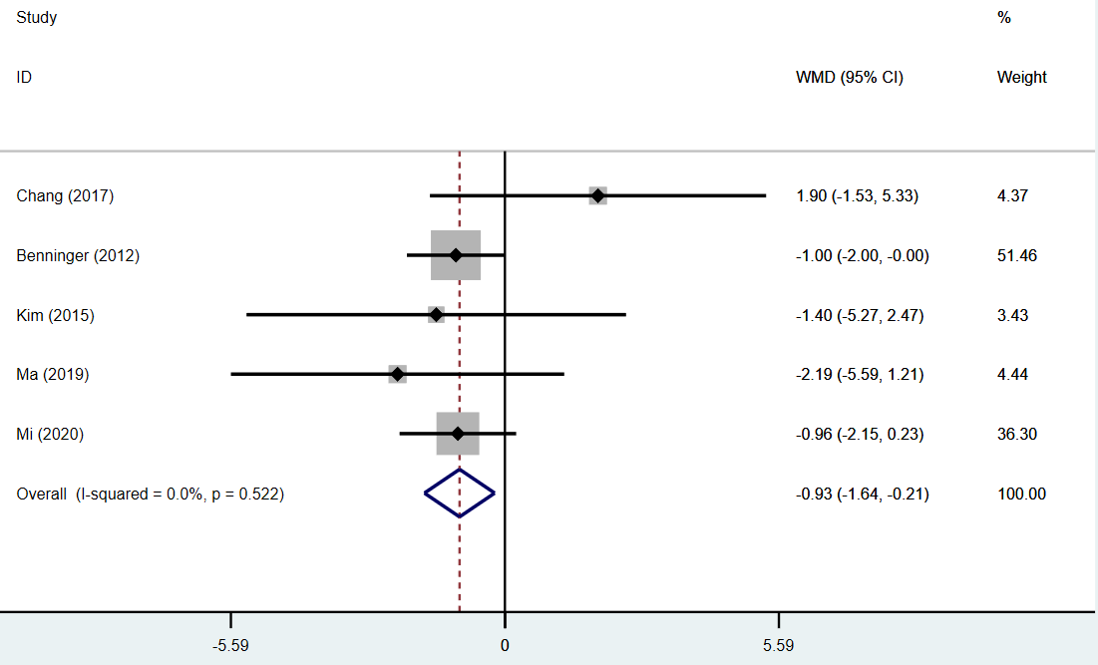
Supplementary Figure S3. Forest plot for the short-term effect of repetitive transcranial magnetic stimulation on Freezing of Gait Questionnaire

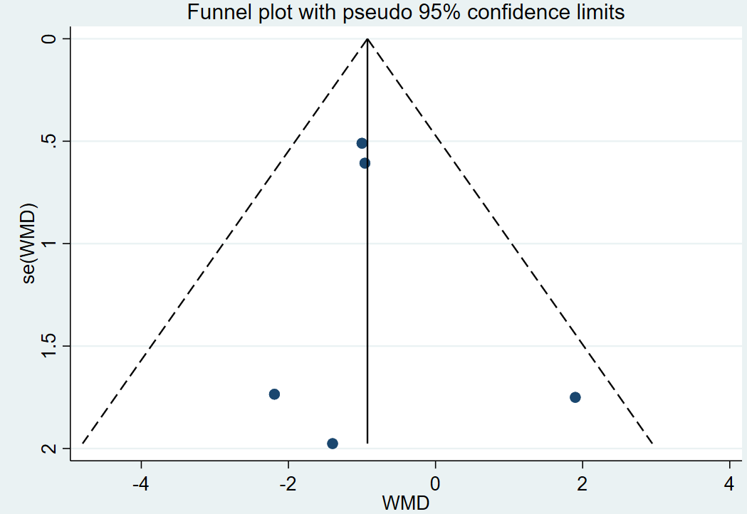
Supplementary Figure S4. Funnel plot for the short-term effect of repetitive transcranial magnetic stimulation on Freezing of Gait Questionnaire
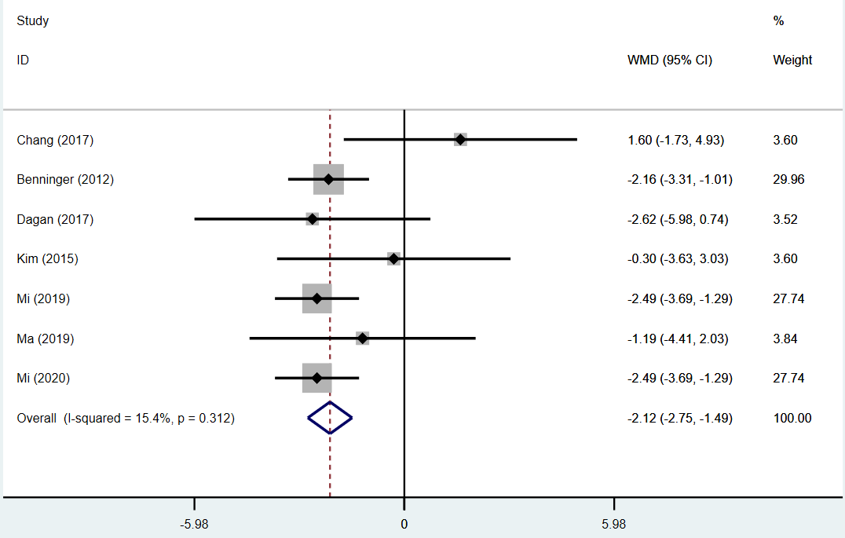
Supplementary Figure S5. Forest plot for the long-term effect of repetitive transcranial magnetic stimulation on Freezing of Gait Questionnaire

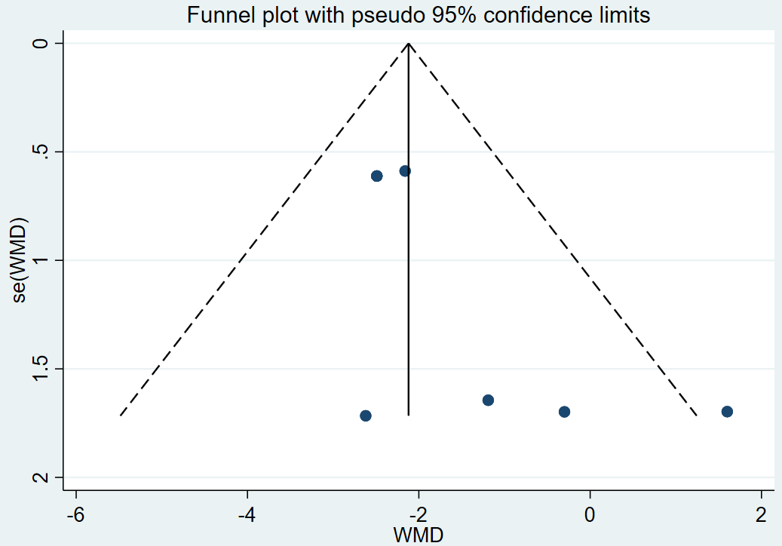
Supplementary Figure S6. Funnel plot for the long-term effect of repetitive transcranial magnetic stimulation on Freezing of Gait Questionnaire

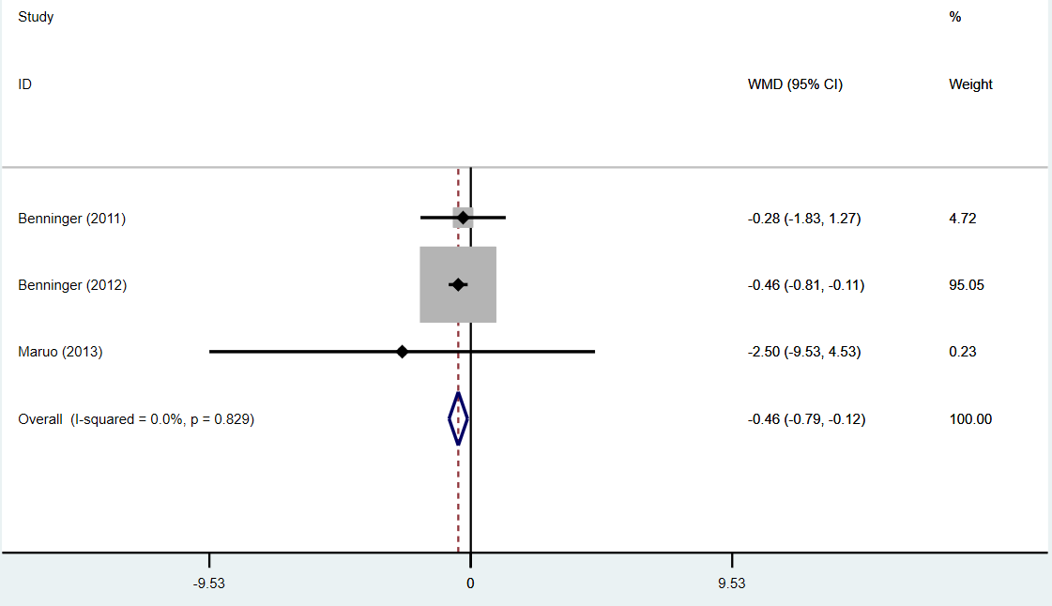
Supplementary Figure S7. Forest plot for the short-term effect of repetitive transcranial magnetic stimulation on 10-m walking time

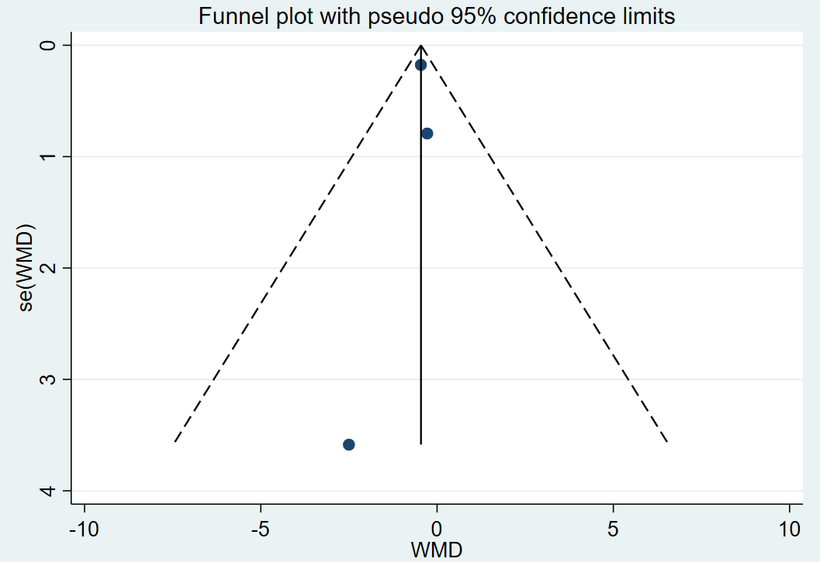
Supplementary Figure S8. Funnel plot for the short-term effect of repetitive transcranial magnetic stimulation on 10-m walking time

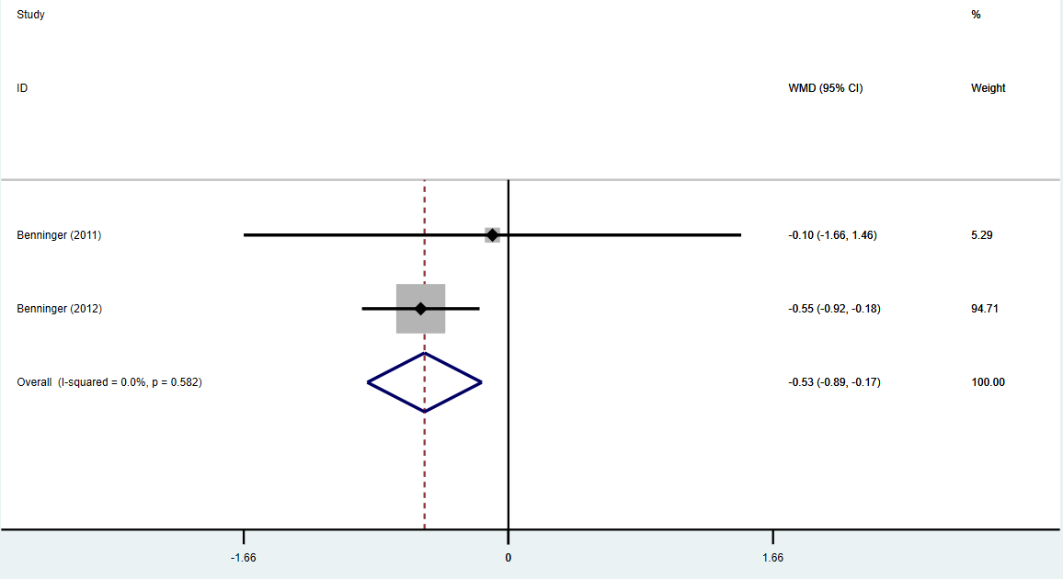
Supplementary Figure S9. Forest plot for the long-term effect of repetitive transcranial magnetic stimulation on 10-m walking time

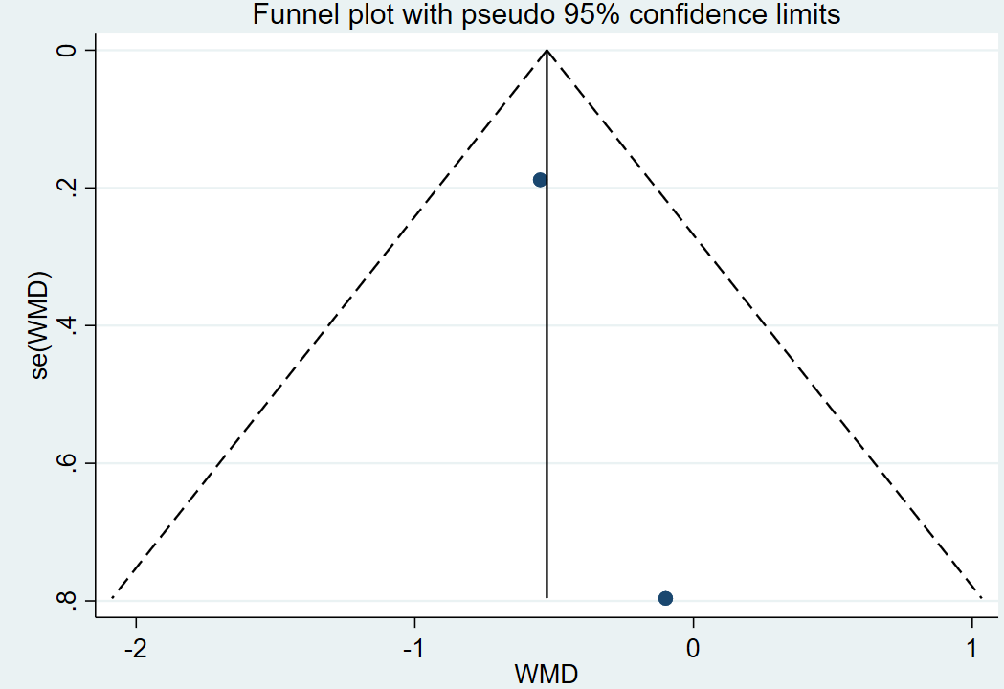
Supplementary Figure S10. Funnel plot for the long-term effect of repetitive transcranial magnetic stimulation on 10-m walking time

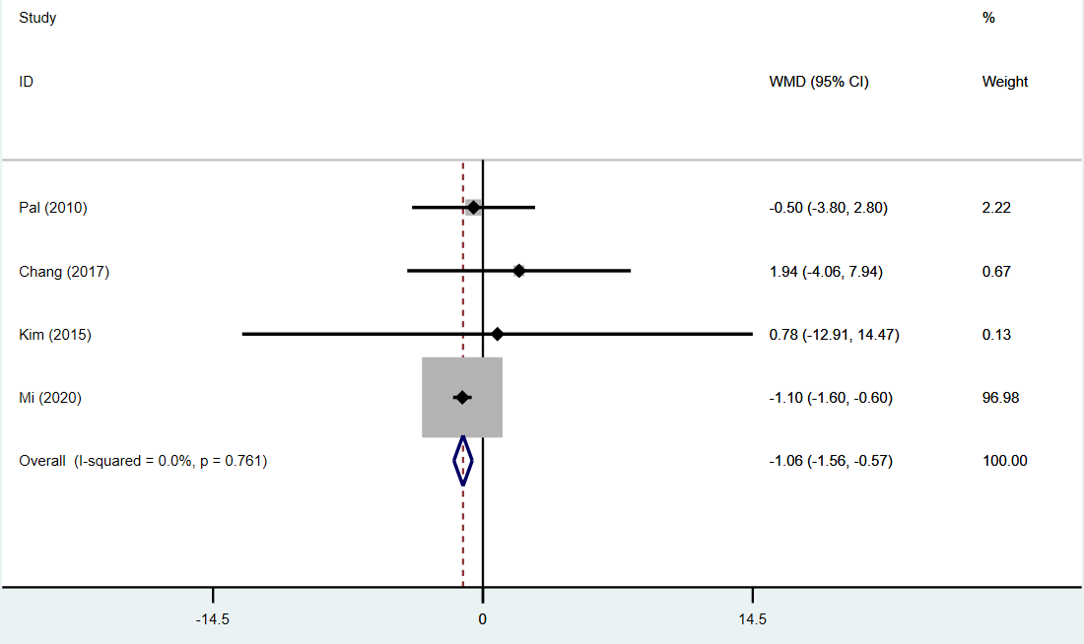
Supplementary Figure S11. Forest plot for the short-term effect of repetitive transcranial magnetic stimulation on Timed Up-and-Go test

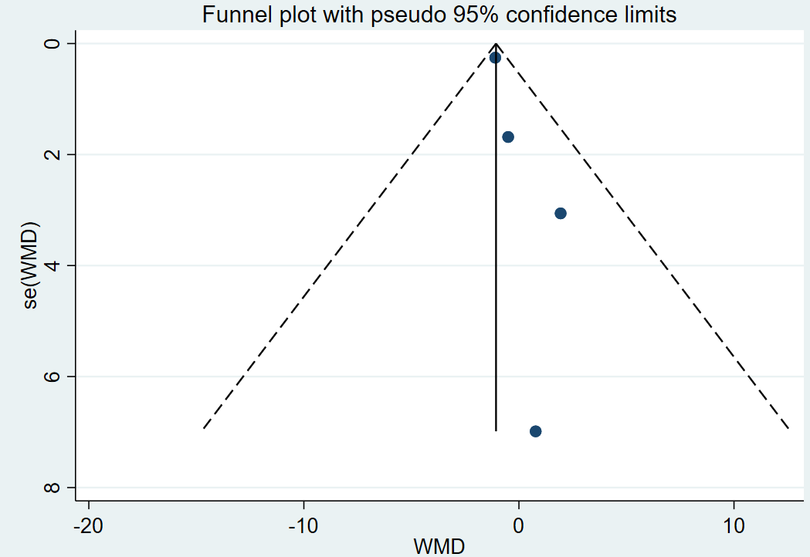
Supplementary Figure S12. Funnel plot for the short-term effect of repetitive transcranial magnetic stimulation on Timed Up-and-Go test

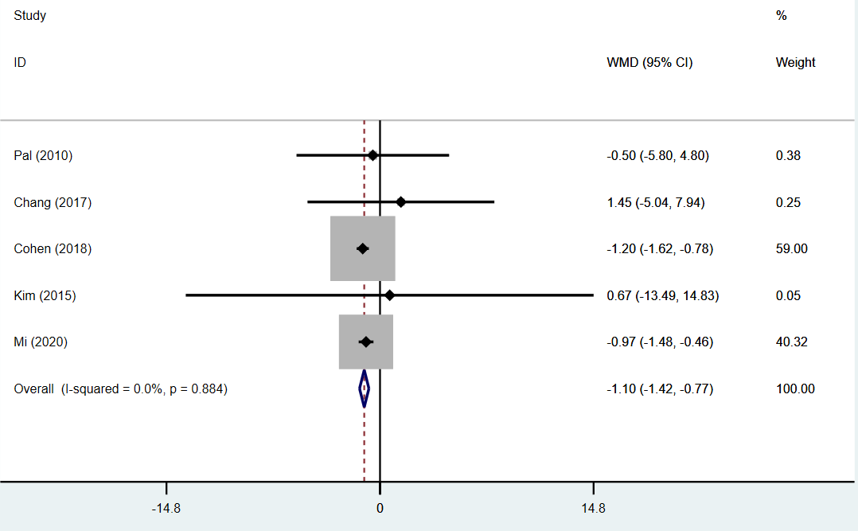
Supplementary Figure S13. Forest plot for the long-term effect of repetitive transcranial magnetic stimulation on Timed Up-and-Go test

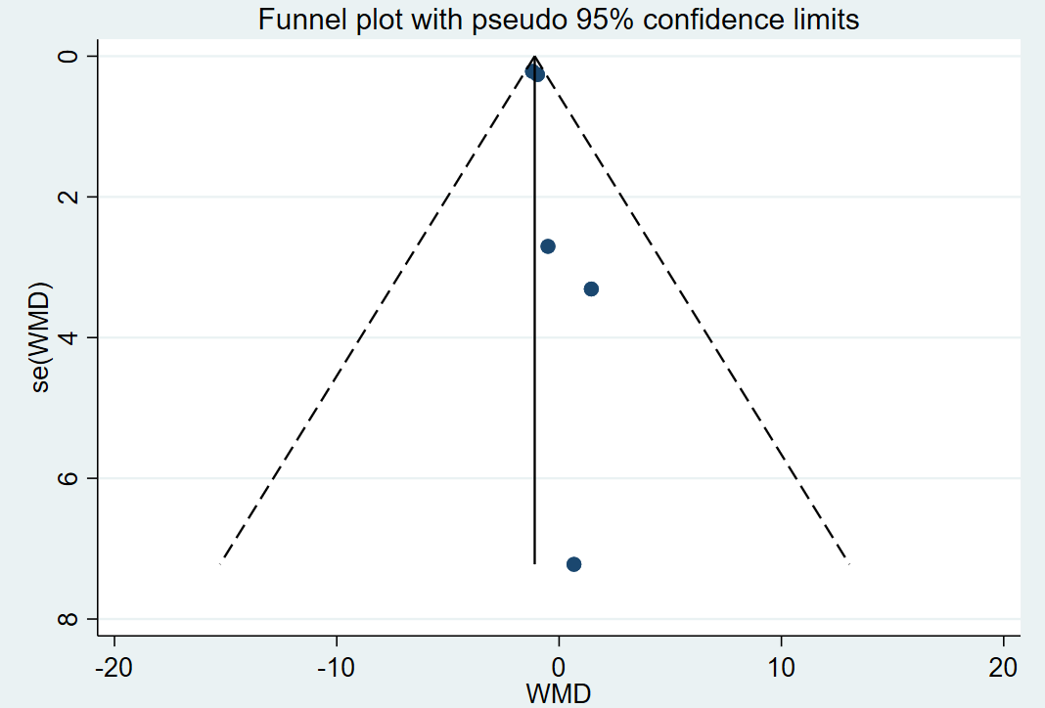
Supplementary Figure S14. Funnel plot for the long-term effect of repetitive transcranial magnetic stimulation on Timed Up-and-Go test

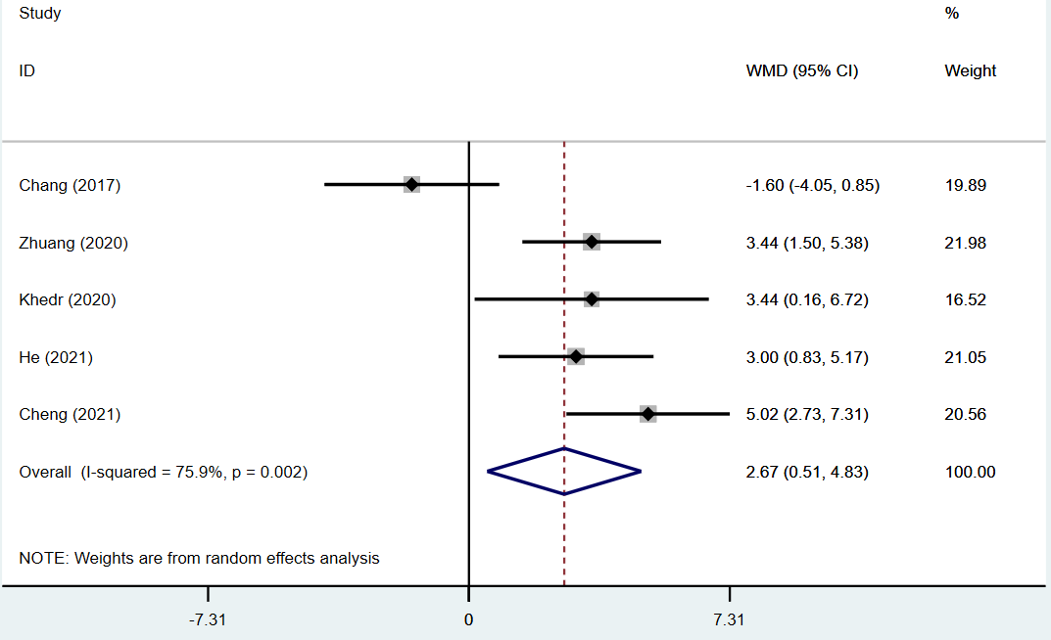
Supplementary Figure S15. Forest plot for the effect of repetitive transcranial magnetic stimulation on Montreal Cognitive Assessment

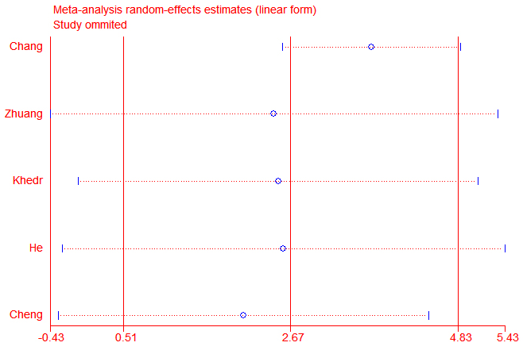
Supplementary Figure S16. The result of the sensitivity analysis of trials including Montreal Cognitive Assessment

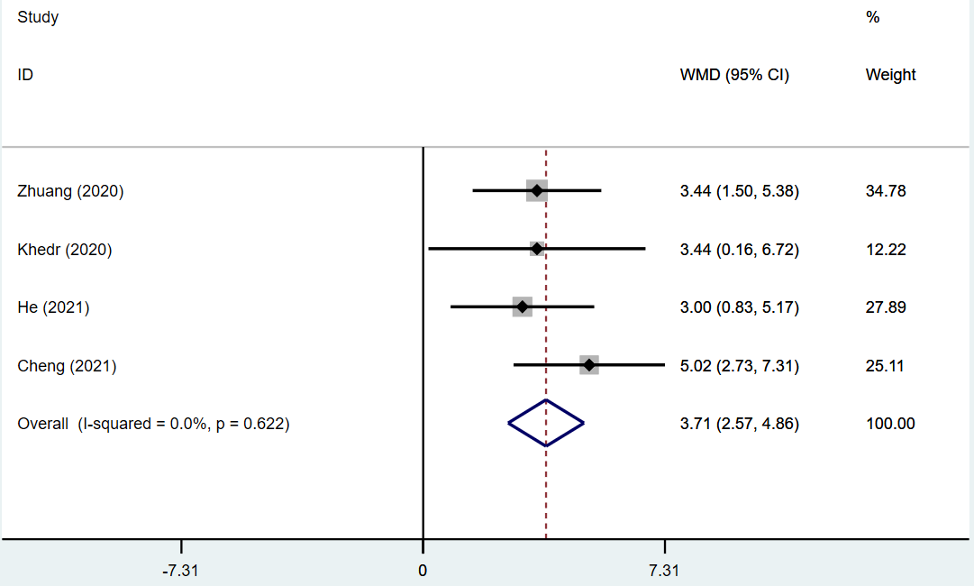
Supplementary Figure S17. Forest plot for the effect of repetitive transcranial magnetic stimulation on Montreal Cognitive Assessment after sensitivity analysis

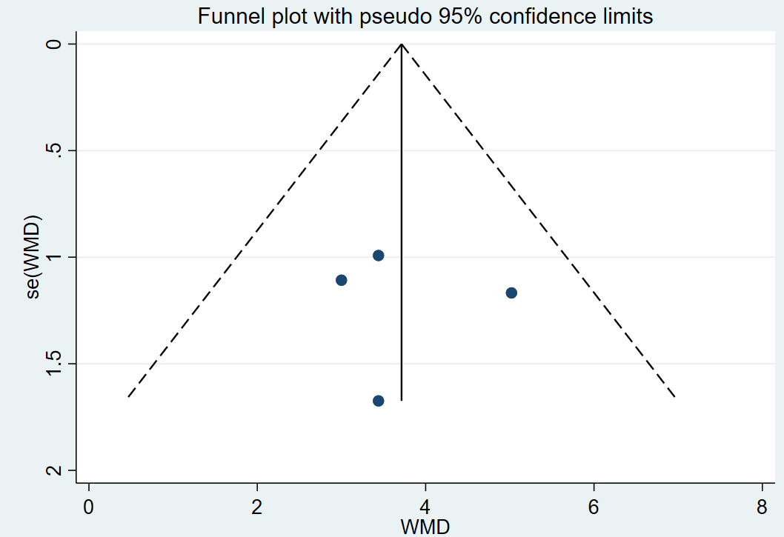
Supplementary Figure S18. Funnel plot for the effect of repetitive transcranial magnetic stimulation on Montreal Cognitive Assessment after sensitivity analysis
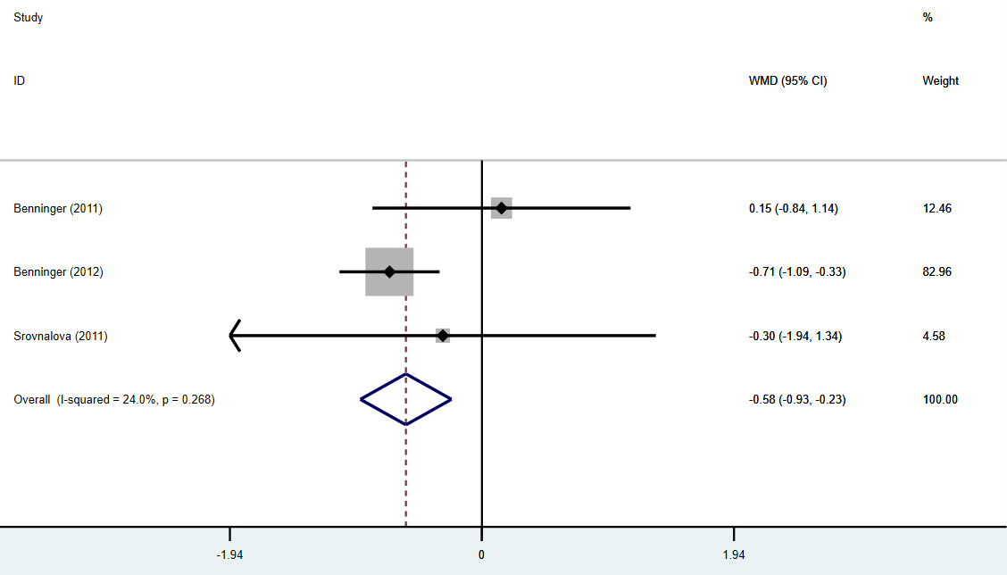
Supplementary Figure S19. Forest plot for the effect of repetitive transcranial magnetic stimulation on Frontal Assessment Battery

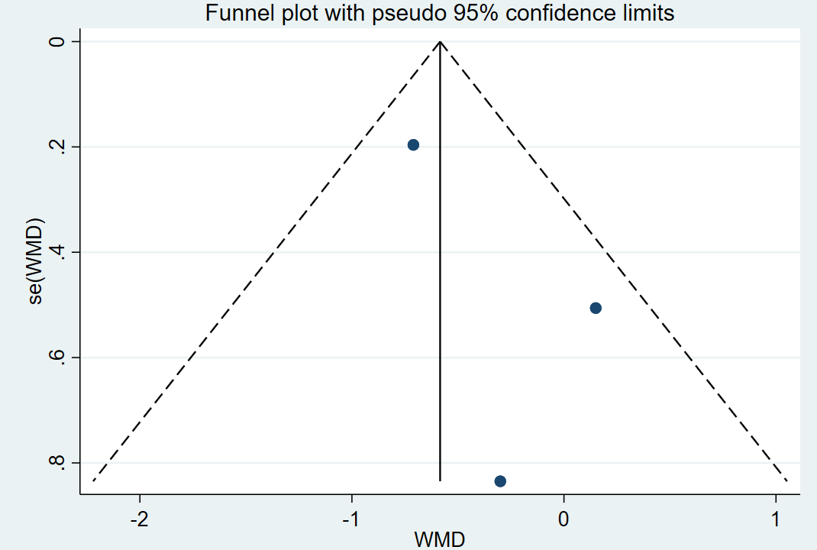
Supplementary Figure S20. Funnel plot for the effect of repetitive transcranial magnetic stimulation on Frontal Assessment Battery

