Bronchoscopic lung volume reduction coil treatment for severe emphysema: systematic review and individual patient data meta-analysis

Supplementary appendix

 | Page
Search strategy | 2
Record selection | 3 – 5
eTable 1. Records excluded after full text screening including exclusion reason | 3 – 5
eTable 2. Adjusting follow-up to be calculated from final treatment | 6
eTable 3. Included trials per follow-up category and number of patients | 6
eTable 4. Inclusion and exclusion criteria of all included trials | 7
eTable 5. Baseline characteristics according to group. | 8
eFigure 1. Risk of Bias assessment | 9
eTable 6. Summary of mixed model results. | 10
eTable 7. Summary of procedure and coil details of 411 patients. | 11
eFigure 2. Distribution per lobe of 6639 coils used in 651 procedures. | 11
eFigure 3. Boxplots of outcome variables per trial. | 12-13

Search strategy
PubMed:
("Pulmonary Disease, Chronic Obstructive"[Mesh] OR COPD[tiab] OR "Chronic Obstructive Pulmonary Disease*"[tiab] OR COAD[tiab] OR "Chronic Obstructive Airway Disease*"[tiab] OR "Chronic Obstruct*"[tiab] OR emphysema[tiab] OR hyperinflation[tiab]) AND (coil*[tiab] OR repneu[tiab])

Web of Science:
ALL = ("Chronic Obstructive Pulmonary Disease*" OR COPD OR COAD OR "Chronic obstructive airway disease*" OR emphysema OR hyperinflation OR "Chronic obstructive lung disease*")
Indexes=SCI-EXPANDED, SSCI, A&HCI, ESCI Timespan=All years

ALL = (coil* OR repneu)
Indexes=SCI-EXPANDED, SSCI, A&HCI, ESCI Timespan=All years

#2 AND #1
Indexes=SCI-EXPANDED, SSCI, A&HCI, ESCI Timespan=All years

Embase:
#1 'chronic obstructive lung disease':ti,ab,kw OR copd:ti,ab,kw OR 'chronic obstructive pulmonary disease*':af OR 'chronic obstructive airway' OR (chronic AND obstructive AND ('airway'/exp OR airway) AND disease*) OR coad OR 'emphysema'/exp OR emphysema OR 'hyperinflation'/exp OR hyperinflation

#2 coil:ti,ab,kw OR repneu:ti,ab,kw

#1 AND #2

record selection
Total records retrieved: 814
Total records removed after title and abstract screening: 407 (88% agreement, Cohen’s κ: 0.50).
Total records excluded after full text screening: 35 (98% agreement, Cohen;s κ: 0.93)
- No full text available: 1
- Conference abstract: 22
- No registered clinical trial: 10
- Wrong study duration: 1
- Trial protocol: 1

eTable 1. Records excluded after full text screening including exclusion reason

Authors (year of publication) | Title | Exclusion reason
No authors listed (2015) | Endobronchial coils for better quality of life | No full text found
Achenbach, H. J.; Juech, M. (2014) | First experiences of a regional lung center offering coil treatment for severe emphysema | Abstract only
Bezzi, M.; Novali, M.; Bonifazi, M.; Failla, G.; Zuccatosta, L.; Foccoli, P.; Gasparini, S. (2013) | Lung volume reduction coils (LVR-coils) for pulmonary emphysema: Results of the Italian National registry | Abstract only
Bezzi, M.; Novali, M.; Bonifazi, M.; Failla, G.; Zuccatosta, L.; Giustolisi, M.; Foccoli, P.; Gasparini, S. (2013) | First results of the Italian national registry for the endoscopic treatment of pulmonary emphysema by lung volume reduction coils | Abstract only
Biener, L.; Skowasch, D.; Hollmann, S.; Schreiber, T.; ickenig, G.; Fimmers, R.; Pizarro, C. (2020) | Endoscopic Lung Volume Reduction in COPD: The Impact of Coil Implantation on Patients' Physical Activity | Wrong study design
Bostancı, K.; Bilgi, Z.; Ömercikoğlu, H.; Çetinkaya, Ç.; Olgun Yıldızeli, Ş.; Yüksel, M.; Stamenovic, D. (2019) | Endobronchial coils in treatment of advanced emphysema: A single center experience | Wrong study design
Bostanci, K.; Bilgi, Z.; Omercikoglu, H.; Olgun, S.; Stamenovic, D.; Yuksel, M. (2015) | Endobronchial coils for COPD palliation: A single institution experience | Abstract only
Connolly, T. A. (2016) | Lung Volume Reduction Coils as a Novel Bronchoscopic Treatment for Emphysema | Wrong study design
Deslée, G.; Leroy, S.; Perotin, J. M.; Mal, H.; Dutau, H.; Bourdin, A.; Vergnon, J. M.; Pison, C.; Kessler, R.; Jounieaux, V.; Salaün, M.; Marceau, A.; Dury, S.; Benzaquen, J.; Bonnaire, M.; Dukic, S.; Barbe, C.; Marquette, C. H. (2017) | Two-year follow-up after endobronchial coil treatment in emphysema: results from the REVOLENS study | Wrong study duration
Fellrath, J. M.; Plojoux, J.; Scherer, T.; Franzen, D.; Lovis, A.; Brutsche, M.; Soccal, P. M. (2017) | Endobronchial coil therapy: First results from the Swiss registry | Abstract only
Grosse, U.; Hetzel, J.; Gündel, L.; Gatidis, S.; Syha, R.; Schabel, C.; Springer, F.; Horger, M. (2014) | Impact of endobronchial coiling for lung volume reduction on pulmonary volume and attenuation: Preinterventional and postinterventional computed tomography-quantification using separate lobe measurements | Wrong study design
Hartman, J. E.; Klooster, K.; Augustijn, S.; Van Geffen, W. H.; Garner, J.; Shah, P. L.; Ten Hacken, N. H. T.; Slebos, D. J. (2019) | Mechanisms of action of endobronchial coil treatment | Abstract only
Herth, F. J.; Eberhard, R.; Gompelmann, D.; Slebos, D. J.; Ernst, A. (2010) | Bronchoscopic lung volume reduction with a dedicated coil: a clinical pilot study | Wrong study design
Herth, F.J.; Slebos, D.J.; Shah, P.L.; Hetzel, M.; Schmid-Bindert, G.; LaPrad, A.S.; Deslée, G.; Valipour, A. (2019) | Protocol of a Randomized Controlled Study of the PneumRx Endobronchial Coil System versus Standard-of-Care Medical Management in the Treatment of Subjects with Severe Emphysema (ELEVATE) | Trial protocol and published results included
Hetzel, M.; Merk, T.; Philipp, A.; Veitshans, S.; Willmes, P. (2013) | Six months outcomes from patients treated with lung volume reduction coils in a commercial setting: The RKK Stuttgart experience | Abstract only
Jabuonski, T. A.; Lazarus, D. R. (2016) | Lung Volume Reduction Coils for Severe Emphysema | Wrong study design
Jüch, M.; Achenbach, H. J. (2015) | Endoscopic lung volume reduction with nitinol coils in very severe emphysema: Mid-term effectiveness vs. disease related continuous loss of lung function | Abstract only
Kayikçi, H.; Çimen, P.; Katgi, N.; Tuksavul, F. F. (2019) | Efficacy and safety of the brochial volum reduction treatment for emphysema | Abstract only
Kemp, S. V.; Zoumot, Z.; Caneja, C.; Singh, S.; Ross, E.; Bicknell, S.; Chaudry, R.; Hopkinson, N. S.; Polkey, M. I.; Shah, P. L. (2012) | Randomised controlled trial of repneu endobronchial coils for the treatment of severe emphysema with hyperinflation (reset study) | Abstract only
Klose, H.; Harbaum, L.; Oqueka, T.; Baumann, H. J.; Trautmann, H.; er, U.; Gläser, S.; Bollmann, T. (2014) | ELVR - Coil treatment for severe emphysema: Program experience from Northern Germany | Abstract only
Lepper, P. M.; Hetzel, J.; Bals, R.; Hetzel, M. (2013) | Safety and short term results of 152 lung volume reduction (LVR) procedures using repneu LVR-coils | Abstract only
Mang, S.; Huss, N.; Schäfers, H. J.; Wehrfritz, H.; Massmann, A.; Lensch, C.; Langer, F.; Seiler, F.; Bals, R.; Lepper, P. M. | Endoscopic lung volume reduction coils for patients with severe emphysema-a single-centre retrospective analysis | Wrong study design
Marchetti, N.; Kaufman, T.; Chra, D.; Herth, F. J.; Shah, P. L.; Slebos, D. J.; Dass, C.; Bicknell, S.; Blaas, S. H.; Pfeifer, M.; Stanzell, F.; Witt, C.; Deslee, G.; Gesierich, W.; Hetzel, M.; Kessler, R.; Leroy, S.; Hetzel, J.; Sciurba, F. C.; Criner, G. J. (2018) | Endobronchial Coils Versus Lung Volume Reduction Surgery or Medical Therapy for Treatment of Advanced Homogenous Emphysema | Wrong study design
Pizarro, C.; Hollmann, S.; Tuleta, I.; Nickenig, G.; Skowasch, D. (2017) | Impact of lung volume reduction coils on patient's physical activity | Abstract only
Schwick, B. (2014) | Repneu lung volume reduction coils (LVRC) for severe emphysema | Abstract only
Shah, P. L.; Kemp, S. V. (2015) | Springing forward to medium-term results for endobronchial coils for emphysema | Wrong study design
Slebos, D.; Kerstjens, H. A. M.; Ernst, A.; Eberhardt, R.; Herth, F. J. (2010) | Lung Volume Reduction Coil Treatment Of Severe Heterogeneous Emphysema. A Pilot Study | Abstract only
Slebos, D. J.; Bicknell, S.; Gesierich, W.; Herth, F.; Hetzel, J.; Hetzel, M.; Kessler, R.; Marquette, C. H.; Pfeifer, M.; Shah, P.; Stanzel, F.; Witt, C.; Deslee, G. (2013) | Lung volume reduction coil sustained treatment effectiveness in heterogeneous and homogeneous emphysema | Abstract only
Slebos, D. J.; Blaas, S.; Deslee, G.; Geseirich, W.; Herth, F. J.; Hetzel, J.; Hetzel, M.; Kessler, R.; Marquette, C. H.; Pfeifer, M.; Stanzel, F.; Witt, C. (2012) | Lung volume reduction coil treatment for patients with severe heterogeneous emphysema, a multicenter feasibility trial | Abstract only
Slebos, D. J.; Ernst, A. Blaas, S.; Gesierich, W.; Herth, F. (2010) | Bronchoscopic Lung Volume Reduction Coil treatment of severe heterogeneous emphysema | Abstract only
Stanzel, F.; Gesierich, W.; Hetzel, M.; Deslee, G.; Kessler, R.; Witt, C.; Marquette, C. H.; Pfeifer, M.; Blaas, S.; Hetzel, J.; Herth, F.; Slebos, D. J. (2012) | 12-Month effectiveness data in 85 patients treated bilaterally with LVRC | Abstract only
Trautmann, H. (2013) | Unilateral treatment with lung volume reduction coils in patients with severe emphysema | Abstract only
Wise, J. (2016) | Coils implanted into lungs show promise for emphysema | Wrong study design
Zoumot, Z.; Kemp, S.; Chaudhuri, R.; Caneja, C.; Bicknell, S.; Hopkinson, N. (2012) | Outcomes of the RePneu Endobronchial Coils for the treatment of severe emphysema with hyperinflation (RESET) trial | Abstract only
Zoumot, Z.; Kemp, S. V.; Caneja, C.; Hopkinson, N. S.; Singh, S.; Shah, P. L (2013) | Preliminary medium-term follow-up data from a single centre experience of a randomised controlled crossover study of the lung volume reduction coils | Abstract only

eTable 2. Adjusting follow-up to be calculated from final treatment
Trial | Original follow up | Time between original follow-up endpoint and second coil treatment | Adjusted follow-up† | Follow-up categorisation*
Slebos⁴ | 6 months  after final treatment | - | 6 months | 6 months
Deslée⁶ | 6 and 12 months  after final treatment | - | 6 and 12 months | 6 and 12 months
Klooster⁷ | 6 months  after 1st treatment | 2 months | 4 months | 3 months
RESET^{5,8} | 3, 6 and 12 months after final treatment | - | 3, 6 and 12 months | 3, 6 and 12 months
RENEW¹⁰ | 12 months  after 1st treatment | 4 months | 8 months | 6 months
REVOLENS⁹ | 6 and 12 months  after randomization | 1 – 3 months | 4 (3-5) and 10 (9 – 11) months | 3 and 12 months
REACTION¹¹ | 3 months  after final treatment | - | 3 months | 3 months
ELEVATE¹² | 6 months  after 1st treatment | 2 months | 4 months | 3 months
† original follow-up minus time between original follow-up and second coil treatment
* Follow-up categories:
- 3 months (0-4 months after final treatment)
- 6 months (5 – 8 months after final treatment)
- 12 months (9 – 12 months after final treatment)

eTable 3. Included trials per follow-up category and number of patients
Follow-up category | Trials | Total number of patients | Number of patients in standard-of-care group | Number of patients in coil treatment group
3 month | Klooster⁷  RESET⁵  REVOLENS⁹  REACTION¹¹  ELEVATE¹² | 292 | 112 | 180
6 month | Slebos⁴  Deslée⁶  RESET⁸  RENEW¹⁰ | 411 | 157 | 254
12 month | Deslée⁶  RESET⁸  REVOLENS⁹ | 183 | 50 | 133

eTable 4. Inclusion and exclusion criteria of all included trials
MAJOR INCLUSION CRITERIA
 | Age (years) | FEV₁ (% predicted) | RV (% predicted) | TLC (% predicted) | MMRC | Smoking cessation | Emphysema distribution
Slebos⁴ | > 35 | < 45 | - | > 100 | ≥ 2 | > 8 weeks | Heterogeneous
RESET^{5,8} | ≥ 35 | ≤ 45 | - | > 100 | ≥ 2 | > 8 weeks | Hetero- or homogeneous
Klooster⁷ | > 35 | ≤ 35 | > 225 | > 120 | ≥ 2 | > 6 months | Homogeneous
Deslée⁶ | > 35 | < 45 | > 175 | > 100 | > 2 | > 8 weeks | Heterogeneous
REVOLENS⁹ | - | < 50% | > 220 | > 100 | ≥ 2 | > 8 weeks | Hetero- or homogeneous
RENEW¹⁰ | ≥ 35 | ≤ 45 | > 175 | > 100 | ≥ 2 | > 8 weeks | Heterogeneous
REACTION¹¹ | - | < 45% | > 175 | > 100 | ≥ 2 | > 6 months | Hetero- or homogeneous
ELEVATE¹² | - | 15 – 45 | ≥ 200 | > 100 | ≥ 2 | Yes, no specific duration | Hetero- or homogeneous
MAJOR EXCLUSION CRITERIA (similar for all trials)
Change in FEV₁ > 20% postbronchodilator
DLCO < 20% of predicted
Severe gas exchange abnormalities defined as PaCO₂ > 8.0 kPa and/or PaO₂ < 6.0 kPa on room air
Uncontrolled pulmonary hypertension defined by right ventricular pressure > 50 mmHg and/or evidenced by echocardiogram
History of recurrent clinically significant respiratory infections and/or COPD exacerbations
Clinically significant bronchiectasis
Previous lung surgery or lung transplant
Giant bulla (>1/3 of the lung volume)
6-minute walk test < 140 meter
Use of antiplatelet therapy (e.g. clopidogrel) or anticoagulant therapy
Use of > 20 mg prednisone (or equivalent) daily
Any other disease that might compromise survival or is likely to interfere with completion of study or follow-up assessments or would adversely affect outcomes
Abbreviations: FEV₁, forced expiratory volume in 1 second; RV, residual volume; TLC, total lung capacity; MMRC, modified medical research council; DLCO, diffusion capacity of the lung for carbon monoxide; PaCO₂, partial pressure of carbon dioxide; PaO₂, partial pressure of oxygen; COPD, chronic obstructive pulmonary disease.

eTable 5. Baseline characteristics according to group. Results are reported as frequency (percentage), mean (SD) or median (IQR). Univariate analysis was performed using Fisher’s exact test, independent sample T-test or Mann-Whitney U-test, where appropriate.

 | Usual care (n = 269) | Coil treatment (n = 411) | P-value
Gender (female) | 124 (46%) | 216 (53%) | .12
Age (years) | 64 (58 – 69) | 63 (57 – 68) | .07
BMI | 23.5 (20.7 –27.1) | 23.8 (21.1 – 27.0) | .86
Smoking (pack-years) | 41.0 (30.0 –59.5) | 40.0 (29.8 – 50.0) | .07
FEV₁ (L) | 0.69 (0.59 – 0.84) | 0.68 (0.58 – 0.84) | .58
FEV₁ (% predicted) | 25.5 (21.0 – 30.5) | 25.3 (20.8 – 29.8) | .54
FVC (L) | 2.39 (1.96 –2.91) | 2.45 (1.95 – 2.90) | .98
RV (L) | 5.31 (4.55 – 6.13) | 5.26 (4.45 – 6.06) | .35
RV (% predicted) | 241 (225 –268) | 241 (217 –276) | .98
RV/TLC ratio | 67.0 (6.82) | 66.9 (6.95) | .77
DLCO (% predicted) | 32.2 (26.2 – 40.2) | 31.5 (25.7 – 38.7) | .32
SGRQ (total score) | 56.5 (14.6) | 60.1 (12.3) | < .001
6MWD (m) | 311 (247 – 366) | 314 (245 – 374) | .67
MMRC |  |  | .55
1 | 1 (0.4%) | 0 (0.0)
2 | 83 (36.2%) | 113 (27.5)
3 | 103 (45.0%) | 155 (37.7)
4 | 42 (18.3%) | 70 (17.0)

BMI, body mass index; FEV₁, forced expiratory volume in 1 second; FVC, forced vital capacity; RV, residual volume; TLC, total lung capacity; DLCO, diffusing capacity of the lung for carbon monoxide; SGRQ, St. George respiratory questionnaire; 6MWD, 6-minute walk distance; MMRC, modified medical research council.

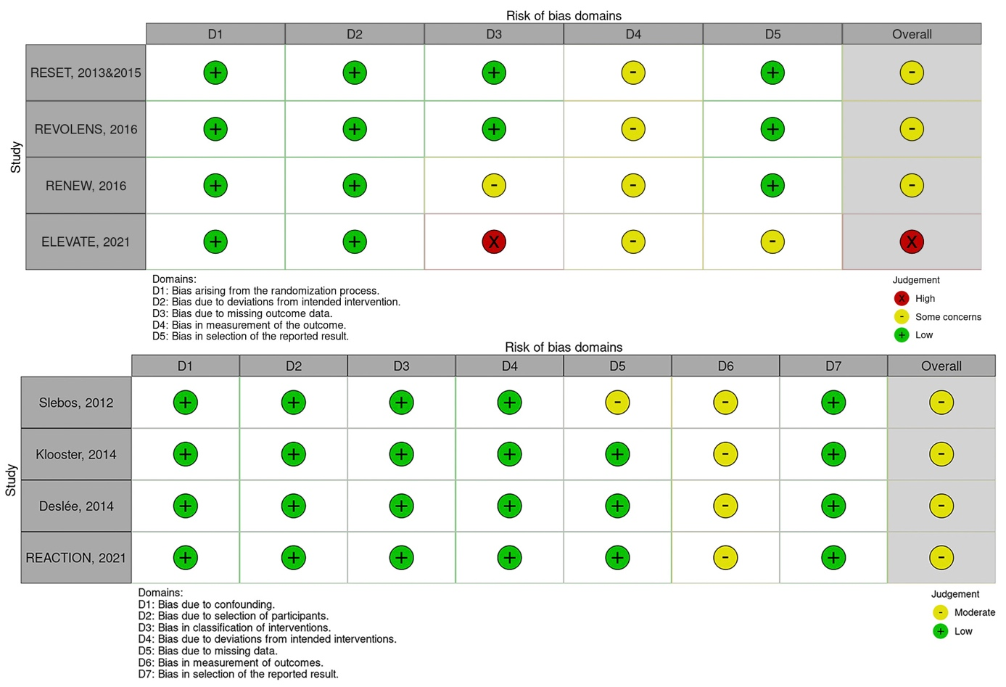

eFigure 1. Risk of Bias assessment using the revised Cochrane Risk of Bias tool for randomized trials (above) and the risk of bias in non-randomized studies of interventions tool (below).

eTable 6. Summary of mixed model results.

 | Follow-up | N (patients・trials) | Estimated effect of coil treatment (95%CI)
FEV₁ (L) | 3-month | 264・5 | 0.09 (0.06 to 0.12)
FEV₁ (L) | 6-month | 367・4 | 0.07 (0.03 to 0.10)
FEV₁ (L) | 12-month | 144・3 | 0.07 (0.00 to 0.14)
RV (L) | 3-month | 261・5 | -0.45 (-0.62 to -0.28)
RV (L) | 6-month | 368・4 | -0.33 (-0.52 to -0.14)
RV (L) | 12-month | 140・3 | -0.36 (-0.64 to -0.08)
SGRQ (Points) | 3-month | 258・5 | -12.3 (-15.8 to -8.8)
SGRQ (Points) | 6-month | 371・4 | -10.1 (-12.8 to -7.3)
SGRQ (Points) | 12-month | 140・3 | -9.8 (-15.0 to -4.7)
6MWD (m) | 3-month | 164・4† | 38 (18 to 58)
6MWD (m) | 6-month | 369・4 | 10 (-7 to 26)
6MWD (m) | 12-month | 140・3 | 27 (-5 to 58)

† The ELEVATE trial did not report 6MWD outcomes and therefore 6MWD data was only available for 164 patients at 3-month follow-up (56%).

95%CI, 95% confidence interval; FEV₁, forced expiratory volume in 1 second; RV, residual volume; SGRQ, St. George Respiratory Questionnaire; 6MWD, 6-minute walk distance.

eTable 7. Summary of procedure and coil details of 411 patients. Data are presented as frequency (percentage) or median (range).

Variable | No. procedures | Outcome
Treatment  Unilateral  Bilateral | 788 | 34 (8%)  377 (92%)
Procedure time (min)† | 484 | 41 (15 – 140)
Coils per treatment* | 651 | 10 (2 – 20)
Coil sizes*  70 mm  85 mm  100 mm  125 mm  150 mm  175 mm  200 mm | 651 | 5 (0.1%)  21 (0.3%)  2908 (43.8%)  3200 (48.2%)  445 (6.7%)  58 (0.9%)  2 (0.03%)
† No data supplied by RENEW trial
* No data supplied by ELEVATE trial
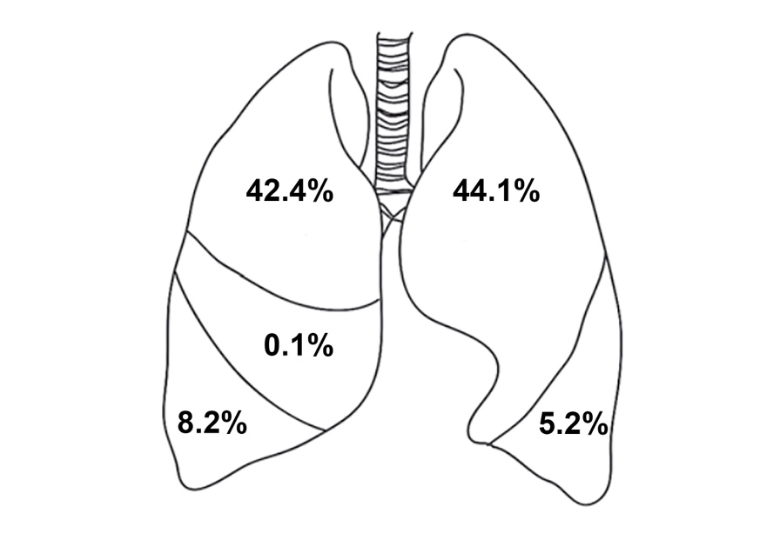
eFigure 2. Distribution per lobe of 6639 coils used in 651 procedures.

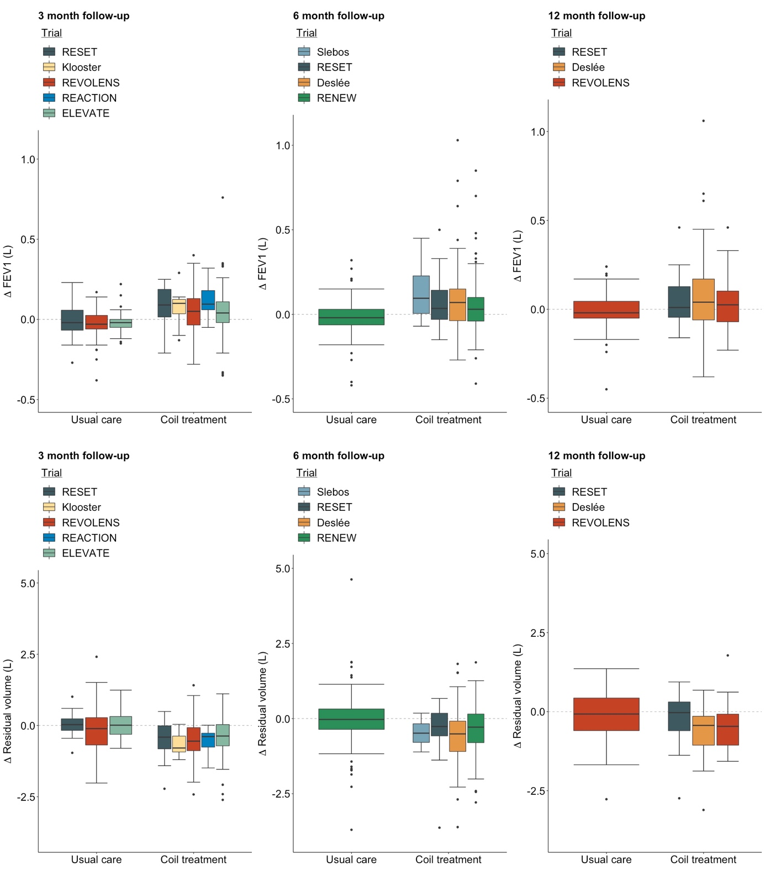
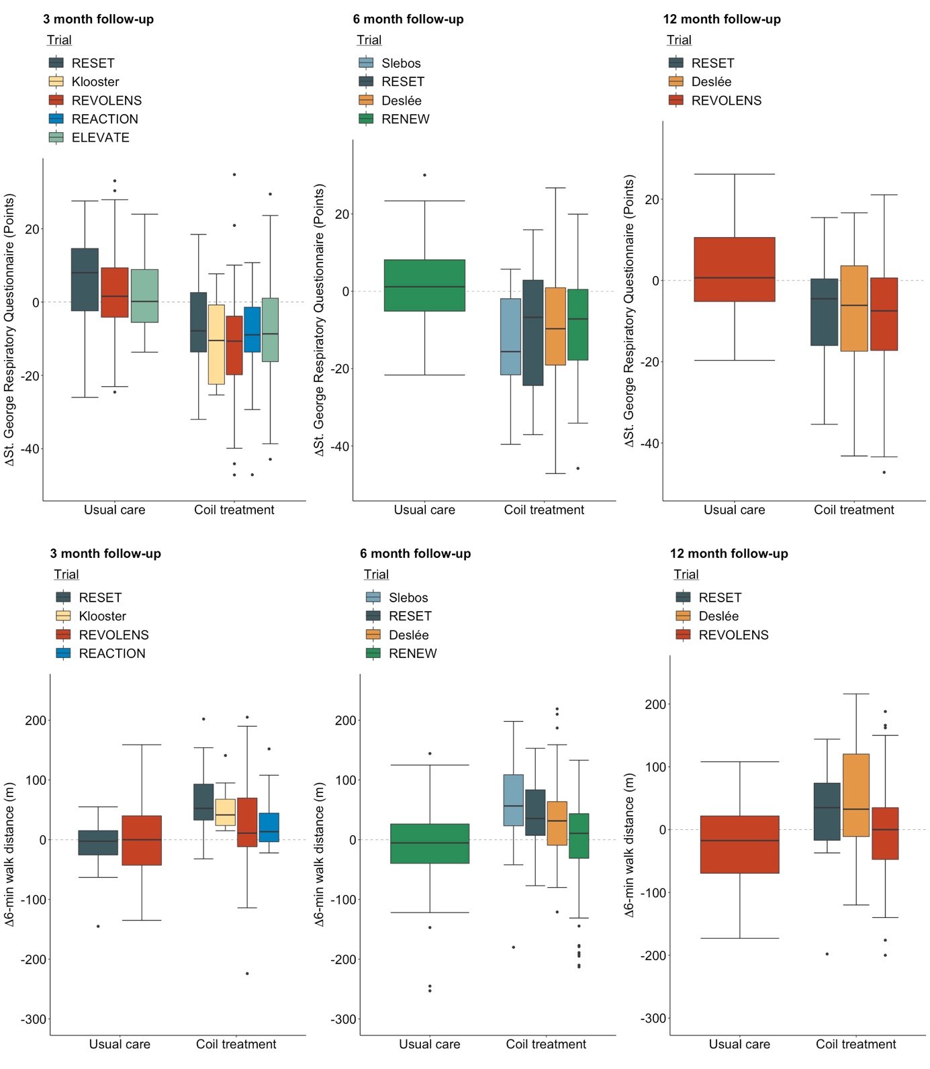

eFigure 3. Boxplots of outcome variables per trial. FEV₁, forced expiratory volume in 1 second.

