Differences in clinical presentation and management between pre- and postsurgical diagnoses of urinary bladder paraganglioma: is there clinical relevance?
a systematic review

Minghao Li ^{a,b}, Xiaowen Xu ^{b}, Nicole Bechmann ^{a,c}, Christina Pamporaki ª, Jingjing Jiang ^{d}, Stefan Propping ^{e}, Longfei Liu ^{b}, Hans Langenhuijsen ^{f}, Karel Pacak ^{g}, Graeme Eisenhofer ^{a,c}, Jacques W. M. Lenders ^{a,h*}

ª Department of Medicine III, Technische Universität Dresden, Dresden, Germany;
^{b} Department of Urology, Xiangya Hospital, Central South University, Changsha, China;
^{c} Institute of Clinical Chemistry and Laboratory Medicine, Technische Universität Dresden, Dresden, Germany;
^{d} Department of Endocrinology and Metabolism, Zhongshan Hospital Fudan University, Shanghai, China;
^{e} Department of Urology, Technische Universität Dresden, Dresden, Germany;
^{f} Department Urology, Radboud University Medical Center, Nijmegen, The Netherlands;
^{g} Section on Medical Neuroendocrinology, Eunice Kennedy Shriver National Institute of Child Health and Human Development, National Institutes of Health, Bethesda, Maryland, US;
^{h} Department of Internal Medicine, Radboud University Medical Center, Nijmegen, The Netherlands

*Correspondence to Jacques W.M. Lenders, MD, PhD, Radboud University Medical Center, Nijmegen, Department of Internal Medicine, P.O. Box 6500 HB, Geert Grooteplein Zuid 8, Nijmegen, 6525GA, The Netherlands.
Tel: +31243618819; fax: +31243541734; e-mail: Jacques.lenders@radboudumc.nl

ORCID: ML: 0000-0001-9267-0471; NB: 0000-0002-6932-333X

Table S1. Items for data extraction and definitions.
Items | Definitions/Explanations | Outcome and measurement units
Paper number | Number of paper | Number
Case number | Number of a case | Number
Author | First author | Name of first author
Journal | Name of journal | Abbreviated name of journal
Year | Year of publication | Year
Sex | Gender of patient | M/F/not reported
Age | Age at diagnosis | Number (years)
Primary UBPGL | Diagnosed as primary UBPGL. yes: if reported or if clear from description; no: if reported as absent | Yes/no/not reported
Diagnosis of UBPGL | Pre-surgical: a clear diagnosis of UBPGL before initial surgery; Post-surgical: a clear diagnosis of UBPGL after initial surgery | Pre-surgical/Post-surgical/not reported
Sweating | Excessive profuse sweating | Yes/no/not reported
Headache | Paroxysmal or sustained headache | Yes/no/not reported
Palpitations | Palpitations or reporting fast heartbeats | Yes/no/not reported
Hypertension | Known with history of hypertension or diagnosed hypertension before surgery defined as BP >140/90 or at antihypertension-medication | Yes/no/not reported
Nausea/vomiting | Nausea and/or vomiting | Yes/no/not reported
Hematuria | Hematuria (microscopic or macroscopic) | Yes/no/not reported
Other symptoms | Any other symptom believed to be related to the UBPGL | Free text
Catecholamine related Symptoms | Sweating, headache, palpitations or nausea/vomiting | Yes/no/not reported
Catecholamine related symptoms related to micturition | Catecholamine related symptoms elicited by micturition (during or after micturition) | Yes/no/not reported
Presurgical systolic BP | Highest systolic BP value before surgery (with or without details of measurement procedure) | mmHg
Presurgical diastolic BP | Highest diastolic BP value before surgery (with or without details of measurement procedure) | mmHg
Biopsy | Biopsy done before initial surgery. | Yes/no/not reported
Diagnosis of UBPGL by biopsy before surgery | Yes; UBPGL confirmed by pathology examination of biopsied tissue before surgery; no: if not a clear diagnosis of UBPGL according to the pathology of biopsy before surgery | Yes/no/not reported
Biochemical testing done before surgery | Any biochemical test (metanephrines, catecholamines and/or VMA of plasma and/or 24 hours urine) done before surgery | Yes/no/not reported
Result of biochemical testing | Yes: elevated result of any of biochemical tests; no: not elevated result of any of biochemical measurements | Yes/no
Alpha-adrenergic blockade before surgery | Yes; use of any alpha-adrenergic blocker as preparation for initial surgery; no: if not reported | Yes/no
Systolic BP during surgery | Maximal reported systolic BP during surgery | mmHg
Diastolic BP during surgery | Maximal reported diastolic BP during surgery | mmHg
Cardiovascular accident during surgery | Occurrence of any cardiovascular accident during surgery | Yes/no/not reported
Surgical procedure | Initial surgery approach, including patients in whom surgery had to be abandoned | TUR/Partial cystectomy/Radical cystectomy/not reported.
Discontinued surgery | Patients with surgery had to be interrupted and discontinued because of complications such as high blood pressure. | Yes/no
Residual tumor | Residual tumor after first surgery as verified by biochemical testing after surgery and/or by pathological evidence in case of additional surgery for the same tumor. | Yes/no/not reported
Additional surgery | Yes: if additional surgery was reported for patients with residual tumor or after discontinued surgery; no: if additional surgery was reported as not done for patients with residual tumor or discontinued surgery; or not reported | Yes/no/not reported
Surgical procedure of additional surgery | Additional surgery approach for patients with surgery discontinued or residual tumor | TUR/Partial cystectomy/Radical cystectomy/not reported.
Tumor size | Reported size according to imaging or pathology: if size was reported by less than three diameters, volume was calculated assuming the diameters were similar in all three directions. | cm³
M male, F female, UBPGL urinary bladder paraganglioma, BP blood pressure, TUR transurethral resection, VMA Vanillylmandelic acid.

Table S2. Papers and cases included.
Paper No | Case No | Author | Journal | Year
1 | 1 | Jandou, I | Int J Surg Case Rep | 2020
2 | 2 | Teragaki, M | Intern Med | 2020
3 | 3 | Tan, J.L | ANZ J Surg | 2020
4 | 4 | Wang, S | Urol J | 2020
5 | 5 | Johnson, J.T | BMJ Case Rep | 2020
6 | 6 | Kazakova, V | BMJ Case Rep | 2020
7 | 7 | Rzepka, E | Endokrynol Pol | 2020
8 | 8 | Degrieck, B | J Belg Soc Radiol | 2020
9 | 9 | Choi, Y.H | Urology | 2020
10 | 10 | Sonmez, G | Urol Case Rep | 2020
11 | 11 | Yoo, K.H | Pathol Oncol Res | 2020
12 | 12 | Li, H | Mol Clin Oncol | 2020
 | 13 | Li, H | Mol Clin Oncol | 2020
 | 14 | Li, H | Mol Clin Oncol | 2020
 | 15 | Li, H | Mol Clin Oncol | 2020
13 | 16 | Sunil, V.N | BMJ Case Rep | 2020
14 | 17 | Kurose, H | IJU Case Rep | 2020
15 | 18 | Alkhatatbeh, H | Urol Case Rep | 2020
16 | 19 | Cakici, M.C | J Coll Physicians Surg Pak | 2020
17 | 20 | Falcão, G | Pan Afr Med J | 2020
18 | 21 | Bosserman, A.J | Clin Nucl Med | 2019
19 | 22 | Chan, V | BMJ Case Rep | 2019
20 | 23 | Sugimura, R | IJU Case Rep | 2019
21 | 24 | Alanee, S | Urol Case Rep | 2019
22 | 25 | Roehmholdt, M | Curr Urol | 2019
23 | 26 | Białek, W | J Ultrason | 2019
24 | 27 | Hermi, A | Case Rep Urol | 2019
25 | 28 | Urabe, F | IJU Case Rep | 2019
26 | 29 | Malhotra, A.K | Can Urol Assoc J | 2018
27 | 30 | Chaaya, G | Am J Med Sci | 2018
28 | 31 | El-Tholoth, H.S | J Endourol Case Rep | 2018
29 | 32 | Kido, K | Transplant Proc | 2018
30 | 33 | Romano, I.J | J Am Soc Hypertens | 2018
31 | 34 | Kroiss, A.S | Rev Esp Med Nucl Imagen Mol | 2018
32 | 35 | Kaulanjan, K | J Endourol Case Rep | 2018
33 | 36 | Mahjoubi, Z | Urol Case Rep | 2018
34 | 37 | Kumar, A.V | Nephrology (Carlton) | 2017
35 | 38 | Lee, J | Diagn Cytopathol | 2017
36 | 39 | Youssef, A | Urol Case Rep | 2017
37 | 40 | Mithqal, A | Clin Nucl Med | 2017
38 | 41 | Lazareth, H | Mol Clin Oncol | 2017
39 | 42 | Fernandes, A.M | Radiol Bras | 2017
40 | 43 | El, A.A | BMJ Case Rep | 2017
41 | 44 | Wen, C.Y | Ci Ji Yi Xue Za Zhi | 2017
42 | 45 | Williams, P | JAAPA | 2017
43 | 46 | Hu, W | Int J Clin Exp Pathol | 2017
44 | 47 | Iwamoto, G | J Med Case Rep | 2017
45 | 48 | Ravichandran-Chandra, A | Cent European J Urol | 2017
46 | 49 | Yadav, S | BMJ Case Rep | 2016
47 | 50 | Spessoto, L.C | Urol Case Rep | 2016
48 | 51 | Gkikas, C | Urol Case Rep | 2016
49 | 52 | Yang, C | Oncol Lett | 2016
50 | 53 | Jain, T.K | World J Nucl Med | 2016
51 | 54 | Bishnoi, K | J Robot Surg | 2016
52 | 55 | Katiyar, R | J Clin Diagn Res | 2016
 | 56 | Katiyar, R | J Clin Diagn Res | 2016
53 | 57 | Gupta, S | Endocr Pathol | 2016
54 | 58 | You, D | Mol Clin Oncol | 2016
55 | 59 | Marić, P | Vojnosanit Pregl | 2016
56 | 60 | Ching, D | Int J Surg Case Rep | 2016
57 | 61 | Salvatori, R | Endocrine | 2015
58 | 62 | Sangwatanaroj, S | Am J Med Sci | 2015
59 | 63 | Han, Y.J | Sao Paulo Med J | 2015
60 | 64 | Quist, E.E | Pathol Res Pract | 2015
61 | 65 | Verma, A | J Clin Diagn Res | 2015
62 | 66 | Shah, V.B | Indian J Pathol Microbiol | 2015
63 | 67 | Bagchi, A | Am J Case Rep | 2015
64 | 68 | Sherwani, P | Indian J Radiol Imaging | 2015
65 | 69 | Sajjan, R.S | Clin Nucl Med | 2015
66 | 70 | Peng, C | Oncol Lett | 2015
67 | 71 | Rayamajhi, S.J | Clin Nucl Med | 2015
68 | 72 | Priyadarshi, V | Urol Ann | 2015
69 | 73 | Valsangkar, R.S | Urol Ann | 2015
70 | 74 | Loveys, F.W | Radiographics | 2015
71 | 75 | Cai, Y | Medicine (Baltimore) | 2015
72 | 76 | Dattatrya, K.Y | J Clin Diagn Res | 2015
73 | 77 | Dragović, T | Vojnosanit Pregl | 2015
74 | 78 | Lacefield, E | Curr Urol | 2015
75 | 79 | Patnayak, R | J Cancer Res Ther | 2015
76 | 80 | Nerli, R.B | Indian J Surg Oncol | 2015
77 | 81 | Adraktas, D | Ultrasound Q | 2014
78 | 82 | Pichler, R | Urol Int | 2014
79 | 83 | Lai, Y | Oncol Lett | 2014
80 | 84 | Dhull, V.S | Clin Nucl Med | 2014
81 | 85 | Ranaweera, M | World J Clin Cases | 2014
 | 86 | Ranaweera, M | World J Clin Cases | 2014
 | 87 | Ranaweera, M | World J Clin Cases | 2014
82 | 88 | Neugarten, C.J | Urol Case Rep | 2014
83 | 89 | Calamaro, P | Anal Quant Cytopathol Histpathol | 2014
84 | 90 | Song, Y | Intern Med J | 2013
85 | 91 | Xiang, S.T | Chin Med J (Engl) | 2013
86 | 92 | Christodoulidou, M | BMJ Case Rep | 2013
87 | 93 | Beilan, J | BMC Res Notes | 2013
88 | 94 | Feng, N | Chin J Cancer | 2013
89 | 95 | Ahn, S.G | Can Urol Assoc J | 2013
90 | 96 | Maeda, M | Aktuelle Urol | 2013
91 | 97 | Kumar, U.M | J Clin Diagn Res | 2013
92 | 98 | Malik, A.A | BMJ Case Rep | 2013
93 | 99 | Li, S | Exp Ther Med | 2013
94 | 100 | Mallat, F | Case Rep Urol | 2013
95 | 101 | Li, W | Int J Clin Exp Med | 2013
96 | 102 | Khatavkar, S.S | J Anaesthesiol Clin Pharmacol | 2013
97 | 103 | Yang, Y | J Endourol | 2012
 | 104 | Yang, Y | J Endourol | 2012
 | 105 | Yang, Y | J Endourol | 2012
98 | 106 | Darlong, V | Singapore Med J | 2012
99 | 107 | Ghafoor, A.U | J Pak Med Assoc | 2012
100 | 108 | Manohar, K | Clin Nucl Med | 2012
101 | 109 | Hanji, A.M | Saudi J Kidney Dis Transpl | 2012
102 | 110 | Luchey, A | Can J Urol | 2012
103 | 111 | She, H.L | Ann Acad Med Singap | 2012
104 | 112 | El, K.F | J Med Liban | 2012
105 | 113 | Persec, Z | Coll Antropol | 2012
106 | 114 | Pahwa, H.S | BMJ Case Rep | 2012
107 | 115 | Wang, H | Eur J Radiol | 2011
 | 116 | Wang, H | Eur J Radiol | 2011
 | 117 | Wang, H | Eur J Radiol | 2011
 | 118 | Wang, H | Eur J Radiol | 2011
108 | 119 | De Pasquale, V | Urol Int | 2011
109 | 120 | Bohn, O.L | Pediatr Dev Pathol | 2011
110 | 121 | Tsai, C.C | Kaohsiung J Med Sci | 2011
 | 122 | Tsai, C.C | Kaohsiung J Med Sci | 2011
111 | 123 | Kang, S.G | Urol Int | 2011
112 | 124 | Bhalani, S.M | J Urol | 2011
113 | 125 | Zeitlin, I | Isr Med Assoc J | 2011
114 | 126 | Vyas, S | Indian J Nephrol | 2011
 | 127 | Vyas, S | Indian J Nephrol | 2011
115 | 128 | Oderda, M | Scand J Urol Nephrol | 2010
116 | 129 | Pandey, R | Minerva Anestesiol | 2010
117 | 130 | Xu, D.F | J Med Case Rep | 2010
118 | 131 | Al-Zahrani, A.A | Adv Urol | 2010
119 | 132 | Nayyar, R | JSLS | 2010
120 | 133 | Schaefer, I.M | Cancer Genet Cytogenet | 2010
121 | 134 | Ghayee, H | Endocr Relat Cancer | 2009
122 | 135 | Cho, D.K | Eur Heart J | 2009
123 | 136 | Jayram, G | J Robot Surg | 2009
124 | 137 | Chen, Y.C | Kidney Int | 2009
125 | 138 | Huang, Y | Chin Med J (Engl) | 2009
126 | 139 | Mun, K.S | Malays J Pathol | 2009
127 | 140 | Yan, J.A | ANZ J Surg | 2009
128 | 141 | Chen, C.H | Can Urol Assoc J | 2009
129 | 142 | Tazi, M.F | Cases J | 2009
130 | 143 | Vesin, C | South Med J | 2009
131 | 144 | Mou, J.W | Pediatr Surg Int | 2008
132 | 145 | Kappers, M.H | Neth J Med | 2008
133 | 146 | Fournier, J.R | P R Health Sci J | 2008
134 | 147 | Heinrich, E | Urol J | 2008
135 | 148 | Im, S.H | Headache | 2008
136 | 149 | Dhawan, D.R | Urol J | 2008
137 | 150 | Sharma, P.K | Indian J Surg | 2008
138 | 151 | Havekes, B | J Clin Endocrinol Metab | 2007
139 | 152 | Madani, R | World J Surg | 2007
 | 153 | Madani, R | World J Surg | 2007
140 | 154 | Huang, K.H | Int J Urol | 2007
141 | 155 | Kairi-Vassilatou, E | Eur J Gynaecol Oncol | 2007
142 | 156 | Sharma, S | Indian J Surg | 2007
143 | 157 | Thambugala, G.M | Australas Radiol | 2007
144 | 158 | Athyal, R.P | Australas Radiol | 2007
145 | 159 | Safwat, A.S | Can J Urol | 2007
 | 160 | Safwat, A.S | Can J Urol | 2007
 | 161 | Safwat, A.S | Can J Urol | 2007
146 | 162 | Dilbaz, B | Surg Laparosc Endosc Percutan Tech | 2006
147 | 163 | Bozbora, A | JSLS | 2006
148 | 164 | Tsutsui, A | Hinyokika Kiyo | 2006
149 | 165 | Segawa, N | Hinyokika Kiyo | 2005
150 | 166 | Purandare, N.C | J Ultrasound Med | 2005
151 | 167 | Naqiyah, I | Singapore Med J | 2005
152 | 168 | Usuda, H | Pathol Int | 2005
153 | 169 | Kovacs, K | Endocr Pathol | 2005
154 | 170 | Yoshida, S | Int J Urol | 2004
155 | 171 | Pastor-Guzmán, J.M | Urol Int | 2004
 | 172 | Pastor-Guzmán, J.M | Urol Int | 2004
156 | 173 | Minagawa, T | Hinyokika Kiyo | 2004
157 | 174 | Lawrence, J.K | Hormones (Athens) | 2004
158 | 175 | Hwang, J.J | J Urol | 2003
159 | 176 | Kang, W.Y | Kaohsiung J Med Sci | 2003
160 | 177 | Onishi, T | Int J Urol | 2003
161 | 178 | Dundr, P | Pathol Res Pract | 2003
162 | 179 | Naguib, M | Am J Clin Oncol | 2002
163 | 180 | Peczkowska, M | Blood Press | 2002
164 | 181 | Nakatani, T | Oncol Rep | 2002
165 | 182 | Lamarre-Cliche, M | Circulation | 2002
166 | 183 | Tan, S.M | Anaesth Intensive Care | 2002
167 | 184 | Doran, F | APMIS | 2002
168 | 185 | Gaur, D.D | Minim Invasive Ther Allied Technol | 2002
169 | 186 | Seki N | Urol Int | 2001
170 | 187 | Kozlowski, P.M | Urology | 2001
171 | 188 | Takezawa, Y | Hinyokika Kiyo | 2001
172 | 189 | Salanitri, J | Australas Radiol | 2001
173 | 190 | Moritani, H | Intern Med | 2001
174 | 191 | Dewan, M | J R Soc Promot Health | 2001
175 | 192 | Taue, R | Int J Urol | 2001
176 | 193 | Bonacruz, K.G | J Paediatr Child Health | 2001
177 | 194 | Ansari, M.S | Int Urol Nephrol | 2001

Table S3. Clinical features of patients with pre- or postsurgical diagnosis of urinary bladder paraganglioma.
 | Total | Presurgical diagnosis |  | Postsurgical diagnosis |  | P value
Patients, n | 194 | 90 | 104
Females, n (%)* | 98 (50.5) | 44 (48.9) | 54 (51.9) |  | 0.396
Age, mean± SD (years) | 43.6± 18.6 | 39.7± 18.7 | 47.1± 17.9 |  | 0.005
Presurgical SBP, mean± SD (mmHg)$ | 169.2± 47.9 | 184.7± 45.8 | 138± 31 |  | <0.001
Presurgical DBP, mean± SD (mmHg)$$ | 100.9± 25.2 | 108.9± 23.5 | 85.8± 18.9 |  | <0.001
Primary tumor, n (%) | 183 (94.3) | 82 (91.1) | 101 (97.1) |  | 0.117
Signs and symptoms, n (%)
- Hypertension | 95 (49.0) | 68 (75.6) | 27 (26.0) |  | <0.001
- Catecholamine-associated symptoms# | 87 (44.8) | 61 (67.8) | 26 (25.0) |  | <0.001
- Hematuria | 67 (34.5) | 21 (23.3) | 46 (44.2) |  | 0.003
- Other | 22 (11.3) | 5 (5.6) | 17 (16.3) |  | 0.022
- None | 20 (10.3) | 3 (3.3) | 17 (16.3) |  | 0.004
Catecholamine-associated symptoms, n (%)
- Sweating | 25 (12.9) | 20 (22.2) | 5 (4.8) |  | <0.001
- Headache | 63 (32.5) | 49 (54.4) | 14 (13.5) |  | <0.001
- Palpitations | 47 (24.2) | 35 (38.9) | 12 (11.5) |  | <0.001
- Nausea/vomiting | 8 (4.1) | 6 (6.7) | 2 (1.9) |  | 0.148
Catecholamine-associated symptoms triggered by  micturition, n (%) | 59 (30.4) | 46 (51.1) | 13 (12.5) |  | <0.001
Alpha-adrenergic blockade before initial surgery, n (%) | 53 (27.3) | 48 (53.3) | 5 (4.8) |  | <0.001
Initial surgical approach, n (%) |  |  |  |  | <0.001
- TUR | 78 (40.2) | 5 (5.6) | 73 (70.2)
- Partial cystectomy | 87 (44.8) | 65 (72.2) | 22 (21.2)
- Radical cystectomy | 8 (4.1) | 6 (6.7) | 2 (1.9)
- Not reported | 21 (10.8) | 14 (15.6) | 7 (6.7)
Patients with SBP >180 mmHg during surgery, n (%) | 28 (14.4) | 3 (3.3) | 25 (24) |  | <0.001
- without reported presurgical hypertension | 20 (71.4) | 1 (33.3) | 19 (76)
- with reported presurgical hypertension | 8 (28.6) | 2 (66.7) | 6 (24)
Size (cm), median (IQR)&  Cardiovascular incidents during surgery, n (%) | 3 (2.3-4.3)  10 (5.2) | 3.7 (2.6-5.0)  0 | 2.7 (2.0-3.7)  10 (9.6) |  | <0.001  0.002
Discontinued surgery, n (%) | 14 (7.2) | 1 (1.1) | 13 (12.5) |  | 0.004
Residual tumor, n (%) | 33 (17.0) | 5 (5.6) | 28 (26.9) |  | <0.001

UBPGL urinary bladder paraganglioma, SBP systolic blood pressure, DBP diastolic blood pressure, TUR transurethral resection,
IQR interquartile ranges.
* In two patients gender was not reported.
$ In 43 presurgical diagnosis and 80 postsurgical diagnosis patients SBP was not reported.
$$ In 48 presurgical diagnosis and 80 postsurgical diagnosis patients DBP was not reported.
# Patients presented with symptoms (single or multiple) in sweating, headache, palpitation or nausea/vomiting.
& Tumor size of 23 patients with presurgical diagnosis and 24 patients with postsurgical diagnosis of UBPGL were not available.

Table S4. Characteristics of patients with positive or negative biochemical testing results versus without biochemical testing.
 | Without  biochemical test | With  biochemical test
 |  | Positive  results | Negative  results
Patients, n | 90 | 82 | 22
Alpha-adrenergic blockade before surgery, n (%) | 3 (3.3) | 45 (54.9)** | 5 (22.7)$
Initial surgical approach, n (%)
- TUR | 65 (72.2) | 5 (6.1)** | 8 (36.4)$
- Cystectomy | 21 (23.3) | 65 (79.3)** | 9 (40.9)
- Not clear | 4 (4.4) | 12 (14.6)* | 5 (22.7)$
Patients with SBP>180 mmHg during surgery, n (%) | 20 (22.2) | 3 (3.7)** | 5 (22.7)
Cardiovascular incidents during surgery, n (%) | 10 (11.1) | 0* | 0
Discontinued surgery, n (%) | 12 (13.3) | 1 (1.2)* | 1 (4.5)
Residual tumor, n (%) | 25 (27.8) | 5 (6.1)** | 3 (13.6)

TUR transurethral resection, SBP systolic blood pressure
* P<0.05, ** P<0.001, indicating the differences between patients with positive biochemical testing results versus without biochemical testing.
$ P<0.05, indicating the differences between patients with negative biochemical testing results versus without biochemical testing.

Table S5. Univariable and multivariable binary logistic regression analysis of factors associated with a probability of presurgical biochemical testing.
 | Univariable logistic regression | Multivariable logistic regression
Age (year) | 0.98 (0.96-1.00)* | 0.97 (0.94-0.99)*
Size (cm)# | 1.35 (1.09-1.68)* | 1.13 (0.85-1.49)
Signs and symptoms
- Hypertension | 5.92 (3.17-11.04)** | 4.45 (1.66-11.94)*
- Catecholamine-associated symptoms | 7.06 (3.69-13.49)** | 2.33 (0.66-8.18)
- Hematuria | 0.27 (0.14-0.50)** | 0.23 (0.09-0.60)*
- Other | 0.28 (0.11-0.76)* | 0.45 (0.09-2.11)
- None | 0.68 (0.27-1.73)
Catecholamine-associated symptoms triggered by micturition | 8.33 (3.79-18.34)** | 2.14 (0.53-8.65)

Results were presented as OR (95% CI).
# There were 47 missing values.
* P<0.05; ** P<0.001

Figure S1.
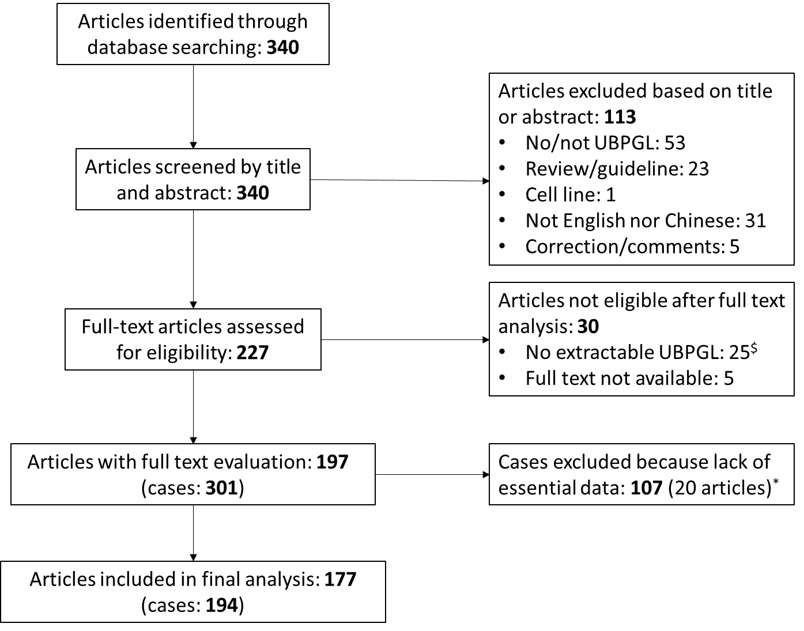

Figure S2.

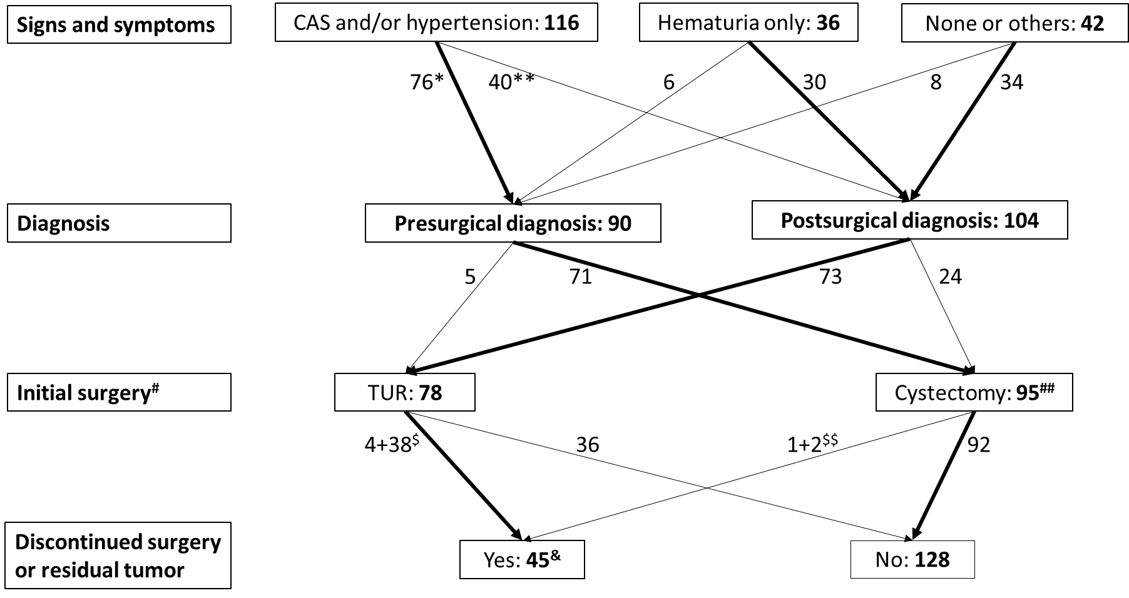

Figure S3.
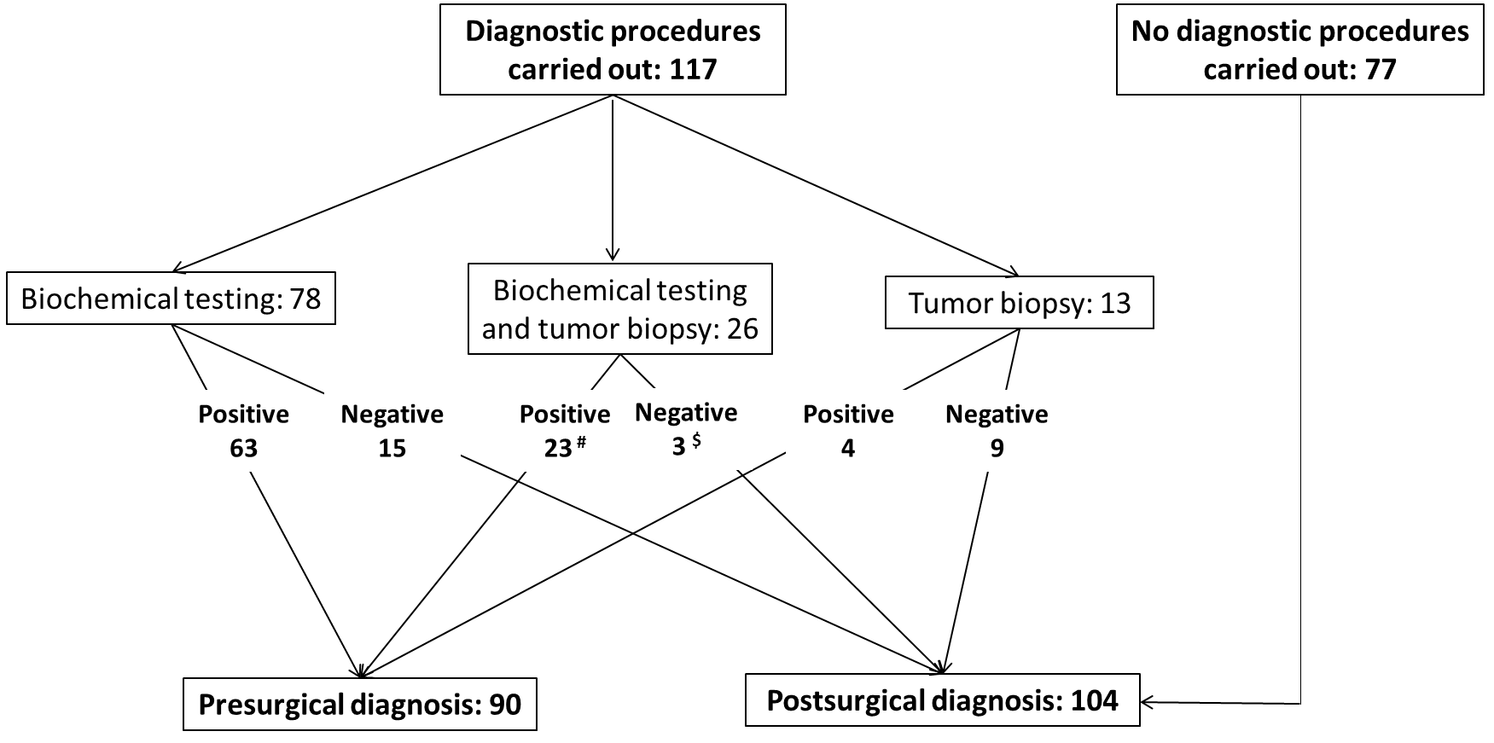
Figure legends
Figure S1: Flow chart of studies considered for analysis.
Some articles contained more than one case.
$ Twenty-five articles were excluded from further analysis because they provided no detailed description of individual clinical data in single patients.
* Twenty articles were excluded from the analysis because the times of diagnosis (before or after surgery) of the urinary bladder paraganglioma (UBPGL) was not reported.

Figure S2: Flow diagram of the number of patients in different phases of clinical management.
CAS, catecholamine-associated symptoms.
* Including 15 patients with hematuria; ** Including 16 patients with hematuria.
# Initial surgical approach was not available in 21 patients; ## Including laparoscopic or open partial cystectomy for 87 patients and radical cystectomy for eight patients.
$ Four patients were presurgically diagnosed and 38 patients were postsurgically diagnosed; $$ One patient was presurgically diagnosed and two patients were postsurgicallly diagnosed.
& Patients with discontinued surgery (n=13) or with residual tumor (n=32) after surgery.

Figure S3: Flow diagram of diagnostic procedures related to the time of diagnosis.
# Patients who had positive results of biochemical testing and/or tumor biopsy.
$ Patients who had negative results of biochemical testing and tumor biopsy.

