SUPPLEMENTARY MATERIAL
Search Strategy MEDLINE (PubMed) d.d. 02-07-2020
#1 | "Colorectal Surgery"[Mesh] OR "Colectomy"[Mesh] OR colectom*[tiab] OR hemicolectom*[tiab] OR "Proctectomy"[Mesh] OR proctectom*[tiab] OR ((colorectal[tiab] OR "Colon"[Mesh] OR colon*[tiab] OR "Rectum"[Mesh] OR rectum*[tiab] OR rectal[tiab] OR large bowel[tiab] OR ileocecal[tiab] OR ileocaecal[tiab] OR ileocolon*[tiab]) AND (surger*[tiab] OR surgical[tiab] OR "surgery"[Subheading] OR "Surgical Procedures, Operative"[Mesh] OR resection*[tiab]))
#2 | "Metabolic Syndrome"[Mesh] OR metabolic syndrome*[tiab] OR insulin resistance syndrome[tiab] OR metabolic X syndrome[tiab] OR dysmetabolic Syndrome[tiab] OR reaven syndrome[tiab] OR metabolic cardiovascular syndrome*[tiab] OR syndrome X[tiab] OR deadly quartet[tiab] OR MetS[tiab] OR "Glucose Intolerance"[Mesh] OR "Blood Glucose"[Mesh] OR "Hyperglycemia"[Mesh] OR "Glycated Hemoglobin A"[Mesh] OR "Diabetes Mellitus"[Mesh:NoExp] OR "Diabetes Mellitus, Type 2"[Mesh] OR "Prediabetic State"[Mesh] OR "Insulin Resistance"[Mesh] OR "Hyperinsulinism"[Mesh] OR glucose intoleran*[tiab] OR glucose toleran*[tiab] OR glucose dysregulation[tiab] OR igt[tiab] OR blood glucose[tiab] OR blood sugar[tiab] OR plasma glucose[tiab] OR glucose level*[tiab] OR glucose blood[tiab] OR fasting glucose[tiab] OR hyperglycem*[tiab] OR hyperglycaem*[tiab] OR Hb A1c[tiab] OR HbA1c[tiab] OR Hemoglobin A1c[tiab] OR diabet*[tiab] OR type 2 dm[tiab] OR type II dm[tiab] OR dm type 2[tiab] OR dm type II[tiab] OR NIDDM[tiab] OR IDDM[tiab] OR insulin resistan*[tiab] OR insulin sensitiv*[tiab] OR insulin insensitiv*[tiab] OR homa-ir[tiab] OR homa2[tiab] OR hyperinsulin*[tiab] OR prediabet*[tiab]
#3 | "Postoperative Complications"[Mesh] OR "Treatment Outcome"[Mesh] OR ((postoperative[tiab] OR post operative[tiab] OR postsurgical[tiab] OR post surgical[tiab] OR postsurgery[tiab] OR post surgery[tiab] OR perioperative[tiab] OR peri operative[tiab]) AND (complication*[tiab] OR outcome*[tiab])) OR "Length of Stay"[Mesh] OR length of stay[tiab] OR stay length*[tiab] OR hospital stay*[tiab] OR "Anastomotic Leak"[Mesh] OR anastomotic leak*[tiab] OR anastomotic dehiscence*[tiab] OR "Mortality"[Mesh] OR mortalit*[tiab] OR morbimortalit*[tiab] OR death rate*[tiab] OR case fatality rate*[tiab]
#4 | #1 AND #2 AND #3
#5 | #1 AND #2 AND #3 Filters: Publication date from 1998/01/01

Search strategy EMBASE (Ovid) d.d. 09-07-2020

1 | exp colorectal surgery/
2 | exp colon resection/
3 | exp rectum resection/
4 | (colectom* or hemicolectom* or proctectom*).ab,kw,ti.
5 | (colorectal or colon* or rectum* or rectal or large bowel or ileocecal or ileocaecal or ileocolon*).ab,kw,ti.
6 | exp colon/
7 | exp rectum/
8 | 5 or 6 or 7
9 | exp surgery/
10 | (surger* or surgical or resection*).ab,kw,ti.
11 | 9 or 10
12 | 8 and 11
13 | 1 or 2 or 3 or 4 or 12
14 | exp metabolic syndrome X/ or exp glucose intolerance/ or exp glucose blood level/ or exp hyperglycemia/ or exp glycosylated hemoglobin/ or exp diabetes mellitus/ or exp insulin dependent diabetes mellitus/ or exp non insulin dependent diabetes mellitus/ or exp impaired glucose tolerance/ or exp insulin resistance/ or exp hyperinsulinism/
15 | (metabolic syndrome or glucose intoleran* or glucose toleran* or glucose dysregulation or igt or blood glucose or blood sugar or plasma glucose or glucose level or glucose blood or fasting glucose or hyperglycem* or hyperglycaem* or Hb A1c or HbA1c or Hemoglobin A1c or diabet* or type 2 dm or type II dm or NIDDM or IDDM or insulin resistan* or insulin sensitiv* or homa-ir or homa2 or hyperinsulin* or prediabet*).ab,kw,ti.
16 | 14 or 15
17 | exp postoperative complication/
18 | exp treatment outcome/
19 | exp "length of stay"/
20 | exp anastomosis leakage/
21 | exp mortality/
22 | ((postoperative or post operative or postsurgical or post surgical or postsurgery or post surgery or perioperative or peri operative) and (complication* or outcome*)).ab,kw,ti.
23 | (length of stay or stay length* or hospital stay*).ab,kw,ti.
24 | (anastomotic leak* or anastomotic dehiscence*).ab,kw,ti.
25 | (mortalit* or morbimortalit* or death rate* or case fatality rate*).ab,kw,ti.
26 | 17 or 18 or 19 or 20 or 21 or 22 or 23 or 24 or 25
27 | 13 and 16 and 26
28 | limit 27 to yr="1998 -Current"
29 | limit 28 to conference abstracts
30 | 28 not 29

Search strategy Cochrane Library d.d. 09-07-2020
#1 | (colectom* OR hemicolectom* OR proctectom*):ti,ab,kw
#2 | (colorectal OR colon OR rectum OR rectal OR "large bowel" OR ileoc*cal OR ileocolon):ti,ab,kw
#3 | (surger* OR surgical OR resection*):ti,ab,kw
#4 | #2 AND #3
#5 | #1 OR #4
#6 | ("metabolic syndrome" OR "insulin resistance syndrome" OR "metabolic X syndrome" OR "dysmetabolic syndrome" OR "raeven syndrome" OR "metabolic cardiovascular syndrome" OR "syndrome X" OR "deadly quartet" OR MetS):ti,ab,kw
#7 | glucose OR hyperglyc*mia OR h*moglobin OR diabetes OR diabetic OR prediabetic OR insulin OR hyperinsulinism OR "blood sugar"
#8 | #6 OR #7
#9 | #5 AND #8
#10 | (postoperative OR “post operative” OR postsurgical OR “post surgical” OR postsurgery OR “post surgery” OR perioperative OR “peri operative”):ti,ab,kw AND (complication* OR outcome*):ti,ab,kw
#11 | "length of stay" OR stay length* OR hospital stay* OR anastomotic leak* OR “anastomotic dehiscence” OR mortalit* OR morbimortalit* OR death rate* OR fatality rate*
#12 | #10 OR #11
#13 | #5 AND #9 AND #12

Supplementary Table 1. Inclusion and exclusion criteria based on CHARMS checklist ¹⁷
Inclusion criteria | Exclusion criteria
Study type
- Published peer-reviewed retrospective and prospective observational studies (e.g. cohort, cross-sectional and case-control studies) | - Interventional studies, systematic reviews, narrative reviews, meta-analyses, opinions, clinical guidelines, editorials, case reports, congress abstracts
Population
- Adult patients (≥18 years of age) | - Patients < 18 years of age
- Patients who underwent colorectal, colonic or rectal surgery | - Minor procedures (day surgical procedures)
- Indication for surgery; malignant or benign disease
Index prognostic factor
- Studies reporting the relationship between MetS (compared with non-MetS) or preoperative hyperglycemia (compared with normoglycemia)  - MetS defined by the NCEP ATP III, AHA, WHO or IDF criteria  - Hyperglycemia defined by one or more of the following measures: FPG, OGTT, HbA1c, random BG | - Studies reporting on an individual component of metabolic syndrome rather than the syndrome
Outcome
- Studies reporting on one of the following outcomes: any complication, severe complication, CAL, SSI, mortality or LoS.

Timing
- Hyperglycemia had to be defined before surgery  - Follow-up information within 30 to 90 days after surgery | - Studies reporting on intraoperative and postoperative glycemic measurements.
Setting
- Elective and emergency surgery

Abbreviations: AHA/NHLBI, American Heart Association/National heart, Lung and Blood Institute Scientific Stagement; BG, blood glucose; CAL, colorectal anastomotic leakage; FPG, fasting plasma glucose; HbA1c, hemglobin A1c; IDF, International Diabetes Federation; LoS, Length of stay; MetS, Metabolic syndrome; NCEP ATP III, National Cholesterol Education Program Adult Treatment Panel III; OGTT, oral glucose tolerance test; SSI, Surgical site infection; WHO World Health Organisation

Supplementary Table 2. Risk of bias of included studies (n = 13)
 | Selection  (0-4) |  |  |  | Comparability  (0-2) | Outcome  (0-4) |  |  | Total  count
Metabolic Syndrome
Zarzavadjian et al. ²² | * | * | * | * |  | * | * | * | 7
Akinyemiju et al. ²³ | * | * | * | * | * * | * |  |  | 7
Shariq et al. ²⁴ | * | * | * | * | * * | * | * | * | 9
Goulart et al. ²⁵ ª | * | * | * | * |  | * | * | * | 7
Lohsiriwat. et al. ²⁶ | * | * | * | * | * * |  | * | * | 7
Zhou et al. ²⁷ | * | * | * | * | * * | * | * | * | 9
Preoperative hyperglycemia
Chen et al. ³³ | * | * | * | * | * * | * | * | * | 9
Gachabayov et al. ³¹ | * | * | * | * |  | * | * | * | 7
Goh et al. ³⁰ |  | * | * | * | * * | * |  |  | 6
Gustafsson et al. ²⁸ |  | * | * | * | * * | * | * | * | 8
Jiang et al. ³⁴ | * | * | * | * | * * | * | * | * | 9
Silvestri et al. ³² | * | * | * | * |  | * | * | * | 7
Ziegler et al. ²⁹ | * | * | * | * |  |  | * | * | 6
The Newcastle-Ottawa Scale (NOS) score, based on three domains; selection (0-4 points), comparability (0-2) outcomes of interest (0-3 points). A total score of 8-9 is considered as high, 6-7 as moderate and ≤ 5 as low level of quality.
ª This study reported on both MetS and hyperglycemia as a component of MetS

a 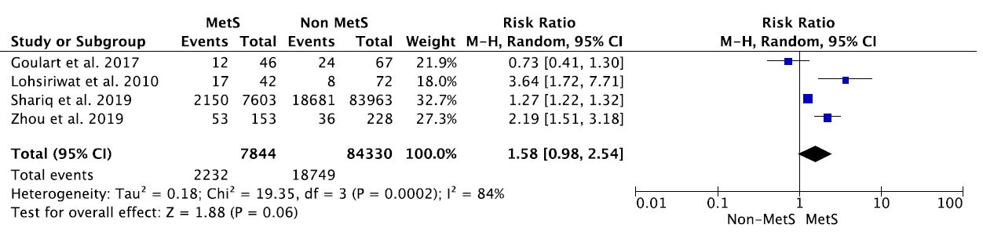b 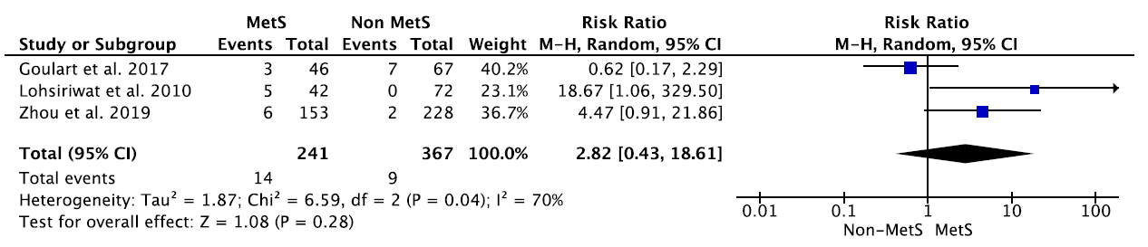
c 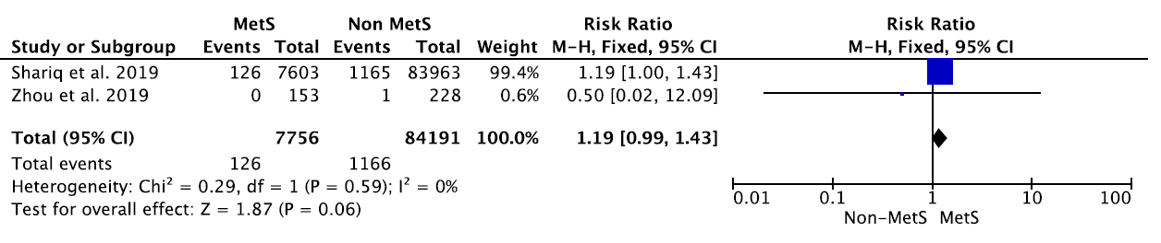
Supplementary Figure 1. Sensitivity analyses excluding the study of Zarzavadjian Le Bian et al. ²² based on length of follow-up. Forest plot showing the relationship between MetS and any complication (a), anastomotic leakage (b), and mortality (c). Abbreviations: CI, confidence interval; M-H, Mantel Haenszel; MetS, metabolic syndrome; Random; random-effects modelling.

