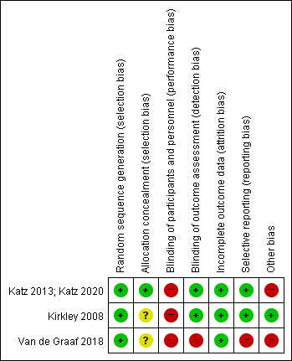
(A)

(B)
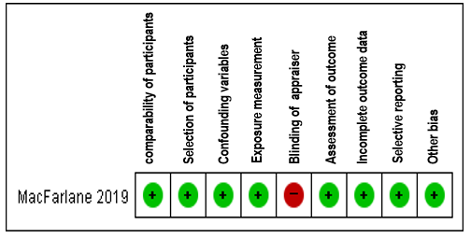
Supplementary Fig. 1. Risk of bias assessment. (A) Randomized controlled trial: Cochrane Risk of Bias tool. (B) Cohort study: Risk of Bias for Nonrandomized Studies tool.

