Supplementary data
Table S1. Search strategy and study selection.
1. Research question: PICO approach
Person (P) | People with drug-resistant tuberculosis
Intervention (I) | Treatment with bedaquiline-containing regimens
Comparator (C) | -
Outcome (O) | Frequency of acquired bedaquiline resistance
2. Objectives
Primary | Estimation of the frequency of acquired bedaquiline resistance
Secondary | Assessment of trial characteristics, treatment regimens and treatment outcomes  Analysis of patient features with acquired bedaquiline resistance (e.g. resistance profile, treatment regimen and duration)
3. Search terms
CENTRAL | ‘bedaquiline AND resistan*’ (full text)
PubMed | ‘bedaquiline resistan*’ (full text, automated term mapping)
Embase | ‘”bedaquiline NEAR/10 resistan*”’ (full text)
4. Study selection
Inclusion  criteria | English language  Only human participants  Only original studies  Mycobacterium tuberculosis  Bedaquiline-containing regimens  Sequential bedaquiline drug-susceptibility testing  Not solely reporting on bedaquiline resistance
Exclusion criteria | Article not available in English  Animal studies  No original studies (e.g. reviews)  No Mycobacterium tuberculosis (e.g. non-tuberculous mycobacteria)  No bedaquiline-containing regimens  No clear denominator for number of patients treated with a bedaquiline-containing regimen  No sequential bedaquiline drug-susceptibility testing  Average treatment duration < 6 months  Solely reporting on bedaquiline resistance (e.g. case reports)

Table S2. Calculation of the frequency of acquired bedaquiline resistance.
Measure | Numerator | Denominator
Phenotypic ABR | Number of patients with  MIC-basedª ABR | Number of patients treated with BDQ and  without baseline MIC-based^{b} BDQ resistance
Genotypic ABR | Number of patients with  RAV-based^{c} ABR | Number of patients treated with BDQ and  without baseline RAV-based^{d} BDQ resistance
Phenotypic ABR with adverse outcome^{e} | Number of patients with  MIC-basedª ABR and adverse outcome^{e} | Number of patients treated with BDQ and  without baseline MIC-based^{b} BDQ resistance
Genotypic ABR with adverse outcome^{e} | Number of patients with  RAV-based^{c} ABR and adverse outcome^{e} | Number of patients treated with BDQ and  without baseline RAV-based^{d} BDQ resistance
7H9/7H11: Middlebrook 7H9 broth or 7H11 agar base, ABR: Acquired bedaquiline resistance, BDQ: Bedaquiline, MGIT: Mycobacteria growth indicator tube, RAV: Resistance-associated variant
ª In patients initially susceptible to BDQ, phenotypic ABR (MIC-based) was defined when the follow-up MIC was either above defined thresholds (7H9/7H11: 0,25 mg/L; in MGIT: 1 mg/L) or was increased at least 4-fold but not lower than 0.12 mg/L on 7H9/7H11 or 0.5 mg/L on MGIT
^{b} Phenotypic baseline BDQ resistance (MIC-based) was defined when the initial MIC was above certain thresholds (7H9/7H11: 0.25 mg/L; MGIT: 1 mg/L)
^{c} The appearance of any new Rv0678, atpE or pepQ mutations in sequential isolates was considered as genotypic ABR (RAV-based)
^{d} Genotypic baseline BDQ resistance (RAV-based) was defined when the initial genotyping showed a Rv0678, atpE or pepQ mutation
^{e} Adverse outcomes were treatment failure, death and loss to follow-up

Study | Patients with ABR |  | Mutations (type, number and percentage) |  |  |  | Median number of acquired mutations per patient (range) |  |  |  | Median month when ABR was detected (IQR)³ | Median change in MIC (IQR) | Median MIC when ABR was detected in mg/L (IQR) | Outcomes of patients with ABR
Study | MIC¹ | RAV² | Rv0678 | atpE | pepQ | Rv1979c | Rv0678 | atpE | pepQ | Rv1979c | Median month when ABR was detected (IQR)³ | Median change in MIC (IQR) | Median MIC when ABR was detected in mg/L (IQR) | MIC¹ | RAV²
Conradie et al. 2020 ³⁶ | 1 | 1 | 1/1  (100.0 %) | N/A | N/A | N/A | 1  (1) | N/A | N/A | N/A | N/A | MGIT: 8x  (-) | MGIT: 4  (-) | 1 FL | 1 FL
Ghodousi et al. 2019ª ¹⁴ | 8 | 11 | 8/15  (53.3 %) | 0/15  (0.0 %) | 6/15  (40.0 %) | 1/15  (6.7 %) | 1  (1-2) | 0  (0) | 1  (1-2) | 1  (0) | 4  (2.5-5.5) | 7H11: 4x (1.75-8x) | 7H11: 0.185 (0.06-0.3125)^{b} | 2 CU, 5 FL,  1 D | 5 CU, 6 FL
Liu et al. 2020 ³⁷ | 8 | 5 | 5/5  (100.0 %) | 0/5  (0 %) | 0/5  (0.0 %) | 0/5  (0 %) | 1  (1) | 0  (0) | 0  (0) | 0  (0) | N/A | 7H9: 6x  (4-8x) | 7H11 : 0.25 (0.12-0.25) | 5 CC,  3 CNC | 2 CC, 3 CNC
Nimmo et al. 2020a^{c} ¹⁶ | 6 | 5 | 6/12  (50.0 %) | 0/12  (0.0 %) | 0/12  (0.0 %) | 6/12  (50.0 %) | 1  (1-9) | 0  (0) | 0  (0) | 1  (1-2) | 4  (2.5-5.5) | 7H11: 12x  (8-32x) | 7H11: 0.5  (0.3125-0.875) | 1 SU, 1 FL,  4 D | 1 SU, 1 FL, 3 D
Nimmo et al. 2020b ³⁸ | 9 | 8 | 9/17  (52.9 %) | 0/17  (0.0 %) | 0/17  (0 %) | 8/17  (47.1 %) | 1  (1-9) | 0  (0) | 0  (0) | 1  (1-2) | 4  (2-6) | 7H11: 8x  (8-20x)^{d} | 7H11: 0.5  (0.25-0.625)^{d} | 1 SU, 1 FL,  4 D, 2 N/A | 1 SU, 1 FL, 3 D, 3 N/A
Diacon et al. 2014 ³⁹ | 1 | 0 | N/A | 0/1  (0.0 %) | N/A | N/A | N/A | N/A | N/A | N/A | N/A | 7H11: 4x  (-) | N/A | N/A | N/A
Pym et al. 2016 ¹⁷ | 12 | 12 | 12/12  (100.0 %) | 0/12  (0.0 %) | N/A | N/A | N/A | N/A | N/A | N/A | N/A | N/A | N/A | 5 SU, 3 FL,  4 N/A | 5 SU, 3 FL,  4 N/A
Guglielmetti et al. 2017 ⁴⁰ | 1 | N/A | N/A | N/A | N/A | N/A | N/A | N/A | N/A | N/A | 14  (-) | N/A | N/A | 1 FL | N/A
Guglielmetti et al. 2018 ⁴¹ | 0 | N/A | N/A | N/A | N/A | N/A | N/A | N/A | N/A | N/A | N/A | N/A | N/A | 0 | N/A
Diacon et al. 2012 ²² | 0 | N/A | N/A | N/A | N/A | N/A | N/A | N/A | N/A | N/A | N/A | N/A | N/A | 0 | N/A
Kempker et al. 2020 ⁴² | 1 | N/A | N/A | N/A | N/A | N/A | N/A | N/A | N/A | N/A | N/A | 7H9: 8x  (-) | 7H9: 0.03  (-) | N/A | N/A
Mokrousov et al. 2020 ⁴³ | N/A | 5 | 4/5  (80.0 %) | 1/5  (20.0 %) | 0/5  (0.0 %) | 0/5  (0.0 %) | 1.5  (1-4) | 1  (1) | 0  (0) | 0  (0) | N/A | N/A | N/A | N/A | 4 FL,  1 LTFU
Nimmo et al. 2020c ⁴⁴ | N/A | 6 | 6/6  (100.0 %) | 0/6  (0.0 %) | 0/6  (0.0 %) | N/A | 1.5  (1-8) | 0  (0) | 0  (0) | N/A | 5  (2-6) | N/A | N/A | N/A | N/A
Table S3. Summary of characteristics of individual patients.
7H9/7H11: Middlebrook 7H9 broth or 7H11 agar base, ABR: Acquired bedaquiline resistance, CC: Culture converted, CNC: Culture non-conversion, CU: Cured, D: Death, FL: Failure, LTFU: Loss to follow-up, MGIT: Mycobacteria growth indicator tube, N/A: Not available, RAV: Resistance-associated variant, SU: Successful
¹ In patients initially susceptible to BDQ, phenotypic ABR (MIC-based) was defined when the follow-up MIC was either above certain thresholds (7H9/7H11: 0.25 mg/L; MGIT: 1 mg/L) or was increased at least 4-fold but not lower than 0.12 mg/L on 7H9/7H11 or 0.5 mg/L on MGIT
² The appearance of any new Rv0678, atpE or pepQ mutations in sequential isolates was considered as genotypic ABR (RAV-based)
³ Primarily based on MIC evolution. If no MIC data was available, based on the appearance of Rv0678, atpE or pepQ mutations
ª Complemented with data from Tahseen et al. 2020 ¹⁹
^{b} Not available for 2 patients
^{c} Complemented with data from Nimmo et al. 2020b ³⁸
^{d} MIC data was not available for one patient with BDQ RAV
Table S4. Individual treatment regimens, DST results and treatment outcomes in patients with acquired BDQ resistance (if reported).
Study | Pat. | TBH | BDQ-containing regimen¹ | Initial resistance² | DST profile | Number of LEDs³ | BDQ Protection⁴ | BDQ mutation and month |  | Change in MIC in mg/L⁵ | OC
Ghodousi et al. 2019ª ¹⁴ | 1 | N/A | BDQ, LZD, ETO, CFZ, Z, MFX, AM, E | MFX, AM, E | pre-XDR | 5 | LZD | Rv0678: | M4 | 7H11:  0.12 → 0.5 | FL
Ghodousi et al. 2019ª ¹⁴ | 2 | N/A | BDQ, LFX, LZD, ETO, CFZ, CS, AM, PAS, Z | Z | MDR | 5 | FQ, LZD | Rv0678:  Rv1979c: | M5  M0 | 7H11:  0.03 → 0.5 | CU
Ghodousi et al. 2019ª ¹⁴ | 3 | N/A | BDQ, MFX, CM, LZD, CFZ, CS, PAS, ETO, E, Z | ETO, E, Z | MDR | 5 | FQ, SLID, LZD | Rv0678:  pepQ: | M6  N/A | 7H11:  0.06 → 0.25 | FL
Ghodousi et al. 2019ª ¹⁴ | 4 | N/A | BDQ, LZD, CFZ, CS, PAS, MFX, CM, ETO, Z | MFX, CM, ETO, Z | XDR | 3 | LZD | Rv0678: | M7 | 7H11:  0.03 → 0.25 | CU
Ghodousi et al. 2019ª ¹⁴ | 5 | N/A | BDQ, LZD, CFZ, CS, LFX, ETO, E, H, Z | LFX, ETO, E, H, Z | pre-XDR | 3 | LZD | Rv0678: | M3 | 7H11:  0.03 → 0.12 | FL
Ghodousi et al. 2019ª ¹⁴ | 6 | N/A | BDQ, LZD, DLM, ETO, CFZ, LFX, H, Z | LFX, H, Z | pre-XDR | 5 | LZD | Rv0678: | M1 | 7H11:  0.03 → 0.5 | FL
Ghodousi et al. 2019ª ¹⁴ | 7 | N/A | BDQ, LZD, CFZ, CS, AM, PAS | MFX, CM, ETO, Z | XDR | 3 | LZD | Rv0678:  pepQ: | M5  N/A | 7H11:  0.03 → 0.12 | FL
Ghodousi et al. 2019ª ¹⁴ | 8 | N/A | BDQ, LZD, CFZ, CS, LFX, ETO, H, Z | LFX, ETO, H, Z | pre-XDR | 3 | LZD | WT |  | 7H11:  0.03 → 0.25 | D
Ghodousi et al. 2019ª ¹⁴ | 9 | N/A | BDQ, LZD, CFZ, CS, PAS, LFX, ETO, E, Z | LFX, ETO, E, Z | pre-XDR | 3 | LZD | pepQ: | M9 | 7H11:  0.12 → 0.06 | CU
Ghodousi et al. 2019ª ¹⁴ | 10 | N/A | BDQ, CM, ETO, CFZ, Z, MFX, E | MFX, E | pre-XDR | 5 | SLID | pepQ: | M1 | 7H11:  0.06 → 0.06 | CU
Ghodousi et al. 2019ª ¹⁴ | 11 | N/A | BDQ, LZD, ETO, CFZ, PAS, Z, CS, LFX, CM | LFX, CM | XDR | 6 | LZD | Rv0678:  pepQ: | M2 N/A | 7H11:  0.008 → 0.016 | CU
Ghodousi et al. 2019ª ¹⁴ | 12 | N/A | BDQ, MFX, CM, LZD, CFZ, DLM, ETO, CS, PAS, AM, CLR | E | MDR | 9 | FQ, SLID, LZD | pepQ: | M4 | 7H11:  0.25 → 0.03 | FL
Nimmo et al. 2020a^{b} ¹⁶ | 1 | No | BDQ, LZD, CFZ, TZ, PAS, Z, FQ | FQ, SLID, H, R | XDR | 6 | LZD | Rv0678: Rv1979c: | M4  M0 | 7H11:  0.06 → 1.0 | D
Nimmo et al. 2020a^{b} ¹⁶ | 2 | Yes | BDQ, ETO, LZD, CFZ, TZ, PAS Z, E, FQ | FQ, SLID, H, R | XDR | 6 | LZD | Rv0678:  Rv1979c: | M4  M0 | 7H11:  0.03 → 1.0 | SU
Nimmo et al. 2020a^{b} ¹⁶ | 3 | Yes | BDQ, LZD, TZ, PAS, Z, FQ, CFZ, ETO, E | FQ, SLID, CFZ, ETO, H, R, E | XDR | 4 | LZD | Rv0678:  Rv1979c: | M6  M0 | 7H11:  0.06 → 0.5 | FL
Nimmo et al. 2020a^{b} ¹⁶ | 4 | Yes | BDQ, LZD, CFZ, TZ, PAS, DLM | FQ, SLID, H, R | XDR | 6 | LZD | Rv0678: | M6 | 7H11:  0.03 → 0.25 | D
Nimmo et al. 2020a^{b} ¹⁶ | 5 | No | BDQ, CFZ, LZD, TZ, PAS, Z, FQ, ETO | FQ, SLID, ETO, H, R | XDR | 5 | LZD | Rv0678: | M2 | 7H11:  0.03 → 1.0 | D
Nimmo et al. 2020a^{b} ¹⁶ | 6 | Yes | LZD, TZ, PAS, IMP/A-C, BDQ, FQ, CFZ, Z | BDQ, FQ, CFZ, H, R, Z | pre-XDR | 4 | LZD | Rv0678: | M0 | 7H11:  0.03 → 0.25 | D
Gugliel-metti et al. 2017 ⁴⁰ | 1 | N/A | BDQ, LZD, CFZ, AM, ETO, PAS | N/A | XDR | N/A | No | N/A |  | N/A | FL
Mokrou-sov et al. 2020 ⁴³ | 1 | Yes | BDQ, CM, TZ, PCZ, Z, MFX | OFX, ETO, PAS, H, R, S, E | pre-XDR | 5 | SLID | Rv0678: | N/A | N/A | FL
Mokrou-sov et al. 2020 ⁴³ | 2 | Yes | BDQ, PAS, PCZ, LFX, AM, Z | OFX, KM, CM, CS, PTO, H, R, S, Z, E | XDR | 3 | No | atpE: | N/A | N/A | LTFU
 | 3 | N/A | BDQ, LZD, CS, E, PCZ, LFX | OFX, KM, CM, AM, PTO, H, R, S, Z | XDR | 5 | LZD | Rv0678: | N/A | N/A | FL
 | 4 | Yes | BDQ, CFZ, PCZ, LFX, Z | OFX, KM, AM, PAS, CS, ETO, H, R, S, E, Z | XDR | 3 | No | Rv0678: | N/A | N/A | FL
 | 5 | Yes | BDQ, PAS, Z, LFX, AM | OFX, KM, ETO, CS, H, R, S, E | XDR | 3 | No | Rv0678: | N/A | N/A | FL
Nimmo et al. 2020c ⁴⁴ | 1 | N/A | BDQ, LFX, CFZ, ETO, E, Z, Hh | R | RR | 7 | FQ | Rv0678: | M0 | N/A | N/A
Nimmo et al. 2020c ⁴⁴ | 2 | N/A | BDQ, TZ, PAS, LFX, CFZ, Z | FQ, SLID, R, H, ETO, Z, CFZ, S | XDR | 3 | No | Rv0678: | M4 | N/A | N/A
Nimmo et al. 2020c ⁴⁴ | 3 | N/A | BDQ, TZ, PAS, LFX, CFZ, ETO, E, Z | FQ, SLID, H, R, Z, E, CFZ, ETO, S | XDR | 3 | No | Rv0678: | M6 | N/A | N/A
Nimmo et al. 2020c ⁴⁴ | 4 | N/A | BDQ, DLM, LZD, CFZ, TZ, PAS | FQ, SLID, R, H, Z, E | XDR | 6 | LZD | Rv0678: | M6 | N/A | N/A
Nimmo et al. 2020c ⁴⁴ | 5 | N/A | BDQ, LZD, TZ, PAS, LFX, CFZ, ETO, Z | FQ, SLID, R, H, Z, E, CFZ, ETO | XDR | 4 | LZD | Rv0678: | M2 | N/A | N/A
Nimmo et al. 2020c ⁴⁴ | 6 | N/A | BDQ, LFX, CFZ, E, Z, Hh | R | RR | 6 | FQ | Rv0678: | M6 | N/A | N/A
Liu et al. 2020 ³⁷ | 1 | Yes | N/A | N/A | MDR | N/A | N/A | WT | N/A | 7H9:  0.03 → 0.5 | CC
Liu et al. 2020 ³⁷ | 2 | Yes | N/A | N/A | XDR | N/A | N/A | Rv0678 | N/A | 7H9:  0.03 → 0.25 | CNC
Liu et al. 2020 ³⁷ | 3 | Yes | N/A | N/A | XDR | N/A | N/A | Rv0678 | N/A | 7H9:  0.06 → 0.25 | CNC
Liu et al. 2020 ³⁷ | 4 | Yes | N/A | N/A | Pre-XDR | N/A | N/A | Rv0678 | N/A | 7H9:  0.03 → 0.25 | CNC
Liu et al. 2020 ³⁷ | 5 | No | N/A | N/A | Pre-XDR | N/A | N/A | WT | N/A | 7H9:  0.03 → 0.25 | CC
Liu et al. 2020 ³⁷ | 6 | Yes | N/A | N/A | XDR | N/A | N/A | Rv0678 | N/A | 7H9:  0.03 → 0.12 | CC
Liu et al. 2020 ³⁷ | 7 | Yes | N/A | N/A | MDR | N/A | N/A | Rv0678 | N/A | 7H9:  0.03 → 0.12 | CC
Liu et al. 2020 ³⁷ | 8 | Yes | N/A | N/A | Pre-XDR | N/A | N/A | WT | N/A | 7H9:  0.03 → 0.12 | CC
Liu et al. 2020 ³⁷ | 1 | Yes | N/A | N/A | MDR | N/A | N/A | WT | N/A | 7H9:  0.03 → 0.5 | CC
7H11: Middlebrook 7H11 agar base, AM: Amikacin, BDQ: Bedaquiline, CM: Capreomycin, CFZ; Clofazimine, CLR: Clarithromycin, CS: Cycloserine, CU: Cured, D: Death, DLM: Delamanid, DST: Drug-susceptibility testing, E: Ethambutol, ETO: Ethionamide, FL: Failure, FQ: Fluoroquinolone, Hh: Isoniazid high dose, IMP/A-C: Imipenem(Amoxicillin-Clavulanic acid), KM: Kanamycin, LEDs: Likely effective drugs, LFX: Levofloxacin, LTFU: Loss to follow-up, LZD: Linezolid, MFX: Moxifloxacin, OC: Outcome, OFX: Ofloxacin, PAS: Para-aminosalicylic acid, PTM: Pretomanid, pre-XDR: pre-extensively drug-resistance, Pat.: Patient, PCZ: Perchlozone, PTO: Prothionamide, RR: Rifampicin-resistant, SLID: Second-line injectable drug, SU: Successful, TBH: TB History, TZ: Terizidone, WT: Wild type, Z: Pyrazinamide
¹ When starting BDQ; drugs previously used in italic, drugs with known initial resistance are underscored
² Following the WHO 2020 definitions of resistance patterns. Pre-XDR was defined as MDR-TB with additional drug resistance to any FQ or SLID ⁶
³ Includes those drugs with data on initial susceptibility; if no DST data were reported for a specific drug, drugs were considered to be likely effective
⁴ By a FQ, SLID or LZD; if the drug was included in the regimen when BDQ was started and also likely effective
⁵ Primarily based on MIC evolution. If no MIC data was available, based on the appearance of any new Rv0678, atpE or pepQ mutations
ª Complemented with data from Tahseen et al. 2020 ¹⁹
^{b} Complemented with data from Nimmo et al. 2020b ³⁸
Inspired by Tahseen et al. 2020 ¹⁹

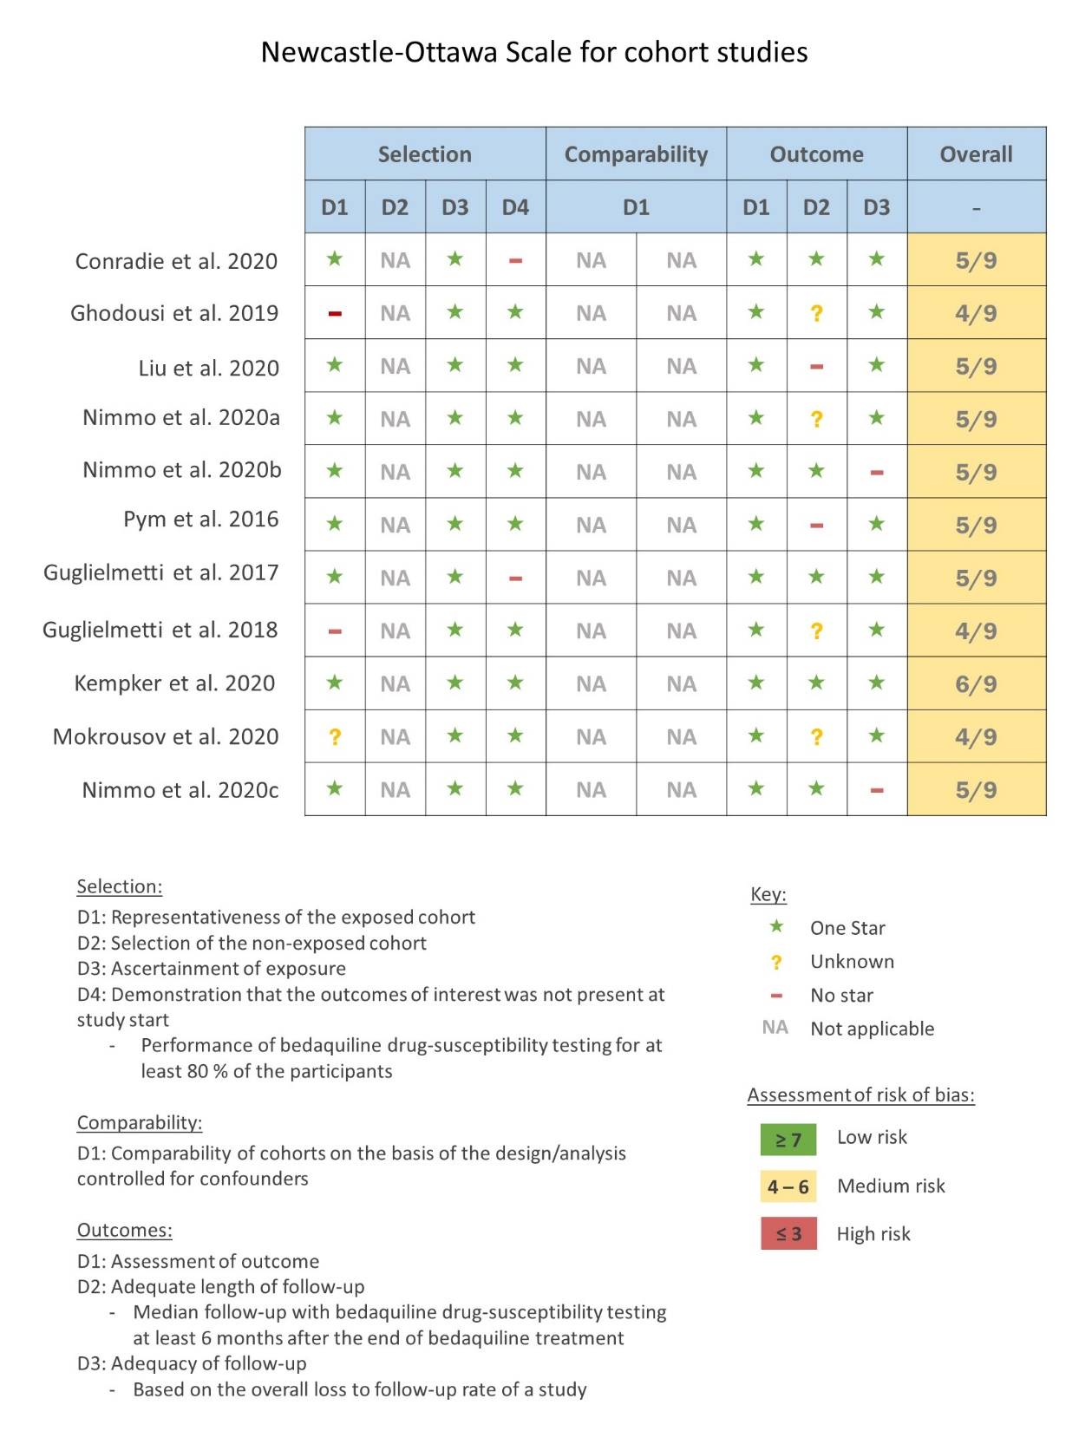
Figure S1. Qualitative assessment with the Newcastle-Ottawa Scale for cohort studies.

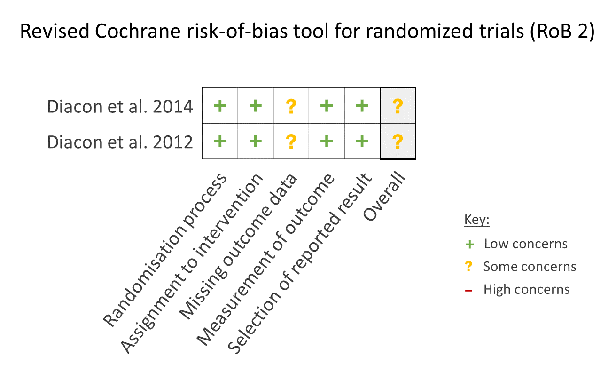
Figure S2. Qualitative assessment with the Revised Cochrane risk-of-bias tool for randomized trials (RoB 2).

