Appendix 1: RoB 2 for risk of bias of RCTs

Study | Allocation: generation  (Selection) | Allocation: concealment  (Selection) | Blinding: participants  (Performance) | Blinding: assessors  (Detection) | Outcome: complete (Attrition) | Outcome: selective  (Reporting) | Other bias
Hallstrom et al 2006 (ASPIRE) | Unclear | Unclear | High | Unclear | Low | Unclear | High
Smekal et al 2011 | Unclear | Unclear | High | Unclear | Low | Unclear | High
Wik et al 2014 (CIRC) | Unclear | Unclear | High | High | Low | Unclear | Unclear
Rubertsson et al 2014 (LINC) | Unclear | Low | High | Unclear | Low | Unclear | Unclear
Perkins et al 2015 (PARAMEDIC) | Low | Unclear | High | Low | Low | Unclear | High
Gao et al 2016 | Low | High | High | Unclear | Low | Unclear | Low

Appendix 2: The NOS tool for risk of bias in observational studies

Study | Selection | Comparability | Outcome | Score
Castner 2005 | 4 | 2 | 3 | 9/9
Axelsson 2006 | 3 | 1 | 3 | 7/9
Ong 2006 | 4 | 2 | 3 | 9/9
Steinmetz 2008 | 3 | 0 | 3 | 6/9
Ong 2012 | 4 | 2 | 3 | 9/9
Jennings 2012 | 3 | 2 | 3 | 8/9
Axelsson 2013 | 4 | 2 | 3 | 9/9
Satterlee 2013 | 4 | 0 | 3 | 7/9
Zeiner 2015 | 3 | 1 | 3 | 7/9

Appendix 3: Main results for Random effects Maximum Likelihood metaregression covariates (Log Odds ratio and Z-distribution)

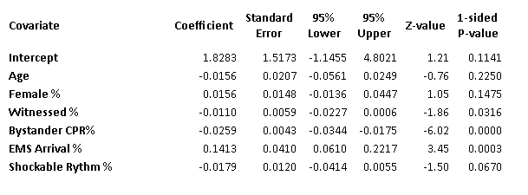

Appendix 4: Excluded studies with reasons for exclusion:

Name | n | Reason for exclusion
Box et al. 2008 | 87 | ACD- CPR* usage
Lairet et al. 2005 | 479 | Only abstract published
Plaisance et al. 1999 | 750 | ACD- CPR usage, publication period exclusion**
Skogvoll et al. 1999 | 431 | ACD- CPR usage, publication period exclusion
Wolcke et al. 2003 | 210 | ACD- CPR with ITD
Dickinson et al. 1999 | 20 | Thumper usage, publication period exclusion
Halperin et al. 1993 | 63 | Thoracic vest usage, publication period exclusion
Koster et al. 2017 | 374 | Safety of usage was the studied outcome
Lu et al. 2010 | 1007 | Thumper usage, systems exclusion†
Taylor et al. 1978 | 50 | Publication period exclusion
Kim et al. 2019 | 820 | Systems exclusion
Liu et al. 2010 | 85 | Systems exclusion, biochemical markers were the studied outcome
Kurowski et al. 2014 | 150 | CardioPump feedback usage, Quality of CPR was the studied outcome, letter to the editor
Maule Y et al. 2007 | 290 | No English publication found
Ornato et al. 2005 | 1086 | Only abstract published
Swanson et al. 2006 | 876 | Only abstract published
Wilde et al. 2008 | 220 | Only abstract published
Paradis et al. 2009 | 1024 | Only abstract published
Truhlar et al. 2010 | 30 | Only abstract published
Morozov et al. 2012 | 188 | Only abstract published
Lin et al. 2015 | 455 | Thumper device usage, systems exclusion
Buckler et al. 2016 | 80,681 | No matching of case-control, all mechanical devices used, no demography specified or excluded, letter to the editor
Ananthraman et al. 2017 | 1178 | Systems exclusion
Hayasida et al. 2017 | 6537 | Systems exclusion
Hardig et al. 2017 | 757 | A subset of the LINC trial results already included in Rubertsson et al. 2014 study

*ACD- CPR: Active Compression- Decompression device CPR
**Publication period exclusion: Published before 2000 or after 2020
†Systems exclusion: Study conducted outside of advanced American or European EMS systems

