Supplementary data

Appendix 1: Search terms (October 28, 2019)

Pubmed: 151 citations
(shock-refractory OR shock-resistant OR refractory OR resist* OR persist* OR fail*) AND (VF OR VT OR pVT OR VF/pVT OR (ventricular fibrillation) OR (ventricular tachycardia) OR defibrillation OR shock*) AND ((cardiac OR cardiopulmonary OR circulat*) AND (arrest OR failure OR collapse OR resuscitation)) AND (out-of-hospital OR pre-hospital OR prehospital OR (outside hospital)) AND (random*)

Scopus: 32 citations
( TITLE-ABS-KEY ( ( shock-refractory OR shock-resistant OR refractory OR resist* OR persist* OR fail* ) ) AND TITLE-ABS-KEY ( ( vf OR vt OR pvt OR vf/pvt OR ( ventricular AND fibrillation ) OR ( ventricular AND tachycardia ) OR defibrillation OR shock* ) ) AND TITLE-ABS-KEY ( ( ( cardiac OR cardiopulmonary OR circulat* ) AND ( arrest OR failure OR collapse OR resuscitation ) ) ) AND TITLE-ABS-KEY ( ( out-of-hospital OR pre-hospital OR prehospital OR ( outside AND hospital ) ) ) AND TITLE-ABS-KEY ( ( random* ) ) )

Web of Science: 98 citations
TOPIC: ((shock-refractory OR shock-resistant OR refractory OR resist* OR persist* OR fail*) AND (VF OR VT OR pVT OR VF/pVT OR (ventricular fibrillation) OR (ventricular tachycardia) OR defibrillation OR shock*) AND ((cardiac OR cardiopulmonary OR circulat*) AND (arrest OR failure OR collapse OR resuscitation)) AND (out-of-hospital OR pre-hospital OR prehospital OR (outside hospital)) AND (random*))
Timespan: All years. Indexes: SCI-EXPANDED, SSCI, A&HCI, CPCI-S, CPCI-SSH, BKCI-S, BKCI-SSH, ESCI.

Cochrane CENTRAL: 111 citations
(shock-refractory OR shock-resistant OR refractory OR resist* OR persist* OR fail*) AND (VF OR VT OR pVT OR VF/pVT OR (ventricular fibrillation) OR (ventricular tachycardia) OR defibrillation OR shock*) AND ((cardiac OR cardiopulmonary OR circulat*) AND (arrest OR failure OR collapse OR resuscitation)) AND (out-of-hospital OR pre-hospital OR prehospital OR (outside hospital)) AND (random*) in Title Abstract Keyword

Academic Search Complete: 55 citations
(shock-refractory OR shock-resistant OR refractory OR resist* OR persist* OR fail*) AND (VF OR VT OR pVT OR VF/pVT OR (ventricular fibrillation) OR (ventricular tachycardia) OR defibrillation OR shock*) AND ((cardiac OR cardiopulmonary OR circulat*) AND (arrest OR failure OR collapse OR resuscitation)) AND (out-of-hospital OR pre-hospital OR prehospital OR (outside hospital)) AND (random*)

CINAHL Complete: 37 citations
(shock-refractory OR shock-resistant OR refractory OR resist* OR persist* OR fail*) AND (VF OR VT OR pVT OR VF/pVT OR (ventricular fibrillation) OR (ventricular tachycardia) OR defibrillation OR shock*) AND ((cardiac OR cardiopulmonary OR circulat*) AND (arrest OR failure OR collapse OR resuscitation)) AND (out-of-hospital OR pre-hospital OR prehospital OR (outside hospital)) AND (random*)

Hand Search: 17 citations

Appendix 2: Table of study characteristics

Study ID | Participants | Intervention arms | Guideline and additional interventions
Allegra 2001 | Inclusion criteria  - 18 years old or older  - Non-traumatic cardiac arrest presenting VF refractory to three electrical hocks | - 2g Epinephrine with either 2g Magnesium sulphate  - 2g Epinephrine normal saline
Amino 2010 | Inclusion criteria  - Out-of-hospital cardiopulmonary arrest patients with first defibrillation failure or VF recurrence | - 125mg Amiodarone  - 0.15mg/kg Nifekalant | CPR protocol of Tokai university
Dorian 2002 | Inclusion criteria  - Out-of-hospital ventricular fibrillation resistant to three shocks, intravenous epinephrine, and a further shock; or if they had recurrent ventricular fibrillation after initially successful defibrillation | - Amiodarone  - Lidocaine | Guidelines 2000 for Cardiopulmonary Resuscitation and Emergency Cardiovascular Care
Dybvik 1995 | Inclusion criteria  - ≥ 16 years old  - out-of-hospital cardiac arrest  - persistent ventricular fibrillation after first defibrillation attempt or asystole  Exclusion criteria  - induced hypothermia  - cardiac arrest of non-cardiac origin | Sodium bicarbonate 160 mmol/l, trometamol 300 mmol/l, disodium phosphate 20 mmol/l, and acetate 200 mmol/l  250 ml of 0.9% normal saline | Guidelines for cardiopulmonary resuscitation and emergency cardiac care 1992  Standards and Guidelines for Cardiopulmonary Resuscitation and Emergency Cardiac Care 1986  European Resuscitation Council Guidelines for advanced life support 1992
Hassan 2002 | Inclusion criteria  - Patient who have either VF resistant to three defibrillatory shocks(refractory VF) or a second episode of VF during a resuscitation cycle for none VF treatment  Exclusion criteria  - Age less than 18  - Mechanism of CA being related to trauma,hanging or drowning | - 2g Magnesium sulphate + further 2g if the patient remained in VF after six defibrillations  - placebo | ERC guideline
Haynes 1981 | Inclusion criteria  - Those whose rhythm became organized or remained in ventricular fibrillation  Exclusion criteria  - Patients whose rhythm converted to asystole or profound bradycardia with the initial shock(before administration of the study drug) | - Bretylium (500mg each)  - Lidocaine (100mg each)
Kovoor 2005 | Inclusion criteria  - Patient with CARDIAC arrest due to refractory ventricular fibrillation  Exclusion criteria  - If asystole lasted >= 3 min preceding refractory ventricular fibrillation | - Sotalol 100 mg  - Lignocaine 100 mg | Utstein Style guidelines
Kudenchuk 1999 | Inclusion criteria  - Adults with nontraumatic out-of-hospital cardiac arrest  - Receive three or more precordial shocks still pulseless and had ventricular fibrillation or tachycardia. | - 1 mg epinephrine + 300 mg of amiodarone  - 1 mg epinephrine + placebo | American Heart Association (AHA) Guidelines
Kudenchuk 2016 | Inclusion criteria  - 18 years or older  - Nontraumatic out-of-hospital cardiac arrest and shock-refractory ventricular fibrillation or pulseless ventricular tachycardia  - Intravenous or intraosseous vascular access  Exclusion criteria  - Patients who had already received open-label intravenous lidocaine or amiodarone during resuscitation or had known hypersensitivity to these drugs. | - 150 mg of amiodarone  - 60 mg of lidocine | American Heart Association (AHA) Guidelines
Lindner 1991 | Inclusion criteria  - Out-of-hospital patients when 3 rapidly and consecutively administered direct-current shocks failed to convert VF | - 1 mg of Epinephrine  - 1 mg of Norepinephrine | American Heart Association (AHA) Guidelines
Lindner 1997 | Inclusion criteria  - Patients in ventricular fibrillation resistant to electrical defibrillation | - Epinephrine (1 mg intravenously)  - Vasopressin(40 U intravenously) | European Resuscitation Council and the American Heart Association
Olson 1984 | Exclusion criteria  - Pediatric patients ( those less than 18 years of age)  - Patients who has traumatic PNBs  - Poisoned patients | - Bretylium tosylate  - Lidocaine | Milwaukee County Paramedic System
Olson 1989 | Inclusion criteria  - Patients in ventricular fibrillation not responding to initial defibrillations with a pulsatile rhythm | - Methoxamine (10 mg/ml)  - Epinephrine (1 mg2ml) | The American Heart Association (AHA) protocol
Weaver 1990 | Inclusion criteria  - Patients with out-of-hospital cardiac arrest persisted in ventricular fibrillation after the first defibrillation attempt | - Lidocaine(100mg)  - Epinephrine(0.5mg) | The American Heart Association (AHA) Guidelines
Wenzel 2004 | Inclusion criteria  - Out of hospital cardiac arrest  - Ventricular fibrillation  - Pulseless electrical activity  - Asystole requiring CPR with vasopressor therapy  Exclusion criteria  - Successful defibrillation without the administration of a vasopressor  - Documented terminal illness  - Lack of intravenous access  - Hemorrhagic shock  - Pregnancy  - Cardiac arrest after trauma  - Age less than 18 | - Vasopressin 40 IU  - Epinephrine 1 mg | The European agency for evaluation of medicinal product

Appendix 3: Quality assessment of the included studies using the RoB2: A revised Cochrane risk-of-bias tool for randomized trials

RoB 2 is structured into 5 domains through which bias might be introduced into the result. These were identified based on both empirical evidence and theorical considerations. The five domains for individually randomized trials are: (1) Bias arising from the randomization process; (2) bias due to deviations from intended interventions; (3) bias due to missing outcome data; (4) bias in measurement of the outcome; and (5) bias in selection of the reported result.
Study | Randomization | Deviation from the intended interventions | Missing outcome data | Measurement of outcome | Selection of the reported result | Overall
Allegra 2001 | LR | LR | LR | LR | LR | LR
Amino 2010 | SC | LR | LR | LR | LR | SC
Dorian 2002 | LR | LR | LR | LR | LR | LR
Dybvik 1995 | LR | SC | LR | LR | LR | SC
Gueugniaud 1998 | LR | LR | LR | LR | LR | LR
Gueugniaud 2008 | LR | LR | LR | LR | LR | LR
Hassan 2002 | LR | LR | LR | LR | LR | LR
Haynes 1981 | LR | SC | LR | LR | LR | SC
Jacobs 2011 | LR | LR | LR | LR | LR | LR
Kovoor 2005 | LR | LR | LR | LR | LR | LR
Kudenchuk 1999 | LR | LR | LR | LR | LR | LR
Kudenchuk 2016 | LR | LR | LR | LR | LR | LR
Lindner 1991 | SC | SC | LR | LR | LR | SC
Lindner 1997 | LR | LR | LR | LR | LR | LR
Olson 1984 | SC | SC | LR | LR | LR | SC
Olson 1989 | SC | LR | LR | LR | LR | SC
Weaver 1990 | SC | SC | LR | LR | LR | SC
Wenzel 2004 | LR | LR | LR | LR | LR | LR

LR: Low risk of bias; SC: Some concerns; HR: High risk of bias
Appendix 4: Abbreviations of pharmaceutical interventions

Ami = Amiodarone
Bret = Bretylium tosylate
Epi = Epinephrine
H-Epi = High-Dose Epinephrine
Lid = Lidocaine / Lignocaine
Mg = Magnesium Sulfate
Nif = Nifekalant
Nor= Norepinephrine
Pla = Placebo
Sot = Sotalol
Vas = Vasopressin
Met = Methoxamine
Buff = Buffer (bicarbonate)

Appendix 5: Return of Spontaneous Circulation

Table 5S-1 Head-to-head odd ratio comparisons of the return of spontaneous circulation among the pharmaceutical interventions

Drugs are reported in alphabetical order. Results are the ORs (with 95% CIs) in the column-defining treatment compared with the row-defining treatment. For efficacy, ORs higher than 1 favour the row-defining treatment.
 | Ami | Bret | Epi | H-Epi | Lid | Mg | Nif | Nor | Pla | Sot | Vas | Vas+Epi
Ami |  | 2.60  (0.85-8.00) | 0.52  (0.20-1.37) | 0.62  (0.19-1.97) | 1.08  (0.67-1.75) | 0.89  (0.35-2.27) | 2.29  (0.47-11.10) | 0.14  (0.03-0.70) | 1.23  (0.79-1.90) | 0.87  (0.23-1.91) | 0.53  (0.17-1.64) | 0.66  (0.19-2.23)
Bret |  |  | 0.20  (0.05-0.84) | 0.24  (0.05-1.14) | 0.42  (0.15-1.15) | 0.34  (0.08-1.40) | 0.88  (0.13-6.11) | 0.05  (0.1-0.37) | 0.47  (0.15-1.48) | 0.33  (0.06-1.48) | 0.20  (0.04-0.96) | 0.25  (0.05-1.27)
Epi |  |  |  | 1.18  (0.62-2.26) | 2.08  (0.76-5.68) | 1.71  (0.52-5.63) | 4.38  (0.69-27.88) | 0.26  (0.07-0.97) | 2.36  (1.00-5.57) | 1.66  (0.65-5.57) | 1.01  (0.55-1.86) | 1.26  (0.59-2.67)
H-Epi |  |  |  |  | 1.76  (0.53-5.83) | 1.45  (0.37-5.64) | 3.71  (0.52-26.42) | 0.22  (0.05-0.96) | 2.00  (0.68-5.88) | 1.41  (0.45-5.88) | 0.85  (0.35-2.09) | 1.07  (0.39-2.88)
Lid |  |  |  |  |  | 0.82  (0.31-2.18) | 2.11  (0.41-10.99) | 0.13  (0.03-0.66) | 1.14  (0.67-1.91) | 0.80  (0.20-1.91) | 0.49  (0.15-1.58) | 0.61  (0.17-2.13)
Mg |  |  |  |  |  |  | 2.56  (0.41-16.06) | 0.15  (0.03-0.90) | 1.38  (0.60-3.15) | 0.97  (0.21-3.15) | 0.59  (0.15-2.25) | 0.73  (0.18-3.01)
Nif |  |  |  |  |  |  |  | 0.06  (0.01-0.58) | 0.54  (0.10-2.77) | 0.38  (0.05-3.02) | 0.23  (0.03-1.62) | 0.29  (0.04-2.12)
Nor |  |  |  |  |  |  |  |  | 8.91  (1.88-42.29) | 6.28  (1.27-31.16) | 3.81  (0.91-16.01) | 4.75  (1.06-21.31)
Pla |  |  |  |  |  |  |  |  |  | 0.71  (0.20-2.52) | 0.43  (0.15-1.23) | 0.53  (0.17-1.67)
Sot |  |  |  |  |  |  |  |  |  |  | 0.60  (0.20-1.86) | 0.76  (0.22-2.51)
Vas |  |  |  |  |  |  |  |  |  |  |  | 1.25  (0.47-3.30)
Vas+Epi

Table 5S-2 Surface under the cumulative ranking (SUCRA) score ranking of return of spontaneous circulation among the pharmaceutical interventions

 | P-score
Norepinephrine | 0.9857
Epinephrine | 0.7587
Vasopressin | 0.7293
High-dose Epinephrine | 0.6412
Vasopressin plus Epinephrine | 0.6048
Magnesium sulfate | 0.4856
Sotalol | 0.4627
Amiodarone | 0.4335
Lidocaine | 0.3762
Placebo | 0.2738
Nifekalant | 0.1637
Bretylium tosylate | 0.0849

Table 5S-3 Node splitting method of the network meta-analysis of return of spontaneous circulation

 | k | Prop | NMA | Direct | Indirect | RoR | z | P-value
Ami : Lid | 2 | 0.92 | 1.0836 | 1.0722 | 1.2257 | 0.8747 | -0.15 | 0.8825
Ami : Pla | 2 | 0.96 | 1.2304 | 1.1498 | 5.7802 | 0.1989 | -1.45 | 0.1467
Lid : Pla | 1 | 0.79 | 1.1355 | 1.2581 | 0.7763 | 1.6205 | 0.74 | 0.4586

k = number of studies
Prop = weight of direct effect size in the network meta-analysis
Direct = direct effect size
Indirect = indirect effect size
RoR = direct effect size to indirect effect size ratio
z = z-value of the difference between direct and indirect effect sizes
P-value = P-value of the difference between direct and indirect effect sizes
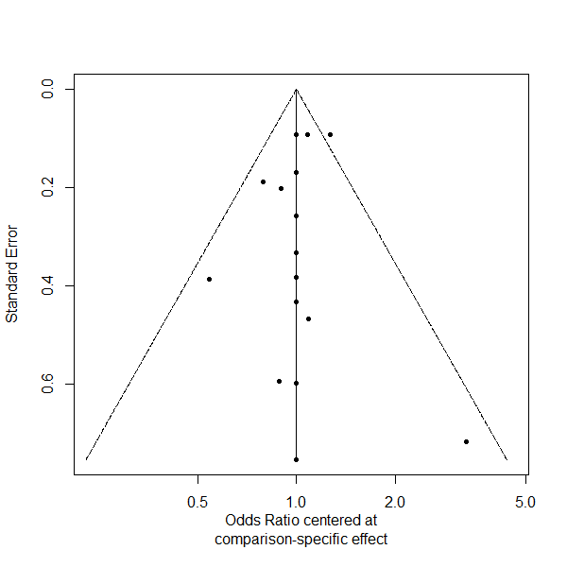

Figure 5S-1: The funnel plot of the network meta-analysis comparing the return of spontaneous circulation among the pharmaceutical-intervention

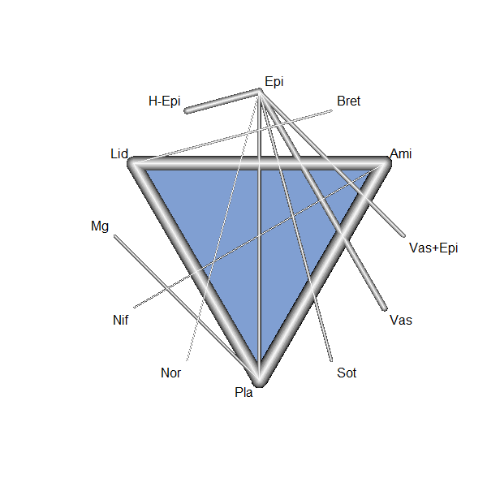

Figure 5S-2: The network graph of the network meta-analysis comparing the return of spontaneous circulation among the pharmaceutical-intervention

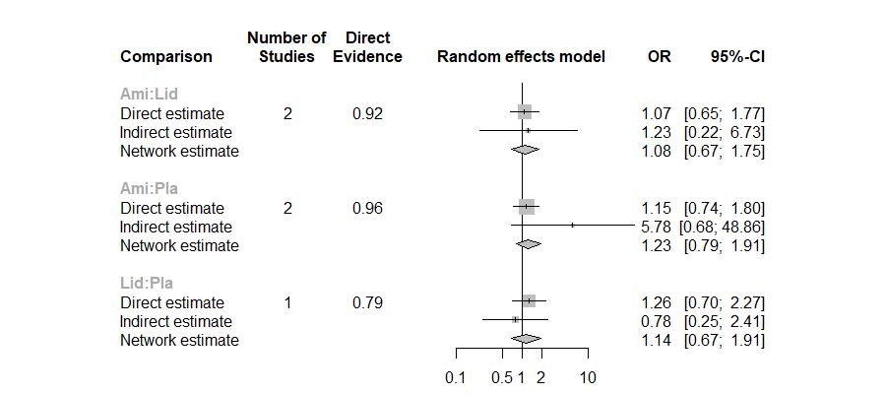

Figure 5S-3: The node splitting graph of the network meta-analysis comparing the return of spontaneous circulation among the pharmaceutical-intervention

Appendix 6: Survival to Hospital Admission

Table 6S-1 Head-to-head odd ratio comparisons of the survival to hospital admission among the pharmaceutical interventions

Drugs are reported in alphabetical order. Results are the ORs (with 95% CIs) in the column-defining treatment compared with the row-defining treatment. For efficacy, ORs higher than 1 favour the row-defining treatment.
 | Ami | Epi | H-Epi | Lid | Met | Mg | Nif | Pla | Sot | Vas | Vas+Epi
Ami |  | 1.09  (0.67-1.75) | 1.41  (0.63-3.17) | 1.12  (0.69-1.81) | 1.97  (0.53-7.30) | 1.32  (0.52-3.37) | 2.28  (0.47-11.05) | 1.52  (1.00-2.32) | 2.49  (0.74-8.35) | 0.96  (0.42-2.16) | 1.19  (0.47-2.95)
Epi |  |  | 1.29  (0.67-2.49) | 1.03  (0.65-1.61) | 1.80  (0.53-6.12) | 1.21  (0.47-3.12) | 2.09  (0.40-10.88) | 1.40  (0.90-2.18) | 2.29  (0.75-6.94) | 0.88  (0.45-1.69) | 1.09  (0.50-2.37)
H-Epi |  |  |  | 0.79  (0.35-1.75) | 1.39  (0.34-5.55) | 0.93  (0.29-2.95) | 1.61  (0.27-9.48) | 1.07  (0.49-2.37) | 1.76  (0.48-6.38) | 0.68  (0.26-1.70) | 0.83  (0.30-2.31)
Lid |  |  |  |  | 1.75  (0.47-6.43) | 1.18  (0.45-3.08) | 2.03  (0.39-10.54) | 1.36  (0.84-2.19) | 2.22  (0.66-7.35) | 0.85  (0.38-1.89) | 1.06  (0.43-2.59)
Met |  |  |  |  |  | 0.67  (0.14-3.14) | 1.15  (0.14-8.99) | 0.78  (0.21-2.83) | 1.26  (0.24-6.58) | 0.49  (0.12-1.94) | 0.60  (0.14-2.56)
Mg |  |  |  |  |  |  | 1.72  (0.28-10.72) | 1.15  (0.50-2.64) | 1.87  (0.43-8.05) | 0.72  (0.22-2.27) | 0.89  (0.26-3.03)
Nif |  |  |  |  |  |  |  | 0.67  (0.13-3.41) | 1.09  (0.14-7.94) | 0.42  (0.07-2.46) | 0.52  (0.08-3.21)
Pla |  |  |  |  |  |  |  |  | 1.63  (0.49-5.39) | 0.63  (0.28-1.38) | 0.77  (0.31-1.89)
Sot |  |  |  |  |  |  |  |  |  | 0.38  (0.10-1.39) | 0.48  (0.12-1.85)
Vas |  |  |  |  |  |  |  |  |  |  | 1.24  (0.44-3.44)
Vas+Epi

Table 6S-2 Surface under the cumulative ranking (SUCRA) score ranking of survival to hospital admission among the pharmaceutical interventions

 | P-score
Amiodarone | 0.7554
Vasopressin | 0.7499
Epinephrine | 0.6798
Vasopressin plus Epinephrine | 0.5840
Magnesium sulfate | 0.5084
High-dose Epinephrine | 0.4489
Placebo | 0.3524
Methoxamine | 0.3067
Nifekalant | 0.2820
Sotalol | 0.1918

Table 6S-3 Node splitting method of the network meta-analysis of survival to hospital admission

 | k | Prop | NMA | Direct | Indirect | RoR | z | P-value
Ami : Epi | 1 | 0.68 | 1.0900 | 1.2798 | 0.7746 | 1.6523 | 0.96 | 0.3353
Ami : Lid | 2 | 0.83 | 1.1245 | 1.0519 | 1.5451 | 0.6808 | -0.60 | 0.5489
Ami : Pla | 2 | 0.92 | 1.5297 | 1.3865 | 4.9887 | 0.2779 | -1.60 | 0.1092
Epi : Lid | 2 | 0.91 | 1.0317 | 0.9180 | 3.3026 | 0.2780 | -1.60 | 0.1092
Epi : Pla | 2 | 0.86 | 1.4034 | 1.3276 | 1.9510 | 0.6804 | -0.60 | 0.5485
Lid : Pla | 1 | 0.69 | 1.3603 | 1.3508 | 1.3815 | 0.9778 | -0.04 | 0.9660
k = number of studies
Prop = weight of direct effect size in the network meta-analysis
Direct = direct effect size
Indirect = indirect effect size
RoR = direct effect size to indirect effect size ratio
z = z-value of the difference between direct and indirect effect sizes
P-value = P-value of the difference between direct and indirect effect sizes
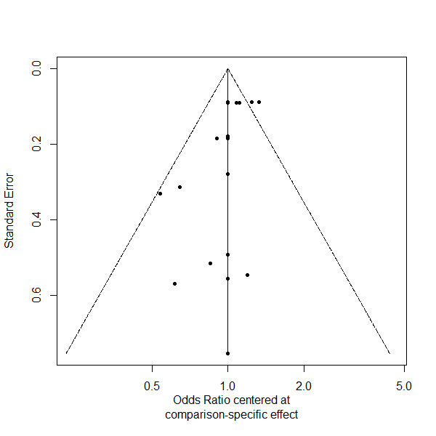

Figure 6S-1: The funnel plot of the network meta-analysis comparing the survival to hospital admission among the pharmaceutical-intervention
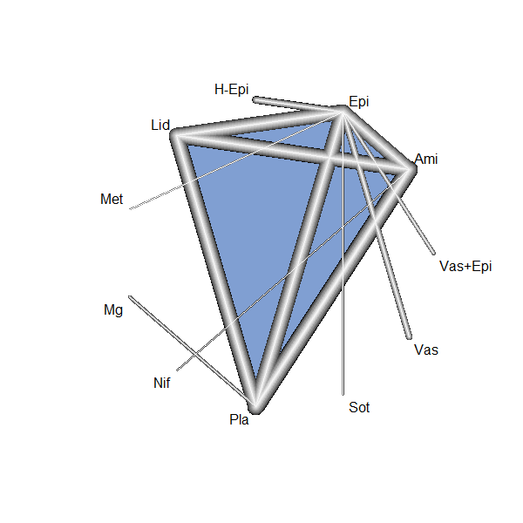

Figure 6S-2: The network graph of the network meta-analysis comparing the survival to hospital admission among the pharmaceutical-intervention
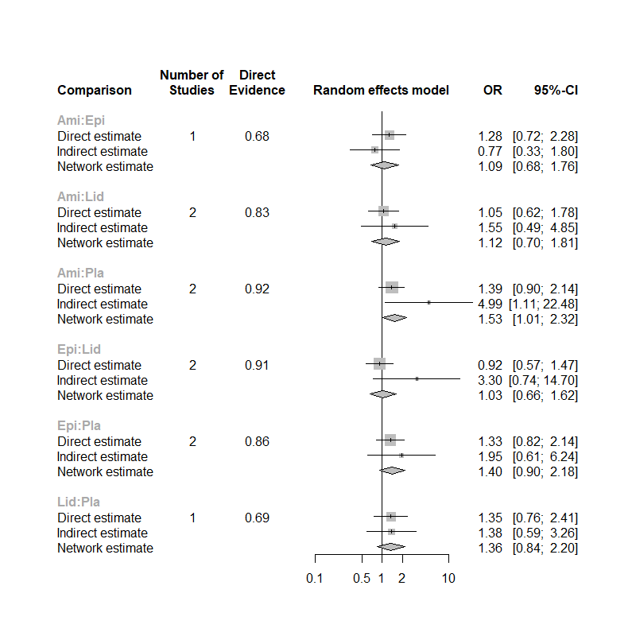

Figure 6S-3: The node splitting graph of the network meta-analysis comparing the survival to hospital admission among the pharmaceutical-intervention

Appendix 7: Survival to Hospital Discharge

Table 7S-1 Head-to-head odd ratio comparisons of the survival to hospital discharge among the pharmaceutical interventions

Drugs are reported in alphabetical order. Results are the ORs (with 95% CIs) in the column-defining treatment compared with the row-defining treatment. For efficacy, ORs higher than 1 favour the row-defining treatment.
 | Ami | Bret | Buff | Epi | H-Epi | Lid | Met | Mg | Nif | Nor | Pla | Sot | Vas | Vas+Epi
Ami |  | 1.36  (0.57-3.19) | 1.52  (0.78-2.94) | 0.76  (0.38-1.51) | 1.21  (0.47-3.08) | 1.04  (0.85-1.27) | 1.10  (0.22-5.34) | 0.90  (0.19-4.27) | 3.14  (0.68-14.50) | 0.46  (0.09-2.20) | 1.19  (0.98-1.45) | 1.63  (0.34-7.77) | 0.73  (0.32-1.67) | 1.20  (0.39-3.66)
Bret |  |  | 1.12  (0.38-3.23) | 0.55  (0.19-1.62) | 0.89  (0.25-3.07) | 0.77  (0.33-1.75) | 0.81  (0.13-4.78) | 0.66  (0.11-3.86) | 2.31  (0.40-13.30) | 0.34  (0.05-1.97) | 0.88  (0.37-2.06) | 1.20  (0.20-6.97) | 0.54  (0.17-1.72) | 0.89  (0.22-3.51)
Buff |  |  |  | 0.50  (0.19-1.26) | 0.79  (0.25-2.45) | 0.69  (0.35-1.33) | 0.73  (0.13-3.95) | 0.59  (0.11-3.14) | 2.07  (0.39-10.93) | 0.30  (0.05-1.63) | 0.78  (0.41-1.48) | 1.07  (0.20-5.76) | 0.48  (0.17-1.35) | 0.79  (0.22-2.83)
Epi |  |  |  |  | 1.59  (0.84-3.00) | 1.37  (0.70-2.67) | 1.45  (0.35-5.99) | 1.18  (0.21-6.38) | 4.13  (0.77-22.05) | 0.60  (0.14-2.46) | 1.57  (0.79-3.09) | 2.14  (0.52-8.69) | 0.97  (0.61-1.51) | 1.58  (0.65-3.79)
H-Epi |  |  |  |  |  | 0.86  (0.34-2.16) | 0.91  (0.19-4.31) | 0.74  (0.12-4.50) | 2.59  (0.43-15.57) | 0.38  (0.08-1.77) | 0.99  (0.39-2.50) | 1.35  (0.29-6.26) | 0.61  (0.28-1.32) | 0.99  (0.34-2.92)
Lid |  |  |  |  |  |  | 1.06  (0.22-5.08) | 0.86  (0.18-4.09) | 3.01  (0.64-14.07) | 0.44  (0.09-2.09) | 1.15  (0.93-1.40) | 1.57  (0.33-7.38) | 0.71  (0.32-1.58) | 1.15  (0.38-3.47)
Met |  |  |  |  |  |  |  | 0.82  (0.09-7.39) | 2.84  (0.31-25.59) | 0.42  (0.05-3.07) | 1.08  (0.22-5.22) | 1.48  (0.20-10.85) | 0.67  (0.15-2.95) | 1.09  (0.20-5.77)
Mg |  |  |  |  |  |  |  |  | 3.48  (0.39-30.84) | 0.51  (0.05-4.58) | 1.33  (0.28-6.21) | 1.81  (0.20-16.20) | 0.81  (0.14-4.67) | 1.33  (0.20-8.91)
Nif |  |  |  |  |  |  |  |  |  | 0.15  (0.01-1.30) | 0.38  (0.08-1.78) | 0.52  (0.05-4.61) | 0.23  (0.04-1.33) | 0.38  (0.06-2.53)
Nor |  |  |  |  |  |  |  |  |  |  | 2.60  (0.54-12.45) | 3.56  (0.48-25.91) | 1.60  (0.36-7.04) | 2.62  (0.49-13.76)
Pla |  |  |  |  |  |  |  |  |  |  |  | 1.36  (0.28-6.46) | 0.62  (0.27-1.38) | 1.01  (0.33-3.04)
Sot |  |  |  |  |  |  |  |  |  |  |  |  | 0.45  (0.10- 1.96) | 0.74  (0.14-3.83)
Vas |  |  |  |  |  |  |  |  |  |  |  |  |  | 1.63  (0.61-4.36)
Vas+Epi

Table 7S-2 Surface under the cumulative ranking (SUCRA) score ranking of survival to hospital discharge among the pharmaceutical interventions

 | P-score
Norepinephrine | 0.8471
Vasopressin | 0.7588
Epinephrine | 0.7562
Amiodarone | 0.6034
Magnesium sulfate | 0.5895
Lidocaine | 0.5533
Methoxamine | 0.4988
Vasopressin plus Epinephrine | 0.4420
High-dose Epinephrine | 0.4268
Placebo | 0.4011
Bretylium | 0.3750
Sotalol | 0.3276
Buffer | 0.2920
Nifekalant | 0.1284

Table 7S-3 Node splitting method of the network meta-analysis of survival to hospital discharge
 | k | Prop | NMA | Direct | Indirect | RoR | z | P-value
Ami : Lid | 2 | 0.96 | 1.0436 | 1.0609 | 0.7021 | 1.5110 | 0.79 | 0.4297
Ami : Pla | 2 | 0.99 | 1.1981 | 1.1853 | 2.8829 | 0.4111 | -0.99 | 0.3214
Epi : Lid | 1 | 0.66 | 1.3698 | 1.2095 | 1.7379 | 0.6959 | -0.50 | 0.6140
Epi : Pla | 1 | 0.36 | 1.5725 | 1.9800 | 1.3379 | 1.4369 | 0.50 | 0.6140
Lid : Pla | 1 | 0.93 | 1.1480 | 1.1640 | 0.9416 | 1.2362 | 0.51 | 0.6104

k = number of studies
Prop = weight of direct effect size in the network meta-analysis
Direct = direct effect size
Indirect = indirect effect size
RoR = direct effect size to indirect effect size ratio
z = z-value of the difference between direct and indirect effect sizes
P-value = P-value of the difference between direct and indirect effect sizes

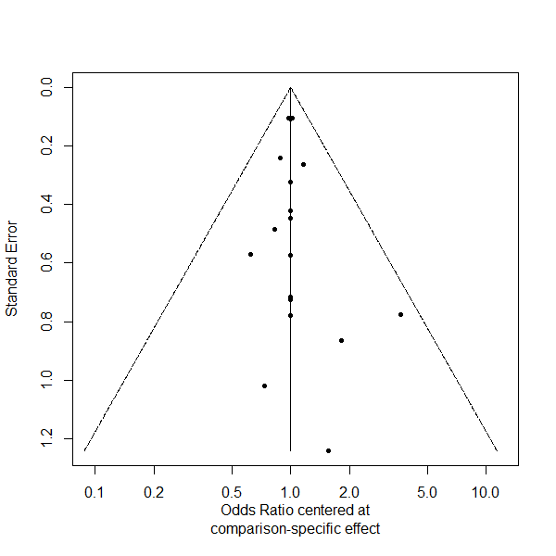

Figure 7S-1: The funnel plot of the network meta-analysis comparing the survival to hospital discharge among the pharmaceutical-intervention

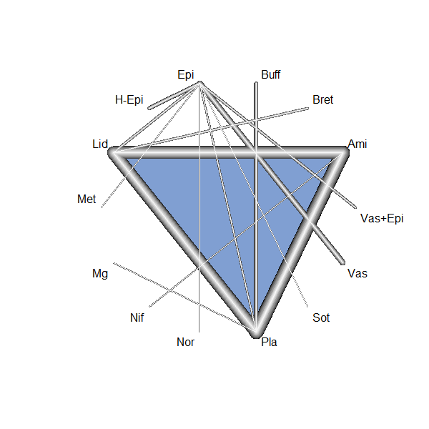

Figure 7S-2: The network graph of the network meta-analysis comparing the survival to hospital discharge among the pharmaceutical-intervention
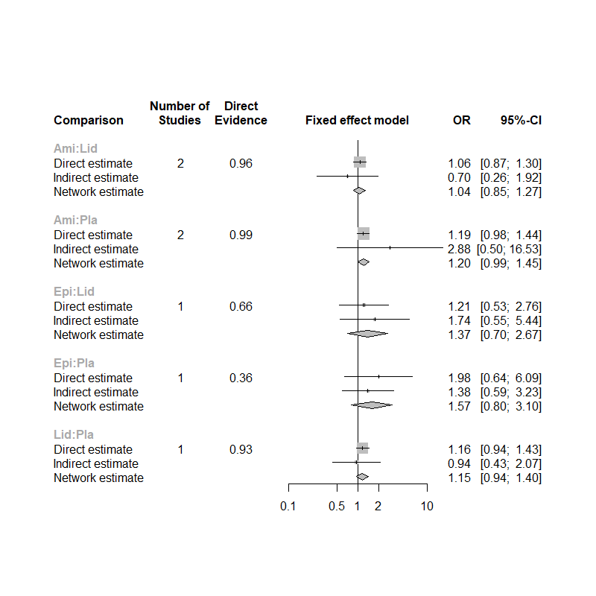

Figure 7S-3: The node splitting graph of the network meta-analysis comparing the survival to hospital discharge among the pharmaceutical-intervention

Appendix 8: Survival with Good Neurological Outcome

Table 8S-1 Head-to-head odd ratio comparisons of the survival with good neurological outcome among the pharmaceutical interventions
 | Ami | Lid | Mg | Nif | Pla
Ami |  | 1.09  (0.86-1.37) | 0.39  (0.02-9.83) | 1.00  (0.19-5.04) | 1.16  (0.92-1.46)
Lid |  |  | 0.36  (0.01-8.98) | 0.91  (0.17-4.68) | 1.07  (0.84-1.34)
Mg |  |  |  | 2.57  (0.06-95.44) | 3.00  (0.11-75.27)
Nif |  |  |  |  | 1.17  (0.22-5.97)
Pla

Drugs are reported in alphabetical order. Results are the ORs (with 95% CIs) in the column-defining treatment compared with the row-defining treatment. For efficacy, ORs higher than 1 favour the row-defining treatment.

Table 8S-2 SUCRA score ranking of survival with good neurological outcome among the pharmaceutical interventions
 | P-score
Magnesium | 0.7239
Amiodarone | 0.6170
Nifekalant | 0.4801
Lidocaine | 0.4117
Placebo | 0.2674

