S-Figure-1 (a-e): Begg’s Funnel Plot for the association of Lp (a) level with the risk of stroke types and subtypes vs. Control (a) Ischemic stroke vs. Control; (b) Large artery atherosclerosis vs. Control; (c) Small Vessel disease vs. Control; (d) Cardioembolic stroke vs. Control and (e) Intracerebral Hemorrhage vs. Control

(a) Ischemic stroke vs. Control  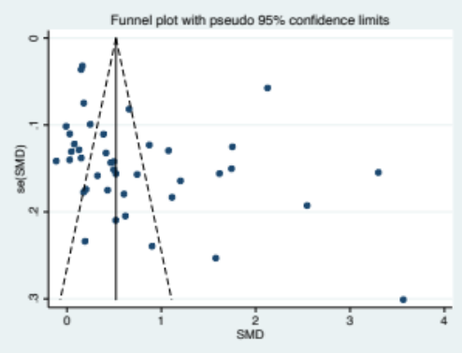 | (b)Large artery atherosclerosis vs. Control  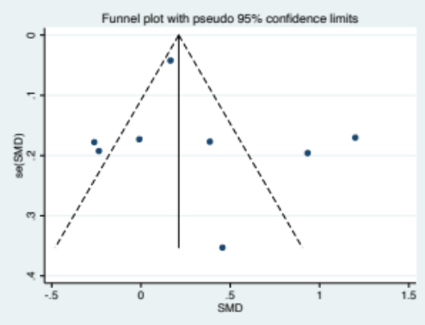
(c) Small vessel disease vs. Control  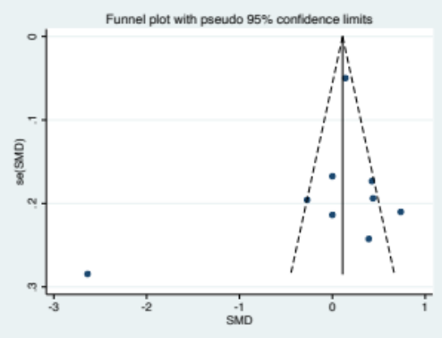 | (d) Cardioembolic stroke vs. Control  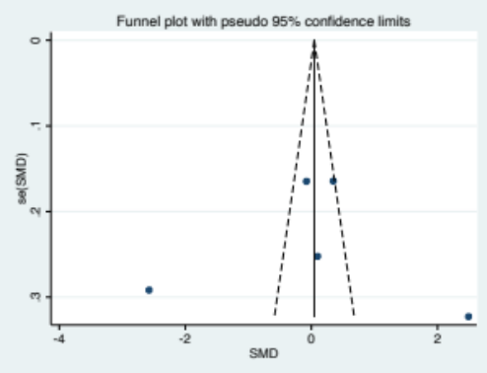
(e) Intracerebral Hemorrhage vs. Control

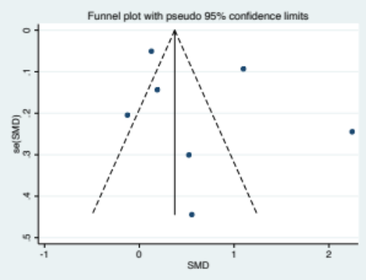

S-Figure-2 (a-e): Meta-regression plot for the association of Lp(a) level with the risk of stroke types and subtypes vs. Control (a) Ischemic stroke vs. Control; (b) Large artery atherosclerosis vs. Control; (c) Small Vessel disease vs. Control; (d) Cardioembolic stroke vs. Control and (e) Intracerebral Hemorrhage vs. Control based on NOS quality score

(a) Ischemic stroke vs. Control  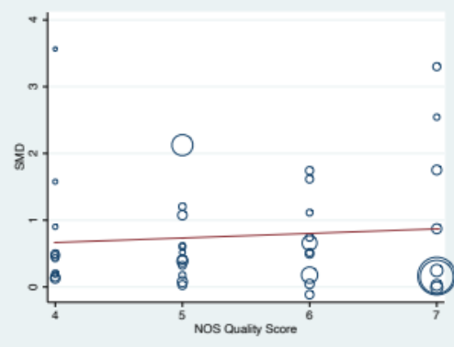 | (b)Large artery atherosclerosis vs. Control  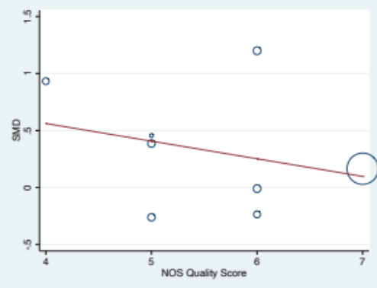
(c) Small vessel disease vs. Control  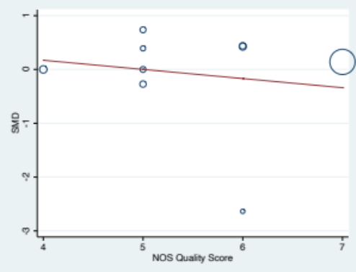 | (d) Cardioembolic stroke vs. Control  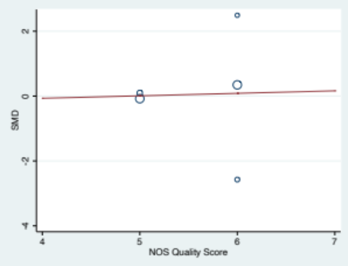
(e) Intracerebral Hemorrhage vs. Control

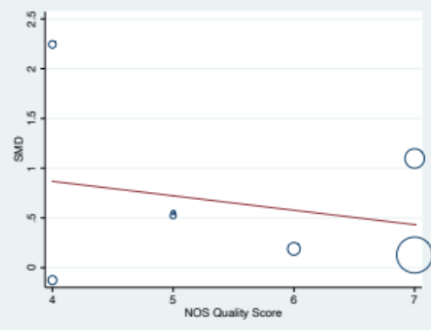

S-Figure-3: Meta-regression plot for the association of Lp(a) level with the risk Ischemic stroke vs. Control based on study design

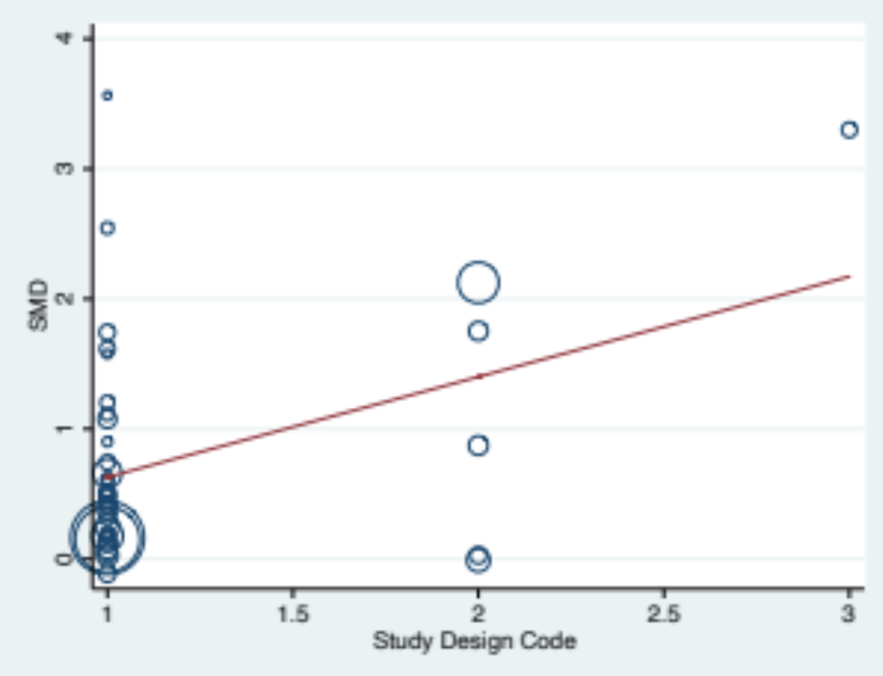
S-Figure-4 (a-e): Meta-regression plot for the association of Lp(a) level with the risk of stroke types and subtypes vs. Control (a) Ischemic stroke vs. Control; (b) Large artery atherosclerosis vs. Control; (c) Small Vessel disease vs. Control; (d) Cardioembolic stroke vs. Control and (e) Intracerebral Hemorrhage vs. Control based on ethnicity

(a) Ischemic stroke vs. Control  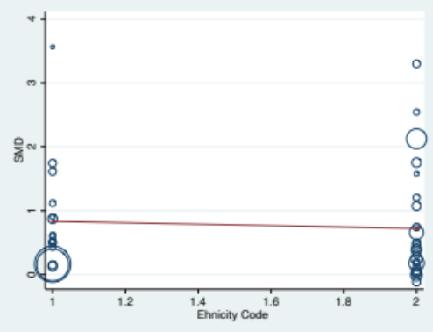 | (b)Large artery atherosclerosis vs. Control  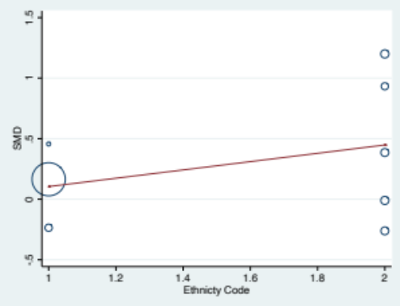
(c) Small vessel disease vs. Control  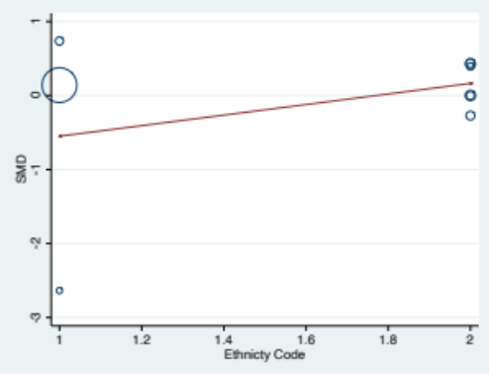 | (d) Cardioembolic stroke vs. Control  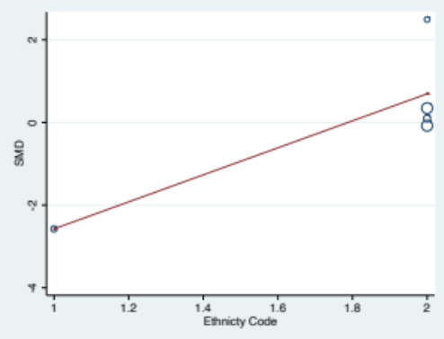
(e) Intracerebral Hemorrhage vs. Control

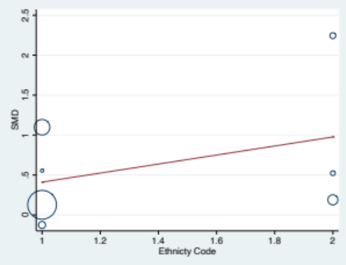

S-Figure-5 (a-e): Sensitivity Analysis for the association of Lp (a) level with the risk of of stroke types and subtypes vs. Control (a) Ischemic stroke vs. Control; (b) Large artery atherosclerosis vs. Control; (c) Small Vessel disease vs. Control; (d) Cardioembolic stroke vs. Control and (e) Intracerebral Hemorrhage vs. Control

5 (a) Ischemic stroke vs. Control

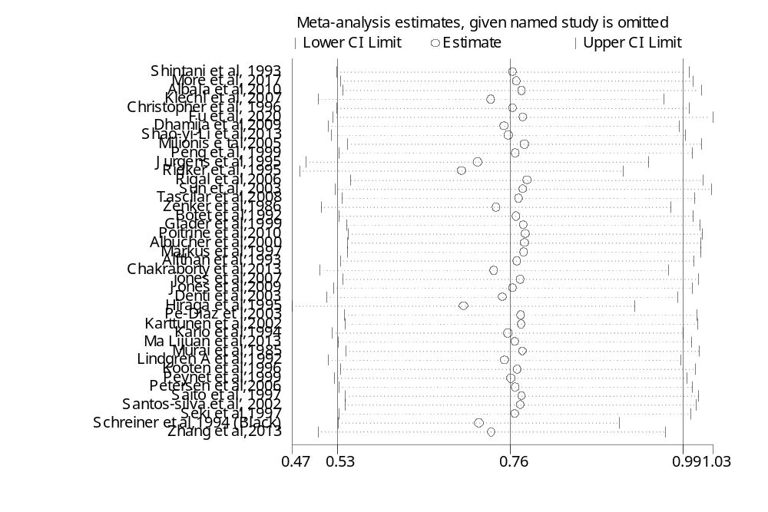

5 (b) Large artery atherosclerosis vs. Control

5(c) Small Vessel disease vs. Control

5 (d) Cardioembolic stroke vs. Control

5 (e) Intracerebral Hemorrhage vs. Control

