Supplementary materials
Table S1 Search strategy used for the systematic review in Pubmed, Web of Science and Scopus

Database | Keywords
Pubmed
#1 | "cancer s"[All Fields] OR "cancerated"[All Fields] OR "canceration"[All Fields] OR "cancerization"[All Fields] OR "cancerized"[All Fields] OR "cancerous"[All Fields] OR "neoplasms"[MeSH Terms] OR "neoplasms"[All Fields] OR "cancer"[All Fields] OR "cancers"[All Fields]
#2 | "malignan*"[All Fields]
#3 | "cysts"[MeSH Terms] OR "cysts"[All Fields] OR "cyst"[All Fields] OR "neurofibroma"[MeSH Terms] OR "neurofibroma"[All Fields] OR "neurofibromas"[All Fields] OR "tumor s"[All Fields] OR "tumoral"[All Fields] OR "tumorous"[All Fields] OR "tumour"[All Fields] OR "neoplasms"[MeSH Terms] OR "neoplasms"[All Fields] OR "tumor"[All Fields] OR "tumour s"[All Fields] OR "tumoural"[All Fields] OR "tumourous"[All Fields] OR "tumours"[All Fields] OR "tumors"[All Fields]
#4 | "neoplasm s"[All Fields] OR "neoplasms"[MeSH Terms] OR "neoplasms"[All Fields] OR "neoplasm"[All Fields]
#5 | "cancer s"[All Fields] OR "cancerated"[All Fields] OR "canceration"[All Fields] OR "cancerization"[All Fields] OR "cancerized"[All Fields] OR "cancerous"[All Fields] OR "neoplasms"[MeSH Terms] OR "neoplasms"[All Fields] OR "cancer"[All Fields] OR "cancers"[All Fields] OR "malignan*"[All Fields] OR "cysts"[MeSH Terms] OR "cysts"[All Fields] OR "cyst"[All Fields] OR "neurofibroma"[MeSH Terms] OR "neurofibroma"[All Fields] OR "neurofibromas"[All Fields] OR "tumor s"[All Fields] OR "tumoral"[All Fields] OR "tumorous"[All Fields] OR "tumour"[All Fields] OR "neoplasms"[MeSH Terms] OR "neoplasms"[All Fields] OR "tumor"[All Fields] OR "tumour s"[All Fields] OR "tumoural"[All Fields] OR "tumourous"[All Fields] OR "tumours"[All Fields] OR "tumors"[All Fields] OR "neoplasm s"[All Fields] OR "neoplasms"[MeSH Terms] OR "neoplasms"[All Fields] OR "neoplasm"[All Fields]
#6 | ("severe acute respiratory syndrome coronavirus 2"[Supplementary Concept] OR "severe acute respiratory syndrome coronavirus 2"[All Fields] OR "2019 ncov"[All Fields]) AND ("pneumonia"[MeSH Terms] OR "pneumonia"[All Fields] OR "pneumoniae"[All Fields] OR "pneumonias"[All Fields] OR "pneumoniae s"[All Fields])
#7 | "severe acute respiratory syndrome coronavirus 2"[Supplementary Concept] OR "severe acute respiratory syndrome coronavirus 2"[All Fields] OR "sars cov 2"[All Fields]
#8 | "coronavirus"[MeSH Terms] OR "coronavirus"[All Fields] OR "coronaviruses"[All Fields]
 | "severe acute respiratory syndrome coronavirus 2"[Supplementary Concept] OR "severe acute respiratory syndrome coronavirus 2"[All Fields] OR "ncov"[All Fields] OR "2019 ncov"[All Fields] OR "covid 19"[All Fields] OR "sars cov 2"[All Fields] OR (("coronavirus"[All Fields] OR "cov"[All Fields]) AND 2019/11/01:3000/12/31[Date - Publication])
#9 | "severe acute respiratory syndrome coronavirus 2"[Supplementary Concept] OR "severe acute respiratory syndrome coronavirus 2"[All Fields] OR "ncov"[All Fields] OR "2019 ncov"[All Fields] OR "covid 19"[All Fields] OR "sars cov 2"[All Fields] OR (("coronavirus"[All Fields] OR "cov"[All Fields]) AND 2019/11/01:3000/12/31[Date - Publication])
#10 | (("severe acute respiratory syndrome coronavirus 2"[Supplementary Concept] OR "severe acute respiratory syndrome coronavirus 2"[All Fields] OR "2019 ncov"[All Fields]) AND ("pneumonia"[MeSH Terms] OR "pneumonia"[All Fields] OR "pneumoniae"[All Fields] OR "pneumonias"[All Fields] OR "pneumoniae s"[All Fields])) OR ("severe acute respiratory syndrome coronavirus 2"[Supplementary Concept] OR "severe acute respiratory syndrome coronavirus 2"[All Fields] OR "sars cov 2"[All Fields]) OR ("coronavirus"[MeSH Terms] OR "coronavirus"[All Fields] OR "coronaviruses"[All Fields]) OR ("severe acute respiratory syndrome coronavirus 2"[Supplementary Concept] OR "severe acute respiratory syndrome coronavirus 2"[All Fields] OR "ncov"[All Fields] OR "2019 ncov"[All Fields] OR "covid 19"[All Fields] OR "sars cov 2"[All Fields] OR (("coronavirus"[All Fields] OR "cov"[All Fields]) AND 2019/11/01:3000/12/31[Date - Publication]))
#11 | ("cancer s"[All Fields] OR "cancerated"[All Fields] OR "canceration"[All Fields] OR "cancerization"[All Fields] OR "cancerized"[All Fields] OR "cancerous"[All Fields] OR "neoplasms"[MeSH Terms] OR "neoplasms"[All Fields] OR "cancer"[All Fields] OR "cancers"[All Fields] OR "malignan*"[All Fields] OR ("cysts"[MeSH Terms] OR "cysts"[All Fields] OR "cyst"[All Fields] OR "neurofibroma"[MeSH Terms] OR "neurofibroma"[All Fields] OR "neurofibromas"[All Fields] OR "tumor s"[All Fields] OR "tumoral"[All Fields] OR "tumorous"[All Fields] OR "tumour"[All Fields] OR "neoplasms"[MeSH Terms] OR "neoplasms"[All Fields] OR "tumor"[All Fields] OR "tumour s"[All Fields] OR "tumoural"[All Fields] OR "tumourous"[All Fields] OR "tumours"[All Fields] OR "tumors"[All Fields]) OR ("neoplasm s"[All Fields] OR "neoplasms"[MeSH Terms] OR "neoplasms"[All Fields] OR "neoplasm"[All Fields])) AND ((("severe acute respiratory syndrome coronavirus 2"[Supplementary Concept] OR "severe acute respiratory syndrome coronavirus 2"[All Fields] OR "2019 ncov"[All Fields]) AND ("pneumonia"[MeSH Terms] OR "pneumonia"[All Fields] OR "pneumoniae"[All Fields] OR "pneumonias"[All Fields] OR "pneumoniae s"[All Fields])) OR ("severe acute respiratory syndrome coronavirus 2"[Supplementary Concept] OR "severe acute respiratory syndrome coronavirus 2"[All Fields] OR "sars cov 2"[All Fields]) OR ("coronavirus"[MeSH Terms] OR "coronavirus"[All Fields] OR "coronaviruses"[All Fields]) OR ("severe acute respiratory syndrome coronavirus 2"[Supplementary Concept] OR "severe acute respiratory syndrome coronavirus 2"[All Fields] OR "ncov"[All Fields] OR "2019 ncov"[All Fields] OR "covid 19"[All Fields] OR "sars cov 2"[All Fields] OR (("coronavirus"[All Fields] OR "cov"[All Fields]) AND 2019/11/01:3000/12/31[Date - Publication]))) AND ("solid"[All Fields] OR "solid s"[All Fields] OR "clinical chracteristics"[All Fields] OR "OUTCOMES*"[All Fields])
Web of Science (WoS)
#1 | TOPIC: (cancer) Indexes=SCI-EXPANDED, SSCI, A&HCI, CPCI-S, CPCI-SSH, BKCIS, BKCI-SSH, ESCI, CCR-EXPANDED, IC Timespan=All years
#2 | TOPIC: (malignan*) Indexes=SCI-EXPANDED, SSCI, A&HCI, CPCI-S, CPCI-SSH, BKCIS, BKCI-SSH, ESCI, CCR-EXPANDED, IC Timespan=All years
#3 | TOPIC: (tumour) Indexes=SCI-EXPANDED, SSCI, A&HCI, CPCI-S, CPCI-SSH, BKCIS, BKCI-SSH, ESCI, CCR-EXPANDED, IC Timespan=All years
#4 | TOPIC: (neoplasm) Indexes=SCI-EXPANDED, SSCI, A&HCI, CPCI-S, CPCI-SSH, BKCIS, BKCI-SSH, ESCI, CCR-EXPANDED, IC Timespan=All years
#5 | #4 OR #3 OR #2 OR #1 Indexes=SCI-EXPANDED, SSCI, A&HCI, CPCI-S, CPCI-SSH, BKCIS, BKCI-SSH, ESCI, CCR-EXPANDED, IC Timespan=All years
#6 | TOPIC: (2019-nCoV pneumonia) Indexes=SCI-EXPANDED, SSCI, A&HCI, CPCI-S, CPCI-SSH, BKCIS, BKCI-SSH, ESCI, CCR-EXPANDED, IC Timespan=All years
#7 | TOPIC: (SARS-CoV-2) Indexes=SCI-EXPANDED, SSCI, A&HCI, CPCI-S, CPCI-SSH, BKCIS, BKCI-SSH, ESCI, CCR-EXPANDED, IC Timespan=All years
#8 | TOPIC: (Coronavirus) Indexes=SCI-EXPANDED, SSCI, A&HCI, CPCI-S, CPCI-SSH, BKCIS, BKCI-SSH, ESCI, CCR-EXPANDED, IC Timespan=All years
#9 | TOPIC: (COVID-19) Indexes=SCI-EXPANDED, SSCI, A&HCI, CPCI-S, CPCI-SSH, BKCIS, BKCI-SSH, ESCI, CCR-EXPANDED, IC Timespan=All years
#10 | #9 OR #8 OR #7 OR #6 Indexes=SCI-EXPANDED, SSCI, A&HCI, CPCI-S, CPCI-SSH, BKCIS, BKCI-SSH, ESCI, CCR-EXPANDED, IC Timespan=All years
#11 | #10 AND #5 Indexes=SCI-EXPANDED, SSCI, A&HCI, CPCI-S, CPCI-SSH, BKCIS, BKCI-SSH, ESCI, CCR-EXPANDED, IC Timespan=All years
Scopus
#1 | Cancer
#2 | malignan*
#3 | tumour
#4 | neoplasm
#5 | ( TITLE-ABS-KEY ( cancer ) ) OR ( TITLE-ABSKEY ( malignan* ) ) OR ( TITLE-ABSKEY ( tumour ) ) OR ( TITLE-ABS-KEY ( neoplasm ) )
#6 | 2019-ncov AND pneumonia
#7 | sars-cov-2
#8 | coronavirus
#9 | covid-19
#10 | ( 2019-ncov AND pneumonia ) OR ( sars-cov2 ) OR ( coronavirus ) OR ( covid-19 )
#11 | ( ( TITLE-ABS-KEY ( cancer ) ) OR ( TITLE-ABSKEY ( malignan* ) ) OR ( TITLE-ABSKEY ( tumour ) ) OR ( TITLE-ABSKEY ( neoplasm ) ) ) AND ( ( 2019- ncov AND pneumonia ) OR ( sars-cov2 ) OR ( coronavirus ) OR ( covid19 ) )
Table S2 Quality assessment of the included studies
Author | Country | Selection | Comparability | Outcome | Total
Adejumo et al. 2021 | Nigeria | *** | ** | ** | *******
Akhtar et al. 2021 | UK | *** | ** | *** | ********
Alpert et al. 2020 | USA | **** | ** | ** | ********
Arslan et al. 2021 | Turkey | *** | ** | ** | *******
Azarkar et al. 2021 | Iran | *** | ** | ** | *******
Baker et al. 2021 | UK | **** | ** | ** | ********
Benelli et al. 2020 | Italy | **** | ** | *** | *********
Bennett et al. 2021 | Ireland | **** | *** | ** | *********
Bergman et al. 2021 | Sweden | *** | ** | ** | *******
Bernard et al. 2021 | France | **** | *** | ** | *********
Bhargava et al. 2021 | USA | *** | ** | ** | *******
Borobia et al. 2020 | Spain | **** | ** | *** | *********
Carmine Pinto et al. 2020 | Italy | *** | ** | ** | *******
Chai et al. 2021 | China | ** | ** | ** | ******
Chen Fu et al. 2021 | US | *** | ** | ** | *******
Chudasama et al. 2021 | UK | ** | ** | ** | ******
Costa et al. 2020 | Brazil | **** | *** | ** | *********
Duanmu et al. 2020 | USA | **** | ** | *** | *********
Gold et al. 2020 | USA | *** | ** | *** | ********
Gorgulu et al. 2020 | Turkey | *** | ** | ** | *******
Goyal et al. 2020 | USA | **** | ** | ** | ********
Gude-Sampedro et al. 2021 | Spain | **** | ** | ** | ********
Guo et al. 2021 | China | ** | ** | ** | ******
Joharatnam-Hogan et al. 2020 | UK | *** | * | ** | ******
Katkat et al. 2021 | Turkey | ** | ** | ** | ******
Kim et al. 2021 | Korea | *** | ** | ** | *******
Kokturk et al. 2021 | Turkey | *** | ** | ** | *******
Liang et al. 2021 | China | *** | ** | ** | *******
Lova Sun et al. 2021 | USA | **** | ** | ** | ********
Luigi Cavanna et al. 2020 | Italy | ** | ** | ** | ******
Lunski et al. 2021 | USA | *** | * | ** | ******
Martinot et al. 2021 | France | **** | *** | ** | *********
Mirgh et al. 2021 | India
Miyashita et al. 2020 | USA | **** | * | ** | *******
Nakamura et al. 2020 | Japan | *** | ** | ** | *******
Nikpouraghdam et al. 2020 | Iran | **** | ** | ** | ********
Panda et al. et al. 2021 | India/China | *** | ** | ** | *******
Péron et al. 2021 | France | ** | ** | ** | ******
Poli et al. 2021 | Italy | *** | ** | ** | *******
Qiubai Li et al. 2020 | China | ** | ** | ** | ******
Reddy et al. 2021 | India | ** | ** | ** | ******
Regina et al. 2020 | Swiss | **** | ** | ***
Ricoca Peixoto et al. 2020 | Portugal | **** | ** | *** | *********
Rossi et al. 2021 | Italy | **** | ** | ** | ********
Rugge et al. 2020 | Italy | *** | ** | ** | *******
Sahingoz-Erdal et al. 2021 | Turkey | *** | ** | ** | *******
Sami et al. 2020 | Iran | **** | ** | *** | *********
Santorelli et al. 2021 | UK | ** | ** | ** | ******
Segura et al. 2021 | Spain | *** | ** | ** | *******
Serraino et al. 2021 | Italy | ** | ** | ** | ******
Soodabeh Shahidsales et al. 2021 | Iran | ** | ** | ** | ******
Sorouri et al. 2020 | Iran | ** | ** | ** | ******
Stroppa et al. 2020 | Italy | ** | * | *** | ******
Tehrani et al. 2021 | USA | **** | *** | ** | *********
Vergara et al. 2021 | Italy | *** | ** | ** | *******
Vila-Corcoles et al. 2021 | Spain | ** | ** | ** | ******
Zhang et al. 2022 | China | **** | *** | ** | *********
Zhou et al. 2021 | China | *** | ** | ** | *******

Table S3 Incidence of cancer in COVID-19 patients among different countries
Country | Incidence (95% CI) | Number of the included studies | Total Patients
Nigeria | 0.00 (0.00-0.01) | 1 | 2848
Brazil | 0.02 (0.02-0.02) | 1 | 322816
Ireland | 0.04 (0.04-0.04) | 1 | 19789
Turkey | 0.06 (0.02-0.12) | 5 | 7693
China | 0.07 (0.02-0.21) | 6 | 42504
Iran | 0.07 (0.01-0.35) | 5 | 4162
India | 0.07 (0.00-0.94) | 2 | 4694
USA | 0.07 (0.06-0.09) | 10 | 30483
Korea | 0.07 (0.07-0.08) | 1 | 7590
Spain | 0.08 (0.03-0.16) | 5 | 26980
Sweden | 0.08 (0.08-0.08) | 1 | 68575
Italy | 0.08 (0.07-0.10) | 8 | 58044
UK | 0.11 (0.08-0.15) | 4 | 2897
Swiss | 0.13 (0.09-0.18) | 1 | 200
Japan | 0.11 (0.10-0.19) | 1 | 235
France | 0.17 (0.05-0.43) | 3 | 89952

Fig. S1 Forest plot for region subgroup analysis of the ICU admission in COVID-19 patients

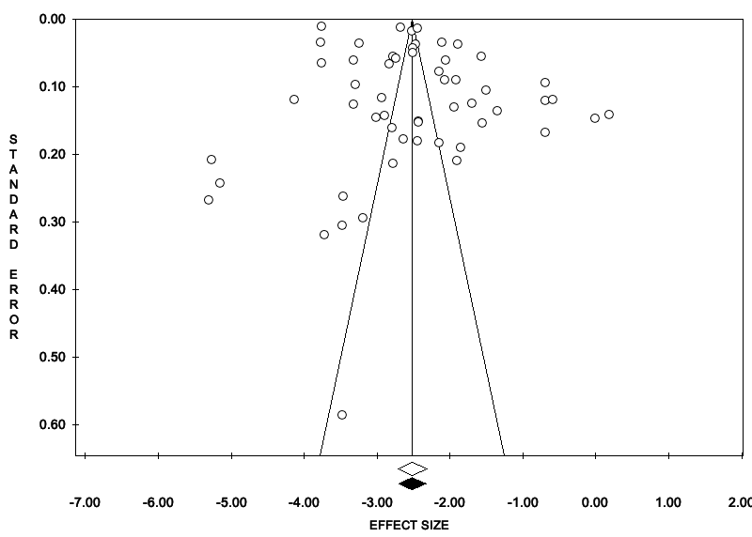
Fig. S2 Funnel plot showing the incidence of patients with cancer in COVID-19 patients
Fig. S3 Funnel plot showing the mortality of patients with cancer and SARS-CoV-2 infection

Fig. S4 Funnel plot showing the ICU admission in COVID-19 patients

Fig. S5 Funnel plot for region subgroup analysis of the cancer mortality in COVID-19 patients

Fig. S6 Funnel plot for region subgroup analysis of the ICU admission in COVID-19 patients

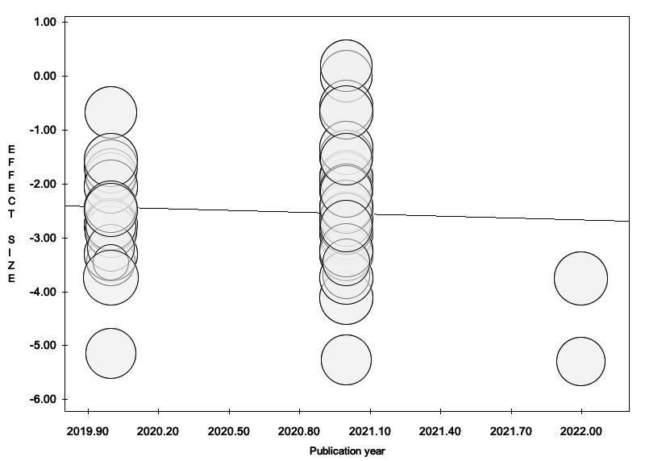
Fig. S7 Bubble plot for publication year analysis of the included studies

