Appendix Material

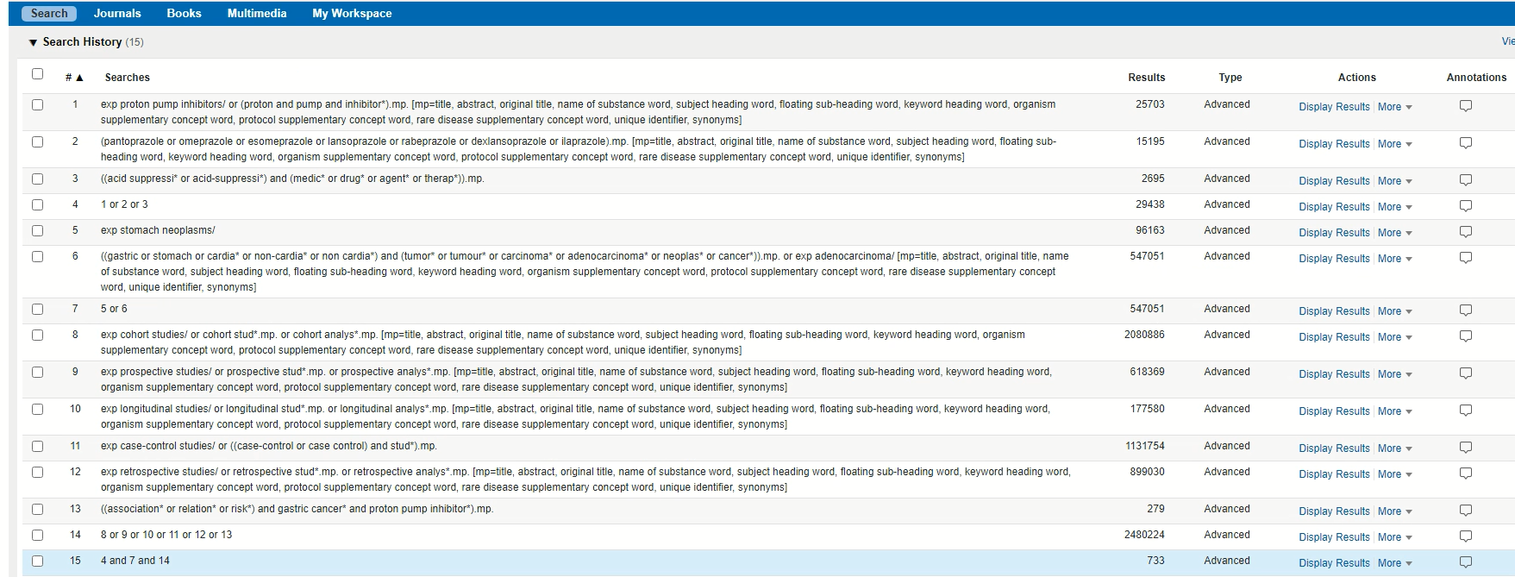

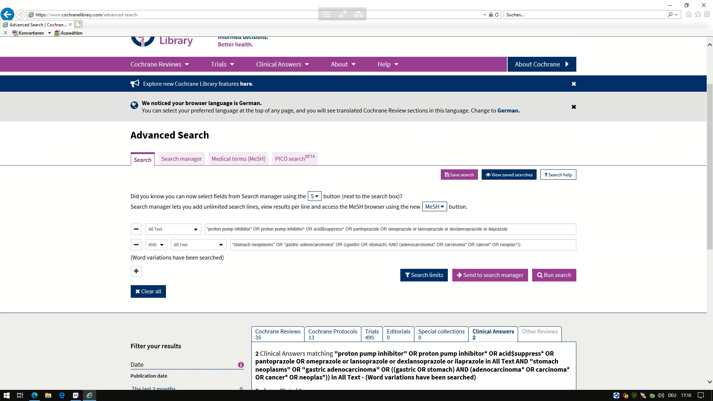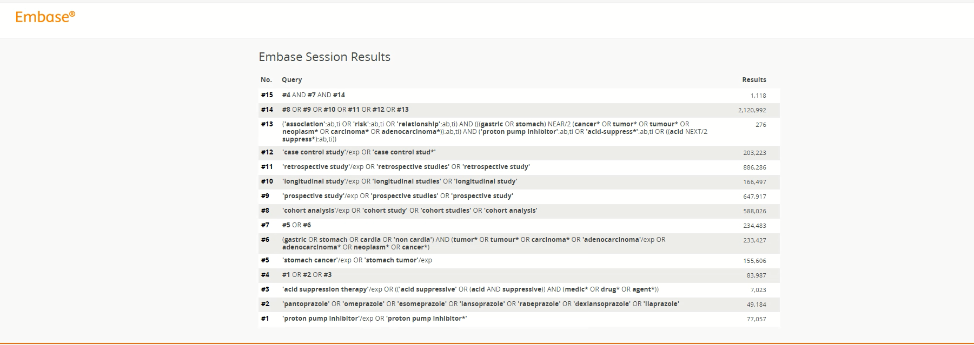

Appendix Figure 1: Search strategies in EMBASE, Ovid Medline, and the Cochrane Library (July, 18, 2020)

Total articles: (n = 2,396)
EMBASE: 1,118*
Ovid Medline: 733*
Cochrane Library 545*

Duplicates excluded: 397
1,999 articles screened by title and abstract
1,966 articles excluded due to non-eligibility
33 articles undergoing full-text review

19 articles excluded due to:
- lack of comparison between PPI and non-PPI users: 6
- no separate analyses for PPI, only acid-suppressive drugs: 2
- no specific analysis on GC, but all gastrointestinal cancers: 1
- study among GC patients only: 1
- secondary analyses/abstracts/journal clubs/meta-analysis - including original publications: 9

14 studies (14 articles) for qualitative synthesis

One article excluded due to incomplete information for quantitative synthesis

13 studies (13 articles) meeting criteria for complete data extraction: eight case-control studies, five retrospective cohort studies

Appendix Figure 2: Flow chart
* Records from Ovid MEDLINE,EMBASE, and the Cochrane Library (inception- July, 18th, 2020)
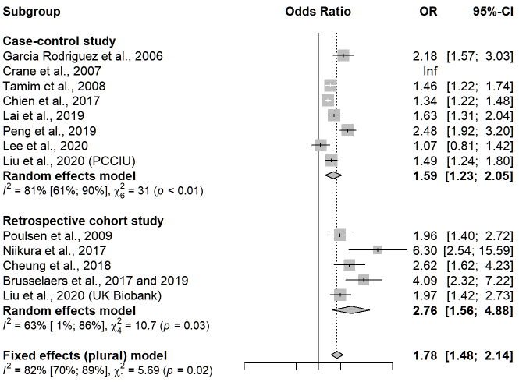

Appendix Figure 3: Association between PPI use and GC risk stratified by study design

Abbreviations:
95%-CI: 95% confidence interval; GC: gastric cancer; I²: percentage of variance attributable to study heterogeneity, Inf: infinity; OR: odds ratio; p = p-value; PPI: proton pump inhibitors; χ²: standard chi-squared test for statistical heterogeneity.
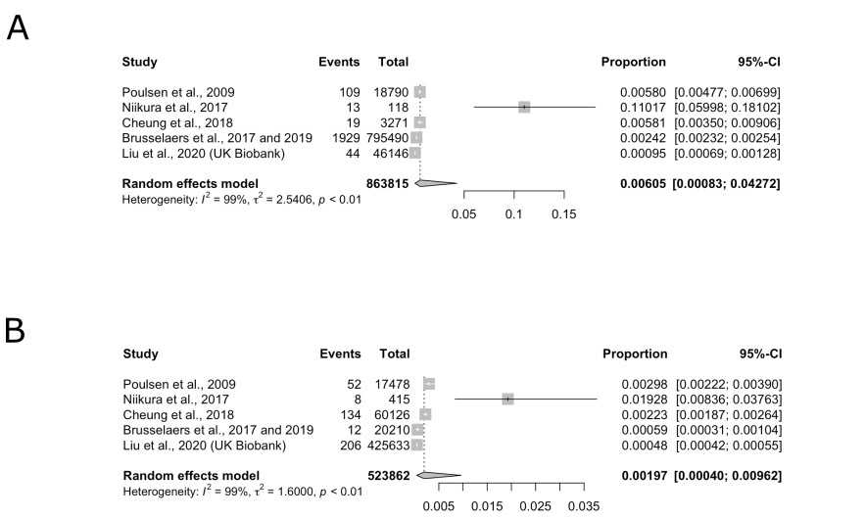
Appendix Figure 4: Pooled prevalence of GC among PPI users (Panel A) and non-PPI users (Panel B) in retrospective cohort studies.
The y-axis indicates the fraction of the population studied with GC.

Abbreviations:
95%-CI: 95% confidence interval; GC: gastric cancer; I²: percentage of variance attributable to study heterogeneity, p = p-value; PPI: proton pump inhibitors; τ²: variance of the effect size parameters across included studies.

Study design | Study | Bias due to confounding | Bias in selection of participants into the study | Bias in classification of interventions | Bias due to deviations from intended interventions | Bias due to missing data | Bias in measurement of outcomes | Bias in selection of the reported result | Overall risk of bias
 | Niikura et al. | Severe | Moderate | Severe | Severe | Low | Low | Low | Severe
 | Cheung et al. | Moderate | Low | Low | Moderate | Low | Low | Low | Moderate
Cohort studies | Poulsen et al. | Moderate | Low | Low | Moderate | Low | Low | Low | Moderate
 | Brusselaers et al. 2017 and 2019 | Moderate | Low | Low | Moderate | Low | Low | Low | Low
 | García Rodríguez et al. | Moderate | Moderate | Low | Moderate | Low | Low | Low | Moderate
 | Tamim et al. | Moderate | Moderate | Low | Moderate | Moderate | Low | Low | Moderate
 | Lai et al. | Moderate | Moderate | Low | Moderate | Low | Low | Low | Moderate
Case-control studies | Peng et al. | Moderate | Severe | Moderate | Moderate | Moderate | Low | Low | Moderate
 | Chien et al. | Moderate | Moderate | Low | Moderate | Moderate | Low | Moderate | Moderate
 | Lee et al. | Moderate | Moderate | Low | Moderate | Moderate | Low | Low | Moderate
 | Crane et al. | Moderate | Moderate | Low | Moderate | Moderate | Low | Moderate | Moderate
 | Liu et al. | Moderate | Moderate | Low | Moderate | Low | Low | Low | Moderate

Appendix Table 1: Risk of bias in non-randomised studies of interventions (ROBINS-I)

