Supplementary Table 1. PRISMA checklist for systematic review and meta-analysis. (From Moher D, Liberati A, Tetzlaff J, Altman DG, The PRISMA Group (2009). Preferred Reporting Items for Systematic Reviews and Meta-Analyses: The PRISMA Statement. PLoS Med 6(7): e1000097. doi:10.1371/journal.pmed1000097)
SECTION/TOPIC | # | CHECKLIST ITEM | REPORTED ON PAGE #
TITLE
Title | 1 | Identify the report as a systematic review, meta-analysis, or both. | Title
ABSTRACT
Structured summary | 2 | Provide a structured summary including, as applicable: background; objectives; data sources; study eligibility criteria, participants, and interventions; study appraisal and synthesis methods; results; limitations; conclusions and implications of key findings; systematic review registration number. | Abstract
INTRODUCTION
Rationale | 3 | Describe the rationale for the review in the context of what is already known. | Section 3.1
Objectives | 4 | Provide an explicit statement of questions being addressed with reference to participants, interventions, comparisons, outcomes, and study design (PICOS). | Section 3.2 and 3.3
METHODS
Protocol and registration | 5 | Indicate if a review protocol exists, if and where it can be accessed (e.g., Web address), and, if available, provide registration information including registration number. | NA
Eligibility criteria | 6 | Specify study characteristics (e.g., PICOS, length of follow-up) and report characteristics (e.g., years considered, language, publication status) used as criteria for eligibility, giving rationale. | Section 4.1
Information sources | 7 | Describe all information sources (e.g., databases with dates of coverage, contact with study authors to identify additional studies) in the search and date last searched. | Section 4.1
Search | 8 | Present full electronic search strategy for at least one database, including any limits used, such that it could be repeated. | Section 4.1
Study selection | 9 | State the process for selecting studies (i.e., screening, eligibility, included in systematic review, and, if applicable, included in the meta-analysis). | Section 4.2
Data collection process | 10 | Describe method of data extraction from reports (e.g., piloted forms, independently, in duplicate) and any processes for obtaining and confirming data from investigators. | Section 4.3
Data items | 11 | List and define all variables for which data were sought (e.g., PICOS, funding sources) and any assumptions and simplifications made. | Section 4.3
Risk of bias in individual studies | 12 | Describe methods used for assessing risk of bias of individual studies (including specification of whether this was done at the study or outcome level), and how this information is to be used in any data synthesis. | Section 4.2
Summary measures | 13 | State the principal summary measures (e.g., risk ratio, difference in means). | Section 4.3
Synthesis of results | 14 | Describe the methods of handling data and combining results of studies, if done, including measures of consistency (e.g., I²) for each meta-analysis. | Section 4.4
Risk of bias across studies | 15 | Specify any assessment of risk of bias that may affect the cumulative evidence (e.g., publication bias, selective reporting within studies). | Section 4.4
Additional analyses | 16 | Describe methods of additional analyses (e.g., sensitivity or subgroup analyses, meta-regression), if done, indicating which were pre-specified. | NA
RESULTS
Study selection | 17 | Give numbers of studies screened, assessed for eligibility, and included in the review, with reasons for exclusions at each stage, ideally with a flow diagram. | Section 5.1
Study characteristics | 18 | For each study, present characteristics for which data were extracted (e.g., study size, PICOS, follow-up period) and provide the citations. | Section 5.2
Risk of bias within studies | 19 | Present data on risk of bias of each study and, if available, any outcome level assessment (see item 12). | Section 5.1
Results of individual studies | 20 | For all outcomes considered (benefits or harms), present, for each study: (a) simple summary data for each intervention group (b) effect estimates and confidence intervals, ideally with a forest plot. | Section 5.5 and 5.6
Synthesis of results | 21 | Present results of each meta-analysis done, including confidence intervals and measures of consistency. | Section 5.5 and 5.6
Risk of bias across studies | 22 | Present results of any assessment of risk of bias across studies (see Item 15). | Section 5.5 and 5.6
Additional analysis | 23 | Give results of additional analyses, if done (e.g., sensitivity or subgroup analyses, meta-regression [see Item 16]). | NA
DISCUSSION
Summary of evidence | 24 | Summarize the main findings including the strength of evidence for each main outcome; consider their relevance to key groups (e.g., healthcare providers, users, and policy makers). | Section 5.5 and 5.6
Limitations | 25 | Discuss limitations at study and outcome level (e.g., risk of bias), and at review-level (e.g., incomplete retrieval of identified research, reporting bias). | Section 6
Conclusions | 26 | Provide a general interpretation of the results in the context of other evidence, and implications for future research. | Section 5 and 6
FUNDING
Funding | 27 | Describe sources of funding for the systematic review and other support (e.g., supply of data); role of funders for the systematic review. | Section 9

Supplementary Table 2. Summary of subject characteristics and outcomes reported in studies included in this systematic review.
Study (reference) | Country | Subject characteristics | Relevant outcome(s) (term used in article, if different, indicated in parentheses) | Outcome grading
Aizen & Gilhar, 2001¹ | NR | 80 males and females, 59-91 years, race NR | Wrinkles | Graded 1-5
Akiba et al., 1999² | Japan (Akiba, Kagoshima) | 195 males and females, 20-29 and 50-59 years, race NR | Pigmentation (hyper-pigmentation)  Wrinkles  Skin colour (sun exposure index for darkness) | Graded 1-5, using images captured by FaCIS  Recorded count and total length using WIS  Derived from L*A*B* measurements
Allen et al., 1973³ | US | 650 males and females, 20-80 years, Whites and Blacks | Wrinkles | Graded 1-6 (Daniell scale)
Asakura et al., 2009⁴ | Japan | 802 males and females, >65 years, Asian | Pigmentation (hyperpigmented macules)  Pores  Texture  Wrinkles | Quantified using software  Quantified using software  Quantified using software  Quantified using software  Quantified using software
Bastiaens et al., 1999⁵ | Netherlands (Leiden) | 272 males and females, 23-69 years, race NR | Ephelides  Lentigines (solar lentigines) | Counted, then graded 1-6 according to frequency  Counted, then graded 1-6 according to frequency
Bastiaens et al., 2004⁶ | Netherlands (Leiden) | 961 males and females, 30-80 years, race NR (Leiden skin cancer study cohort) | Ephelides  Lentigines (solar lentigines) | Presence or absence  Presence or absence
Battistutta et al., 2006⁷ | Australia (Nambour) | 195 males and females, 18-79 years, race NR | Skin surface microtopography | Graded 1-6 (Beagley-Gibson scale)
Buendía-Eisman et al., 2020⁸ | Spain | 1,474 males and females, 18-60 years, race NR | Photoaging (degree of aging) | Graded 1-4 (Glogau scale)
Bhatt et al., 2019⁹ | Nepal (Dharan) | 110 males and females, 30-70 years, Asians and Caucasians | Wrinkles | Calculated using formula (from Castelo-Branco et al., 1998)
Castelo-Branco et al., 1998¹⁰ | Spain (Barcelona) | 730 females, 40-60 years, race NR | Wrinkles | Calculated using formula
Chien et al., 2016¹¹ | US (Michigan) | 143 males and females, 21-91 years, various races | Wrinkles | Graded 0-8
Chien et al., 2018¹² | US (Baltimore) | 75 females, 18-96, Blacks | Photoaging | Graded 0-8
Chung et al., 2001¹³ | South Korea | 407 males and females, 30-92 years, Asian | Pigmentation (dyspigmentation)  Wrinkles  Pigmentation (hyper-pigmented macules)  Seborrheic keratosis | Graded 0-5  Graded 0-7  Count  Count
Cosgrove et al., 2007¹⁴ | US | 3,808 females, 40-74 years, various races (NHANES I cohort) | Dryness  Thinning (skin atrophy)  Wrinkles | Presence or absence  Presence or absence  Presence or absence
Daniell, 1971¹⁵ | US (California) | 1,104 males and females, 30-70 years, 98% white | Wrinkles | Graded 1-6, Daniell scale
Derancourt et al., 2007¹⁶ | France | 285 males and females, 18-58 years, Caucasian | Lentigines (solar lentigines) | Count
Ding et al., 2017¹⁷ | China (Taizhou) | 874 males and females, 35-89 years, Asian, recruited in 2012 from Taizhou cohort; 1,003 males and females, 56-74 years, Asian, recruited in 2014 | Pigmentation (pigment spots)  Sagging (laxity)  Wrinkles (coarse wrinkles)  Cutis rhomboidalis nuchae  Elastosis (solar elastosis)  Favre-racouchot syndrome  Skin colour (even pigmentation)  Telangiectasia  Wrinkles (fine wrinkles) | Counted, then graded 0-3 according to count; graded 0-5 according to severity (SCINEXA)  Graded 0-5  Graded 0-5  Presence or absence  Presence or absence  Presence or absence  Presence or absence  Presence or absence  Presence or absence
Dobos et al., 2015¹⁸ | Germany (Berlin) | 24 females, 30-80 years, race NR | Pigmentation (hyperpigmentation)  Pigmentation (hypopigmentation)  Pigmentation (dyspigmentation) | Graded 0-5 and quantified using digital image analysis  Graded 0-5 and quantified using digital image analysis  Graded 0-5 and quantified using digital image analysis
Dunn et al., 1997¹⁹ | US | 3,875 females, 40-74 years, Whites and Blacks (NHANES I cohort) | Dryness  Thinning (skin atrophy)  Wrinkles | Presence or absence  Presence or absence  Presence or absence
Ekiz et al., 2012²⁰ | Turkey (Ankara) | 574 males and females, 18-89 years, race NR | Wrinkles | Graded 1-6, Daniell scale
Elfakir et al., 2010²¹ | France (Paris) | 530 females, 44-70 years, Whites (SUVIMAX cohort) | Photoaging | Graded 1-6, Lanier scale
Engel et al., 1988²² | US | 20,295 males and females, 1-74 years, Whites and Blacks (NHANES I cohort) | Photoaging (actinic skin damage)  Elastosis (senile elastosis)  Ephelides (freckles)  Solar keratosis (actinic keratosis)  Lentigines (senile lentigines)  Pigmentation (localised hypermelanism)  Pigmentation (localised hypomelanism)  Telangiectasia (fine telangiectasia) | Presence or absence  Graded absent, minimal, moderate, or severe  Graded absent, minimal, moderate, or severe  Graded absent, minimal, moderate, or severe  Graded absent, minimal, moderate, or severe  Graded absent, minimal, moderate, or severe  Graded absent, minimal, moderate, or severe  Graded absent, minimal, moderate, or severe
Ernster et al., 1995²³ | US (California) | 1,136 males and females, 30-69 years, Whites | Wrinkles | Calculated by assigning 1, 1.5 or 2 to shallow, medium, and deep wrinkles, respectively; then taking length of each wrinkle in cm; multiply both numbers; add the scores for all wrinkles at the locations of interest
Eun, 2001²⁴ | NR | 407 males and females, 30-92 years, Asian | Wrinkles | Graded 0-7
Ezzedine et al., 2013²⁵ | France (Paris) | 523 females, 44-70 years, race NR (SUVIMAX cohort) | Ephelides  Lentigines | Presence or absence  Graded using a six-grade scale by Morizot et al., 2002. Global severity was estimated by a score built using principal component analysis and linear regression and standardised
Flament & Qiu, 2017²⁶ | China (Shanghai) | 83 females, age NR, Asian | Pigmentation  Pores  Sagging  Telangiectasia (vascular disorders)  Wrinkles | Graded according to Skin Aging Atlas. Volume 2. Asian Type. (Bazin & Flament, 2010)
Flament et al., 2013²⁷ | France (Montpellier) | 298 females, 30-78 years, white | Wrinkles  sagging  pigmentation  Telangiectasia (vascular disorders) | Graded according to Skin Aging Atlas. Volume 1. Caucasian Type. (Bazin & Flament, 2007)
Flament et al., 2015²⁸ | China (Guangzhou) | 301 female, 20-80 years, Asian | Pigmentation  pores  sagging  wrinkles | Graded according to skin aging atlas. Volume 2. Asian type. (Bazin & Flament, 2010)
Flament et al., 2018²⁹ | China (Baoding, Dalian) | 204 females, 25-45 years, Asian | Pigmentation  Pores  Sagging  Telangiectasia (vascular disorders)  Wrinkles | Graded according to Skin Aging Atlas. Volume 2. Asian Type. (Bazin & Flament, 2010)
Flament et al., 2019³⁰ | China (Baoding, Dalian) | 201 males, 20-60 years, Chinese | Pigmentation  Pores (sebaceous pores)  Sagging  Telangiectasia (vascular disorders)  Wrinkles | Graded according to Skin Aging Atlas. Volume 2. Asian Type. (Bazin & Flament, 2010)
Flament et al., 2019³¹ | Japan (Tokyo) | 1,011 females, 18-83 years, Asian | Pigmentation  Sagging  Telangiectasia (vascular disorders)  Wrinkles | Graded according to Skin Aging Atlas. Volume 2. Asian Type. (Bazin & Flament, 2010)
Flament et al., 2019³² | China (Hong Kong, Shanghai) | 261 males, 18-75 years, Asian | Pigmentation  Pores  Sagging  Telangiectasia (vascular disorders)  Wrinkles | Graded according to Skin Aging Atlas. Volume 2. Asian Type. (Bazin & Flament, 2010)
Fritschi & Green, 1995³³ | Australia; Scotland | 1307 males and females, 13-15 years, race NR | Skin surface microtopography | Graded none, mild moderate, or severe
Fuks et al., 2019³⁴ | Germany (Berlin, Ruhr) | 2013 males and females, 20-84 years, race NR (SALIA and BASE-II cohort) | Wrinkles (coarse wrinkles)  Pigmentation (pigment spots) | Graded according to SCINEXA  Graded according to SCINEXA
Gao et al., 2013³⁵ | China (Hainan, Liaoning) | 691 males and females, 10-86 years, Asian | Skin surface microtopography | Graded 1-6, Beagley-Gibson scale
Garbe et al., 1994³⁶ | Germany | 1,011 males and females, age and race NR | Lentigines (actinic lentigines) | Graded none, few, or many
Gill et al., 2000³⁷ | Australia (Melbourne) | 170 males and females, 15-30 years, various races | Seborrheic keratosis | Count
Goodman et al., 2018³⁸ | Australia; Canada; UK; US | 1,472 females, 18-75 years, Caucasians and Asians | Wrinkles (lines)  Wrinkles (nasolabial fold)  Others (midface volume loss)  Others (oral commissures)  Others (tear troughs) | Graded 0-3  Graded 0-4  Graded 0-5  Graded 0-3  Graded 0-4
Green et al., 1988³⁹ | Australia (Nambour) | 834 males and females, 20-69 years, race NR | Seborrheic keratosis | Count
Green et al., 2011⁴⁰ | Australia (Nambour) | 1,400 males and females, 20-54 years, race NR | Skin surface microtopography  Lentigines (solar lentigines)  Telangiectasia  Cutis rhomboidalis nuchae  Favre-racouchot syndrome | Graded 1-6, Beagley-Gibson scale  Count  Graded as mild, moderate, or severe  Graded as mild to moderate, or severe  Graded as mild to moderate, or severe
Green, 1991⁴¹ | Australia (Nambour) | 807 males and females, 20-55 years, race NR | Skin surface microtopography | Graded 1-6, Beagley-Gibson scale
Gunn et al., 2015⁴² | Netherlands (Leiden)  UK | 670 males and females, age and race NR (Leiden Longevity Study cohort)  162 females, 45-75 years, Whites | Perceived age (perceived facial age)  Wrinkles  Perceived age (perceived facial age) | Estimated in years  Graded 1-9  Estimated in years
Guyuron et al., 2009⁴³ | US | 196 (98 twin pairs) males and females, 18-76 years, race NR | Perceived age (perceived age difference) | Estimated in years
Hamer et al., 2017⁴⁴ | Netherlands (Rotterdam) | 3,831 males and females, >45 years, race NR (Rotterdam study cohort) | Wrinkles | Quantified using digital image analysis
Helfrich et al., 2007⁴⁵ | US | 82 males and females, 22-91 years, various races | Wrinkles (fine wrinkles) | Graded 0-8
Hillebrand et al., 2001⁴⁶ | Japan (Akita, Kagoshima) | 602 females, 5-65 years, Asian | Pigmentation  Wrinkles | Quantified using FaCIS  Quantified using WIS
Holman et al., 1984⁴⁷ | Australia (Busselton) | 1,216 males and females, 16-86 years, race NR | Skin surface microtopography | Graded 1-6, Beagley-Gibson scale
Hüls et al., 2016⁴⁸ | China (Taizhou) | 1,072 males and females, 27-90 years, Asian; 806 females, 66-79 years, Caucasian (SALIA cohort) | Lentigines | Counted, then graded 0, 5, 30, or 75 according to frequency category (SCINEXA)
Hüls et al., 2018⁴⁹ | Germany (Ruhr) | 799 females, 69-79 years, Caucasian | Lentigines | Counted, then graded 0-3 based on frequency category (SCINEXA)
Ichibori et al., 2014⁵⁰ | Japan (Osaka) | 134 (67 twin pairs) males and females, 40-87 years, Asian | Permanent erythema (erythema)  Pigmentation (spots)  Pores  Texture  Wrinkles | Quantified using VISIA  Quantified using VISIA  Quantified using VISIA  Quantified using VISIA  Quantified using VISIA
Ippen & Ippen, 1965⁵¹ | NR | 224 females, 35-84 years, race NR | Smoker's face (smoker’s skin) | Presence or absence
Jacobs et al., 2014⁵² | Netherlands (Rotterdam) | 5,578 males and females, over 45 years, race NR (Rotterdam Study cohort) | Sagging | Graded as normal, mild, moderate, or severe
Kadunce et al., 1991⁵³ | US (Utah) | 132 males and females, 35-59 years, Whites | Wrinkles | Graded 1-5, modified from Daniell, 1971
Kennedy et al., 2003⁵⁴ | Netherlands (Leiden) | 956 males and females, 30-80 years, race NR (Leiden Skin Cancer Study cohort) | Elastosis  Telangiectasia | Graded as light, moderate, or severe  Graded as light, moderate, or severe
Kennedy et al., 2003⁵⁵ | Netherlands (Leiden) | 966 males and females, 30-80 years, race NR (Leiden Skin Cancer Study cohort) | Solar keratosis (actinic keratosis) | Count
Keough et al., 1997⁵⁶ | US (Texas) | 56 males and females, 37-90 years, race NR | Favre-racouchot syndrome | Presence or absence
Kim et al., 2014⁵⁷ | China (Beijing, Shanghai, Wuhan, Guangzhou) | 441 females, 20-35 years, Asian | Wrinkles | Quantified using Visioline
Kimlin & Guo, 2012⁵⁸ | Australia (Brisbane) | 180 males and females, 18-83 years, race NR | Pigmentation (hyperpigmentation)  Wrinkles | Quantified using VISIA  Quantified using VISIA
Knuutinen et al., 2002⁵⁹ | Finland | 98 males, 34-71 years, race NR | Thinning (thickness) | Quantified using ultrasound device
Koh et al., 2002⁶⁰ | South Korea | 350, gender NR, 20-69 years, race NR | Wrinkles | Graded 1-5, modified from Daniell, 1971
Kwon et al., 2003⁶¹ | South Korea | 303 males, 40-70 years, Asian | Seborrheic keratosis | Count
Latreille et al., 2013⁶² | France (Paris) | 2,919 males and females, 45-60 years, race NR (SUVIMAX cohort) | Photoaging (skin photodamage) | Graded 1-6, Larnier scale
Leung & Harvey, 2002⁶³ | UK (Cardiff) | 560 males and females, 60-97 years, race NR | Elastosis | Graded 0-10, adapted from Daniell scale
Li et al., 2015⁶⁴ | China (Pingding, Taizhou) | 1,129 females, 30-90 years, Asian | Pigmentation (pigment spots)  Sagging (laxity)  Wrinkles (coarse wrinkles)  Cutis rhomboidalis nuchae  Elastosis (solar elastosis)  Favre-racouchot syndrome  Skin colour (even pigmentation)  Telangiectasia  Wrinkles (fine wrinkles) | Counted, then graded 0-3 according to frequency category (modified SCINEXA)  Graded 0-5 (SCINEXA)  Graded 0-5 (SCINEXA)  Presence or absence  Presence or absence  Presence or absence  Presence or absence  Presence or absence  Presence or absence
Lichterfeld et al., 2016⁶⁵ | Germany | 1,524 males and females, elderly subjects, age and race NR | Dryness | Graded 0-4 (overall dry skin score)
Lucas et al., 2009⁶⁶ | Australia | 534 males and females, 18-61 years, race NR (Ausimmune study cohort) | Skin surface microtopography | Graded 1-6 (Beagley-Gibson scale)
Malvy et al., 2000⁶⁷ | France | 6,630 males and females, 45-60 years, race NR (SUVIMAX cohort) | Photoaging (skin photodamage) | Graded 1-6 (Larnier scale)
Martires et al., 2009⁶⁸ | US (Ohio) | 130 (65 twin pairs) males and females, 18-77 years, race NR, twins | Photoaging | Graded 0-9, (scale from Griffiths et al., 1992)
Mayes et al., 2010⁶⁹ | China (Shanghai) | 220 females, 25-70 years, Chinese | Perceived age (perceived facial age) | Estimated in years
Mekic et al., 2019⁷⁰ | Netherlands (Rotterdam) | 2,753 males and females, median age 67.3, race NR (Rotterdam study cohort) | Wrinkles | Quantified digitally using Matlab
Mekic et al., 2019⁷¹ | Netherlands (Rotterdam) | 5,547 males and females, 51-101 years, race NR (Rotterdam Study cohort) | Dryness (dry skin) | Presence or absence
Mekić et al., 2020⁷² | Netherlands (Rotterdam) | 2,842 males and females, >45 years, race NR (Rotterdam Study cohort) | Telangiectasia | Quantified using image analysis system
Mizuno et al., 2016⁷³ | Japan (Wakayama) | 14 males and females, 62-91 years, Asian | Pigmentation (spots)  Wrinkling | Quantified using image analysis system  Quantified using image analysis system
Model, 1985⁷⁴ | NR | 116 males and females, 35-69 years, Whites and 1 Asian | Smoker's face | Presence or absence
Monestier et al., 2006⁷⁵ | France (Marseille) | 236 males and females, 60-79 years, Caucasian | Lentigines (senile lentigo) | Count
Muizzuddin et al., 1997⁷⁶ | US (New York, New Jersey, Pennsylvania) | 100, no other data reported | Wrinkles | Quantified using image analysis system
Nagata et al., 2010⁷⁷ | Japan (Gifu) | 716 females, 20-74 years, Asian | Wrinkles | Graded 1-6 (Daniell scale)
Nouveau-Richard et al., 2005⁷⁸ | China (Suzhou); France (Besancon) | 320 females, 20-60 years, race NR | Pigmentation (pigmented spots)  Wrinkles | Graded none, few, or many  Graded none, few, or many
O'Hare et al., 1999⁷⁹ | US (Winston-Salem) | 200 males and females, 35-75 years, Whites | Wrinkles | Graded 0-5 (modified Daniell scale)
Oyetakin‐White et al., 2015⁸⁰ | US (Ohio) | 60 females, 30-49 years, race NR | Overall skin aging (skin aging) | Graded according to SCINEXA
Okada et al., 2013⁸¹ | US (Ohio) | 158 (79 twin pairs) males and females, 18-78 years, race NR, twins | Wrinkles | Graded 0-5 (Lemperle assessment scale)
Park et al., 2019⁸² | South Korea (Seoul) | 188 males and females, 21-66 years, race NR | Pigmentation  Wrinkles | Quantified via image analysis (smartphone app which graded 0-100)
Peng et al., 2017⁸³ | China (Beijing) | 400 females, 40-90 years, Asian | Lentigines (senile lentigo)  Seborrheic keratosis | Counted, then graded 0, 5, 30, or 75 based on frequency (SCINEXA from Li et al., 2015)
Perner et al., 2011⁸⁴ | Germany (Düsseldorf); Japan (Nagoya) | 87 females, age NR, Asian and Caucasian | Lentigines  Wrinkles | Graded according to SCINEXA  Graded according to SCINEXA
Purba et al., 2001⁸⁵ | Australia; China; Greece; Japan; Sweden | 453 males and females, >70 years, race NR | Skin surface microtopography | Graded 1-6 (Beagley-Gibson scale)
Qiu et al., 2011⁸⁶ | China (Shanghai) | 354 females, 18-80 years, Chinese | Pigmentation (pigmentation spot)  Sagging  Wrinkles | Quantified using mexameter  NR  graded 0-6
Raduan et al., 2008⁸⁷ | Brazil (Rio de Janeiro) | 301 males and females, 25-86 years, race NR | Wrinkles | Graded 1-6, Daniell scale
Raitio et al., 2004⁸⁸ | Finland (northern region) | 89 males, 15-56 years, race NR | Wrinkles | Graded 1-6 ( Daniell scale); also quantified using computer analysis
Rexbye et al., 2006⁸⁹ | Denmark | 1,826 males and females, 63-90 years, race NR (LSADT 2001 cohort) | Perceived age | Estimated in years
Schäfer et al., 2006⁹⁰ | Germany (Augsburg) | 2,823 males and females, 25-74 years, race NR (KORA-survey 2000 cohort) | Solar keratosis  Cutis rhomboidalis nuchae  Elastosis  Favre-racouchot syndrome  Ephelides  Lentigines (lentigines solaris)  Lentigines (lentigines senilis) | Presence or absence  Graded absent, mild, moderate, or severe  Graded absent, mild, moderate, or severe  Graded absent, mild, moderate, or severe  Count  Count  Count
Seddon et al., 1992⁹¹ | US (Massachusetts) | 115 males and females, 18-77 years, race NR | Skin surface microtopography | Graded 1-6 (Beagley-Gibson scale)
Silva et al., 2009⁹² | UK (Hertfordshire, Yorkshire) | 754 females, 18-46 years, white | Skin surface microtopography | Graded 1-6 (Beagley-Gibson scale)
Singer et al., 1994⁹³ | US (Michigan) | 120 males and females, 43-81 years, race NR | Photoaging (photodamage) | Graded 0-8 (scale from Griffiths et al., 1992)
Song et al., 2015⁹⁴ | South Korea (Seoul, Gyeonggi-do) | 100 males, 20-59 years, Asian | Wrinkles | Quantified using PRIMOS lite
Suehara et al., 2006⁹⁵ | Brazil (Sao Paulo) | 77 males and females, 41-60 years, race NR | Smoker's face | Graded 1-7
Suppa et al., 2011⁹⁶ | UK (Yorkshire, Northern Region south of the River Tyne') | 1,342 males and females, 18-76 years, race NR | Pigmentation  Telangiectasia (vascularity)  Wrinkles | Graded 0-5  Graded 0-4  Graded 0-7
Takahashi et al., 2017⁹⁷ | Japan (Tokyo) | 169 females, 6-62 years, Asian | Pigmentation | Quantified using VISIA
Tsukahara et al., 2007⁹⁸ | Japan (Tokyo); China (Shanghai); Thailand (Bangkok) | 277 females, 10-70 years, Asians | Sagging  Wrinkles | Graded 0-5  Graded 0-5
Tsukahara et al., 2013⁹⁹ | Japan (Tochigi) | 173 males and females, 21-75 years, Asian | Wrinkles | Graded 1-5
Tsukahara et al., 2013¹⁰⁰ | Japan (Tokyo) | 32 males and females, 35-47 years, Asian | Wrinkles | Graded 1-5
Vierkötter et al., 2009¹⁰¹ | Germany (North Rhine Westphalia) | 74 males and females, 19-72 years, race NR | Comedones  Dryness  Elastosis  Ephelides (sunburn freckles)  Lentigines (lentigines solaris)  Others (change of skin phototype)  Others (pigment change)  Others (pseudoscars)  Others (reduced fat tissue)  Others (yellowness)  Permanent erythema  Sagging (lax appearances)  Seborrheic keratosis (benign skin tumour)  Telangiectasia  Wrinkles (coarse wrinkles)  Wrinkles (fine wrinkles)  Cancer (basal cell carcinoma)  Cancer (malignant melanoma)  Cancer (squamous cell carcinoma)  Cutis rhomboidalis nuchae  Favre-racouchot syndrome  Solar keratosis (actinic precancerosis)  Pigmentation (uneven pigmentation) | Graded 0-3  Graded 0-3  Graded 0-3  Graded 0-3  Graded 0-3  Graded 0-3  Graded 0-3  Graded 0-3  Graded 0-3  Graded 0-3  Graded 0-3  Graded 0-3  Graded 0-3  Graded 0-3  Graded 0-3  Graded 0-3  Presence or absence  Presence or absence  Presence or absence  Presence or absence  Presence or absence  Presence or absence  Presence or absence
Vierkötter et al., 2010¹⁰² | Germany (Ruhr, Borken) | 400 females, 68-79 years, race NR (SALIA study cohort) | Pigmentation (pigment spots)  Seborrheic keratosis  Elastosis (solar elastosis)  Sagging (laxity)  Telangiectasia  Wrinkles (coarse wrinkles) | Counted, then graded 0, 5, 30, or 75 according to frequency (SCINEXA)  Presence or absence  Graded 0-5  Graded 0-5  Graded 0-5
Vierkötter et al., 2016¹⁰³ | China; Germany; Japan | 2,326 females, 30-90 years, Asians and Caucasians | Pigmentation (pigment spots) | Graded 0-5 for severity; counted and graded 0-3 according to frequency category (SCINEXA)
Vierkötter et al., 2016¹⁰³ | China; Germany; Japan | 2,326 females, 30-90 years, Asians and Caucasians | Wrinkles (coarse wrinkles) | Graded 0-5
Wang et al., 2009¹⁰⁴ | China (Hangzhou) | 848 males and females, mean age 35.8, Asian | Wrinkles | Graded none, fine, moderate, severe
Warren et al., 1991¹⁰⁵ | US (Arizona) | 41 females, 25-51 years, Caucasian | Wrinkles (furrows)  Perceived age | Measured according to method by Gartstein and Shaya (1986)  Estimated in years
Yin et al., 2001¹⁰⁶ | Japan | 83 males and females, 23-95 years, race NR | Wrinkles | Graded 1-6 (Daniell scale)
Yin et al., 2001¹⁰⁷ | Japan | 63 males and females, mean age 67.5, race NR, | Skin surface microtopography | Quantified using NIH image processing system
Youn et al., 2003¹⁰⁸ | South Korea | 186 females, 20-89 years, Asian | Wrinkles | Graded 0-7 (scale from Chung et al., 2001)
Zhao et al., 1998¹⁰⁹ | China (north-eastern region) | 470 males and females, 10-80 years, Asian | Skin surface microtopography | Graded 1-6 (Beagley-Gibson scale)

Supplementary Table 3. Skin aging definitions by studies from the literature search, where provided, paraphrased from the original text.
Study | Search | Definition of skin aging
Bhatt et al., 2019⁹ | Primary | Both intrinsic and extrinsic factors determine the skin aging process. Intrinsic aging or chronological aging is unavoidable, whereas extrinsic skin aging is dependent on environmental and behavioral factors.
Ekiz et al., 2012²⁰ | Primary | Cutaneous ageing is a continuous process, with intrinsic factors determining which extrinsic factors (chronic sun exposure and other environmental factors, particularly smoking) have the greatest influence. The cutaneous changes that occur with age lead to a gradual physiological decline.
Green et al., 2011⁴⁰ | Primary | The severity of skin aging at any particular age is mostly a function of the degree of skin photoaging. Superimposed on the thinning and fine wrinkling of chronological aging, photoaging causes skin dryness, irregular pigmentation and coarse wrinkles due to the destruction of skin elasticity by cumulative sun exposure.
Green, 1991⁴¹ | Primary | Degeneration due to sun exposure rather than simply to the passage of time is known as premature ageing of the skin or photoageing.
Hamer et al., 2017⁴⁴ | Primary | Skin aging is an ongoing process associated with declined skin function and changes in its appearance. ... Both intrinsic and extrinsic factors contribute to skin aging; smoking and UV radiation are the most well-known extrinsic risk factors.
Latreille et al., 2013⁶² | Primary | Skin aging results from a combination of intrinsic and extrinsic aging factors. Intrinsic aging is an ineluctable process due to the natural degeneration of cell functioning that occurs with age and is genetically determined. … On the contrary, extrinsic aging is dependent on environmental and behavioral factors and can be prevented.
Leung & Harvey, 2002⁶³ | Primary | There are two independent processes governing skin ageing: intrinsic and extrinsic ageing. Intrinsic ageing is the slow irreversible degeneration of tissue that affects almost all body organs. Extrinsic ageing (often termed photoageing) is widely thought to be due primarily to exposure to the ultraviolet (UV) radiation of the sun.
Peng et al., 2017⁸³ | Primary | Skin ageing includes extrinsic and intrinsic ageing.
Raitio et al., 2004⁸⁸ | Primary | Skin ageing is due to intrinsic ageing, where genetic factors play a major role, and extrinsic ageing, in which sun exposure is a well known factor, with distinct clinical and histological features.
Vierkötter et al., 2016¹⁰³ | Primary | Ageing of the skin is influenced by two separate processes. The general ageing process, which is genetically determined and occurs over time alone, is called the intrinsic skin ageing process, whereas the skin ageing process induced by environmental factors is termed the extrinsic skin ageing process.
Youn et al., 2003¹⁰⁸ | Primary | The ageing process of the skin can be divided into intrinsic ageing and photo-ageing. Damage to human skin as a result of repeated exposure to ultraviolet (UV) radiation from the sun (photo-ageing) and damage occurring because of the passage of time (chronologic ageing) are considered distinct entities rather than similar skin ageing processes.
Battistutta et al., 2006⁷ | Secondary | Skin photoaging is a complex process, comprising clinical, cellular, histological and immunological changes which reflect chronological ageing as well as damage directly attributable to ultraviolet radiation (UVR).
Buendía-Eisman et al., 2020⁸ | Secondary | Cited from Krutmann et al., 2017: ‘The skin ageing exposome consists of external and internal factors and their interactions, affecting a human individual from conception to death as well as the response of the human body to these factors that lead to biological and clinical signs of skin aging.’
Castelo-Branco et al., 1998¹⁰ | Secondary | The normal aging process of the skin includes gradual thinning, atrophy, dryness, skin fragility and wrinkling.
Cosgrove et al., 2007¹⁴ | Secondary | Skin aging is a continuous process that is heavily determined by the combined influences arising from intrinsic aging, the environment (eg, sun exposure), and lifestyle factors [eg, cigarette smoking, low body mass index (BMI; in kg/m2), and menopausal status].
Ding et al., 2017¹⁷ | Secondary | Skin aging is caused by both intrinsic and extrinsic factors. Extrinsic skin aging is known to be affected by various environmental factors including sun exposure, tobacco smoking, and air pollution.
Elfakir et al., 2010²¹ | Secondary | Aging of the skin is influenced both by intrinsic factors, such as chronological age, and by extrinsic or environmental factors, such as chronic UV exposure and smoking. Skin photoaging is defined as premature aging of the skin due to chronic sun exposure and presents characteristic morphological changes to both the epidermal and the dermal compartments.
Eun, 2001²⁴ | Secondary | Skin aging can be divided into two basic processes. One is photoaging, which indicates premature skin aging in chronically photodamaged skin.
Flament et al., 2013²⁷ | Secondary | Described implicitly as the 'result of several concomitant processes', with both chronological aging and photoaging contributing to clinical effects on the skin.
Flament et al., 2015²⁸ | Secondary | … overall aging process is the combined effects of chronological (intrinsic) and sun-induced (extrinsic) damages …
Goodman et al., 2018³⁸ | Secondary | The appearance and structure of skin changes with age due to intrinsic (chronological) processes, extrinsic factors that include sun and UV exposure, gravity, pollution, and lifestyle factors such as diet, smoking, illness or stress. Solar UV irradiation is the primary extrinsic factor causing human skin ageing. The cumulative process of photoageing depends primarily on the degree of sun exposure and amount of skin pigment.
Hillebrand et al., 2001⁴⁶ | Secondary | Skin photodamage or ‘photoaging’ is the superimposition of chronic sun damage (extrinsic aging) on top of intrinsic aging and is marked by an acceleration in the appearance of fine and coarse wrinkling, mottled pigmentation and lentigenes, and skin sagging.
Martires et al., 2009⁶⁸ | Secondary | Aging is attributed to both intrinsic and extrinsic processes. Photoaging - the most recognised form of extrinsic aging of skin - describes changes brought about by long-term sun exposure, resulting in photodamage. Photodamage, therefore, refers to the physical and morphologic alterations secondary to solar UV exposure and is the main component of photoaging.
Qiu et al., 2011⁸⁶ | Secondary | Internally, it undergoes progressive alterations, over decades, resulting from a regular decline in many biological functions, globally defined as the aging process, including intrinsic (chronological) and sun-induced, otherwise known as photo-ageing. These, combined, lead to slow and progressive changes in both skin functions and structures, ultimately altering physical appearance, most of the time assessed on the face by oneself and others.
Raduan et al., 2008⁸⁷ | Secondary | Cutaneous ageing is a continuous process involving intrinsic ageing (a universal and inevitable alteration attributed to the passage of time) and extrinsic ageing (the superposition over intrinsic ageing of changes attributed to chronic solar exposure and other environmental factors, among them, smoking).
Takahashi et al., 2017⁹⁷ | Secondary | Skin aging occurs intrinsically chronological effect and influenced by environmental and genetic factors.
Vierkoetter et al., 2009¹⁰¹ | Secondary | Skin ageing is the consequence of intrinsic and extrinsic factors. Intrinsic or chronological skin ageing and extrinsic skin ageing, which is primarily due to chronic exposure to ultraviolet (UV) radiation and therefore is also called photoageing, can be distinguished histologically and clinically, involve distinct pathogenetic causes and mechanisms and their prevention is based on different principles.
Vierkoetter et al., 2010¹⁰² | Secondary | Aging results from the combined action of intrinsic and extrinsic factors.
Yin et al., 2001¹⁰⁷ | Secondary | Premature skin aging is the result of programmed senescence and prolonged environmental injury to skin.

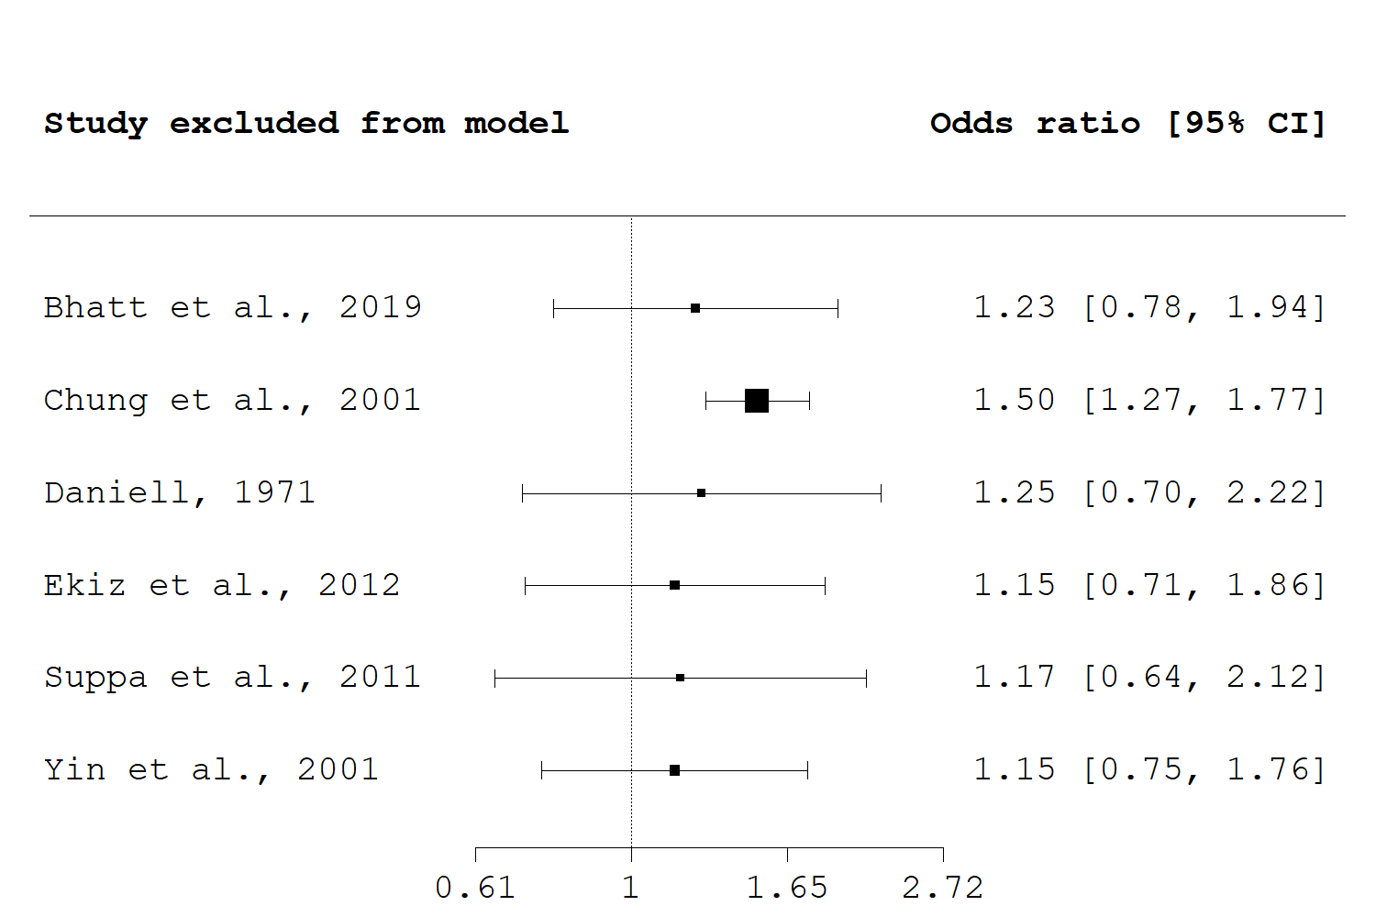

Supplementary Figure 1. Sensitivity analysis for meta-analysis of wrinkling and male gender.

Supplementary Table 4. Summary of associations for skin aging signs and air pollutant exposure.
Pollutant/exposure | Subject characteristics | Outcome | Association/Effect size, if reported | Study
AQI | 201 males, 20-60 years, Asian | Greater perceived age  Pigmentation  Sagging  Telangiectasia  Wrinkling | S  S (20-39 years and 50-59 years only)  S (20-29 years only)  S (20-29 years and 40-59 years only)  S | Flament et al., 2019³⁰
AQI | 204 females, 25-45 years, Asian | Pigmentation  Wrinkling | S (30 years and above)  S (30 years and above) | Flament et al., 2018²⁹
CO | 188 males and females, 21-66 years | Pigmentation  Wrinkling | spearman's r: 1.15, SE: 1.53, p=0.453  spearman's r: 2.81, SE: 2.25, p=0.212 | Park et al., 2019⁸²
Contact with fossil fuels | 400 females, 40-90 years, Asian | Lentigines (cheek) | OR: 2.358, 95% CI: 1.152-4.825 | Peng et al., 2017⁸³
Cooking with solid fuels | 1129 females, 30-90 years, Asian | Laxity (cheeks)  Laxity (eyelids)  Lentigines  Wrinkling (crows feet)  Wrinkling (fine, hand dorsum)  Wrinkling (forehead)  Wrinkling (frownlines)  Wrinkling (nasolabial fold)  Wrinkling (upper lip) | AMR: 1.06, 95% CI: 1.01-1.11  AMR: 1.06, 95% CI: 1.02-1.11  NS  AMR: 1.06, 95% CI: 1.02-1.11  OR: 1.74, 95% CI: 1.2-2.55  AMR: 1.09, 95% CI: 1.05-1.14  AMR: 1.05, 95% CI: 1.01-1.11  AMR: 1.08, 95% CI: 1.04-1.11  AMR: 1.07, 95% CI: 1.01-1.13 | Li et al., 2015⁶⁴
Distance <=100 m from a busy road | 400 females, 68-79 years, Caucasian (SALIA study) | Skin aging signs in SCINEXA scale | NS | Vierkoetter et al., 2010¹⁰²
NO₂ | 1072 males and females, 27-90 years, Asian (Taizhou) | Lentigines (cheek) | GMR: 1.11, 95% CI: 1.03-1.20 | Hüls et al., 2016⁴⁸
NO₂ | 806 females, 66-79 years, Caucasian (SALIA) | Lentigines (cheek) | S | Hüls et al., 2016⁴⁸
O₃ | 188 males and females, 21-66 years | Pigmentation  Wrinkling | spearman's r: 0.02, SE: 0.02, p=0.34  spearman's r: -0.04, SE: 0.04, p=0.278 | Park et al., 2019⁸²
O₃ | 2013 males and females, 20-84 years (SALIA and BASE-II) | Lentigines  Wrinkling (forehead) | NS  % change: 8.34, 95% CI: 2.01-14.67 | Fuks et al., 2019³⁴
Occupations exposed to toxic and harmful substances | 400 females, 40-90 years, Asian | Lentigines  Seborrheic keratosis | NS  NS | Peng et al., 2017⁸³
PM10 | 188 males and females, 21-66 years | Pigmentation  Wrinkling | spearman's r: 0.02, SE: 0.02, p=0.164  spearman's r: 0.04, SE: 0.03, p=0.109 | Park et al., 2019⁸²
PM10 | 400 females, 68-79 years, Caucasian (SALIA study) | Pigmentation (cheeks)  Wrinkling (nasolabial fold) | MR/OR: 1.08, 95% CI: 1.01-1.15  MR/OR: 1.01, 95% CI: 1.01-1.02 | Vierkoetter et al., 2010¹⁰²
PM2.5 | 188 males and females, 21-66 years | Pigmentation  Wrinkling | spearman's r: -0.01, SE: 0.03, p=0.657  spearman's r: -0.06, SE: 0.04, p=0.192 | Park et al., 2019⁸²
PM2.5 | 799 females, 69-79 years, Caucasian (SALIA) | Lentigines (cheek) | S | Hüls et al., 2019⁴⁹
PM2.5 | 1877 males and females, 35-89 years, Asian (Taizhou) | Cutis rhomboidalis nuchae  Laxity (eyelids)  Lentigines (forehead)  Wrinkling (fine, hand dorsum)  Wrinkling (forehead)  Wrinkling (under eyes)  Wrinkling (upper lip) | OR: 1.346, 95% CI: 1.086-1.669  AMR: 1.032, 95% CI: 1.012-1.052  AMR: 1.079, 95% CI: 1.017-1.141  OR: 1.4, 95% CI: 1.017-1.927  AMR: 1.033, 95% CI: 1.004-1.062  AMR: 1.034, 95% CI: 1.004-1.064  AMR: 1.094, 95% CI: 1.049-1.138 | Ding et al., 2017¹⁷
PM2.5 (low vs high exposure) | 400 females, 40-90 years, Asian | Lentigines (cheek)  Lentigines (hand dorsum) | OR: 0.403, 95% CI: 0.239-0.679  OR: 0.263, 95% CI: 0.156-0.441 | Peng et al., 2017⁸³
Second-hand smoking | 400 females, 40-90 years, Asian | Lentigines (cheek)  Seborrheic keratosis (hand dorsum) | OR: 1.784, 95% CI: 1.145-2.781  OR: 2.341, 95% CI: 1.288-4.254 | Peng et al., 2017⁸³
SO₂ | 188 males and females, 21-66 years | Pigmentation  Wrinkling | spearman's r: -0.43, SE: 0.19, p=0.021  spearman's r: -0.31, SE: 0.26, p=0.235 | Park et al., 2019⁸²
Soot | 400 females, 68-79 years, Caucasian (SALIA study) | Pigmentation (cheeks)  Pigmentation (forehead)  Wrinkling (nasolabial fold) | MR/OR: 1.22, 95% CI: 1.03-1.45  MR/OR: 1.2, 95% CI: 1.03-1.40  MR/OR: 1.04, 95% CI: 1.01-1.06 | Vierkoetter et al., 2010¹⁰²
Traffic-associated particles | 400 females, 68-79 years, Caucasian (SALIA study) | Pigmentation (cheeks)  Pigmentation (forehead)  Wrinkling (nasolabial fold) | MR/OR: 1.17, 95% CI: 1.08-1.27  MR/OR: 1.16, 95% CI: 1.06-1.27  MR/OR: 1.03, 95% CI: 1.01-1.04 | Vierkoetter et al., 2010¹⁰²

Supplementary Table 5. Summary of associations for skin aging signs and nutritional intake.
Exposure |  | Outcome | Significant association | Study
Alcohol |  | Wrinkling  Pigmentation | none  none | Park et al., 2019⁸²
 |  | Skin surface microtopography | none | Purba et al., 2001⁸⁵
Carbohydrate (50g Increase) |  | Thinning | increased likelihood | Cosgrove et al., 2007¹⁴
Dairy |  | Skin surface microtopography | increase | Purba et al., 2001⁸⁵
Fatty Acids | Linoleic Acid | Dryness  Thinning | lower likelihood  lower likelihood | Cosgrove et al., 2007¹⁴
Fatty Acids | ALA  DPA  EPA  PUFA | Photoaging  Photoaging  Photoaging  Photoaging | decrease (men only)  decrease (women with highest intakes only)  decrease (women with highest intakes only)  decrease (women with highest intakes only) | Latreille et al., 2013⁶²
Fatty Acids | MUFA  PUFA | Wrinkling  Wrinkling | none  none | Nagata et al., 2010⁷⁷
Fatty Acids | MUFA | Skin surface microtopography | decrease | Purba et al., 2001⁸⁵
Fat | Fat (17g Increase) | Wrinkling | increased likelihood | Cosgrove et al., 2007¹⁴
Fat | Fat  Saturated Fat | Wrinkling  Wrinkling | none  increase (after adjustment for green & yellow vegetable intake) | Nagata et al., 2010⁷⁷
Fat | Fat  Oils And Fats | Skin surface microtopography  Skin surface microtopography | decrease  decrease | Purba et al., 2001⁸⁵
Fruit  Dutch Healthy Diet Index  Unhealthy Diet |  | Wrinkling  Wrinkling  Wrinkling | decrease (women only)  decrease (women only)  increase (women only) | Mekic et al., 2019⁷⁰
Instant Food Intake |  | Wrinkling  Pigmentation | none  none | Park et al., 2019⁸²
Micronutrients | Zinc | Wrinkling | none | Nagata et al., 2010⁷⁷
Micronutrients | Calcium  Iron  Magnesium  Phosphorus  Zinc | Skin surface microtopography  Skin surface microtopography  Skin surface microtopography  Skin surface microtopography  Skin surface microtopography | decrease  decrease  decrease  decrease  decrease | Purba et al., 2001⁸⁵
Seafood | Fish & Shell Fish | Wrinkling | none | Nagata et al., 2010⁷⁷
Seafood | Fish | Skin surface microtopography | decrease | Purba et al., 2001⁸⁵
Sugar Products |  | Skin surface microtopography | increase | Purba et al., 2001⁸⁵
Vegetables | Green & Yellow Vegetables | Wrinkling | decrease | Nagata et al., 2010⁷⁷
Vegetables | Legumes  Vegetables | Skin surface microtopography  Skin surface microtopography | decrease  decrease | Purba et al., 2001⁸⁵
Vitamins | Vitamin C | Dryness  Wrinkling | lower likelihood  lower likelihood | Cosgrove et al., 2007¹⁴
Vitamins | Vitamin C | Wrinkling | none | Nagata et al., 2010⁷⁷
Vitamins | Vitamin C  Retinol | Skin surface microtopography  Skin surface microtopography | decrease  decrease | Purba et al., 2001⁸⁵

Supplementary Table 6. Summary of associations for skin aging signs and sun exposure.
Outcome | N | Exposure | Effect size, if reported | Significance | Study
Dryness | 3808 | increase | NR | S (p<0.001) | Cosgrove et al., 2007¹⁴
Elastosis | 20295 | high exposure | NR | S (p<0.001), Caucasian males and females | Engel et al., 1988²²
Elastosis | 956 | lifetime, >40 h x1000 vs 8-20 h x1000  lifetime, 20-30 h x1000 vs 8-20 h x1000  lifetime, 30-40 h x1000 vs 8-20 h x1000 | OR: 2.8, 95% CI: 1.3-6.1  OR: 1.3, 95% CI: 0.7-2.4  OR: 2.3, 95% CI: 1.2-4.4 | S  NS  S | Kennedy et al., 2003⁵⁴
Elastosis | 560 | increase (lifetime h) | OR: 1.000028, 95% CI: 0.999931-1.000125 | NS | Leung & Harvey, 2002⁶³
Ephelides | 961 | increase (h/y)  increase (lifetime h) | NR  NR | S (p=0.01)  S (p<0.0001) | Bastiaens et al., 2004⁶
Ephelides | 20295 | high exposure | NR | S (p<0.001), Caucasian males and females | Engel et al., 1988²²
Ephelides | 523 | High score values vs Low score values  Medium score values vs Low score values | OR: 1.10, 95% CI: 0.71-1.70  OR: 1.32, 95% CI: 0.86-2.04 | NS  NS | Ezzedine et al., 2013²⁵
Lentigines | 961 | increase (h/y)  increase (lifetime h) | NR  NR | NS  S (p<0.0001) | Bastiaens et al., 2004⁶
Lentigines | 20295 | high exposure | NR | S (p<0.01), Caucasian females | Engel et al., 1988²²
Lentigines | 523 | High score values vs Low score values  Medium score values vs Low score values | OR: 2.12, 95% CI: 1.36-3.31  OR: 1.79, 95% CI: 1.15-2.79 | S  S | Ezzedine et al., 2013²⁵
Perceived age | 196 | increase | NR | S | Guyuron et al., 2009⁴³
Perceived age | 1826 | increase | NR | S, males only | Rexbye et al., 2006⁸⁹
Perceived age | 41 | increase | NR | S (45-51 years) | Warren et al., 199¹⁰⁵
Perceived age (decrease) | 220 | less time spent in the sun | NR | S | Mayes et al., 2010⁶⁹
Photoaging | 75 | increase | linear regression B: -0.388, p=0.063 | NS | Chien et al., 2018¹²
Photoaging | 530 | High vs Low/moderate | OR: 1.38, 95% CI: 0.91-2.11 | NS | Elfakir et al., 2010²¹
Photoaging | 20295 | high exposure | NR | S, Caucasian males and females, Black males | Engel et al., 1988²²
Photoaging | 6630 | Mild vs None, females  Mild vs None, males  Moderate vs None, females  Moderate vs None, males  Severe vs None, females  Severe vs None, males | OR: 0.9, 95% CI: 0.5-1.8  OR: 0.6, 95% CI: 0.4-1.3  OR: 1.0, 95% CI: 0.5-1.9  OR: 0.7, 95% CI: 0.4-1.4  OR: 1.1, 95% CI: 0.5-2.2  OR: 0.8, 95% CI: 0.4-1.6 | NS  NS  NS  NS  NS  NS | Malvy et al., 2000⁶⁷
Photoaging | 120 | sun exposure in automobile | NR | Time spent as automobile driver was significantly associated with higher photodamage score of the left face, which was exposed to the sun when driving (p=0.015) | Singer et al., 1994⁹³
Pigmentation | 20295 | high exposure | NR | S | Engel et al., 1988²²
Pigmentation | 180 | increase | r=0.0003, SE: 0.00007, p<0.01 | S | Kimlin & Guo, 2012⁵⁸
Pigmentation | 298 | increase | NR | S | Flament et al., 2013²⁷
Pigmentation | 301 | increase | NR | S | Flament et al., 2015²⁸
Pigmentation | 1011 | increase | NR | S | Flament et al., 2019³¹
Pigmentation | 261 | increase | NR | S (above 31 years only) | Flament et al., 2019³²
Pores | 301 | increase | NR | NS | Flament et al., 2015²⁸
Pores | 261 | increase | NR | no consistent trend across age groups | Flament et al., 2019³²
Sagging | 298 | increase | NR | NS | Flament et al., 2013²⁷
Sagging | 301 | increase | NR | S | Flament et al., 2015²⁸
Sagging | 1011 | increase | NR | S (above 31 years only) | Flament et al., 2019³¹
Sagging | 261 | increase | NR | S (above 60 years only) | Flament et al., 2019³²
Seborrheic keratosis | 303 | >6 h/d vs <3h/d  3-6 h/d vs <3h/d | POR: 2.28, 95% CI: 1.19-4.38  POR: 1.35, 95% CI: 0.68-2.68 | S  NS | Kwon et al., 2003⁶¹
Skin surface microtopography | 691 | hours, 2nd tertile vs 1st tertile  hours, 3rd tertile vs 1st tertile | OR: 2.1, 95% CI: 1.3-3.3  OR: 4.3, 95% CI: 2.2-8.3 | S  S | Gao et al., 2013³⁵
Skin surface microtopography | 470 | high vs low  high vs low | OR: 2.08, 95% CI: 1.41-3.07  OR: 2.09, 95% CI: 1.36-3.21 | S  S | Zhao et al., 1998¹⁰⁹
Solar keratosis | 20295 | high exposure | NR | S (p<0.001), Caucasian males and females | Engel et al., 1988²²
Solar keratosis | 966 | lifetime, >=40000 h vs 8932 - 19999 h  lifetime, 20000 - 29999 h vs 8932 - 19999 h  lifetime, 30000 - 39999 h vs 8932 - 19999 h | OR: 4.5, 95% CI: 1.9-10.5  OR: 1.60, 95% CI: 0.79-3.00  OR: 1.80, 95% CI: 0.81-3.80 | S  NS  NS | Kennedy et al., 2003⁵⁵
Telangiectasia | 20295 | high exposure | NR | S (p<0.001), Caucasian males and females | Engel et al., 1988²²
Telangiectasia | 298 | increase | NR | NS | Flament et al., 2013²⁷
Telangiectasia | 1011 | increase | NR | does not discriminate between high and low sun exposures consistently across age classes | Flament et al., 2019³¹
Telangiectasia | 261 | increase | NR | S (31-40 years and above 51 years only) | Flament et al., 2019³²
Telangiectasia | 956 | lifetime, >40 h x1000 vs 8-20 h x1000, female  lifetime, >40 h x1000 vs 8-20 h x1000, male  lifetime, 20-30 h x1000 vs 8-20 h x1000, female  lifetime, 20-30 h x1000 vs 8-20 h x1000, male  lifetime, 30-40 h x1000 vs 8-20 h x1000, female  lifetime, 30-40 h x1000 vs 8-20 h x1000, male | OR: 1.9, 95% CI: 0.64-5.9  OR: 4.8, 95% CI: 1.2-18.7  OR: 1.4, 95% CI: 0.7-2.8  OR: 2, 95% CI: 0.6-6.7  OR: 1.9, 95% CI: 0.81-4.7  OR: 1.4, 95% CI: 0.37-5.7 | NS  S  NS  NS  NS  NS | Kennedy et al., 2003⁵⁴
Telangiectasia | 1342 | increase (daily hours) | OR: 1.12, 95% CI: 1.02-1.24 | S | Suppa et al., 2011⁹⁶
Thinning | 3808 | increase | NR | S (p<0.001) | Cosgrove et al., 2007¹⁴
Wrinkling | 650 | increase | NR | NS | Allen et al., 1973³
Wrinkling | 110 | >1h/d vs <1h/d | OR: 2.478, 95% CI: 1.093-5.62 | S | Bhatt et al., 2019⁹
Wrinkling | 370 | >4 h/d vs <2 h/d  2-4 h/d vs <2 h/d | RR: 2.26, 95% CI: 1.70-4.24  RR: 1.72, 95% CI: 0.87-3.19 | S  NS | Castelo-Branco et al., 1998¹⁰
Wrinkling | 407 | >=5h/d vs 1-2h/d  3-4h/d vs 1-2h/d | OR: 4.85, 95% CI: 2.35-10.17  OR: 0.84, 95% CI: 0.31-2.24 | S  NS | Chung et al., 2001¹³
Wrinkling | 3808 | increase | NR | S (p<0.001) | Cosgrove et al., 2007¹⁴
Wrinkling | 574 | >10 h/w vs <=10 h/w | OR: 1.12, 95% CI: 0.79-1.60 | NS | Ekiz et al., 2012²⁰
Wrinkling | 1136 | >2 h/d vs <1 h/d, females  1-2 h/d vs <1 h/d, females  daily, any exposure, males | OR: 2.3, 95% CI: 1.2-4.3  OR: 1.5, 95% CI: 0.8-2.5  NR | S  NS  NS | Ernster et al., 1995²³
Wrinkling | 298 | increase | NR | S | Flament et al., 2013²⁷
Wrinkling | 301 | increase | NR | S | Flament et al., 2015²⁸
Wrinkling | 1011 | increase | NR | S | Flament et al., 2019³¹
Wrinkling | 261 | increase | NR | S (above 41 years only) | Flament et al., 2019³²
Wrinkling | 82 | daily hours | r=0.02, p=0.87 | NS | Helfrich et al., 2007⁴⁵
Wrinkling | 132 | lifetime, >50,000 h vs <50,000 h | RR: 3.1, 95% CI: 1.2-7.1 | S | Kadunce et al., 1991⁵³
Wrinkling | 180 | increase | r=0.003, SE: 0.00007, p<0.01 | S | Kimlin & Guo, 2012⁵⁸
Wrinkling | 716 | increase (cumulative h) | spearman's r: 0·17, p<0.01 | S | Nagata et al., 2010⁷⁷
Wrinkling | 301 | strong exposure, yes vs no | OR: 2.72, p-value: 0.016 | S | Raduan et al., 2008⁸⁷
Wrinkling | 89 | increase | NR | NS | Raitio et al., 2004⁸⁸
Wrinkling | 848 | increase | NR | S, especially for the higher age groups | Wang et al., 2009¹⁰⁴
Wrinkling | 41 | increase | NR | S (45-51 years) | Warren et al., 1991¹⁰⁵
Wrinkling | 83 | >=2 h/d vs <2 h/d | OR: 2.65, 95% CI: 1.00-7.00 | S | Yin et al., 2001¹⁰⁶

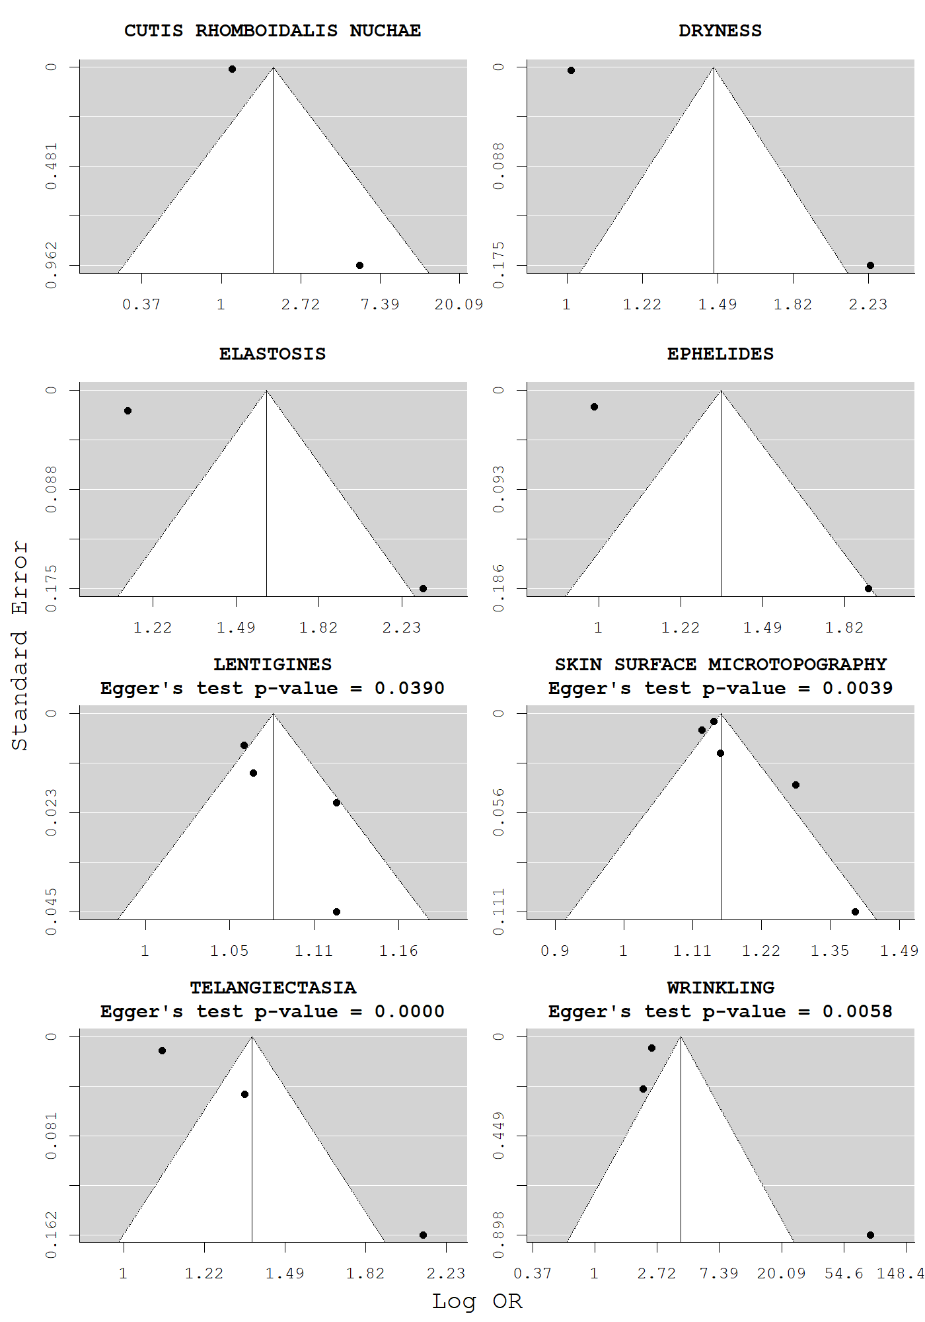

Supplementary Figure 2. Begg’s funnel plots and Egger’s test p-values for age and skin aging.

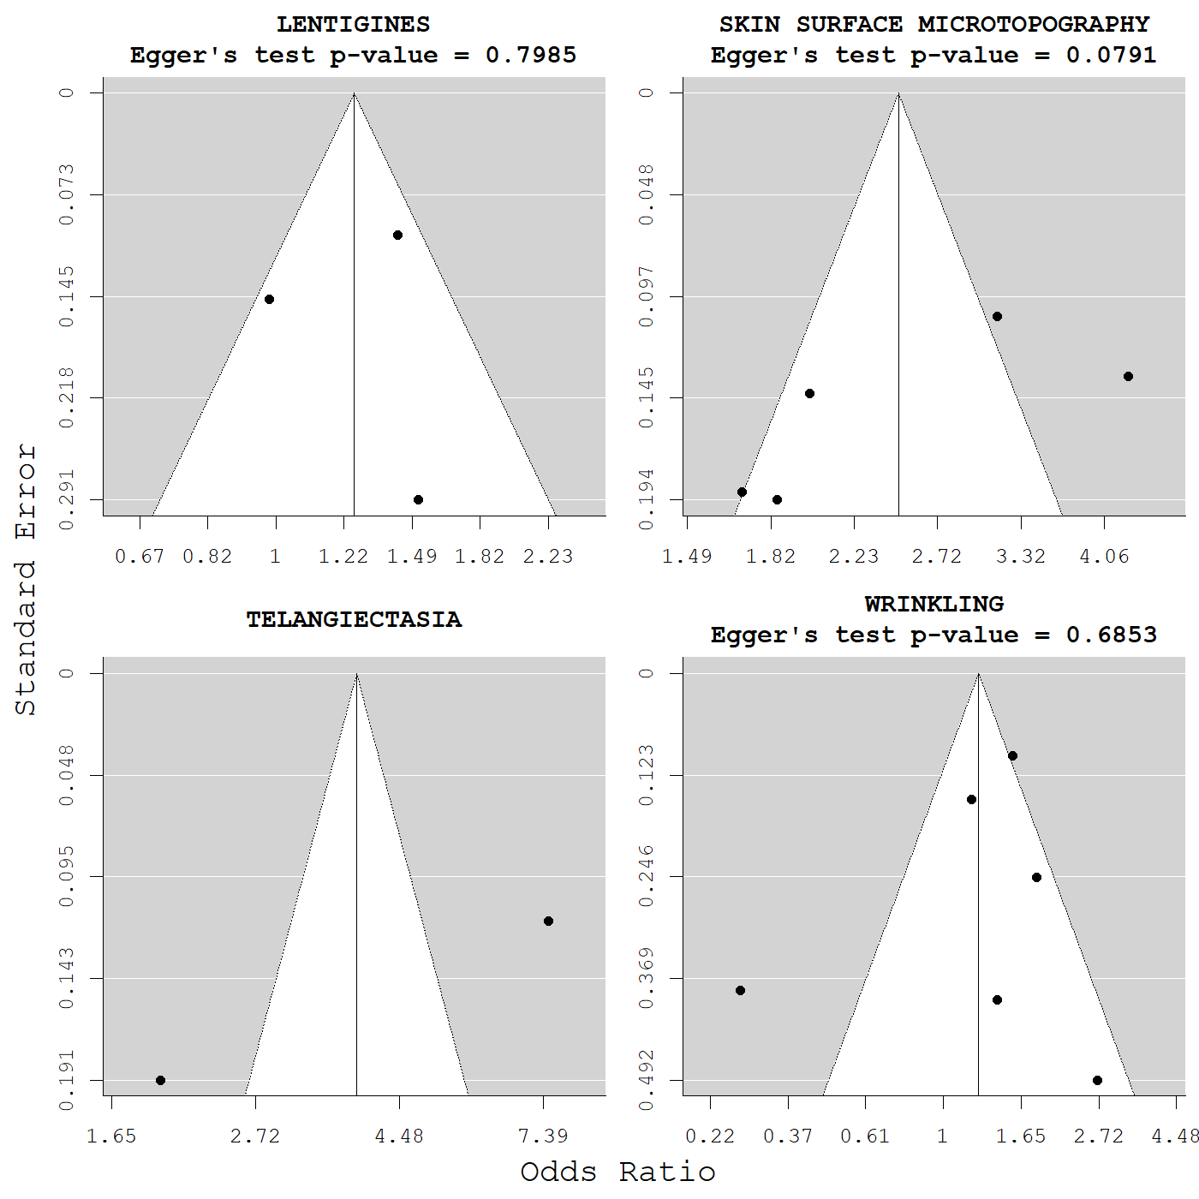

Supplementary Figure 3. Begg’s funnel plots and Egger’s test p-values for male gender (female gender as reference) and skin aging.

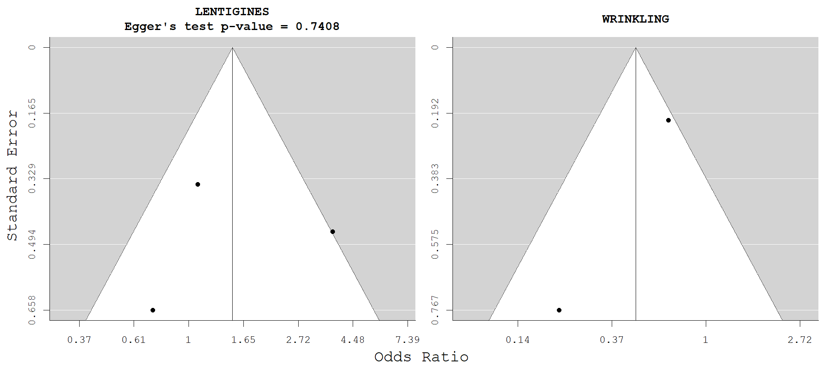

Supplementary Figure 4. Begg’s funnel plots and Egger’s test p-values for HRT us and skin aging.

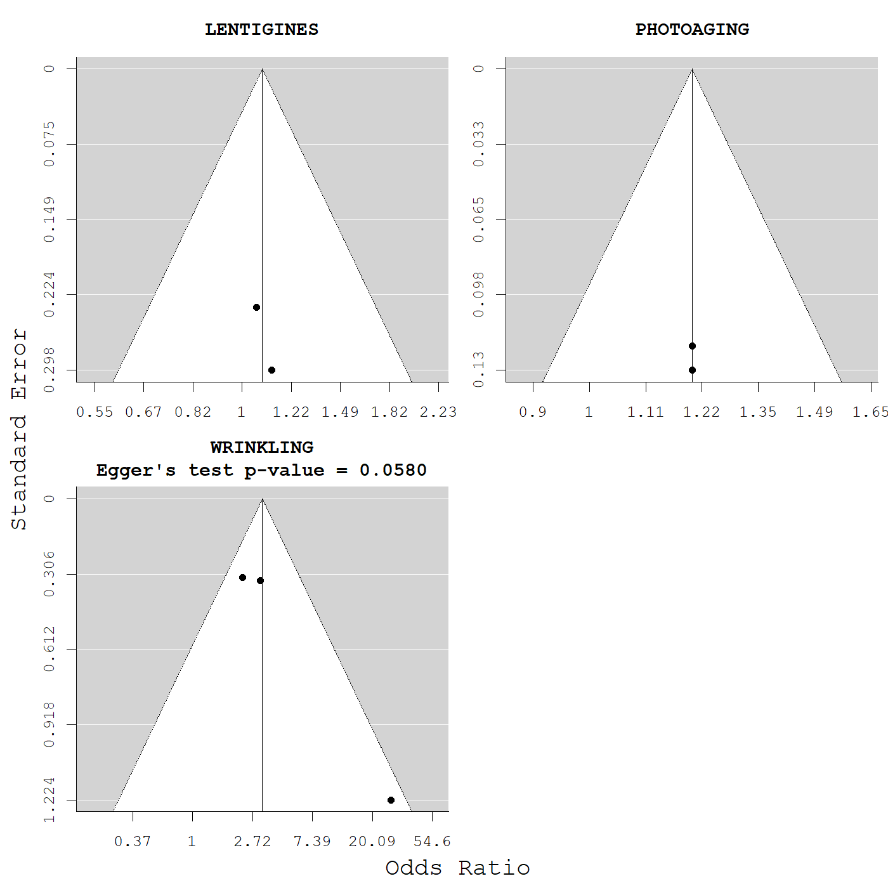

Supplementary Figure 5. Begg’s funnel plots and Egger’s test for current smoking and skin aging.

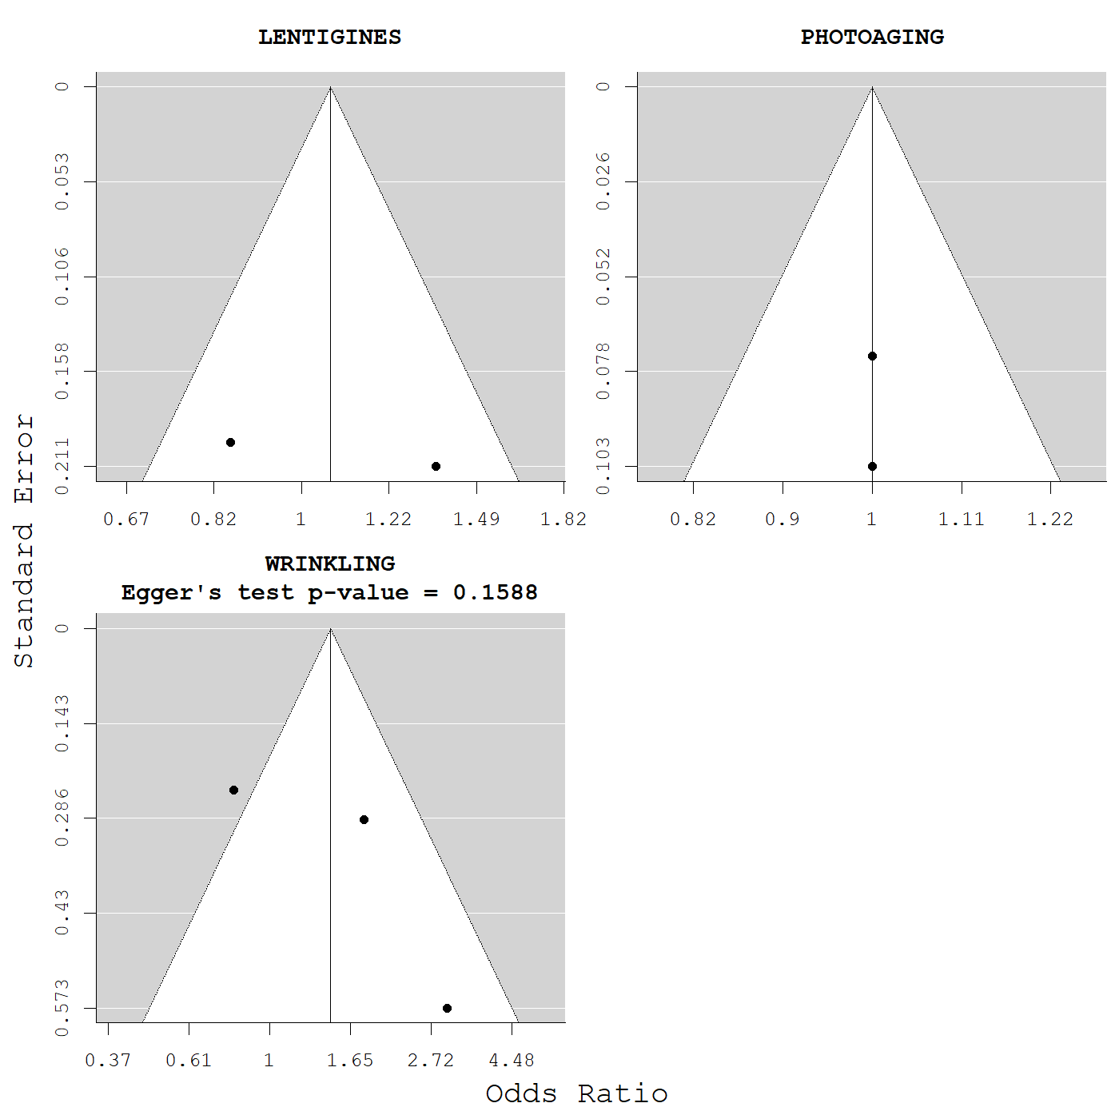

Supplementary Figure 6. Begg’s funnel plots and Egger’s test for former smoking and skin aging.

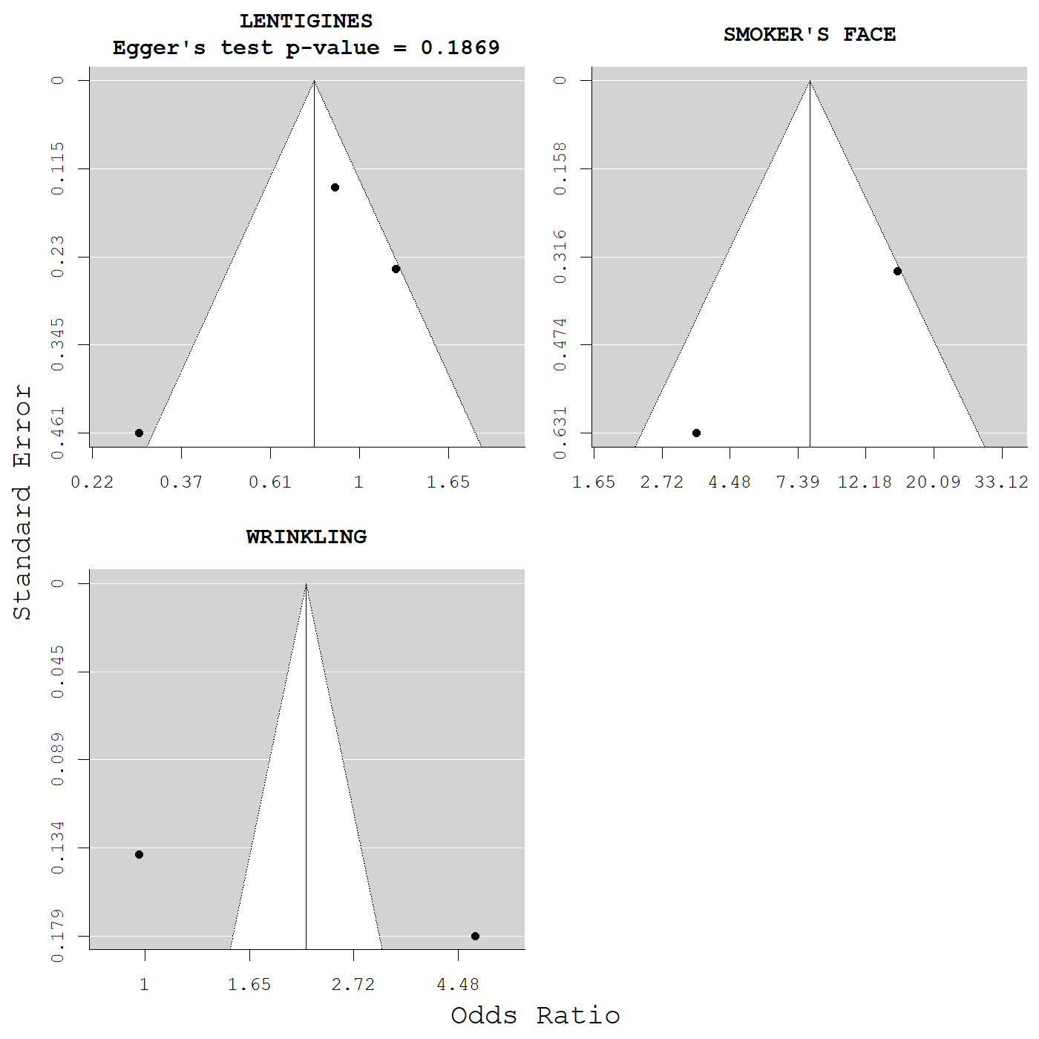

Supplementary Figure 7. Begg’s funnel plots and Egger’s test for former smoking and skin aging.

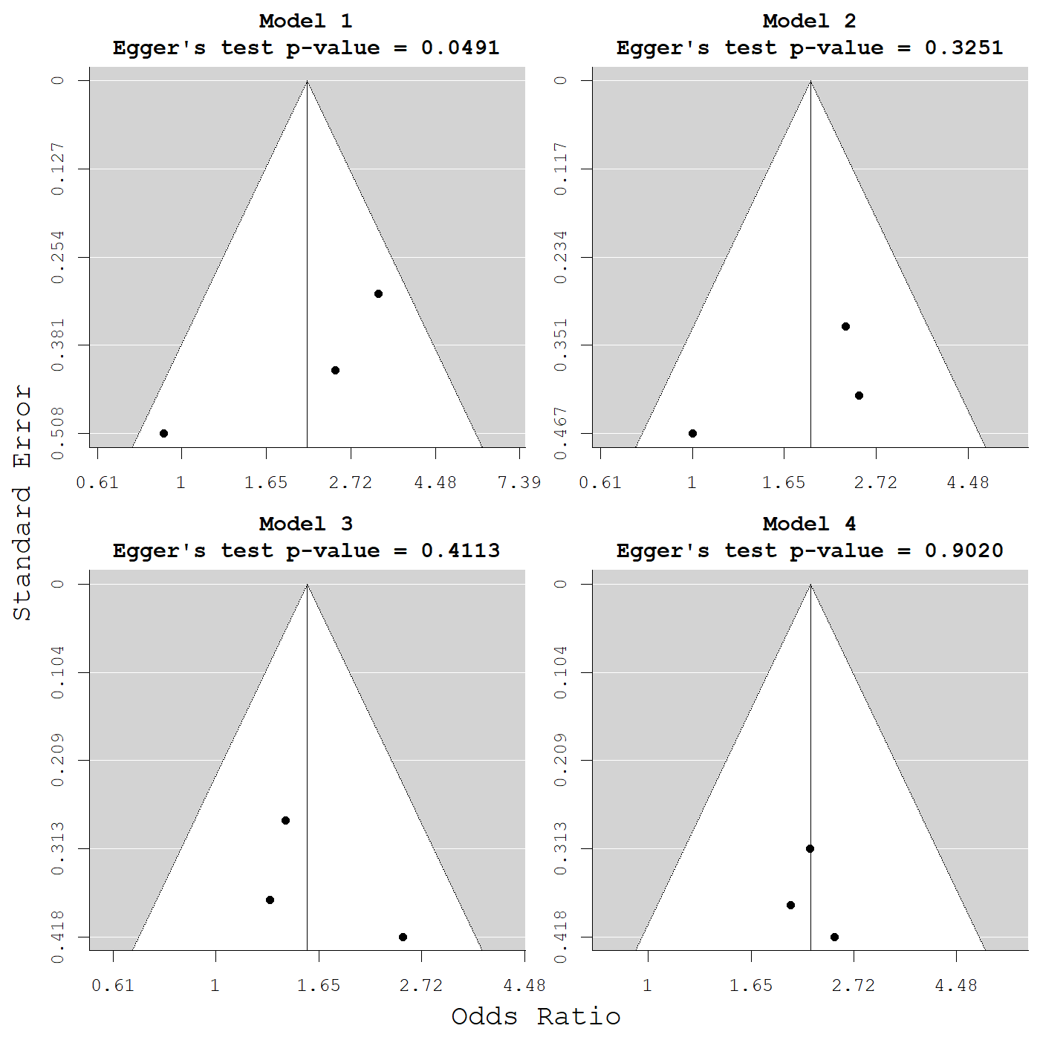

Supplementary Figure 8. Begg’s funnel plots and Egger’s test for more than 1h/d of sun exposure and wrinkling.

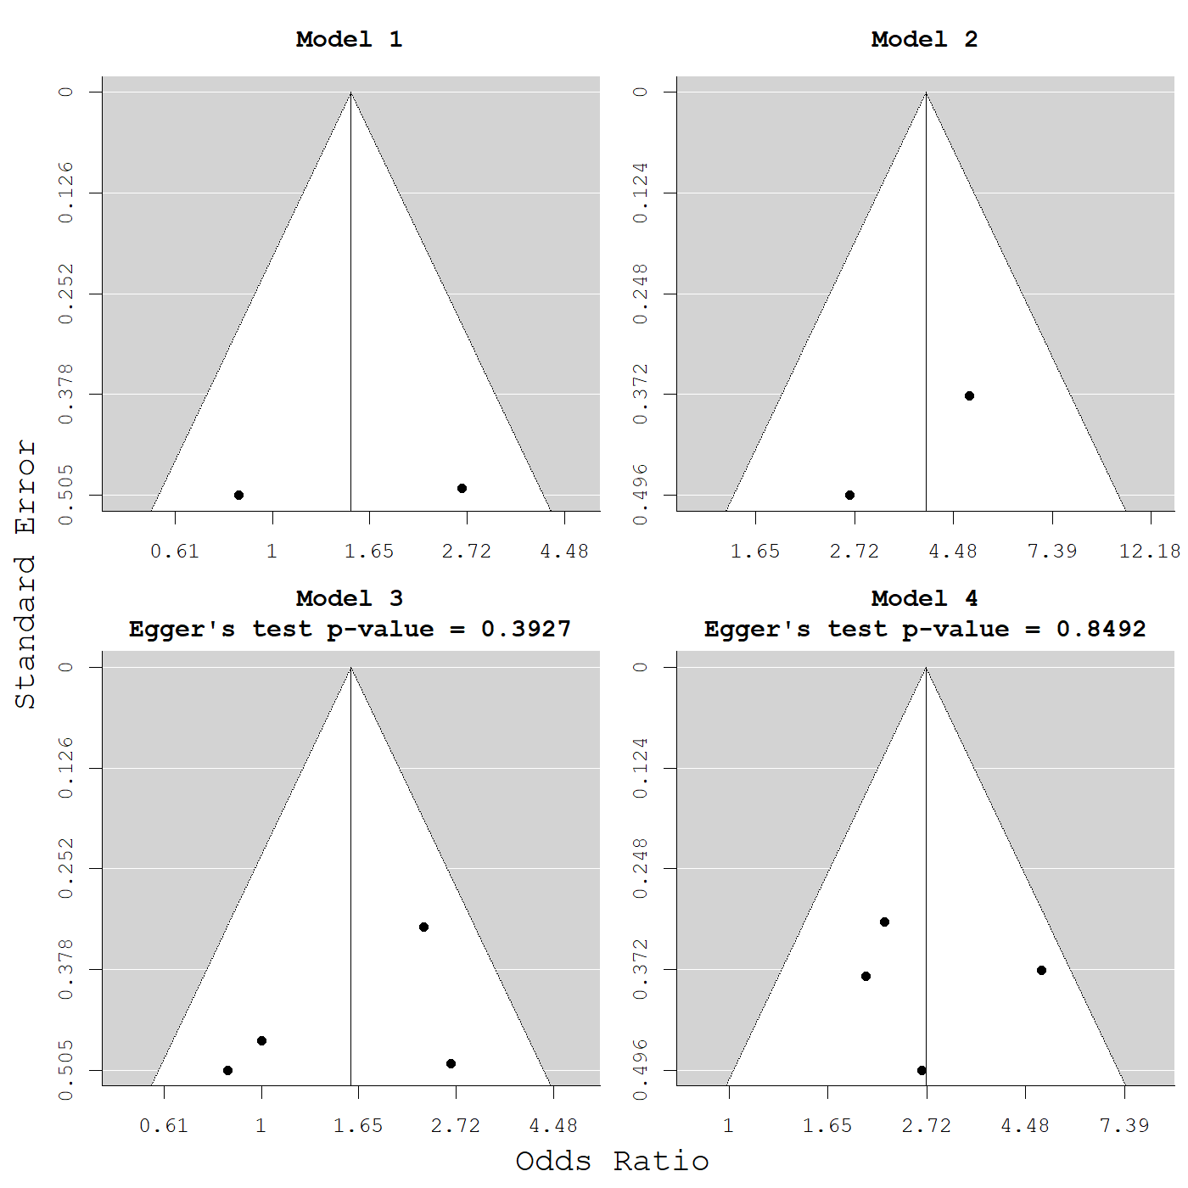

Supplementary Figure 9. Begg’s funnel plots and Egger’s test for more than 2h/d of sun exposure and wrinkling (compared with less than 2h/d of sun exposure).

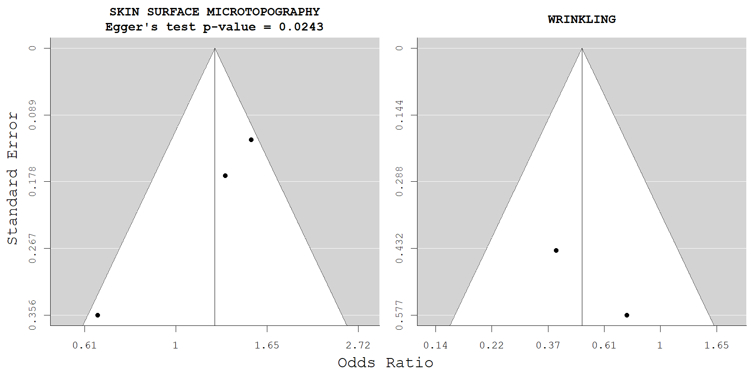

Supplementary Figure 10. Begg’s funnel plots and Egger’s test for sunscreen use and skin aging.

Supplementary References
1 Aizen, E. & Gilhar, A. Smoking effect on skin wrinkling in the aged population. International Journal of Dermatology 40, 431-433, doi:https://doi.org/10.1046/j.1365-4362.2001.01238.x (2001).
2 Akiba, S. et al. Influence of chronic UV exposure and lifestyle on facial skin photo-aging--results from a pilot study. J Epidemiol 9, S136-142, doi:10.2188/jea.9.6sup_136 (1999).
3 Allen, H. B., Johnson, B. L. & Diamond, S. M. Smoker's wrinkles? Jama 225, 1067-1069 (1973).
4 Asakura, K. et al. Lifestyle factors and visible skin aging in a population of Japanese elders. J Epidemiol 19, 251-259, doi:10.2188/jea.je20090031 (2009).
5 Bastiaens, M. T., Westendorp, R. G., Vermeer, B. J. & Bavinck, J. N. Ephelides are more related to pigmentary constitutional host factors than solar lentigines. Pigment Cell Res 12, 316-322, doi:10.1111/j.1600-0749.1999.tb00765.x (1999).
6 Bastiaens, M., Hoefnagel, J., Westendorp, R., Vermeer, B. J. & Bouwes Bavinck, J. N. Solar lentigines are strongly related to sun exposure in contrast to ephelides. Pigment Cell Res 17, 225-229, doi:10.1111/j.1600-0749.2004.00131.x (2004).
7 Battistutta, D. et al. Skin surface topography grading is a valid measure of skin photoaging. Photodermatology, Photoimmunology & Photomedicine 22, 39-45, doi:https://doi.org/10.1111/j.1600-0781.2006.00194.x (2006).
8 Buendia-Eisman, A., Prieto, L., Abarquero, M. & Arias-Santiago, S. Study of the Exposome Ageing-related Factors in the Spanish Population. Acta Derm Venereol 100, adv00153, doi:10.2340/00015555-3500 (2020).
9 Bhatt, N., Agrawal, S. & Mehta, K. Risk factors and self-perception for facial aging among Nepalese population. Journal of Cosmetic Dermatology 18, 1794-1799, doi:https://doi.org/10.1111/jocd.12885 (2019).
10 Castelo-Branco, C., Figueras, F., Martínez de Osaba, M. J. & Vanrell, J. A. Facial wrinkling in postmenopausal women. Effects of smoking status and hormone replacement therapy. Maturitas 29, 75-86, doi:10.1016/s0378-5122(97)00087-x (1998).
11 Chien, A. L. et al. Perioral wrinkles are associated with female gender, aging, and smoking: Development of a gender-specific photonumeric scale. J Am Acad Dermatol 74, 924-930, doi:10.1016/j.jaad.2015.11.042 (2016).
12 Chien, A. L. et al. Effect of Age, Gender, and Sun Exposure on Ethnic Skin Photoaging: Evidence Gathered Using a New Photonumeric Scale. J Natl Med Assoc 110, 176-181, doi:10.1016/j.jnma.2017.05.001 (2018).
13 Chung, J. H. et al. Cutaneous photodamage in Koreans: influence of sex, sun exposure, smoking, and skin color. Arch Dermatol 137, 1043-1051 (2001).
14 Cosgrove, M. C., Franco, O. H., Granger, S. P., Murray, P. G. & Mayes, A. E. Dietary nutrient intakes and skin-aging appearance among middle-aged American women. Am J Clin Nutr 86, 1225-1231, doi:10.1093/ajcn/86.4.1225 (2007).
15 Daniell, H. W. Smoker's wrinkles. A study in the epidemiology of "crow's feet". Ann Intern Med 75, 873-880, doi:10.7326/0003-4819-75-6-873 (1971).
16 Derancourt, C. et al. Multiple large solar lentigos on the upper back as clinical markers of past severe sunburn: a case-control study. Dermatology 214, 25-31, doi:10.1159/000096909 (2007).
17 Ding, A. et al. Indoor PM2.5 exposure affects skin aging manifestation in a Chinese population. Sci Rep 7, 15329, doi:10.1038/s41598-017-15295-8 (2017).
18 Dobos, G. et al. Quantifying dyspigmentation in facial skin ageing: an explorative study. Int J Cosmet Sci 37, 542-549, doi:10.1111/ics.12233 (2015).
19 Dunn, L. B., Damesyn, M., Moore, A. A., Reuben, D. B. & Greendale, G. A. Does estrogen prevent skin aging? Results from the First National Health and Nutrition Examination Survey (NHANES I). Arch Dermatol 133, 339-342, doi:10.1001/archderm.133.3.339 (1997).
20 Ekiz, O. et al. Factors influencing skin ageing in a Mediterranean population from Turkey. Clin Exp Dermatol 37, 492-496, doi:10.1111/j.1365-2230.2012.04386.x (2012).
21 Elfakir, A. et al. Functional MC1R-gene variants are associated with increased risk for severe photoaging of facial skin. J Invest Dermatol 130, 1107-1115, doi:10.1038/jid.2009.366 (2010).
22 Engel, A., Johnson, M. L. & Haynes, S. G. Health effects of sunlight exposure in the United States. Results from the first National Health and Nutrition Examination Survey, 1971-1974. Arch Dermatol 124, 72-79 (1988).
23 Ernster, V. L. et al. Facial wrinkling in men and women, by smoking status. Am J Public Health 85, 78-82, doi:10.2105/ajph.85.1.78 (1995).
24 Eun, H. C. Cutaneous photodamage in Asians. J Dermatol 28, 614-616, doi:10.1111/j.1346-8138.2001.tb00045.x (2001).
25 Ezzedine, K. et al. Freckles and solar lentigines have different risk factors in Caucasian women. J Eur Acad Dermatol Venereol 27, e345-356, doi:10.1111/j.1468-3083.2012.04685.x (2013).
26 Flament, F. & Qiu, H. Effects of seasonality and a daily photo-protection upon some facial signs of Chinese women. Int J Cosmet Sci 39, 256-268, doi:10.1111/ics.12369 (2017).
27 Flament, F. et al. Effect of the sun on visible clinical signs of aging in Caucasian skin. Clin Cosmet Investig Dermatol 6, 221-232, doi:10.2147/CCID.S44686 (2013).
28 Flament, F. et al. Solar exposure(s) and facial clinical signs of aging in Chinese women: impacts upon age perception. Clin Cosmet Investig Dermatol 8, 75-84, doi:10.2147/CCID.S72244 (2015).
29 Flament, F., Bourokba, N., Nouveau, S., Li, J. & Charbonneau, A. A severe chronic outdoor urban pollution alters some facial aging signs in Chinese women. A tale of two cities. Int J Cosmet Sci 40, 467-481, doi:10.1111/ics.12487 (2018).
30 Flament, F., Ye, C. & Amar, D. Assessing the impact of an aerial chronic urban pollution (UP) on some facial signs of differently-aged Chinese men. Int J Cosmet Sci 41, 450-461, doi:10.1111/ics.12558 (2019).
31 Flament, F. et al. Clinical impacts of sun exposures on the faces and hands of Japanese women of different ages. Int J Cosmet Sci 41, 425-436, doi:10.1111/ics.12555 (2019).
32 Flament, F., Amar, D., Forichon, M., Caron, J. & Negre, C. Distinct Habits Of Sun Exposures Lead To Different Impacts On Some Facial Signs Of Chinese Men Of Different Ages. Clin Cosmet Investig Dermatol 12, 833-841, doi:10.2147/CCID.S226331 (2019).
33 Fritschi, L. & Green, A. Sun damage in teenagers' skin. Australian Journal of Public Health 19, 383-386, doi:https://doi.org/10.1111/j.1753-6405.1995.tb00390.x (1995).
34 Fuks, K. B. et al. Tropospheric ozone and skin aging: Results from two German cohort studies. Environ Int 124, 139-144, doi:10.1016/j.envint.2018.12.047 (2019).
35 Gao, Q. et al. An epidemiological survey of skin damage on the dorsal hand in rural populations in northern and southern China. J Photochem Photobiol B 120, 163-170, doi:10.1016/j.jphotobiol.2012.11.010 (2013).
36 Garbe, C. et al. Associated factors in the prevalence of more than 50 common melanocytic nevi, atypical melanocytic nevi, and actinic lentigines: multicenter case-control study of the Central Malignant Melanoma Registry of the German Dermatological Society. J Invest Dermatol 102, 700-705, doi:10.1111/1523-1747.ep12374298 (1994).
37 Gill, D., Dorevitch, A. & Marks, R. The Prevalence of Seborrheic Keratoses in People Aged 15 to 30 Years: Is the Term Senile Keratosis Redundant? Archives of Dermatology 136, 759-762, doi:10.1001/archderm.136.6.759 (2000).
38 Goodman, G. J., Armour, K. S., Kolodziejczyk, J. K., Santangelo, S. & Gallagher, C. J. Comparison of self-reported signs of facial ageing among Caucasian women in Australia versus those in the USA, the UK and Canada. Australas J Dermatol 59, 108-117, doi:10.1111/ajd.12637 (2018).
39 Green, A. et al. Skin cancer in a Queensland population. J Am Acad Dermatol 19, 1045-1052, doi:10.1016/s0190-9622(88)70270-4 (1988).
40 Green, A. C., Hughes, M. C., McBride, P. & Fourtanier, A. Factors associated with premature skin aging (photoaging) before the age of 55: a population-based study. Dermatology 222, 74-80, doi:10.1159/000322623 (2011).
41 Green, A. C. Premature ageing of the skin in a Queensland population. Medical Journal of Australia 155, 473-478, doi:https://doi.org/10.5694/j.1326-5377.1991.tb93845.x (1991).
42 Gunn, D. A. et al. Lifestyle and youthful looks. Br J Dermatol 172, 1338-1345, doi:10.1111/bjd.13646 (2015).
43 Guyuron, B. et al. Factors contributing to the facial aging of identical twins. Plast Reconstr Surg 123, 1321-1331, doi:10.1097/PRS.0b013e31819c4d42 (2009).
44 Hamer, M. A. et al. Lifestyle and Physiological Factors Associated with Facial Wrinkling in Men and Women. J Invest Dermatol 137, 1692-1699, doi:10.1016/j.jid.2017.04.002 (2017).
45 Helfrich, Y. R. et al. Effect of smoking on aging of photoprotected skin: evidence gathered using a new photonumeric scale. Arch Dermatol 143, 397-402, doi:10.1001/archderm.143.3.397 (2007).
46 Hillebrand, G. G. et al. Quantitative evaluation of skin condition in an epidemiological survey of females living in northern versus southern Japan. J Dermatol Sci 27 Suppl 1, S42-52, doi:10.1016/s0923-1811(01)00118-9 (2001).
47 Holman, C. D., Evans, P. R., Lumsden, G. J. & Armstrong, B. K. The determinants of actinic skin damage: problems of confounding among environmental and constitutional variables. Am J Epidemiol 120, 414-422, doi:10.1093/oxfordjournals.aje.a113906 (1984).
48 Huls, A. et al. Traffic-Related Air Pollution Contributes to Development of Facial Lentigines: Further Epidemiological Evidence from Caucasians and Asians. J Invest Dermatol 136, 1053-1056, doi:10.1016/j.jid.2015.12.045 (2016).
49 Huls, A., Sugiri, D., Fuks, K., Krutmann, J. & Schikowski, T. Lentigine Formation in Caucasian Women-Interaction between Particulate Matter and Solar UVR. J Invest Dermatol 139, 974-976, doi:10.1016/j.jid.2018.09.034 (2019).
50 Ichibori, R. et al. Objective assessment of facial skin aging and the associated environmental factors in Japanese monozygotic twins. Journal of Cosmetic Dermatology 13, 158-163, doi:https://doi.org/10.1111/jocd.12081 (2014).
51 Ippen, M. & Ippen, H. Approaches to a Prophylaxis of Skin Aging. J Soc Cosmetic Chemists 16, 305-308 (1965).
52 Jacobs, L. C. et al. Intrinsic and extrinsic risk factors for sagging eyelids. JAMA Dermatol 150, 836-843, doi:10.1001/jamadermatol.2014.27 (2014).
53 Kadunce, D. P. et al. Cigarette smoking: risk factor for premature facial wrinkling. Ann Intern Med 114, 840-844, doi:10.7326/0003-4819-114-10-840 (1991).
54 Kennedy, C. et al. Effect of smoking and sun on the aging skin. J Invest Dermatol 120, 548-554, doi:10.1046/j.1523-1747.2003.12092.x (2003).
55 Kennedy, C., Bajdik, C. D., Willemze, R., De Gruijl, F. R. & Bouwes Bavinck, J. N. The influence of painful sunburns and lifetime sun exposure on the risk of actinic keratoses, seborrheic warts, melanocytic nevi, atypical nevi, and skin cancer. J Invest Dermatol 120, 1087-1093, doi:10.1046/j.1523-1747.2003.12246.x (2003).
56 Keough, G. C., Laws, R. A. & Elston, D. M. Favre-Racouchot Syndrome: A Case for Smokers' Comedones. Archives of Dermatology 133, 796-797, doi:10.1001/archderm.1997.03890420142027 (1997).
57 Kim, E. J. et al. Effect of the regional environment on the skin properties and the early wrinkles in young Chinese women. Skin Res Technol 20, 498-502, doi:10.1111/srt.12144 (2014).
58 Kimlin, M. G. & Guo, Y. Assessing the impacts of lifetime sun exposure on skin damage and skin aging using a non-invasive method. Sci Total Environ 425, 35-41, doi:10.1016/j.scitotenv.2012.02.080 (2012).
59 Knuutinen, A., Kallioinen, M., Vähäkangas, K. & Oikarinen, A. Smoking and skin: a study of the physical qualities and histology of skin in smokers and non-smokers. Acta Derm Venereol 82, 36-40, doi:10.1080/000155502753600867 (2002).
60 Koh, J. S., Kang, H., Choi, S. W. & Kim, H. O. Cigarette smoking associated with premature facial wrinkling: image analysis of facial skin replicas. Int J Dermatol 41, 21-27, doi:10.1046/j.1365-4362.2002.01352.x (2002).
61 Kwon, O. S. et al. Seborrheic keratosis in the Korean males: causative role of sunlight. Photodermatol Photoimmunol Photomed 19, 73-80, doi:10.1034/j.1600-0781.2003.00025.x (2003).
62 Latreille, J. et al. Association between dietary intake of n-3 polyunsaturated fatty acids and severity of skin photoaging in a middle-aged Caucasian population. J Dermatol Sci 72, 233-239, doi:10.1016/j.jdermsci.2013.07.006 (2013).
63 Leung, W. C. & Harvey, I. Is skin ageing in the elderly caused by sun exposure or smoking? Br J Dermatol 147, 1187-1191, doi:10.1046/j.1365-2133.2002.04991.x (2002).
64 Li, M. et al. Epidemiological evidence that indoor air pollution from cooking with solid fuels accelerates skin aging in Chinese women. J Dermatol Sci 79, 148-154, doi:10.1016/j.jdermsci.2015.04.001 (2015).
65 Lichterfeld, A., Lahmann, N., Blume-Peytavi, U. & Kottner, J. Dry skin in nursing care receivers: A multi-centre cross-sectional prevalence study in hospitals and nursing homes. Int J Nurs Stud 56, 37-44, doi:10.1016/j.ijnurstu.2016.01.003 (2016).
66 Lucas, R. M. et al. Associations between silicone skin cast score, cumulative sun exposure, and other factors in the ausimmune study: a multicenter Australian study. Cancer Epidemiol Biomarkers Prev 18, 2887-2894, doi:10.1158/1055-9965.Epi-09-0191 (2009).
67 Malvy, J.-M. et al. Epidemiologic determinants of skin photoaging: baseline data of the SU.VI.MAX. cohort. J Am Acad Dermatol 42, 47-55, doi:10.1016/s0190-9622(00)90008-2 (2000).
68 Martires, K. J., Fu, P., Polster, A. M., Cooper, K. D. & Baron, E. D. Factors That Affect Skin Aging: A Cohort-Based Survey on Twins. Archives of Dermatology 145, 1375-1379, doi:10.1001/archdermatol.2009.303 (2009).
69 Mayes, A. E. et al. Environmental and lifestyle factors associated with perceived facial age in Chinese women. PLoS One 5, e15270, doi:10.1371/journal.pone.0015270 (2010).
70 Mekic, S. et al. A healthy diet in women is associated with less facial wrinkles in a large Dutch population-based cohort. J Am Acad Dermatol 80, 1358-1363 e1352, doi:10.1016/j.jaad.2018.03.033 (2019).
71 Mekic, S. et al. Prevalence and determinants for xerosis cutis in the middle-aged and elderly population: A cross-sectional study. J Am Acad Dermatol 81, 963-969 e962, doi:10.1016/j.jaad.2018.12.038 (2019).
72 Mekic, S. et al. Epidemiology and determinants of facial telangiectasia: a cross-sectional study. J Eur Acad Dermatol Venereol 34, 821-826, doi:10.1111/jdv.15996 (2020).
73 Mizuno, M. et al. The effects of continuous application of sunscreen on photoaged skin in Japanese elderly people - the relationship with the usage. Clin Cosmet Investig Dermatol 9, 95-105, doi:10.2147/CCID.S104392 (2016).
74 Model, D. Smoker's face: an underrated clinical sign? British Medical Journal (Clinical research ed.) 291, 1760-1762, doi:10.1136/bmj.291.6511.1760 (1985).
75 Monestier, S., Gaudy, C., Gouvernet, J., Richard, M. A. & Grob, J. J. Multiple senile lentigos of the face, a skin ageing pattern resulting from a life excess of intermittent sun exposure in dark-skinned caucasians: a case-control study. Br J Dermatol 154, 438-444, doi:10.1111/j.1365-2133.2005.06996.x (2006).
76 Muizzuddin, N., Marenus, K., Vallon, P. & Maes, D. Effect of cigarette smoke on skin. Journal of the Society of Cosmetic Chemists 48, 235-242 (1997).
77 Nagata, C. et al. Association of dietary fat, vegetables and antioxidant micronutrients with skin ageing in Japanese women. British Journal of Nutrition 103, 1493-1498, doi:10.1017/s0007114509993461 (2010).
78 Nouveau-Richard, S. et al. Skin ageing: a comparison between Chinese and European populations. A pilot study. J Dermatol Sci 40, 187-193, doi:10.1016/j.jdermsci.2005.06.006 (2005).
79 O'Hare, P. M. et al. Tobacco smoking contributes little to facial wrinkling. J Eur Acad Dermatol Venereol 12, 133-139 (1999).
80 Oyetakin-White, P. et al. Does poor sleep quality affect skin ageing? Clin Exp Dermatol 40, 17-22, doi:10.1111/ced.12455 (2015).
81 Okada, H. C., Alleyne, B., Varghai, K., Kinder, K. & Guyuron, B. Facial changes caused by smoking: a comparison between smoking and nonsmoking identical twins. Plast Reconstr Surg 132, 1085-1092, doi:10.1097/PRS.0b013e3182a4c20a (2013).
82 Park, J. H., Oh, S. J. & Lee, J. H. Effects of particulate matter on healthy human skin: a panel study using a smartphone application measuring daily skin condition. J Eur Acad Dermatol Venereol 33, 1363-1368, doi:10.1111/jdv.15517 (2019).
83 Peng, F. et al. Exposure to fine particulate matter associated with senile lentigo in Chinese women: a cross-sectional study. J Eur Acad Dermatol Venereol 31, 355-360, doi:10.1111/jdv.13834 (2017).
84 Perner, D. et al. Association between sun-exposure, smoking behaviour and plasma antioxidant levels with the different manifestation of skin ageing signs between Japanese and German women--a pilot study. J Dermatol Sci 62, 138-140, doi:10.1016/j.jdermsci.2011.02.010 (2011).
85 Purba, M. B. et al. Skin wrinkling: can food make a difference? J Am Coll Nutr 20, 71-80, doi:10.1080/07315724.2001.10719017 (2001).
86 Qiu, H. et al. Influence of season on some skin properties: winter vs. summer, as experienced by 354 Shanghaiese women of various ages. Int J Cosmet Sci 33, 377-383, doi:10.1111/j.1468-2494.2011.00639.x (2011).
87 Raduan, A. P., Luiz, R. R. & Manela-Azulay, M. Association between smoking and cutaneous ageing in a Brazilian population. J Eur Acad Dermatol Venereol 22, 1312-1318, doi:10.1111/j.1468-3083.2008.02804.x (2008).
88 Raitio, A. et al. Comparison of clinical and computerized image analyses in the assessment of skin ageing in smokers and non-smokers. Acta Derm Venereol 84, 422-427, doi:10.1080/00015550410014969 (2004).
89 Rexbye, H. et al. Influence of environmental factors on facial ageing. Age Ageing 35, 110-115, doi:10.1093/ageing/afj031 (2006).
90 Schafer, T. et al. The epidemiology of nevi and signs of skin aging in the adult general population: Results of the KORA-survey 2000. J Invest Dermatol 126, 1490-1496, doi:10.1038/sj.jid.5700269 (2006).
91 Seddon, J. M. et al. Evaluation of skin microtopography as a measure of ultraviolet exposure. Investigative Ophthalmology & Visual Science 33, 1903-1908 (1992).
92 Silva Idos, S. et al. Overseas sun exposure, nevus counts, and premature skin aging in young English women: a population-based survey. J Invest Dermatol 129, 50-59, doi:10.1038/jid.2008.190 (2009).
93 Singer, R. S., Hamilton, T. A., Voorhees, J. J. & Griffiths, C. E. Association of asymmetrical facial photodamage with automobile driving. Arch Dermatol 130, 121-123, doi:10.1001/archderm.1994.01690010127031 (1994).
94 Song, E. J. et al. A study on seasonal variation of skin parameters in Korean males. Int J Cosmet Sci 37, 92-97, doi:10.1111/ics.12174 (2015).
95 Suehara, L. Y., Simone, K. & Maia, M. Evaluation of facial aging related to cigarette smoking. Anais Brasileiros de Dermatologia 81, 34-39 (2006).
96 Suppa, M. et al. The determinants of periorbital skin ageing in participants of a melanoma case-control study in the U.K. Br J Dermatol 165, 1011-1021, doi:10.1111/j.1365-2133.2011.10536.x (2011).
97 Takahashi, Y., Fukushima, Y., Kondo, K. & Ichihashi, M. Facial skin photo-aging and development of hyperpigmented spots from children to middle-aged Japanese woman. Skin Res Technol 23, 613-618, doi:10.1111/srt.12380 (2017).
98 Tsukahara, K. et al. Comparison of age-related changes in facial wrinkles and sagging in the skin of Japanese, Chinese and Thai women. J Dermatol Sci 47, 19-28, doi:10.1016/j.jdermsci.2007.03.007 (2007).
99 Tsukahara, K. et al. Gender-dependent differences in degree of facial wrinkles. Skin Res Technol 19, e65-71, doi:10.1111/j.1600-0846.2011.00609.x (2013).
100 Tsukahara, K., Osanai, O., Kitahara, T. & Takema, Y. Seasonal and annual variation in the intensity of facial wrinkles. Skin Res Technol 19, 279-287, doi:10.1111/srt.12038 (2013).
101 Vierkotter, A. et al. The SCINEXA: a novel, validated score to simultaneously assess and differentiate between intrinsic and extrinsic skin ageing. J Dermatol Sci 53, 207-211, doi:10.1016/j.jdermsci.2008.10.001 (2009).
102 Vierkotter, A. et al. Airborne particle exposure and extrinsic skin aging. J Invest Dermatol 130, 2719-2726, doi:10.1038/jid.2010.204 (2010).
103 Vierkotter, A. et al. Extrinsic skin ageing in German, Chinese and Japanese women manifests differently in all three groups depending on ethnic background, age and anatomical site. J Dermatol Sci 83, 219-225, doi:10.1016/j.jdermsci.2016.05.011 (2016).
104 Wang, Y. N., Fang, H. & Zhu, W. F. Survey on skin aging status and related influential factors in Southeast China. J Zhejiang Univ Sci B 10, 57-66, doi:10.1631/jzus.B0820071 (2009).
105 Warren, R. et al. Age, sunlight, and facial skin: a histologic and quantitative study. J Am Acad Dermatol 25, 751-760, doi:10.1016/s0190-9622(08)80964-4 (1991).
106 Yin, L., Morita, A. & Tsuji, T. Skin aging induced by ultraviolet exposure and tobacco smoking: evidence from epidemiological and molecular studies. Photodermatol Photoimmunol Photomed 17, 178-183, doi:10.1034/j.1600-0781.2001.170407.x (2001).
107 Yin, L., Morita, A. & Tsuji, T. Skin premature aging induced by tobacco smoking: the objective evidence of skin replica analysis. J Dermatol Sci 27 Suppl 1, S26-31, doi:10.1016/s0923-1811(01)00112-8 (2001).
108 Youn, C. S. et al. Effect of pregnancy and menopause on facial wrinkling in women. Acta Derm Venereol 83, 419-424, doi:10.1080/00015550310015464 (2003).
109 Zhao, P. et al. Solar ultraviolet radiation and skin damage: an epidemiological study among a Chinese population. Arch Environ Health 53, 405-409, doi:10.1080/00039899809605728 (1998).

