Figure S1. Forrest and funnel plots of meta-analyzed variables.
Patients characteristics forest plots
Male
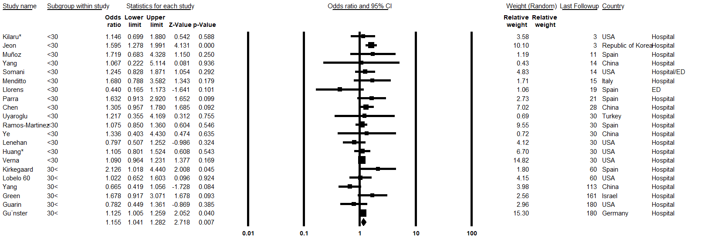

Age
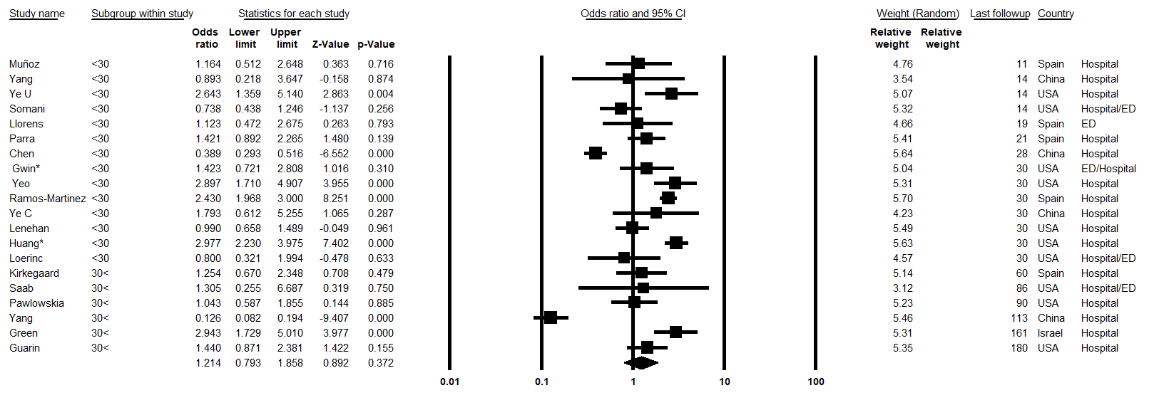

Hispanic
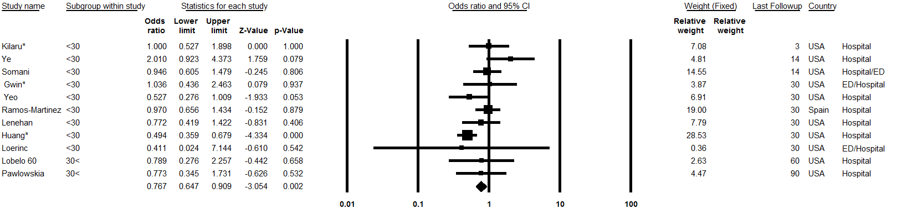

Asian
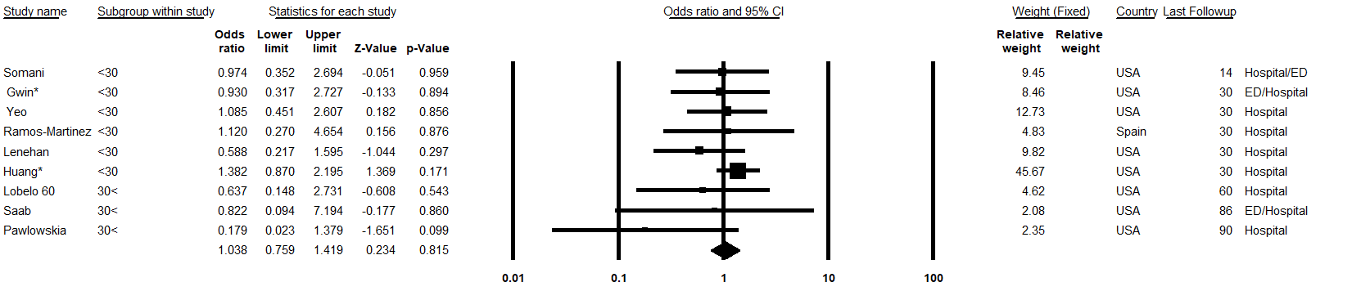

Black
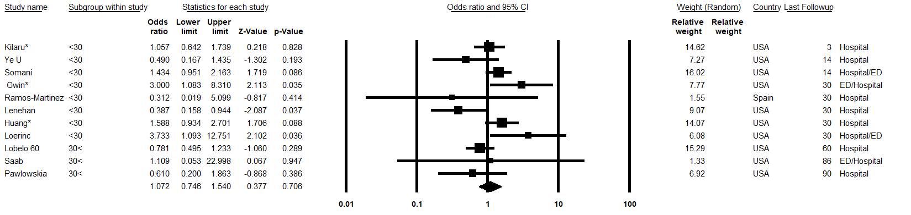

White
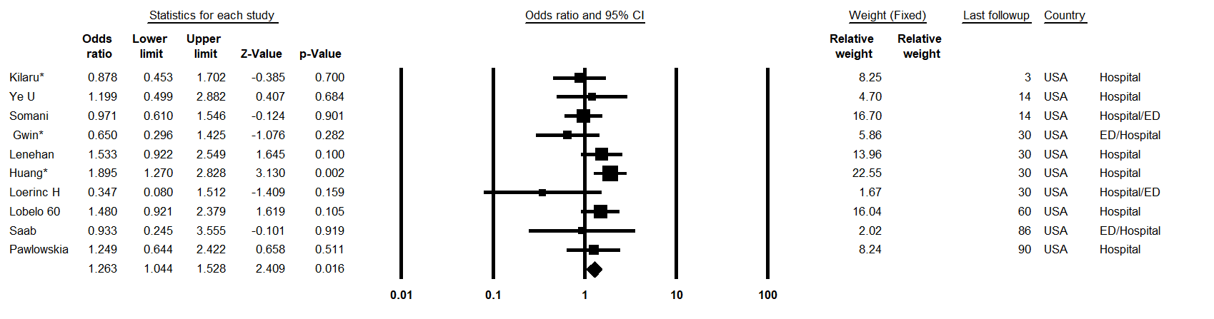

Comorbidities forest plots
No-comorbidity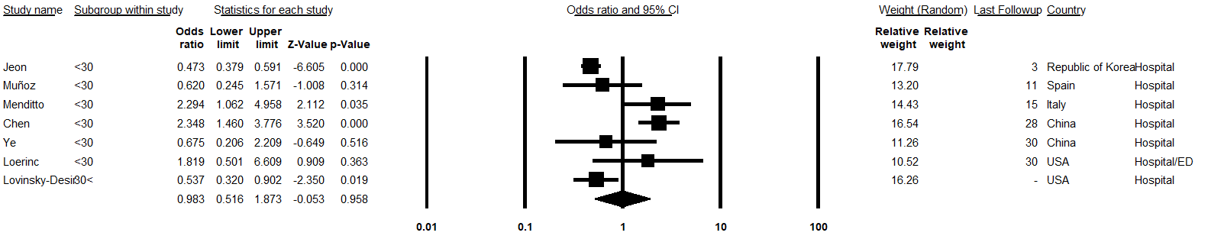

Immunosuppression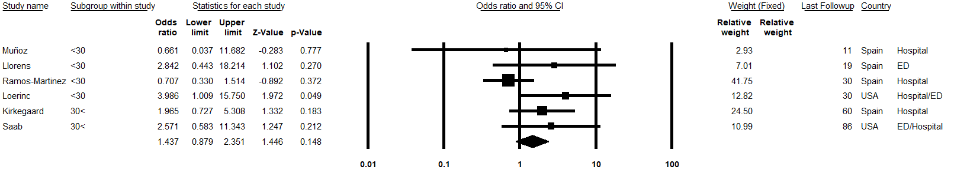

Cerebrovascular
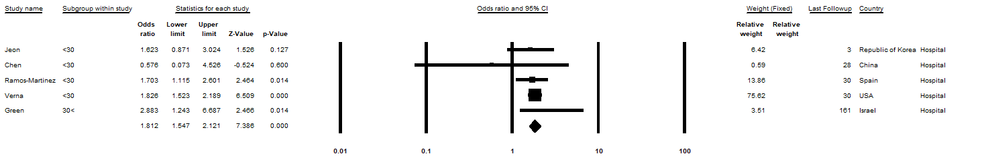

Cardiovascular
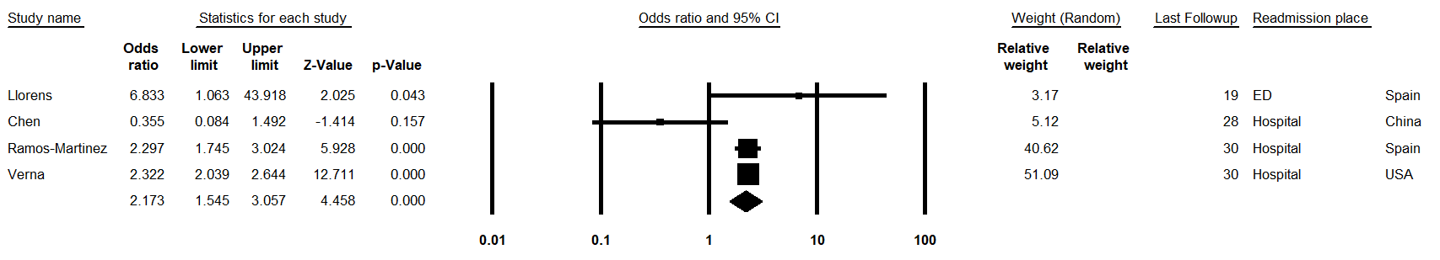

Hypertension
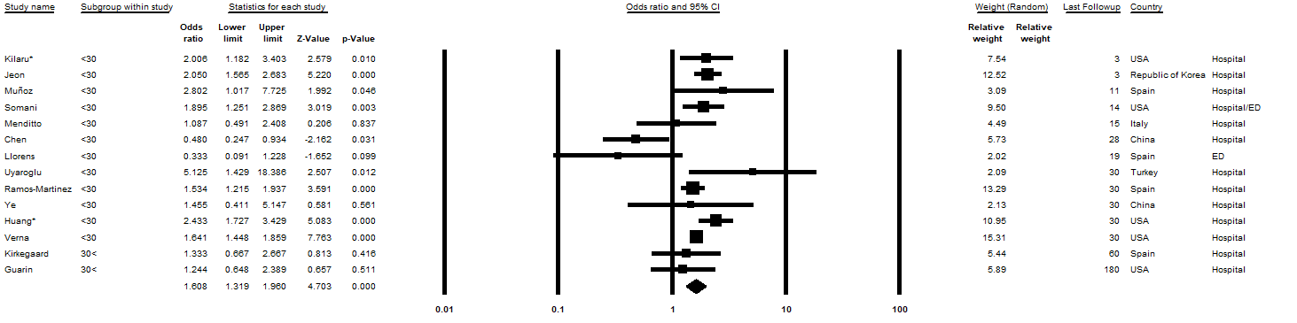

Coronary (Ischemic) artery disease
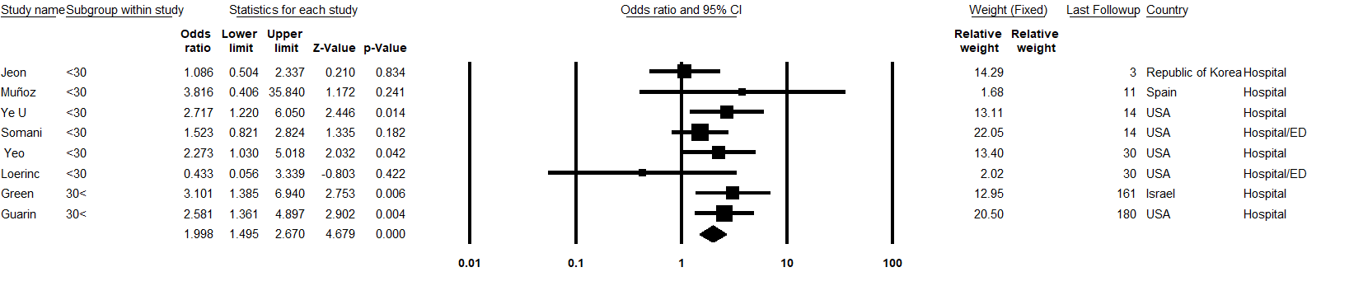

Heart failure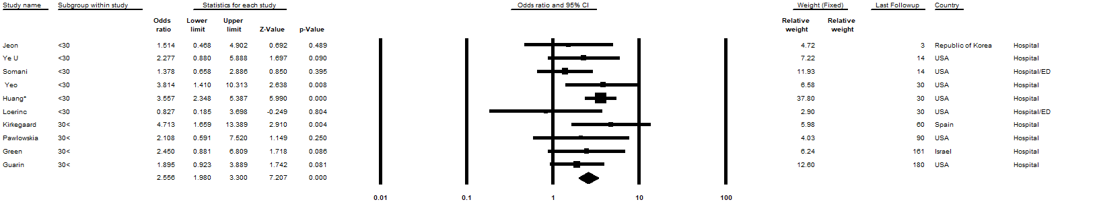

Obesity
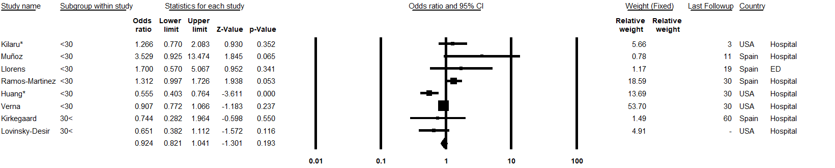

Diabetes
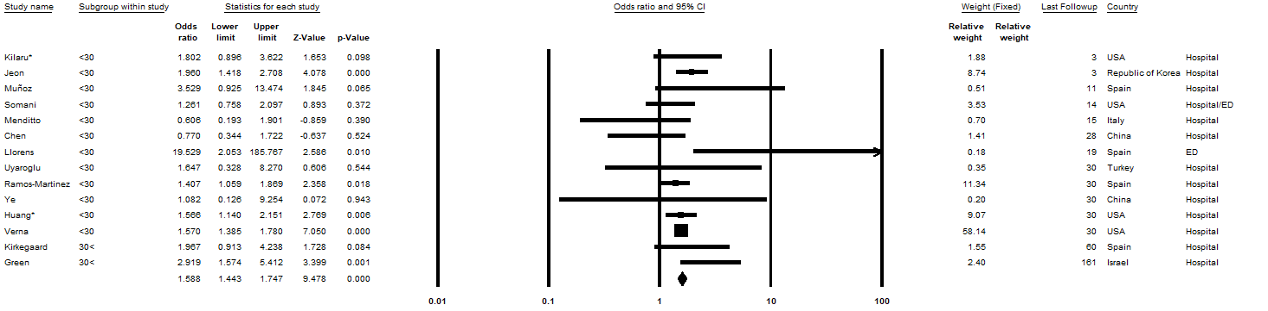

Liver disease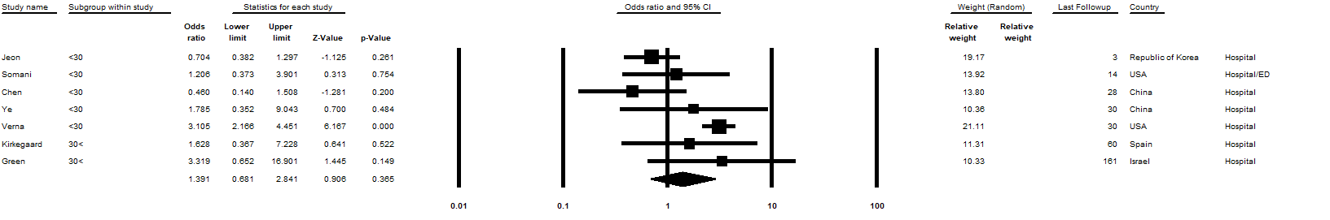

Renal failure
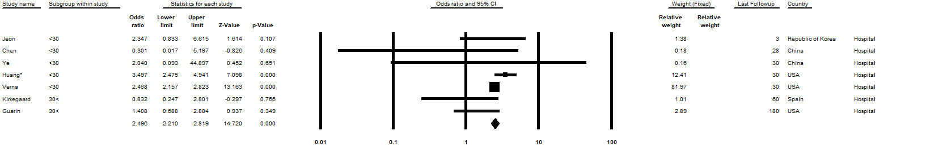

Chronic kidney disease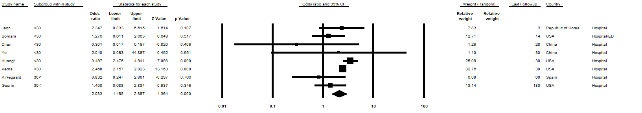

HIV
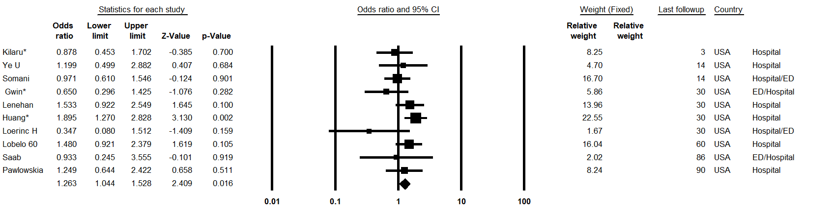

Chronic pulmonary disease
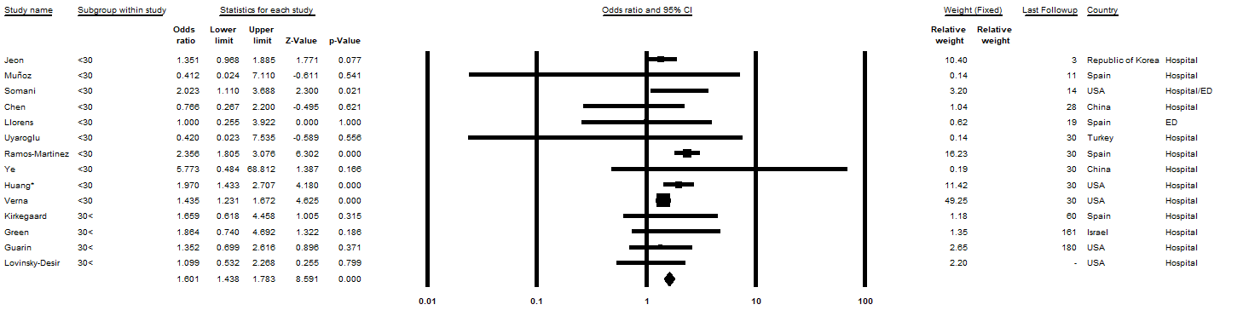

COPD
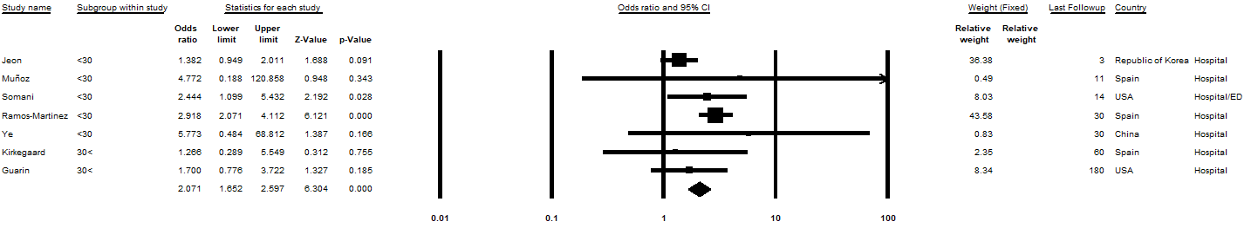

Asthma
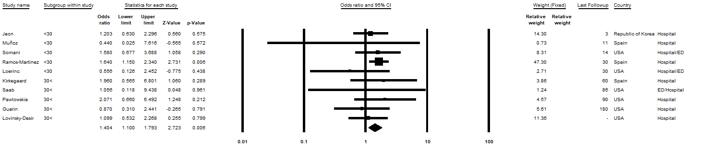

Cancer
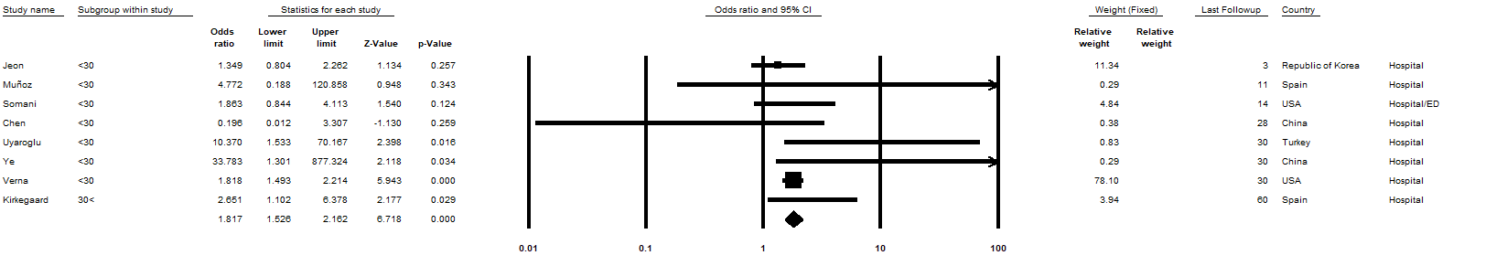

Inpatients factors forest plots
Length of hospital stay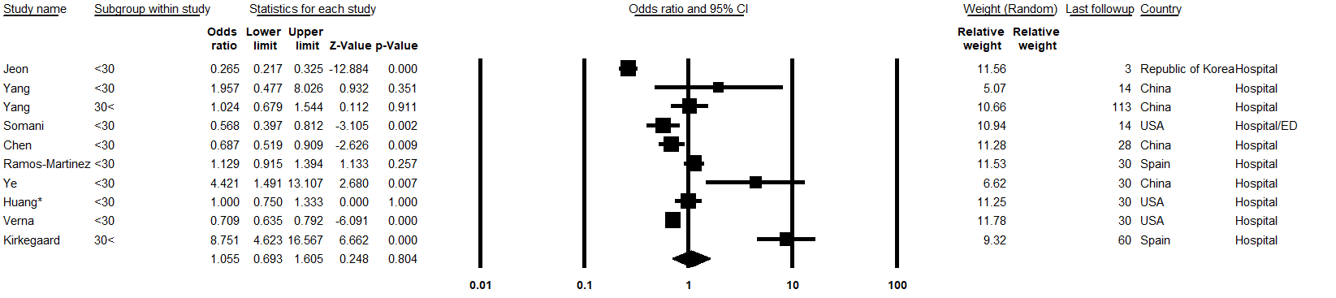

Mechanical ventilation
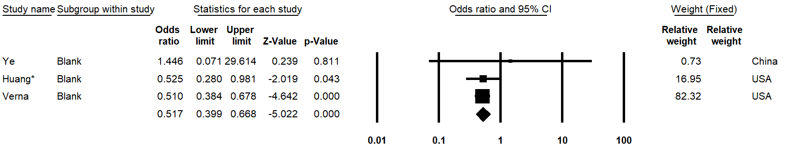

ICU admission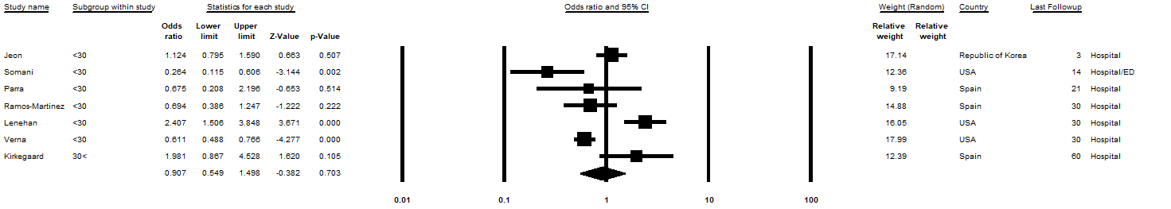

Death
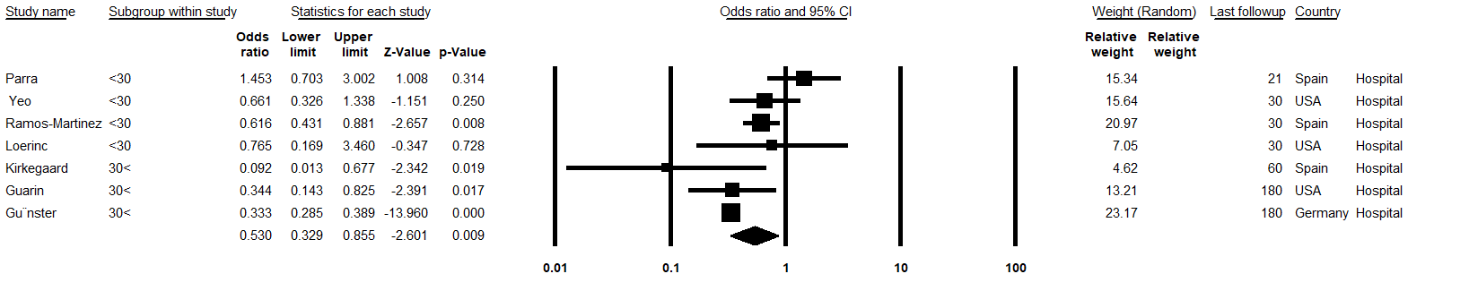

Re- hospitalization
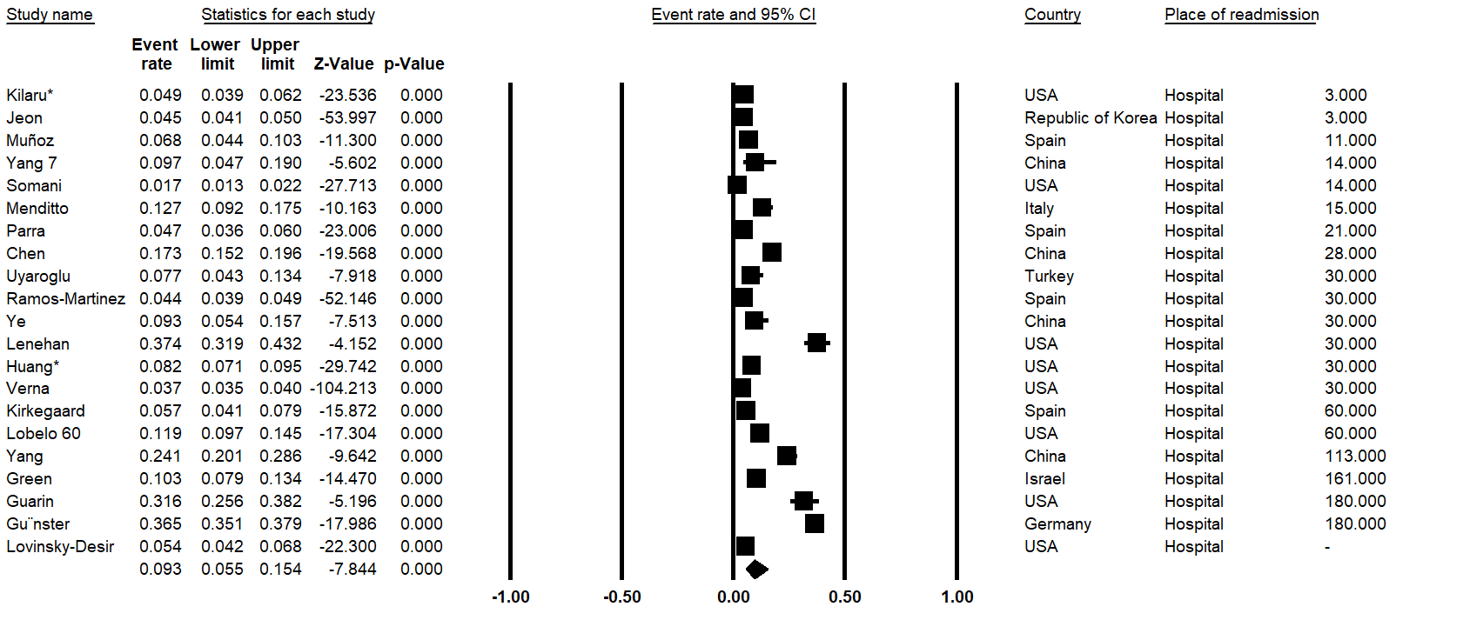

Male
Age
White
Black
Asian
Hispanic
Coronary (Ischemic) artery disease

Heart failure

Obesity

Hypertension

Cerebrovascular
Cardiovascular
Immunosuppression
No-comorbidity
Chronic pulmonary disease

Diabetes

Liver disease

Cancer

Renal failure

Chronic kidney disease

HIV

COPD

Death

Death

Re-hospitalization

Asthma

Length of hospital stay
Mechanical ventilation
ICU admission

