Original position | Biomarker | BA vs HC | BA vs non-BA | post-KPE persistent jaundice | post-KPE portal hypertension | post-KPE significant liver fibrosis
Serum | MIP-3α |  | ↑
Serum | MMP-3 | ↑ |  | ⊕ | ⊕
Serum | MMP-7 | ↑ | ↑ |  |  | ⊕
Serum | IL-8 | ↑
Serum | IL-12p40 |  |  | ∅
Serum | IL-18 | ↑ |  | ⊕
Serum | IL-33 | ↑
Serum | IFN- | ↑
Serum | FGF-21 |  | ↑ |  |  | ⊕
Serum | anti-BPO |  | ↑
Serum | ANAs |  | ↑
Serum | UDP-IV |  | ↑
Serum | Apo C-II | ↓ | ↑
Serum | Apo C-III | ↑ | ↑
Serum | APRi |  |  |  |  | ⊕
Serum | HMGB1 | ↑ | ↑
Serum | HA |  | ↑ |  |  | ⊕
Serum | adiponectin | ↑ |  | ⊕ |  | ⊕
Serum | galectin-3 | ↑ |  | ⊕ | ⊕ | ⊕
Serum | TIMP-1 | ↑ |  | ⊕ | ⊕
Serum | bFGF | ↑ |  | ⊕ | ⊕
Serum | HSP70 | ↑ |  | ⊕ | ⊕
Serum | periostin | ↑ |  | ⊕ |  | ⊕
Serum | sRAGE | ↑ |  | ⊕ |  | ⊕
Serum | ANCAs | ↑
Serum | sICAM-1 | ↑
Serum | GPC3 |  | ↑ | ⊕ |  | ⊕
Serum | GATA6 | ↑
Serum | GGT |  | ↑ |  |  | ⊕
Serum | uPAR | ↑ |  | ⊕ |  | ⊕
Serum | ATX | ↑
Serum | TGF-β1 | ↑ |  | ⊕
Serum | RBP4 | ↓ |  | ∅ | ∅ | ∅
Serum | 25-(OH)D |  |  | ⊕
Serum | M2BPGi |  |  | ⊕
Serum | miR-4689 | ↑
Serum | miR-200b/429 |  | ↑
Serum | miR-4429 | ↓
Serum | miR-140-3p | ↓
Plasma | ET-1 |  | ↑ |  | ⊕ | ⊕
Plasma | endoglin |  | ↑ | ⊕ | ⊕
Plasma | 8-OHdG | ↑
Plasma | TCDCA/CDCA | ↑ | ↑
Leukocyte | mtDNA copy number | ↓ |  |  |  | ∅
Leukocyte | RTL | ↓ |  | ∅ |  | ∅
eTable 1. Summary of biomarkers in identifications of biliary atresia diagnosis and post-KPE prognosis.
↑ in green square and ↓ in yellow square mean significant higher and significant lower respectively.
⊕ in turquoise square and ∅ in red mean positive correlation and negative correlation respectively.
Abbreviations: BA, biliary atresia; HC, health control; MIP-3α, macrophage inflammatory protein-3α; FGF-21, fibroblast growth factor 21; ANAs, anti-nuclear antibodies; UDP-IV, urinary dipeptidyl peptidase IV; Apo, apolipoprotein; HMGB1, High Mobility Group Box 1; HA, hyaluronic acid; TIMP-1, tissue inhibitors of metalloproteinase 1; bFGF, basic fibroblast growth factor; HSP70, heat shock protein 70; sRAGE, soluble receptor for advanced glycation end products; ANCAs, antineutrophil cytoplasmic antibodies; sICAM-1, soluble intercellular adhesion molecule-1; GPC3, glypican-3; GGT, γ-glutamyltransferase; uPAR, urokinase plasminogen activator receptor; ATX, autotaxin; TGF-β1, transforming growth factor-β1; RBP4, retinol binding protein 4; M2BPGi, Mac-2 binding protein glycosylation-modified isomer; ET-1, endothelin-1; 8-OHdG, 8-hydroxy-2'-deoxyguanosine; TCDCA/CDCA, The ratio of taurochenodeoxycholic acid level to chenodeoxycholic acid level; mtDNA, mitochondrial DNA; RTL, relative telomere length.

Analysis | Cochran Q (p) |  |  |  |  | Higgins I²
Analysis | Sensitivity | Specificity | PLR | NLR | DOR |  | Sensitivity | Specificity | PLR | NLR | DOR
MMP-7 for BA diagnosis | 0.5110 | 0.1033 | 0.0499 | 0.5656 | 0.5508 |  | 0.0% | 51.4% | 61.0% | 0.0% | 0.0%
IL-33 for BA diagnosis | 0.0015 | 0.0136 | 0.0055 | 0.0014 | 0.0011 |  | 90.0% | 83.6% | 87.0% | 90.2% | 90.6%
GGT for BA diagnosis | 0.0710 | 0.8180 | 0.8770 | 0.3470 | 0.9400 |  | 57.3% | 0.0% | 0.0% | 9.2% | 0.0%
APRi for predicting significant liver fibrosis | 0.9239 | 0.3720 | 0.4070 | 0.6540 | 0.4376 |  | 0.0% | 0.0% | 0.0% | 0.0% | 0.0%
APRi for predicting cirrhosis | 0.4110 | 0.8948 | 0.9710 | 0.5399 | 0.6275 |  | 0.0% | 0.0% | 0.0% | 0.0% | 0.0%
eTable 2. Heterogenicity test.

Analysis | Spearman correlation coefficient | Weighted regression p value
MMP-7 for BA diagnosis | -0.200 (p=0.800) | 0.876
GGT for BA diagnosis | 0.400 (p=0.600) | 0.820
APRi for cirrhosis of BA after KPE | 0.500 (p=0.667) | 0.525
eTable 3. Diagnostic threshold effect and weighted regression.

eFigure 1. Coupled forest plots of the positive likelihood ratio, negative likelihood ratio and diagnostic odds ratio of MMP-7 for biliary atresia diagnosis.
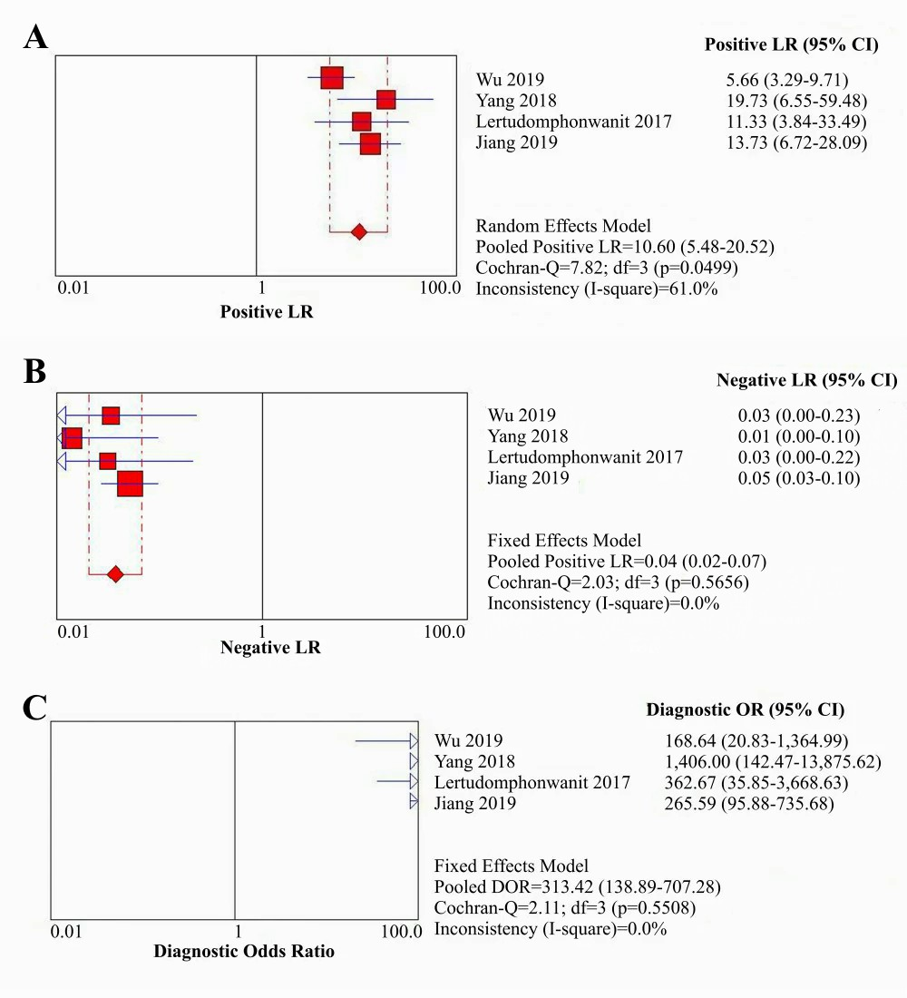
A. Positive likelihood ratio of MMP-7 for BA diagnosis; B. Negative likelihood ratio of MMP-7 for BA diagnosis; C. Diagnostic odds ratio of MMP-7 for BA diagnosis.
Abbreviations: LR, likelihood ratio; OR, odds ratio; DOR, diagnostic odds ratio.

eFigure 2. Coupled forest plots of the positive likelihood ratio, negative likelihood ratio and diagnostic odds ratio of IL-33 for biliary atresia diagnosis.
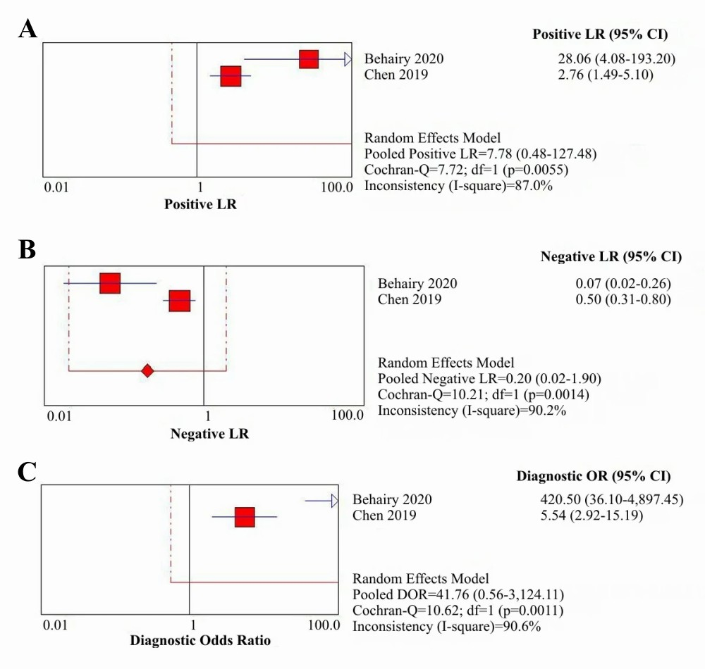
A. Positive likelihood ratio of IL-33 for BA diagnosis; B. Negative likelihood ratio of IL-33 for BA diagnosis; C. Diagnostic odds ratio of IL-33 for BA diagnosis.
Abbreviations: LR, likelihood ratio; OR, odds ratio; DOR, diagnostic odds ratio.

eFigure 3. Coupled forest plots of the positive likelihood ratio, negative likelihood ratio and diagnostic odds ratio of GGT for biliary atresia diagnosis.
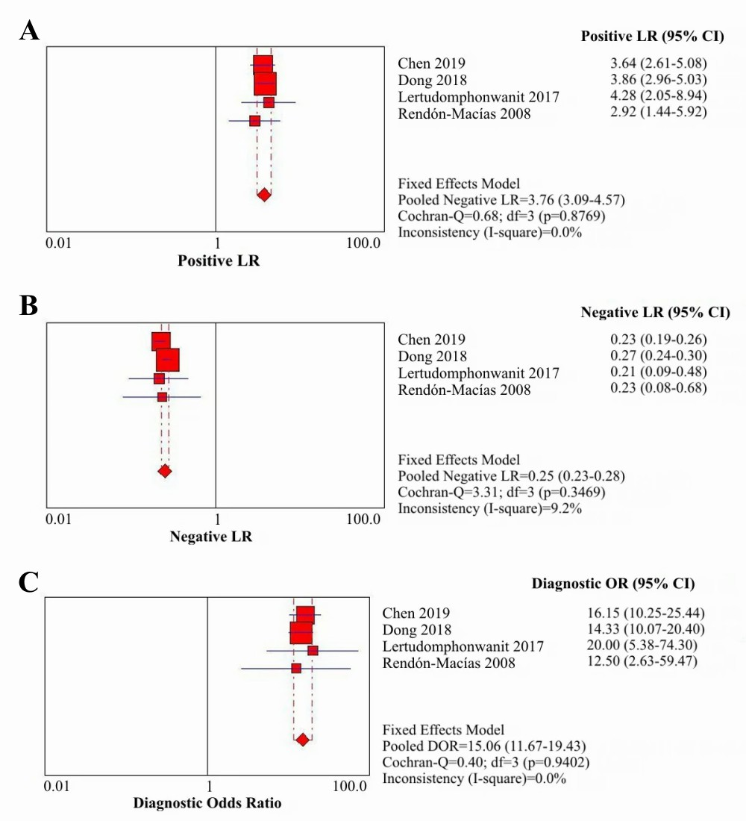
A. Positive likelihood ratio of GGT for BA diagnosis; B. Negative likelihood ratio of GGT for BA diagnosis; C. Diagnostic odds ratio of GGT for BA diagnosis.
Abbreviations: LR, likelihood ratio; OR, odds ratio; DOR, diagnostic odds ratio.

eFigure 4. Coupled forest plots of the positive likelihood ratio, negative likelihood ratio and diagnostic odds ratio of APRi for post-KPE significant fibrosis of BA patients.
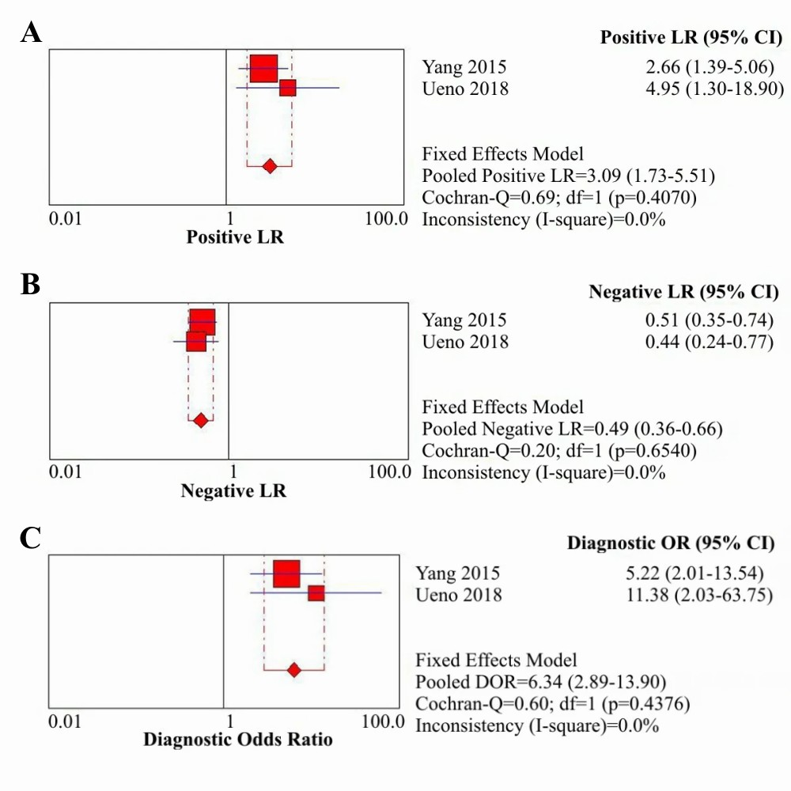
A. Positive likelihood ratio of APRi for significant fibrosis; B. Negative likelihood ratio of APRi for significant fibrosis; C. Diagnostic odds ratio of APRi for significant fibrosis.
Abbreviations: LR, likelihood ratio; OR, odds ratio; DOR, diagnostic odds ratio.

eFigure 5. Coupled forest plots of the positive likelihood ratio, negative likelihood ratio and diagnostic odds ratio of APRi for post-KPE cirrhosis of BA patients.
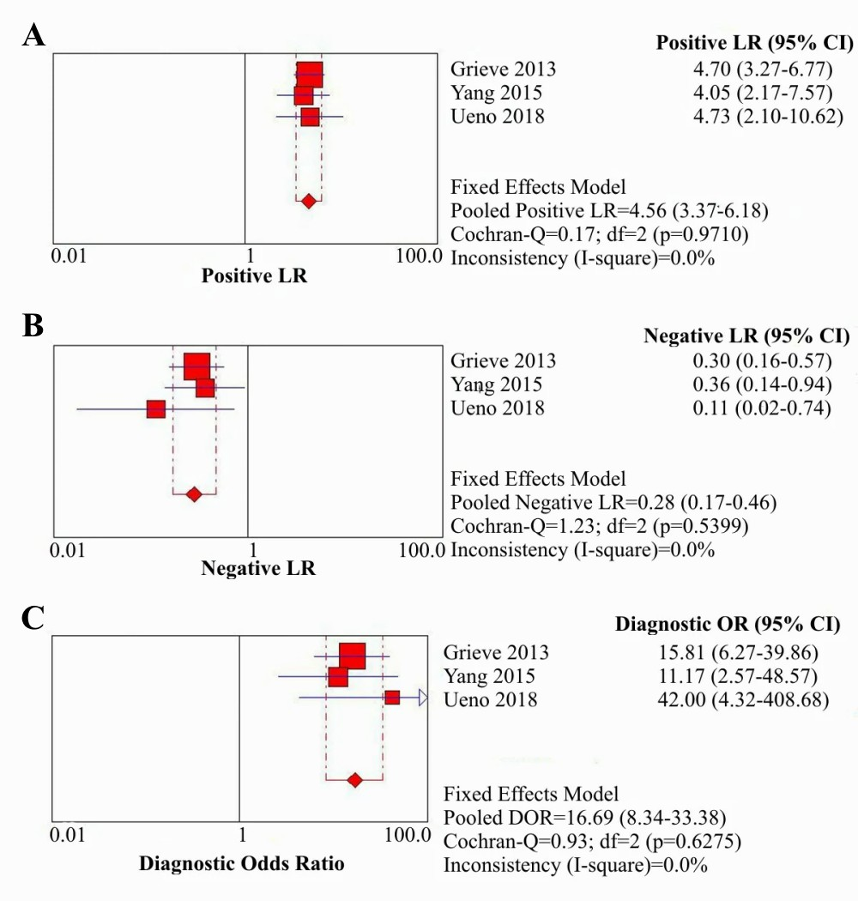
A. Positive likelihood ratio of APRi for cirrhosis; B. Negative likelihood ratio of APRi for cirrhosis; C. Diagnostic odds ratio of APRi for cirrhosis.
Abbreviations: LR, likelihood ratio; OR, odds ratio; DOR, diagnostic odds ratio.

eFigure 6. The analysis of summary ROC curve.
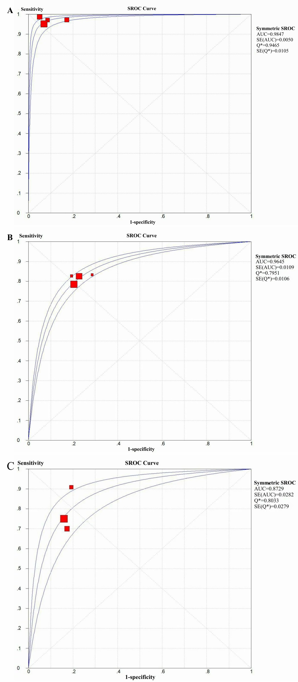
A. MMP-7 for BA diagnosis; B. GGT for BA diagnosis; C. APRi for post-KPE cirrhosis.
All SROC curve are charted via Mantel-Haenszel Fixed Effect Model due to no significance of their weighted regression analysis.

