Appendix A
Supplementary figure A1: Subgroup analysis of the risk of preterm birth (RCTs)
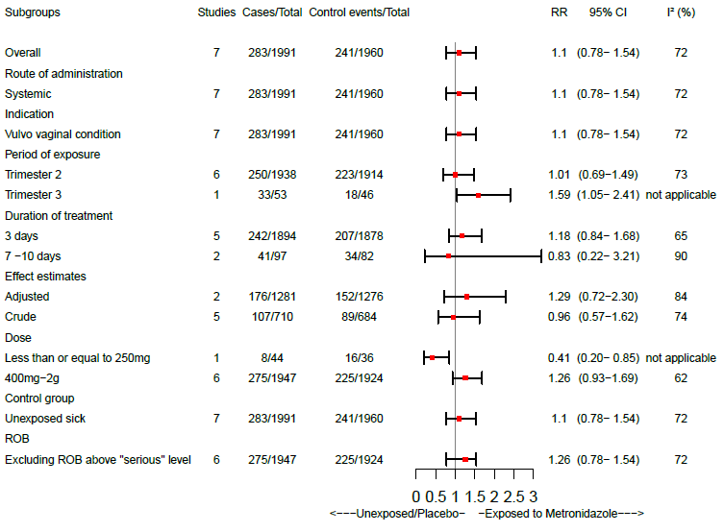

Supplementary figure A2: Subgroup analysis of the risk of preterm birth (observational studies)
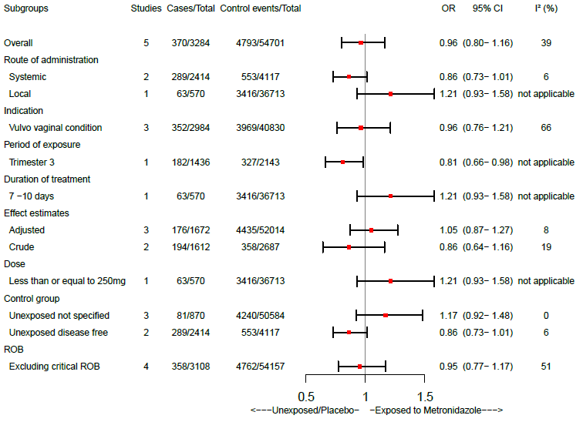

Supplementary figure A3: Subgroup analysis of the risk of preterm birth among women with a history of preterm birth (RCTs)
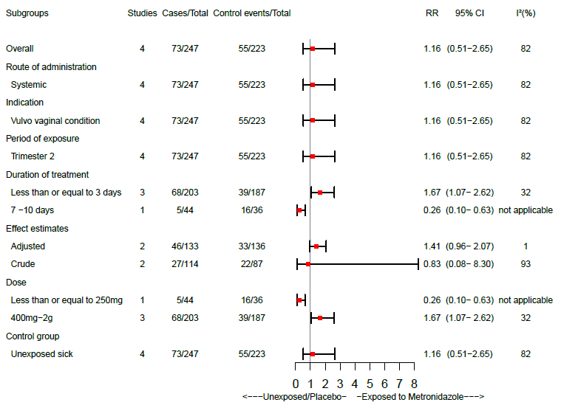

Supplementary figure A4: Subgroup analysis of the risk of low birth weight (RCTs)
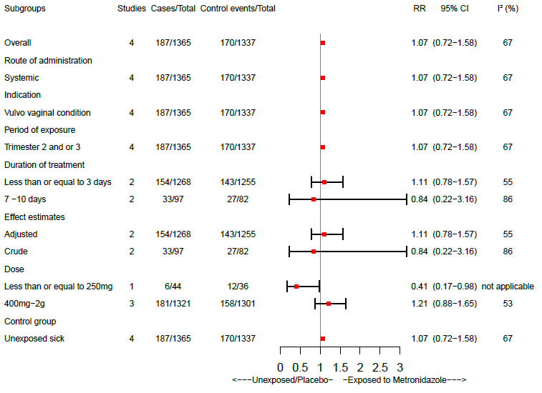

Supplementary figure A5: Funnel plot
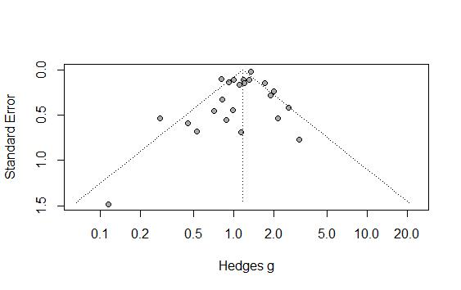

Appendix B
Figure B1: Summary of ROB assessment for observational studies
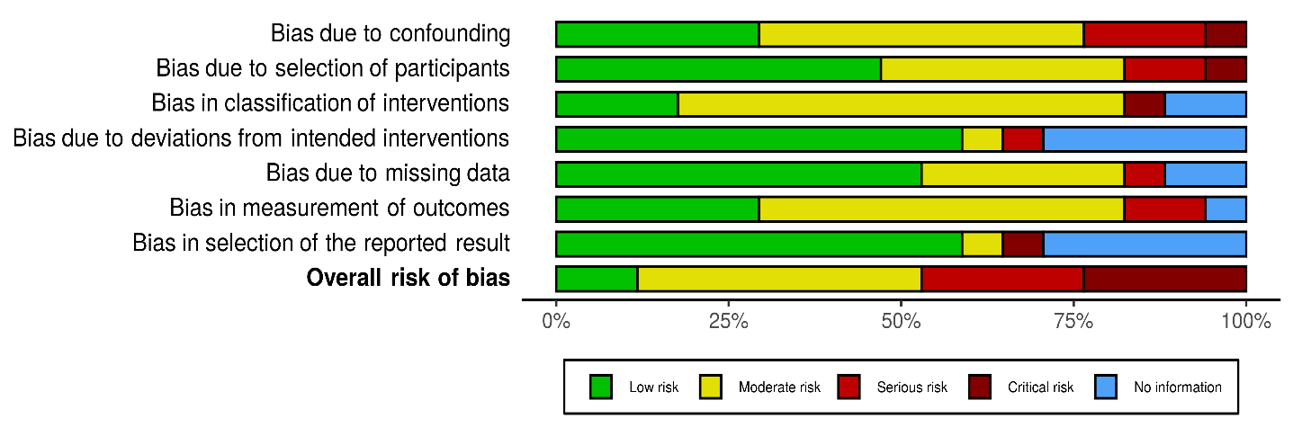

Figure B2: Summary of ROB assessment for RCTS

