Additional Appendix

Additional Table 1: The search strategy used for Ovid Medline, Embase, Cochrane Library and SinoMed

Additional Table 2: Description of MBPS in included studies (definition and measurement of MBPS)

Additional Table 3: Risk of bias assessments table

Additional Table 4: Results of the subgroup analysis for different antihypertensive classes

Additional Table 5: Adverse effects reported during the trials

Additional Figure 1: Forest plot: evening versus morning dosing regimen in categorical MBPS

Additional Figure 2: Forest plot: evening versus morning dosing regimen in night blood pressure dipping

Additional Figure 3: Forest plot: overall adverse effects and adverse effects leading to discontinuation in evening and morning regimen

Additional Table 1: The search strategy

Ovid Medline 1860-2020
1 Hypertension/
2 blood pressure$.mp.
3 hypertens$.mp.
4 exp blood pressure/
5 1 or 2 or 3 or 4
6 exp Chronotherapy/
7 (chronopharm$ or chronomodulat$ or chronotherap$).mp.
8 6 or 7
9 (morning or day or am or diurnal$ or daytim$ or awak$).mp.
10 (evening or bedtim$ or night$ or nocturnal$ or pm).mp.
11 9 and 10
- 8 or 11
- (morning surge or morning blood pressure surge).ti,ab.
- MBPS.mp.
- 13 or 14
- ((evening or night* or nocturnal) adj3 (dip* or difference or decline or decrease*)).tw.
- ("night or day" or "day to night" or night?day or day?night).tw.
- 16 and 17
- 15 OR 18
- 5 and 12 and 19
- randomized controlled trial.pt.
- controlled clinical trial.pt.
- randomized.ab.
- placebo.ab.
- drug therapy.fs.
- randomly.ab.
- trial.ab.
- groups.ab.
- 21 or 22 or 23 or 24 or 25 or 26 or 27 or 28
- (animals not (humans and animals)).sh.
- 29 not 30
- 19 and 31

Embase 1966-2020
#1 random* OR factorial* OR crossover* OR placebo* OR assign* OR allocat* OR volunteer* OR doubl* NEAR/5 blind* OR singl* NEAR/5blind*
#2 'crossover procedure'/exp
#3 'double-blind procedure'/exp
#4 'randomized controlled trial'/exp
#5 'single blind procedure'/exp
#6 #1 OR #2 OR #3 OR #4 OR #5
#7 'hypertension'/exp
#8 hypertens*
#9 'blood pressure'/exp
#10 #7 OR #8 OR #9
#11 'chronotherapy'/exp
#12 chronopharm* OR chronomodulat* OR chronotherap*
#13 morning OR day OR am OR diurnal* OR daytim* OR awak
#14 evening OR bedtim* OR night* OR nocturnal* OR pm
#15 #13 AND #14
#16 #11 OR #12 OR #15
#17 'morning surge'/exp OR 'morning blood pressure surge'/exp OR 'morning blood pressure surge'
#18 ((evening OR night* OR nocturnal) NEAR/3 (dip* OR difference OR decline OR decrease*)):ab
#19 #17 OR #18
#20 #6 AND #10 AND #16 AND #19

The Cochrane Library database 2000-2020
#1 (morning blood pressure surge):ti,ab,kw
#2 (MBPS):ti,ab,kw
#3 #1 OR #2
#4 (hypertension):ti,ab,kw
#5 MeSH descriptor: [Essential Hypertension] explode all trees
#6 #4 OR #5
#7 ("chronotherapy"):ti,ab,kw
#8 MeSH descriptor: [Drug Chronotherapy] explode all trees
#9 #7 OR #8
#10 (morning OR day OR am OR diurnal OR daytime OR awake):ti,ab,kw
#11 (evening OR bedtime OR night OR nocturnal OR pm):ti,ab,kw
#12 #10 AND #11
#13 #9 OR #12
#14 (night dipping OR night decline OR night fall OR evening dipping OR evening decline OR evening fall OR nocturnal dipping OR nocturnal decline OR nocturnal fall):ti,ab,kw
#15 #13 OR #14
#16 #3 AND #6 AND #15

SinoMed
12 (#11) AND (#9) AND (#9)
11 (#10) OR (#3)
10 (#2) OR (#1)
9 (#8) OR (#7) OR (#6) OR (#5)
8 (早晨 or 起床 or 凌晨 or 早间 or 上午) and (晚上 or 夜间 or 睡前)
7 (早上 or ⽩天 or 醒后 or 清晨) and (晚上 or 夜间 or 睡前)
6 "时间治疗学"[不加权:扩展]
5 "时间疗法"[不加权:扩展]
4 "高血压"[不加权:扩展]
3 "夜间血压下降率"[常用字段:智能]
2 血压晨峰现象
1 "晨峰血压"[常用字段:智能]

Additional Table 2: Description of MBPS in included studies (definition and measurement of MBPS).
Stud | Definition of MBPS | Method of BP  measurement | Measuring Device  (model) | Categorical  or continuous variable | Threshold
Hermida et al. | sleep-trough surge | 24-h ABPM | SpaceLabs 90207 device | Continuous | None used
Hoshino et al | sleep-trough surge | 24-h ABPM | ABPM device (TM-2431) | Continuous | None used
Acelajado et al. | sleep-trough surge AND  Prewaking surge | 24-h ABPM | Oscar-2 device, SunTech Medical | Continuous | None used
Peng et al. | sleep-trough surge | 24-h ABPM | MGY-ABP l | Categorical | ≥35 mm Hg
Zhang et al. | sleep-trough surge | 24-h ABPM | MOBIL-O-GRAPH | Both | ≥23.58 mm Hg
Dion et al. | sleep-trough surge | 24-h ABPM | Not stated | Continuous | None used
Lai et al | sleep-trough surge | 24-h ABPM | MOBIL-O-GRAPH | Continuous | ≥23 mm Hg
Qiao et al. | sleep-trough surge | 24-h ABPM | MEIGAOYIMGY -ABP1 | Continuous | ≥23.58 mm Hg
Zhao et al. | sleep-trough surge | 24-h ABPM | Spacelabs.90217 | Continuous | None used
Li et al | sleep-trough surge | 24-h ABPM | WelchAllyn-6100 | Continuous | ≥35 mm Hg
Abbreviation: MBPS, morning blood pressure surge; ABPM, ambulatory blood pressure measurement.

Additional Table 3: Risk of bias assessments table.
Studies | Random Sequence Generation  (selection bias) | Allocation Concealment  (selection bias) | Blinding Participants and Personnel  (performance bias) | Blinding of outcome Assessment  (detection bias) | Incomplete Outcome Data  (attrition bias) | Selective Reporting  (reporting bias) | Other bias
Hermida 2009 | low | low | low | low | low | low | low
Hoshino 2010 | low | low | low | low | low | low | unclear ª
Acelajado 2012 | low | low | low | low | low | unclear | high ^{b}
Peng 2013 | low | low | low | low | low | unclear | unclear ª
Zhang 2014 | low | low | low | low | low | unclear | unclear ª
Dion 2015 | low | low | low | low | low | low | low
Lai 2015 | low | low | low | low | low | low | unclear ª
Qiao 2015 | low | low | low | low | low | unclear | high ^{c}
Zhao 2015 | low | low | low | low | low | unclear | unclear ª
Li 2016 | low | low | low | low | low | unclear | unclear ª
NOTE: The assessment of risk of bias were according to Cochrane risk of bias assessments tool.
Abbreviation: low, low risk of bias; unclear, unclear risk of bias; high, high risk of bias.
ª Insufficient information to assess whether an important risk of bias exist.
^{b} As a cross-over RCT, only the first-period data are available.
^{c} Baseline imbalance. No information about patients' baseline BP and mALB. In addition to intervention, patients haven't stopped their "conventional treatments", which may have influence on outcomes.

Additional Table 4: Results of the subgroup analysis for different antihypertensive classes.
 | No. of studies | No. of participants | Mean  difference  (95% CI) | Test for overall  effect Z (P) | I²% (P) | Test for subgroup  differences
24-h SBP | 7 | 1458 | -1.39 (-3.89 to 1.11) | Z =1.09 (P =0.28) | 82% (<0.0001) | (Chi² =24.02; P ＜0.00001 )
CCB | 2 | 482 | -4.10 (-5.28 to -2.92) | Z =6.82 (P < 0.00001)*** | 0% (P =1.00)
RASI | 2 | 735 | 0.69 (-0.94 to 2.32) | Z =0.83 (P =0.41) | 0% (P =0.74)
Combined therapy | 3 | 241 | 0.66 (-2.06 to 3.37) | Z =0.47 (P =0.63) | 0% (P =0.47)
24-h DBP | 7 | 1458 | -1.05 (-3.19 to 1.10) | Z =0.96 (P =0.34) | 88% (<0.00001) | (Chi² =7.58; P =0.02)
CCB | 2 | 482 | -3.32 (-5.85 to -0.78) | Z =2.56 (P =0.01)** | 80% (P =0.03)
RASI | 2 | 735 | -0.50 (-0.48 to 1.48) | Z =1.00 (P =0.32) | 0% (P =0.65)
Combined therapy | 3 | 241 | 0.02 (-1.82 to 1.86) | Z =0.02 (P =0.98) | 0% (P =0.93)
Daytime SBP | 8 | 1566 | -0.33 (-2.93 to 2.27) | Z =0.5 (P =0.80) | 82% (<0.0001) | (Chi² =21.48; P ＜0.0001 )
CCB | 2 | 482 | -3.72 (-5.04 to -2.39) | Z =5.50 (P < 0.00001)*** | 0% (P =0.81)
RASI | 3 | 843 | 1.12 (-0.48 to 2.72) | Z =1.37 (P =0.17) | 0% (P =0.99)
Combined therapy | 3 | 241 | 1.16 (-4.66 to 6.98) | Z =0.39 (P =0.70) | 61% (P =0.08)
Daytime DBP | 8 | 1566 | -0.95 (-3.06 to 1.17) | Z =0.88 (P =0.38) | 87% (<0.00001) | (Chi² =10.27; P =0.006 )
CCB | 2 | 482 | -3.15 (-6.38 to 0.08) | Z =1.91 (P =0.06) | 86% (P =0.06)
RASI | 3 | 843 | 0.89 (-0.11 to 1.90) | Z =0.88 (P =0.38) | 0% (P =0.96)
Combined therapy | 3 | 241 | -1.99 (-4.01 to 0.03) | Z =1.93 (P =0.05)** | 0% (P =0.66)
Night-time SBP | 8 | 1566 | -2.30 (-4.52 to -0.08) | Z =2.03 (P =0.04)** | 76% (P =0.0004) | (Chi² =19.74; P ＜0.0001 )
CCB | 2 | 482 | -5.37 (-6.92 to -3.82) | Z =6.78 (P < 0.00001)*** | 0% (P =0.95)
RASI | 3 | 843 | -0.28 (-2.06 to 1.50) | Z =0.31 (P =0.76) | 15% (P =0.31)
Combined therapy | 3 | 241 | -1.12 (-3.76 to 1.52) | Z =0.83 (P =0.41) | 0% (P =0.99)
Night-time DBP | 8 | 1566 | -1.68 (-3.34 to -0.02) | Z =1.98 (P =0.05)** | 80% (<0.0001) | (Chi² =8.74; P =0.01 )
CCB | 2 | 482 | -3.81 (-5.45 to -2.18) | Z =4.57 (P < 0.00001)*** | 46% (P =0.17)
RASI | 3 | 843 | -0.70 (-2.40 to 1.00) | Z =0.81 (P =0.42) | 58% (P =0.09)
Combined therapy | 3 | 241 | -0.68 (-2.51 to 1.15) | Z =0.73 (P =0.47) | 0% (P =0.97)

Abbreviations: SBP, systolic blood pressure; DBP, diastolic blood pressure; CCB, calcium channel blockers; RASI, renin-angiotensin system inhibitors.
P values for trend, **: p≤0.05; ***: p ≤0.001.

Additional Table 5: Adverse effects reported during the trials.

 | Hermida 2009 |  | Zhao 2015 |  | Dion 2015 |  | RR (95%CI) | P value
 | Evening  (n=120) | Morning  (n=118) | Evening  (n=122) | Morning  (n=122) | Evening  (n=323) | Morning  (n=316)
Headache | 1  (0.83%) | 1  (0.85%) | 2  (1.64%) | 3  (2.46%) | 12  (3.72%) | 13  (4.11%) | 0.87 (0.44, 1.72) | 0.68
Nasopharyngitis | NA | NA | NA | NA | 8  (2.48%) | 9  (2.85%) | 0.87 (0.34, 2.23) | 0.77
Edema | 1  (0.83%) | 13  (11%) | 3  (2.46%) | 3  (2.46%) | NA | NA | 0.29 (0.02, 4.06) | 0.86
Bronchitis | NA | NA | NA | NA | 15  (4.64%) | 8  (2.53%) | 1.83 (0.79, 4.27) | 0.16
Nicturia | 1  (0.83%) | 0 | NA | NA | NA | NA | 2.95 (0.12, 71.70) | 0.61
Cough | NA | NA | NA | NA | 12  (3.72%) | 8  (2.53%) | 1.47 (0.61, 3.54) | 0.39
Nausea | NA | NA | NA | NA | 1  (0.31%) | 8  (2.53%) | 0.12 (0.02, 0.97) ** | 0.05
Vertigo | NA | NA | NA | NA | 6  (1.86%) | 6  (1.9%) | 0.98 (0.32, 3.00) | 0.97
Constipation | NA | NA | 2  (1.64%) | 3  (2.46%) | NA | NA | 0.67 (0.11, 3.92) | 0.65
Palpitations | 0 | 1  (0.85%) | NA | NA | NA | NA | 0.33 (0.01, 7.97) | 0.49
Upper abdominal pain | NA | NA | NA | NA | 3  (0.93%) | 5  (1.58%) | 0.59 (0.14, 2.44) | 0.46
Diarrhoea | NA | NA | NA | NA | 4 | 4 | 0.98 (0.25, 3.88) | 0.98
Back pain | NA | NA | NA | NA | 9 | 3 | 2.93 (0.80, 10.74) | 0.10
Skin rash | 1  (0.83%) | 2  (1.69%) | NA | NA | NA | NA | 0.49 (0.05, 5.35) | 0.56
NOTE: Data are presented as n (%); n, number of patients with at least one event.
P values for trend, **: p≤0.05.
Abbreviation: RR, risk ratios; NA: Not available.

Additional Figure 1: Forest plot: evening versus morning dosing regimen in categorical MBPS

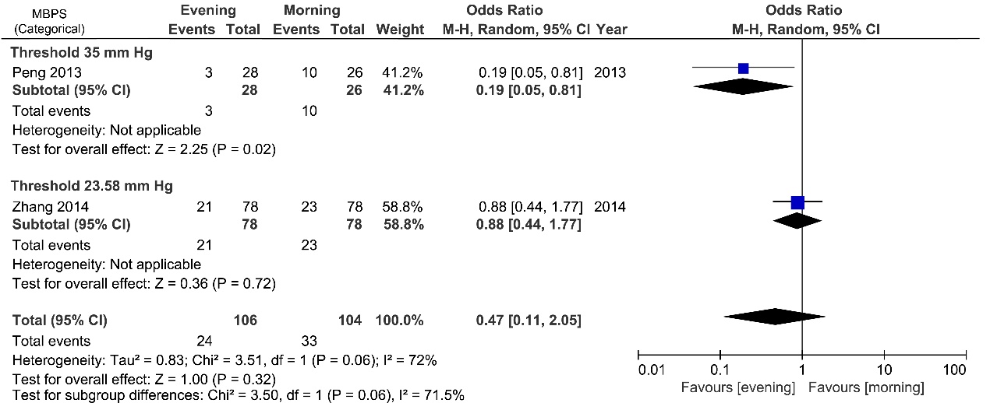

Additional Figure 2: Forest plot: evening versus morning dosing regimen in night blood pressure dipping
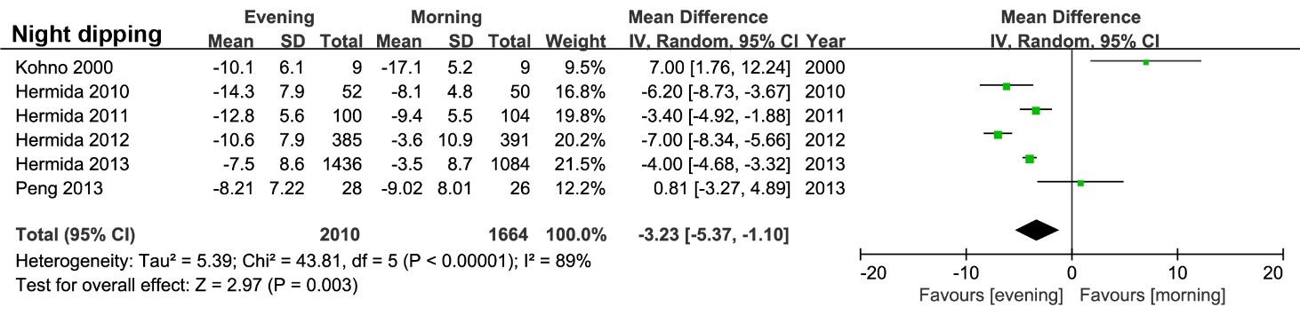

Additional Figure 3: Forest plot: overall adverse effects and adverse effects leading to discontinuation in evening and morning regimen



