Supplementary material for the paper:
Direct to angiography suite approaches for the triage of suspected acute stroke patients – a systematic review and meta-analysis
Brehm Alex MD, Tsogkas Ioannis MD, Ospel Johanna M. MD, Appenzeller-Herzog Christian PhD, Junya Aoki MD, Kazumi Kimura MD, Pfaff Johannes A.R. MD, MBHA, Möhlenbruch Markus A. MD, Requena Manuel MD, Ribo Marc J. PhD MD, Sarraj Amrou MD, Sporns Peter MD MBA, Psychogios Marios-Nikos MD

Section/topic | # | Checklist item | Reported on page #
TITLE
Title | 1 | Identify the report as a systematic review, meta-analysis, or both. | 1
ABSTRACT
Structured summary | 2 | Provide a structured summary including, as applicable: background; objectives; data sources; study eligibility criteria, participants, and interventions; study appraisal and synthesis methods; results; limitations; conclusions and implications of key findings; systematic review registration number. | 2
INTRODUCTION
Rationale | 3 | Describe the rationale for the review in the context of what is already known. | 3
Objectives | 4 | Provide an explicit statement of questions being addressed with reference to participants, interventions, comparisons, outcomes, and study design (PICOS). | 3
METHODS
Protocol and registration | 5 | Indicate if a review protocol exists, if and where it can be accessed (e.g., Web address), and, if available, provide registration information including registration number. | 4
Eligibility criteria | 6 | Specify study characteristics (e.g., PICOS, length of follow-up) and report characteristics (e.g., years considered, language, publication status) used as criteria for eligibility, giving rationale. | 4
Information sources | 7 | Describe all information sources (e.g., databases with dates of coverage, contact with study authors to identify additional studies) in the search and date last searched. | 4
Search | 8 | Present full electronic search strategy for at least one database, including any limits used, such that it could be repeated. | supplement
Study selection | 9 | State the process for selecting studies (i.e., screening, eligibility, included in systematic review, and, if applicable, included in the meta-analysis). | 4-5
Data collection process | 10 | Describe method of data extraction from reports (e.g., piloted forms, independently, in duplicate) and any processes for obtaining and confirming data from investigators. | 5
Data items | 11 | List and define all variables for which data were sought (e.g., PICOS, funding sources) and any assumptions and simplifications made. | 5
Risk of bias in individual studies | 12 | Describe methods used for assessing risk of bias of individual studies (including specification of whether this was done at the study or outcome level), and how this information is to be used in any data synthesis. | supplement
Summary measures | 13 | State the principal summary measures (e.g., risk ratio, difference in means). | 5
Synthesis of results | 14 | Describe the methods of handling data and combining results of studies, if done, including measures of consistency (e.g., I²) for each meta-analysis. | 5

Section/topic | # | Checklist item | Reported on page #
Risk of bias across studies | 15 | Specify any assessment of risk of bias that may affect the cumulative evidence (e.g., publication bias, selective reporting within studies). | 9
Additional analyses | 16 | Describe methods of additional analyses (e.g., sensitivity or subgroup analyses, meta-regression), if done, indicating which were pre-specified. | 5
RESULTS
Study selection | 17 | Give numbers of studies screened, assessed for eligibility, and included in the review, with reasons for exclusions at each stage, ideally with a flow diagram. | 6, figure1
Study characteristics | 18 | For each study, present characteristics for which data were extracted (e.g., study size, PICOS, follow-up period) and provide the citations. | 6, table 1
Risk of bias within studies | 19 | Present data on risk of bias of each study and, if available, any outcome level assessment (see item 12). | Supplement
Results of individual studies | 20 | For all outcomes considered (benefits or harms), present, for each study: (a) simple summary data for each intervention group (b) effect estimates and confidence intervals, ideally with a forest plot. | Figure 2 and figure 3
Synthesis of results | 21 | Present results of each meta-analysis done, including confidence intervals and measures of consistency. | Table 2 and 3
Risk of bias across studies | 22 | Present results of any assessment of risk of bias across studies (see Item 15). | Supplement
Additional analysis | 23 | Give results of additional analyses, if done (e.g., sensitivity or subgroup analyses, meta-regression [see Item 16]). | 7
DISCUSSION
Summary of evidence | 24 | Summarize the main findings including the strength of evidence for each main outcome; consider their relevance to key groups (e.g., healthcare providers, users, and policy makers). | 7 – 10
Limitations | 25 | Discuss limitations at study and outcome level (e.g., risk of bias), and at review-level (e.g., incomplete retrieval of identified research, reporting bias). | 9
Conclusions | 26 | Provide a general interpretation of the results in the context of other evidence, and implications for future research. | 10
FUNDING
Funding | 27 | Describe sources of funding for the systematic review and other support (e.g., supply of data); role of funders for the systematic review. | 11

Part 1 – Additional Forest Plots

eFigure 1: Forest plot of meta-analysis on good clinical outcome (modified Rankin Scale ≤ 2)
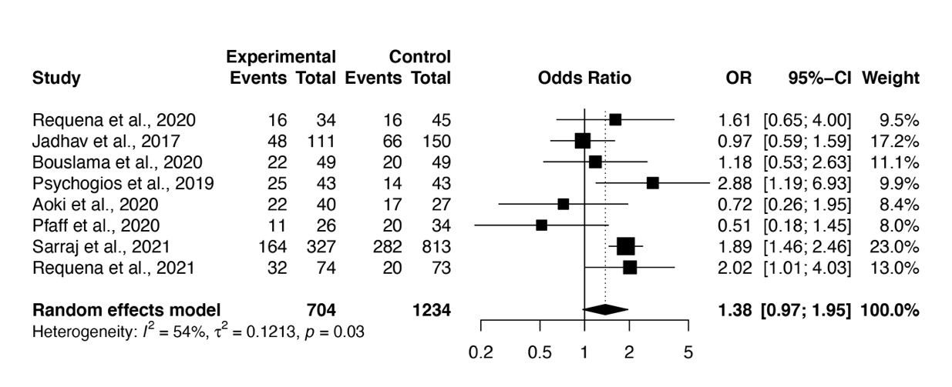
eFigure 2: Forest plot of meta-analysis on symptomatic intracranial hemorrhage
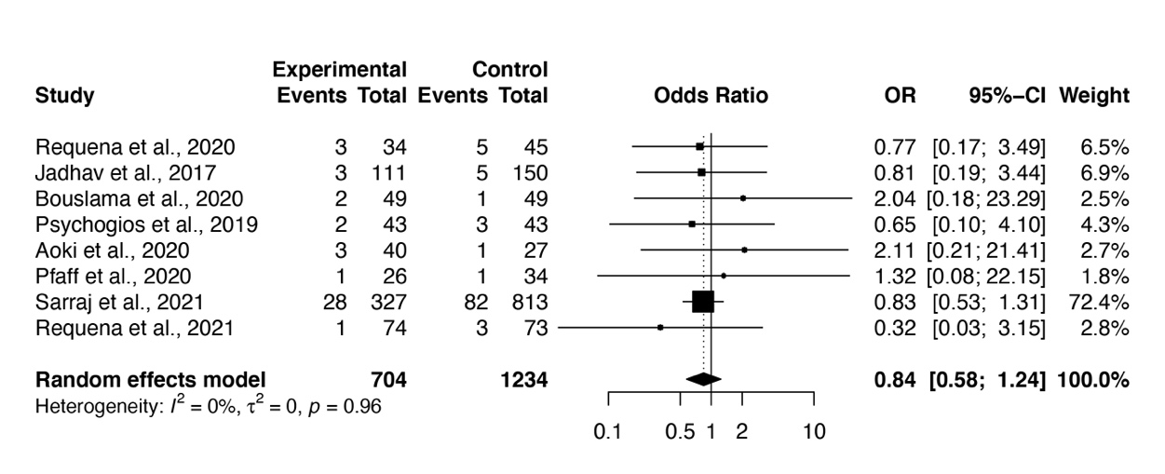
eFigure3: Forest plot of meta-analysis on mortality within 90 days
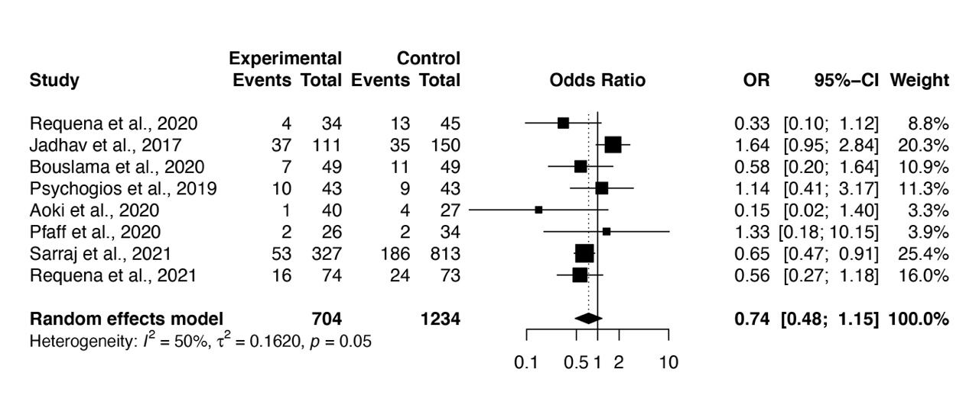

Part 2: Risk of Bias Assessment

2.1 Overall Risk of Bias of all Studies

Study | Risk of Bias Assessment | Assessment Tool
Aoki et al. 2020 | Serios | Robins I
Bouslama et al. 2020 | Moderate | Robins I
Jadhav et al. 2017 | Serios | Robins I
Pfaff et al. 2020 | Some Concerns | Rob 2 CRT
Psychogios et al. 2019 | Serious | Robins I
Requena et al. 2020 | Moderate | Robins I
Requena et al. 2021 | Low | Rob 2
Sarray et al. 2021 | Moderate | Robins I

2.2 Detailed overview of risk domains for the randomized studies

Domain of Bias | Pfaff et al. 2020 | Requena et al. 2020
Domain 1a: Risk of bias arising from the randomization process | Some concerns | Low
Domain 1b: Risk of bias arising from the timing of identification or recruitment of participants in a cluster-randomized trial | Low | Low
Domain 2a: Risk of bias due to deviations from the intended interventions (effect of assignment to intervention) | Low | Low
Domain 2b: Risk of bias due to deviations from the intended interventions (effect of adhering to intervention) | Low | Low
Domain 3: Risk of bias due to missing outcome data | Low | Low
Domain 4: Risk of bias in measurement of the outcome | Low | Low
Domain 5: Risk of bias in selection of the reported result | Some concerns | Low

2.3 Detailed overview of risk domains for the observational studies

Domain of Bias | Aoki et al. 2020 | Bouslama et al. 2020 | Jadhav et al. 2017 | Psychogios et al. 2019 | Requena et al. 2020 | Sarray et al. 2021
Confounding | Serious | Moderate | Serious | Serious | Moderate | Moderate
Selection of participants into the study | Moderate | Moderate | Moderate | Moderate | Moderate | Moderate
Classification of intervention | Low | Low | Low | Low | Low | Low
Deviations from intended interventions | Low | Low | Low | Low | Low | Low
Missing Data | Moderate | Moderate | Moderate | Moderate | Moderate | Moderate
Measurement of Outcomes | Low | Low | Low | Low | Low | Low
Selection of reported results | Low | Low | Low | Low | Low | Low

Part 3: Search Strategy for the different databases

Embase.com
('cerebrovascular accident'/de OR 'cardioembolic stroke'/de OR 'occlusive cerebrovascular disease'/de OR 'middle cerebral artery occlusion'/de OR 'brain embolism'/de OR 'brain ischemia'/de OR 'brain infarction'/de OR 'brain embolism'/de OR ('brain'/de AND ('thromboembolism'/de OR
'embolism'/de OR 'thrombosis'/de)) OR (stroke* OR ictus OR ((cerebrovascular OR 'cerebro vascular' OR 'cerebrum vascular' OR cerebral OR cerebri OR brain OR intracranial OR intra-cranial OR intracerebral OR intra-cerebral OR carotid OR neural OR hemispher* OR 'circle of willis') NEAR/3
(accident* OR lesion* OR insult* OR attack* OR insufficienc* OR arrest* OR failure* OR injur* OR vasculopath* OR occlu* OR obstruct* OR thrombosis OR phlebothrombosis OR thromboembolism OR thrombus OR thrombi OR blockage OR clot OR interruption OR obliterat* OR embol* OR ischemi* OR ischaemi* OR infarct* OR 'blood flow disturbance' OR 'blood flow disorder' OR 'circulation disorder' OR 'circulatory disorder')) OR apoplexia OR apoplexy OR apoplectic OR 'ischaemic seizure*' OR 'ischemic seizure*' OR 'ischaemic encephalopath*' OR 'ischemic encephalopath*' OR CVA OR AIS OR ((Heubner* OR MCA OR ACA OR PCA) NEAR/3 (infarct* OR syndrome*))):ab,ti)
AND
('thrombectomy'/exp OR 'endovascular surgery'/exp OR 'embolectomy'/exp OR 'thrombectomy device'/exp OR 'endovascular therapy'/de OR (thrombectom* OR embolectom* OR 'mechanical thrombolysis' OR 'mechanical clot disruption' OR ((endovascular OR intravascular OR intraarterial OR endo-vascular OR intra-vascular OR intra-arterial OR neuroendovascular) NEXT/3 (procedure* OR surgery OR treatment* OR management OR therapy OR recanalization* OR recanalization* OR revascularization* OR revascularization* OR 're-canalization*' OR 're-canalization*' OR 're-vascularization*' OR 're-vascularisation*' OR technolog* OR 'clot retrieval' OR 'clot removal')) OR
'stent retriever*' OR stentriever* OR merci OR solitaire OR trevo OR mindframe OR soehendra OR AngioJet OR APERIO OR ASPIRE OR BONnet OR FlowTriever OR pREset OR 'Revive device' OR Rotarex OR 3MAX OR 4MAX OR 5MAX OR 'ACE 64' OR 'ACE 68' OR Amplatz OR Angiojet OR ASPIREX OR CAT8 OR 'Diver CE' OR EPAR OR 'Fast Funnel' OR Hydrolyser OR Indigo OR ThromCat OR X-Sizer OR Xpeedior):ab,ti)
AND
('time to treatment'/de OR 'workflow'/de OR 'time factor'/de OR 'flat detector computed tomography'/de OR (((time* OR timing OR delay*) NEAR/3 (treatment* OR therap* OR intervention* OR recanalization OR recanalisation OR re-canalization OR re-canalisation OR reperfusion OR re- perfusion OR groin OR angiosuite OR angio-suite OR angiography OR neuroangiosuite OR neuroangio-suite OR neuroangiography OR door-to-needle OR puncture)) OR 'procedural time*' OR workflow OR 'work flow' OR 'time factor*' OR triage* OR (flat NEAR/3 (CT OR 'computed tomography')) OR (direct* NEAR/3 (angiosuite OR angio-suite OR angiography OR neuroangiosuite OR neuroangio-suite OR neuroangiography)) OR ((bypass* OR circumvent* OR avoid* OR omit* OR skip*) NEAR/3 (multidetector OR multi-detector OR emergency OR 'CT suite' OR 'Computed Tomography suite' OR 'CT room' OR 'Computed Tomography room')) OR 'one stop'):ab,ti)
NOT
(('animal'/de OR 'animal experiment'/exp OR 'nonhuman'/de) NOT ('human'/exp OR 'human experiment'/de))
NOT
[conference abstract]/lim

Medline (Ovid)
(exp stroke/ OR exp "intracranial embolism and thrombosis"/ OR brain ischemia/ OR (brain/ AND
("embolism and thrombosis"/ OR thromboembolism/ OR embolism/ OR thrombosis/)) OR (stroke* OR ictus OR ((cerebrovascular OR cerebro vascular OR cerebrum vascular OR cerebral OR cerebri OR brain OR intracranial OR intra-cranial OR intracerebral OR intra-cerebral OR carotid OR neural OR hemispher* OR circle of willis) ADJ3 (accident* OR lesion* OR insult* OR attack* OR insufficienc* OR arrest* OR failure* OR injur* OR vasculopath* OR occlu* OR obstruct* OR thrombosis OR phlebothrombosis OR thromboembolism OR thrombus OR thrombi OR blockage OR clot OR interruption OR obliterat* OR embol* OR ischemi* OR ischaemi* OR infarct* OR blood flow disturbance OR blood flow disorder OR circulation disorder OR circulatory disorder)) OR apoplexia OR apoplexy OR apoplectic OR ischaemic seizure* OR ischemic seizure* OR ischaemic encephalopath* OR ischemic encephalopath* OR CVA OR AIS OR ((Heubner* OR MCA OR ACA OR PCA) ADJ3 (infarct* OR syndrome*))).ab,ti.)
AND
(exp thrombectomy/ OR endovascular procedures/ OR exp embolectomy/ OR (thrombectom* OR embolectom* OR mechanical thrombolysis OR mechanical clot disruption OR ((endovascular OR intravascular OR intraarterial OR endo-vascular OR intra-vascular OR intra-arterial OR neuroendovascular) ADJ3 (procedure* OR surgery OR treatment* OR management OR therapy OR recanalization* OR recanalization* OR revascularization* OR revascularization* OR re-canalization* OR re-canalization* OR re-vascularization* OR re-vascularisation* OR technolog* OR clot retrieval OR clot removal)) OR stent retriever* OR stentriever* OR merci OR solitaire OR trevo OR mindframe OR soehendra OR AngioJet OR APERIO OR ASPIRE OR BONnet OR FlowTriever OR pREset OR Revive device OR Rotarex OR 3MAX OR 4MAX OR 5MAX OR ACE 64 OR ACE 68 OR Amplatz OR Angiojet OR ASPIREX OR CAT8 OR Diver CE OR EPAR OR Fast Funnel OR Hydrolyser OR Indigo OR ThromCat OR X-Sizer OR Xpeedior).ab,ti.)
AND
(time-to-treatment/ OR workflow/ OR time factors/ OR triage/ OR (((time* OR timing OR delay*) ADJ3 (treatment* OR therap* OR intervention* OR recanalization OR recanalisation OR re- canalization OR re-canalisation OR reperfusion OR re-perfusion OR groin OR angiosuite OR angio-suite OR angiography OR neuroangiosuite OR neuroangio-suite OR neuroangiography OR door-to-needle OR puncture)) OR procedural time* OR workflow OR work flow OR time factor* OR triage* OR (flat ADJ3 (CT OR computed tomography)) OR (direct* ADJ3 (angiosuite OR angio-suite OR angiography OR neuroangiosuite OR neuroangio-suite OR neuroangiography)) OR ((bypass* OR circumvent* OR avoid* OR omit* OR skip*) ADJ3 (multidetector OR multi-detector OR emergency OR CT suite OR Computed Tomography suite OR CT room OR Computed Tomography room)) OR one stop).ab,ti.)
NOT (exp animals/ NOT humans/)

Scopus
TITLE-ABS((stroke* OR ictus OR ((cerebrovascular OR "cerebro vascular" OR "cerebrum vascular" OR cerebral OR cerebri OR brain OR intracranial OR intra-cranial OR intracerebral OR intra-cerebral OR carotid OR neural OR hemispher* OR "circle of willis") W/5 (accident* OR lesion* OR insult* OR attack* OR insufficienc* OR arrest* OR failure* OR injur* OR vasculopath* OR occlu* OR obstruct* OR thrombosis OR phlebothrombosis OR thromboembolism OR thrombus OR thrombi OR blockage OR clot OR interruption OR obliterat* OR embol* OR ischemi* OR ischaemi* OR infarct* OR "blood flow disturbance" OR "blood flow disorder" OR "circulation disorder" OR "circulatory disorder")) OR apoplexia OR apoplexy OR apoplectic OR "ischaemic seizure" OR "ischemic seizure" OR "ischaemic encephalopathy" OR "ischemic encephalopathy" OR CVA OR AIS OR ((Heubner* OR MCA OR ACA OR PCA) W/5 (infarct* OR syndrome*))))
AND
TITLE-ABS((thrombectom* OR embolectom* OR "mechanical thrombolysis" OR "mechanical clot disruption" OR ((endovascular OR intravascular OR intraarterial OR endo-vascular OR intra-vascular OR intra-arterial OR neuroendovascular) W/5 (procedure* OR surgery OR treatment* OR management OR therapy OR recanalization* OR recanalization* OR revascularization* OR revascularization* OR "re-canalization" OR "re-canalization" OR "re-vascularization" OR "re-vascularisation" OR technolog* OR "clot retrieval" OR "clot removal")) OR "stent retriever" OR stentriever* OR merci OR solitaire OR trevo OR mindframe OR soehendra OR AngioJet OR APERIO OR ASPIRE OR BONnet OR FlowTriever OR pREset OR "Revive device" OR Rotarex OR 3MAX OR 4MAX OR 5MAX OR "ACE 64" OR "ACE 68" OR Amplatz OR Angiojet OR ASPIREX OR CAT8 OR "Diver CE" OR EPAR OR "Fast Funnel" OR Hydrolyser OR Indigo OR ThromCat OR X-Sizer OR Xpeedior))
AND
TITLE-ABS((((time* OR timing OR delay*) W/5 (treatment* OR therap* OR intervention* OR recanalization OR recanalisation OR re-canalization OR re-canalisation OR reperfusion OR re-perfusion OR groin OR angiosuite OR angio-suite OR angiography OR neuroangiosuite OR neuroangio-suite OR neuroangiography OR door-to-needle OR puncture)) OR "procedural time" OR workflow OR "work flow" OR "time factor" OR triage* OR (flat W/5 (CT OR "computed tomography")) OR (direct* W/5 (angiosuite OR angio-suite OR angiography OR neuroangiosuite OR neuroangio-suite OR neuroangiography)) OR ((bypass* OR circumvent* OR avoid* OR omit* OR skip*) W/5 (multidetector OR multi-detector OR emergency OR "CT suite" OR "Computed Tomography suite" OR "CT room" OR"Computed Tomography room")) OR "one stop"))

Clinical Trials.gov
(stroke* OR ictus OR "cerebrovascular accident" OR apoplexia OR CVA OR AIS)
AND
(thrombectom* OR embolectom* OR "mechanical thrombolysis" OR "endovascular treatment" OR "stent retriever")
Part 4: Data extraction forms
Abbreviations:
1st first quartile, 3rd third quartile, c, control, dTG, door to groin, dTR, door to reperfusion, GO good outcome, i, intervention, M Mothership, Me, median, Mor, mortality, sICH symptomatic intracranial hemorrhage, T Transfer
This data extraction form was used for the primary analysis except for door to reperfusion times

study | n_c | n_i | dTG_c_Me | dTG_c_1st | dTG_c_3rd | dTg_i_Me | dTG_i_1st | dTG_i_3rd | GO_c | GO_i | sICH_c | sICH_i | Mor_c | Mor_i
Psychogios_2019 | 43 | 43 | 60 | 48 | 68 | 25 | 19 | 30 | 14 | 25 | 3 | 2 | 9 | 10
Aoki_2020 | 27 | 40 | 31 | 27 | 40 | 22 | 16 | 31 | 17 | 22 | 1 | 3 | 4 | 1
Bouslama_2020 | 49 | 49 | 55 | 44.5 | 66 | 33 | 26.5 | 47 | 20 | 22 | 1 | 2 | 11 | 7
Jadhav_2017 | 150 | 111 | 81 | 46 | 91 | 22 | 12 | 25 | 66 | 48 | 5 | 3 | 35 | 37
Requena_2020 | 45 | 34 | 78 | 57 | 100 | 19 | 16 | 23 | 16 | 16 | 5 | 3 | 13 | 4
Pfaff_2020 | 34 | 26 | 40 | 31 | 48 | 41 | 30 | 48 | 20 | 11 | 1 | 1 | 2 | 2
Requena_2021 | 73 | 74 | 42 | 35 | 51 | 18 | 15 | 24 | 20 | 32 | 3 | 1 | 24 | 16
Sarraj_2021 | 813 | 327 | 60 | 37 | 95 | 34 | 20 | 62 | 282 | 164 | 82 | 28 | 186 | 53

study | T_n_c | T_n_i | T_dTG_c_Me | T_dTG_c_1st | T_dTG_c_3rd | T_dTG_i_Me | T_dTG_i_1st | T_dTG_i_3rd
Psychogios_2019 | 13 | 25 | 40 | 30 | 69 | 21 | 19 | 26
Aoki_2020 | 27 | 40 | 31 | 27 | 40 | 22 | 16 | 31
Bouslama_2020 | 49 | 49 | 55 | 44.5 | 66 | 33 | 26.5 | 47
Jadhav_2017 | 150 | 111 | 81 | 46 | 91 | 22 | 12 | 25
Requena_2020 | NA | NA | NA | NA | NA | NA | NA | NA
Pfaff_2020 | 23 | 19 | 33 | 30 | 43 | 37 | 25 | 45
Requena_2021 | 52 | 55 | 42 | 34 | 51 | 17 | 15 | 25
Sarraj_2021 | 813 | 327 | 60 | 37 | 95 | 34 | 20 | 62

study | M_n_c | M_n_i | M_dTG_c_Me | M_dTG_c_1st | M_dTG_c_3rd | M_dTG_i_Me | M_dTG_i_1st | M_dTG_i_3rd
Psychogios_2019 | 30 | 18 | 61 | 54 | 67 | 26 | 25 | 38
Aoki_2020 | NA | NA | NA | NA | NA | NA | NA | NA
Bouslama_2020 | NA | NA | NA | NA | NA | NA | NA | NA
Jadhav_2017 | NA | NA | NA | NA | NA | NA | NA | NA
Requena_2020 | 45 | 34 | 78 | 57 | 100 | 19 | 16 | 23
Pfaff_2020 | 11 | 7 | 46 | 40 | 85 | 47 | 44 | 54
Requena_2021 | 21 | 19 | 43 | 39 | 51 | 20 | 17 | 23
Sarraj_2021 | NA | NA | NA | NA | NA | NA | NA | NA

Data extraction form for the primary analysis and secondary analysis of door to reperfusion times
study | n_c | n_i | dTR_c_Me | dTR_c_1st | dTR_c_3rd | dTR_i_Me | dTR_i_1st | dTR_i_3rd
Psychogios_2019 | 43 | 43 | 102 | 85 | 117 | 68 | 53 | 89
Aoki_2020 | 27 | 40 | 67 | 56 | 122 | 56 | 43 | 80
Bouslama_2020 | 49 | 49 | 110 | 80 | 153 | 85 | 57.5 | 115.5
Jadhav_2017 | 150 | 111 | 125 | 81 | 146 | 66 | 39 | 84
Requena_2020 | 175 | 174 | 114 | 90 | 142 | 55 | 40 | 80
Pfaff_2020 | 34 | 26 | 78 | 58 | 92 | 80 | 66 | 118
Requena_2021 | 73 | 74 | 84 | 63 | 117 | 57 | 43 | 77
Sarraj_2021 | 813 | 327 | NA | NA | NA | NA | NA | NA

study | T_n_c | T_n_i | T_dTR_c_Me | T_dTRR_c_1st | T_dTR_c_3rd | T_dTR_i_Me | T_dTR_i_1st | T_dTR_i_3rd
Psychogios_2019 | 13 | 25 | 102 | 68 | 109 | 64 | 51 | 88
Aoki_2020 | 27 | 40 | 67 | 56 | 122 | 56 | 43 | 80
Bouslama_2020 | 49 | 49 | 110 | 80 | 153 | 85 | 57.5 | 115.5
Jadhav_2017 | 150 | 111 | 125 | 81 | 146 | 66 | 39 | 84
Requena_2020 | 130 | 140 | 110 | 79 | 137 | 53 | 39 | 73
Pfaff_2020 | 23 | 19 | 73 | 57 | 91 | 74 | 64 | 122
Requena_2021 | 52 | 55 | 90 | 69 | 121 | 56 | 43 | 76
Sarraj_2021 | 813 | 327 | NA | NA | NA | NA | NA | NA

study | M_n_c | M_n_i | M_dTR_c_Me | M_dTR_c_1st | M_dTR_c_3rd | M_dTR_i_Me | M_dTR_i_1st | M_dTR_i_3rd
Psychogios_2019 | 30 | 18 | 103 | 85 | 121 | 72 | 58 | 87
Aoki_2020 | NA | NA | NA | NA | NA | NA | NA | NA
Bouslama_2020 | NA | NA | NA | NA | NA | NA | NA | NA
Jadhav_2017 | NA | NA | NA | NA | NA | NA | NA | NA
Requena_2020 | 45 | 34 | 127 | 104 | 154 | 73 | 47 | 97
Pfaff_2020 | 11 | 7 | 87 | 73 | 95 | 89 | 74 | 107
Requena_2021 | 21 | 19 | 80 | 55 | 90 | 60 | 51 | 85
Sarraj_2021 | NA | NA | NA | NA | NA | NA | NA | NA

Part 5: Detailed list of excluded studies
No | Reference | Reason for exclusion
1 | Janssen PM, Venema E, Dippel DWJ. Effect of workflow improvements in endovascular stroke treatment: A systematic review and meta-analysis. Stroke 2019;50:665-674. | Mixture of interventions (Anesthesia, direct to angiography, organization of angioroom etc.)
2 | Kansagra AP, Wallace AN, Curfman DR, et al. Streamlined triage and transfer protocols improve door-to-puncture time for endovascular thrombectomy in acute ischemic stroke. Clinical Neurology and Neurosurgery 2018;166:71-75. | Wrong comparator (Comparison over time (quarters) with change in pre-transfer imaging; for example, pre-transfer CT-A rate increased significantly)
3 | Menéndez ES, Espot PG, Macho LC, Rodríguez-Samaniego MT, Santana Román KE, Fueyo MRD. Implementation of a protocol for direct stroke patient transfer and mobilization of a stroke team to reduce times to reperfusion. Emergencias 2019;31:385-390. | Double reporting of data (at least partly included in Requena et al. 2020)
4 | Qureshi AI, Egila H, Adil MM, et al. "No turn back approach" to reduce treatment time for endovascular treatment of acute ischemic stroke. Journal of Stroke and Cerebrovascular Diseases 2014;23:e317-e323. | No direct to angiography suite approach evaluated
5 | Aghaebrahim A, Streib C, Rangaraju S, et al. Streamlining door to recanalization processes in endovascular stroke therapy. Journal of NeuroInterventional Surgery 2017;9:340-345. | No direct to angiography suite approach evaluated
6 | Sablot D, Farouil G, Laverdure A, Arquizan C, Bonafe A. Shortening time to reperfusion after transfer from a primary to a comprehensive stroke center. Neurology: Clinical Practice 2019;9:417-423. | No direct to angiography suite approach evaluated
7 | Bohmann FO, Kurka N, du Mesnil de Rochemont R, et al. Simulation-Based Training of the Rapid Evaluation and Management of Acute Stroke (STREAM)—A Prospective Single-Arm Multicenter Trial. Frontiers in Neurology 2019;10. | No direct to angiography suite approach evaluated
8 | Hung SC, Lin CJ, Guo WY, et al. Toward the era of a one-stop imaging service using an angiography suite for neurovascular disorders. BioMed Research International 2013;2013. | Review; no data included
9 | Clarençon F, Rosso C, Degos V, et al. Triage in the Angiography Suite for Mechanical Thrombectomy in Acute Ischemic Stroke: Not Such a Good Idea. AJNR American journal of neuroradiology 2018;39:E59-E60. | Comment, no data given
10 | Mashni SK, O'Neal CR, Abner E, Lee J, Fraser JF. Time Intervals for Direct Versus Transfer Cases of Thrombectomy for Stroke in a Primarily Rural System of Care. Journal of Stroke and Cerebrovascular Diseases 2020;29. | No direct to angiography suite approach evaluated
11 | Psychogios MN, Behme D, Schregel K, et al. One-stop management of acute stroke patients minimizing door-to-reperfusion times. Stroke 2017;48:3152-3155. | Double reporting (included in Psychogios et al. 2020)
12 | Mendez B, Requena M, Aires A, et al. Direct transfer to Angio-suite to reduce workflow times and increase favorable clinical outcome a case-control study. Stroke 2018;49:2723-2727. | Double reporting (included in Requena et al. 2020)
13 | Ribo M, Boned S, Rubiera M, et al. Direct transfer to angiosuite to reduce door-to-puncture time in thrombectomy for acute stroke. Journal of NeuroInterventional Surgery 2018;10:221-224. | Double reporting (included in Requena et al. 2020)
14 | Brehm A, Tsogkas I, Maier IL, et al. One-stop management with perfusion for transfer patients with stroke due to a large-vessel occlusion: Feasibility and effects on in-hospital times. American Journal of Neuroradiology | Double reporting (included in Psychogios et al. 2020)
15 | Psychogios MN, Bähr M, Liman J, Knauth M. One Stop Management in Acute Stroke: First Mothership Patient Transported Directly to the Angiography Suite. Clinical Neuroradiology 2017;27:389-391. | Case report
16 | Tong E, Komlosi P, Wintermark M. One-stop-shop stroke imaging with functional CT. European Journal of Radiology 2015;84:2425-2431. | No data included on endpoint
17 | Ragoschke-Schumm A, Yilmaz U, Kostopoulos P, et al. Stroke Room': Diagnosis and Treatment at a Single Location for Rapid Intraarterial Stroke Treatment. Cerebrovascular Diseases 2015;40:251-257. | Hybrid concept: MDCT and angiography suite in the same room
18 | Pfaff J, Herweh C, Pham M, et al. Mechanical thrombectomy using a combined CT/C-arm X-ray system. Journal of NeuroInterventional Surgery 2016;8:621-625. | Hybrid concept: MDCT and angiography suite in the same room
19 | Pfaff J, Schönenberger S, Herweh C, et al. Influence of a combined CT/C-arm system on periprocedural workflow and procedure times in mechanical thrombectomy. European Radiology 2017;27:3966-3972. | Hybrid concept: MDCT and angiography suite in the same room
20 | Jeon SB, Ryoo SM, Lee DH, et al. Multidisciplinary Approach to Decrease In-Hospital Delay for Stroke Thrombolysis. J Stroke 2017;19:196-204. | No direct to angiography suite approach evaluated
21 | McTaggart RA, Yaghi S, Cutting SM, et al. Association of a primary stroke center protocol for suspected stroke by large-vessel occlusion with efficiency of care and patient outcomes. JAMA Neurology 2017;74:793-800. | No direct to angiography suite approach evaluated
22 | Mehta BP, Leslie-Mazwi TM, Chandra RV, et al. Reducing door-to-puncture times for intra-arterial stroke therapy: A pilot quality improvement project. Journal of the American Heart Association 2014;3. | No direct to angiography suite approach evaluated
23 | Schregel K, Behme D, Tsogkas I, et al. Effects of Workflow Optimization in Endovascularly Treated Stroke Patients - A Pre-Post Effectiveness Study. PLoS ONE 2016;11. | No direct to angiography suite approach evaluated
24 | Li W, Burgin WS, Beba Abadal K, Mokin M, Ren Z. Direct angiographic intervention for acute ischemic stroke with large vessel occlusion. Neurol Res 2021:1-6. | Review; no data included
25 | van Meenen LCC, Arrarte Terreros N, Groot AE, et al. Value of repeated imaging in patients with a stroke who are transferred for endovascular treatment. J Neurointerv Surg 2021. | Wrong comparator (Patients in the conventional triage arm presented with changing symptoms, i.e. improved or worsened stroke)

