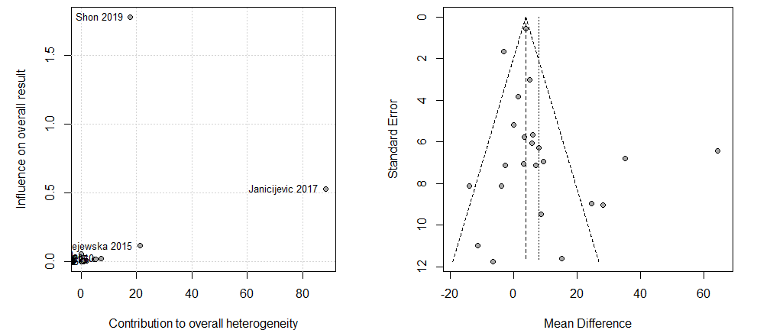
Figure S1. Baujat- and Funnel-Plot for meta-analysis on total cholesterol and glaucoma.

