Supporting Information
Supplementary Figures and Tables
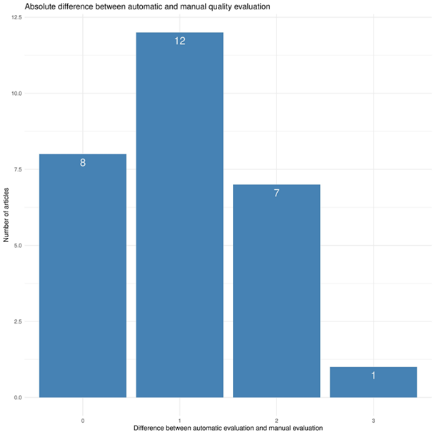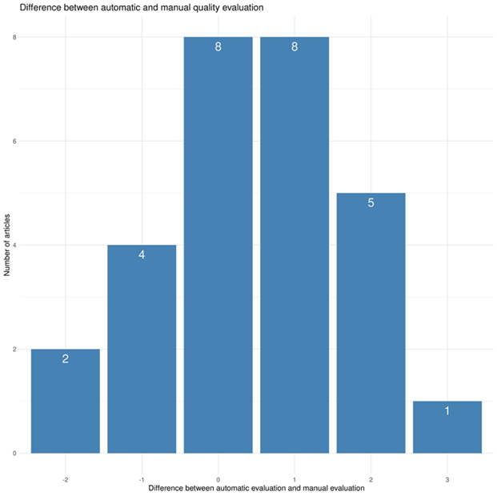
Figure S1: Difference between the manual and automatic evaluation of the article quality, left: absolute difference in scoring, right: the notes of the manual evaluation were subtracted from the automatic evaluation.
Table S1: List of the predefined section names for segmentation.
"Introduction", "INTRODUCTION",
"Materials", "Material", "materials", "material", "MATERIALS", "MATERIAL",
"Methods", "Method", "methods", "method", "METHODS", "METHOD",
"Acknowledgements", "Acknowledgments", "ACKNOWLEDGEMENTS", "ACKNOWLEDGMENTS",
"Acknowledgement", "Acknowledgment", "ACKNOWLEDGEMENT", "ACKNOWLEDGMENT",
"References", "REFERENCES",
"Results", "RESULTS",
"Discussion", "DISCUSSION", "discussion",
"Abstract", "ABSTRACT",
"Conclusions", "Conclusion", "CONCLUSION", "CONCLUSIONS",
"Background", "BACKGROUND",
"Experimental", "EXPERIMENTAL", "Experiment",
"Supplementary", "SUPPLEMENTARY",
"Methodology",
"Appendix",
"Section", "SECTION"

Table S2: Comparison of manual end automatic extraction of Materials and Method section.

Manual_extraction | Automatic_extraction | Cosine_similarity
Abbasalipourkabir R et al 2015.pdf.rds | segmenteR_Abbasalipourkabir R et al 2015.pdf.rds | 0.999994540538458
Abe S et al 2012.pdf.rds | segmenteR_Abe, S et al 2012.pdf.rds | 1,00
Adedara I A et al 2018.pdf.rds | segmenteR_Adedara, I A et al 2018.pdf.rds | 0.999862534072248
Aijie C et al 2017.pdf.rds | segmenteR_Aijie, C et al 2017.pdf.rds | 1.00000000000001
Amrollahi-Sharifabadi et al. 2018.pdf.rds | segmenteR_Amrollahi-Sharifabadi et al. 2018.pdf.rds | 1.00000000000001
Ansari M 2018.pdf.rds | segmenteR_Ansari, M 2018.pdf.rds | 0.999960418291695
Aragao-Santiago L 2016.pdf.rds | segmenteR_Aragao-Santiago, L 2016.pdf.rds | 0.994714350875484
AshaRani et al. 2009.pdf.rds | segmenteR_AshaRani et al. 2009.pdf.rds | 0.999956878313193
Bai K J et al 2018.pdf.rds | segmenteR_Bai, K J et al 2018.pdf.rds | 1,00
Bendre V et al 2011.pdf.rds | segmenteR_Bendre, V et al 2011.pdf.rds | 0,00
Blum J L et al 2014.pdf.rds | segmenteR_Blum, J L et al 2014.pdf.rds | 1,00
Cabral H et al 2005.pdf.rds | segmenteR_Cabral, H et al 2005.pdf.rds | 0.999917856649757
Chen et al 2008.pdf.rds | segmenteR_Chen et al 2008.pdf.rds | 1,00
Jamshidzadeh A et al 2015.pdf.rds | segmenteR_Jamshidzadeh, A et al 2015.pdf.rds | 0.995753754683567
Li C et al 2009.pdf.rds | segmenteR_Li, C et al 2009.pdf.rds | 1,00
Li J et al 2013.pdf.rds | segmenteR_Li, J et al 2013.pdf.rds | 0.999968502871919
Li J G et al 2009.pdf.rds | segmenteR_Li, J G et al 2009.pdf.rds | 0.999983166205566
Li Y et al 2010.pdf.rds | segmenteR_Li, Y et al 2010.pdf.rds | 0.998074541111967
Liu Y et al 2014.pdf.rds | segmenteR_Liu, Y et al 2014.pdf.rds | 0.999810348758169
Love S A et al 2012.pdf.rds | segmenteR_Love, S A et al 2012.pdf.rds | 0.999458706078455
Maurizi L et al 2015.pdf.rds | segmenteR_Maurizi, L et al 2015.pdf.rds | 0.999999999999996
NeÅ¡koviÄ‡ O et al 2013.pdf.rds | segmenteR_NeÅ¡koviÄ‡, O et al 2013.pdf.rds | 0.999071650085047
Neun B W et al 2018.pdf.rds | segmenteR_Neun, B W et al 2018.pdf.rds | 0.99177293738389
Reddy A et al 2010.pdf.rds | segmenteR_Reddy, A et al 2010.pdf.rds | 0.999876206235163
Richter AW et al 1983.pdf.rds | segmenteR_Richter, AW et al 1983.pdf.rds | 0,00
Sadaf A et al 2012.pdf.rds | segmenteR_Sadaf, A et al 2012.pdf.rds | 0.99713598196992
Tang J et al 2009.pdf.rds | segmenteR_Tang, J et al 2009.pdf.rds | 0.995735653018931
Vicente S et al 2017.pdf.rds | segmenteR_Vicente, S et al 2017.pdf.rds | 0.719379601414012
Wang X et al 2010.pdf.rds | segmenteR_Wang, X et al 2010.pdf.rds | 0.99994746751755
Xiaoli F et al 2017.pdf.rds | segmenteR_Xiaoli, F et al 2017.pdf.rds | 0.73411296323334
Yan M et al 2011.pdf.rds | segmenteR_Yan, M et al 2011.pdf.rds | 0.999882247434263
Yu T et al 2011.pdf.rds | segmenteR_Yu, T et al 2011.pdf.rds | 0.946030328634252
Zook J M et al 2011.pdf.rds | segmenteR_Zook, J M et al 2011.pdf.rds | 0.999999999999998

Table S3: Sources of errors in article segmentation
Source of the error in segmentation (document type) | Number of documents
Abstracts | 1
Article in Chinese | 1
Case report | 1
Editorial | 1
Erratum | 1
Medical hypothesis | 1
News | 1
No material and method section | 1
Note | 1
Phd thesis | 1
Summary of a symposium | 1
Scientific report | 2
Book | 3
Not an article | 4
Scan | 5
Supplementary information | 5
Review | 6
Communication | 7
Letter | 8

Table S4: List of keywords for the nanomaterial characterization regarding five basic properties of nanomaterials.
Size | "diameter", "size", "dimension", "radius", "nm"
Surface area | "surface area"
Surface charge | "zeta potential", "surface charge", "mv"
Chemical composition/structure | "chemical composition", "coating", "core", "shell", "content", "configuration", "molecular ratio"
Stability/Aggregation | "aggregation", "aggregate", "polydisperse", "monodisperse", "stability", "agglomeration", "stable", "agglomerate"

Table S5: List of keywords for the classification of in vivo vs in vitro experiments.
In vitro | "incubation temperature", "incubator", "incubated", "viability", "cells/ml", "cells/mL”, “cells/well", "cells per well", "cultured", "culture", "medium", "media", "penicillin", "% of CO", "streptomycin", "well plates", "well plate", "cell line", "cells"
In vivo | "age", "year old", "month old", "year-old", "month-old", "cage", "holding rooms", "housed", "facility", "diet", "ad libitum",  "dark cycle", "light cycle", "euthanized", "acclimate", "acclimatized", "body weight", "administration route", "dose in mg/kg"

Table S6: List of keywords for the classification of the documents into different types of toxicity.
Cardiotoxicity: | "cardiac toxicity", "cardiomyopathies", "cardiotoxicity", "cardiovascular effect", "heart parameters", "heart failure", "creatine kinase", "oedema",  "myofibrilis", "bradycardia", "arrhythmia", "heart attack", "accumulation heart", "myocardial fibrosis",
Genotoxicity | "mutagenicity", "genetic toxicity", "mutation", "DNA damage", "DNA strand breaks", " carcinogenicity", "genotoxicity", "chromosome aberrations", "clastogenic","aneugenic effects", "micronucleus formation", "epigenetic changes",
Haemotoxicity | "thrombosis", "thrombogenicity", "plasma coagulation", "anti-coagulant", "haemotoxicity", "pro-coagulant fibrin", "platelet activation", "haemolysis", "coagulopathies"
Immune effects | "spleen toxicity", "immune effect", "immune response", "immune reaction", "complement activation", "hypersensitivity", "CARPA", "anaphylaxis",  "macrophage uptake", "macrophage take up", "immunosuppression", "cytokine induction", "cytokine storm", "pyrogenicity", "inflammasome activation", "MPS uptake", "macrophage activation", "immunogenicity", "antigenicity", "accelerated blood clearance", "ABC", "allergy", "spleen accumulation"
Lung toxicity | "pulmonary toxicity", "lung injury", "pulmonary injury", "lung toxicity", "airway remodelling", "asthma", "allergic responses", "thickening alveolar walls", "granuloma formation", "lung accumulation", "pulmonary fibrosis"
Liver toxicity | "hepatotoxicity", "liver injury", "liver damage", "hepatitis", "cholestasis", "steatosis", "acute liver failure", "glutamic pyruvic transaminase level", "liver toxicity", "alkaline phosphatase level", "hepatic cell injury", "liver accumulation", "cirrhosis"
Nephrotoxicity | "renal toxicity", "kidney injury", "kidney toxicity", "interstitial nephritis", "glomerulonephritis", "glomerular lesion", "nephrotoxicity", "glomerular damage", "creatinine clearance", "creatinine level", "urea level", "swelling proximal tubule", "swelling tubular epithelium", "tubular necrosis", "kidney metallothionein", "kidney accumulation", "nephrogenic fibrosis"
Neurotoxicity | "neurologic disorders", "nervous system disorder", "brain damage", "neurotoxicity", "neuronal damage", "neurocognitive deficit", "neurocognitive disorder", "neurocognitive impairment", "loss motor control", "cognitive deterioration", "nervous system dysfunction", "neurodegenerative process", "neuronal degeneration"
Not-specific toxicity | - "inflammation", "pro-inflammatory",  - "oxidative stress", "ROS production ", "nitrosative stress",  - "apoptosis", "apoptotic death",  - "autophagic death", "autophagy",  - "accumulation", "organ accumulation", "organ distribution", "organ uptake", "organ take up",  - "necrosis"

Table S7: List of keywords for the classification of nanomaterials.
Polymeric nanoparticles | "polymeric NP", "polymer NP"**
Lipid based nanoparticles | "lipid NP"
Liposomes | liposome
Polystyrene nanoparticles | "polystyrene NP"
Metal based nanoparticles* | copper NP", "zinc oxide NP", "titanium dioxide NP", "iron oxide NP", "gold NP", "silver NP", "aluminium oxide NP", "cerium NP", "manganese NP"
Nanotubes | "carbon NP", "peptide NP"
Quantum Dots | "quantum dot"
Dendrimers | "dendrimer"
Carbon based nanoparticles | “carbon NP”, “fullerene”
Silica nanoparticles | silica NP", "silicon dioxide", "SiO"
* For metal-based nanoparticles the text of the result section was also parsed for formula of the metal in addition to their common denomination (a search for “gold” was followed by a search for “Au”.)
** If a keyword contained the abbreviation “NP”, the sentence was screened for all words starting with “nano” (e.g. nanotube, nanoparticle …).

Table S8: List of keywords for the extraction of specific toxicity effects.
Immune effects | "complement activation", "CARPA", "hypersensitivity", "anaphylaxis", "immunosuppression", "cytokine induction", "cytokine storm", "pyrogenicity",  "inflammasome activation", "MPS uptake", "macrophage activation", "macrophage uptake", "antigenicity", "accelerated blood clearance", "allergy", "ABC", "spleen accumulation", "spleen toxicity"
Liver toxicity | "hepatitis", "liver inflammation", "cholestasis", "steatosis", "acute liver failure", "glutamic pyruvic transaminase level", "GPT", "alkaline phosphatase level", "ALP", "hepatic cell injury", "liver accumulation", "cirrhosis", "liver cancer", "liver fibrosis"
Genotoxicity | "mutagenicity", "mutation", "DNA damage", "DNA strand breaks", "carcinogenicity", "chromosome aberrations", "clastogenic", "aneugenic effects", "micronucleus formation", "epigenetic changes", "nucleus accumulation"
Nephrotoxicity | "interstitial nephritis", "glomerulonephritis", "glomerular lesion", "glomerular damage", "creatinine clearance", "creatinine level", "urea level", " swelling of the proximal tubule", "swelling of the tubular epithelium", "tubular necrosis", "kidney metallothionein", "kidney accumulation",  "nephrogenic systemic fibrosis"
Lung toxicity | "airway remodelling", "asthma", "allergic responses", "thickening of alveolar walls", "granuloma formation", "lung accumulation ", "pulmonary fibrosis"

