Supplementary Table S1: Study characteristics of the included studies
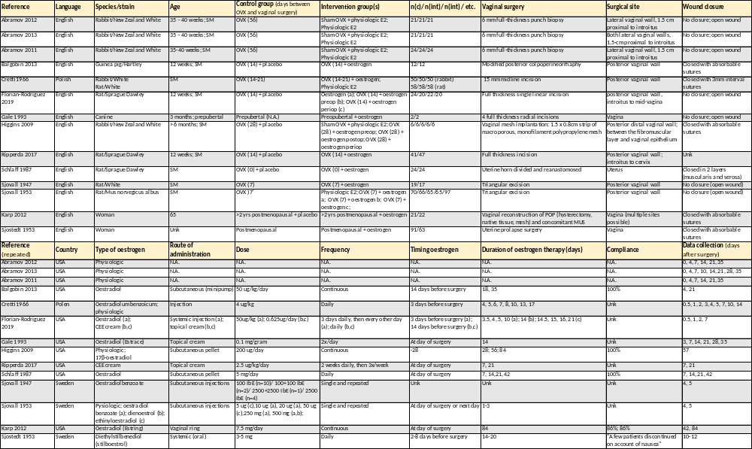
SM = sexually mature, OVX = ovariectomy, unk = unknown, CEE = conjugated equine (o)estrogen, preop = preoperative, periop = perioperative (preoperative and postoperative), postop = postoperative, POP = pelvic organ prolapse, MUS = mid-urethral sling, c = control, int = intervention, N.A. = not applicable.
Editable version:
Reference | Language | Species/strain | Age | Control group (days between OVX and vaginal surgery) | Intervention group(s) | n(c)/ n(int)/ n(int) / etc. | Vaginal surgery | Surgical site | Wound closure
Abramov 2012 | English | Rabbit/New Zealand White | 35 – 40 weeks; SM | OVX (56) | Sham OVX + physiologic E2;  Physiologic E2 | 21/21/21 | 6 mm full-thickness punch biopsy | Lateral vaginal wall, 1.5 cm proximal to introitus | No closure; open wound
Abramov 2013 | English | Rabbit/New Zealand White | 35 – 40 weeks; SM | OVX (56) | Sham OVX + physiologic E2;  Physiologic E2 | 21/21/21 | 6 mm full-thickness punch biopsy | Both lateral vaginal walls,  1.5-cm proximal to introitus | No closure; open wound
Abramov 2011 | English | Rabbit/New Zealand White | 35-40 weeks; SM | OVX (56) | Sham OVX + physiologic E2;  Physiologic E2 | 24/24/24 | 6 mm full-thickness punch biopsy | Lateral vaginal wall, 1.5 cm proximal to introitus | No closure; open wound
Balgobin 2013 | English | Guinea pig/Hartley | 12 weeks; SM | OVX (14) + placebo | OVX (14) + oestrogen | 12/12 | Modified posterior colpoperineorrhaphy | Posterior vaginal wall | Closed with absorbable sutures
Cretti 1966 | Polish | Rabbit/White  Rat/White | SM | OVX (14-21) | OVX (14-21) + oestrogen;  Physiologic E2 | 50/50/50 (rabbit)  58/58/58 (rat) | 15 mm midline incision | Posterior vaginal wall | Closed with 3mm interval sutures
Florian-Rodriguez 2019 | English | Rat/Sprague Dawley | 12 weeks; SM | OVX (14) + placebo | Oestrogen (a); OVX (14) + oestrogen preop (b); OVX (14) + oestrogen periop (c) | 24/20/22/20 | Full thickness single linear incision | posterior vaginal wall, introitus to mid-vagina | No closure; open wound
Gale 1993 | English | Canine | 3 months; prepubertal | Prepubertal (N.A.) | Preopubertal + oestrogen | 2/2 | 4 full thickness radial incisions | Vagina | No closure; open wound
Higgins 2009 | English | Rabbit/New Zealand White | > 6 months; SM | OVX (28) + placebo | Sham OVX + physiologic E2; OVX (28) + oestrogen preop; OVX (28) + oestrogen postop; OVX (28) + oestrogen periop | 6/6/6/6/6 | Vaginal mesh implantation: 1.5 x 0.8cm strip of macroporous, monofilament polypropylene mesh | Posterior distal vaginal wall; between the fibromuscular layer and vaginal epithelium | Closed with absorbable sutures
Ripperda 2017 | English | Rat/Sprague Dawley | 12 weeks; SM | OVX (14) + placebo | OVX (14) + oestrogen | 41/47 | Full thickness incision | Posterior vaginal wall; introitus to cervix | Unk
Schlaff 1987 | English | Rat/Sprague Dawley | SM | OVX (0) + placebo | OVX (0) + oestrogen | 24/24 | Uterine horn divided and reanastomosed | Uterus | Closed in 2 layers (muscularis and serosa)
Sjovall 1947 | English | Rat/White | SM | OVX (7) | OVX (7) + oestrogen | 19/17 | Triangular excision | Posterior vaginal wall | No closure (open wound)
Sjovall 1953 | English | Rat/Mus norvegicus albus | SM | OVX (7) | Physiologic E2; OVX (7) + oestrogen a; OVX (7) + oestrogen b; OVX (7) + oestrogen c; | 70/66/65/65/97 | Triangular excision | Posterior vaginal wall | No closure (open wound)
Karp 2012 | English | Woman | 65 | >2 yrs postmenopausal + placebo | >2 yrs postmenopausal + oestrogen | 21/22 | Vaginal reconstruction of POP (hysterectomy, native tissue, mesh) and concomitant MUS | Vagina (multiple sites possible) | Closed with absorbable sutures
Sjostedt 1953 | English | Woman | Unk | Postmenopausal | Postmenopausal + oestrogen | 91/63 | Uterine prolapse surgery | Vagina | Closed with absorbable sutures
Reference (repeated) | Country | Type of oestrogen | Route of administration | Dose | Frequency | Timing oestrogen | Duration of oestrogen therapy (days) | Compliance | Data collection (days after surgery)
Abramov 2012 | USA | Physiologic | N.A. | N.A. | N.A. | N.A. | N.A. | N.A. | 0, 4, 7, 14, 21, 35
Abramov 2013 | USA | Physiologic | N.A. | N.A. | N.A. | N.A. | N.A. | N.A. | 0, 4, 7, 10, 14, 21, 28, 35
Abramov 2011 | USA | Physiologic | N.A. | N.A. | N.A. | N.A. | N.A. | N.A. | 0, 4, 7, 14, 21, 35
Balgobin 2013 | USA | Oestradiol | Subcutaneous (minipump) | 50 ug/kg/day | Continuous | 14 days before surgery | 18, 35 | 100% | 4, 21
Cretti 1966 | Polen | Oestradiolum benzoicum; physiologic | Injection | 4 ug/kg | Daily | 3 days before surgery | 4, 5, 6, 7, 8, 10, 13, 17 | Unk | 0.5, 1, 2, 3, 4, 5, 7, 10, 14
Florian-Rodriguez 2019 | USA | Oestradiol (a);  CEE cream (b,c) | Systemic injection (a); topical cream (b,c) | 50ug/kg (a); 0.625ug/day (b,c) | 3 days daily, then every other day (a); daily (b,c) | 3 days before surgery (a);  14 days before surgery (b,c) | 3.5, 4, 5, 10 (a); 14 (b); 14.5, 15, 16, 21 (c) | Unk | 0.5, 1, 2, 7
Gale 1993 | USA | Oestradiol (Estrace) | Topical cream | 0.1 mg/gram | 2x/day | At day of surgery | 14 | Unk | 3, 7, 14, 21, 28, 35
Higgins 2009 | USA | Physiologic;  17β-oestradiol | Subcutaneous pellet | 200 ug/day | Continuous | -28 | 28; 56; 84 | 100% | 57
Ripperda 2017 | USA | CEE cream | Topical cream | 2.5 ug/kg/day | 2 weeks daily, then 3x/week | At day of surgery | 7, 21 | Unk | 7, 21
Schlaff 1987 | USA | Oestradiol | Subcutaneous pellet | 5 mg/day | Daily | At day of surgery | 7, 14,21, 42 | 100% | 7, 14, 21, 42
Sjovall 1947 | Sweden | Oestradiolbenzoate | Subcutaneous injections | 100 IbE (n=10)/ 100+100 IbE (n=2)/ 2500+2500 IbE (n=1)/ 2500 IbE (n=4) | Single and repeated | Unk | Unk | Unk | 4, 5
Sjovall 1953 | Sweden | Pysiologic; oestradiol benzoate (a); dienoestrol (b); ethinyloestradiol (c) | Subcutaneous injections | 5 ug (c),10 ug (a), 20 ug (a), 50 ug (c),250 mg (a), 500 mg (a,b); | Single and repeated | At day of surgery or next day | 1-3 | Unk | 4, 5
Karp 2012 | USA | Oestradiol (Estring) | Vaginal ring | 7.5 mg/day | Continuous | At day of surgery | 84 | 86%; 86% | 42, 84
Sjostedt 1953 | Sweden | Diethylstilbenediol (stilboestrol) | Systemic (oral) | 3-5 mg | Daily | 2-8 days before surgery | 14-20 | "A few patients discontinued on account of nausea" | 10-12

