a
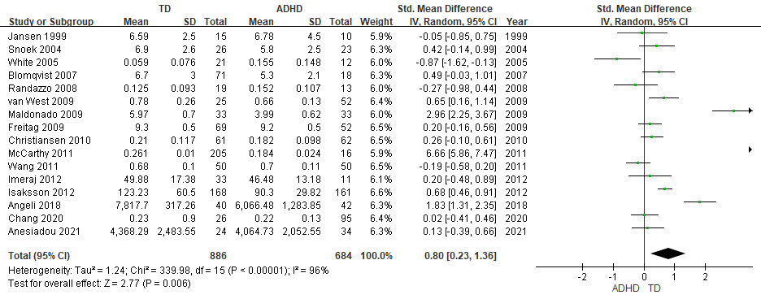

b
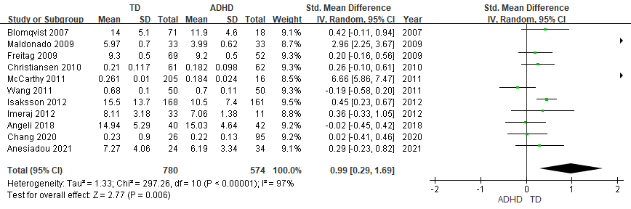

c
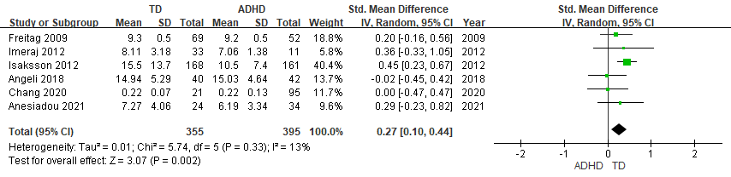
Supplementary Figure 3. Forest plots comparing effect sizes of (a) salivary cortisol levels, (b) salivary morning cortisol levels and (c) salivary awakening cortisol levels between ADHD and TD groups.
Forest plots showing effect sizes (Hedges’s g) and 95% confidence intervals (CIs) from individual studies and pooled results comparing (a) salivary cortisol levels, (b) salivary morning cortisol levels and (c) salivary awakening cortisol levels between ADHD population and TD group. ADHD, attention deficit hyperactivity disorder; CI, confidence interval; Std, standard; TD, typically developing youth.

