a
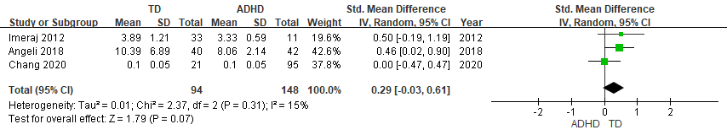

b
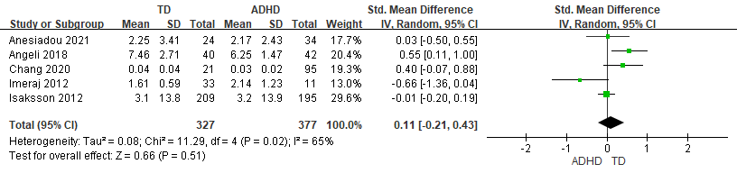
Supplementary Figure 4. Forest plots comparing effect sizes of (a) noon and (b) bedtime cortisol levels between ADHD and TD groups.
Forest plots showing effect sizes (Hedges’s g) and 95% confidence intervals (CIs) from individual studies and pooled results comparing (a) noon and (b) bedtime cortisol levels between ADHD population and TD group. ADHD, attention deficit hyperactivity disorder; CI, confidence interval; Std, standard; TD, typically developing youth.

