a
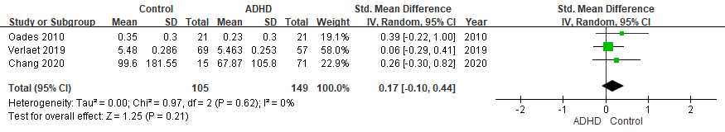

b
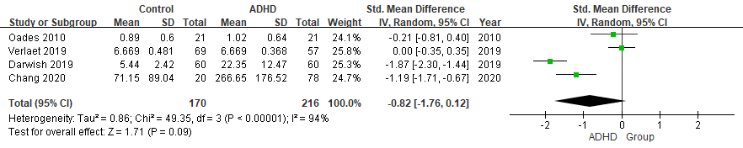

c
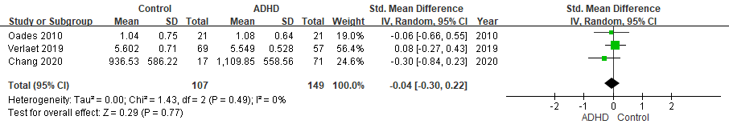
Supplementary Figure 5. Forest plots comparing effect sizes of IL-1β, (b) IL-6, and (c) IL-10 levels between ADHD and TD groups.
Forest plots showing effect sizes (Hedges’s g) and 95% confidence intervals (CIs) from individual studies and pooled results comparing (a) IL-1β, (b) IL-6, and (c) IL-10 levels between ADHD population and TD group. ADHD, attention deficit hyperactivity disorder; CI, confidence interval; Std, standard; TD, typically developing youth.

