Comparative Effectiveness of Botulinum Toxin Injections and Extracorporeal Shockwave Therapy for Post-Stroke Spasticity: A Systematic Review and Network Meta-Analysis

Supplemental Material:
Supplemental Method
Supplemental Table 1-3
Supplemental Figure 1-4

Supplemental Method
Search strategy:
PubMed (Updated on September 25, 2021)
1. (((((stroke) OR (cerebrovascular disease)) OR (cerebral infarction)) OR (intracerebral hemorrhage)) OR (hemiplegia)) OR (hemiparesis): 641,356
2. (spasticity) OR (hypertonia): 34,783
3. (shock wave) OR (shockwave therapy): 13,308
4. botulinum toxin: 22,881
5. #1 AND #2 AND #3: 48
6. #1 AND #2 AND #4: 793
7. #5 OR #6: 836
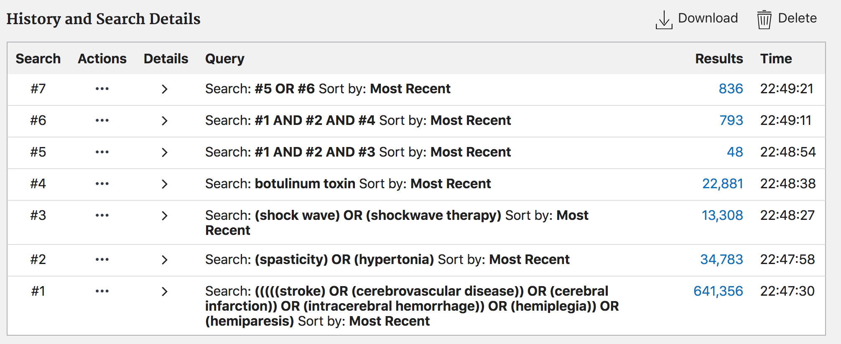

EMBASE (Updated on September 25, 2021)
1. (((((stroke) OR (cerebrovascular disease)) OR (cerebral infarction)) OR (intracerebral hemorrhage)) OR (hemiplegia)) OR (hemiparesis): 698,602
2. (spasticity) OR (hypertonia): 37,491
3. (shock wave) OR (shockwave therapy): 23,730
4. botulinum toxin: 43,267
5. #1 AND #2 AND #3: 67
6. #1 AND #2 AND #4: 1,709
7. #5 OR #6: 1,768
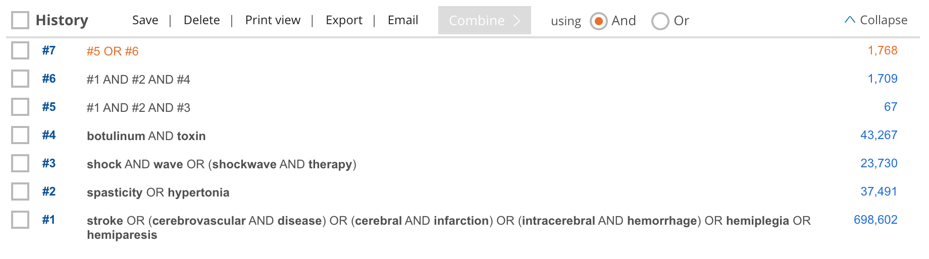

Medline (via OVID) (Updated on September 25, 2021)
1. (((((stroke) OR (cerebrovascular disease)) OR (cerebral infarction)) OR (intracerebral hemorrhage)) OR (hemiplegia)) OR (hemiparesis): 378,600
2. (spasticity) OR (hypertonia): 19,292
3. (shock wave) OR (shockwave therapy): 9,370
4. botulinum toxin: 15,162
5. #1 AND #2 AND #3: 47
6. #1 AND #2 AND #4: 585
7. #5 OR #6: 627
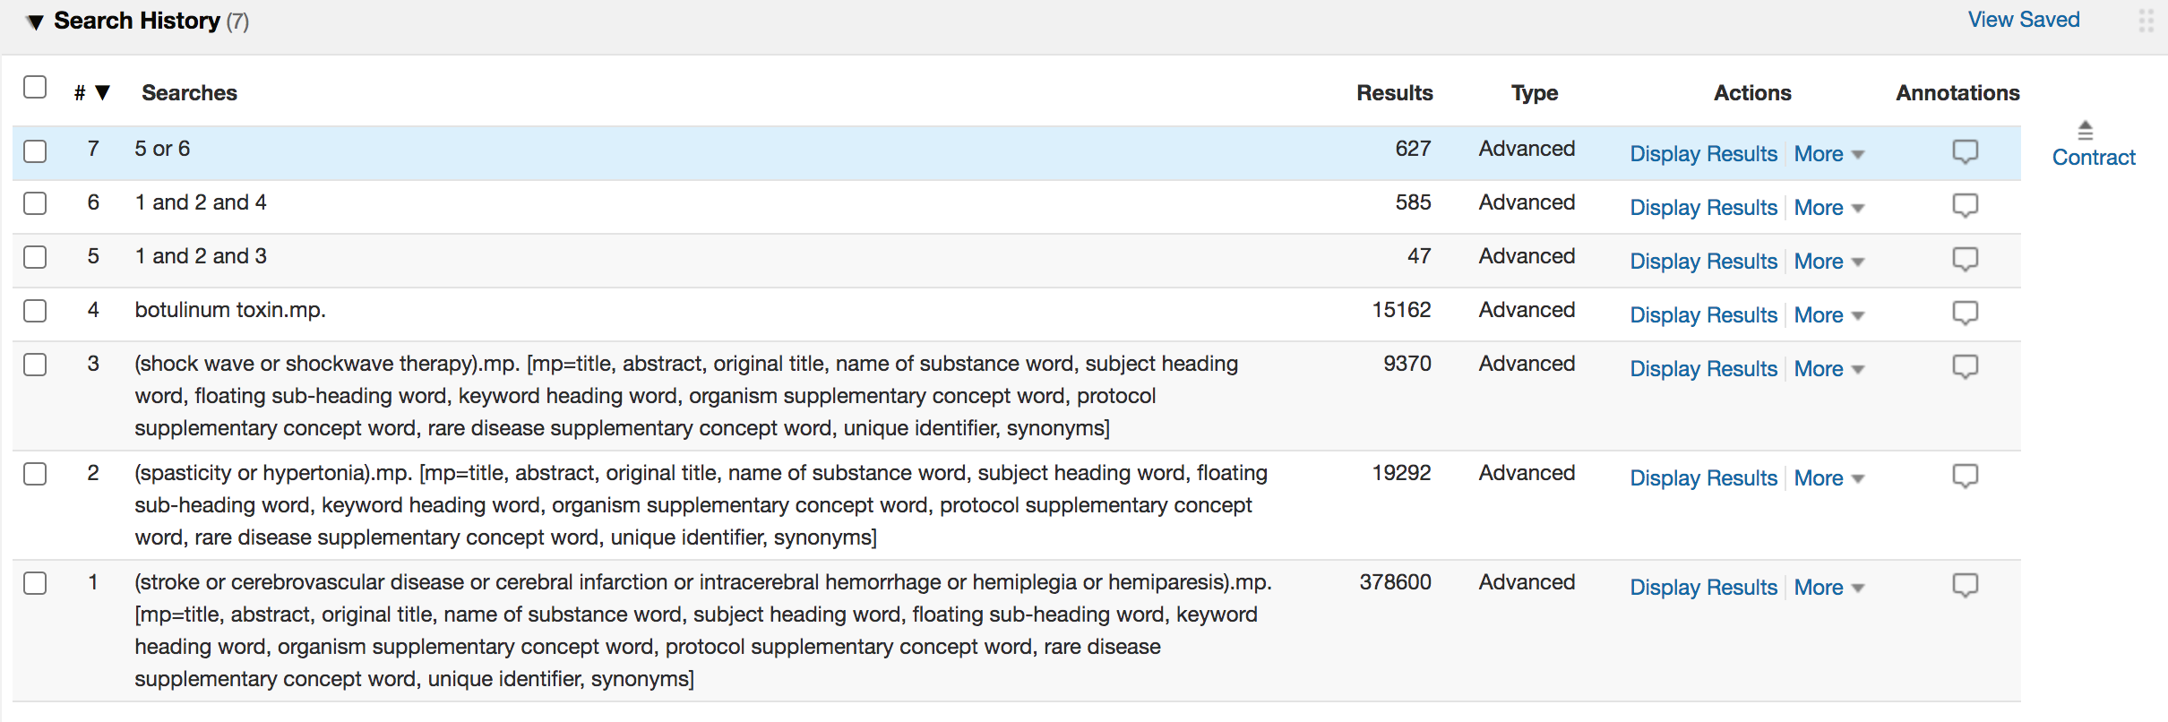

Cochrane CENTRAL (Updated on September 25, 2021)
1. stroke OR cerebrovascular disease OR cerebral infarction OR intracerebral hemorrhage OR hemiplegia OR hemiparesis:ti,ab,kw : 79,354
2. spasticity OR hypertonia:ti,ab,kw : 3,928
3. shock wave OR shockwave therapy:ti,ab,kw : 2,560
4. botulinum toxin:ti,ab,kw : 3,795
5. #1 AND #2 AND #3: 51
6. #1 AND #2 AND #4: 501
7. #5 OR #6: 547
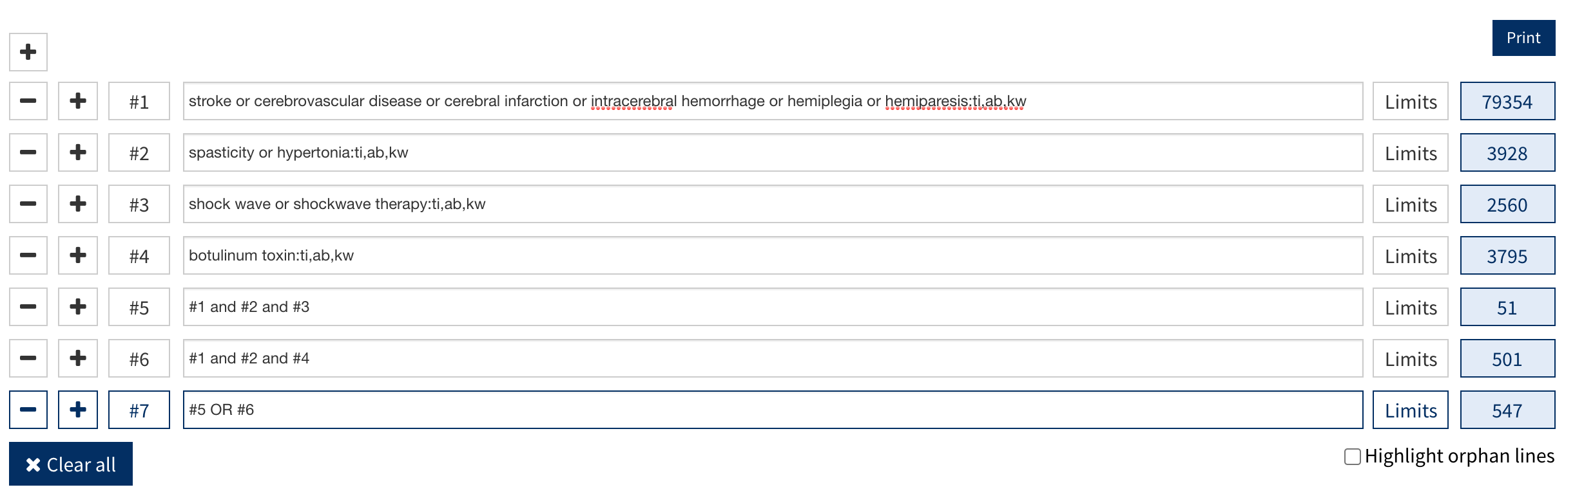

Supplemental Table 1 Excluded studies and reasons
Reason | Numbers | References
Lack of retrievable MAS data | 11 | [1-11]
Including non-stroke related spasticity | 6 | [12-17]
Secondary analysis of the trials | 3 | [18-20]
Not using MAS for spasticity measurement | 13 | [21-33]
Comparing therapeutic arms other than inclusion criteria | 3 | [34-36]
Abbreviation: MAS, Modified Ashworth Scale

References:
- Burbaud P, Wiart L, Dubos JL, et al. A randomised, double blind, placebo controlled trial of botulinum toxin in the treatment of spastic foot in hemiparetic patients. J Neurol Neurosurg Psychiatry 1996; 61(3): 265-9.
- Dunne JW, Gracies JM, Hayes M, Zeman B, Singer BJ, Multicentre Study G. A prospective, multicentre, randomized, double-blind, placebo-controlled trial of onabotulinumtoxinA to treat plantarflexor/invertor overactivity after stroke. Clin Rehabil 2012; 26(9): 787-97.
- Kanovsky P, Slawek J, Denes Z, et al. Efficacy and safety of botulinum neurotoxin NT 201 in poststroke upper limb spasticity. Clin Neuropharmacol 2009; 32(5): 259-65.
- Li G, Yuan W, Liu G, et al. Effects of radial extracorporeal shockwave therapy on spasticity of upper-limb agonist/antagonist muscles in patients affected by stroke: a randomized, single-blind clinical trial. Age Ageing 2020; 49(2): 246-52.
- Pittock SJ, Moore AP, Hardiman O, et al. A double-blind randomised placebo-controlled evaluation of three doses of botulinum toxin type A (Dysport) in the treatment of spastic equinovarus deformity after stroke. Cerebrovasc Dis 2003; 15(4): 289-300.
- Rosales RL, Kong KH, Goh KJ, et al. Botulinum toxin injection for hypertonicity of the upper extremity within 12 weeks after stroke: a randomized controlled trial. Neurorehabil Neural Repair 2012; 26(7): 812-21.
- Rousseaux M, Buisset N, Daveluy W, Kozlowski O, Blond S. Comparison of botulinum toxin injection and neurotomy in patients with distal lower limb spasticity. Eur J Neurol 2008; 15(5): 506-11.
- Simpson DM, Gracies JM, Yablon SA, Barbano R, Brashear A, Bo NTTZDST. Botulinum neurotoxin versus tizanidine in upper limb spasticity: a placebo-controlled study. J Neurol Neurosurg Psychiatry 2009; 80(4): 380-5.
- Suputtitada A, Suwanwela NC. The lowest effective dose of botulinum A toxin in adult patients with upper limb spasticity. Disabil Rehabil 2005; 27(4): 176-84.
- Tao W, Yan D, Li JH, Shi ZH. Gait improvement by low-dose botulinum toxin A injection treatment of the lower limbs in subacute stroke patients. J Phys Ther Sci 2015; 27(3): 759-62.
- Yelnik AP, Colle FM, Bonan IV, Vicaut E. Treatment of shoulder pain in spastic hemiplegia by reducing spasticity of the subscapular muscle: a randomised, double blind, placebo controlled study of botulinum toxin A. J Neurol Neurosurg Psychiatry 2007; 78(8): 845-8.
- Fietzek UM, Kossmehl P, Schelosky L, Ebersbach G, Wissel J. Early botulinum toxin treatment for spastic pes equinovarus--a randomized double-blind placebo-controlled study. Eur J Neurol 2014; 21(8): 1089-95.
- Gracies J-M, Brashear A, Jech R, et al. Safety and efficacy of abobotulinumtoxinA for hemiparesis in adults with upper limb spasticity after stroke or traumatic brain injury: a double-blind randomised controlled trial. The Lancet Neurology 2015; 14(10): 992-1001.
- Guo F, Yue W, Ren L, Zhang YM, J Y. Botulinum toxin type A plus rehabilitative training for improving the motor function of the upper limbs and activities of daily life in patients with stroke and brain injury. Neural regeneration research 2006; 1(9): 859-61.
- Smith SJ, Ellis E, White S, Moore AP. A double-blind placebo-controlled study of botulinum toxin in upper limb spasticity after stroke or head injury. Clin Rehabil 2000; 14(1): 5-13.
- Verplancke D, Snape S, Salisbury CF, Jones PW, Ward AB. A randomized controlled trial of botulinum toxin on lower limb spasticity following acute acquired severe brain injury. Clin Rehabil 2005; 19(2): 117-25.
- Wein T, Esquenazi A, Jost WH, Ward AB, Pan G, Dimitrova R. OnabotulinumtoxinA for the Treatment of Poststroke Distal Lower Limb Spasticity: A Randomized Trial. PM R 2018; 10(7): 693-703.
- Marciniak C, McAllister P, Walker H, et al. Efficacy and Safety of AbobotulinumtoxinA (Dysport) for the Treatment of Hemiparesis in Adults With Upper Limb Spasticity Previously Treated With Botulinum Toxin: Subanalysis From a Phase 3 Randomized Controlled Trial. PM R 2017; 9(12): 1181-90.
- O'Dell MW, Brashear A, Jech R, et al. Dose-Dependent Effects of AbobotulinumtoxinA (Dysport) on Spasticity and Active Movements in Adults With Upper Limb Spasticity: Secondary Analysis of a Phase 3 Study. PM R 2018; 10(1): 1-10.
- Turner-Stokes L, Baguley IJ, De Graaff S, et al. Goal attainment scaling in the evaluation of treatment of upper limb spasticity with botulinum toxin: a secondary analysis from a double-blind placebo-controlled randomized clinical trial. J Rehabil Med 2010; 42(1): 81-9.
- Brashear A, Gordon MF, Elovic E, et al. Intramuscular injection of botulinum toxin for the treatment of wrist and finger spasticity after a stroke. N Engl J Med 2002; 347(6): 395-400.
- Brashear A, McAfee AL, Kuhn ER, Fyffe J. Botulinum toxin type B in upper-limb poststroke spasticity: a double-blind, placebo-controlled trial. Arch Phys Med Rehabil 2004; 85(5): 705-9.
- Cousins E, Ward A, Roffe C, Rimington L, Pandyan A. Does low-dose botulinum toxin help the recovery of arm function when given early after stroke? A phase II randomized controlled pilot study to estimate effect size. Clin Rehabil 2010; 24(6): 501-13.
- de Boer KS, Arwert HJ, de Groot JH, Meskers CG, Mishre AD, Arendzen JH. Shoulder pain and external rotation in spastic hemiplegia do not improve by injection of botulinum toxin A into the subscapular muscle. J Neurol Neurosurg Psychiatry 2008; 79(5): 581-3.
- Ding X, Zhang G, Chen H, Wang W, Song J, Fu D. Color Doppler ultrasound-guided botulinum toxin type A injection combined with an ankle foot brace for treating lower limb spasticity after a stroke. Eur Rev Med Pharmacol Sci 2015; 19(3): 406-11.
- Elovic EP, Munin MC, Kanovsky P, Hanschmann A, Hiersemenzel R, Marciniak C. Randomized, placebo-controlled trial of incobotulinumtoxina for upper-limb post-stroke spasticity. Muscle Nerve 2016; 53(3): 415-21.
- Kesoema TA, Setiawati E, K MK. Improvement of Hand Motor Function after Radial Shock Wave Therapy in Chronic Stroke Patients. Indonesian Journal of Physical Medicine & Rehabilitation 2018; 7(01).
- Kong KH, Neo JJ, Chua KS. A randomized controlled study of botulinum toxin A in the treatment of hemiplegic shoulder pain associated with spasticity. Clin Rehabil 2007; 21(1): 28-35.
- Meythaler JM, Vogtle L, Brunner RC. A preliminary assessment of the benefits of the addition of botulinum toxin a to a conventional therapy program on the function of people with longstanding stroke. Arch Phys Med Rehabil 2009; 90(9): 1453-61.
- Radinmehr H, Ansari NN, Naghdi S, Tabatabaei A, Moghimi E. Comparison of Therapeutic Ultrasound and Radial Shock Wave Therapy in the Treatment of Plantar Flexor Spasticity After Stroke: A Prospective, Single-blind, Randomized Clinical Trial. J Stroke Cerebrovasc Dis 2019; 28(6): 1546-54.
- Sawan S, Abd-Allah F, Hegazy MM, Farrag MA, El-Den NH. Effect of shock wave therapy on ankle plantar flexors spasticity in stroke patients. NeuroRehabilitation 2017; 40(1): 115-8.
- Simpson DM, Alexander DN, O'Brien CF, et al. Botulinum toxin type A in the treatment of upper extremity spasticity: a randomized, double-blind, placebo-controlled trial. Neurology 1996; 46(5): 1306-10.
- Umar M, Masood T, M. B. Effect of botulinum toxin A & task-specific training on upper limb function in post-stroke focal dystonia. J Pak Med Assoc 2018; 68(4): 526-31.
- Bollens B, Gustin T, Stoquart G, Detrembleur C, Lejeune T, Deltombe T. A randomized controlled trial of selective neurotomy versus botulinum toxin for spastic equinovarus foot after stroke. Neurorehabil Neural Repair 2013; 27(8): 695-703.
- Ding X, Huang L, Wang Q, Liu Y, Zhong J, Chen H. Clinical study of botulinum toxin A injection combined with spasmodic muscle therapeutic instrument on lower limb spasticity in patients with stroke. Exp Ther Med 2017; 13(6): 3319-26.
- Santamato A, Notarnicola A, Panza F, et al. SBOTE study: extracorporeal shock wave therapy versus electrical stimulation after botulinum toxin type a injection for post-stroke spasticity-a prospective randomized trial. Ultrasound Med Biol 2013; 39(2): 283-91.

Supplemental Table 2 League table for the results of the meta-analysis according to the reduction of the Modified Ashworth Scale (MAS) before or at the 6th week after intervention
RSW | -0.30 (-0.77 – 0.17) | 0.12 (-0.01 – 0.26) | -0.67 (-0.80 – -0.55)
-0.26 (-0.64 – 0.11) | FSW | NA | -0.34 (-0.54 – -0.14)
0.06 (-0.21 – 0.34) | 0.33 (-0.05 – 0.70) | BoNT | -0.54 (-0.57 – -0.50)
-0.62 (-0.84 – -0.40) | -0.36 (-0.69 – -0.03) | -0.69 (-0.87 – -0.50) | Control

All data are presented as weighted mean differences of MAS reduction with the 95% confidential intervals. The left lower part is the findings of the network meta-analysis; the right upper part is the finding of the pairwise meta-analyses. BoNT, botulinum toxin; FSW, focused shockwave; RSW, radial shockwave; NA: not applicable.

Supplemental Table 3 League table for the results of the meta-analysis according to the reduction of the MAS (Modified Ashworth Scale) between the 7th and 12th weeks after interventions.
RSW | 0.00 (-0.50 – 0.50) | 0.07 (-0.07 – 0.22) | -1.19 (-1.29 – -1.09)
-0.05 (-0.57 – 0.47) | FSW | NA | -0.70 (-1.14 – -0.26)
-0.35 (-0.65 – -0.04) | -0.30 (-0.84 – 0.24) | BoNT | -0.26 (-0.29 – -0.23)
-0.79 (-1.07 – -0.51) | -0.74 (-1.26 – -0.23) | -0.44 (-0.62 – -0.26) | Control

All data are presented as weighted mean differences of MAS reduction with the 95% confidential intervals. The left lower part is the findings of the network meta-analysis; the right upper part is the finding of the pairwise meta-analyses. BoNT, botulinum toxin; FSW, focused shockwave; RSW, radial shockwave; NA: not applicable.

Supplemental Figure 1 Risk of bias assessment of the included studies. 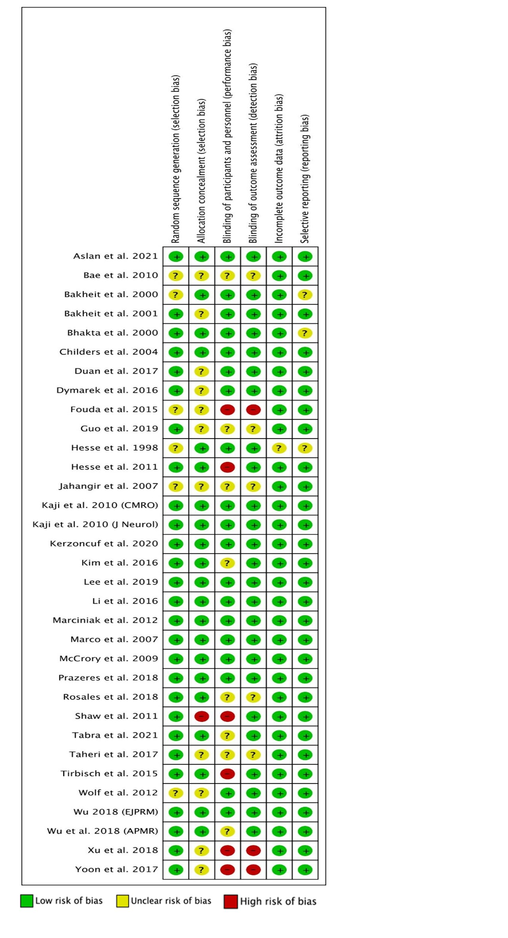

Supplemental Figure 2 Risk of bias graph of the included studies
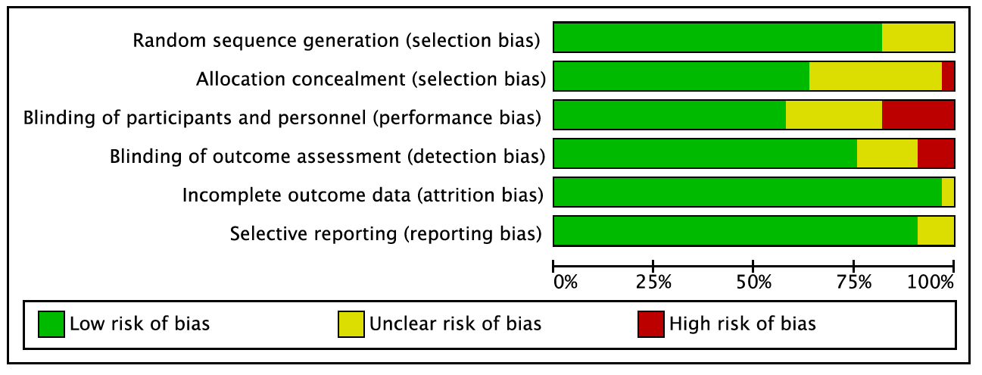
Supplemental Figure 3 Loop inconsistent plots for enrolled treatments in terms of the MAS reduction (A)
before or at the 6th week after intervention and (B) between the 7th and 12th weeks after interventions.
BoNT, botulinum toxin; FSW, focused shockwave; RSW, radial shockwave; MAS, modified Ashworth scale; IF, inconsistency factor.
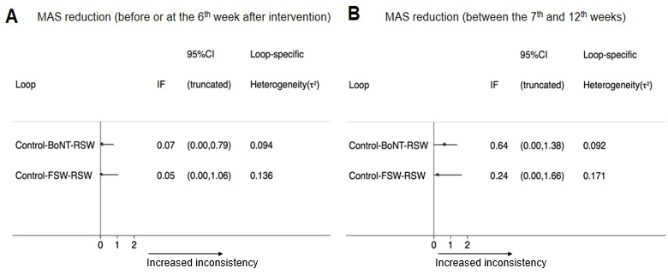

Supplemental Figure 4 Funnel plots for the effect sizes between different in terms of the MAS reduction (A) before or at the 6th week after intervention and (B) between the 7th and 12th weeks after interventions.
BoNT, botulinum toxin; FSW, focused shockwave; RSW, radial shockwave; MAS, modified Ashworth scale.


