Literature search strategies (September 2019)
1/Pubmed [including Medline]: 356 results
(("Complementary Therapies"[Mesh:noexp] OR "Osteopathic Medicine"[Mesh] OR "Manipulation, Osteopathic"[Mesh] OR "Acupuncture Therapy"[Mesh] OR "Acupuncture"[Mesh] OR "Hypnosis"[Mesh] OR "Chiropractic"[Mesh] OR "Auriculotherapy"[Mesh] OR "Musculoskeletal Manipulations"[Mesh] OR "Reflexotherapy"[Mesh] AND ("Gastrointestinal Diseases"[Mesh:noexp] OR "Colonic Diseases, Functional"[Mesh] OR "Irritable Bowel Syndrome"[Mesh]) AND ("Evaluation Studies as Topic"[Mesh] OR "Meta-Analysis as Topic"[Mesh] OR "Treatment Outcome"[Mesh] OR "Clinical Trials as Topic"[Mesh] OR "Pragmatic Clinical Trials as Topic"[Mesh] OR "Controlled Clinical Trials as Topic"[Mesh] OR "Adaptive Clinical Trials as Topic"[Mesh] OR "Outcome Assessment (Health Care)"[Mesh] OR "Systematic Reviews as Topic"[Mesh] OR "Multicenter Studies as Topic"[Mesh] OR "Guidelines as Topic"[Mesh] OR "Randomized Controlled Trials as Topic"[Mesh] OR "Review Literature as Topic"[Mesh] OR "Research Design"[Mesh] OR "Practice Guidelines as Topic"[Mesh] OR "Validation Studies as Topic"[Mesh] OR "Consensus Development Conferences as Topic"[Mesh] OR "Consensus"[Mesh] OR "Bayes Theorem"[Mesh] OR "efficacy"[All fields] OR "evaluation"[All fields]) AND (("1990/01/01"[PDAT] : "2019/09/23"[PDAT]) AND English[lang])) OR (("Osteopathic"[Tiab] OR "Acupuncture"[Tiab] OR "Hypnosis"[Tiab] OR "Hypnoses"[Tiab] OR "Hypnotherapy"[Tiab] OR "Hypnotherapies"[Tiab] OR "Chiropractic"[Tiab] OR "Auriculotherapy"[Tiab] OR "Reflexotherapy"[Tiab] OR "non-drug treatments"[Tiab] OR "Manipulation"[Tiab] OR "Manipulations"[Tiab]) AND ("Functional Colonic Diseases"[Tiab] OR "Functional Colonic Disease"[Tiab] OR "Irritable Bowel Syndrome"[Tiab] OR "Irritable Colon"[Tiab]) AND ("efficacy"[Tiab] OR "evaluation"[Tiab] OR "Meta-Analysis"[Tiab] OR "Meta Analysis"[Tiab] OR "Clinical Trials"[Tiab] OR "Outcome Assessment"[Tiab] OR "Systematic Reviews"[Tiab] OR "Multicenter Studies"[Tiab] OR "Guidelines"[Tiab] OR "Randomized"[Tiab] OR "Review Literature"[Tiab] OR "Research Design"[Tiab] OR "Practice Guidelines"[Tiab] OR "Validation Studies"[Tiab] OR "Consensus"[Tiab] OR "Bayes Theorem"[Tiab]) AND (("1990/01/01"[PDAT] : "2019/09/23"[PDAT]) AND English[lang]))

2/Web of Science [Clarivate Analytics]: 312 results
TOPIC: (manipulati* OR osteopath* OR acupunct* OR hypnos* OR hypnotherap* OR chiropract* OR auriculotherap* OR reflexotherap* OR "non* drug treatment*") AND TOPIC: ("colonic disease*" OR "irritable bowel" OR "irritable colon") AND TOPIC: (effic* OR evaluati*) AND LANGUAGE: (English). Timespan: 1990-2019 Indexes: SCI-EXPANDED, SSCI, A&HCI, CPCI-S, CPCI-SSH, ESCI, CCR-EXPANDED, IC.

3/Scopus [Elsevier]: 404 results
(TITLE-ABS-KEY ((manipulati* OR osteopath* OR acupunct* OR hypnos* OR hypnotherap* OR chiropract* OR auriculotherap* OR reflexotherap* OR "non* drug treatment*")) AND TITLE-ABS-KEY (("colonic disease*" OR "irritable bowel" OR "irritable colon")) AND TITLE-ABS-KEY ((effic* OR evaluati*)) AND LANGUAGE (english)) AND PUBYEAR > 1989 AND PUBYEAR < 2020
4/ ScienceDirect [Elsevier]: 131 results
Equation 1: 89 results
Find articles with these terms : (efficacy OR evaluation) Year(s) : 1990-2019
Title, abstract or author-specified keywords : (manipulation OR osteopathy OR acupuncture OR hypnosis OR hypnotherapy OR chiropractic) AND ("colonic disease" OR "irritable bowel" OR "irritable colon")
Equation 2: 42 results
Find articles with these terms : (efficacy OR evaluation) Year(s) : 1990-2019
Title, abstract or author-specified keywords : (auriculotherapy OR reflexotherapy OR "non-drug treatment") AND ("colonic disease" OR "irritable bowel" OR "irritable colon")

5/Cochrane Library [Wiley]: 130 results (5 Cochrane Reviews + 125 Trials)
5 Cochrane Reviews matching (manipulati* OR osteopath* OR acupunct* OR hypnos* OR hypnotherap* OR chiropract* OR auriculotherap* OR reflexotherap* OR "non* drug treatment*") in Title Abstract Keyword AND ("colonic disease*" OR "irritable bowel" OR "irritable colon") in Title Abstract Keyword AND (effic* OR evaluati*) in Title Abstract Keyword - with Cochrane Library publication date Between Jan 1990 and Sep 2019 (Word variations have been searched)

125 Trials matching (manipulati* OR osteopath* OR acupunct* OR hypnos* OR hypnotherap* OR chiropract* OR auriculotherap* OR reflexotherap* OR "non* drug treatment*") in Title Abstract Keyword AND ("colonic disease*" OR "irritable bowel" OR "irritable colon") in Title Abstract Keyword AND (effic* OR evaluati*) in Title Abstract Keyword - with Cochrane Library publication date Between Jan 1990 and Sep 2019 (Word variations have been searched)
6/ Wiley Online Libray [Wiley]: 37 results
37results
for"(manipulati* OR osteopath* OR acupunct* OR hypnos* OR hypnotherap* OR chiropract* OR auriculotherap* OR reflexotherap* OR "non* drug treatment*")" in Abstract and "("colonic disease*" OR "irritable bowel" OR "irritable colon")" in Abstract and "(effic* OR evaluati*)" in Abstract
Publication Date : 01/1990 to 09/2019

0results for"(manipulati*+OR+osteopath*+OR+acupunct*+OR+hypnos*+OR+hypnotherap*+OR+chiropract*+OR+auriculotherap*+OR+reflexotherap*+OR+"non*+drug+treatment*")" in Keywords and "("colonic disease*" OR "irritable bowel" OR "irritable colon")" in Keywords and "(effic* OR evaluati*)" in Keywords
Publication Date : 01/1990 to 09/2019

0results for"(manipulati*+OR+osteopath*+OR+acupunct*+OR+hypnos*+OR+hypnotherap*+OR+chiropract*+OR+auriculotherap*+OR+reflexotherap*+OR+"non*+drug+treatment*")" in Title and "("colonic disease*" OR "irritable bowel" OR "irritable colon")" in Title and "(effic* OR evaluati*)" in Title
Publication Date : 01/1990 to 09/2019

Criteria Lindfors 2012 Roberts 2006 Vlieger 2007 Filck 2019

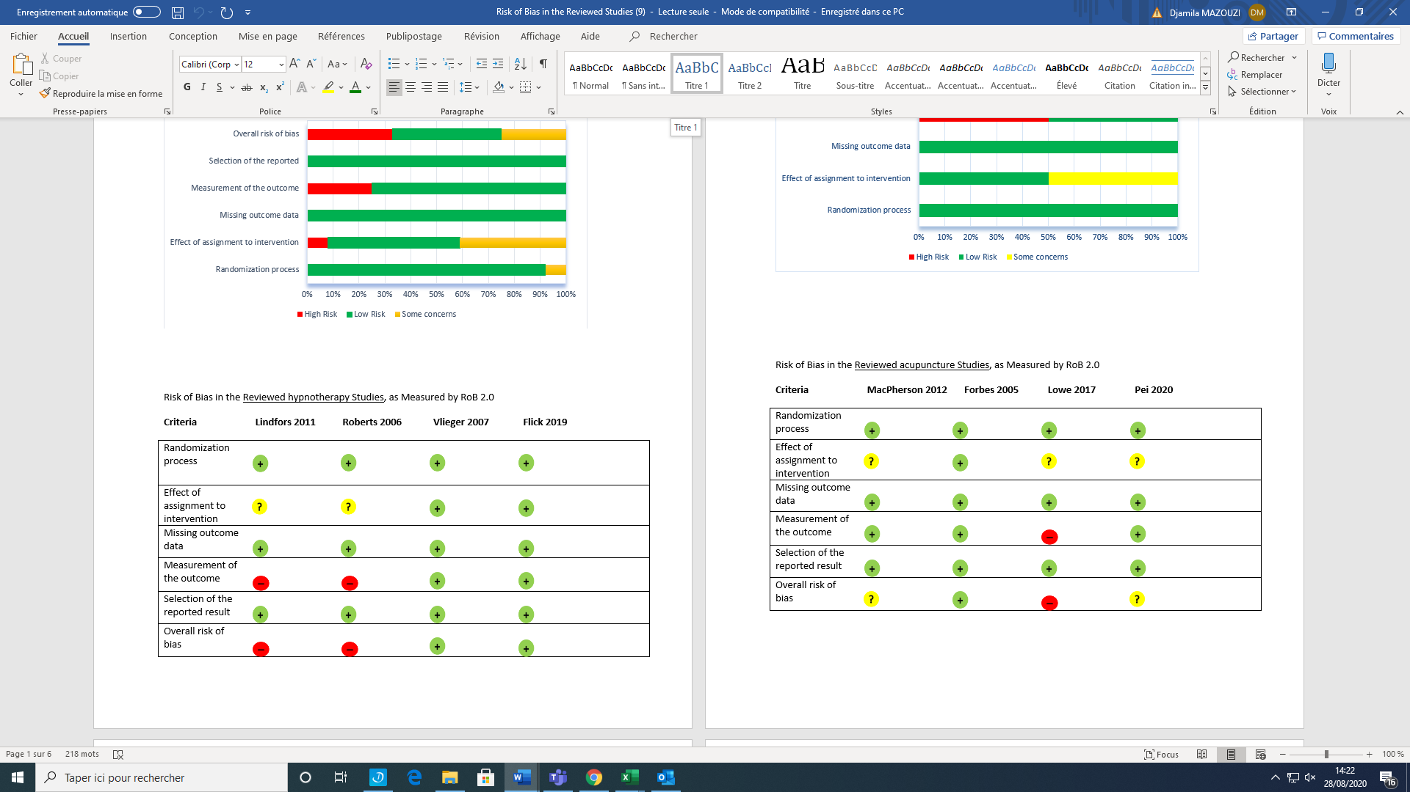

Figure S1: Risk of Bias in the Reviewed hypnotherapy Studies, as Measured by Rob 2.0

Criteria MacPherson 2012 Forbes 2005 Lowe 2017 Pei 2020

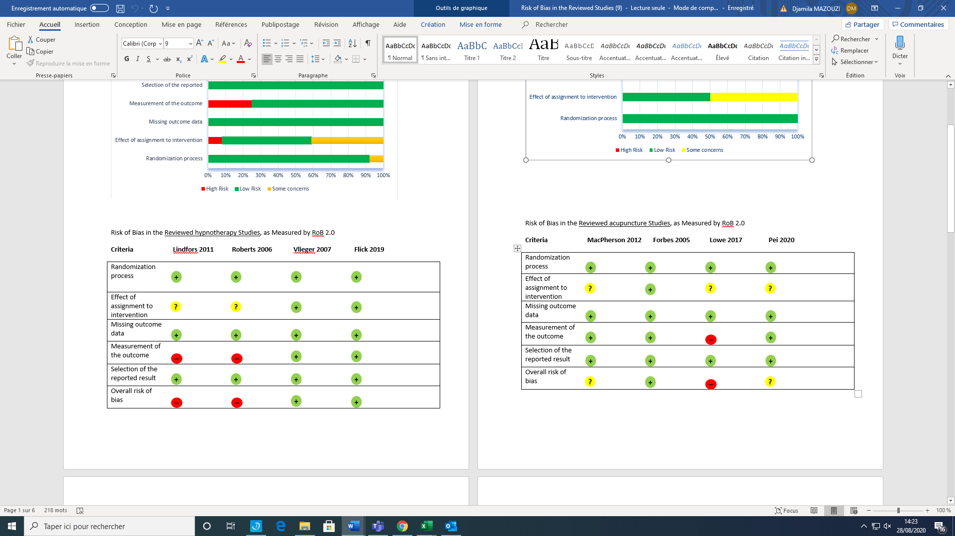

Figure S2: Risk of Bias in the Reviewed acupuncture Studies, as Measured by Rob 2.0

Criteria Krasaelap 2019
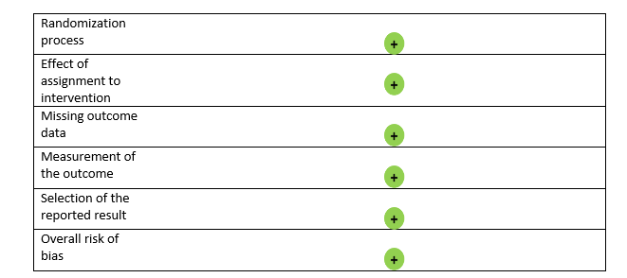

Figure S3: Risk of Bias in the Reviewed auriculotherapy Study, as Measured by Rob 2.0

Criteria Tovey 2002
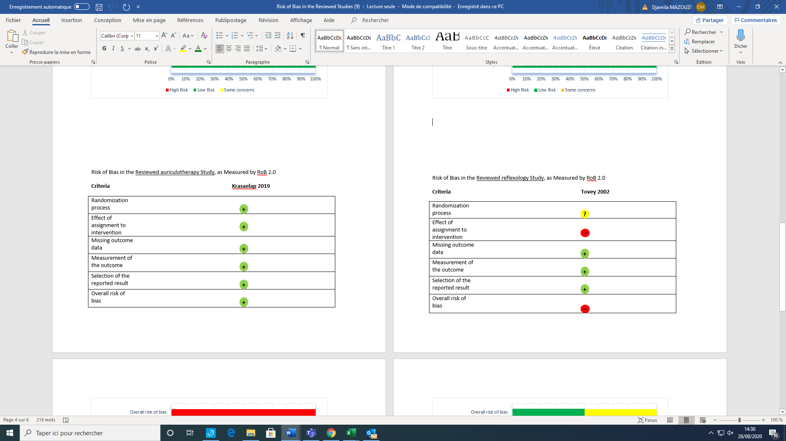

Figure S4: Risk of Bias in the Reviewed reflexology Study, as Measured by Rob 2.0

Criteria Hundscheid 2007

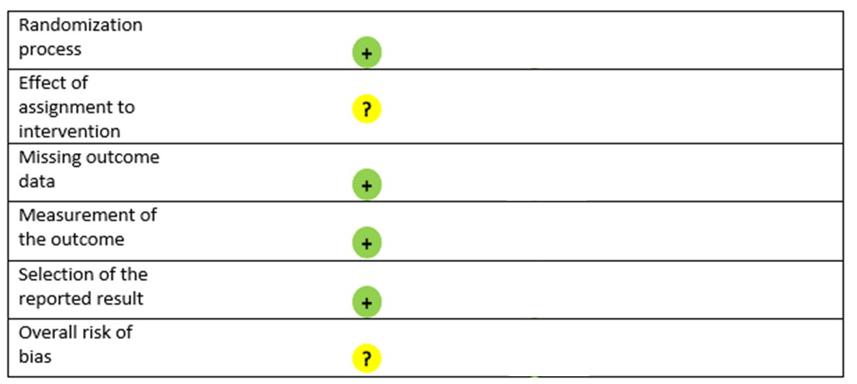

Figure S5: Risk of Bias in the Reviewed osteopathy Studies, as Measured by Rob 2.0

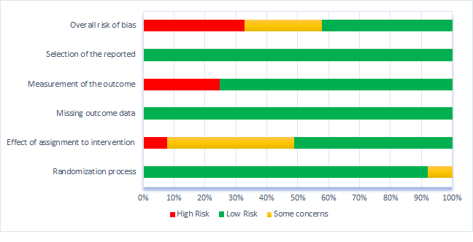

Figure S6: 'Risk of bias' graph: review authors' judgements about each 'risk of bias' domain

Figure S7: Forest plot of studies of NPIs vs sham or SMT or supportive therapy on overall IBS symptoms by type of therapy at 3 months

Figure S8: Forest plot of studies of NPIs vs sham or SMT or supportive therapy on overall IBS symptoms by type of therapy at 3 months (after exclusion of outliers)

Figure S9: Forest plot of studies of NPIs vs sham or SMT or supportive therapy on overall IBS symptoms by type of control group at 3 months

Figure S10: Forest plot of studies of NPIs vs sham or SMT or supportive therapy on overall IBS symptoms by treatment duration at 3 months

Figure S11: Forest plot of studies of NPIs vs sham or SMT or supportive therapy on overall IBS symptoms by instrument at 3 months

Figure S12: Forest plot of studies of body-directed therapies vs SMT on overall IBS symptoms at 6 months

