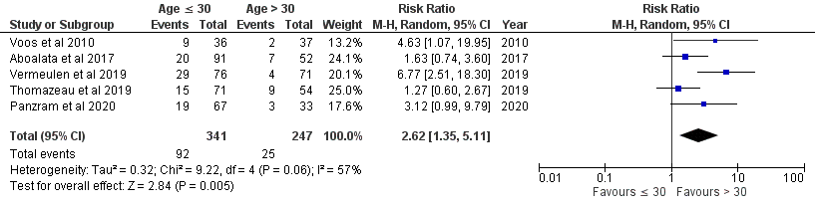
Figure 1 Meta-analysis of risk factor age ≤ 30 years.

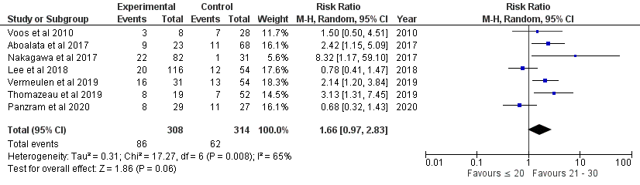
Figure 2 Meta-analysis of risk factor age ≤ 20 years versus 21-30 years.

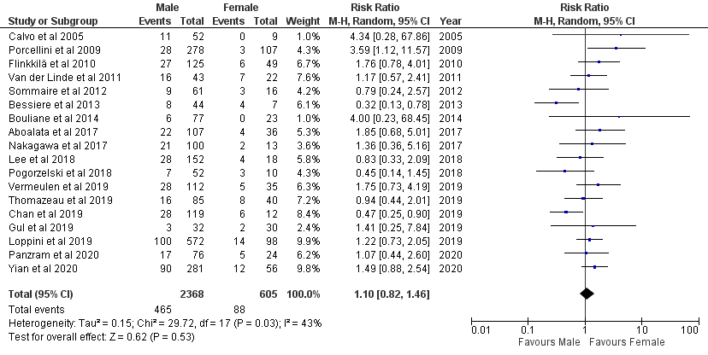
Figure 3 Meta-analysis of risk factor male gender.

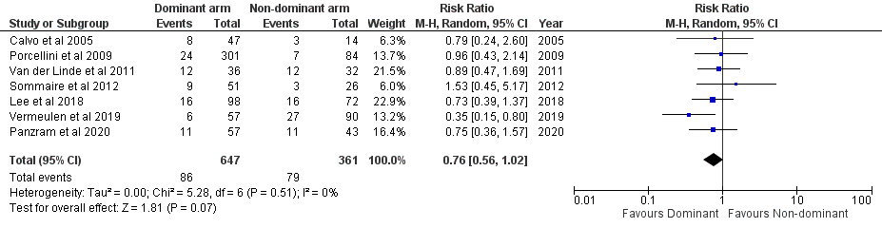
Figure 4 Meta-analysis of risk factor dominant arm affected.

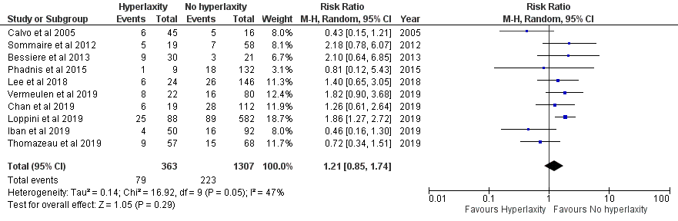
Figure 5 Meta-analysis of risk factor hyperlaxity

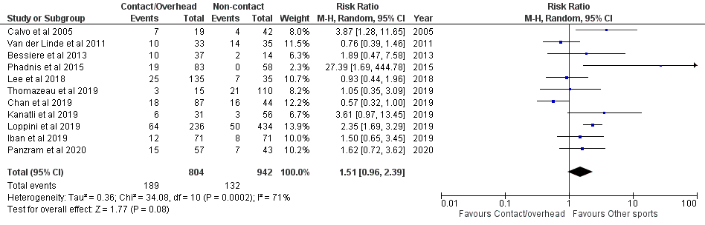
Figure 6 Meta-analysis of risk factor contact or overhead sports

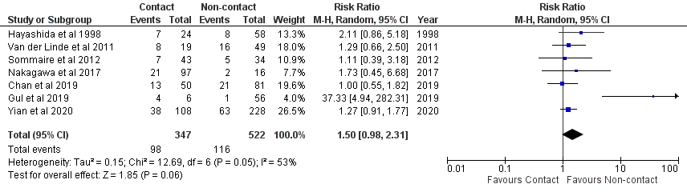
Figure 7 Meta-analysis of risk factor contact sports only

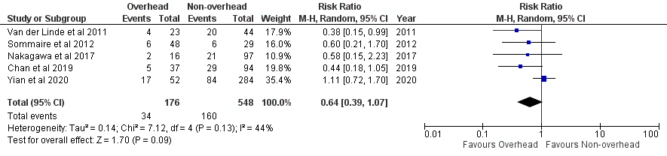
Figure 8 Meta-analysis of risk factor overhead sports only

Figure 9 Meta-analysis of risk factor off-track lesion

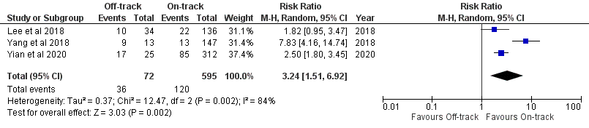

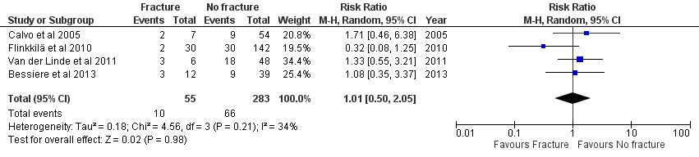
Figure 10 Meta-analysis of risk factor glenoid fracture

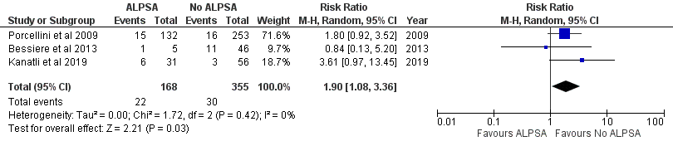
Figure 11 Meta-analysis of risk factor ALPSA lesion

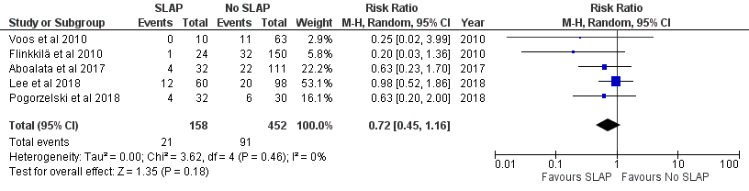
Figure 12 Meta-analysis of risk factor any SLAP lesion

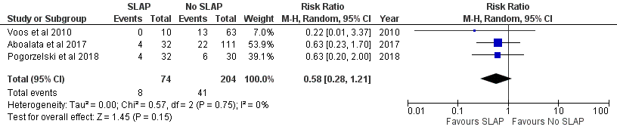
Figure 13 Meta-analysis of risk factor SLAP lesion with repair

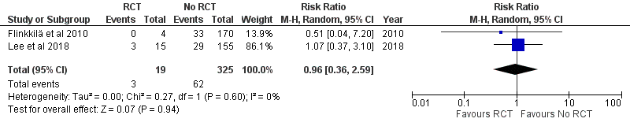
Figure 14 Meta-analysis of risk factor rotator cuff tear

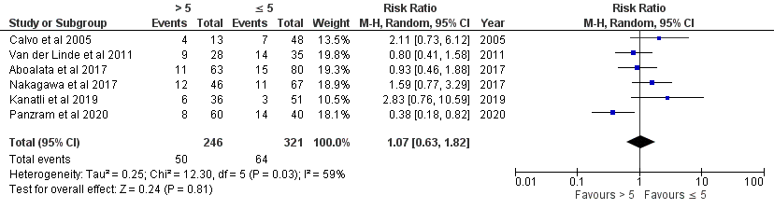
Figure 15 Meta-analysis of risk factor > 5 preoperative dislocations

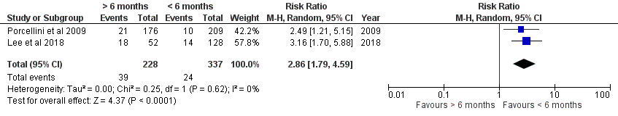
Figure 16 Meta-analysis of risk factor > 6 months delay

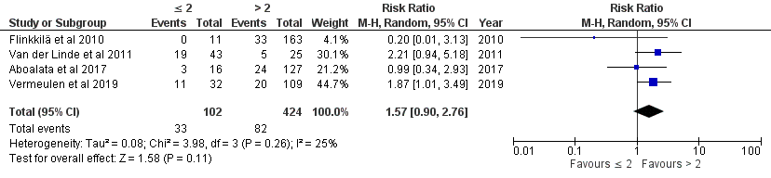
Figure 17 Meta-analysis of risk factor ≤ 2 anchors

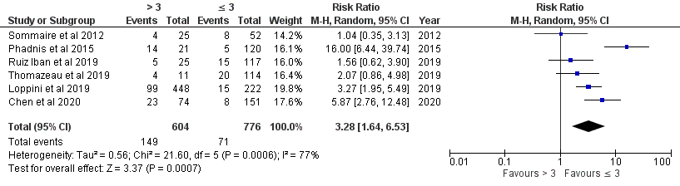
Figure 18 Meta-analysis of risk factor ISIS > 3

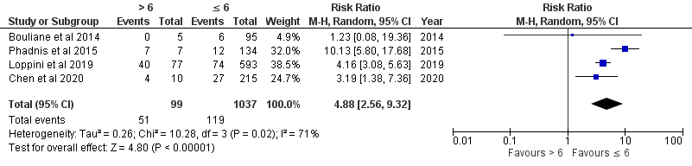
Figure 19 Meta-analysis of risk factor ISIS > 6

