Supplementary File 2: Disease Behavior and Localization of Crohn’s Disease According to Montreal Classification System in Presence of Concomitant Immune-Mediated Inflammatory Diseases
Table of Contents
L1 3
Supplementary Figure 1a: Risk ratio stratified by type of IMID 3
Supplementary Figure 1b: Risk ratio stratified by type of study design 4
Supplementary Figure 1c: Funnel plot 5
L2 6
Supplementary Figure 2a: Risk ratio stratified by type of IMID 6
Supplementary Figure 2b: Risk ratio stratified by type of study design 7
Supplementary Figure 2c: Funnel plot 8
L3 9
Supplementary Figure 3a: Risk ratio stratified by type of IMID 9
Supplementary Figure 3b: Risk ratio stratified by type of study design 10
Supplementary Figure 3c: Funnel plot 11
L4 12
Supplementary Figure 4a: Risk ratio stratified by type of IMID 12
Supplementary Figure 4b: Risk ratio stratified by type of study design 13
Supplementary Figure 4c: Funnel plot 14
L2 or L3 15
Supplementary Figure 5a: Risk ratio stratified by type of IMID 15
Supplementary Figure 5b: Risk ratio stratified by type of study design 16
Supplementary Figure 5c: Funnel plot 17
B1 behavior 18
Supplementary Figure 6a: Risk ratio stratified by type of IMIDs 18
Supplementary Figure 6b: Risk ratio stratified by type of study design 19
Supplementary Figure 6c: Funnel plot 20
B2 behavior 21
Supplementary Figure 7a: Risk ratio stratified by type of IMIDs 21
Supplementary Figure 7b: Risk ratio stratified by type of study design 22
Supplementary Figure 7c: Funnel plot 23
B3 behavior 24
Supplementary Figure 8a: Risk ratio stratified by type of IMIDs 24
Supplementary Figure 8b: Risk ratio stratified by type of study design 25
Supplementary Figure 8c: Funnel plot 26
B2 or B3 behavior 27
Supplementary Figure 9a: Risk ratio stratified by type of IMIDs 27
Supplementary Figure 9b: Risk ratio stratified by type of study design 28
Supplementary Figure 9c: Funnel plot 29
Metaregression on risk of surgery (scatter plots) 30
Supplementary Figure 10a: Association between L1 and risk of CD-related surgery among patients with co-occurring IMIDs 30
Supplementary Figure 10b: Association between L3 and risk of CD-related surgery among patients with co-occurring IMIDs 32
Supplementary Figure 10c: Association between L2 og L3 and risk of CD-related surgery among patients with co-occurring IMIDs 33

L1

Supplementary Figure 1a: Risk ratio stratified by type of IMID

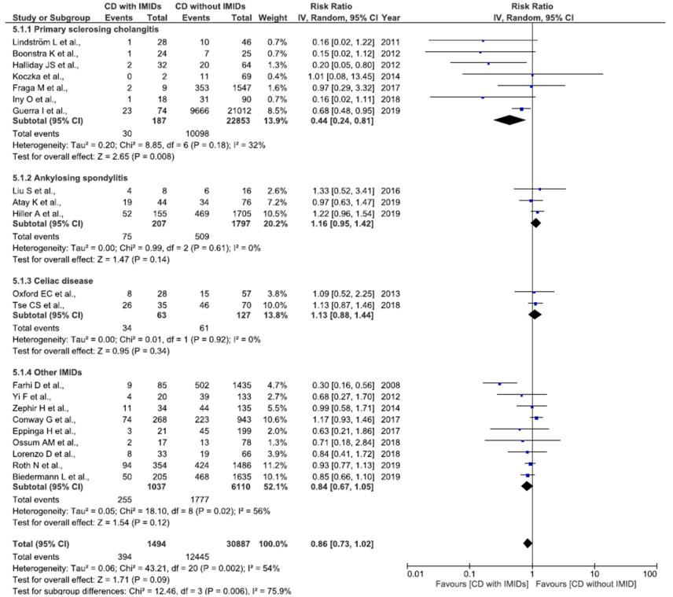

Supplementary Figure 1b: Risk ratio stratified by type of study design
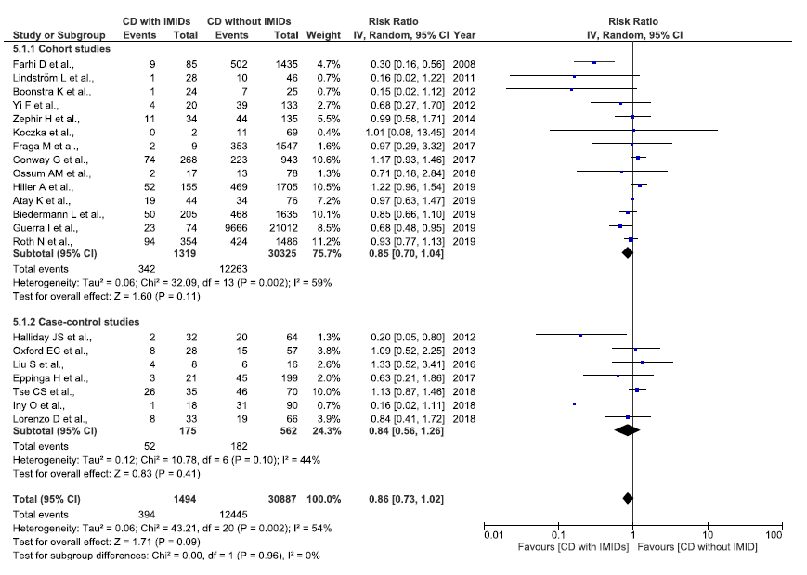

Supplementary Figure 1c: Funnel plot
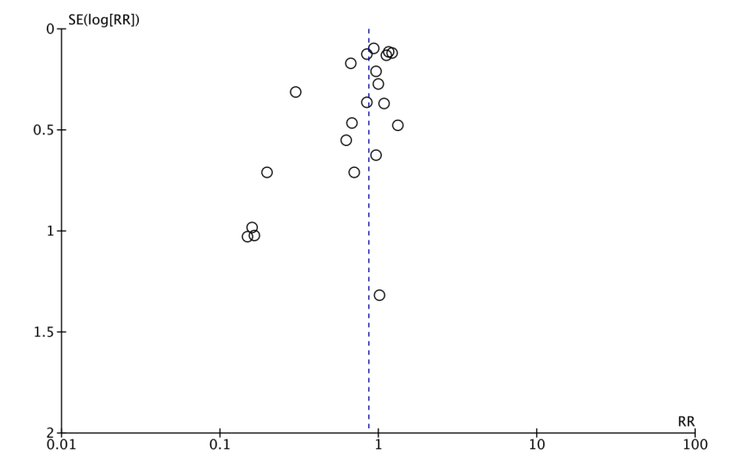

Egger’s Regression Test: p=0.46

L2

Supplementary Figure 2a: Risk ratio stratified by type of IMID
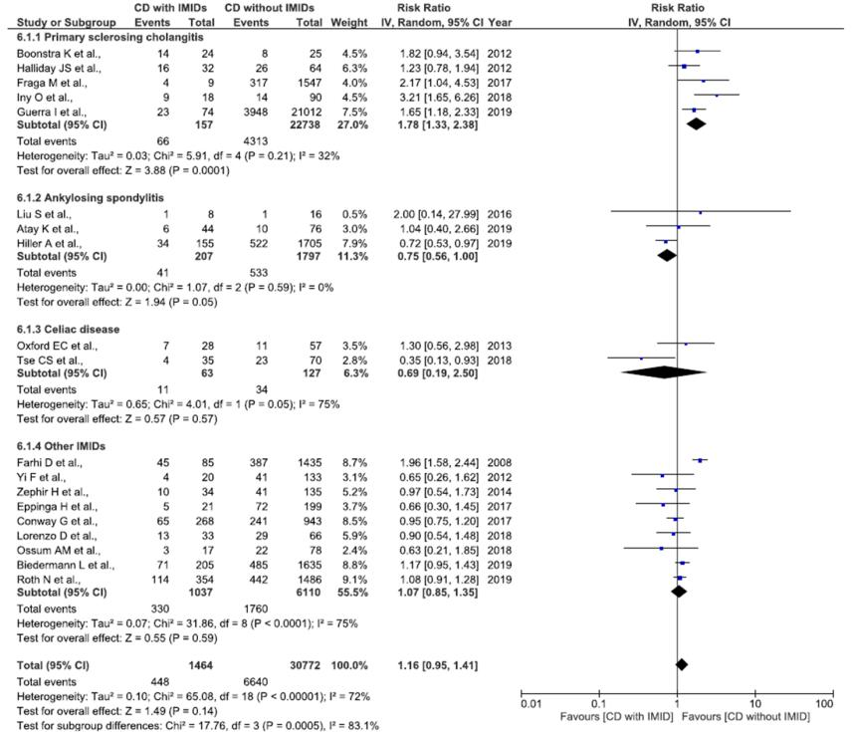

Supplementary Figure 2b: Risk ratio stratified by type of study design
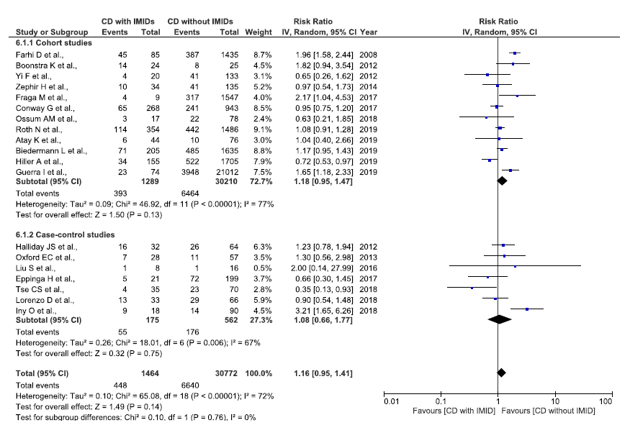

Supplementary Figure 2c: Funnel plot
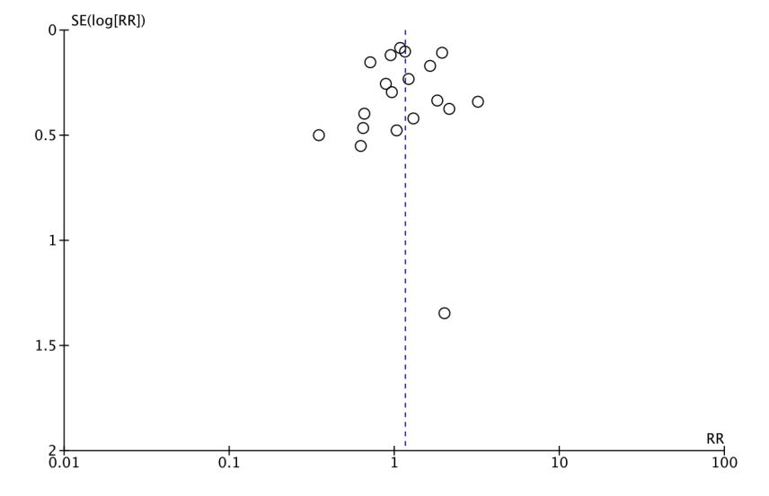
Egger’s Regression Test: p=0.78

L3

Supplementary Figure 3a: Risk ratio stratified by type of IMID

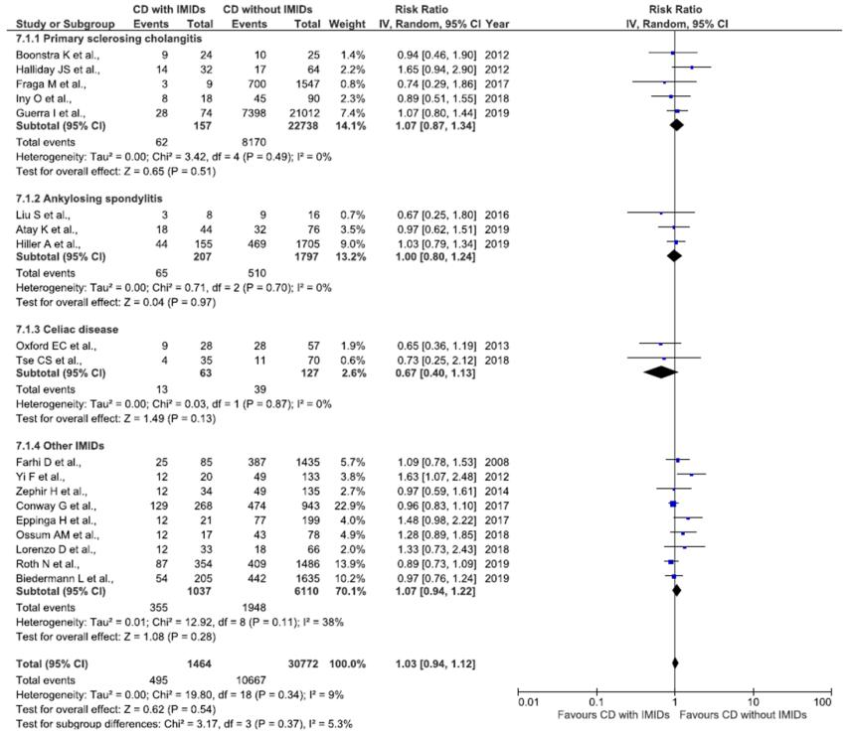

Supplementary Figure 3b: Risk ratio stratified by type of study design

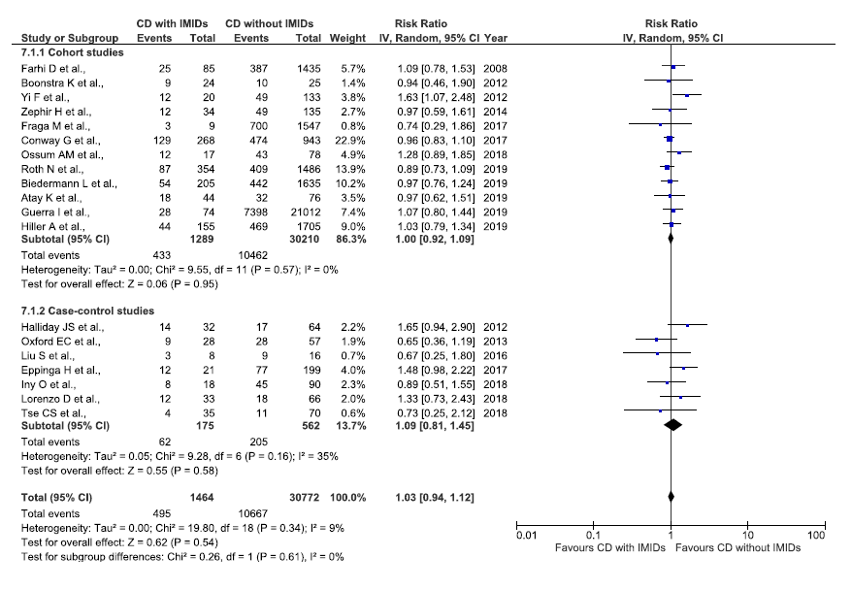

Supplementary Figure 3c: Funnel plot
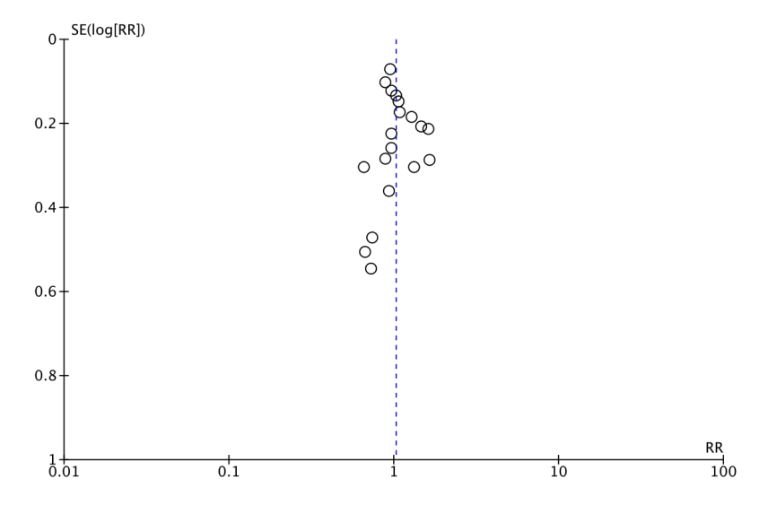
Egger’s Regression Test: p=0.16

L4

Supplementary Figure 4a: Risk ratio stratified by type of IMID
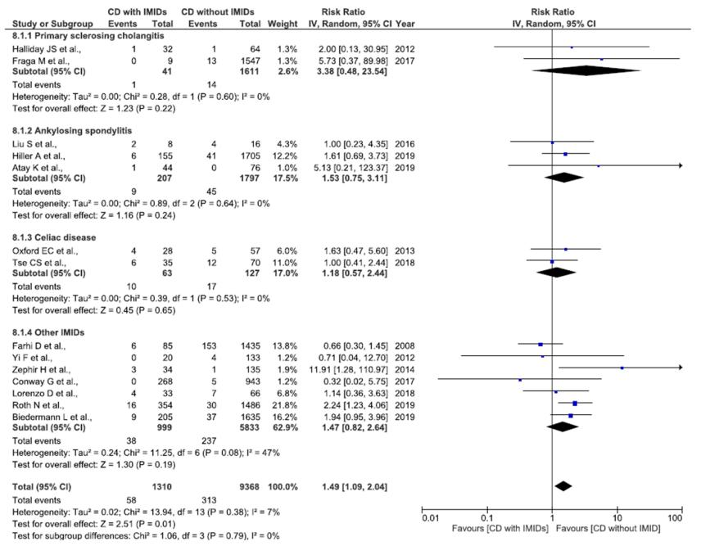

Supplementary Figure 4b: Risk ratio stratified by type of study design

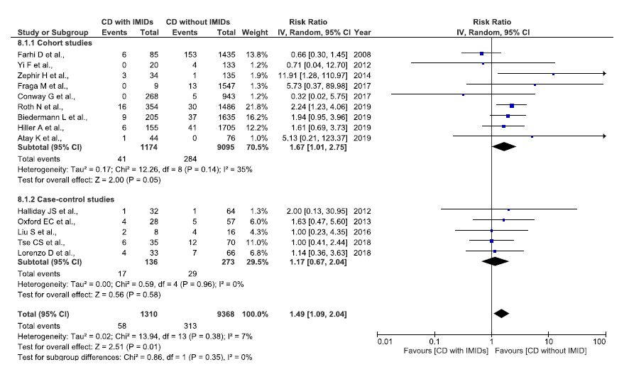

Supplementary Figure 4c: Funnel plot

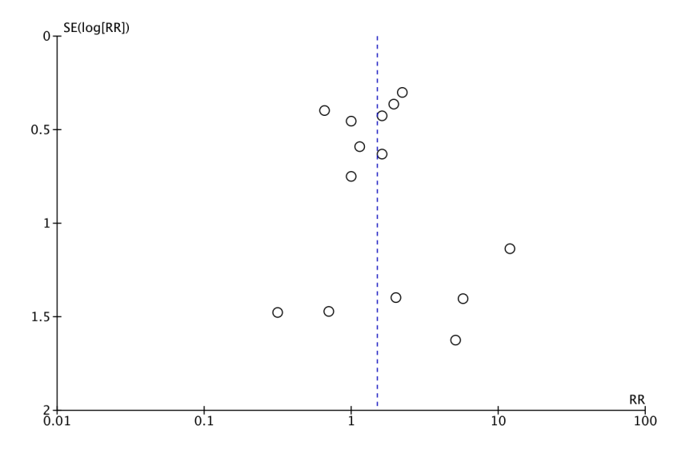
Egger’s Regression Test: p=0.07

L2 or L3

Supplementary Figure 5a: Risk ratio stratified by type of IMID

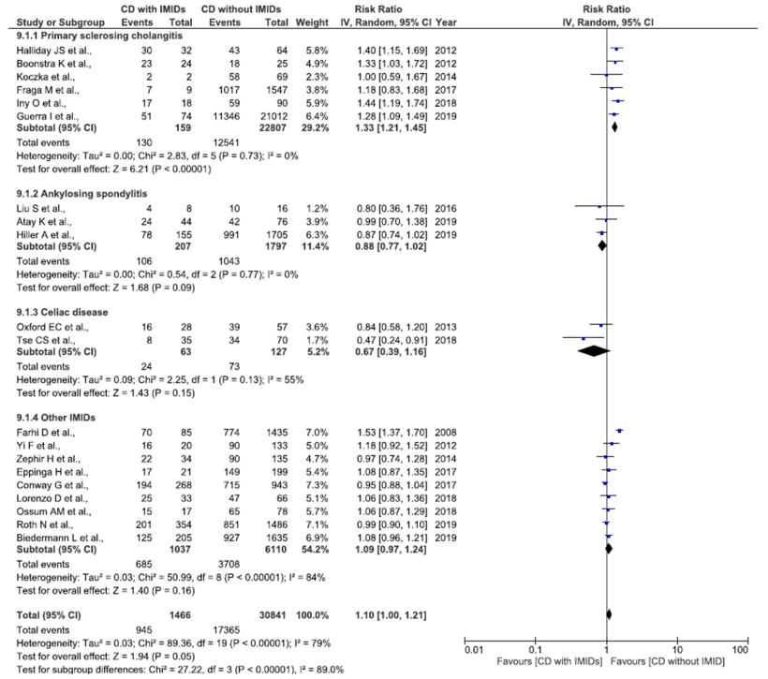

Supplementary Figure 5b: Risk ratio stratified by type of study design

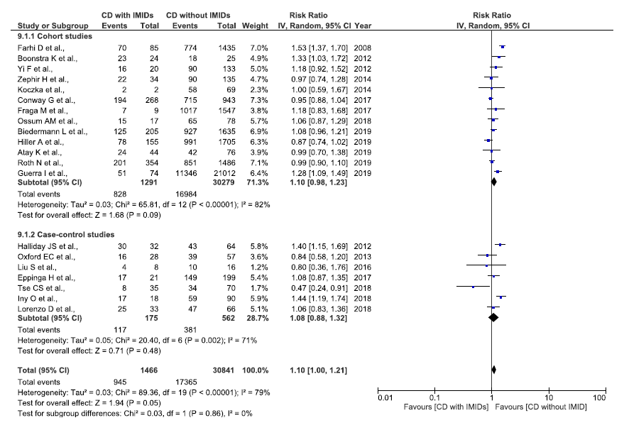

Supplementary Figure 5c: Funnel plot
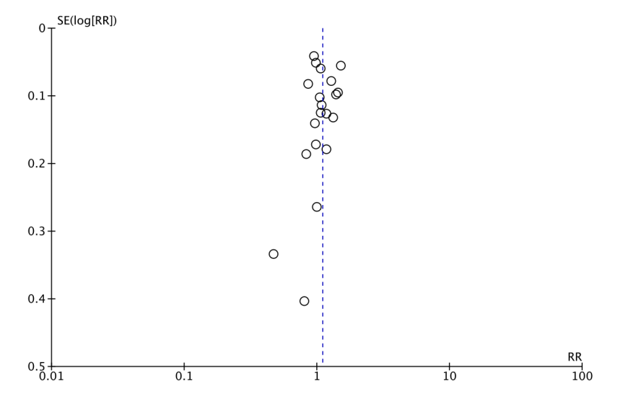
Egger’s Regression Test: p=0.13

B1 behavior

Supplementary Figure 6a: Risk ratio stratified by type of IMIDs

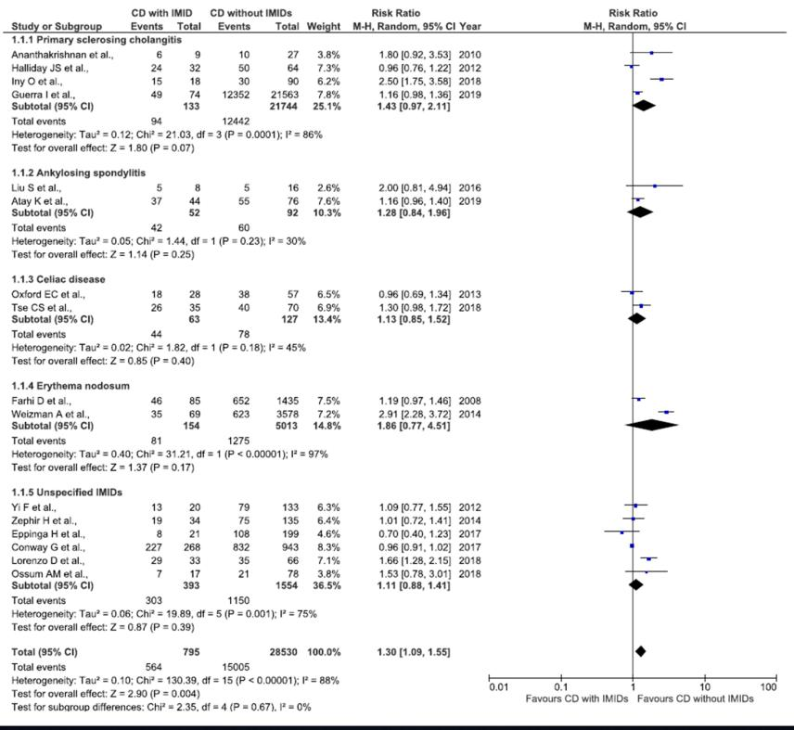

Supplementary Figure 6b: Risk ratio stratified by type of study design

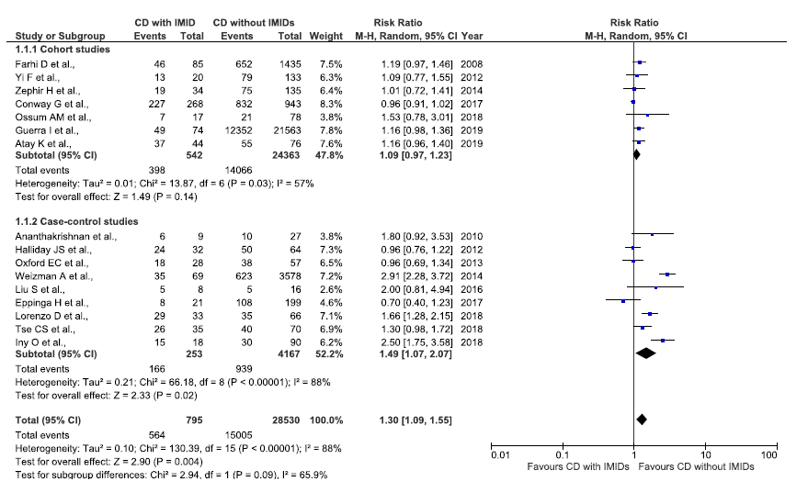

Supplementary Figure 6c: Funnel plot
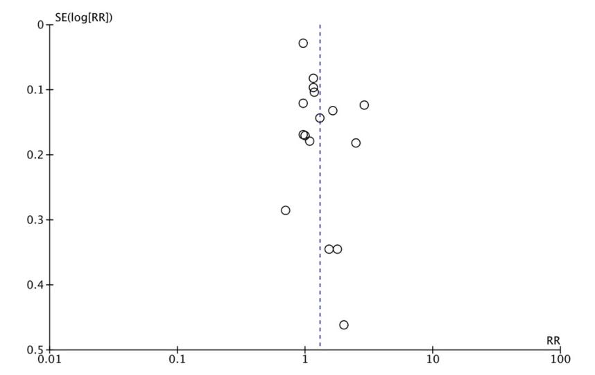

Egger’s Regression Test: p=0.07

B2 behavior

Supplementary Figure 7a: Risk ratio stratified by type of IMIDs

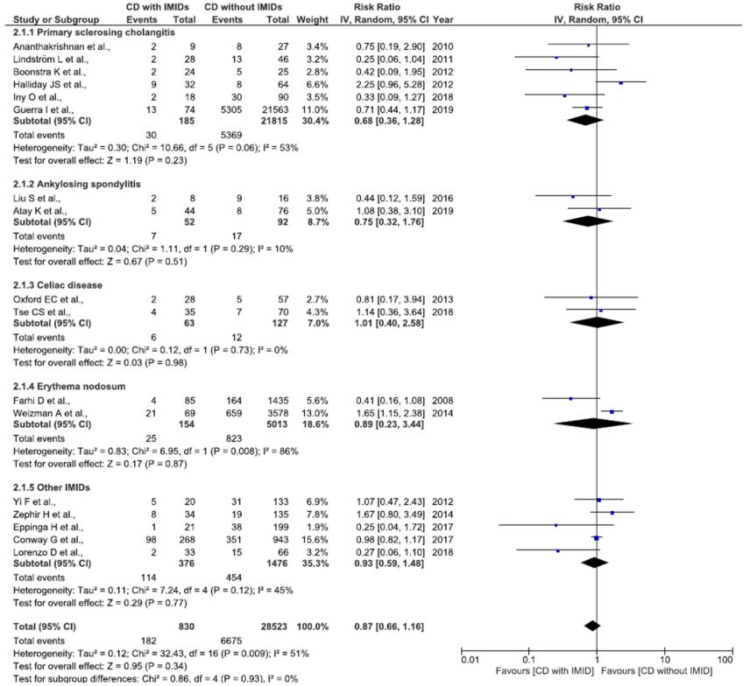

Supplementary Figure 7b: Risk ratio stratified by type of study design

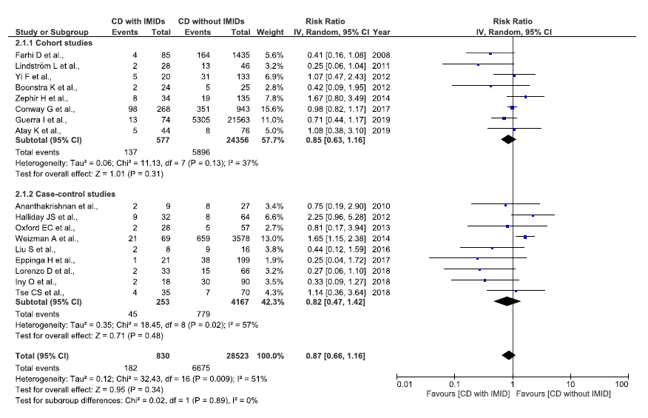

Supplementary Figure 7c: Funnel plot
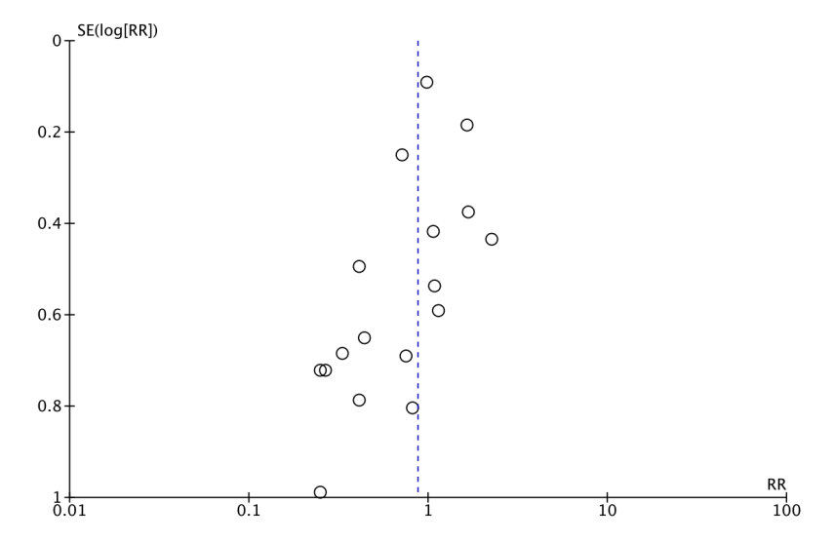
Egger’s Regression Test: p=0.03

B3 behavior

Supplementary Figure 8a: Risk ratio stratified by type of IMIDs

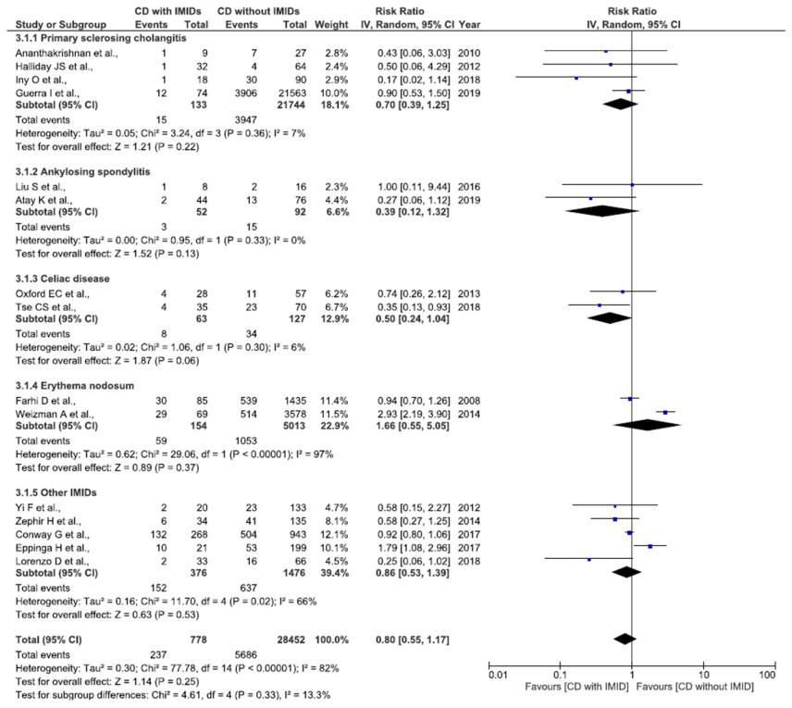

Supplementary Figure 8b: Risk ratio stratified by type of study design

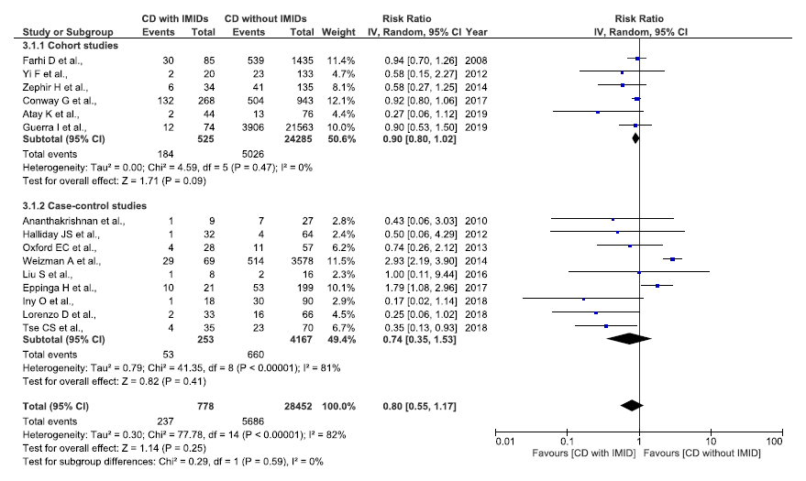

Supplementary Figure 8c: Funnel plot
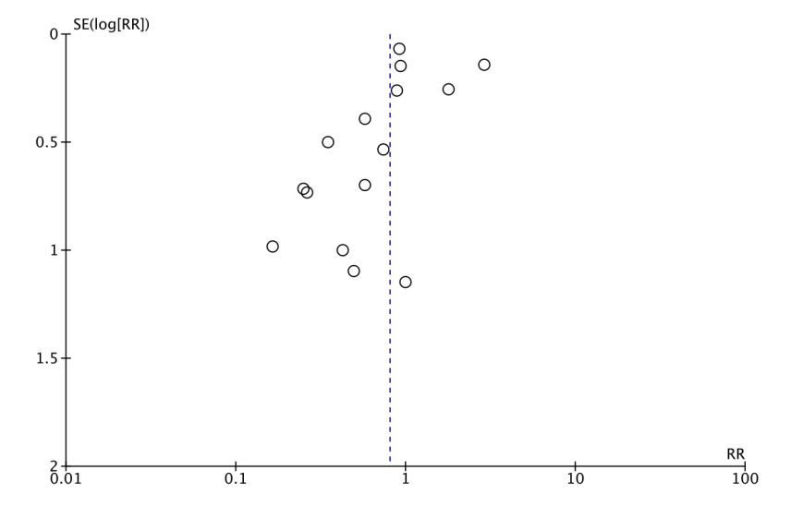
Egger’s Regression Test: p<0.01

B2 or B3 behavior

Supplementary Figure 9a: Risk ratio stratified by type of IMIDs

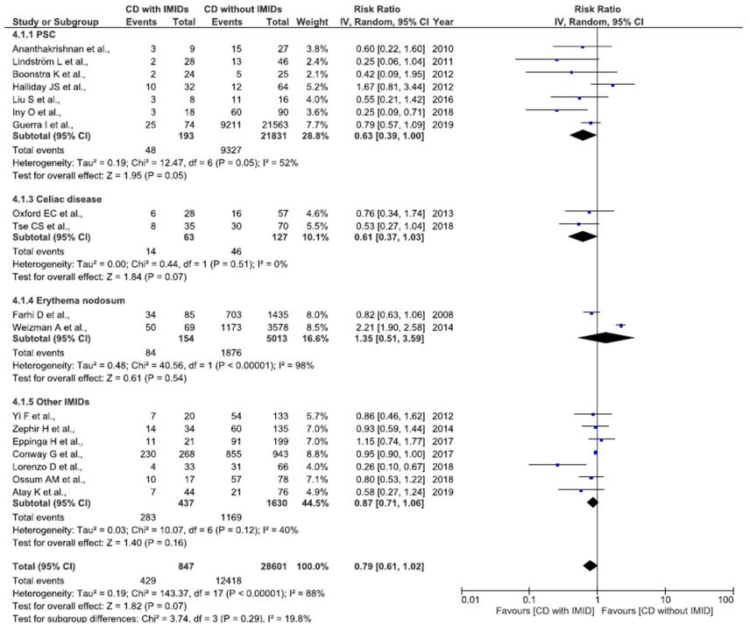

Supplementary Figure 9b: Risk ratio stratified by type of study design

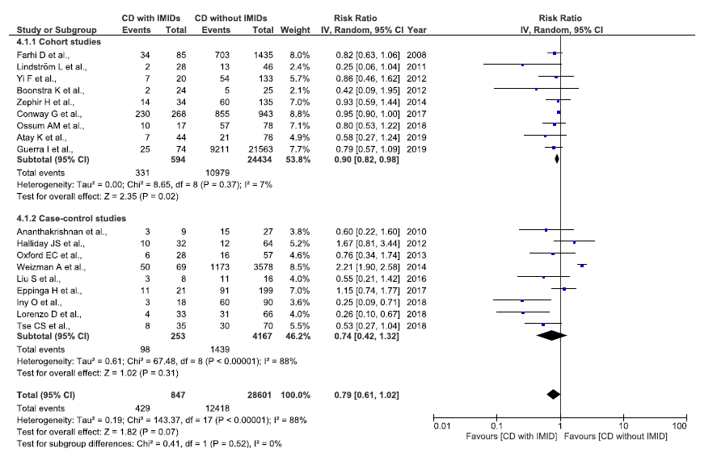

Supplementary Figure 9c: Funnel plot
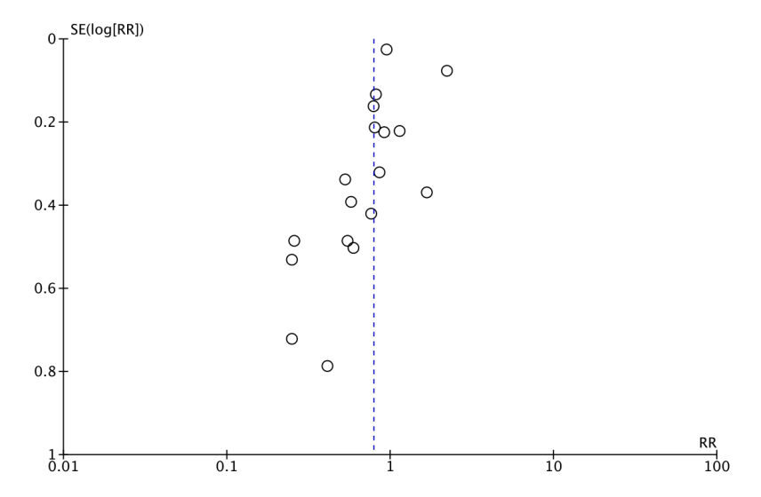

Egger’s Regression Test: p<0.01

Metaregression on risk of surgery (scatter plots)

Supplementary Figure 10a: Association between L1 and risk of CD-related surgery among patients with co-occurring IMIDs
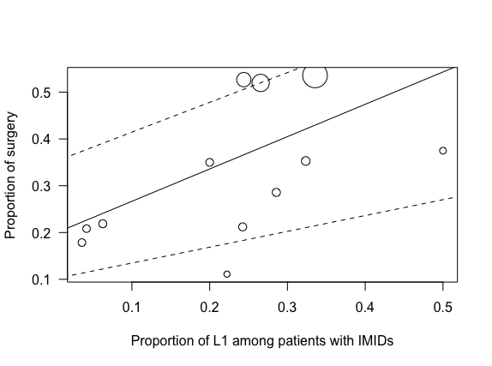

Supplementary Figure 10b: Association between L2 and risk of CD-related surgery among patients with co-occurring IMIDs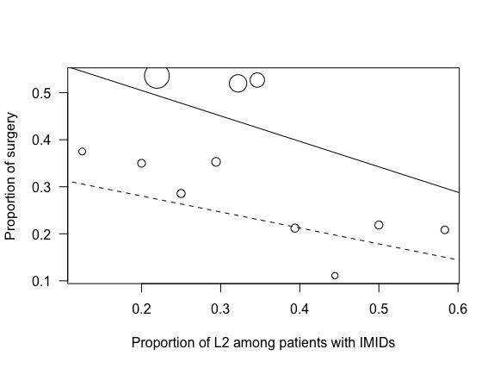

Supplementary Figure 10b: Association between L3 and risk of CD-related surgery among patients with co-occurring IMIDs

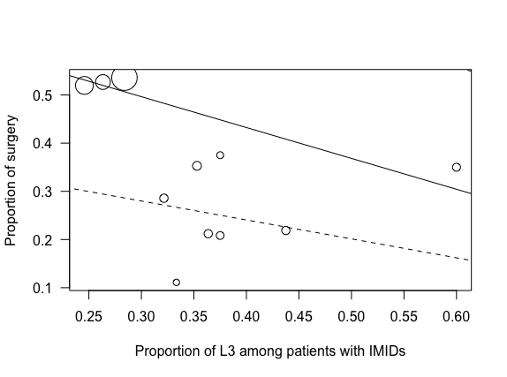

Supplementary Figure 10c: Association between L2 og L3 and risk of CD-related surgery among patients with co-occurring IMIDs


