Supplementary Materials for
“Effect of Drug-Coated Balloon in side branch protection for de novo Coronary Bifurcation Lesions: A Systematic Review and Meta-analysis”

Authors:
Yawei Zheng^{1,3}; Jie Li^{1,2,3}; Lingzhun Wang^{1,2}; Peng Yu^{1,2}; Haibo Shi^{1,2}; Lihua Wu^{1,2}; Jiandong Chen^{1,2,3}
Affiliation:
¹Aﬃliated Hospital of Nanjing University of Chinese Medicine, Nanjing, China.
²Jiangsu Province Hospital of Chinese Medicine, Nanjing, China.
³Nanjing University of Chinese Medicine, Nanjing, China.
*Correspondence: Jiandong Chen: chenjdcardiologist@njucm.edu.cn.
Jie Li: jellylee8803@126.com.

Figure S1 Forest plots for the target lesion revascularization (A: at 1-month follow-up; B: at 6-month follow-up; C: at 9-month follow-up; D: at 12-month follow-up).
A: at 1-month follow-up
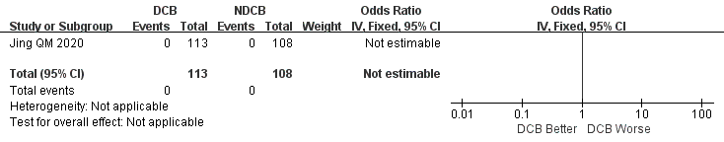
B: at 6-month follow-up
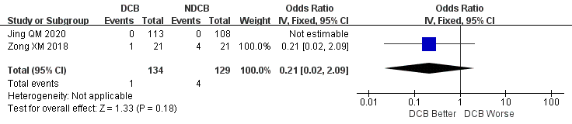
C: at 9-month follow-up
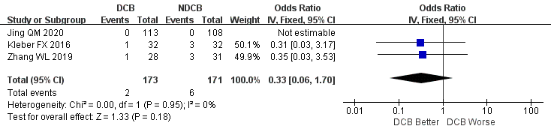
D: at 12-month follow-up
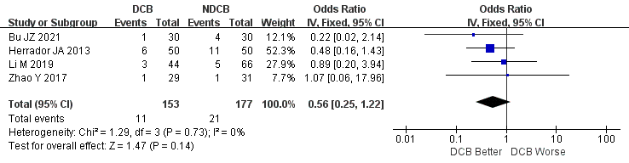

Figure S2 Forest plots for the myocardial infarction (A: at 1-month follow-up; B: at 3-month follow-up; C: at 6-month follow-up; D: at 9-month follow-up; E: at 12-month follow-up).
A: at 1-month follow-up
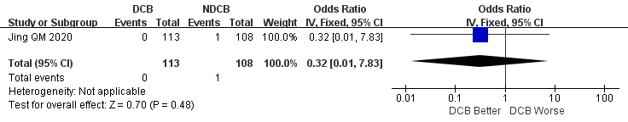
B: at 3-month follow-up
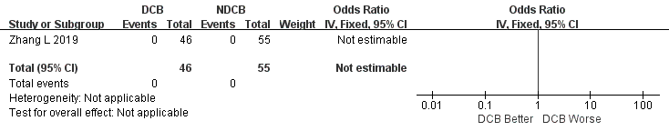
C: at 6-month follow-up
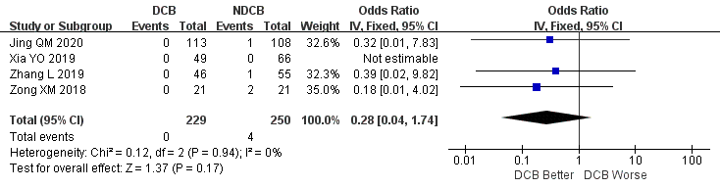
D: at 9-month follow-up
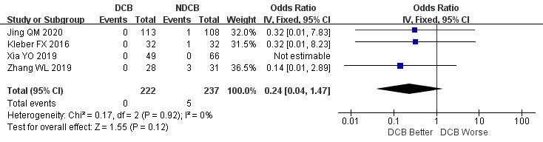
E: at 12-month follow-up
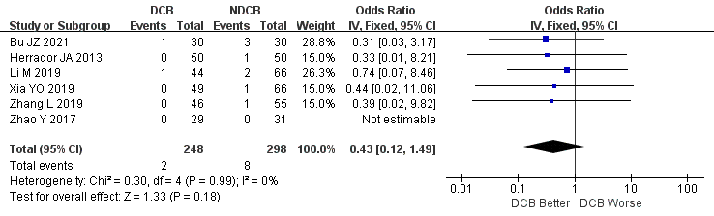

Figure S3 Forest plots for the cardiac death (A: at 1-month follow-up; B: at 3-month follow-up; C: at 6-month follow-up; D: at 9-month follow-up; E: at 12-month follow-up).
A: at 1-month follow-up
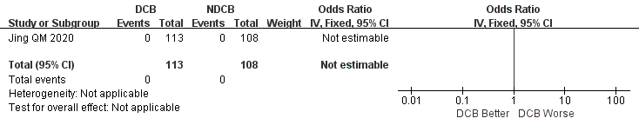
B: at 3-month follow-up
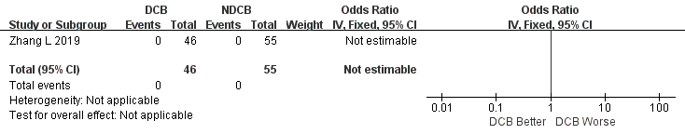
C: at 6-month follow-up
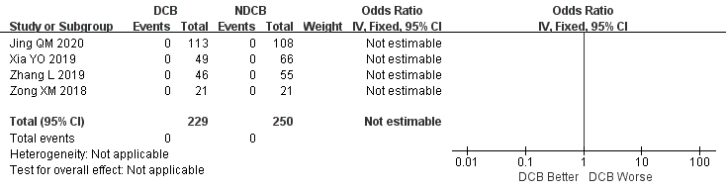
D: at 9-month follow-up
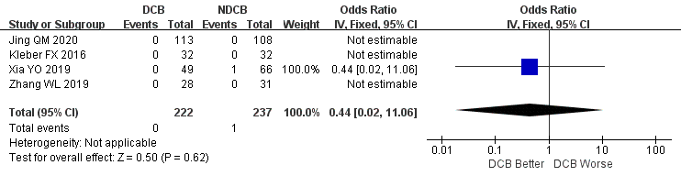
E: at 12-month follow-up
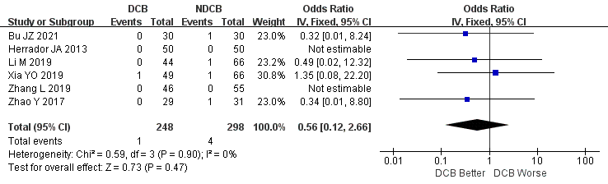

Figure S4 Forest plots for the major adverse cardiac events (A: at 1-month follow-up; B: at 6-month follow-up; C: at 9-month follow-up; D: at 12-month follow-up).
A: at 1-month follow-up
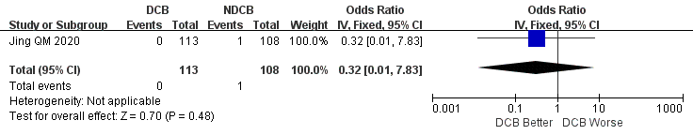
B: at 6-month follow-up
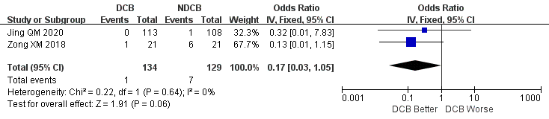
C: at 9-month follow-up
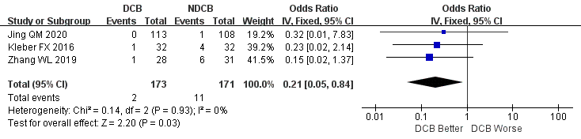
D: at 12-month follow-up
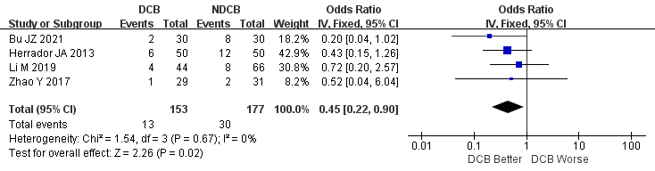

Figure S5 Forest plots for the minimum lumen diameter (A: post-procedure; B: at 6-month follow-up; C: at 9-month follow-up; D: at 12-month follow-up).
A: post-procedure
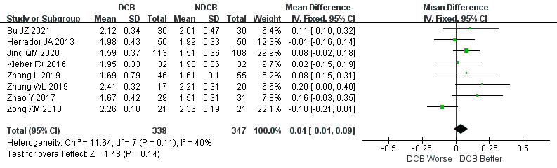
B: at 6-month follow-up
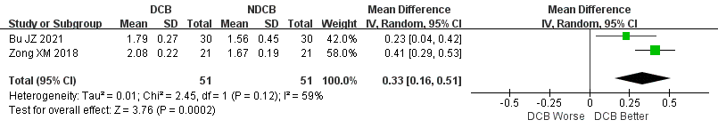
C: at 9-month follow-up
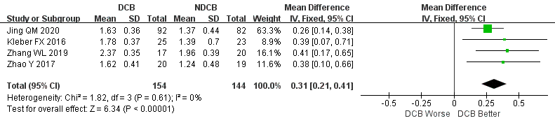
D: at 12-month follow-up
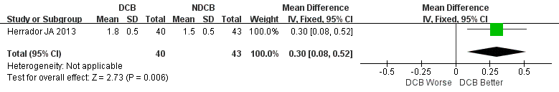

Figure S6 Forest plots for the diameter stenosis (A: post-procedure; B: at 6-month follow-up; C: at 9-month follow-up; D: at 12-month follow-up).
A: post-procedure
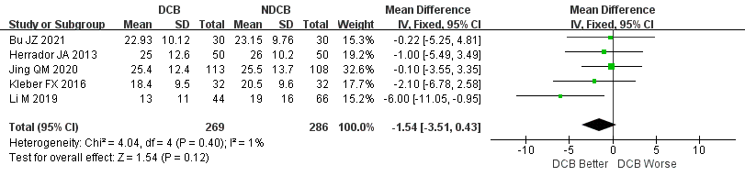
B: at 6-month follow-up
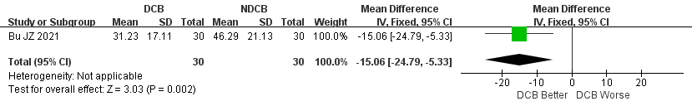
C: at 9-month follow-up
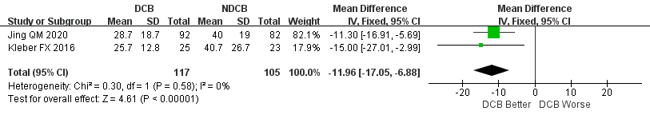
D: at 12-month follow-up
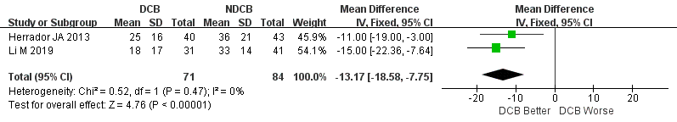

Figure S7 Forest plots for the late lumen loss (A: at 6-month follow-up; B: at 9-month follow-up; C: at 12-month follow-up).
A: at 6-month follow-up
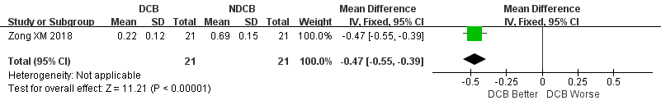
B: at 9-month follow-up
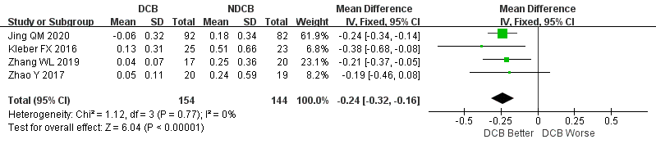
C: at 12-month follow-up
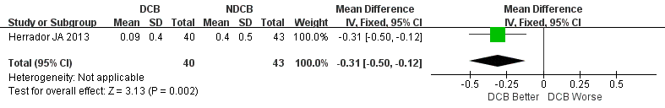

Figure S8 Forest plots for the binary restenosis (A: at 9-month follow-up; B: at 12-month follow-up).
A: at 9-month follow-up
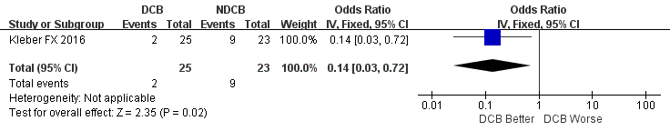
B: at 12-month follow-up
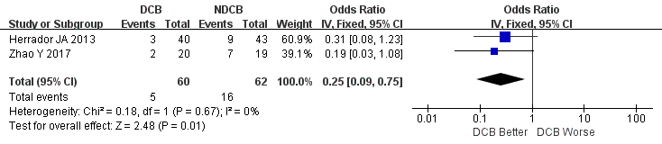

Figure S9 Forest plots for the target lesion failure.


