Supplementary Appendix 1: Search Strategy
PubMed Search Strategy
(Sodium-Glucose Transporter 2 Inhibitors OR Canagliflozin OR Dapagliflozin OR Empagliflozin OR Ertugliflozin OR Ipragliflozin OR Luseogliflozin OR Remogliflozin etabonate OR Sergliflozin etabonate OR Sotagliflozin OR Tofogliflozin) AND (Diabetes Mellitus OR Heart Failure) AND ((left ventricle OR cardiac) AND (mass OR remodeling OR hypertrophy OR volume OR ejection OR metabolism)) NOT (rodent OR mouse OR rat OR pig OR preclinical) AND (randomized OR randomised OR trial)
Applied Filters
- Date upper limit of June 15, 2021

Clinicaltrials.gov Search Strategy
Condition or disease: Heart Failure OR Diabetes
Intervention/treatment: Canagliflozin OR Dapagliflozin OR Empagliflozin OR Ertugliflozin OR Ipragliflozin OR Luseogliflozin OR Remogliflozin etabonate OR Sergliflozin etabonate OR Sotagliflozin OR Tofogliflozin
Applied Filters
- Studies with results
- Interventional studies
- Age group: Adult (18–64) or Older Adult (65+)
- Trial phase: 2 or 3 or 4 or Not Applicable
- Last update posted on or before 06/15/2021

Supplementary Table 1: Justification for Risk of Bias Assessment
Study | Random Sequence Generation | Allocation Concealment | Blinding of participants and personnel | Blinding of Outcome Assessment | Incomplete Outcome Data | Selective Reporting
Brown 2020 | Low Risk - Utilization of a computerized randomization system | Low Risk - Allocation concealed by use of web-based system | Low Risk - participants and personnel blinded | Unclear Risk - analyzers and observers were single-blinded, but the extent of blinding was unclear | Low Risk - Complete data available for all trial participants | Low risk - Results report all outcomes in the methods and is consistent with the trial protocol
Lee 2021 | Low risk - Utilization of a computerized randomization system | Unclear Risk - Publication, states randomization block size of 4. Unclear if investigators were aware during trial. | Low Risk - participants and personnel blinded | Low Risk - Cardiac MRI observers and assessors were completely blinded | Low Risk - Complete data available for all trial participants for outcomes of interest | Low Risk - Results report all primary and secondary outcomes in the methods and is consistent with the trial registration
Santos-Gallego 2021 | Low risk - Utilization of a computerized randomization system | High risk - Published protocol states randomization block size of 4. | Low Risk - participants and personnel blinded | Low Risk - Cardiac MRI observers and assessors were completely blinded | Unclear risk - Table in results does not indicate N for each variable | Unclear risk - Results report all outcomes in the methods but not all from trial protocol
Singh 2020 | Low risk - Utilization of a computerized randomization system | Low Risk - Allocation concealed by onsite clinical trials pharmaceutical manufacturer | Low Risk - participants and personnel blinded | Unclear Risk - analyzers and observers were single-blinded, but the extent of blinding was unclear | Low Risk - Complete data available for all trial participants | Unclear risk - Results report all outcomes in the methods but not all from trial protocol
Verma 2019 | Low risk - Utilization of a computerized randomization system | Low Risk - Allocation concealed by onsite clinical trials pharmaceutical manufacturer | Low Risk - participants and personnel blinded | Low Risk - Cardiac MRI observers and assessors were completely blinded | Low Risk - Complete data available for all trial participants | Low risk - Results report all outcomes in the methods and is consistent with the trial protocol

Supplementary Figure 1: Study Selection

Supplementary Figure 2: Risk of Bias Assessment
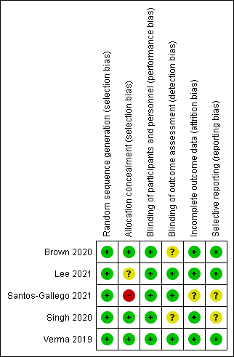

Supplementary Figure 3: Changes in Left Ventricular Mass (Panel A) and Left Ventricular Mass indexed to Body Surface Area (Panel B) from Baseline to Study Endpoint in Randomized Controlled Trials of Patients Treated with Sodium Glucose Transporter-2 Inhibitor Therapy versus Placebo – Sensitivity Analysis Focusing on Diabetes

Supplementary Figure 4: Changes in Left Ventricular End Systolic Volume (Panel A), Left Ventricular End Diastolic Volume (Panel B), and Left Ventricular Ejection Fraction (Panel C) from Baseline to Study Endpoint in Randomized Controlled Trials of Patients Treated with Sodium Glucose Transporter-2 Inhibitor Therapy versus Placebo – Sensitivity Analysis Focusing on Diabetes

