Appendix A: Database: Medline (Ovid MEDLINE® Epub Ahead of Print, In-Process & Other Non-Indexed Citations, Ovid MEDLINE® Daily and Ovid MEDLINE®) 1946 to 24/January/2020
Search Strategy:
Searches | Results
Stress Disorders, Post-Traumatic/ | 31541
Anxiety/ or exp Anxiety Disorders/ | 147646
Stress, Psychological/ | 117413
sleep disorders, intrinsic/ or "sleep initiation and maintenance disorders"/ | 12900
Fatigue/ | 27888
(posttraumatic or post-traumatic or ptsd or trauma*).mp. | 419885
(anxiet* or anxious).mp. | 233293
(phobia? or phobic).mp. | 17069
(obsessive compulsive disorder* or ocd).mp. | 19955
(((psycholog* or mental or acute) adj2 stress*) or stressful).mp. or stress*.ti. | 336898
(insomnia or sleepless* or ((problem? or disturbed or disrupt* or difficult*) adj2 sleep*)).mp. | 32845
(fatigue* or tired*).mp. | 108198
((panic adj2 (attack? or disorder?)) or palpitation?).mp. | 18626
(fear? or worry or worries or concern? or crisis or crises).mp. | 451910
1 or 2 or 3 or 4 or 5 or 6 or 7 or 8 or 9 or 10 or 11 or 12 or 13 or 14 | 1480981
exp Parents/ | 108989
Caregivers/ | 34915
(parent or parents or father* or mother* or mums or moms or dads or maternal or paternal or carer? or caregiver? or care giver? or caretaker? or care taker? or guardian?).mp. | 798493
16 or 17 or 18 | 798493
Intensive Care Units, Neonatal/ | 14162
Infant, Newborn/ and (Intensive Care Units/ or Critical Care/) | 3886
exp infant, low birth weight/ or exp infant, premature/ | 78068
((infan* or neonat* or newborn? or baby or babies or preterm) adj5 (intensive care or intensive therap* or critical care or unit?)).ti,ab. | 27226
((high dependency or special care) adj5 (infan* or neonat* or newborn? or baby or babies)).mp. | 939
(nicu or scbu).ti,ab. | 9493
((infan* or neonat* or newborn? or baby or babies) and (prematur* or preterm or low birth weight or "small for gestational age" or vlbw or lbw or sga)).ti. | 39870
20 or 21 or 22 or 23 or 24 or 25 or 26 | 112387
prevalence/ or incidence/ or epidemiology/ or morbidity/ | 550306
Cross-sectional studies/ | 316346
(prevalence or prevalent).mp. | 797811
(incidence or incident?).mp. | 899309
epidemiolog*.mp. | 1841162
(frequenc* or occurence* or pattern? or burden).mp. | 2372751
((cross-sectional or crossectional) adj (stud* or survey?)).ti,ab. | 188634
28 or 29 or 30 or 31 or 32 or 33 or 34 | 4867800
15 and 19 and 27 and 35 | 1025
exp animals/ not humans/ | 4666511
36 not 37 | 1022

Appendix B: Risk of bias assessment tool, adapted from the Risk of Bias Tool for Prevalence Studies developed by Hoy et al
Risk of Bias Item | Rating: High, Low, Unclear
- Was the study target population a close representation of the parents to babies admitted to NNU?
- Was the sampling frame a true or close representation of the parents admitted to NNU?
- Was some form of random selection used to select the sample, OR, was a census undertaken?
- Were data collected directly from the parents?
- Was anxiety/PTS well defined?
- Were validated and reliable measures used?
- Was the same method used for data collection?
- Was the length of assessment time appropriate?
- Were the numerator(s) and denominator(s) for the
calculation of the prevalence reported and appropriate?

Appendix C: Risk of Bias of included studies - anxiety
Study ID | Population represents the national population | Study sample represents the target population | Study sample selection | Non- response bias | Direct data collection | Anxiety well defined | Validity/  reliability of measures | Same method used for data collection | Length of assessment time appropriate | Prevalence data
Study ID | Low:  > 1 centre | Low: Including both parents to NNU babies without applying any restrictions | Low: Random selection/ census was undertaken | Low:  No difference between responders and non-responders or > 75% response rate | Low:  Data directly collected from parents via self-reported or clinical interviews | Low:  Using standard measure | Low:  Using standard measure with a cut-off point | Low:  Same mode of data collection was used for al | Low:  ASD assessed < 1 month; PTSD > 1 month post birth/NNU admission | Low: Numerator& denominator of prevalence reported & appropriate
Bonacquisti, 2020 | Low | High | High | High | Low | Low | Low | Low | Low | High
Cajiao-Nieto 2021 | High | High | High | Unclear | Low | Low | Low | Low | Low | Low
Carter 2007 | High | Low | Low | Low | Low | Low | Low | Low | Low | High
Dantas 2012 | Low | Low | High | High | Low | Low | Low | Low | Low | Low
Das 2021 | High | High | High | Low | Low | Low | Low | Low | Low | Low
Eutrope 2014 ª | Low | High | High | Unclear | Low | Low | Low | Low | Low | High
Garfield 2015 ª | Low | High | High | Unclear | Low | Low | Low | Low | Low | Low
Gonzalez-Hernandez 2019 | High | High | High | Unclear | Low | Low | Low | Low | Low | Low
Greene 2015 & 2018ª | High | High | High | High | Low | Low | Low | Low | Low | Low
Harris 2018ª | Low | High | High | High | Low | Low | Low | Low | Low | Low
Helle 2016 ª | Low | High | High | High | Low | Low | Low | Low | Low | High
Holditch-Davis 2015 ª | Low | High | Low | Unclear | Low | Low | Low | Low | Low | High
Kong 2013 | High | High | High | Unclear | Low | Low | Low | Low | Low | Low
Misund 2014 & 2016ª | High | High | High | Low | Low | Low | Low | Low | Low | High
Mulder 2014 | High | Low | Low | Low | Low | Low | Low | Low | Low | Low
Ong 2019 | High | High | High | Low | Low | Low | Low | Low | Low | Low
Onay 2021 | High | High | High | Unclear | Low | Low | Low | Low | Low | Low
Pace 2016 ª | High | High | High | High | Low | Low | Low | Low | Low | Low
Rogers 2013 | High | High | High | Low | Low | Low | Low | Low | Low | High
Segre 2014 & McCabe-Beane 2018 | High | High | High | High | Low | Low | Low | Low | Low | Low
Trumello 2018 | High | High | High | Unclear | Low | Low | Low | Low | Low | High

Abbreviations: ª studies included in both anxiety and PTS
Appendix D: Anxiety prevalence and meta-analyses at different time points

Anxiety prevalence≤1 month - study setting
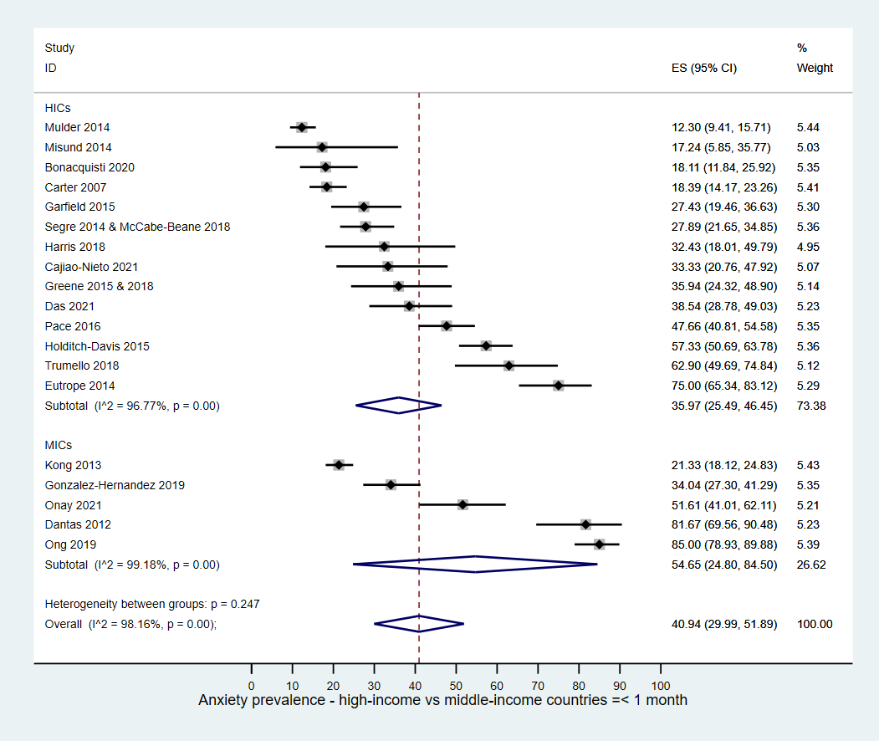

Anxiety prevalence≤1 month - study design
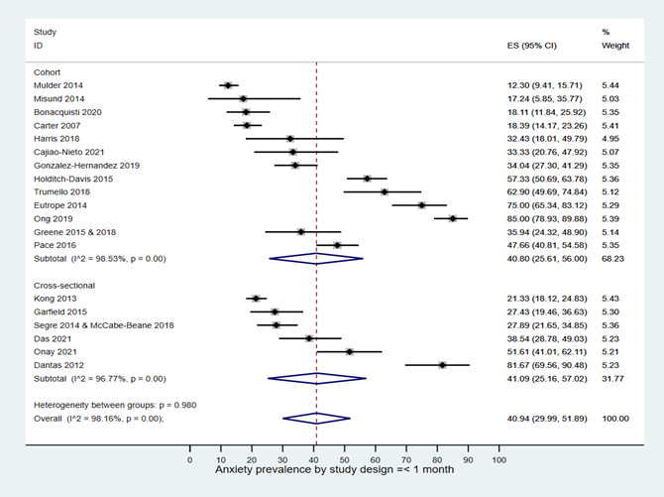

Anxiety prevalence ≤ 1 month-selection bias – sample representativeness
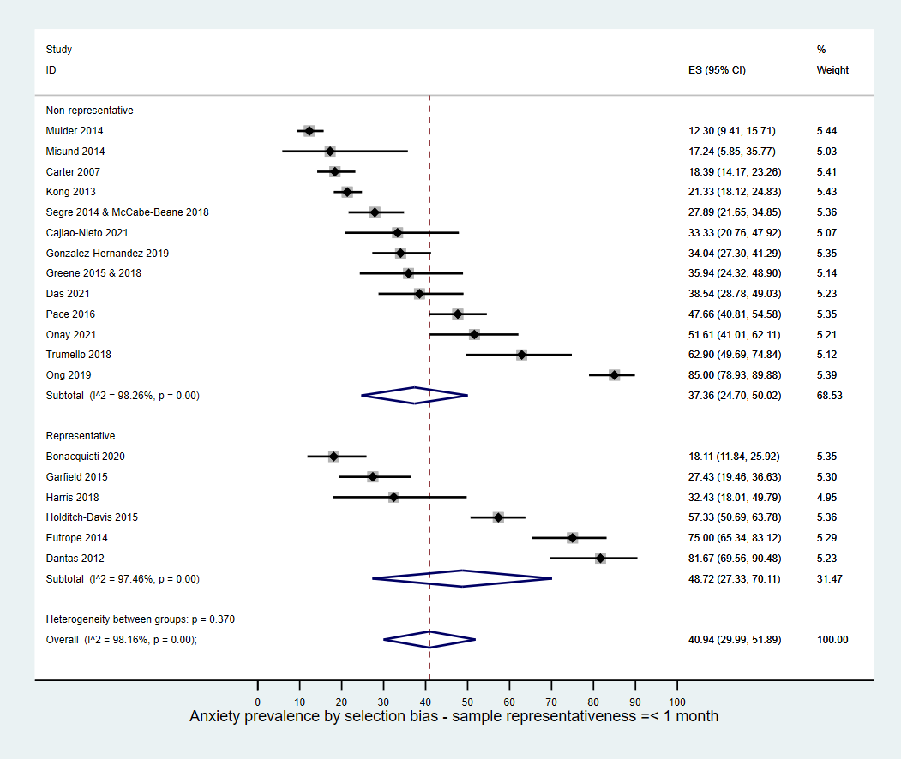

Anxiety prevalence ≤1 month – parents*
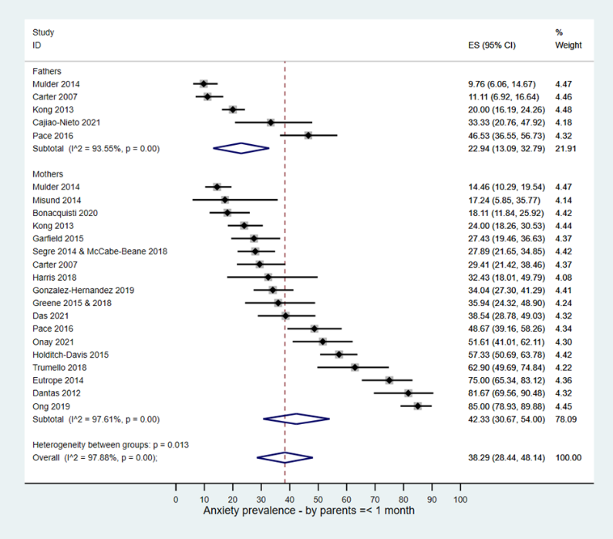

Anxiety prevalence≤1 month – prematurity
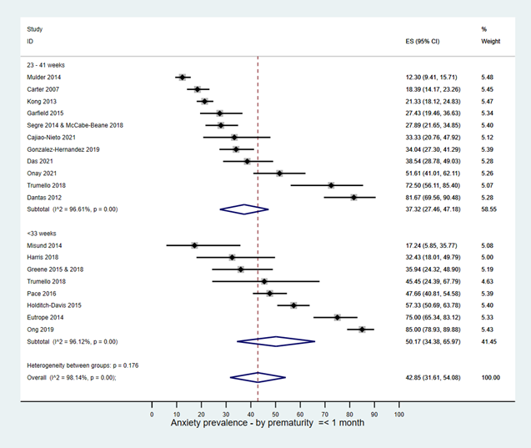

Anxiety prevalence ≤1 month-measuring scales*
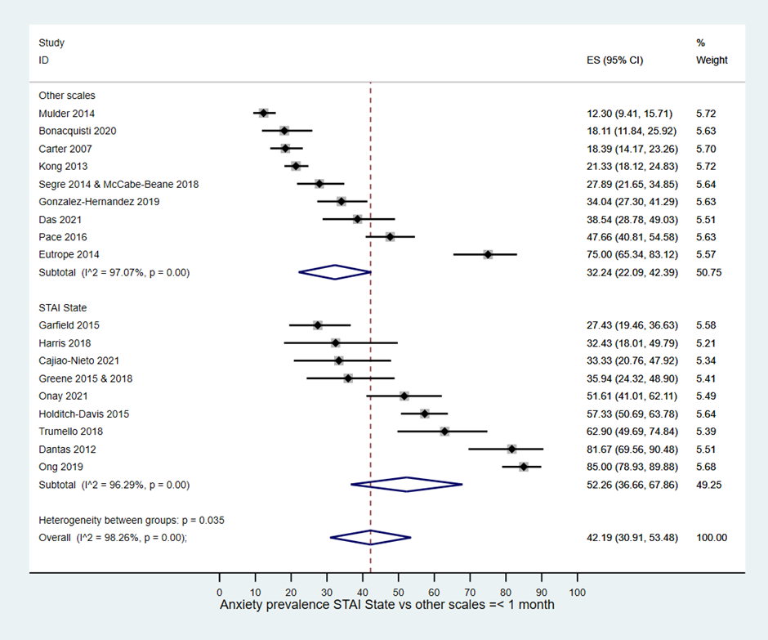

Anxiety prevalence >1 month to ≤ 1 year – study deign
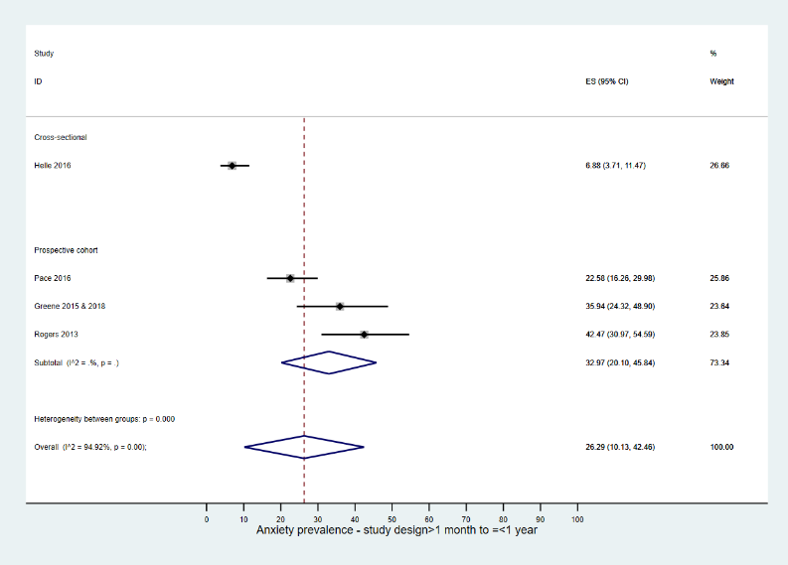

Anxiety >1 month to ≤1year-selection bias - sample representativeness*
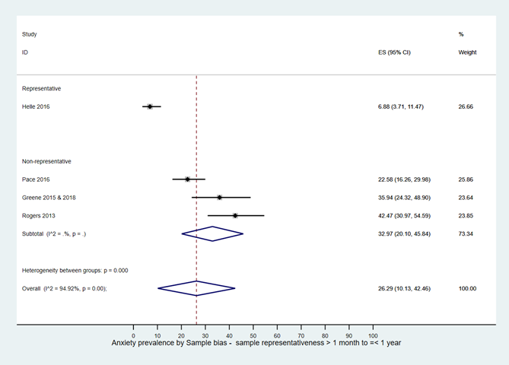

Anxiety >1 month to≤ 1 year-anxiety symptoms*
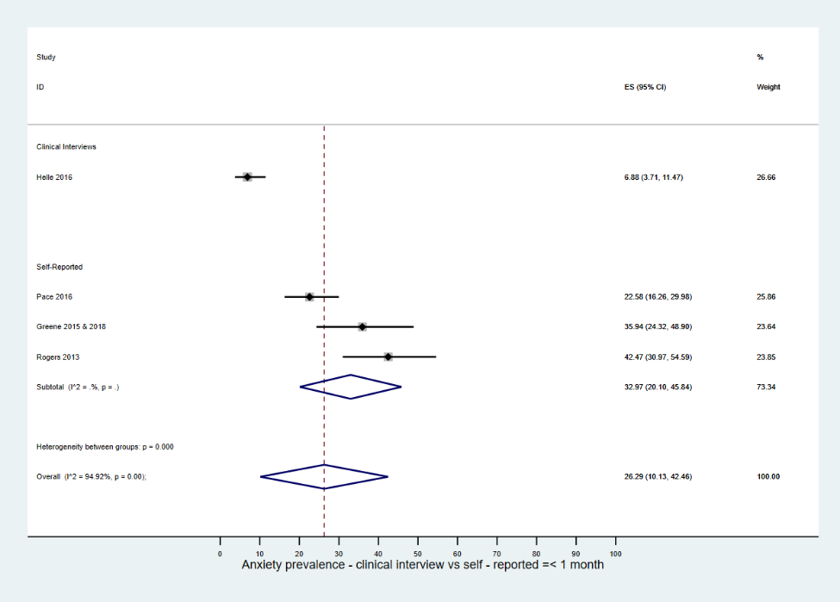

Anxiety prevalence>1 month to ≤1 year-parents*
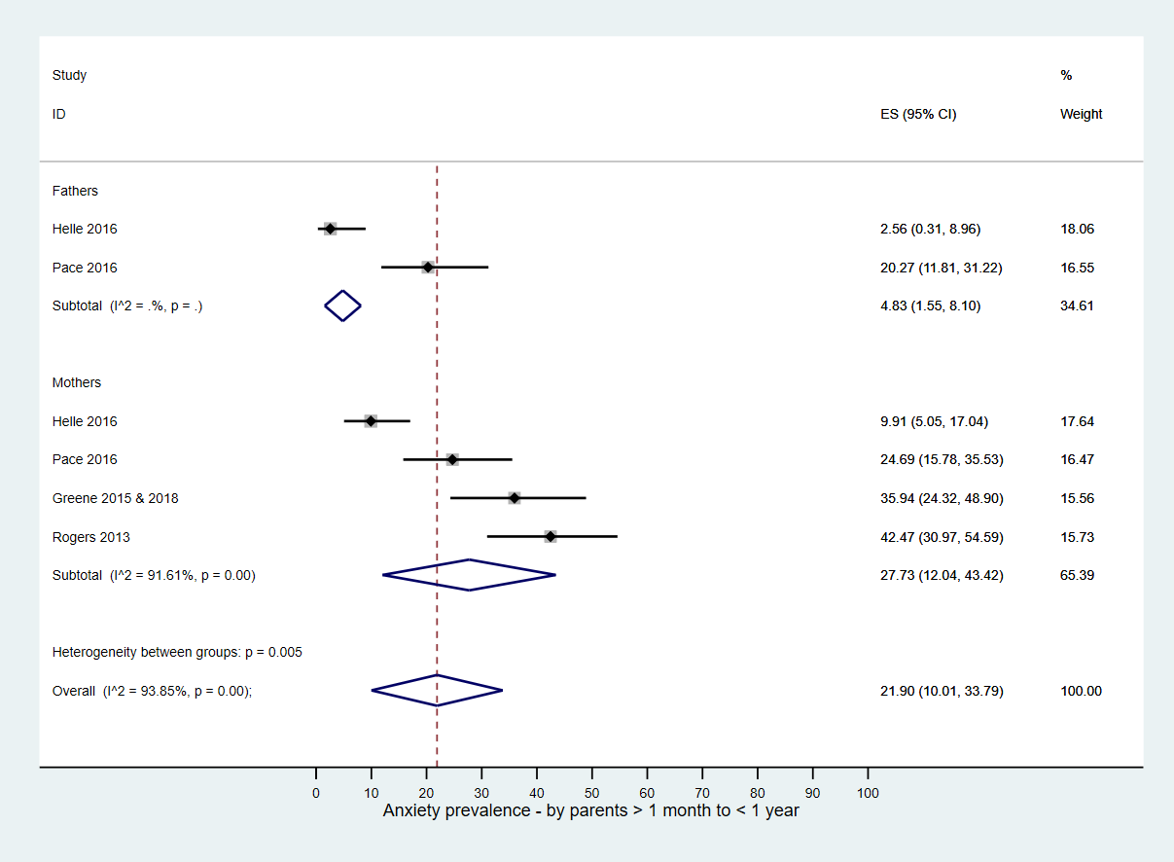

Anxiety prevalence>1 month to≤1 year- prematurity*
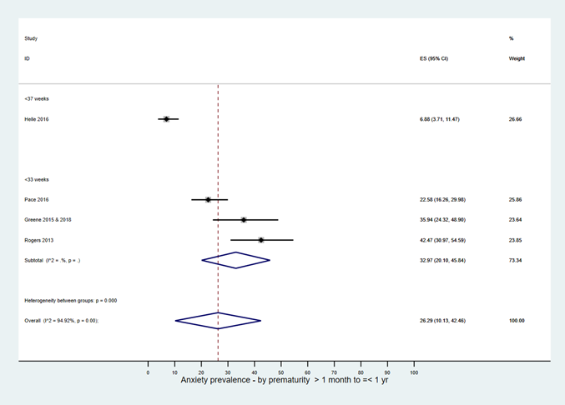

Anxiety prevalence >1 month to≤ 1 year-measuring scales*
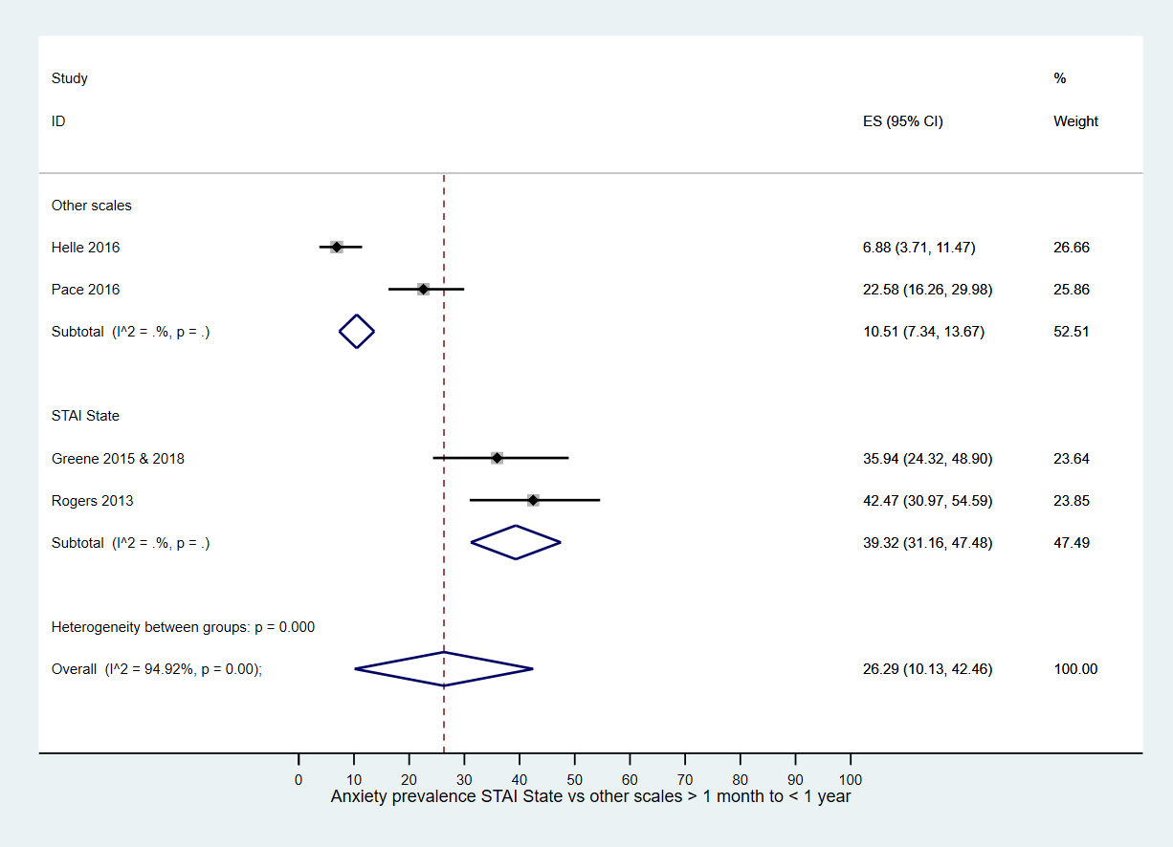

Appendix E: Risk of Bias of included studies - PTS
Study ID | Population representative of the national population | Study sample represents the target population | Study sample selection | Non- response bias | Direct data collection | Anxiety well defined | Validity/  reliability of measures | Same method used for data collection | Length of assessment time appropriate | Prevalence data
Study ID | Low:  > 1 centre | Low: Including both parents to NNU babies without applying any restrictions | Low: Random selection/ census was undertaken | Low:  No difference between responders and non-responders/ > 75% response rate | Low:  Data directly collected from parents via self-reported or clinical interviews | Low:  Using standard measure | Low:  Using standard measure with a cut-off point | Low:  Same mode of data collection was used for all | Low:  ASD assessed < 1 month; PTSD > 1 month post birth/NNU admission | Low:  Numerator(s) & denominator (s) of prevalence reported & appropriate
Aftyka’s study
Aftyka 2014 | High | High | High | High | Low | Low | Low | Low | Low | Low
Aftyka 2017 & 2020 | High | High | High | High | Low | Low | Low | Low | Low | Low
Ahlund 2009 | High | High | High | Low | Low | Low | Low | Low | High | Low
Barr 2010 | High | High | High | Low | Low | Low | Low | Low | Low | Low
Chang 2016 | High | High | High | Unclear | Low | Low | Low | Low | Low | Low
Clark 2021 | High | High | High | High | Low | Low | Low | Low | Low | Low
Eutrope 2014ª | Low | High | High | Unclear | Low | Low | Low | Low | Low | Low
Feeley 2011 | Low | High | High | Unclear | Low | Low | Low | Low | Low | Low
Forcada-Guex 2011 | High | High | High | Low | Low | Low | Low | Low | Low | Low
Garfield 2015ª | High | High | High | Unclear | Low | Low | Low | Low | Low | Low
Gateau 2021 | High | High | Unclear | Low | Low | Low | Low | Low | Low | Low
Goutaudier 2014 | High | High | High | High | Low | Low | Low | Low | Low | Low
Greene 2015& 2018ª | High | High | High | Unclear | Low | Low | Low | Low | Low | Low
Harris 2018ª | Low | High | High | High | Low | Low | Low | Low | Low | Low
Helle 2018 ª | Low | High | High | High | Low | Low | Low | Low | Low | High
Holditch-Davis 2009 | Low | High | Low | Unclear | Low | Low | Low | Low | High | High
Holditch-Davis 2015 ª | Low | High | Low | Unclear | Low | Low | Low | Low | High | High
Jubinville 2012 | High | High | High | Low | Low | Low | Low | Low | Low | Low
Koliouli 2016 | High | High | High | Unclear | Low | Low | Low | Low | Low | Low
Lefkowitz 2010 | High | High | High | Low | Low | Low | Low | Low | Low | Low
Lotterman 2019 | High | High | High | Low | Low | Low | Low | Low | Low | High
Malin 2020 | High | High | High | Low | Low | Low | Low | Low | Low | Low
Misund 2013, 2014 & 2016 | High | High | High | Low | Low | Low | Low | Low | High | High
Naeem 2019 | Low | High | High | Unclear | Low | Low | Low | Low | Low | Low
Pace 2020 ª | High | High | High | Low | Low | Low | Low | Low | Low | Low
Pierrehumber2003 | High | High | High | Low | Low | Low | Low | Low | Low | Low
Rodriguez 2020 | High | High | High | Low | Low | Low | Low | Low | Low | Low
Sharp 2021 | High | High | High | Low | Low | Low | Low | Low | Low | Low
Shaw 2006 & 2009 | High | High | High | High | Low | Low | Low | Low | Low | Low
Shaw 2014 | High | High | High | High | Low | Low | Low | Low | Low | Low
Schecter 2020 | High | Low | High | Unclear | Low | Low | Low | Low | Low | High
Toly 2019 | High | High | High | High | Low | Low | Low | Low | Low | Low
Vanderbilt 2009 | High | High | High | High | Low | Low | Low | Low | Low | Low
Vinall 2018 | High | High | High | Low | Low | Low | Low | Low | Low | Low
Yaman 2015 | Low | Low | High | Low | Low | Low | Low | Low | Low | Low
Zerach 2015 | High | High | Low | High | Low | Low | Low | Low | High | High

ª studies included in both anxiety and PTS
Appendix F: Post traumatic stress (PTS) prevalence and meta-analyses at different time points

PTS prevalence≤1 month-study setting
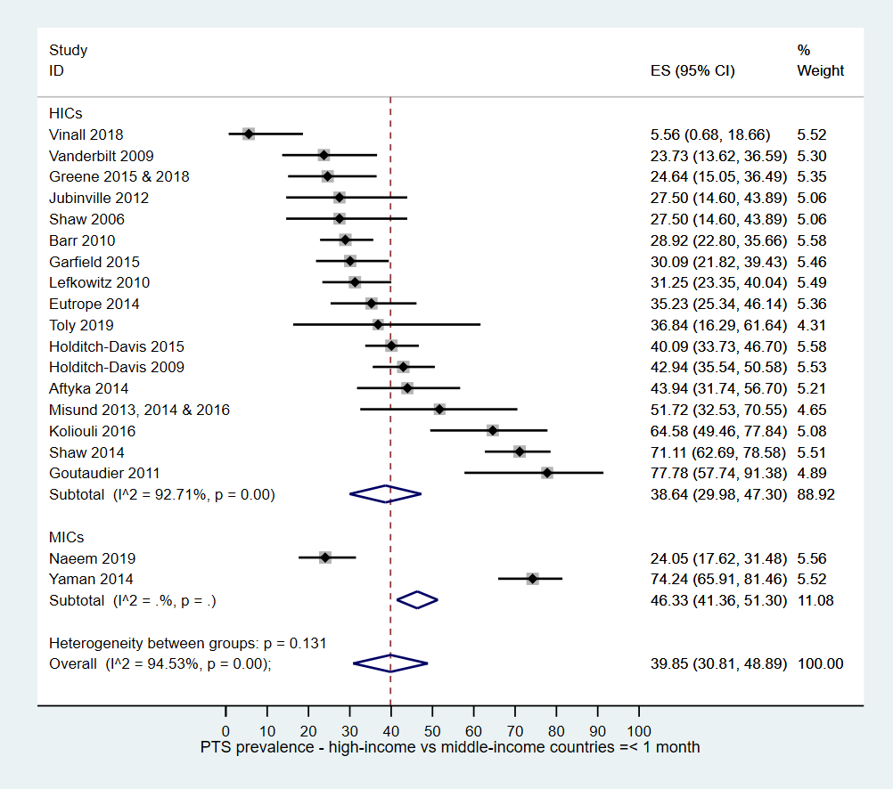

PTS prevalence≤1 month-study design
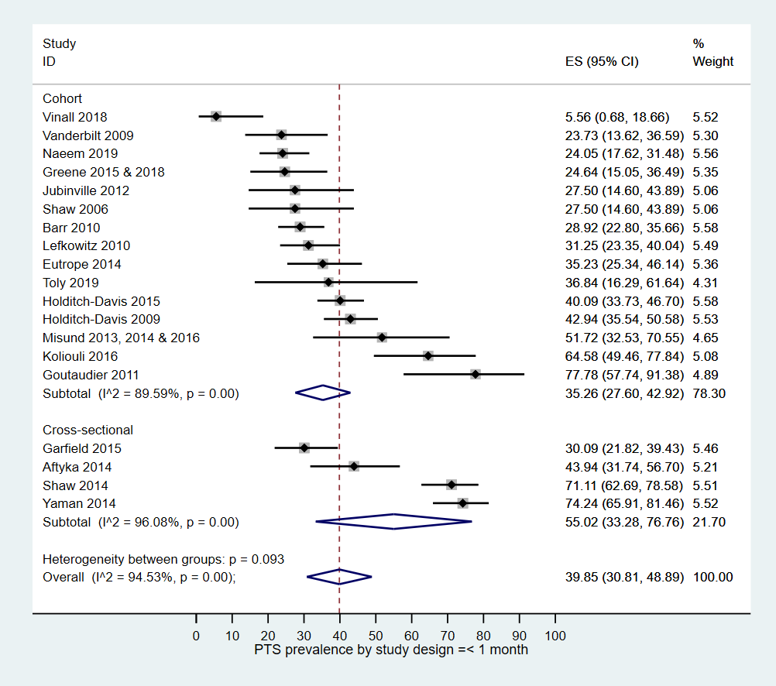

PTS prevalence≤1 month-selection bias- representativeness
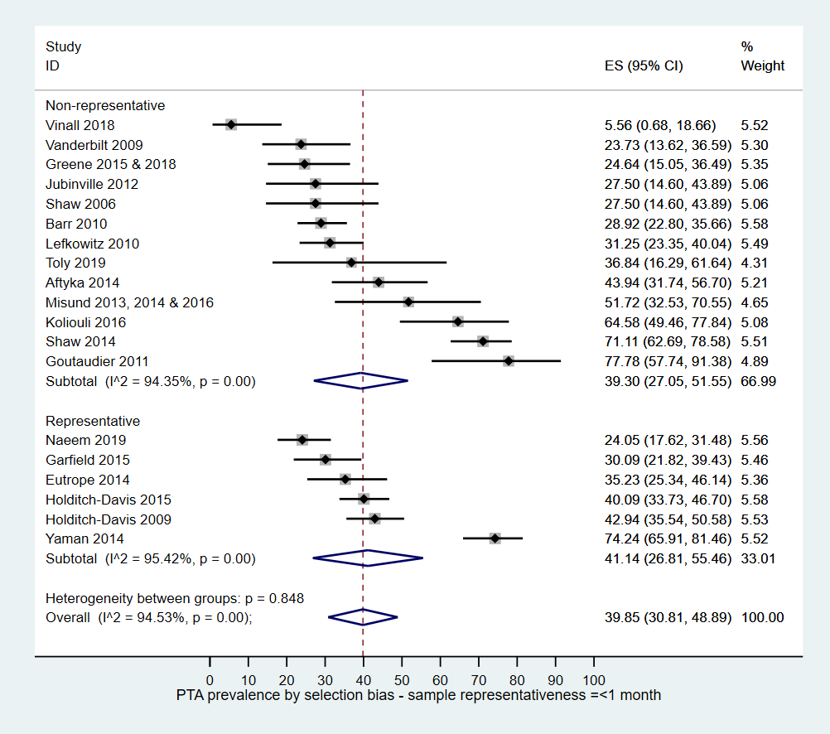

PTS prevalence≤1 month-PTS symptoms*
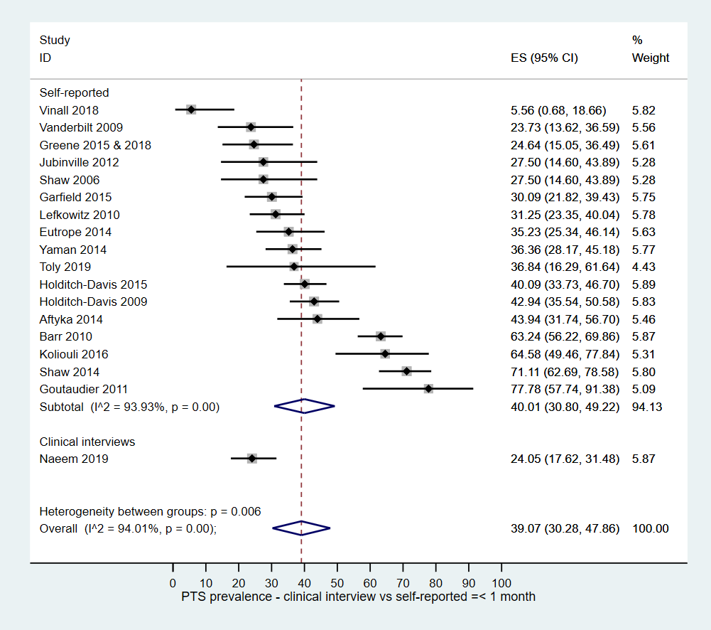

PTS prevalence≤1 month-parents
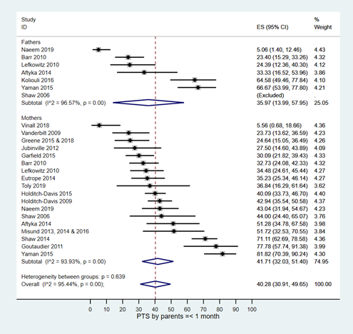

PTS prevalence≤1 month-prematurity
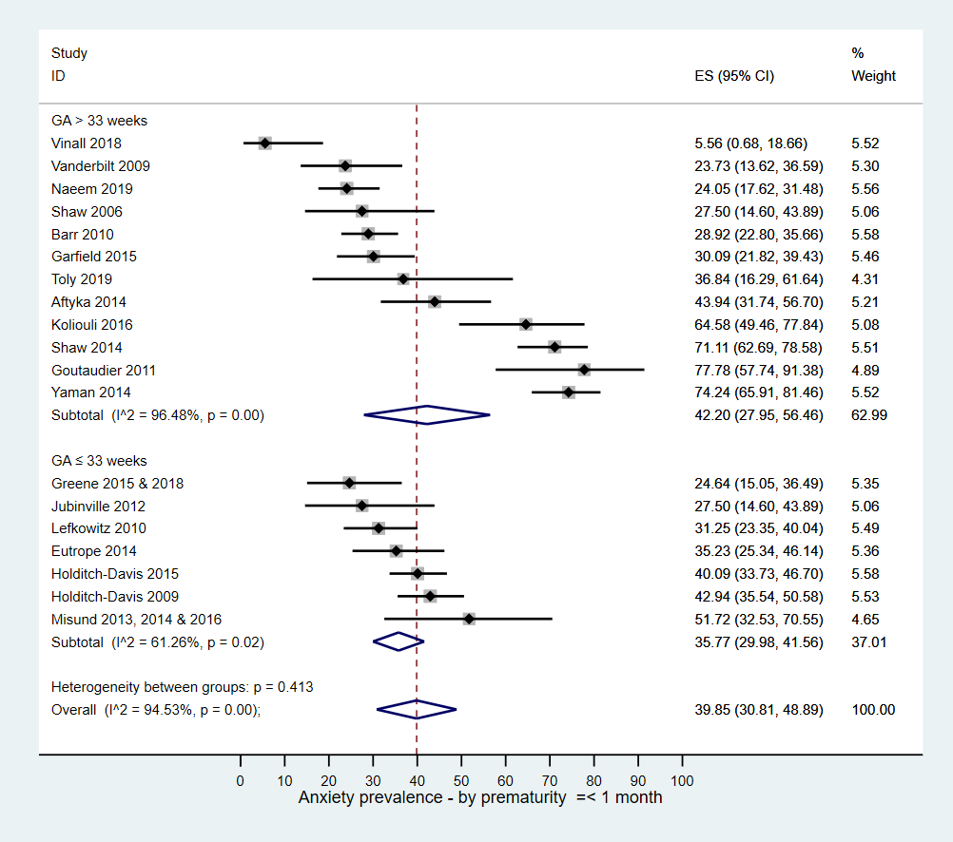

PTS prevalence≤1 month-measuring scales
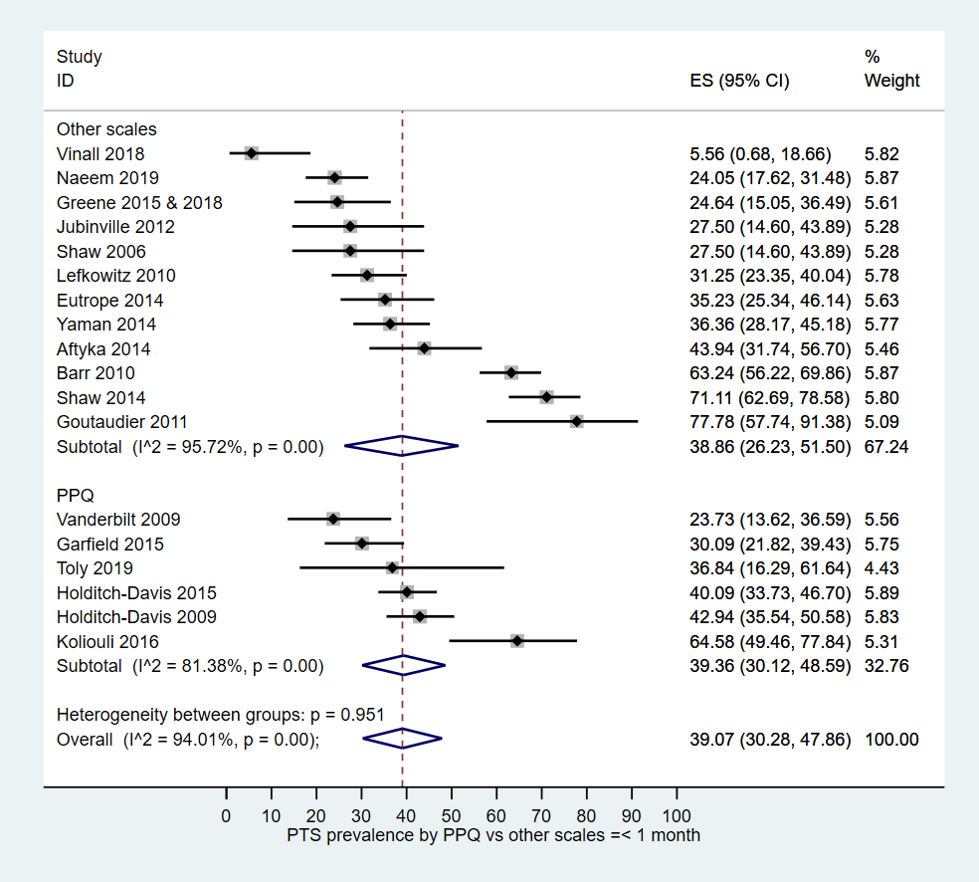

PTS prevalence > 1 month to ≤ 1 year – study setting
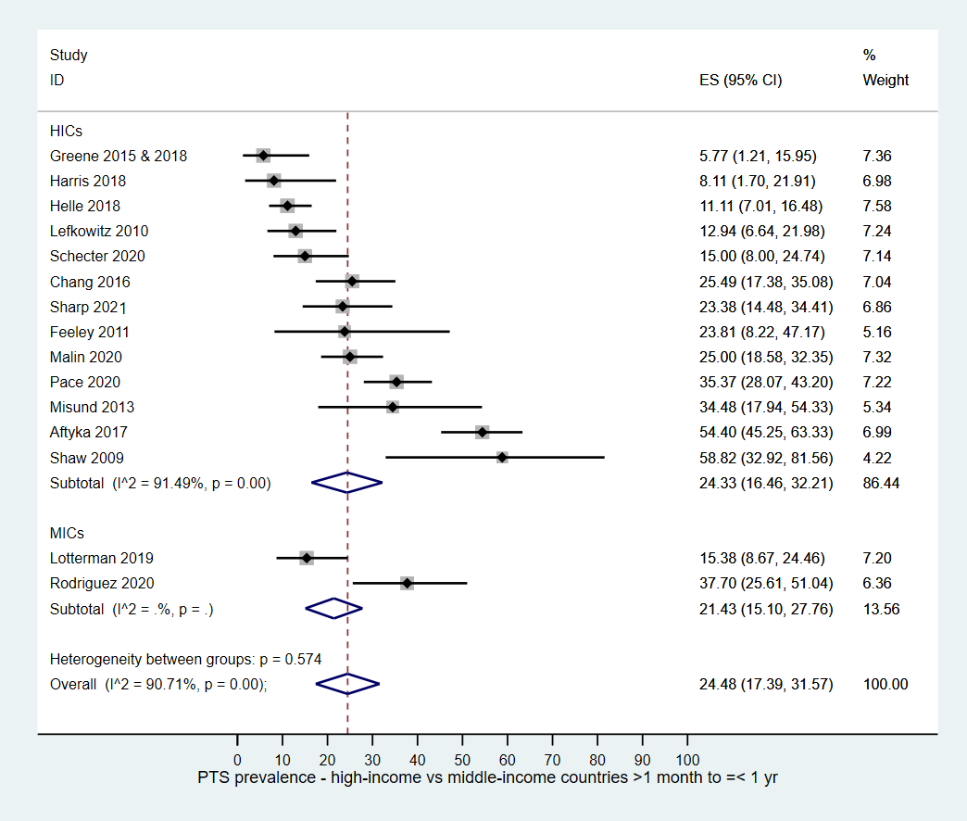

PTS prevalence > 1 month to ≤ 1 year – study design
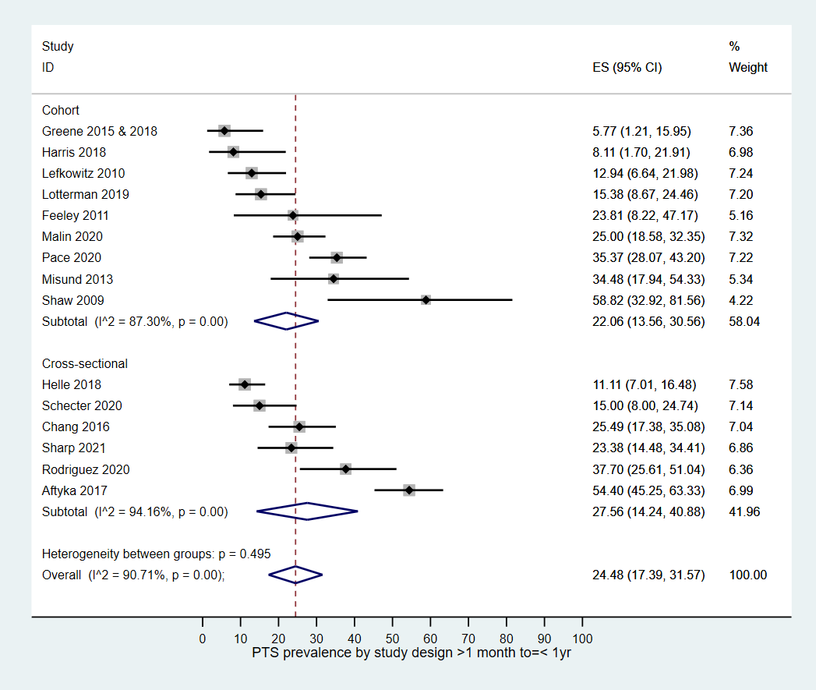

PTS prevalence > 1 month to ≤ 1 year –selection bias-representativeness*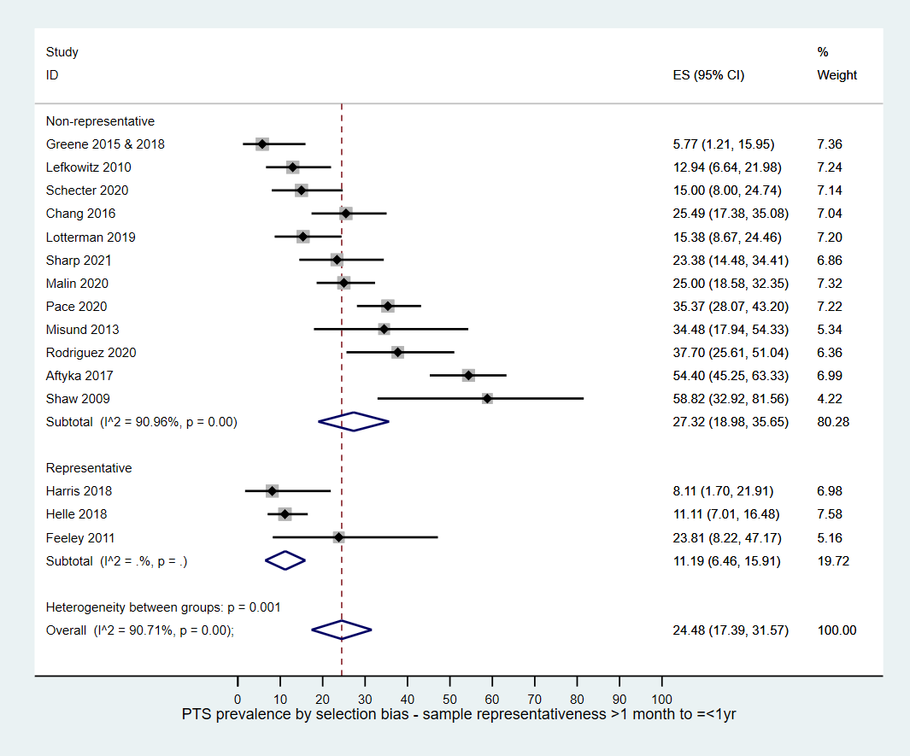

PTS prevalence > 1 month to ≤ 1 year-PTS symptoms*
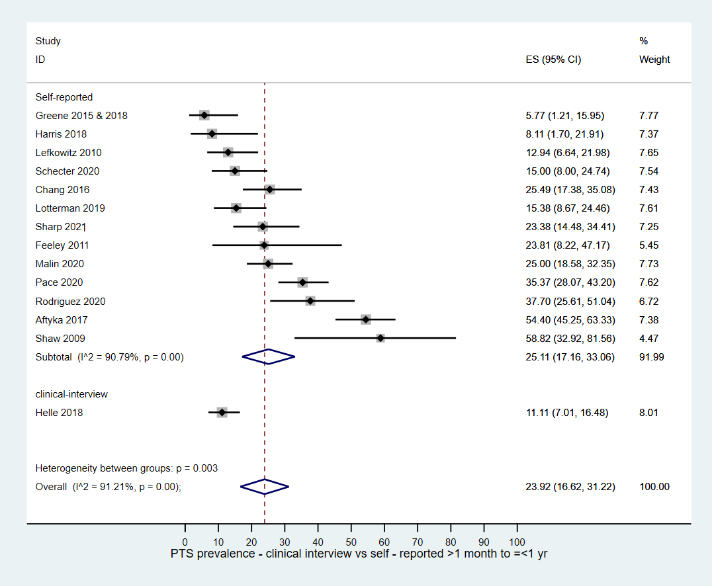

PTS prevalence > 1 month to ≤ 1 year-parents
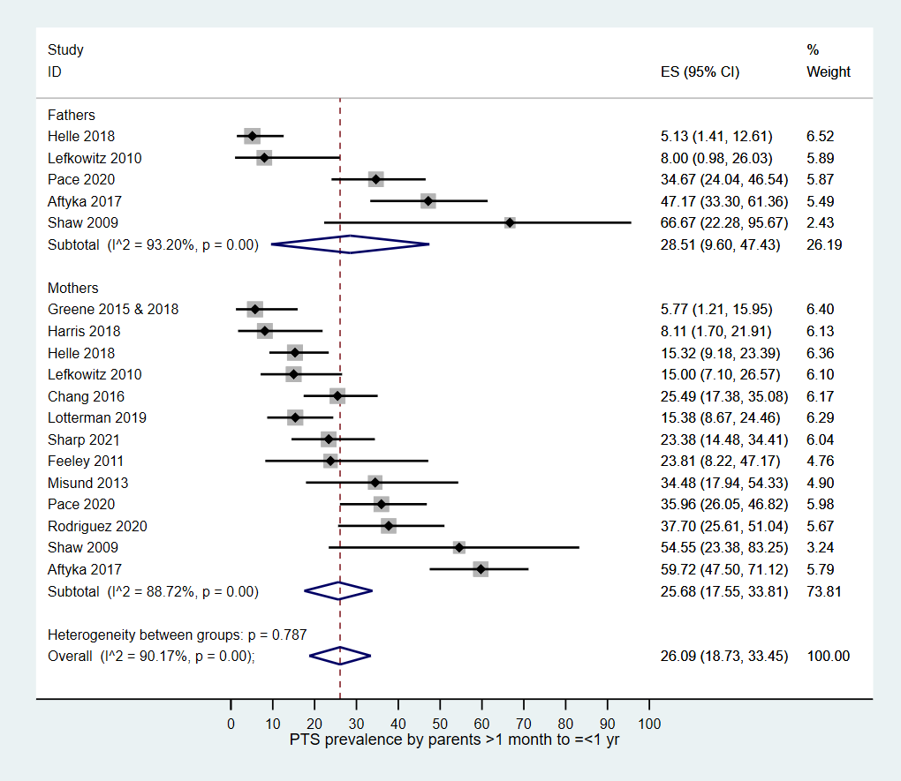

PTS prevalence > 1 month to ≤ 1 year-prematurity
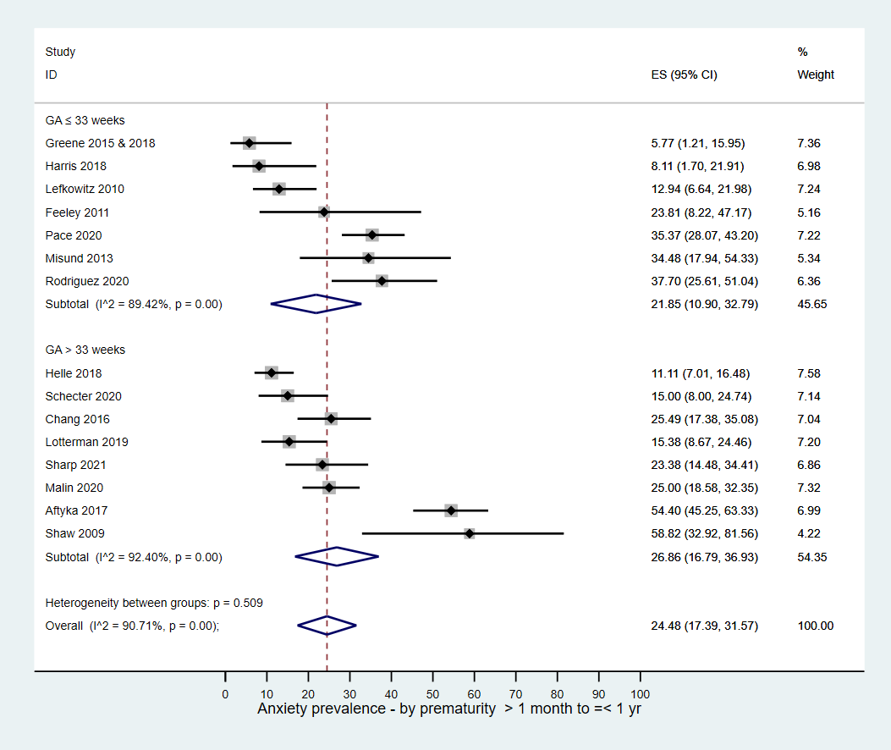

PTS prevalence > 1 month to ≤ 1 year-measuring scales
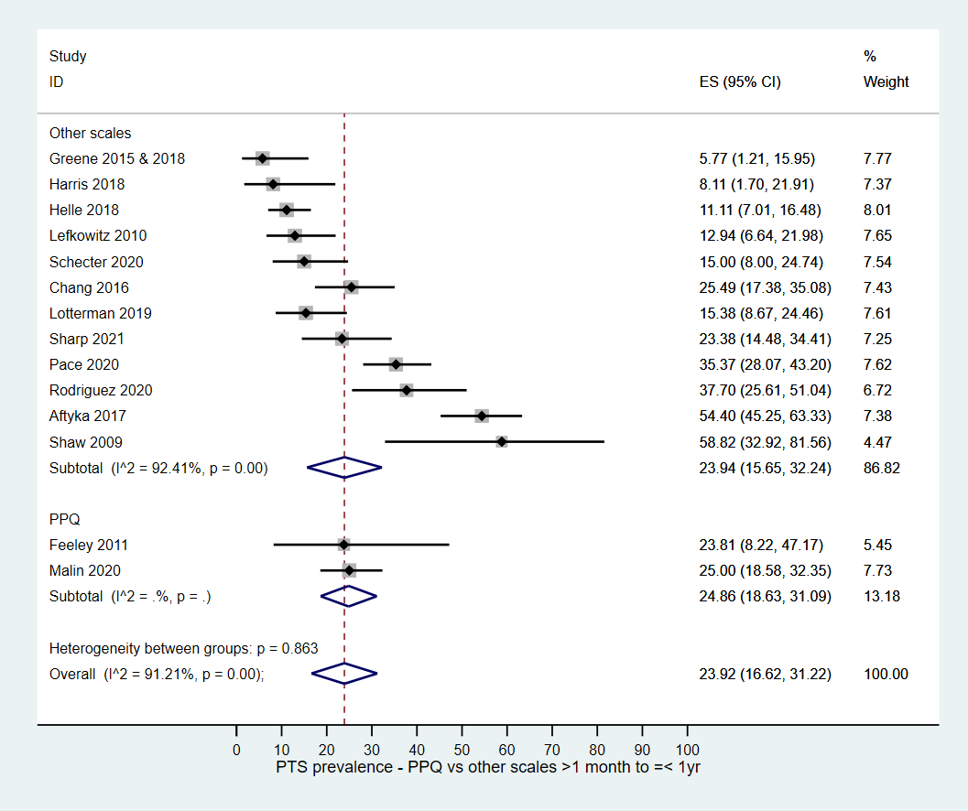

PTS prevalence >1 yr-study setting*
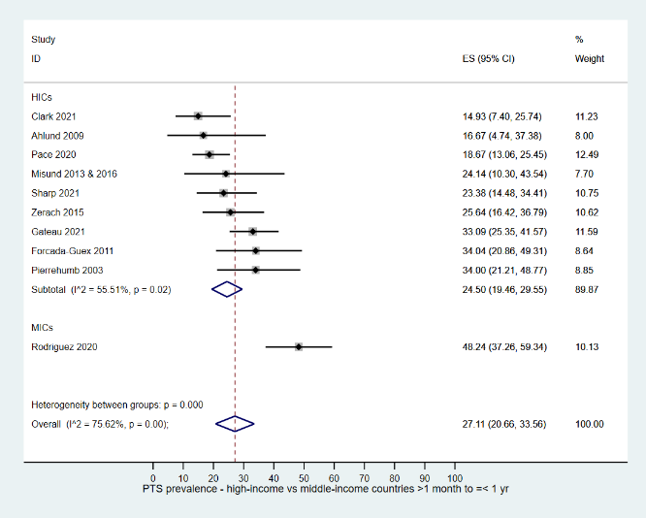

PTS prevalence > 1 year-study design
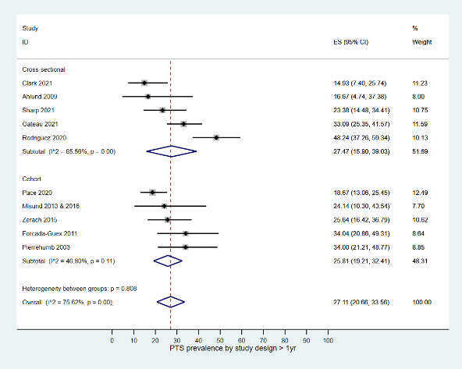

PTS prevalence >1 year-parents*
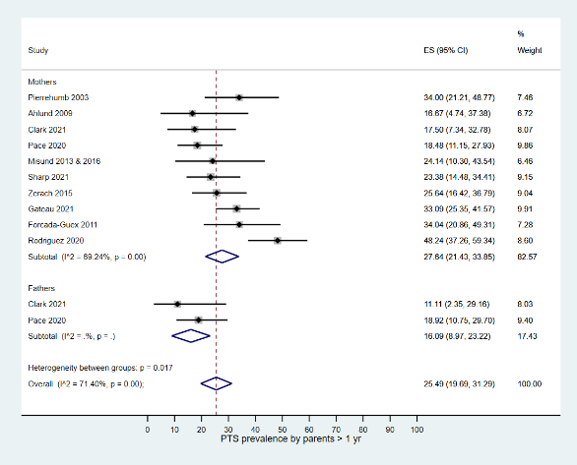

PTS prevalence >1 year-prematurity
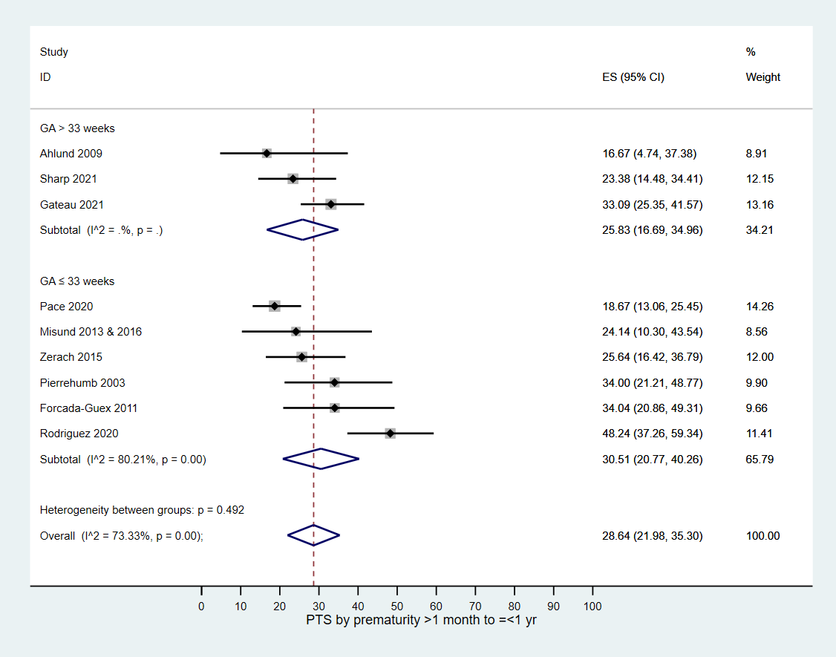

PTS prevalence > 1 year-measuring scales


