S3 Appendix. Risk of Bias Assessment 3a Observational Studies 3b Randomized Controlled Trials

a.
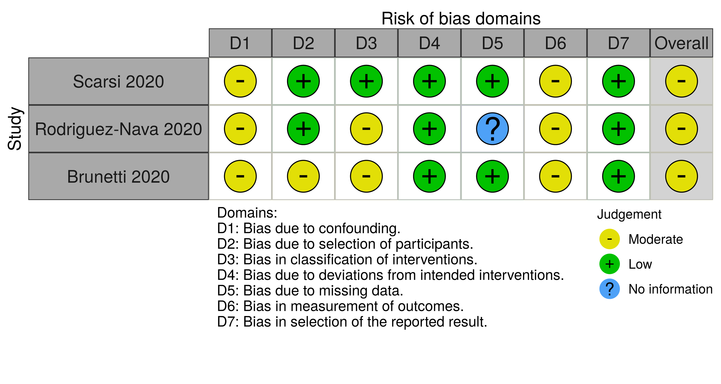

b.


