Supplementary file 2

MMSE
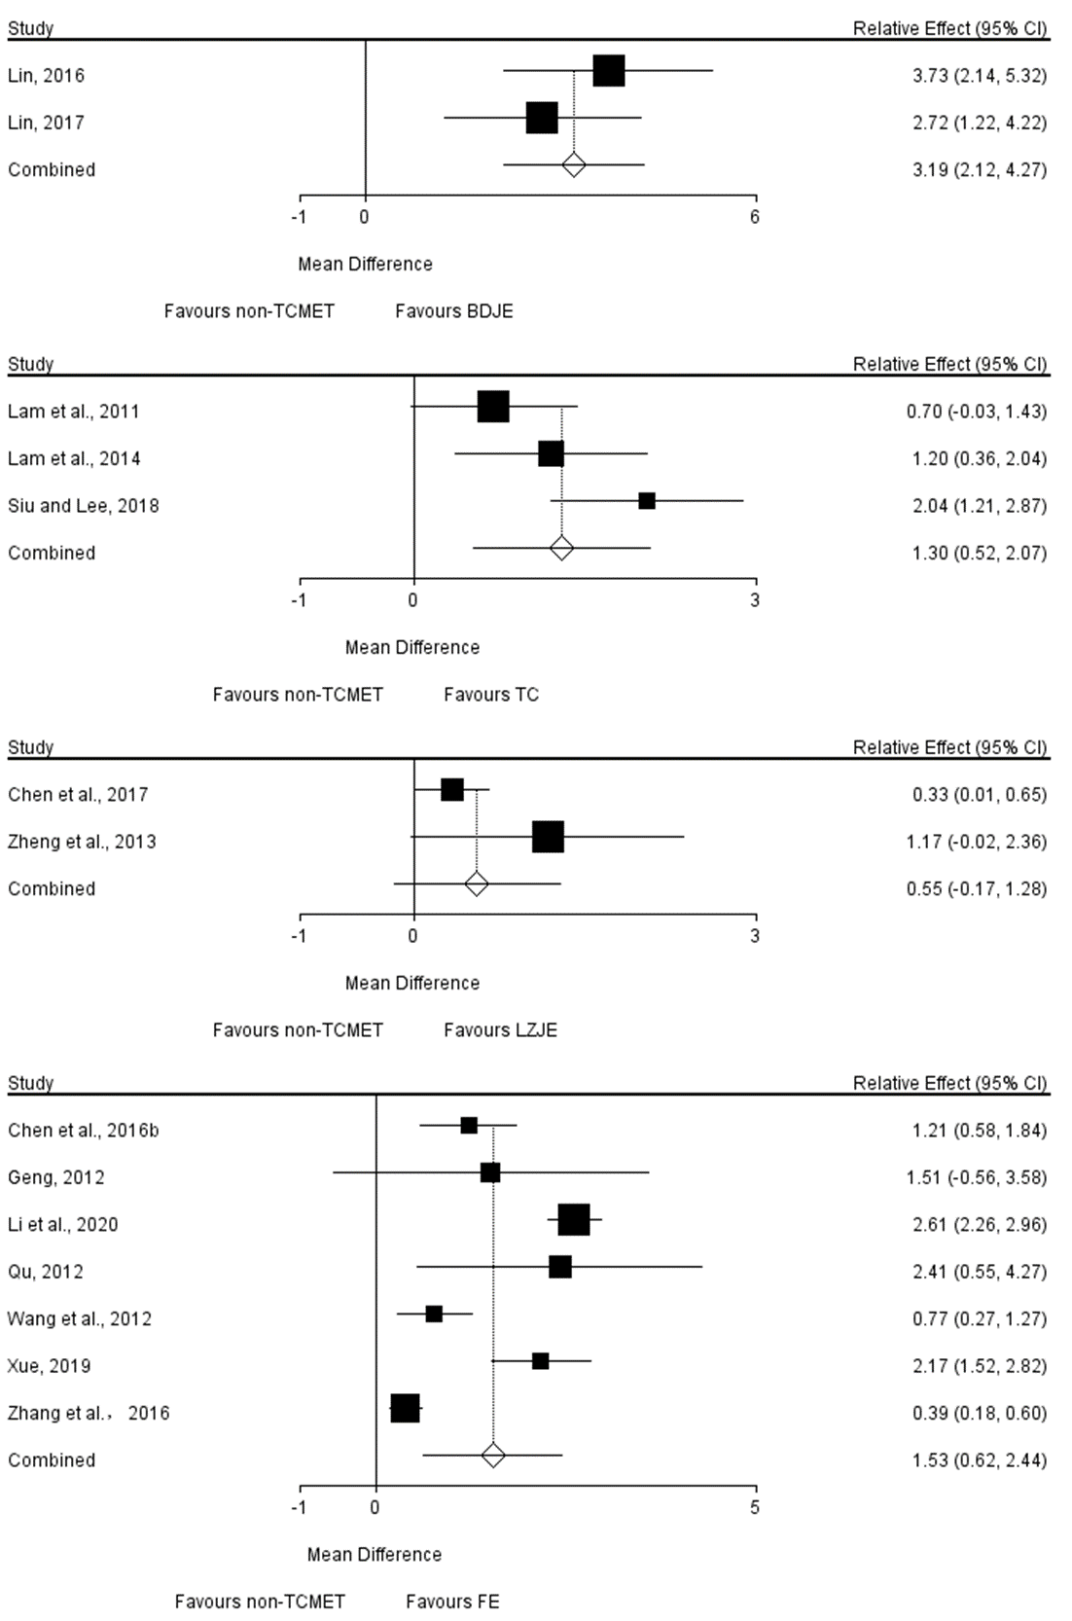
TCMET, traditional Chinese medicine exercise therapy; BDJE, Baduanjin exercise; TC, Tai Chi; LZJE, Liuzijue exercise; FE, finger exercise.
MoCA
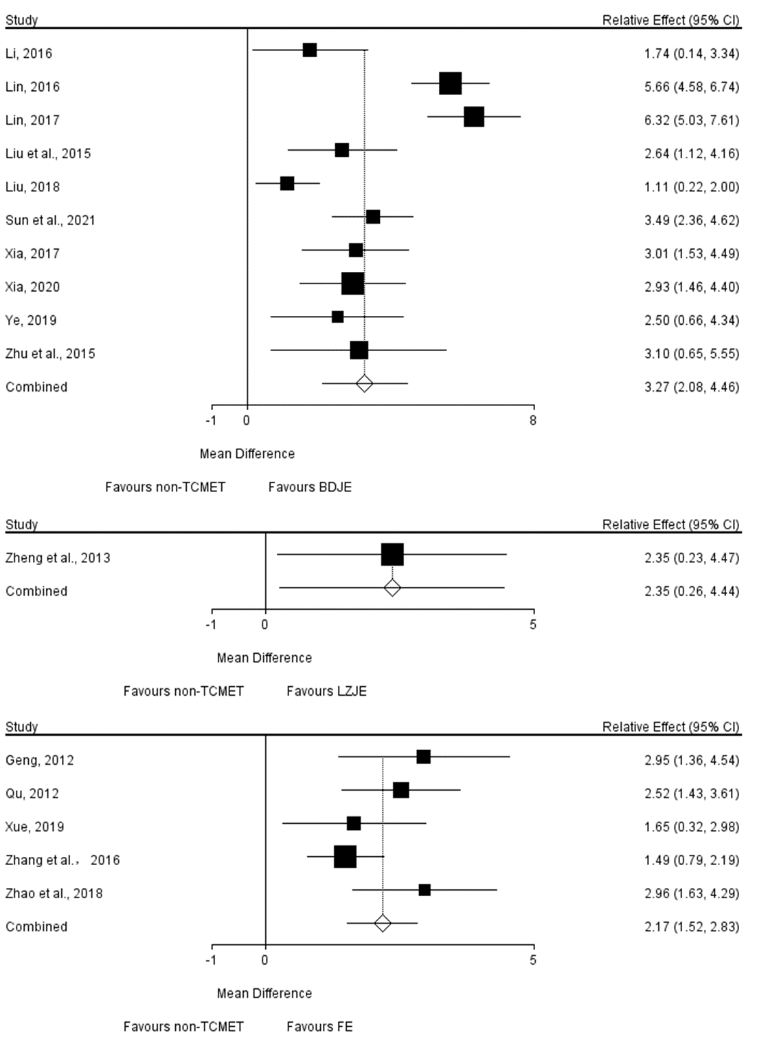
TCMET, traditional Chinese medicine exercise therapy; BDJE, Baduanjin exercise; LZJE, Liuzijue exercise; FE, finger exercise.

ADL
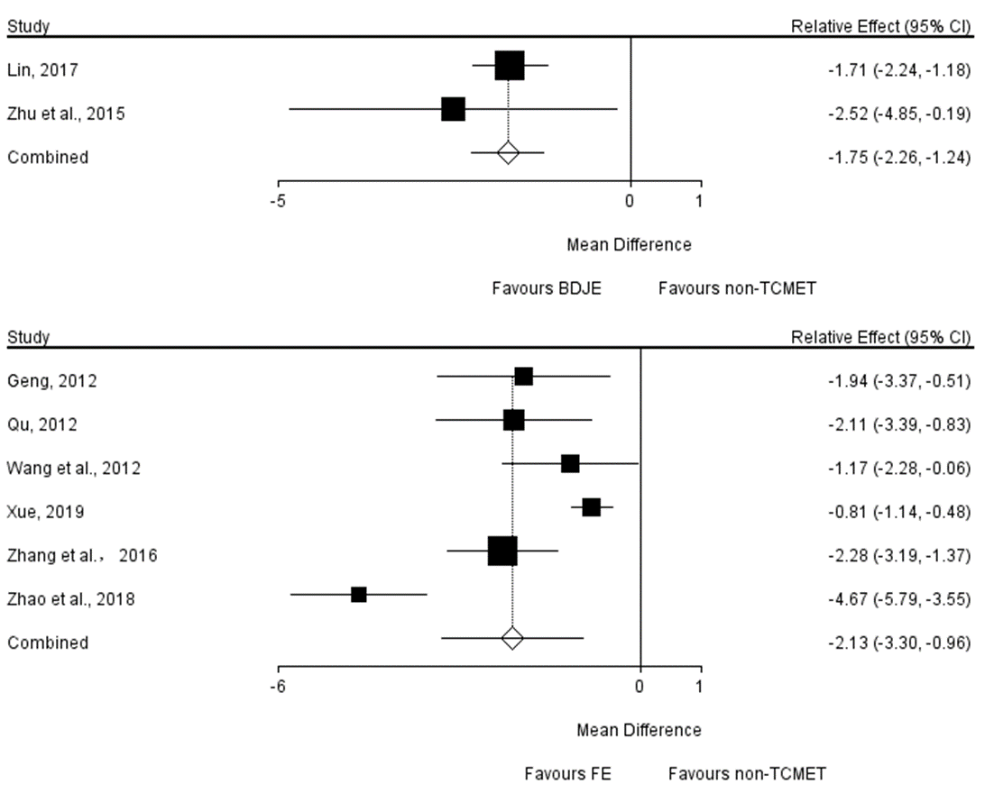
TCMET, traditional Chinese medicine exercise therapy; BDJE, Baduanjin exercise; FE, finger exercise.

