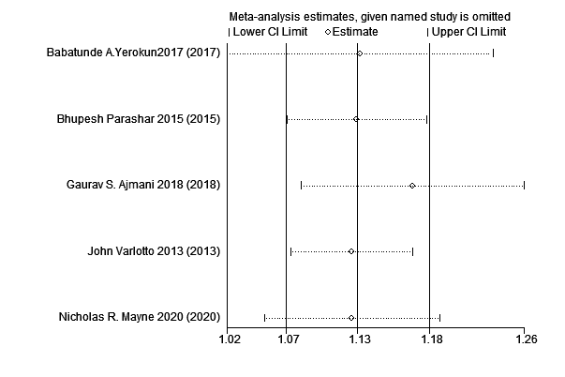
Figure 1: Sensitivity analysis for OS. CI, confidence interval; OS, overall survival.

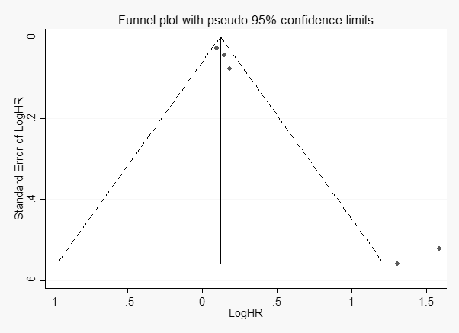
Figure 2: Funnel plots showed the publication bias of the analysis of OS (Egger’s test, P =0.003) . HR, hazad ratio; OS, overall survival.

