AdditionAL file
Efficacy and safety of IL-6 inhibitors in patients with COVID-19 pneumonia: a systematic review and meta-analysis of multicentre randomized trials

A. Belletti, C. Campochiaro, M. Marmiere, V. Likhvantsev,
A. Yavorovskiy, L. Dagna, G. Landoni, A. Zangrillo, L.A. Hajjar

Search strategies | page 3
Supplementary Table 1 | page 4
Supplementary Table 2 | page 5
Supplementary Figure 1 | page 6
Supplementary Figure 2 | page 7
Supplementary Figure 3 | page 8
Supplementary Figure 4 | page 9
Supplementary Figure 5 | page 10
Supplementary Figure 6 | page 11
Supplementary Figure 7 | page 12
Supplementary Figure 8 | page 13
Supplementary Figure 9 | page 14
Supplementary Figure 10 | page 15
Supplementary Figure 11 | page 16
Supplementary Figure 12 | page 17
Supplementary Figure 13 | page 18
Supplementary Figure 14 | page 19
Supplementary Figure 15 | page 20
Supplementary Figure 16 | page 21
Supplementary Figure 17 | page 22
Supplementary Figure 18 | page 23
Supplementary Figure 19 | page 24
Supplementary Figure 20 | page 25
Supplementary Figure 21 | page 26
Supplementary Figure 22 | page 27
Supplementary Figure 23 | page 28
Supplementary Figure 24 | page 29
Supplementary Figure 25 | page 30

SEARCH STRATEGIES
PubMed search strategy
(tocilizumab[tiab] or sarilumab[tiab] or IL-6 inhibitor*[tiab] or interleukin-6 inhibitor*[tiab]) and (randomized [ti] or randomized controlled trial [pt] or randomization [TIAB] or randomly [TIAB] or randomised prospective study [tiab] or post hoc analysis [tiab] or post hoc analyses [tiab] or random number table[tiab] or assigned receive [tiab] or cluster-randomized [tiab] or cluster randomized [tiab] or cluster-crossover randomized [tiab] or cluster crossover randomized [tiab] or cohort study [tiab] or cohort analysis [ti] or retrospective study [ti] or cross-sectional study [tiab] or case control [tiab]) and (covid-19 [tiab] or corona [tiab] or covid [tiab] or nCov [tiab] or sars [tiab]) not (survey [ti] or study protocol [ti] or case-control [ti] or rabbit [ti] or squirrel [ti] or pig [ti] or rat [ti] or animal* [ot] or animal* [ti] or rats[ti])

Scopus search strategy
( TITLE-ABS-KEY ( tocilizumab ) OR TITLE-ABS-KEY ( sarilumab ) AND TITLE-ABS-KEY ( coronavirus AND disease 2019 ) OR TITLE-ABS-KEY ( covid-19 ) OR TITLE-ABS-KEY ( sars-cov-2 ) AND TITLE-ABS-KEY ( randomized ) )

ClinicalTrials.gov search strategy
tocilizumab | Covid19
sarilumab | Covid19

medRxiv search strategy
(sarilumab OR tocilizumab) AND (covid-19 OR coronavirus disease 2019 OR sars-cov-2) AND randomized NOT meta-analysis

SUPPLEMENTARY TABLES
eTable 1 – Definition of outcomes
First Author | Acronym | Journal | Definition of clinical worsening
Gordon AC | REMAP-CAP | N Engl J Med | Death, IMV, or ECMO
Hermine O | CORIMUNO-TOCI 1 | JAMA Intern Med | HFNC/NIMV/IMV/Death by day 14
RECOVERY Collaborative Group | RECOVERY | Lancet | Death, IMV, or ECMO
Lescure FX | N/A | Lancet Respir Med | N/A
Rosas IO | COVACTA | N Engl J Med | Death, need for MV, need for ICU, withdrawal during hospitalization within 28 days
Rutgers A | PreToVid | SSRN Electron J | Death or IMV
Salama C | EMPACTA | N Engl J Med | Death, IMV, or ECMO
Salvarani C | RCT-TCZ-COVID-19 | JAMA Intern Med | Admission to ICU with mechanical ventilation; Death from any cause; PaO2/FIO2 ratio less than 150mmHg in 1 of the scheduled arterial blood gas measurements or in an emergency measurement, confirmed within 4 hours by a second examination
Sivapalasingam S | N/A | medRxiv | N/A
Soin AS | COVINTOC | Lancet Respir Med | Progression from moderate-to-severe or from severe-to-death
Stone JH | BACC Bay Tocilizumab Trial | N Engl J Med | Change in ordinal clinical improvement scale
Talaschian M | N/A | Research Square | N/A
Veiga VC | TOCIBRAS | BMJ | N/A
Wang D | N/A | SSRN Electron J | N/A
Zhao H | N/A | Biomed Pharmacother | Death or MV
ECMO = extracorporeal membrane oxygenation; HFNC = high-flow nasal cannula; ICU = intensive care unit; IMV = invasive mechanical ventilation; MV = mechanical ventilation; N/A = not applicable; NIMV = non-invasive mechanical ventilation
eTable 2 – Risk of Bias
Author | ACRONYM | Randomization process | Deviation from interventions | Missing data | Outcome assessment | Selection of the reported results | Other | Overall
Gordon AC | REMAP-CAP | Low | Some concerns | Low | Low | Low | Low | Some concerns
Hermine O | CORIMUNO-TOCI 1 | Low | Some concerns | Low | Low | Low | Low | Some concerns
Lescure FX | N/A | Low | Some concerns | Low | Low | Low | Some concerns | Some concerns
RECOVERY Collaborative Group | RECOVERY | Low | Some concerns | Low | Low | Low | Low | Some concerns
Rosas IO | COVACTA | Low | Low | Low | Low | Low | Low | Low
Rutgers A | PreToVid | Low | Some concerns | Low | Low | Low | Some concerns | Some concerns
Salama C | EMPACTA | Low | Low | Low | Low | Low | Low | Low
Salvarani C | RCT-TCZ-COVID-19 | Low | Some concerns | Low | Low | Low | Low | Some concerns
Sivapalasingam S | N/A | Low | Some concerns | Low | Low | Low | Some concerns | Some concerns
Soin AS | COVINTOC | Low | Some concerns | Low | Low | Low | Low | Some concerns
Stone JH | BACC Bay Tocilizumab Trial | Low | Low | Low | Low | Low | Low | Low
Talaschian M | N/A | Some concerns | High | Low | Low | Low | Some concerns | High
Veiga Vc | TOCIBRAS | Low | Some concerns | Low | Low | Low | Low | Some concerns
Wang D | Wang D | Low | High | High | Low | Low | Some concerns | High
Zhao H | Zhao H | Unclear | High | Unclear | Low | High | Low | High

SUPPLEMENTARY FIGURES

eFigure 1 – Forest plot for longest follow-up mortality, high versus low-risk of bias
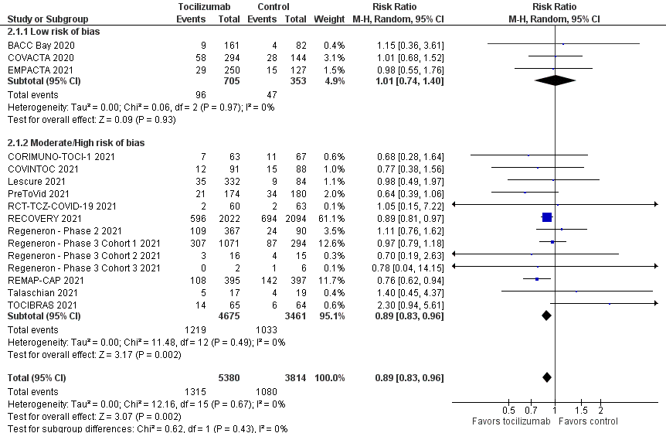

eFigure 2 Forest plot for longest follow-up mortality, excluding patients receiving sarilumab
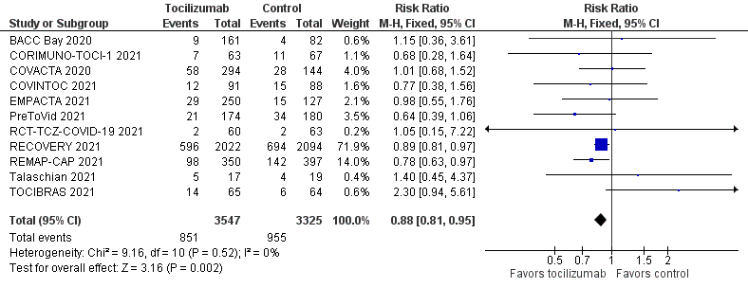
eFigure 3 – Trial sequential analysis for primary outcome, sensitivity analysis assuming a D2=25%
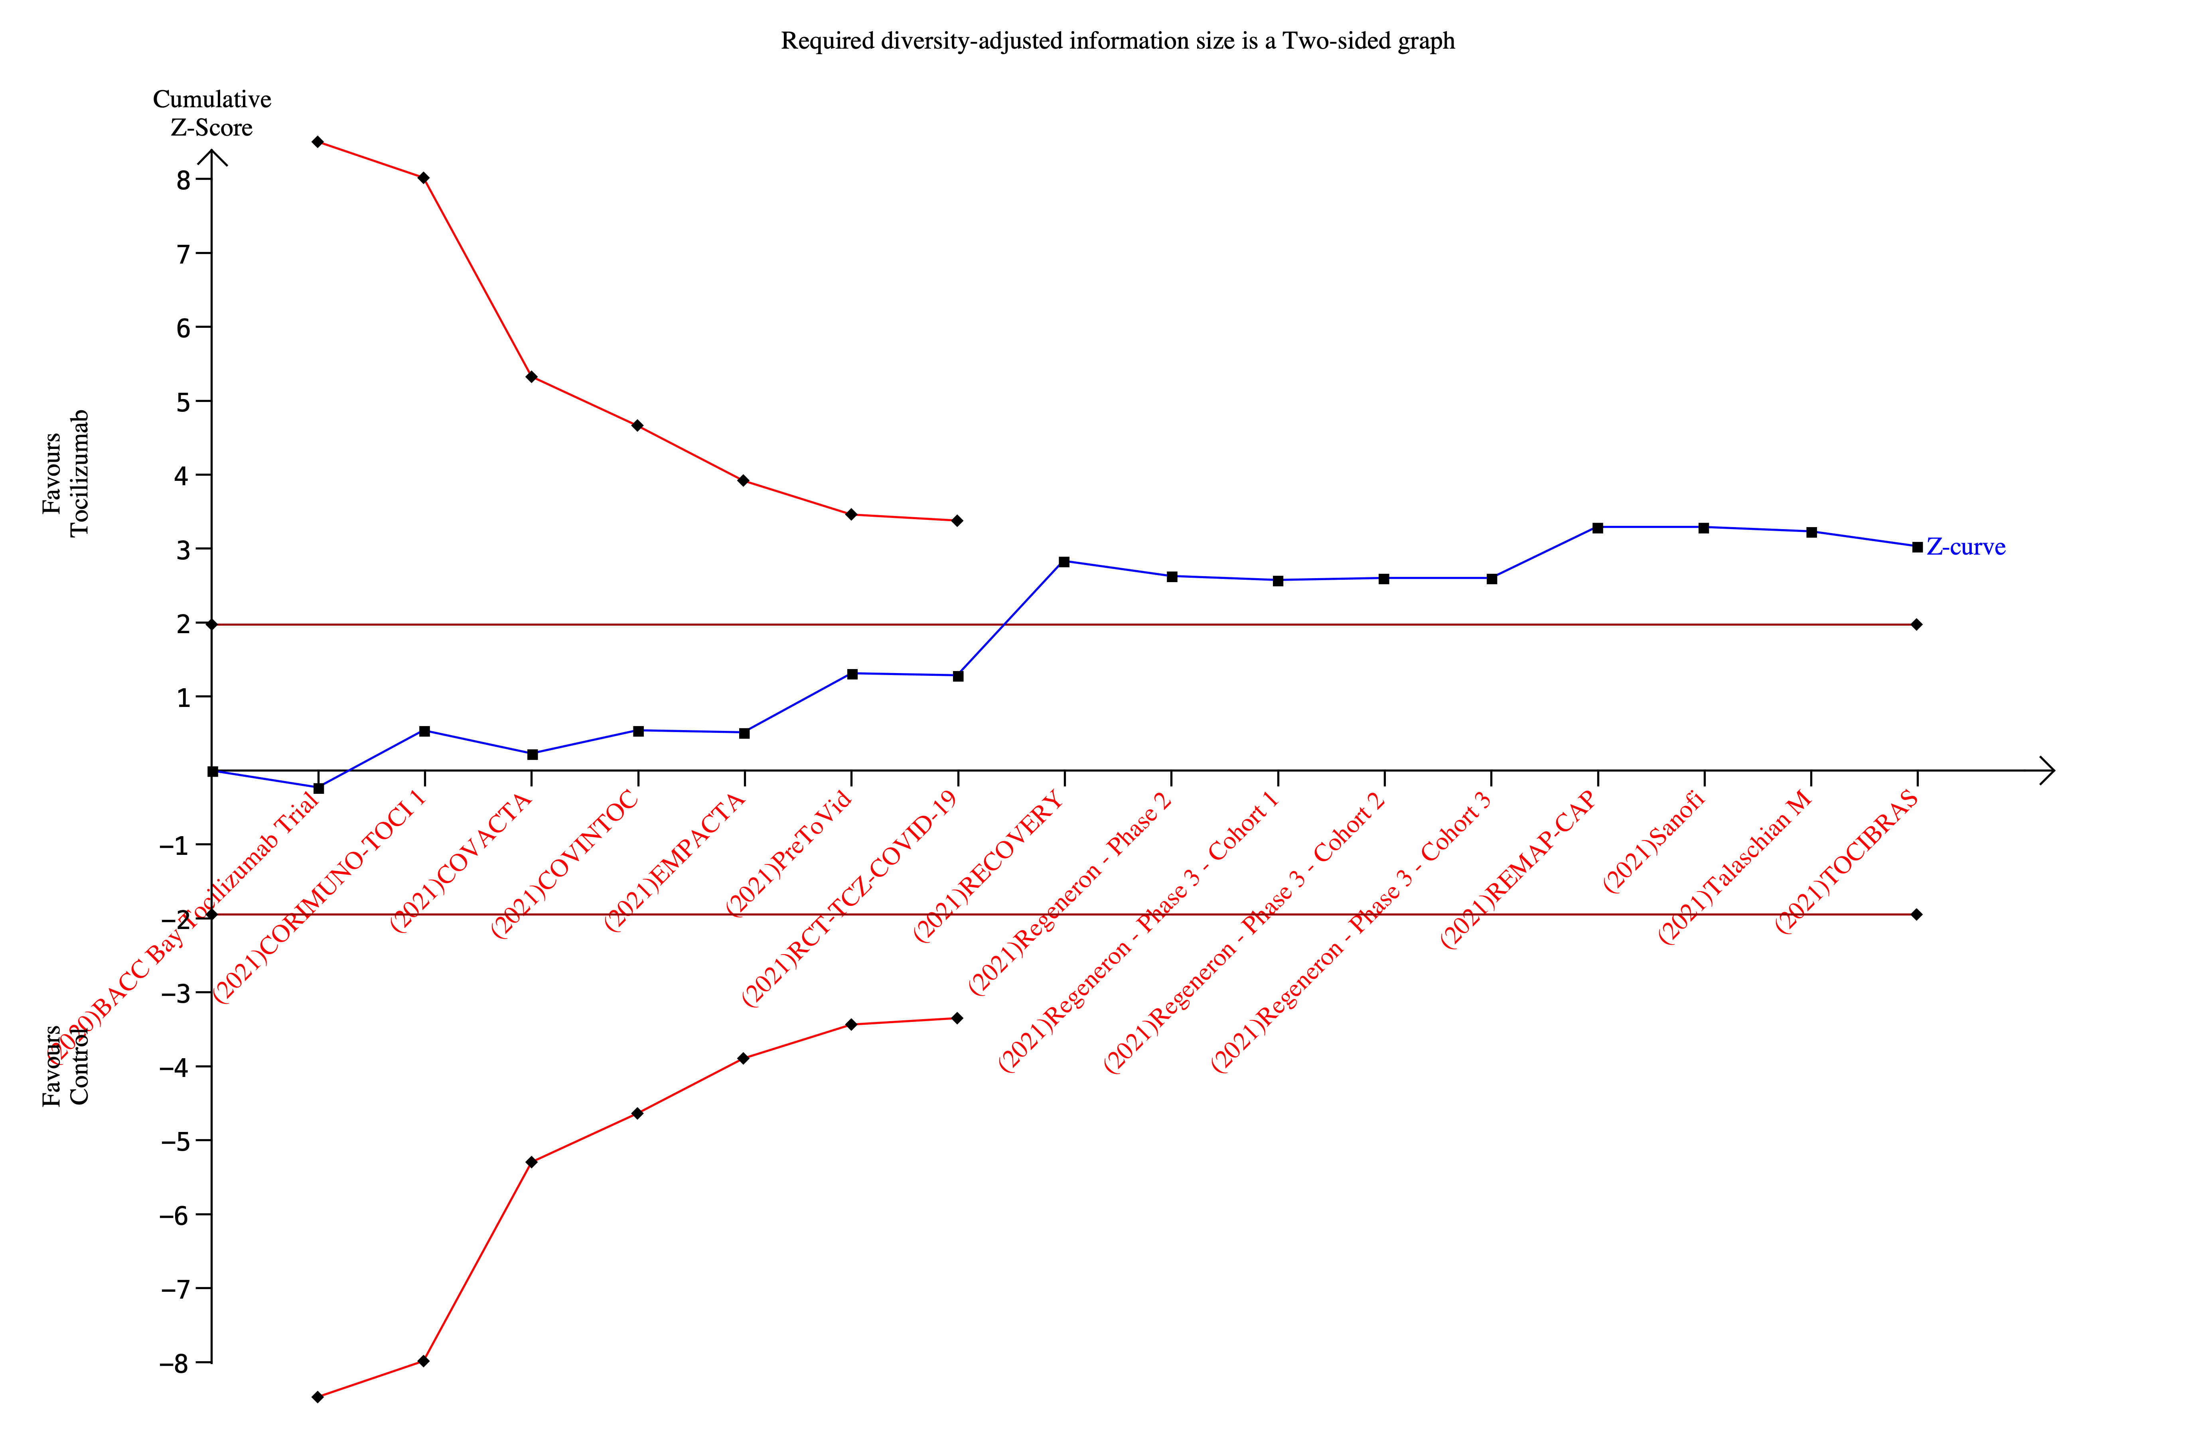

eFigure 4 – Funnel plot for primary outcome
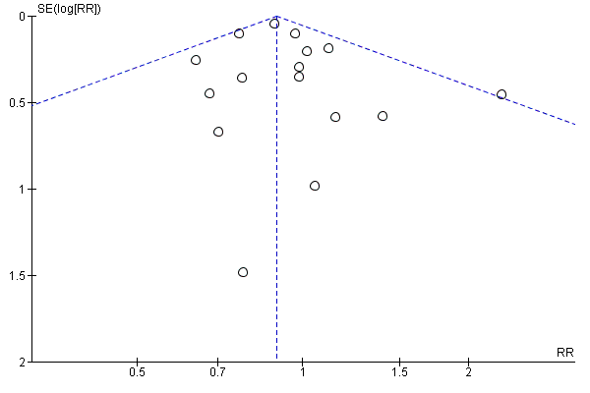

eFigure 5 – Forest plot for 28/30-days mortality
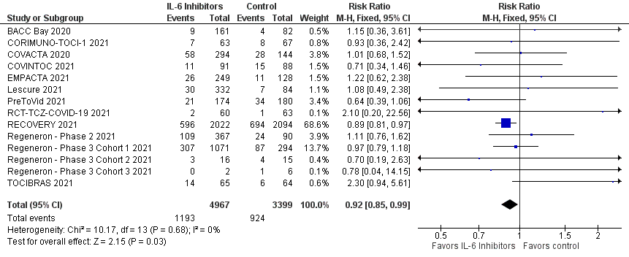

eFigure 6 – Forest plot for need for intubation
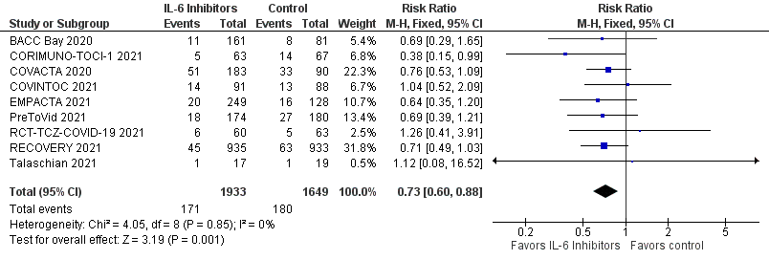

eFigure 7 – Forest plot for incidence of any serious adverse event
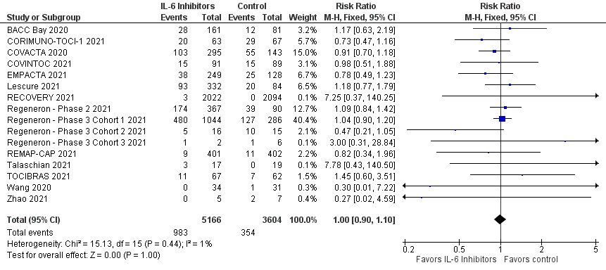
eFigure 8 – Forest plot for incidence of secondary infections
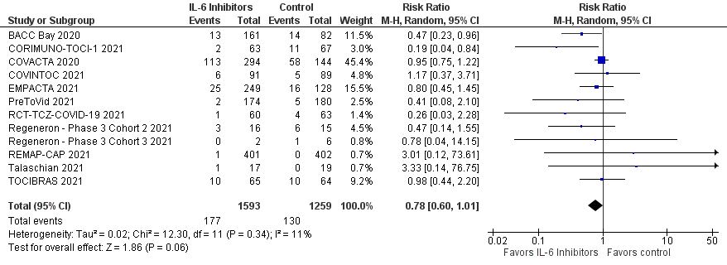

eFigure 9 – Forest plot for 28/30-days mortality, high vs low risk of bias studies

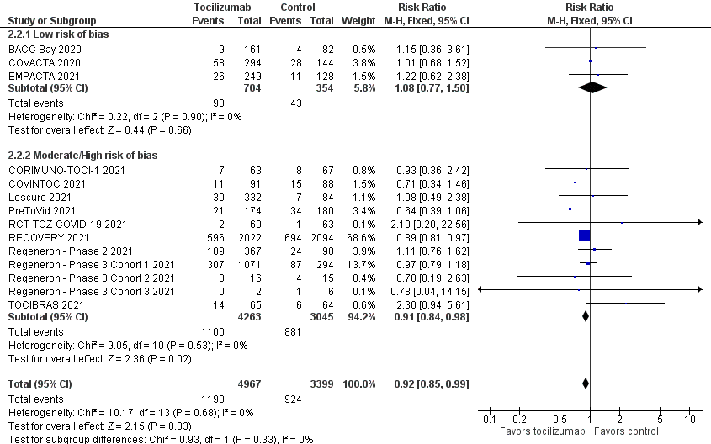

eFigure 10 – Forest plot for intubation, high vs low risk of bias studies.
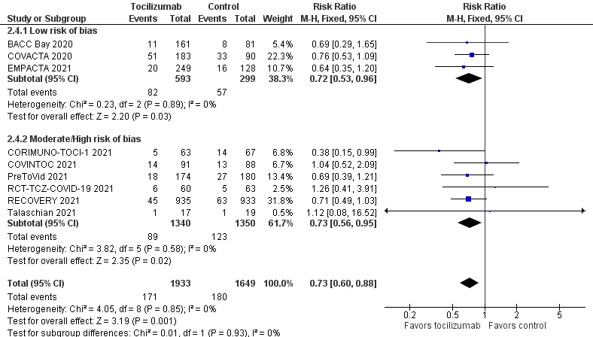
eFigure 11 – Forest plot for serious adverse events, high vs low risk of bias studies
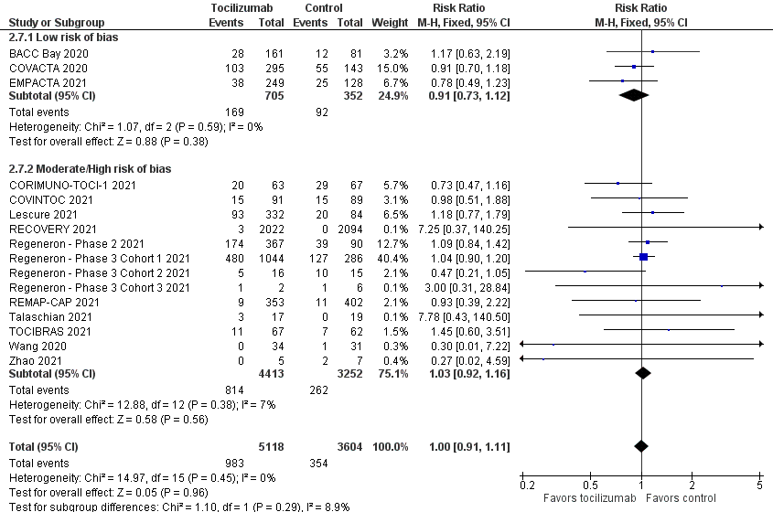

eFigure 12 – Forest plot for secondary infections, high vs low risk of bias studies
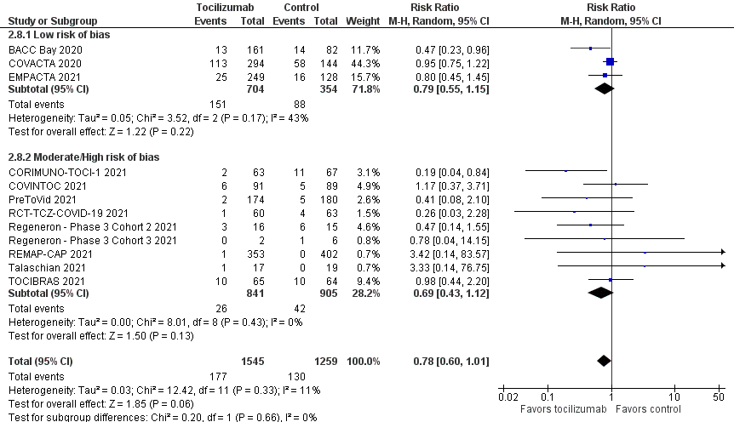

eFigure 13 – Forest plot for clinical worsening, high vs low risk of bias studies
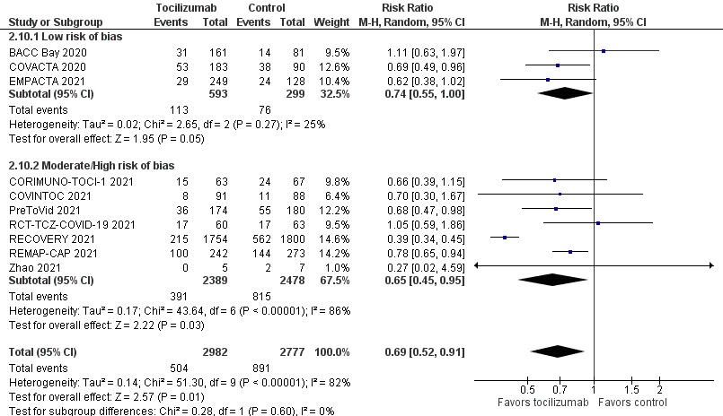

eFigure 14 – Forest plot longest follow-up mortality, studies enrolling vs not enrolling patients on IMV at baseline
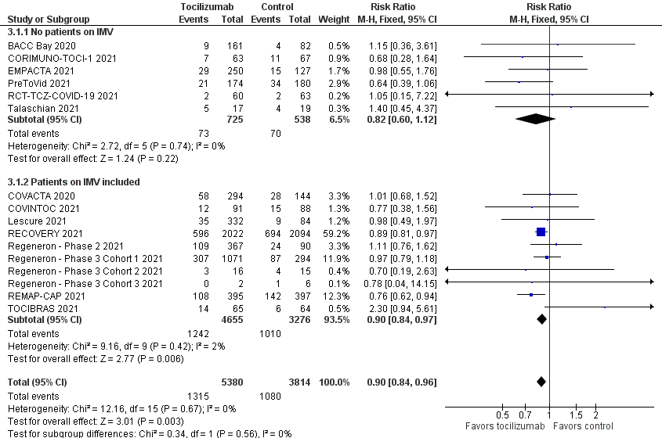
eFigure 15 – Forest plot 28/30-days mortality, studies enrolling vs not enrolling patients on IMV at baseline
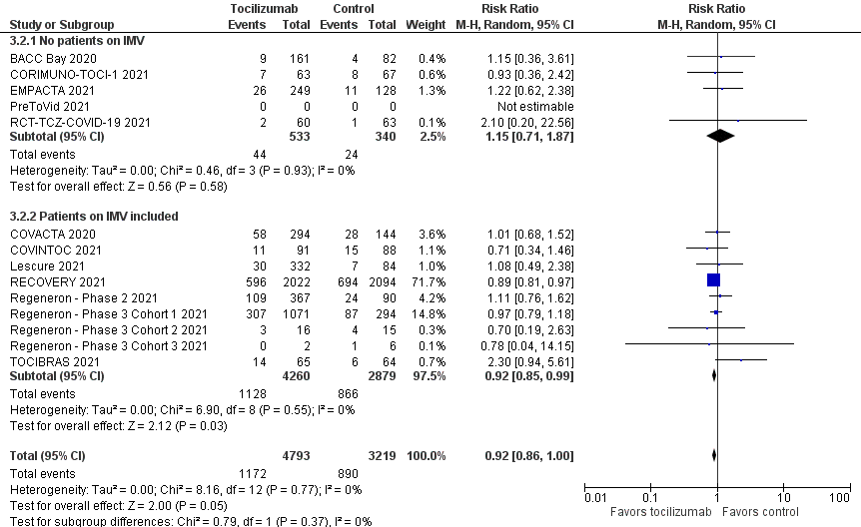
eFigure 16 – Forest plot for serious adverse events, studies enrolling vs not enrolling patients on IMV at baseline
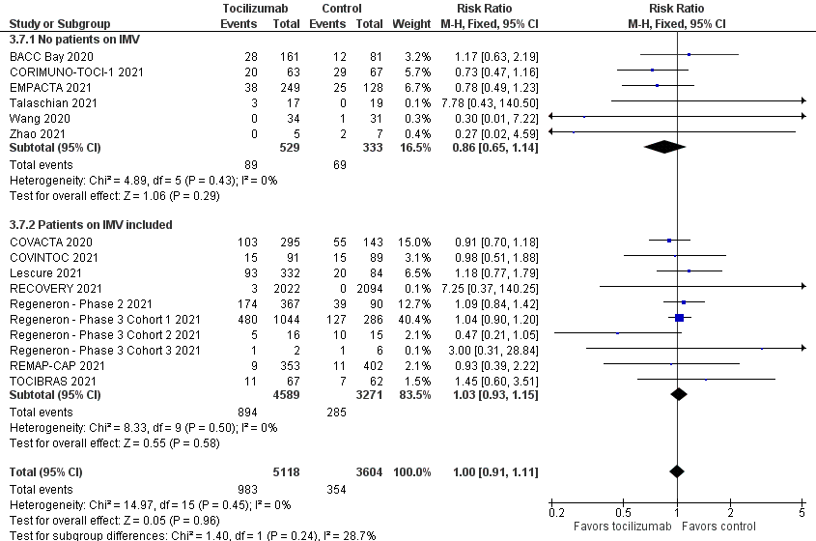
eFigure 17 – Forest plot for secondary infections, studies enrolling vs not enrolling patients on IMV at baseline
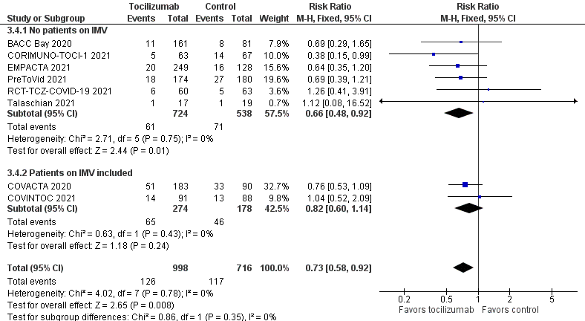

eFigure 18 – Forest plot for clinical worsening, studies enrolling vs not enrolling patients on IMV at baseline
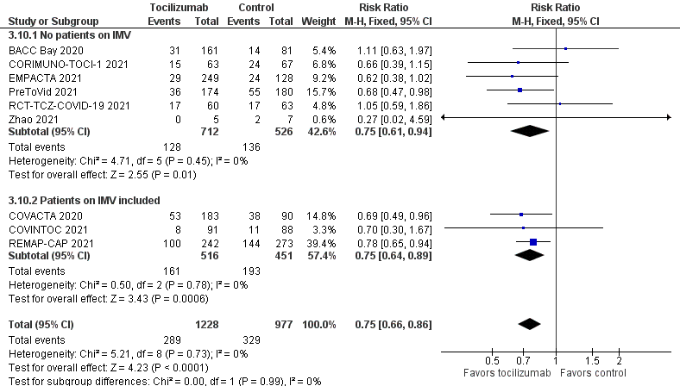
eFigure 19 – Forest plot for longest follow-up mortality, studies with high vs low prevalence of concomitant steroids use

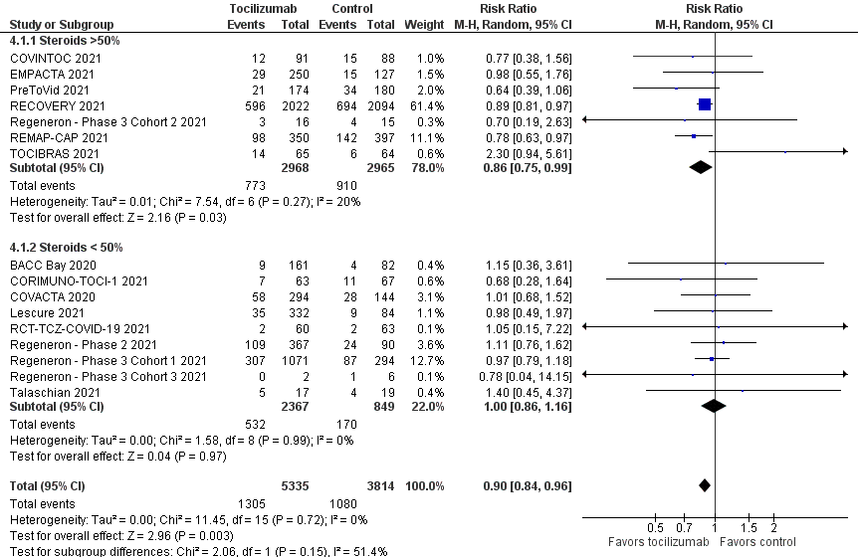

eFigure 20 – Forest plot for 28/30-days mortality, studies with high vs low prevalence of concomitant steroids use

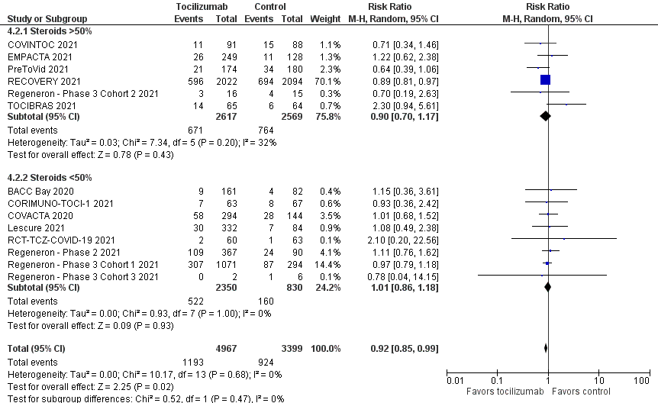

eFigure 21 – Forest plot for need for intubation, studies with high vs low prevalence of concomitant steroids use

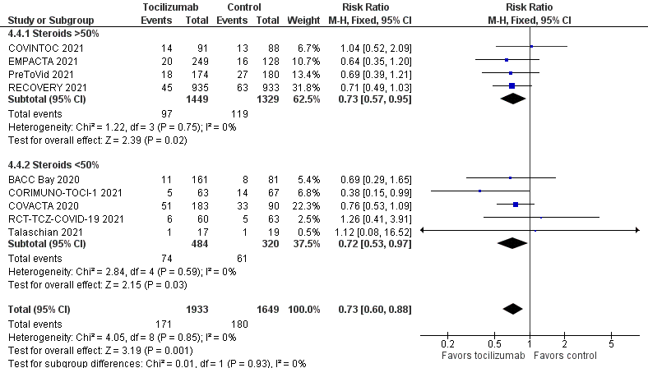

eFigure 22 – Forest plot for serious adverse events, studies with high vs low prevalence of concomitant steroids use

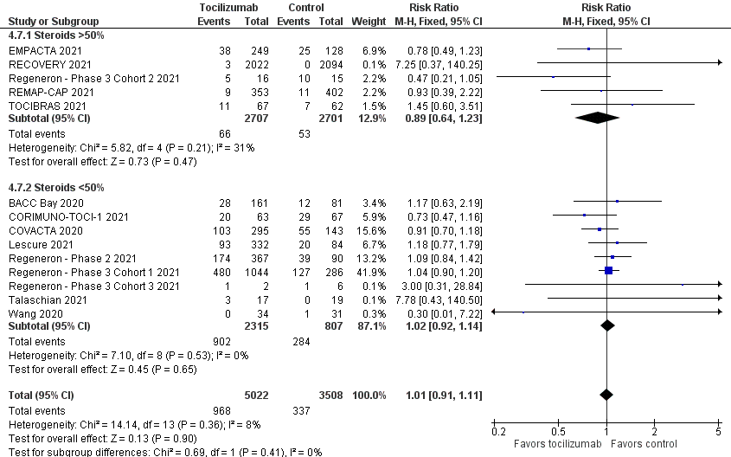

eFigure 23 – Forest plot for secondary infections, studies with high vs low prevalence of concomitant steroids use

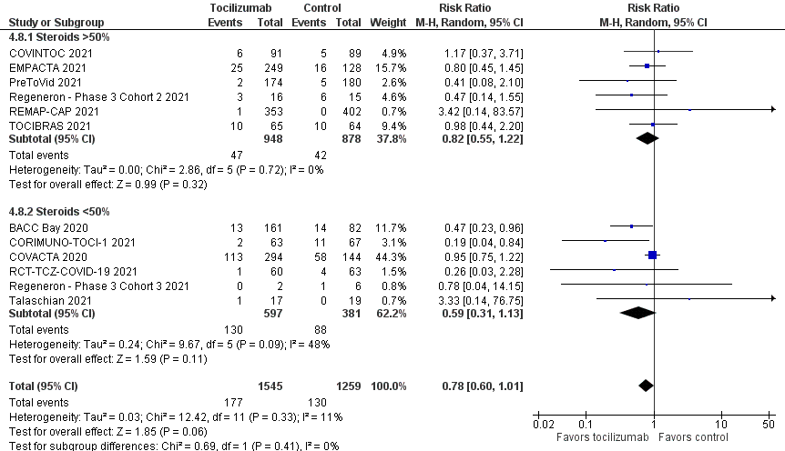

eFigure 24 – Forest plot for clinical worsening, studies with high vs low prevalence of concomitant steroids use

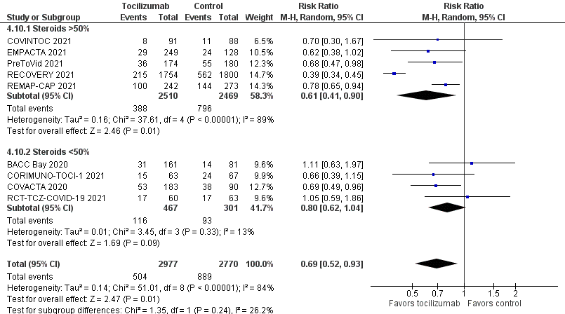
eFigure 25 – Forest plot for 28/30-days mortality, patients receiving versus those not receiving concomitant steroids administration


