Supplementary Materials

Appendix 1
Quality assessment scoring by study in meta-analytic analyses
 | Study |  | Item 1 | Item 2 | Item 3 | Item 4 | Item 5 | Item 6 | QA score
1 | Berg et al., 2020 |  | 0 | 0 | 1 | 1 | 0 | 0 | 2
2 | Taylor, 2020 |  | 1 | 0 | 1 | 1 | 0 | 0 | 3
3 | Invernizzi et al., 2019 |  | 0 | 1 | 1 | 1 | 1 | 0 | 4
4 | Pearce et al., 2019 |  | 1 | 1 | 1 | 0 | 0 | 0 | 3
5 | Rhodes et al., 2019 |  | 0 | 0 | 0 | 1 | 1 | 0 | 2
6 | Robbins et al., 2019 |  | 1 | 0 | 1 | 1 | 1 | 0 | 4
7 | Rodríguez et al., 2019 |  | 1 | 0 | 1 | 0 | 1 | 0 | 3
8 | Vazou et al., 2019 |  | 0 | 0 | 1 | 1 | 1 | 0 | 3
9 | Vitali, et al., 2019 |  | 1 | 0 | 1 | 1 | 0 | 0 | 3
10 | Faro et al., 2019 |  | 1 | 1 | 1 | 1 | 0 | 0 | 4
11 | Gråstén et al., 2019 |  | 0 | 0 | 1 | 1 | 1 | 0 | 3
12 | Andruschko et al., 2018 |  | 0 | 0 | 1 | 0 | 0 | 0 | 1
13 | Miragall et al., 2018 |  | 1 | 0 | 1 | 0 | 1 | 1 | 4
14 | Hutchinson et al., 2018 |  | 1 | 0 | 1 | 1 | 1 | 0 | 4
15 | Noradechanuntet al., 2017 |  | 1 | 1 | 1 | 1 | 1 | 0 | 5
16 | Niedermeier et al., 2017 |  | 0 | 1 | 1 | 1 | 1 | 1 | 5
17 | Billing, 2017 |  | 0 | 1 | 0 | 1 | 0 | 0 | 2
18 | Wang et al., 2015 |  | 0 | 0 | 1 | 1 | 0 | 1 | 3
19 | Kraft et al., 2015 |  | 1 | 0 | 1 | 0 | 0 | 1 | 3
20 | Jekauc, 2015 |  | 0 | 0 | 0 | 1 | 1 | 0 | 2
21 | Mark et al., 2013 |  | 1 | 1 | 1 | 1 | 1 | 1 | 6
22 | Focht, 2013 |  | 1 | 0 | 1 | 1 | 1 | 0 | 4
23 | Fitzsimons et al., 2012 |  | 0 | 0 | 1 | 1 | 1 | 1 | 4
24 | Schneider et al., 2011 |  | 0 | 0 | 1 | 1 | 1 | 0 | 3
25 | Louise et al., 2010 |  | 0 | 0 | 1 | 1 | 0 | 1 | 3
26 | Rhodes, Warburton, & Bredin, 2009 |  | 1 | 1 | 1 | 1 | 0 | 1 | 5
27 | Focht, 2009 |  | 0 | 0 | 1 | 1 | 1 | 0 | 3
28 | Edmunds et al., 2008 |  | 0 | 0 | 0 | 1 | 1 | 0 | 2
29 | Annesi et al., 2008 |  | 0 | 0 | 1 | 1 | 1 | 0 | 3
30 | Baker et al., 2008 |  | 0 | 1 | 1 | 1 | 1 | 1 | 5
31 | Focht et al., 2007 |  | 1 | 0 | 1 | 1 | 0 | 0 | 3
32 | Rose et al., 2007 |  | 0 | 0 | 1 | 1 | 1 | 0 | 3
33 | Robbins et al., 2006 |  | 0 | 0 | 1 | 1 | 0 | 1 | 3
34 | Jamner et al., 2004 |  | 1 | 0 | 1 | 1 | 1 | 0 | 4
35 | McAuley et al., 2003 |  | 1 | 0 | 0 | 0 | 1 | 1 | 3
36 | Digelidis et al., 2003 |  | 0 | 0 | 0 | 1 | 0 | 0 | 1
37 | Nichols et al., 2000 |  | 1 | 1 | 1 | 1 | 0 | 1 | 5

Note. Item 1 = Did the study describe the participant eligibility criteria?; Item 2 = Were the participants randomly selected (or for experimental studies, was the process of randomization clearly described and adequately carried out?); Item 3 = Did the study report the sources and details of physical activity assessment and did the instruments have acceptable reliability for the specific age group?; Item 4 = Did the study report the sources and details of assessment of potential correlates and did all of the methods have acceptable reliability?; Item 5 = Did the study report a power calculation and was the study adequately powered to detect hypothesized relationships?; Item 6 = Did the study report the numbers of individuals who completed each of the different measures and did participants complete at least 80% of physical activity measures?; QA = quality assessment; 1-2 = low, 3-4 = medium, 5-6 = high

Appendix 2
General Study Characteristics
 | Study |  |  | Participants in Intervention Group |  |  |  |  | Intervention |  |  | Affective dimensions |  |  | PA
 | Primary Author &  Year | Setting |  | PA Level | N | Female % | M_{age} (SD) |  | Theory | Length |  | Type | Measure |  | Type | Measure
1 | Berg et al., 2020 | Internet |  | Unreported | 226 | 96.02 | 27±6.68 |  | SDT, DMP | 4 weeks |  | Positive affects | PANAS-X |  | PA | PATCQ
2 | Taylor, 2020 | Internet& university |  | Unreported | 19 | 100 | College freshman |  | SCT, SDT | 9 weeks |  | Enjoyment | PACES |  | PA | IPAQ
3 | Invernizzi et al., 2019 | School |  | Mixed | 62 | 46.77 | 10.5±0.5 |  | CPT | 12 weeks |  | Enjoyment | PACES |  | PA | PAQ-C
4 | Pearce et al., 2019 | School & home |  | Unreported | 63 | 64 | 8 to 13 |  | SMT, SCT, PMT, TTM, TPB | 8 months |  | Enjoyment | PACES |  | MVPA | Accelerometer, PAQ-C
5 | Rhodes et al., 2019 | Family |  | Not meeting guideline | 73 | Null | 11.5±1.3 |  | TPB, SDT | 13 weeks |  | Affective attitude | Semantic differentia |  | Equipment usage | Exercise log
6 | Robbins et al., 2019 | School & internet |  | Mixed | 1519 | 100 | 12.05±1.01 |  | HPM, SDT | 17 weeks |  | Enjoyment | PACES |  | MVPA | Accelerometer
7 | Rodríguez et al., 2019 | School |  | Mixed | 131 | 51.91 | 8.66±1.77 |  | TGM | 8 weeks |  | Affective valence | FS |  | PA | Pedometer
8 | Vazou et al., 2019 | School |  | Mixed | 148 | 52% | 10.39±0.98 |  | ART | 30 minutes |  | Enjoyment, affective valence | S-PACES, FS |  | PA | Accelerometer
9 | Vitali, et al., 2019 | School |  | Mixed | 80 | 48.75 | 10.45±0.23 |  | Null | 4 years |  | Enjoyment | PACES |  | PA | CLASS
10 | Faro et al., 2019 | University |  | Not meeting guideline | 34 | 100 | 27.3±4.5 |  | DMM | 4 weeks |  | Enjoyment, affect | PACES, FS |  | HR | HRM
11 | Gråstén et al., 2019 | School |  | Mixed | 661 | 52.60 | 12.12±0.33 |  | AGT, SEM | 2 years |  | Enjoyment | PEES |  | MVPA | HBSC, Actigraph
12 | Andruschko et al., 2018 | School |  | Not meeting guideline | 20 | 100 | 13.2±0.9 |  | SCT | 6 months |  | Enjoyment | Likert scale |  | PA, MVPA | Accelerometer
13 | Miragall et al., 2018 | Internet & university |  | Not meeting guideline | 76 | 85.5 | 22.18±3.71 |  | TTM | 3 weeks |  | Enjoyment | PACES |  | PA | Pedometer
14 | Hutchinson et al., 2018 | Lab |  | Meeting Guideline | 17 | 47.1 | 28.1±9.9 |  | HT, DMM | 48 hours |  | Affective valence, Remembered pleasure | FS, VAS |  | HR | HRM
15 | Noradechanunt et al., 2017 | Community |  | Not meeting guideline | 39 | 74.36 | 66.6±6.7 |  | Null | 12 weeks |  | Enjoyment | PACES |  | PA | PASE
16 | Niedermeier et al., 2017 | Outdoor, lab |  | Mixed | 42 | 48 | 32.00±11.90 |  | DMM, CM | 170 minutes |  | Mood states | FS, MSS |  | HR | HRM
17 | Billing, 2017 | Telephone |  | Not meeting guideline | 40 | 90 | 39±12 |  | DMM, HT, SCT | 12 weeks |  | Affect, enjoyment | FS, PACES |  | MVPA | Accelerometer, 7DPAR
18 | Wang et al., 2015 | School |  | Unreported | 62 | 50 | 22.3±1.51 |  | SDT, SNST | 8 weeks |  | Enjoyment | IMI |  | PA | IPAQ
19 | Kraft et al., 2015 | University |  | Mixed | 20 | 50 | 22.06±3.6 |  | Null | 15minutes*3 |  | Enjoyment | VAS |  | HR, MET | HRM, Accelerometer
20 | Jekauc, 2015 | Community |  | Unreported | 41 | 87.8 | 46.12 |  | SDT | 8 weeks |  | Enjoyment | PACES |  | Exercise Adherence | Attendance lists
21 | Mark et al., 2013 | Family |  | Not meeting guideline | 30 families | 50.84 | 36.83±6.30 |  | TPB | 6 weeks |  | affective attitude | Likert scale |  | leisure-time PA | GLTEQ
22 | Focht, 2013 | Lab |  | Not meeting guideline | 23 | 100 | 26.62±5.16 |  | SCT, TPB | 30mins/ 10mins |  | Affective valence, exercise-induced feeling | FS, EFI |  | PA | LTEQ
23 | Fitzsimons et al., 2012 | Community |  | Not meeting guideline | 79 | 88.73 | 49±9 |  | TTM | 48 weeks |  | Affect | PANAS |  | PA | Pedometer
24 | Schneider et al., 2011 | School |  | Not meeting guideline | 122 | 100 | 15.04±0.78 |  | SDT | 9 months |  | Enjoyment | PACES |  | PA | 3DPAR
25 | Louise et al., 2010 | School |  | Unreported | 221 | 59.28 | 13.29±0.99 |  | SMT | 16 weeks |  | Enjoyment | PACES |  | LTPA | 7DPAR
26 | Rhodes, Warburton, & Bredin, 2009 | University |  | Meeting guideline | 29 | 0 | 22.7±4.0 |  | TPB | 6 weeks |  | Affective attitude | Semantic differential |  | Adherence to exercise | Attendance list
27 | Focht, 2009 | Lab & Outdoor |  | Meeting guideline | 35 | 100 | 22.14±1.73 |  | TPB | 10 minutes |  | Affective valence, enjoyment, exercise-induced feelings | FS, EFI, SES |  | PA, HR | LTEQ, HRM
28 | Edmunds et al., 2008 | University |  | Mixed | 56 | 100 | 21.32±5.56 |  | SDT | 10 weeks |  | Affect | PANAS |  | Exercise Behavior | Attendance list
29 | Annesi et al., 2008 | Community |  | Unreported | 269 | 59 | 10.6±1.1 |  | SET, SCT | 1 year |  | Vigor | POMS |  | Voluntary Physical Activity | SSMVPA
30 | Baker et al., 2008 | Community |  | Not meeting guideline | 79 | 79.75 | 49.2±8.9 |  | TTM | 12 weeks |  | Affect | PANAS |  | PA | Pedometer
31 | Focht et al., 2007 | Lab |  | Not meeting guideline | 18 | 55.56 | 24.10±3.40 |  | SCT | 8 weeks |  | Affective valence, exercise-induced feelings | FS, EFI |  | - | -
32 | Rose et al., 2007 | Lab |  | Not meeting guideline | 19 | 100 | 39.37±10.29 |  | DMM, SCT, SET | 20 minutes |  | Affective valence | FS |  | HR | HRM
33 | Robbins et al., 2006 | School |  | Not meeting guideline | 77 | 100 | 12.13±0.91 |  | HPM, TTM, SCT | 12 weeks |  | Enjoyment | PACES |  | PA | CAAL
34 | Jamner et al., 2004 | School |  | Not meeting guideline | 58 | 100 | 14.94±0.79 |  | Null | 4 months |  | Enjoyment | PACES |  | PA | 2DPAR, SUPAS
35 | McAuley et al., 2003 | Gymnasium |  | Not meeting guideline | 174 | 71.84 | 65.5 |  | SCT | 6 months |  | Exercise affect | FS |  | Exercise frequency | Exercise log
36 | Digelidis et al., 2003 | School |  | Unreported | 782 | 52.17 | 12.05±0.73 |  | TPB, GPT, TARGETM | 1 year |  | Enjoyment | IMI |  | Exercise behavior | EFS
37 | Nichols et al., 2000 | Worksite |  | Not meeting guideline | 160 | 78.13 | 42.0±9.7 |  | SCT, TTM | 33 months |  | Enjoyment | PACES |  | PA | 7DPAR

Note. PATCQ = Physical activity time consuming questionnaire; PAQ-C = The physical activity questionnaire for children; CLASS = The children’s leisure activities study survey; 7DPAR = 7-day physical activity recall; 3DPAR = 3-day physical Activity Recall; 2DPAR = 2-day physical activity recall; HRM = Heart rate monitor; HBSC = The health behavior in School-aged children research protocol; PASE = The physical activity scale for the elderly; IPAQ = The short-form of the international physical activity questionnaire; GLTEQ = A modified Godin leisure-time exercise questionnaire; LTEQ = Leisure-time exercise questionnaire; SSMVPA = A single-item scale to assess the moderate to vigorous physical activity over the previous week; CAAL = the child and adolescent activity log; SUPAS = the Stanford usual physical activity scale; EFS = 6-point exercise frequency scale; PACES = The physical activity enjoyment scale; S-PACES = Shorted physical activity enjoyment scale for children; FS = The feeling scale; PEES = The PE enjoyment scale; DMP = Dualistic Model of Passion; VAS = Visual analog scale; MSS = A mood survey scale; IMI = The intrinsic motivation inventory; EFI = The Exercise-induced Feeling Inventory; PANAS = The positive and negative affect schedule; PANAS-X = The positive and negative affect schedule-expanded form; TCMM = The trans-contextual model of motivation;SES = Single-item enjoyment scale; POMS = The tension and vigor scales of the profile of mood states-short Form; CPT = Challenge point theory; DMM = The dual-mode model; HPM = the health promotion model; SMT = Self-management theory; PMT = Protection motivation theory; SDT = Self-determination Theory; TGM = Tactical games model; ART = Affective reflective theory; AGT = Achievement goal theory; SEM = Social ecological model; SCT = Social cognitive theory; TTM = The transtheoretical model; TPB = Theory of planned behavior; CM = The circumplex model; SNST = Social network site theory; SMT = Social marketing theory; SET = Self-efficacy theory; GPT = Goal perspectives theory; TARGETM = The TARGET model

Appendix 3
Constructs, dimensions, and measurements of positive affective variables in the included studies
Constructs | Measurement | Dimensions | Studies
Affect
 | FS | Affective valence | 7, 8, 10, 14, 17, 22, 27, 31, 32, 35
 | PANAS | Positive affect | 1, 23, 28, 30
Emotional state
Enjoyment | PACES | PAE | 2, 3, 4, 8, 9, 10, 6, 13, 16, 17, 20, 24, 25, 33, 34, 37
 | PEES | PEE | 11
 | VAS | Enjoyment | 19
 | IMI | Enjoyment | 18, 36
 | SES | Enjoyment | 12, 27
Pleasure | VAS | Remembered pleasure | 14
Exercise-induced feelings | EFI | Revitalization | 22, 27, 31
Exercise-induced feelings | EFI | Positive engagement | 22, 27, 31
Affective attitude | SD | Affective attitude | 5, 26
 | Likert scale | Affective attitude | 21
Mood states | POMS | Vigor | 29
 | MSS | Activation | 16
 | MSS | Excitement | 16
Note. Study content in Appendix 6; FS= Feeling scale; PANAS = Positive and negative affect schedule; PEES = The PE enjoyment scale; SES = Single-item enjoyment scale; VAS = Visual analog scale; IMI = Intrinsic motivation inventory; PACES = The physical activity enjoyment scale; PAE = Physical activity enjoyment; PEE = The PE enjoyment; EFI = Exercise-induced feeling inventory; SD= Semantic differential items on seven-point scales; POMS = Profile of mood states; MSS = Mood survey scale
Appendix 4
Physical activity assessment methods and measurements in each study
Assessment methods | Variables | Measurements | Studies
Objective methods
Pedometer | Steps | The Omron HJ-109E Step-O-Meter | 23, 30
Pedometer | Steps | Pedometer Fitbit One | 13
 |  | Yamax Digiwalker SW-650 (Yamax Corporation, Toyko, Japan) | 7
Accelerometer | MVPA | ActiGraph(did not state the type, manufacturer, and place of origin) | 17
Accelerometer | MVPA | ActiGraph GT3X+ (ActiGraph, Ft. Walton Beach, FL, USA) | 4, 6
Accelerometer | MVPA, PA | Actigraph Model 7164 (Fort Walton Beach, FL, USA) | 12
Accelerometer | MET | ActiGraph GT3X+ (Pensacola, FL) | 19
 |  | The SenseWear Armband Monitor (BodyMedia, Pittsburgh PA) | 8
Log or list | Equipment usage | Log | 5, 35
Log or list | Exercise Adherence | Attendance lists | 20, 26, 28
HR monitoring | HR or %Max HR or HR at VT | HR monitor | 10, 14, 16, 19, 27, 32
Subjective methods
Questionnaires | MVPA | 7DPAR | 12
Questionnaires | MVPA | IPAQ | 2, 18
Questionnaires | MVPA | HBSC | 11
Questionnaires | MVPA | 3DPAR | 24
Questionnaires |  | PAQ-C | 4
Questionnaires | LTPA | 7DPAR | 25
Questionnaires | LTPA | LTEQ | 22
Questionnaires | VPA | SSMVPA | 29
Questionnaires | PA | 7DPAR | 37
Questionnaires | PA | 2DPAR | 34
Questionnaires | PA | PASE | 15
Questionnaires |  | CAAL | 33
Questionnaires |  | PAQ-C  CLASS | 3  9
Questionnaires |  | PATCQ | 1
Questionnaires | LTPA | GLTEQ | 21
Questionnaires | Lifestyle activity | SUPAS | 34
Questionnaires | Exercise behavior | EFS | 36
Note. Study content in Appendix 10; MVPA = Moderate to vigorous physical activity; PA = Physical activity; LTPA = Leisure-time physical activity; LTEQ = Leisure-time exercise questionnaire; GLTEQ = A modified Godin leisure-time exercise questionnaire; SSMVPA = A single-item scale to assess the moderate to vigorous physical activity over the previous week; VPA = Voluntary physical activity; HR = Heart rate; MET = The metabolic equivalent of task; 7DPAR = 7-day physical activity recall; 3DPAR = 3-day physical activity recall; 2DPAR = 2-day physical activity recall; IPAQ = The short-form of the international physical activity questionnaire; PATCQ = Physical activity time consuming questionnaire; HBSC = The health behavior in school-aged children; PASE = The physical activity scale for the elderly; CAAL = the child and adolescent activity log; PAQ-C = The physical activity questionnaire for older children; CLASS = The children’s leisure activities study survey; SUPAS = The Stanford usual physical activity scale; EFS = 6-point exercise frequency scale

Appendix 5
Intervention techniques included in each intervention group in current review
Studies |  | Intervention techniques
1 | Berg et al., 2020 | 16, 34, 37
2 | Taylor, 2020 | 5, 8, 10, 16, 19, 20, 23, 29, 34, 36, 38
3 | Invernizzi et al., 2019 | 1, 5, 7, 8, 9, 16, 19, 20, 21, 22, 28, 29, 36
4 | Pearce et al., 2019 | 1, 5, 7, 8, 9, 20, 21, 22, 36
5 | Rhodes et al., 2019 | 5, 7, 8, 10, 16, 20, 21, 24,29, 34
6 | Rodríguez et al., 2019 | 10, 20, 21, 22, 26
7 | Vazou et al., 2019 | 3, 7, 13, 16, 19, 20, 21, 22
8 | Vitali, et al., 2019 | 1, 5, 10, 20, 21, 22, 23, 29
9 | Faro et al., 2019 | 16, 20, 21, 22
10 | Robbins et al., 2019 | 2, 8, 16, 19, 29, 36, 37
11 | Gråstén et al., 2019
 | Group 1 | 7, 8, 16, 19, 20, 21, 22, 24, 26, 29, 36, 39
 | Group 2 | 7, 8, 16, 19, 20, 21, 22, 24, 26, 29, 36, 39
12 | Andruschko et al., 2018 | 5, 7, 8, 16, 19, 20, 21, 22, 29, 36, 37, 38
13 | Miragall et al., 2018
 | Group 1 | 1, 5, 6, 16, 19, 36
 | Group 2 | 1, 5, 6, 36
14 | Hutchinson et al., 2018 | 10, 16, 20, 21, 24, 36
15 | Noradechanuntet al., 2017
 | Group 1 | 7, 20, 21, 22, 27
 | Group 2 | 7, 20, 21, 22, 27
16 | Niedermeier et al., 2017
 | Group 1 | 5, 9, 20, 21, 24, 29
 | Group 2 | 5, 9, 20, 21, 24, 29
17 | Billing, 2017 | 5, 6, 7, 10, 12, 16, 23, 27, 29, 34, 36
18 | Wang et al., 2015
 | Group 1 | 7, 20, 21, 22
 | Group 2 | 1, 3, 4, 7, 20, 21, 22, 23, 25, 28, 29, 36
 | Group 3 | 1, 3, 4, 8, 16, 21, 22, 23, 24, 25, 28, 29, 36
19 | Kraft et al., 2015
 | Group 1 | 20, 21, 24, 34
 | Group 2 | 20, 21, 24, 26, 34
20 | Jekauc, 2015 | 7,10,11,18,19,20,21, 22, 28,36
21 | Mark et al., 2013 | 3, 16, 20, 21, 24, 34
22 | Focht, 2013 | 9, 20
23 | Fitzsimons et al., 2012
 | Group 1 | 7, 8, 9, 10, 16, 17, 19, 21, 22, 29, 35, 36, 37
 | Group 2 | 7, 8, 9, 10, 16, 17, 19, 21, 22, 29, 35, 36, 37
24 | Schneider et al., 2011
 | Group 1 | 1, 3, 5, 7, 8, 16, 19, 20, 21, 22, 29, 36
 | Group 2 | 1, 3, 5, 7, 8, 16, 19, 20, 21, 22, 29, 36
25 | Louise et al., 2010 | 1, 8, 10, 19, 20, 21, 22, 24, 29, 36, 39
26 | Rhodes, Warburton, & Bredin, 2009 | 7, 16, 20, 21, 24, 34
27 | Focht, 2009 | 20, 24
28 | Edmunds et al., 2008 | 4, 6, 7, 10, 11, 19, 20, 21, 22, 26, 29, 33
29 | Annesi et al., 2008 | 1, 4, 5, 6, 7, 10, 11, 19, 20, 21, 22, 26, 29, 33
30 | Baker et al., 2008 | 7, 8, 9, 10, 16, 17, 19, 21, 22, 29, 35, 36, 37
31 | Focht et al., 2007
 | Group 1 | 7, 20, 21
 | Group 2 | 7, 20, 21
32 | Rose et al., 2007
 | Group 1 | 5, 20, 21, 36
 | Group 2 | 5, 20, 21
 | Group 3 | 5, 20, 21
33 | Robbins et al., 2006 | 1, 2, 3, 4, 7, 8, 19, 20, 21, 22, 24, 29, 36
34 | Jamner et al., 2004 | 1, 3, 5, 7, 8, 16, 19, 20, 21, 22, 29, 36
35 | McAuley et al., 2003 | 7, 9, 20, 21, 22
36 | Digelidis et al., 2003 | 1, 5, 6, 7, 9, 17, 19, 20, 21, 22, 29, 33, 34, 36, 38, 39
37 | Nichols et al., 2000 | 1, 3, 5, 7, 8, 16, 18, 20, 21, 22, 23, 24, 26, 29, 33, 38, 39
Note. Intervention technique content in Table 1.

Appendix 6
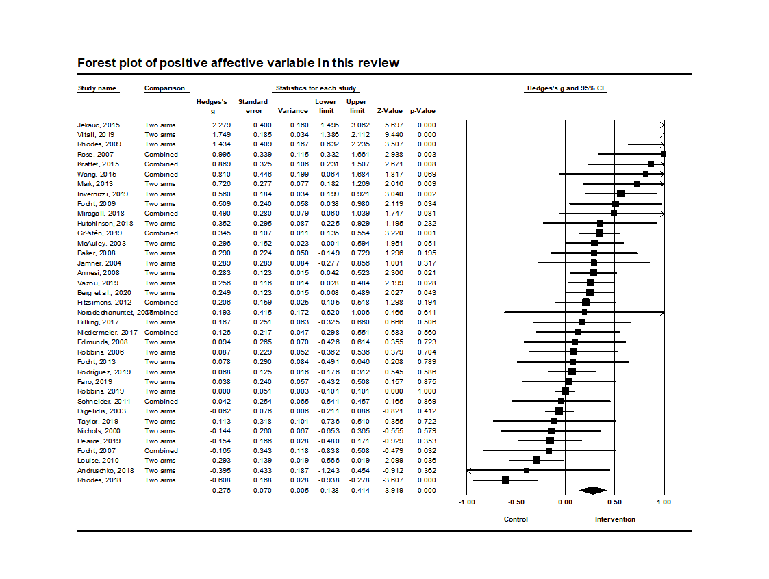
Appendix 7
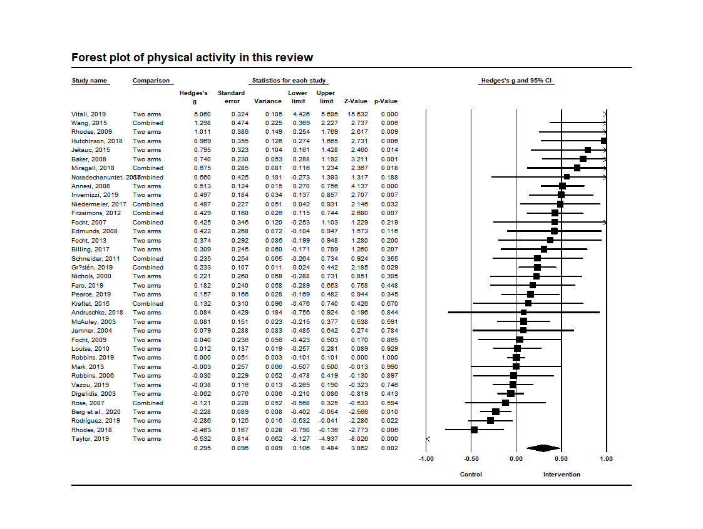Appendix 8
References for Articles included in meta-analytic analyses
- Berg, S., Forest, J., & Stenseng, F. (2020). When Passion Does Not Change, but Emotions Do: Testing a Social Media Intervention Related to Exercise Activity Engagement. Frontiers in Psychology, 11, 71.
- Taylor, M. S. (2020). Fresh start: A group-based intervention to promote physical activity among college freshman (Doctoral dissertation).
- Invernizzi PL, Crotti M, Bosio A, Cavaggioni L, Alberti G, Scurati R. Multi-teaching styles approach and active reflection: Effectiveness in improving fitness level, motor competence, enjoyment, amount of physical activity, and effects on the perception of physical education lessons in primary school children. Sustainability. 2019 Jan;11(2):405.
- Pearce K, Dollman J. Healthy for Life Pilot Study: A Multicomponent School and Home Based Physical Activity Intervention for Disadvantaged Children. International journal of environmental research and public health. 2019 Jan;16(16):2935.
- Rhodes RE, Beauchamp MR, Blanchard CM, Bredin SS, Warburton DE, Maddison R. Predictors of stationary cycling exergame use among inactive children in the family home. Psychology of Sport and Exercise. 2019 Mar 1;41:181-90.
- Robbins LB, Wen F, Ling J. Mediators of Physical Activity Behavior Change in the “Girls on the Move” Intervention. Nursing research. 2019 Jul 1;68(4):257-66.
- Rodríguez-Negro J, Yanci J. Which instructional models influence more on perceived exertion, affective valence, physical activity level, and class time in physical education?. Educational Psychology. 2019 May 9:1-4.
- Vazou S, Mischo A, Ladwig MA, Ekkekakis P, Welk G. Psychologically informed physical fitness practice in schools: A field experiment. Psychology of Sport and Exercise. 2019 Jan 1;40:143-51.
- Vitali F, Robazza C, Bortoli L, Bertinato L, Schena F, Lanza M. Enhancing fitness, enjoyment, and physical self-efficacy in primary school children: a DEDIPAC naturalistic study. PeerJ. 2019 Feb 20;7:e6436.
- Faro J, Wright JA, Hayman LL, Hastie M, Gona PN, Whiteley JA. Functional resistance training and affective response in female college-age students. Medicine & Science in Sports & Exercise. 2019 Jun 1;51(6):1186-94.
- Gråstén A, Yli‐Piipari S. The Patterns of Moderate to Vigorous Physical Activity and Physical Education Enjoyment Through a 2‐Year School‐Based Program. Journal of School Health. 2019 Feb;89(2):88-98.
- Andruschko J, Okely AD, Pearson P. A school-based physical activity and motor development program for low-fit adolescent females: the Sport4Fun pilot randomized controlled trial. Journal of Motor Learning and Development. 2018 Dec 1;6(2):345-56.
- Miragall M, Domínguez-Rodríguez A, Navarro J, Cebolla A, Baños RM. Increasing physical activity through an Internet-based motivational intervention supported by pedometers in a sample of sedentary students: A randomised controlled trial. Psychology & health. 2018 Apr 3;33(4):465-82.
- Hutchinson JC, Jones L, Vitti SN, Moore A, Dalton PC, O'Neil BJ. The influence of self-selected music on affect-regulated exercise intensity and remembered pleasure during treadmill running. Sport, Exercise, and Performance Psychology. 2018 Feb;7(1):80.
- Noradechanunt C, Worsley A, Groeller H. Thai Yoga improves physical function and well-being in older adults: A randomised controlled trial. Journal of science and medicine in sport. 2017 May 1;20(5):494-501.
- Niedermeier M, Einwanger J, Hartl A, Kopp M. Affective responses in mountain hiking—A randomized crossover trial focusing on differences between indoor and outdoor activity. PLoS One. 2017;12(5).
- Billing L. The Efficacy of Affective Behavioral Strategies for Increasing Physical Activity: Implications for Harnessing the Dual-Mode Model.
- Wang JC, Leng HK, Kee YH. Use of Facebook in physical activity intervention programme: Test of self-determination theory.
- Kraft JA, Russell WD, Clark N, Helm J, Jackson A. Influence of experience level on physical activity during interactive video gaming. Journal of Physical Activity and Health. 2015 Jun 1;12(6):794-800.
- Jekauc D. Enjoyment during exercise mediates the effects of an intervention on exercise adherence. Psychology. 2015 Jan 13;6(01):48.
- Mark RS, Rhodes RE. Testing the effectiveness of exercise videogame bikes among families in the home-setting: a pilot study. Journal of Physical Activity and Health. 2013 Feb 1;10(2):211-21.
- Focht BC. Affective responses to 10-minute and 30-minute walks in sedentary, overweight women: Relationships with theory-based correlates of walking for exercise. Psychology of Sport and Exercise. 2013 Sep 1;14(5):759-66.
- Fitzsimons CF, Baker G, Gray SR, Nimmo MA, Mutrie N. Does physical activity counselling enhance the effects of a pedometer-based intervention over the long-term: 12-month findings from the Walking for Wellbeing in the west study. BMC public health. 2012 Dec;12(1):206.
- Schneider M, Cooper DM. Enjoyment of exercise moderates the impact of a school-based physical activity intervention. International Journal of Behavioral Nutrition and Physical Activity. 2011 Dec;8(1):64.
- Louise Bush P, Laberge S, Laforest S. Physical activity promotion among underserved adolescents:“make it fun, easy, and popular”. Health Promotion Practice. 2010 May;11(3_suppl):79S-87S.
- Rhodes RE, Warburton DE, Bredin SS. Predicting the effect of interactive video bikes on exercise adherence: An efficacy trial. Psychology, health & medicine. 2009 Dec 1;14(6):631-40.
- Focht BC. Brief walks in outdoor and laboratory environments: effects on affective responses, enjoyment, and intentions to walk for exercise. Research quarterly for exercise and sport. 2009 Sep 1;80(3):611-20.
- Edmunds J, Ntoumanis N, Duda JL. Testing a self‐determination theory‐based teaching style intervention in the exercise domain. European journal of social psychology. 2008 Mar;38(2):375-88.
- Annesi JJ, Faigenbaum AD, Westcott WL, Smith AE. Relations of self-appraisal and mood changes with voluntary physical activity changes in African American preadolescents in an after-school care intervention. Journal of sports science & medicine. 2008 Jun;7(2):260.
- Baker G, Gray SR, Wright A, Fitzsimons C, Nimmo M, Lowry R, Mutrie N, Scottish Physical Activity Research Collaboration. The effect of a pedometer-based community walking intervention" Walking for Wellbeing in the West" on physical activity levels and health outcomes: a 12-week randomized controlled trial. International Journal of Behavioral Nutrition and Physical Activity. 2008 Dec 1;5(1):44.
- Focht BC, Knapp DJ, Gavin TP, Raedeke TD, Hickner RC. Affective and self-efficacy responses to acute aerobic exercise in sedentary older and younger adults. Journal of Aging and Physical Activity. 2007 Apr 1;15(2):123-38.
- Rose EA, Parfitt G. A quantitative analysis and qualitative explanation of the individual differences in affective responses to prescribed and self-selected exercise intensities. Journal of Sport and Exercise Psychology. 2007 Jun 1;29(3):281-309.
- Robbins LB, Gretebeck KA, Kazanis AS, Pender NJ. Girls on the move program to increase physical activity participation. Nursing research. 2006 May 1;55(3):206-16.
- Jamner MS, Spruijt-Metz D, Bassin S, Cooper DM. A controlled evaluation of a school-based intervention to promote physical activity among sedentary adolescent females: project FAB. Journal of adolescent health. 2004 Apr 1;34(4):279-89.
- McAuley E, Jerome GJ, Marquez DX, Elavsky S, Blissmer B. Exercise self-efficacy in older adults: social, affective, and behavioral influences. Annals of Behavioral Medicine. 2003 Jan 1;25(1):1.
- Digelidis N, Papaioannou A, Laparidis K, Christodoulidis T. A one-year intervention in 7th grade physical education classes aiming to change motivational climate and attitudes towards exercise. Psychology of Sport and exercise. 2003 Jul 1;4(3):195-210.
- Nichols JF, Wellman E, Caparosa S, Sallis JF, Calfas KJ, Rowe R. Impact of a worksite behavioral skills intervention. American Journal of Health Promotion. 2000 Mar;14(4):218-21.

