Supplementary Method 1 Search strategy for PubMed
1 "Dyspepsia"[MeSH Terms] OR "Dyspepsias"[Title/Abstract] OR "Indigestion"[Title/Abstract] OR "Indigestions"[Title/Abstract] OR "FD"[Title/Abstract] OR "functional dyspepsia"[Title/Abstract] OR "function dyspepsia"[Title/Abstract] OR "EPS"[Title/Abstract] OR "postprandial distress syndrome"[Title/Abstract] OR "PDS"[Title/Abstract] OR "epigastric pain syndrome"[Title/Abstract]
2 "Psychotherapy"[MeSH Terms] OR "Psychotherapies"[Title/Abstract] OR "Psychotherapists"[Title/Abstract] OR "Psychotherapist"[Title/Abstract] OR "clinical psychotherapists"[Title/Abstract] OR "clinical psychotherapist"[Title/Abstract] OR "schema therapy"[Title/Abstract] OR "schema therapies"[Title/Abstract] OR "Logotherapy"[Title/Abstract]
3 "Psychodrama"[MeSH Terms] OR "drama therapy"[Title/Abstract] OR "Dramatherapy"[Title/Abstract]
4 "Cognitive Behavioral Therapy"[MeSH Terms] OR "cognitive behavioral therapies"[Title/Abstract] OR "cognitive behavior therapy"[Title/Abstract] OR "cognitive therapy"[Title/Abstract] OR "cognitive behavior therapies"[Title/Abstract] OR "cognitive psychotherapy"[Title/Abstract] OR "cognitive psychotherapies"[Title/Abstract] OR "cognitive therapies"[Title/Abstract] OR "cognition therapy"[Title/Abstract] OR "cognition therapies"[Title/Abstract]
5 "Relaxation Therapy"[MeSH Terms] OR "relaxation techniques"[Title/Abstract] OR "relaxation technique"[Title/Abstract] OR "relaxation technics"[Title/Abstract] OR "relaxation technic"[Title/Abstract] OR "nature therapy"[Title/Abstract] OR "nature therapies"[Title/Abstract] OR "Ecotherapy"[Title/Abstract]
6 "Hypnosis"[MeSH Terms] OR "Hypnoses"[Title/Abstract] OR "Hypnotism"[Title/Abstract] OR "Hypnotherapy"[Title/Abstract] OR "Hypnotherapies"[Title/Abstract] OR "Mesmerism"[Title/Abstract]
7 2 OR 3 OR 4 OR 5 OR 6
8 1 AND 7

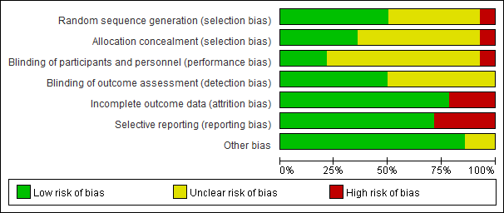
Supplementary Fig. 1 Risk of bias graph.

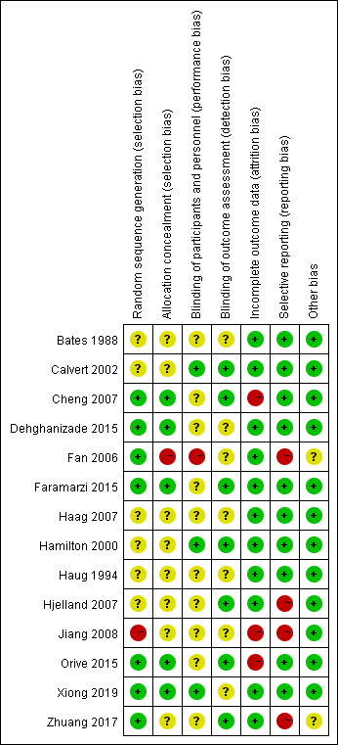
Supplementary Fig. 2 Risk of bias summary.

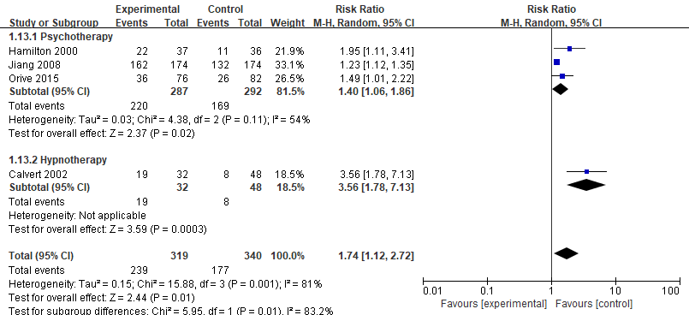
Supplementary Fig. 3 Subgroup analysis of the effect of psychological interventions on symptom improvement.
CI: confidence interval.

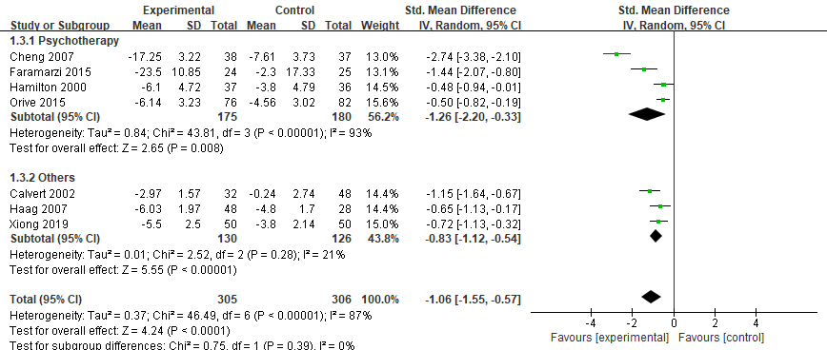
Supplementary Fig. 4 Subgroup analysis of the effect of Psychological interventions on gastrointestinal symptom scores at follow up.
CI: confidence interval; Others: hypnotherapy/ relaxation or cognitive behavioural therapy/ cognitive behavioural therapy.

